# | Pts Possible | Pts missed | Extra Credit
1 | 12
2 | 8
3 | 10
4 | 9
5 | 4
6 | 12
7 | 12
8 | 12
9 | 10
10 | 11+2
Total
Score
DUE 12/6/2018 8:30 am

If you attend the final exam review session, please bring a hard copy of your exam to turn in. If you cannot attend, please upload your exam on the course syllabus site. To allow a margin for computer and internet problems, we recommend uploading the exam on 12/5/2018.

Collaboration with others is NOT permitted. Answers must be in your own words. Do not try to find the answers by searching for old finals or problems sets. No exceptions. Really.

Please show your work.

1. HEART Score History Inter-rater Agreement [12 points]
The HEART Score is one of many clinical prediction tools to identify emergency department (ED) chest pain patients who are at low risk for a short‐term major cardiac event (MACE). The acronym is clever; HEART: History (H), electrocardiogram (ECG, E), Age (A), Risk Factors (R), and Troponin (T). Here we are interested in “History”, which is scored as 0 for slightly suspicious, 1 for moderately suspicious, and 2 for highly suspicious. Gershon (PMID 30428149) compared the scores of an attending emergency physician and an emergency medicine resident on 311 patients. Here are simulated results:
HEART History Score
 |  | Attending Emergency Physician
 |  | 0 | 1 | 2
Emergency Medicine Resident | 0 | 100 | 0 | 0 | 100
Emergency Medicine Resident | 1 | 65 | 100 | 0 | 165
Emergency Medicine Resident | 2 | 10 | 25 | 11 | 46
 |  | 175 | 125 | 11 | 311

- Is agreement balanced? If not, was the resident or the attending more easily impressed by the history (i.e., thought the history was more suspicious)? [2]

- Calculate expected agreement for all cells in the table below: [3]
HEART History Score
 |  | Attending Emergency Physician
 |  | 0 | 1 | 2
Emergency Medicine Resident | 0 |  |  |  | 100
Emergency Medicine Resident | 1 |  |  |  | 165
Emergency Medicine Resident | 2 |  |  |  | 46
 |  | 175 | 125 | 11 | 311

- What is observed percent (complete) agreement? [1]

d) What is expected percent (complete) agreement? [1]

e) What is unweighted kappa? [1]

f) What are the weights for quadratic weighted kappa? [1]

g) What was observed quadratic weighted agreement? [1]

h) What was expected quadratic weighted agreement? [1]

i) What was quadratic weighted kappa? [1]

2. D-Dimer for PE in adolescents (Suggested by Phil Pererra) [8 points]
Recall from Problem Set 7 #3 that a pulmonary embolism (PE) is blood clot in the lungs. For the purposes of this problem, assume that computed tomographic pulmonary angiogram (CTPA) is a perfectly accurate test for PE, but we can’t obtain a CTPA on every emergency department (ED) patient who has a slight possibility of PE; a CTPA involves ionizing radiation, exposure to intravenous contrast, and ties up an imaging resource that may be needed by other ED patients.

For this reason, several diagnostic protocols for patients with symptoms suggestive of PE recommend first obtaining a plasma D-Dimer level, which is a measure of increased clotting activity in the blood, and then obtaining a CTPA for patients with a D-Dimer level ≥ some threshold. The threshold in these protocols can vary between 500 and 1500 ng/mL.

Sharaf et al(1) did a case-control study of the accuracy of plasma D-Dimer as a test for pulmonary embolism in adolescent ED patients. The 88 cases were adolescent ED patients with positive CTPA (the gold standard) who had an ED D-Dimer level (index test result) available. The control patients were selected from all ED patients with negative CTPA and an ED D-Dimer level available, matched 1:1 with the cases based on age, sex, and race.
From the Results:
Seventy‐nine (79/88 [90%]) PE‐positive patients had D‐dimer levels ≥ 500 ng/mL versus 74 (74/88 [84%]) PE‐negative patients.
- Fill in the 2×2 table below using the information from this sentence and calculate the sensitivity and specificity of the D-dimer ≥ 500 ng/mL. [4]

D-Dimer (ng/mL) | PE+ | PE−
≥ 500
< 500
Total

- You are told an adolescent ED patient similar to those included in this study has a D-Dimer ≥ 500 ng/mL. Your colleague directs you to the paper above to justify his estimate that the patient's posterior probability of PE is about 50%. Would you agree? Why or why not? [2]

As mentioned above, the cases and controls in this study were adolescent ED patients with symptoms suggestive or PE who had both a D-Dimer level obtained and a CTPA.

- Assume the emergency physicians treating the adolescent patients in this study followed diagnostic protocols similar to those described in the question stem. What bias would this cause? How would it affect the sensitivity and specificity reported above? [2]

3. Platelet Count as test for Invasive Bacterial Infection [10 points]
JAMA Pediatr. 2017;171
Cruz et al did a cross-sectional study to investigate using the platelet count to identify febrile infants < 60 days old with invasive bacterial infections (IBI) and reported these results.
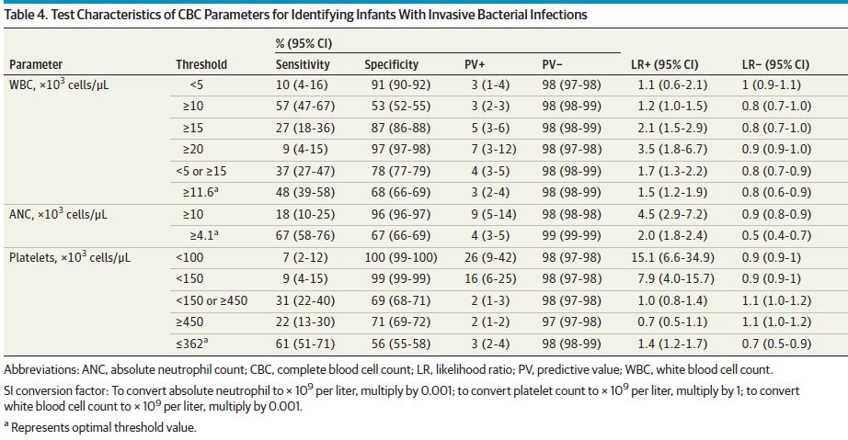

Here is the data table that gave rise to the above:
Platelet Count  × 10³ cells/μL | IBI+ | IBI− | Total
<100 | 7 | 16 | 23
100-<150 | 2 | 26 | 28
150-<450 | 67 | 2909 | 2976
450+ | 21 | 1265 | 1286
 | 97 | 4216 | 4313

- Admittedly some of the numbers are small, but what is the point estimate for the interval likelihood ratio for a platelet count of 100 - < 150 ×10³? (Show calculation.) [2]

- You are working with a population of patients whose prior probability of IBI you believe is very similar to the one in this study. Your current patient is a febrile infant < 60 days old with a platelet count of 125 × 10³ cells/μL. Based on this study and the platelet count, what is your best estimate for the probability of IBI? Explain and show calculations.[2]

- Of the 4 platelet count intervals in the table above, which is the most concerning for IBI? What is the LR for a platelet count in that interval?[2]

- If your treatment threshold probability for IBI is 1% and the only test you were considering was the platelet count, what pre-test probability would allow you to skip the test and forgo treatment. [2]

- In Table 4 from the paper, the authors report an LR of 1.0 for platelets < 150 or ≥ 450. What is the LR for a platelet count 150 - < 450 ? [2]

4. RQI RSI (Suggested by Manasi Deshpandey, Nafeesa Moksud & Bushra Hossain) [9 points]

The Risk Quantification Index (RQI) and Risk Stratification Index (RSI) are scores developed to predict 30-day mortality risk after an operation requiring anesthesia using easily available variables, namely operative procedure, ASA risk level (recorded on all patients prior to an anesthetic), and patient age. Sigakis et al.(2) used a dataset of more than 100,000 patients who underwent anesthesia over a 5-year period at the Massachusetts General Hospital to externally validate the performance of the RQI and RSI.

Below are calibration plot and ROC curve for the RQI. If you can’t read the legend on the calibration plot, the triangles are “grouped observations.” These are groups of patients receiving similarly risky operations; they do not represent groups with predicted risk in a particular range nor do they represent quantiles of risk. Nevertheless, based on your knowledge of calibration plots and ROC curves, you should be able to match the triangles marked a, b, and c to the general region of the ROC curve marked I, II, and III.

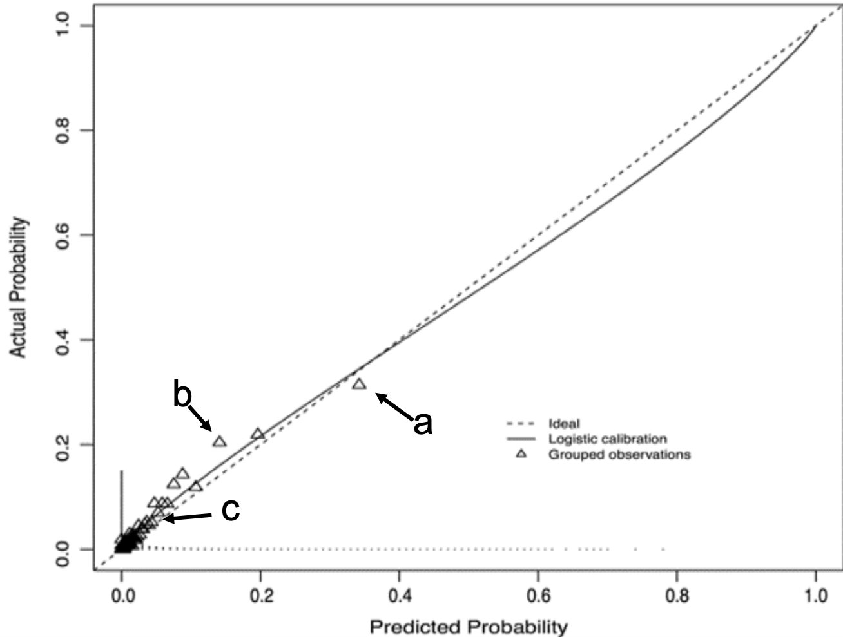
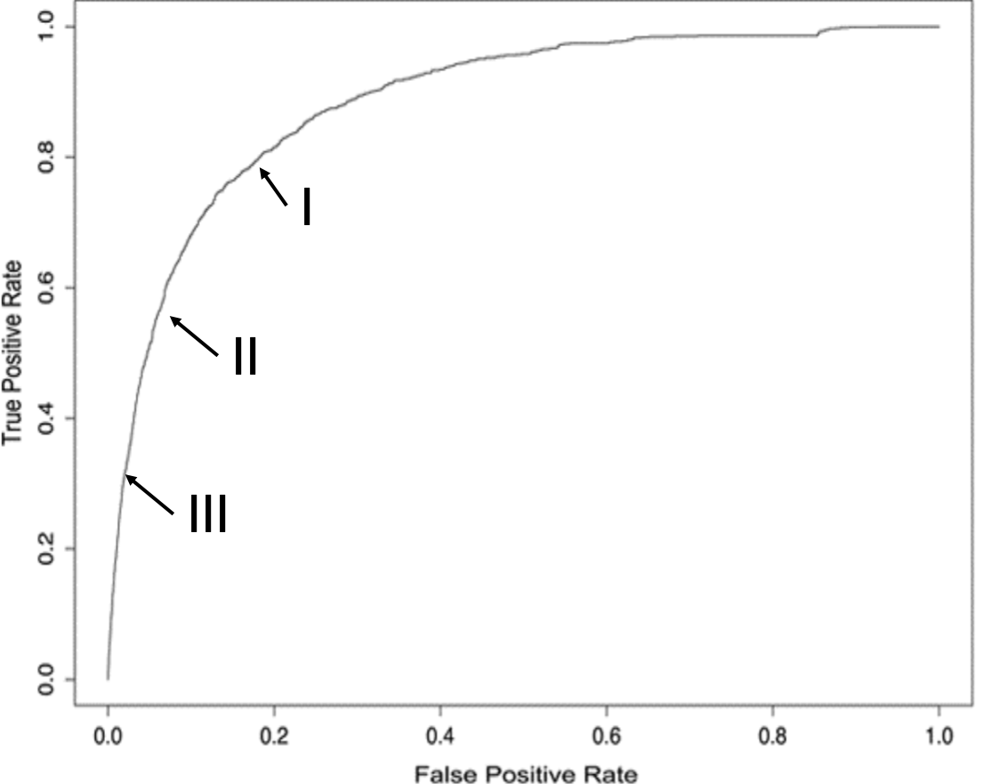
External validation of Risk Quantification Index (RQI) 30-day mortality calibration and discrimination
Match (a), (b), and (c) on the calibration plot to I, II, and III on the ROC curve. [3]

a)
b)
c)

Below are the calibration plot and ROC curve for the RSI.

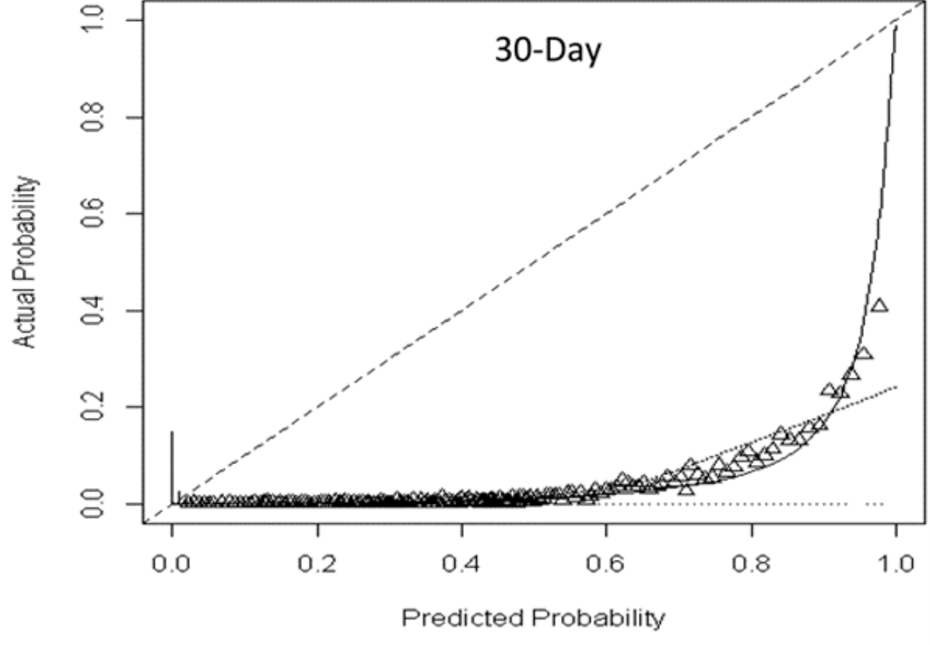

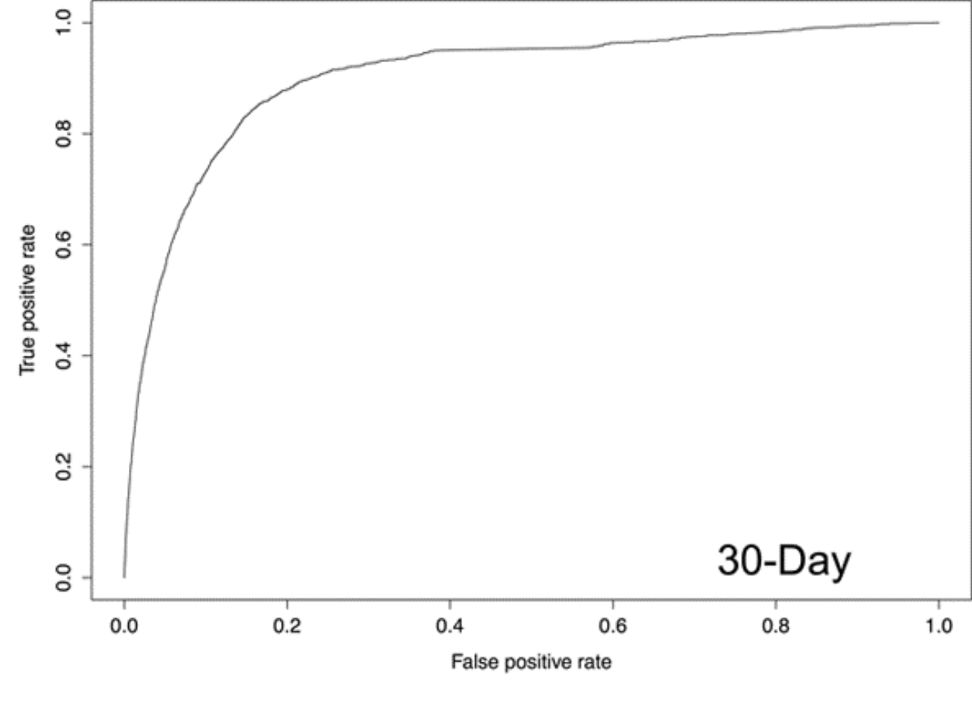
External validation of Risk Stratification Index (RSI) 30-day mortality discrimination and calibration

d) Does the RSI overestimate or underestimate risk? Explain. [2]

e) The Brier Scores for these two indexes were 0.199 and 0.017. Which one was the Brier Score for the RQI? Explain your choice. [2]

The data for these calibration plots and ROC curves came from the same original dataset, but different patient records were excluded from the evaluation of each index depending on whether predicted risk could be calculated according to that index. Many more records were excluded from the evaluation of the RQI. Nevertheless, the overall 30-day mortality was the nearly the same in both analysis sets, 1.9% for RQI and 2.0% for RSI. The AUROC for RQI was 0.88 and for RSI was 0.90.

f) Even if both indexes were evaluated on the same dataset, could they have such different looking calibration plots but similar looking ROC curves? Explain. [2]

5. Maternal age and Trisomy 21 [4 points]

The age at which women first give birth has been increasing in the United States, in some places more than others. According to the New York Times,(3) our home town of San Francisco has the distinction of having the oldest first-time mothers in the US, at an average age of 32 years. The youngest first-time mothers in the U.S. are in Todd County, South Dakota with an average age of 20 years.

As was previously mentioned, maternal age is a strong risk factor for Trisomy 21 (Down syndrome). Assume that the risk of Trisomy 21 increases with maternal age (as illustrated in EBD-2 Figure 7.10) and the same relationship between maternal age and Trisomy 21 applies in both San Francisco and Todd County. For simplicity, let's dichotomize maternal age at first birth at 35 years. You are trying to estimate the likelihood that a fetus of a first-time mother has Trisomy 21. How would you expect the LR+ for the mother being over 35 years old to differ in San Francisco compared with Todd County, SD? Explain.

6. ECMO (Suggested by Kolaitis, Nicholas; Bautista, Roberto; Oh, Anita) [12 points]
Extracorporeal membrane oxygenation (ECMO) is what is commonly called “bypass” and is sometimes used on ICU patients with lung failure to oxygenate the blood while the lungs recover. This is an expensive and risky treatment, but assume that it is worth using ECMO on 12 patients to prevent 1 from dying within the next 60 days.
The EOLIA Trial assessed the efficacy of ECMO in patients with severe acute respiratory distress syndrome (ARDS). (4) See excerpt from the abstract below:
METHODS:
In an international clinical trial, we randomly assigned patients with very severe ARDS…to receive immediate … ECMO (ECMO group) or continued conventional treatment (control group). Crossover to ECMO was possible for patients in the control group who had refractory hypoxemia. The primary end point was mortality at 60 days.
RESULTS:
At 60 days, 44 of 124 patients (35%) in the ECMO group and 57 of 125 (46%) in the control group had died. Crossover to ECMO occurred a mean (±SD) of 6.5±9.7 days after randomization in 35 patients (28%) in the control group, with 20 of these patients (57%) dying.
CONCLUSIONS:
Among patients with very severe ARDS, 60-day mortality was not significantly lower with ECMO than with a strategy of conventional mechanical ventilation that included ECMO as rescue therapy.

- Create a 2x2 table of the intention-to-treat results. Use the Chapter 8 convention of putting the intervention group (ECMO) in the top row and the control group in the bottom row. Also, put the bad outcome (dead at 60 days) in left hand column. [4]

- Based on the intention-to-treat analysis, what is the relative risk of death, the relative risk reduction, and the absolute risk reduction, and the number needed to treat of ECMO compared to continued conventional therapy (with possible subsequent crossover to ECMO)? [4]

As mentioned in the abstract, crossover to ECMO was possible for patients in the control group who had refractory hypoxemia. This occurred in 35 of the 125 patients randomized to the control group. Of the 35 control patients who crossed over to ECMO, 20 died. Assume that more than 20 would have died without crossover to ECMO.
C. Compared to a trial where crossover to ECMO of control-group patients was not possible, would the effect size measurements in (B) be higher or lower? Give the probable effect on each individual measurement of making crossovers impossible, e.g. “the relative risk would be higher/lower; the relative risk reduction would be …” [2]

- The authors report a P-Value for the between-groups comparison of 0.09. Does this study justify the conclusion that ECMO does not lower 60-day mortality in severe ARDS? [2]

7. MASS revisited [12 points]
Recall that problem 1 from HW#8 was about the Multicenter Aneurysm Screening Study (MASS). Many students had trouble with part D, which asked whether the "as treated" comparison of AAA deaths between those were and were not scanned in the invited group was biased. To refresh your memories (hopefully without triggering PTSD), here are the data from the ITT analysis (invited/not invited) and the as treated analysis of the invited group

MASS Study
 | N | AAA-related Deaths | % | Total Deaths | %
Invited | 33,839 | 65 | 0.19% | 3,750 | 11.08%
Not Invited | 33,961 | 113 | 0.33% | 3,855 | 11.35%
Total | 67,800 | 178 |  | 7,605

MASS Study -- Invited Group Only
 | N | AAA Death | % | Total Death | %
Scanned | 27,147 | 43 | 0.16% | 2,590 | 9.54%
Not Scanned | 6,692 | 22 | 0.33% | 1,160 | 17.33%
 | 33,839 | 65 |  | 3,750

When we initially assigned this problem, we had not yet covered Chapter 9, which includes instrumental variables.

- Suppose we wanted to use an instrumental variable (IV) approach to estimate the causal effect of being scanned on AAA mortality from this trial. What would be the instrument? [2]
- What would we need to assume about the instrument to have the IV estimate of the causal effect of scanning be valid? [2]
- Assume that no one in the uninvited group received a scan. What would be the IV estimate of the causal effect of ultrasound scanning on AAA mortality (as a risk difference). Hint: we are looking for the Complier Average Causal Effect. [4]

- To which group of patients would the estimate in part c apply? [2]
- How does your answer to part C compare with the as-treated risk difference in the invited group? Explain. [2]

8. Screening for liver cancer in China (adapted from a problem by Sepehr Hashemi) [12 points]

Liver cancer kills almost 750,000 people per year (half in China), making it the second leading cause of cancer mortality worldwide.(5) Chronic Hepatitis B Virus infection, indicated by a positive Hepatitis B virus Surface Antigen (HBsAg) test, is the most common etiological factor.

Ji et al. (5) invited 35- to 64-year old residents of Zhongshan City, China (N= 68,551) to participate in liver cancer screening. (The paper is on the CLE website, but everything you need to know should be below). Those who participated (N=17,973) had HBsAg screening; the HBsAg-positive subjects were screened for liver cancer with serum alpha-fetoprotein (AFP, a liver cancer blood marker) and invited for biannual liver ultrasound scans for 4 years. Figure 1 (showing the design) is pasted below.

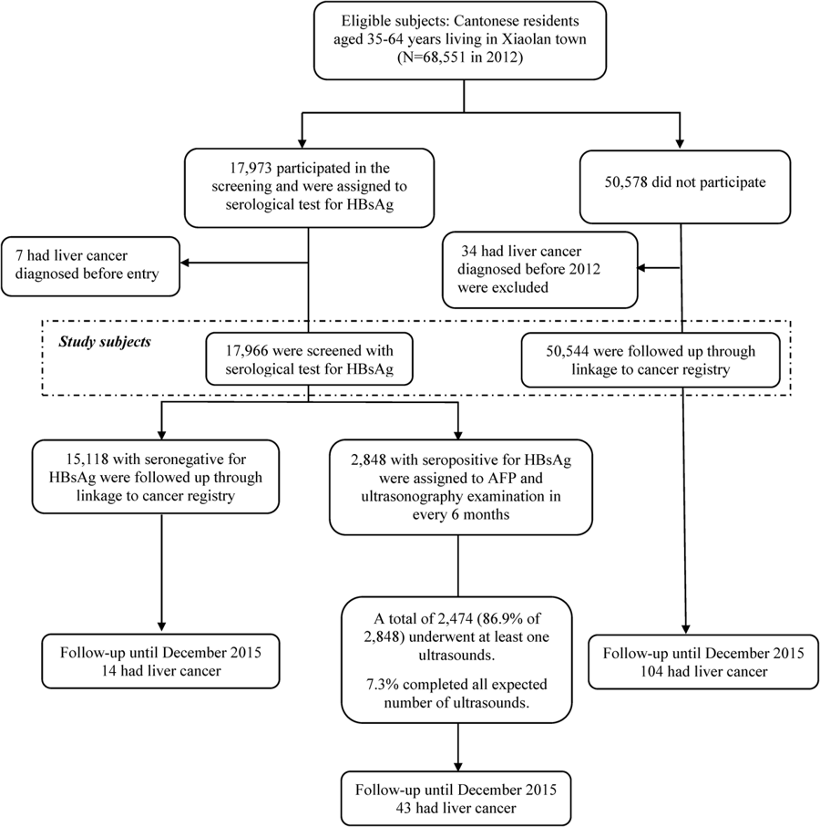
Figure 1: Enrollment and follow-up of the study participants after the initial screening in Xiaolan town (community), Zhongshan City, China.

- The cumulative incidence of (diagnosed) liver cancer was significantly increased among participants (0.32% vs 0.21%; crude RR= 1.54, Exact P= 0.01. For each of the following statements, indicate whether it is true or false and explain.
    - The excess in liver cancer diagnoses could be due to volunteer effect, if people at higher risk of liver cancer or hepatitis B chose to participate. [2]

    - The excess in liver cancer diagnoses could be due to overdiagnosis. [2]

    - The excess in liver cancer diagnoses could be due to sticky diagnosis bias. [2]

Supplemental Figure S2 (showing liver cancer survival) from the study is pasted below.

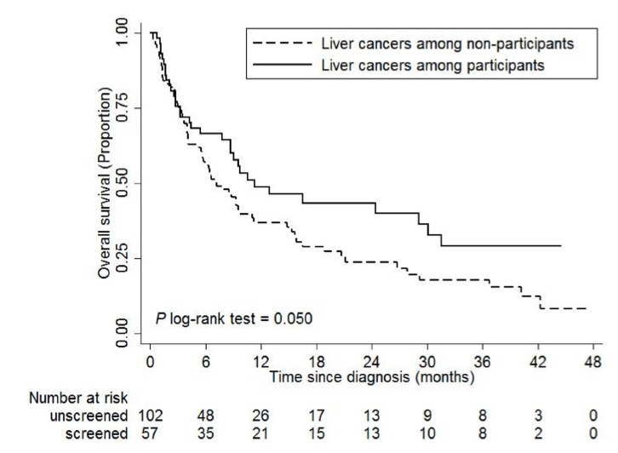
Figure S2. Kaplan-Meier survival estimates for patients with liver cancer in participation group and non- participation group. Log-rank test was used to calculate P values. Two cases were excluded due to no follow-up time. (Figures 1 and 2 reproduced without changes from Li et al under the Creative Commons license agreement: http://creativecommons.org/licenses/by/4.0/.)

- The survival of the liver cancer patients was also increased as seen in Figure S2 above. Which of the following could lead to this difference in liver cancer survival? Circle the correct choice or put it in bold italics. [3]
    - Partial Verification bias Yes No Can't tell
    - Length time bias Yes No Can't tell
    - Overdiagnosis Yes No Can't tell
    - Sticky diagnosis bias Yes No Can't tell
    - Lead time bias Yes No Can't tell
    - Differential Verification bias Yes No Can't tell
- After excluding those with liver cancer at baseline, all-cause and liver cancer mortality among participants who volunteered for the study and the nonparticipant comparison group are shown below.
From Table 3 of the paper | Participants (N = 17,966) | Non-participants (N = 50,544) | Participant vs. Nonparticipant
 | Deaths | Deaths | Unadjusted Relative Risk
All-cause mortality | 274 (1.5%) | 699 (1.4%) | 1.07
Liver cancer mortality | 33 (0.18%) | 69 (0.14%) | 1.29

Which of the following could lead to this slight increase in liver cancer mortality in the participants? Circle Yes or No next to each one. [3]
    - Slippery linkage bias Yes No Can't tell
    - Differential Verification bias Yes No Can't tell
    - Length time bias Yes No Can't tell
    - Overdiagnosis Yes No Can't tell
    - Sticky diagnosis bias Yes No Can't tell
    - Lead time bias Yes No Can't tell

9. Retinopathy [10 points]
Gulshan et al (6)from Google, Inc. developed a "Deep Learning Algorithm" to read retinal photographs and determine whether there was a level of diabetic retinopathy sufficient to warrant referral to an ophthalmologist ("referable diabetic retinopathy"). The prediction of this artificial neural-network based algorithm was compared with the consensus of a panel of 8 board-certified ophthalmologists; subjects were considered to have referable diabetic retinopathy if a majority of the panel members thought so.

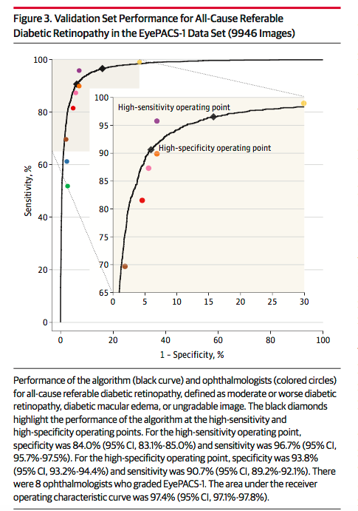
The algorithm performed impressively: AUROC = 0.97. Figure 3 from that paper is reprinted below:

- Consider the ophthalmologists indicated by the brown and yellow dots (at opposite ends of the blown-up insert). If instead of comparing them both with the gold standard you had calculated Kappa for their level of agreement, would their disagreements have been likely balanced or unbalanced? Explain. [2]
If the condition being diagnosed is “referable diabetic retinopathy”, then the decision that this algorithm is supposed to guide is referral to an ophthalmologist for treatment. Call referable “D+” and not referable “D−"and make the following assumptions:

- It is 30 times worse to fail to refer a D+ individual than to refer a D− individual unnecessarily.
- Of 8788 evaluable images, 683 were D+.
- For each image, the machine learning algorithm outputs a numeric Certainty Score that is higher when the probability of D+ is higher. The high specificity operating point corresponds to a score of 94. In other words, a score > 94 is considered positive. The high sensitivity operating point corresponds to a score of 84. In other words, a score > 84 is considered positive.
- As per the figure caption, the sensitivity and specificity for the two operating points are given by the following ROC table:

Certainty Score | Sensitivity | Specificity
> 94 | 90.7% | 93.8%
> 84 | 96.7% | 84.0%

- What is the threshold post-test probability of D+ for referral? [1]

- Fill in the following LR table [2]

 | D+ | D- | LR
> 94 | 90.7% | 6.2% | 14.63
>84-94
≤ 84
 | 100% | 100%

d) You will now apply this algorithm to a patient population with the same pre-test probability of disease as this sample. What is the post-test probability of D+ for patients with Certainty Score ≤ 84, >84-94, and > 94. (Show how you arrived at your answers.) [3]

e) Should you treat everybody, everybody with a Certainty Score > 84, or everybody with a Certainty Score > 94? Explain your answer. (Limit your choices to these 3 options. In other words, don’t say “I would treat for Certainty Score > 90.”) [2]

10. PoopMD (11 points + 2 EC points)
Biliary atresia, a disease in which the bile ducts gradually close off and block the flow of bile from the liver, is the most common reason for children to need a liver transplant. Although it is rare (about 4.5/100,000 births), its incidence appears to be increasing.(7) The disease process begins before or soon after birth, leading to a relapse or prolongation of the jaundice that is normal just after birth. There is evidence that earlier diagnosis and treatment improves outcome, hence there is interest in finding ways to make the diagnosis sooner. (8)

Because bile supplies color to the stools, one sign of biliary atresia is that the baby's stools become acholic. i.e., gray or clay-colored rather than the normal yellow, green or brown. Investigators from Johns Hopkins University(9) recently reported on a mobile phone app they call PoopMD, which parents can use to take and interpret photographs of dirty diapers to see whether the stools look acholic (Figure). (If you have a baby < 6 months old and want to participate in their study, you can download the free PoopMD+ app from Apple or Google stores.)

Fig 2. Screenshots demonstrating PoopMD analytic functionality.
From the abstract: "In order to define the gold standard regarding stool color, seven pediatri- cians were asked to review 45 photographs of infant stool and rate them as acholic, normal, or indeterminate. Samples for which 6+ pediatricians demonstrated agreement defined the gold standard, and only these samples were included in the analysis."

Table 1 from their paper is shown below.
 | Gold Standard
PoopMD | Acholic | Normal | Indeterminate
Acholic | 7 | 0 | 0
Normal | 0 | 24 | 0
Indeterminate | 0 | 3 | 0
Total | 7 | 27 | 0
- The authors reported 100% sensitivity (7/7) and 89% specificity (24/27). Using the shortcuts provided in Chapter 11, what were the lower limits of the 95% confidence intervals for sensitivity and specificity? [+2 bonus points]

- Counting the "Indeterminate" PoopMD rating as false positives, as the authors did, what would be the positive predictive value of a positive PoopMD screen in the general population, assuming a prevalence of 4.5/100,000? Show your work. [3]

- You can see that only 34 of 45 photographs were included in the analysis. Would this be likely to bias the results? If so, name the bias and state how it would be likely to affect sensitivity and specificity. [4]

- The gold standard here was a consensus of pediatricians about the color of the stool, rather than the actual presence or absence of biliary atresia. We might therefore be concerned that the gold standard was imperfect. If that were the case, in what direction do you think it would bias the estimates of sensitivity and specificity? Explain your answer. To get full credit you must commit yourself, not hedge. [4]

REFERENCES

1. Sharaf N, Sharaf VB, Mace SE, Nowacki AS, Stoller JK, Carl JC. D-dimer in Adolescent Pulmonary Embolism. Acad Emerg Med. 2018.
2. Sigakis MJ, Bittner EA, Wanderer JP. Validation of a risk stratification index and risk quantification index for predicting patient outcomes: in-hospital mortality, 30-day mortality, 1-year mortality, and length-of-stay. Anesthesiology. 2013;119(3):525-40.
3. Bui Q, Miller CC. The Age That Women Have Babies: How a Gap Divides America. New York Times. 2018 August 4, 2018.
4. Combes A, Hajage D, Capellier G, Demoule A, Lavoue S, Guervilly C, et al. Extracorporeal Membrane Oxygenation for Severe Acute Respiratory Distress Syndrome. N Engl J Med. 2018;378(21):1965-75.
5. Ji M, Liu Z, Chang ET, Yu X, Wu B, Deng L, et al. Mass screening for liver cancer: results from a demonstration screening project in Zhongshan City, China. Sci Rep. 2018;8(1):12787.
6. Gulshan V, Peng L, Coram M, Stumpe MC, Wu D, Narayanaswamy A, et al. Development and Validation of a Deep Learning Algorithm for Detection of Diabetic Retinopathy in Retinal Fundus Photographs. JAMA. 2016;316(22):2402-10.
7. Hopkins PC, Yazigi N, Nylund CM. Incidence of Biliary Atresia and Timing of Hepatoportoenterostomy in the United States. J Pediatr. 2017;187:253-7.
8. Lien TH, Chang MH, Wu JF, Chen HL, Lee HC, Chen AC, et al. Effects of the infant stool color card screening program on 5-year outcome of biliary atresia in Taiwan. Hepatology. 2011;53(1):202-8.
9. Franciscovich A, Vaidya D, Doyle J, Bolinger J, Capdevila M, Rice M, et al. PoopMD, a Mobile Health Application, Accurately Identifies Infant Acholic Stools. PLoS One. 2015;10(7):e0132270.

Full disclosure: Because it does not affect the point of this problem, we are presenting this study as if all 88 cases had PE diagnosed by CTPA. In fact, 5 of the 88 cases had the PE diagnosed by a high probability V/Q scan.

