- Exercise Objectives

To highlight important concepts from the lecture in week #9 “Methods of Test Development I: Item Analysis and Item Response Theory” and to practice application of these concepts in real-life examples.

- Exercise Questions

The CTT allows us to analyze items in the instrument for difficulty and discrimination. Consider the following test data for 2 items and 10 persons.

Person | Item 1 | Item 2 | Total Score
1 | 0 | 1 | 12
2 | 0 | 1 | 15
3 | 1 | 1 | 16
4 | 0 | 0 | 10
5 | 1 | 1 | 7
6 | 1 | 0 | 5
7 | 1 | 0 | 6
8 | 0 | 1 | 10
9 | 1 | 1 | 15
10 | 1 | 0 | 13

- Calculate item difficulty (p) and explain your results.

- In many common test formats, examinees may raise their scores by guessing if they don't know the correct answer. This means that the p value of an item will often be higher than the proportion of examinees who actually know the material tested by the item. To achieve a maximum discrimination between high and low achievers, we need to know the optimal difficulty for an item adjusted for guessing (p0). Calculate p0 and explain your results.

- What are the indices of discrimination for the two items based on a 50/50 split?

- What are the indices of discrimination for the two items based on a top/bottom 27% split?

Examine the item analysis information in the table below and answers Q5-7:

Item Number | Item Responses |  |  |  |  | Item  Difficulty | Item  Discrimination
Item Number | 1 | 2 | 3 | 4 | Other | Item  Difficulty | Item  Discrimination
21 | 11 | 5 | 149 | 11 | 0 | 0.84 | 0.15
22 | 34 | 11 | 127 | 4 | 0 | 0.72 | 0.3
23 | 11 | 4 | 32 | 128 | 1 | 0.18 | -0.13
24 | 30 | 34 | 1 | 111 | 0 | 0.63 | 0.64
25 | 6 | 0 | 20 | 150 | 0 | 0.85 | 0.34

- Which item appears to be most in need of revision and why?

- Items 21 and 25 are nearly identical in difficulty, yet their item discrimination values differ. How can this be explained?

- If you wanted to improve item 21, how would you try to change it?

- A graduate student has designed a project which requires measurement of attitudes of the mothers of newborn infants who have certain birth defects. The student will be obtaining subjects from all hospitals in the community with maternity wards but still anticipates having only a small sample (approximately 25 to 30) over a one-year period. Faculty on the four-person advisory committee offer four separate suggestions. Choose one and explain your reasoning:

  - Use the first 15 subjects for item analysis; refine the instrument and use the last 15 subjects in the study itself.
  - Use the instrument without any item analysis and take the chance that it will provide “good” information.
  - Administer all items to all subjects; do an item analysis and eliminate bad items; then rescore the instrument for the same subjects using only the “good” items.
  - Do not conduct the study.

Use the information below to answer Q9-10.

The table below shows probability of correct item responses, item information, and test
information for various trait levels that have been computed for a five-item hypothetical test of mathematical ability, a trait with seven levels ranging from -3 to 3. Below are also item characteristic and test information curves (ICC and TIC, respectively) for this test built using a 3PL model.

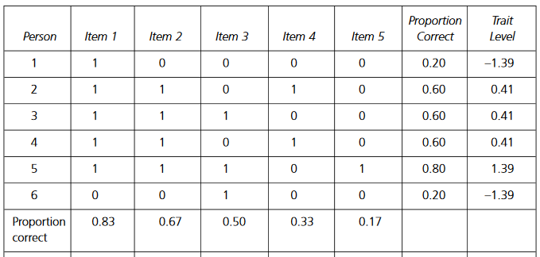

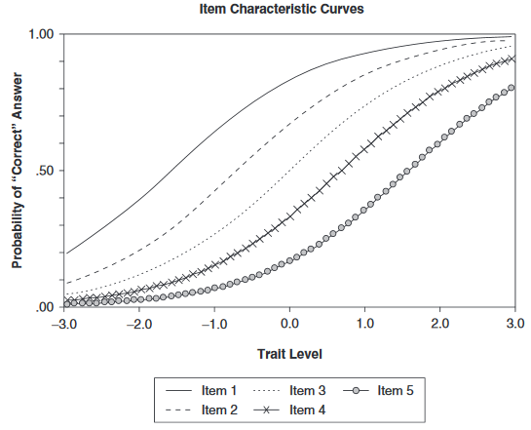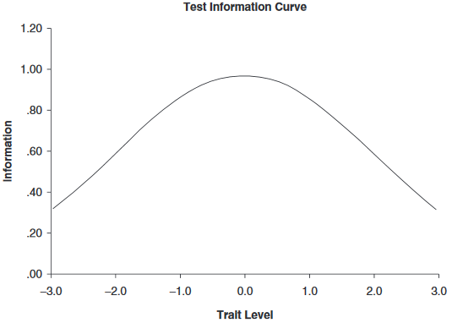

- Compare ICCs for 5 items in terms of item difficulty, item discrimination and guessing.

- Describe the TIC for this hypothetical test.

