# | Pts Possible | Pts missed
1 | 16+3
2 | 15
3 | 7
4 | 9
5 | 4
6 | 10
7 | 8
8 | 8
9 | 7
10 | 9
11 | 7
Total | 100+3
Score
Due on paper 12/5/2013, 8:45 AM by E-mail or in class. Late exams cannot be accepted; email early to be safe if you won't be in class. Do NOT plan to print it in Room 6702.

Collaboration with others is NOT permitted.

Please show your work.

[# points] listed after each question

1. Home Score for Group A Strep
(Adapted from problems by Robert Blount, Matt Hickey, and Melicent Peck with help from Patti Curl).

In patients with sore throat, it is desirable to tell which ones have Group A streptococcus (GAS) because they can be treated with penicillin to prevent complications. However, because diagnostic tests for GAS are costly (e.g., $261 for a rapid strep test at UCSF), scoring systems have been developed to aid clinicians in identifying patients at low risk for GAS pharyngitis who do not need testing or treatment.

(Former UCSF pediatric resident) Andy Fine and colleagues have taken this one step further, and developed a “Home Score” to help patients at home decide whether to seek medical attention for a sore throat. The Home Score assigns points for factors associated with GAS like younger age, the presence of fever and the absence of cough. They studied a cohort of 71,776 patients aged 15 or older who visited CVS MinuteClinics with a sore throat in September 2006-December 2008, all of whom received (gold standard) tests for GAS. To derive the Home Score, the investigators randomly selected 2/3 of their population as a derivation set and used 1/3 as the validation set.

- The subjects for this study included only those who sought medical attention for a sore throat. Suppose some of these subjects knew (or looked up and found) that fever and absence of cough increased the likelihood of strep, and used that information partly to decide whether to go to the clinic.
  - How would this affect the prior probability obtained in this study, compared with a study that included all subjects who were trying to decide whether to seek attention for sore throat? [2]
  - What bias would the greater likelihood of inclusion of subjects with these findings cause, and how would it be expected to affect the estimates of sensitivity and specificity? [2]
Table 4 from the paper, reporting on performance in the derivation data set is reprinted below. Consider the top row only. The labeling is a bit confusing; they are considering a home score ≥ 10 as a “positive” test.
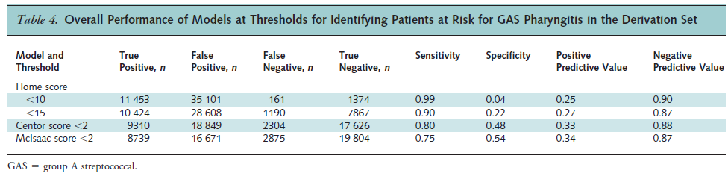
b.) Check the authors’ reported sensitivity, specificity, positive and negative predictive value for a home score ≥ 10. Are their calculations correct? [4]
c.) Table 3 (excerpted below) indicates that in the validation dataset, the sensitivity of a Home Score ≥ 10 was 99% (as in the derivation data), but specificity was only 1%. The authors reported a negative predictive value in the validation set of 87%.
    - Given the prior probability of GAS of 24%, is the reported negative predictive value for the validation set correct? Use likelihood ratios and show work. [2]

    - What is the best estimate for the likelihood ratio for a Home Score of 18? [2]
The authors propose making the Home Score available to patients with sore throats at home to help them decide whether to come into the clinic. They used the data from the derivation set in this study to calculate that use of the Home Score in this way (with a cut-off of < 10 to stay home) could prevent 230,000 clinic visits per year in the US.
d.) Would the estimated number of clinic visits prevented be higher or lower than 230,000 if the authors had used the validation set rather than the derivation set? Explain. [2]
e.) For the calculation above, the authors assumed that the test characteristics of the Home Score among subjects using it at home would be the same as in the derivation dataset and 2) the only way that the Home Score would alter decisions is by changing them from “go to clinic” to “stay home.” Do you believe these assumptions are valid? Why or why not? [2]
f.) (Extra credit; come back to it when you’re done if you have time.) All that the authors tell us about their calculation of visits prevented is that it is based on 12 million visits per year for sore throat in the US.
- If we applied the Home Score to those 12 million people and the test performed the same as in the derivation dataset, and all those who test <10 would stay home, how many would stay home? [+2]
- How many would stay home if the test were perfect? [+1]
2. Epidural analgesia and C-section rates (adapted from a problem by Susan Lee).
The effect of epidural analgesia on the progress of labor has generated considerable controversy. Previous observational studies have found that women who receive epidurals for labor analgesia have longer labors and higher rates of caesarean sections than women that do not receive epidurals.

Zhang et al. took advantage of a policy change in 1993 within the US Department of Defense requiring the availability of on-demand labor epidural analgesia in military centers to study this concern at the Tripler Army Medical Center. Prior to this policy change, epidural rates for labor analgesia were < 1%. After implementation of the new policy, the epidural rate climbed to > 70% within one year, levelling off at 84% by 1995. They found no difference in C-section delivery rates in women with delivery in the year prior to policy change (1993) compared with delivery in 1995 (after the policy change), as shown in figure 1.

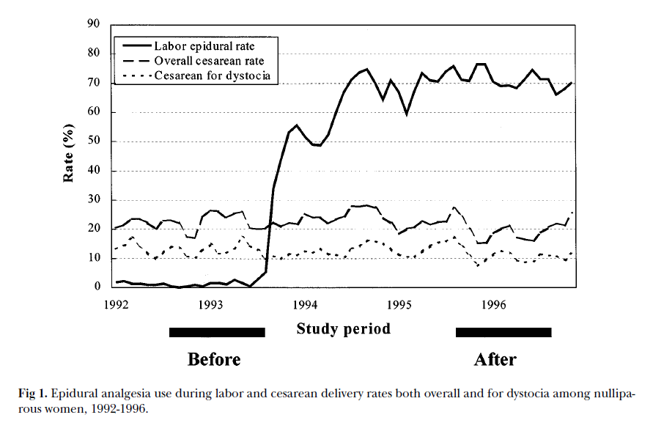
a) We can think of this study as using an instrumental variable to study the effect of a treatment on an outcome. What are the treatment, the instrumental variable, and the outcome variable for this study? [3]

b) In order for an instrumental variable to be used to estimate the effect of a treatment, what assumption is required about its relation to the outcome? [2]

c) Suppose a nearby hospital with 5,000 deliveries a year has had a stable epidural rate of 50% for the last 5 years. Why not take advantage of its large sample size and estimate the effect of epidural analgesia on C-section rates by comparing C-section rates among all the women that did vs. did not receive epidural analgesia for labor at this other site? [2]

d) The observed rates of C-section were 14.4% of 507 deliveries before and 12.1% of 581 deliveries after the policy change. Although not provided by the authors, this is an absolute risk reduction of 2.35%, with a 95% CI of (-1.7% to 6.4%). For each of the following statements about this risk difference and 95% CI, read the statement carefully, indicate whether it is true or false, and explain.
i. The difference does not appear to be statistically significant at the α = 0.05 level. [2]
ii. The 95% CI means that if we could repeat this study many times, we would expect the observed risk difference to fall in this interval about 95% of the time. [2]
iii. The range of changes in C-section rates consistent with this study is between a 1.7% decrease and a 6.4% increase after the policy was implemented. [2]

iv. We can be 95% “confident” (in the statistician sense) that the effect of epidural analgesia on the C-section rate in women like those in this study is between a 6.4% decrease and a 1.7% increase. [2]
3. Clinical prediction rule for septic arthritis in children. (Thanks to Rachel Wattier!)

Kocher et al. developed a clinical prediction rule to differentiate between septic arthritis and transient synovitis in children presenting with acute hip pain. Septic arthritis is a bacterial infection of the joint that requires surgical drainage and antibiotics while transient synovitis is self-resolving inflammation that does not need treatment. Of 168 children who met inclusion criteria for the study and had definitive testing with joint aspiration and culture of synovial fluid, 82 had septic arthritis and 86 had transient synovitis. The authors identified four predictor variables that were associated with increased likelihood of septic arthritis. These variables were combined to develop a clinical score for predicting likelihood of septic arthritis.

Predictor | Positive Likelihood Ratio
History of fever | 29.5
Non-weight-bearing | 10.8
Erythrocyte sedimentation rate (ESR) ≥ 40 mm/hr | 19.1
Peripheral blood white blood cell count > 12,000 cells/mm³ | 14.6

a. Using the baseline prevalence of septic arthritis in the study population, calculate the expected post-test probability of septic arthritis for a child with history of fever who is non-weight-bearing, assuming that all of the predictors are independent. (For the purposes of this question, assume you have not yet drawn blood on this child.) [2]

b. Some of the actual probabilities calculated for different combinations of predictor variables in this study are shown below. State two possible reasons (other than that you made a mistake) why none of these probabilities might match the probability you calculated for part a. [2]

History of fever | Non-weight-bearing | ESR ≥ 40mm/hr | WBC ≥ 12,000 cells/mm³ | Probability of septic arthritis
Yes | Yes | No | No | 58%
Yes | No | Yes | No | 62%
Yes | No | No | Yes | 45%
No | Yes | Yes | No | 48.%
No | Yes | No | Yes | 34%
No | No | Yes | Yes | 35%

c. Based on the different combinations of predictor variables, the authors developed a simplified clinical prediction rule for septic arthritis. The predicted probability of septic arthritis for a child with all four criteria (fever, non-weight-bearing, ESR ≥ 40 mm/hr, and WBC ≥ 12,000 cells/mm³) was 99.6%.
Imagine you are working with a trainee in the emergency department to evaluate a child who presents with hip pain and fever but also has a rash and pain in her hands and shoulders (symptoms that are not typical for septic arthritis or transient synovitis). The trainee tells you that the child has all four Kocher criteria and therefore has a 99.6% probability of having septic arthritis. How would you respond? (Note: In developing this clinical prediction rule, the authors excluded 114 children who had “atypical features” including neonates, immunocompromised children, children with post-operative infections, and children who were ultimately diagnosed with conditions other than septic arthritis or transient synovitis.) [3]

4. Adapted from a question called “Everybody Poops” by Jacob Robson.
When it is bad, ulcerative colitis causes frequent, bloody stools and abdominal pain. However, due to modesty (and general disgust with talking about poop), patients have trouble quantifying their symptoms sufficiently to help their clinicians to make treatment decisions. Therefore, Turner et al (in 2007) created a Pediatric Ulcerative Colitis Activity Index (PUCAI ) with specific questions about symptoms. However, it’s time consuming for physicians to go through the PUCAI with patients/parents. Wouldn’t it be great if the patients could reliably report the PUCAI directly to their doctors? (Former UCSF pediatric resident) Jennifer Lightdale and colleagues looked at this very question in 2011, dividing the PUCAI scores into 3 disease activity groups. Results are shown in Table 2 below.

a.) What was the observed percent complete agreement in this study? [1]

- What percent complete agreement would be expected from the marginals? [1]

- The researchers report an unweighted Kappa statistic of 0.78. Is their calculation correct (± 0.01)? [1]

d.) Explain in words what this Kappa signifies. [2]

- Is the disagreement between patient- and physician-completed PUCAI scores balanced? Support your answer with numbers from the table and explain in what this means. [2]
f.) The researchers are disappointed that based on their Kappa, their agreement is only “substantial.” They feel like they deserve half credit when ratings are off by one category, such as when the MD classifies the disease as inactive and the patient classifies it as mild. Calculate a weighted Kappa using that weighting scheme. [2]

5. (Adapted from a problem by June Chan in our medical student Epi/EBM course.) Petricoin et al. attempted to identify women with and without ovarian cancer using patterns of protein markers found in the blood. Samples from 50 with ovarian cancer and 66 with non-cancerous disorders were analyzed. From the abstract: “The discriminatory pattern correctly identified all 50 ovarian cancer cases in the masked set, including all 18 stage I cases. Of the 66 cases of non-malignant disease, 63 were recognized as not cancer. This result yielded a sensitivity of 100% …, specificity of 95% …, and positive predictive value of 94%.

- Although sensitivity was 100% for the stage I cases, there were only 18 of them. Use the shortcut in Chapter 11 to estimate the lower limit of the 95% confidence interval for the sensitivity of this proteomic test for Stage I ovarian cancer. [2]

- Do you agree with the authors’ calculation of positive predictive value? Explain. [2]
6. TB in people with HIV. (From a problem by Carolyn Hendrickson, Archana Jayakumar and
Ryan Kern)

Latent tuberculosis infection (LTBI) is a dormant form of TB that can progress to active disease. The WHO recommends treatment for LTBI with a single drug in all patients coinfected with HIV to prevent such progression.

a.) Assume presumptive treatment for LTBI is indicated in HIV+ people if the (posterior) probability of LTBI is ≥ 40%. In Uganda, the estimated prevalence of LTBI among people with HIV is 60%, and screening is insensitive, with negative results in those with LTBI half as common as in those without LTBI. Based on this information alone, what are your recommendations for LTBI screening of HIV+ people in Uganda? (Show your work.) [2]

b.) To decide who gets treatment for LTBI, it is important to identify and exclude cases of active TB disease because they are treated with a multi-drug regimen (Rifampin + Isoniazid + Pyrazinamide ± Ethambutol = “RIPE”). Mistakenly treating active disease with an LTBI regimen is ineffective and can cause drug resistance, a major public health concern. However, inappropriately treating a case of LTBI with an active TB regimen (RIPE) is also a concern due to unnecessary side effects and resource expenditures.
The prevalence of active tuberculosis in HIV+ patients in Uganda is 10%. Assume it is twenty times as bad to fail to treat active TB with RIPE as it is to mistakenly treat a case of LTBI with RIPE.

(UCSF fellow) Christina Yoon and colleagues have proposed an algorithm employing high-sensitivity CRP, a nonspecific blood marker of inflammation, to differentiate latent from active TB disease. The specificity of CRP for active TB in HIV-positive patients in Uganda is poor, around 50%. What does the sensitivity of CRP need to be in order to make the posterior probability of active TB disease less than your treatment threshold, and make not treating the best decision? [4]

c.) The San Francisco Department of Public Health read Dr. Yoon’s article about the Ugandan cohort, and wants to know if we should do CRP testing as an initial screen for active TB in our HIV+ population. The prevalence of LTBI and active TB disease are both much lower in HIV+ patients in San Francisco than in Uganda. What effect would the lower prevalence have on sensitivity, specificity, positive and negative predictive value of CRP in this setting? (Assume that, conditional on disease status, probabilities of + and – test results are the same as in Uganda.) [2]

d.) TB often presents at a much later stage in Uganda than in San Francisco. In addition, San Francisco TB suspects are often diagnosed with other inflammatory conditions, compared to Uganda where most disease is tubercular. What named bias would you be concerned about if you applied the results of Yoon’s study to a San Francisco population? How would these differences be predicted to affect sensitivity and specificity of CRP in San Francisco? [2]

7. Drug-induced acute interstitial nephritis (AIN), adapted from a problem by Naomi Anker
Drug-induced acute interstitial nephritis (AIN) is one of the possible causes of a sudden reduction in kidney function (called Acute Kidney Injury =AKI) over a few days to weeks. The gold standard in diagnosis of AIN is kidney biopsy, though this diagnosis is also sometimes made without biopsy--particularly in cases where several other characteristics of AIN are present, such as rash, elevated eosinophil (a certain type of white blood cell frequently involved in allergic reactions) counts in the blood, fever, and recent initiation of a medicine commonly associated with AIN. It would be preferable to find a non-invasive test to make this diagnosis accurately.
- Nolan et al. reported in the NEJM in 1986 that staining urine sediment with a new stain called Hansel’s stain allowed better identification of eosinophils (than Wright’s stain) and correlated urine eosinophils with acute interstitial nephritis. They reported 91% sensitivity and 87% specificity in a study of 104 patients, 11 of whom had AIN.
The authors reported that AIN was diagnosed “in two patients on the basis of [kidney] biopsy” and in nine patients by a clinical assessment, which includes examination of the urine sediment for white blood cells. Could this gold standard introduce bias into the assessment of urine eosinophils for AIN diagnosis? If so, what type? How might it influence sensitivity and specificity reported above? [2]

- This month Muriithi et al published a retrospective cohort study evaluating presence of urine eosinophils for the diagnosis of AIN in 566 patients, all of whom had a kidney biopsy within 1 week of urine eosinophil assessment. They reported sensitivity of 31% and specificity of 68% of urine eosinophil assessment using the gold standard of renal biopsy. Indicate whether each of the following statements is true or false and explain your answer.
  - Because specificity (68%) was significantly higher that sensitivity (31%), a positive urine eosinophil count is more informative than a negative one, i.e., this test is better at ruling in than ruling out AIN. [2]
  - One reason for the poor performance of the urine eosinophils in this study is possible spectrum bias if clinicians do kidney biopsies only in clinically ambiguous cases that end up being either mild AIN or other kidney diseases. [2]
  - The inclusion of subjects whose kidney biopsy was up to 1 week after their urine was tested could lead to double gold standard bias if the AIN resolved by the time the biopsy was done. [2]
8. Esmolol for septic shock. Adapted from a problem by: Brian Chan, Sara Kalkhoran and Frederick Wang. A recent randomized phase 2 study evaluated the effect of heart rate control with the β-blocker esmolol in patients in the ICU treated for septic shock and on a vasopressor. One of the secondary outcomes of the study was the effect of esmolol on hospital mortality. The table below demonstrates some of the outcomes observed in the study:

Outcome | Esmolol (n=77) | Control (n=77) | P-value
Mortality
Hospital | 52 (67.5%) | 70 (90.9%) | <0.001
Length of ICU stay (days)
Median (IQR) | 19 (11-27) | 14 (7-25) | 0.03
Survivors’, Median (IQR) | 17 (9-28) | 21 (11-34) | 0.70

- Construct a 2x2 table that illustrates the difference in hospital mortality of patients in septic shock who were and were not treated with esmolol, and calculate the risk ratio, the relative risk reduction, and the absolute risk reduction. [3]

- How many people in septic shock need to be treated with esmolol to prevent 1 hospital death? [1]

- Assume that patients in septic shock who received the esmolol infusion had an average requirement of 100 mg/hr to maintain their heart rate below 95 beats/min. Also assume that the patients required the infusion for an average of 96 hours. The cost of esmolol is approximately $1.00 for each 10 mg vial. What is the cost needed to prevent 1 hospital death (assume length of treatment with esmolol is 96 hours) [2]

- Do you think that the fact that the trial was not blinded affects the validity of results? Explain your answer. [2]

9. A recent New York Times story, “Risk Calculator for Cholesterol Appears Flawed” includes the following:

“Last week, the nation’s leading heart organizations released a sweeping new set of guidelines for lowering cholesterol, along with an online calculator meant to help doctors assess risks and treatment options. But, in a major embarrassment to the health groups, the calculator appears to greatly overestimate risk, so much so that it could mistakenly suggest that millions more people are candidates for statin drugs.”
“The problems were identified by two Harvard Medical School professors whose findings will be published Tuesday in a commentary in The Lancet, a major medical journal…This week, after they saw the guidelines and the calculator, Dr. Ridker and Dr. Cook evaluated it using three large studies that involved thousands of people and continued for at least a decade. They knew the subjects’ characteristics at the start — their ages, whether they smoked, their cholesterol levels, their blood pressures. Then they asked how many had heart attacks or strokes in the next 10 years and how many would the risk calculator predict.
“The answer was that the calculator overpredicted risk by 75 to 150 percent, depending on the population. A man whose risk was 4 percent, for example, might show up as having an 8 percent risk. With a 4 percent risk, he would not warrant treatment — the guidelines that say treatment is advised for those with at least a 7.5 percent risk and that treatment can be considered for those whose risk is 5 percent.”
  - Is this a problem with discrimination or calibration? Explain. [2]
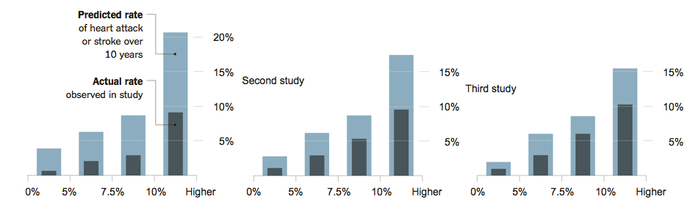
  - The guidelines recommend estimating each subject’s risk using a cardiovascular risk calculator, then managing based on whether the predicted 10-year risk is <5%, 5-7.4%, 7.5-9.9%, or ≥ 10%. The NYT article included a graph of the overestimation, above, which many of your instructors found confusing. Josh gallantly created a calibration plot from these data (below), which should look more familiar. Explain briefly, step by step, how the data to produce figures like these would be obtained. [3] (Hint: the X-axis in each case groups patients with predicted risks in the categories above.)

  - If we assume that, in fact, the risk calculator is overestimating risk, what more do you need to know to conclude that using these overestimated risks with the treatment thresholds in the guidelines will lead to excessive treatment? Explain. [2]

10. For the ovarian cancer portion of the Prostate, Lung, Colorectal and Ovarian (PLCO) screening trial, 78,216 women aged 55-74 years were recruited 1993-2001 at 10 US centers and randomized to be offered annual screening with transvaginal ultrasound and serum cancer antigen 125 (CA-125) vs. usual care. Mortality results for this trial were recently reported.
a. An excerpt from the introduction of the paper states: “Ovarian cancer confined to the ovary has a 5-year survival of 92%. However, most women with ovarian cancer are diagnosed with advanced stage disease, which has a 5-year survival of only 30%.” Explain why this comparison is not valid; include at least 2 relevant biases. [2]
b. Figure 2 from the paper is reprinted on the next page. The relative risk of being diagnosed with ovarian cancer was 1.21 (95% CI 0.99-1.48) and for ovarian cancer mortality the RR was 1.18 (95% CI 0.82, 1.71).
i. What is the most likely explanation (other than chance) for the excess of ovarian cancer diagnoses in the screened group? Explain. [2]

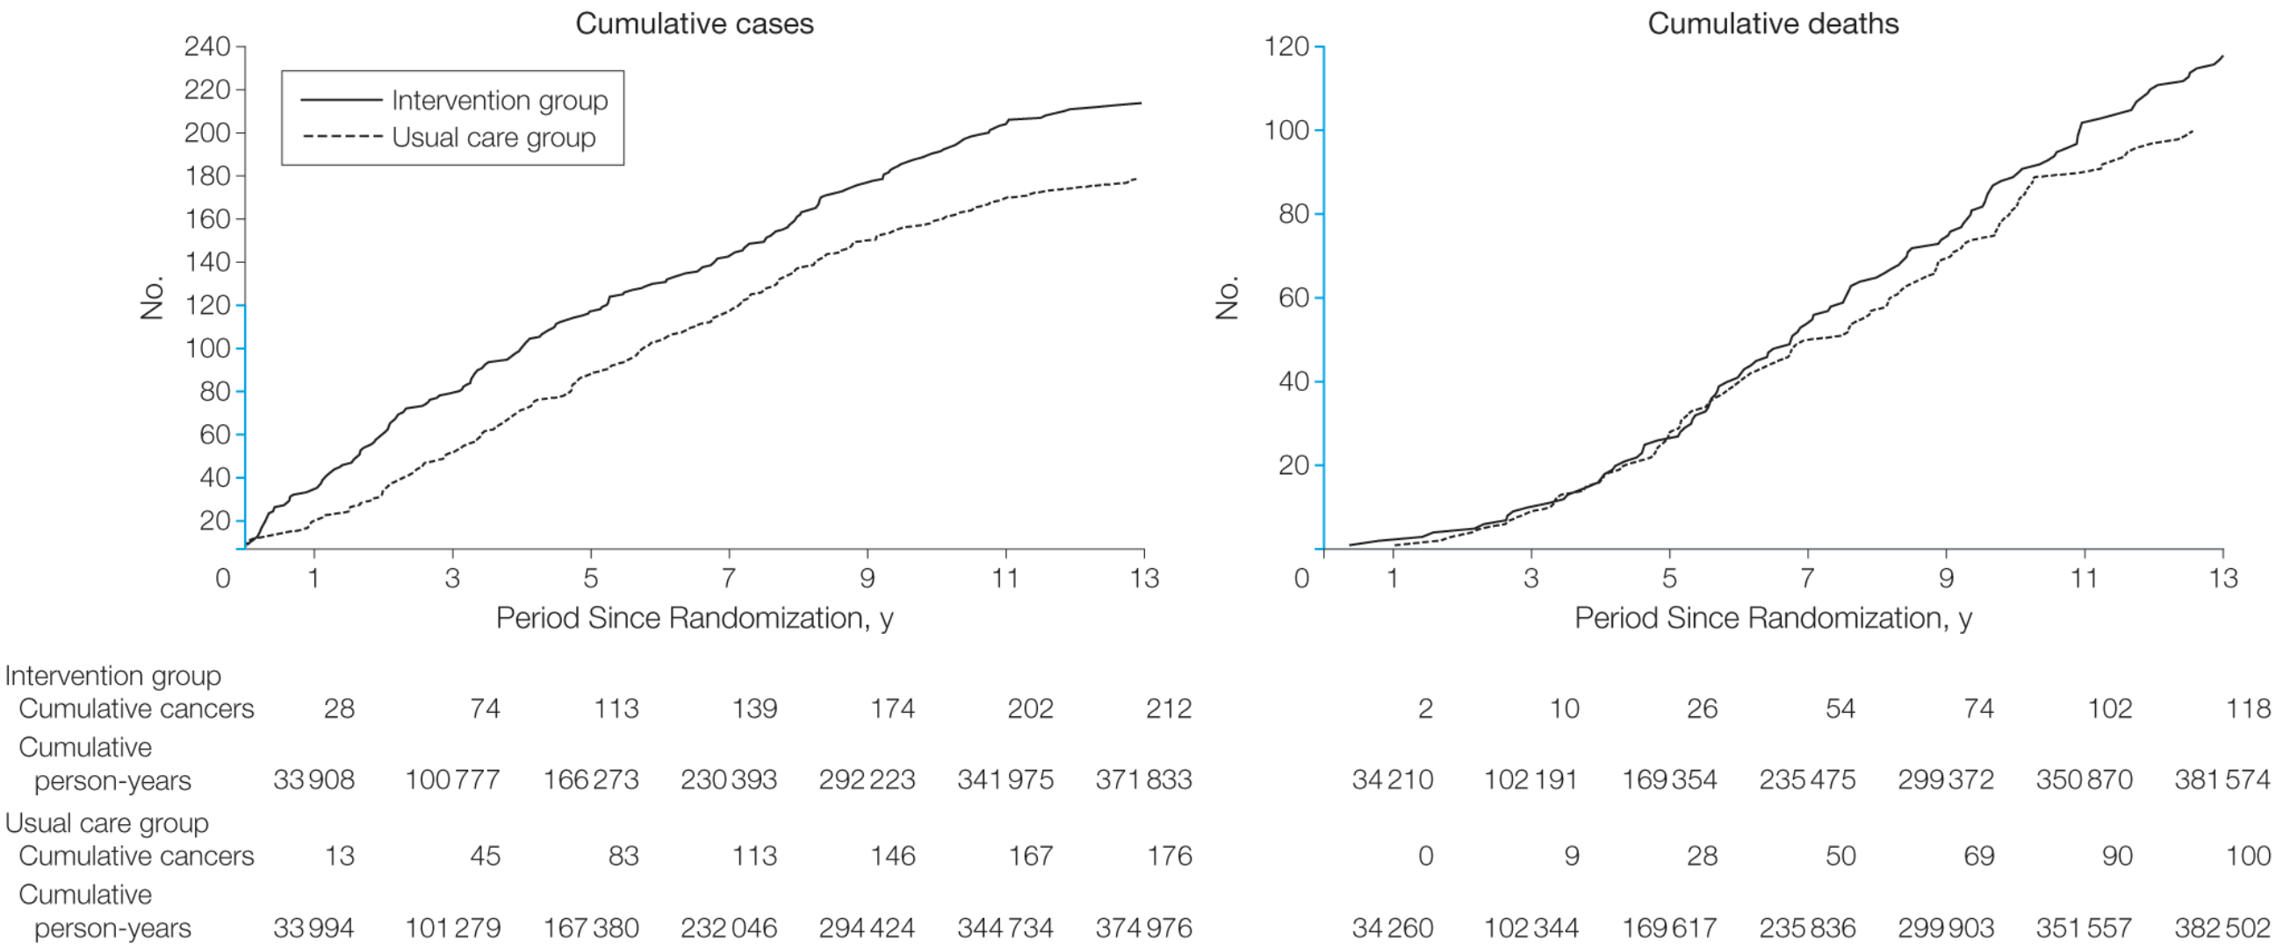

ii. What are at least 3 possible explanations for the observed excess of ovarian cancer deaths in the screened group? [3]
c. As shown in Table 3 of the paper (below), complications associated with diagnostic evaluation for cancer occurred in 52% of the women diagnosed with ovarian cancer in the usual care group, compared with 45% of the women diagnosed with ovarian cancer in the screened group. What are at least 2 reasons why this comparison does not provide evidence against excess complications in the screened group? [2]

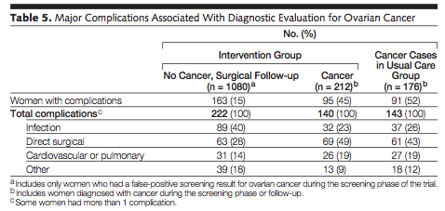

11. A quick screening test for hearing loss is the Calibrated Finger Rub Auditory Screening Test (CALFRAST). The examiner with arms extended stands facing the patient and rubs her fingers together strongly and asks it the patient can hear the rubbing sound on each side. Because this strong stimulus is presented about 70 cm from the patient's ear, it is called CALFRAST Strong 70. If the patient can hear the finger rubbing, the examiner repeats the test at the quietest level the examiner can hear (CALFRAST Faint 70). Torres-Russotto et al recently reported test characteristics for the CALFRAST, using audiometry as the gold standard, with normal hearing defined as < 25 decibel loss at 1000, 2000 and 4000 Hz.

Results from a consecutive sample of consenting patients are summarized in Table 2 from that study:

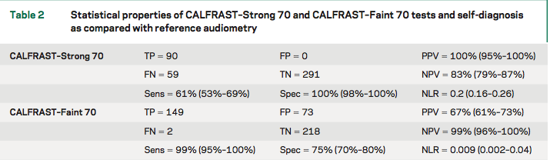

- Draw and label an ROC curve that summarizes the accuracy of the CALFRAST Faint 70 and Strong 70 results summarized above as a single test. [3]

HINTS:
1) There are 2 fewer subjects for the STRONG 70 than the FAINT 70. You can ignore this and just use the percentages calculated by the authors in Table 2 above.
2) For this problem we are asking you to consider the CALFRAST as a SINGLE MUTLI-LEVEL test, where not hearing a strong stimulus is a more abnormal result than not hearing a faint stimulus.
The study also examined the patient’s self assessment of hearing compared with the same gold standard, as shown in the continuation of Table 2 below.

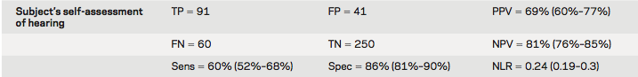

b. You are seeing a patient similar to those included in this study whose self-assessment is that his hearing is OK. What would be that patient's prior probability (before the CALFRAST) of ≥ 25 dB hearing loss? [2]

- Suppose a patient with a 20% prior probability of hearing loss can hear the strong stimulus, but not the weak stimulus. What is your best estimate that he has significant (at least 25 decibels) hearing loss? [2]

Fine AM, Nizet V, Mandl KD. Participatory medicine: a home score for streptococcal pharyngitis enabled by real-time biosurveillance: a cohort study. Ann Intern Med. 2013 Nov 5;159(9):577-83
Zhang J, Yancey MK, Klebanoff MA, Schwarz J, Schweitzer D. Does epidural analgesia prolong labor and increase risk of cesarean delivery? A natural experiment. Am J Obstet Gynecol 2001;185(1):7-7.
Kocher MS, et al. Differentiating between septic arthritis and transient synovitis of the hip in children: an evidence-based clinical prediction algorithm. J Bone Joint Surg Am 1999;81:1662-70.
Lee JJ, Colman RJ, Mitchell PD, Atmadja ML, Bousvaros A, Lightdale JR. Agreement between patient- and physician-completed Pediatric Ulcerative Colitis Activity Index scores. J Pediatr Gastroenterol Nutr. 2011 Jun;52(6):708-13
Petricoin EF et al, Use of proteomic patterns in serum to identify ovarian cancer. The Lancet 2002;359(9306):572-77
Nolan CR 3rd, Anger MS, Kelleher SP. Eosinophiluria--a new method of detection and definition of the clinical spectrum. N Engl J Med. 1986 Dec 11;315(24):1516-9
Muriithi AK, Nasr SH, Leung N. Utility of urine eosinophils in the diagnosis of acute interstitial nephritis. Clin J Am Soc Nephrol. 2013 Nov;8(11):1857-62
Morelli, A. et al. Effect of heart rate control with esmolol on hemodynamic and clinical outcomes in patients with septic shock: a randomized clinical trial. JAMA 310, 1683–1691 (2013).
Kolata G, available at: http://www.nytimes.com/2013/11/18/health/risk-calculator-for-cholesterol-appears-flawed.html
Buys SS et al. Effect of screening on ovarian cancer mortality: the Prostate, Lung, Colorectal and Ovarian (PLCO) Cancer Screening Randomized Controlled Trial. JAMA. 2011 Jun 8;305(22):2295-303
Torres-Russotto D, Landau WM, Harding GW, Bohne BA, Sun K, Sinatra PM. Calibrated finger rub auditory screening test (CALFRAST). Neurology. 2009 May 5;72(18):1595-600

