Epi 204 -- Problem Set #3
Chapter 3 Problems (Multi-level tests)
Upload to CLE by
10/10/2019 1 pm

- Septic arthritis of the knee and WBC count in the joint fluid
Septic arthritis is a bacterial infection in a joint. Patients with septic arthritis of the knee present with a painful, swollen, warm knee, but other conditions such as gout or pseudogout can cause a similar presentation. One test for septic arthritis is to insert a needle into the joint space, withdraw fluid, and send it to the lab for a white blood cell (WBC) count. Septic arthritis tends to cause higher WBC counts than the non-septic arthritis conditions.

You study 15 consecutive patients who presented to the emergency department with a painful, swollen, warm knee, and who had joint fluid WBC counts. On all 15 patients, a final diagnosis was established by an independent, valid gold standard. Five had septic arthritis, ten had something else. Here are the joint fluid WBC counts:

Septic Arthritis Not Septic Arthritis
30 0
37 6
64 7
112 8
128 12
12
23
37
48
71

We are going to draw the ROC curve, so we are sort the test results from most abnormal to least abnormal:

Septic Arthritis | No Septic Arthritis
128
112
 | 71
64
 | 48
37 | 37
30
 | 23
 | 12
 | 12
 | 8
 | 7
 | 6
 | 0

Here is the ROC Curve:

a. Estimate the area under the ROC curve. (Hint: Count boxes and divide by 5 ×10 = 50.)
TP (Sensitivity)
(Sens

b. Now assign ranks to each distinct result. The highest result gets Rank = 1. Assign the average rank to ties. For example, if the same result appears twice after the result ranked 5, assign both occurrences the average rank (6 + 7)/2 = 6.5. If the same result occurs 3 times after the result ranked 2, assign all 3 occurrences the rank 4 (the average of 3, 4 and 5). You can write the ranks next to the values in the sorted list above. (Hint: you can check your answer by remembering that the sum of all of the ranks should = N × (N+1)/2, where N is the total number of subjects.)

c. (See EBD-2, Chapter 3, Box 3.1.) Now calculate the RANK SUM, S, which is the sum of all the ranks in the D+ group, as well as S_{min and} S_{max}, which are defined as d(d+1)/2 and dn + S_{min}, where d = number of D+ individuals and n = number of D- individuals.

e. Now use the formula given in Chapter 3, Box 3.1 to determine the area under the ROC curve from these ranks. You should get the same answer you got for part b above. Isn't that satisfying?

2. Urinalysis in febrile infants
Below are some real data on urine white blood cells from urinalyses as a test for urinary tract infection (UTI) of febrile infants < 3 months old.(1, 2) The top number in each cell is the number of infants; the number just below is the column percent. So, for example, 25.21% of the infants with a UTI had 0-2 White Blood Cells per High-Power Field (WBC/HPF).

MICROSCOPIC| UTI?
URINE WBCS | YES | NO | Total
-----------+--------+----------+--------
0-2/HPF | 30 | 857 | 887
| 25.21 | 83.53 | 77.47
-----------+--------+----------+--------
3-5/HPF | 11 | 94 | 105
| 9.24 | 9.16 | 9.17
-----------+--------+----------+--------
6-10/HPF | 12 | 43 | 55
| 10.08 | 4.19 | 4.80
-----------+--------+----------+--------
11-20/HPF | 33 | 19 | 52
| 27.73 | 1.85 | 4.54
-----------+--------+----------+--------
>20/HPF | 33 | 13 | 46
| 27.73 | 1.27 | 4.02
-----------+--------+----------+--------
Total | 119 | 1026 | 1145
| 100.00 | 100.00 | 100.00

a. Label the axes and draw an ROC curve for this test below.

b) What is the area under it? (You can just estimate it by counting boxes.) [1 point]

c). What are likelihood ratios for each category of urine WBC?

d) You are seeing a febrile 6-week old who you can assume as the same prior probability of UTI as the infants in this study. If the urine has 11-20 WBC/HPF, what is your best estimate of the posterior probability?
e) In this study the prior probability of UTI in a girl was about 12%. What would the posterior probability be if she had 6-10 WBC/HPF on her urinalysis?

f) Let's suppose you would begin empiric treatment for UTI if the probability were 15% or more. At what prior probability of UTI would you treat regardless of the UWBC result?

3. PE Diagnosis
A pulmonary embolism (PE) is a blood clot in the lungs. There are many risk factors, including age >65 years, recent surgery, cancer, and a previous deep vein thrombosis (DVT) or PE. It is an important consideration in the differential diagnosis of acute chest pain or shortness of breath because it is treatable (with anticoagulants) and can cause death if the diagnosis is missed. The “gold standard” (more or less) to make the diagnosis is a CT Pulmonary Angiogram (CTPA), but this entails cost and radiation, so we would prefer not to do it if the probability PE is low enough. For this problem, we will say we should do a CTPA if the (post-test) probability of PE is ≥ 5%, i.e., we are willing to do up to 20 CTPAs to diagnose one PE. D-Dimer is a fibrin degradation product present in blood when there is a blood clot. It is used clinically to help estimate the likelihood of a PE.

Duriseti and Brandeau(3) published a detailed evaluation of different strategies for diagnosing pulmonary embolism (PE). They estimated that among patients at risk of PE, the sensitivity of D-Dimer level ≥ 500 µg/L was 98.1% and the specificity was 45.8%.
  - What would be the LR+ for a D-Dimer level ≥ 500 µg/L?
  - Julie is 67 years old and has acute chest pain and shortness of breath, but no other PE risk factors or signs except her age. Her prior probability of PE is about 10%.(4) Her D-Dimer level is 575 µg/L. Based on the LR calculated in part A, should she get a CTPA?

  - The D-Dimer test is not naturally dichotomous, so the cutoff chosen to define a positive test will determine the sensitivity and specificity, as shown in the (corrected) table from Duriseti and Brandeau below:
D-dimer Level: lower limit for abnl | Sensitivity for PE, % | Specificity for PE, %
Cutoff I (200 μg/L) | 99.9 | 8.31
Cutoff II (350 μg/L) | 99.8 | 30.0
Cutoff III (500 μg/L) | 98.1 | 45.8
Cutoff IV (650 μg/L) | 92.1 | 63.1
Cutoff V (800 μg/L) | 80.0 | 76.1

Use the table above to estimate what percent of patients with a PE will have a D-Dimer level between 500 and 649 µg/L, as Julie does.

  - Now estimate what percent of subjects without a PE will have a D-Dimer level in that range?

  - Use the general definition of a LR to calculate the LR for having a D-Dimer level between 500 and 649 µg/L.

  - Use the LR from part e to estimate the posterior probability that Julie has a PE, given her prior probability of 10% and her D-Dimer of 575 µg/L.
  - Recall that the threshold for ordering a CTPA was a 5% probability of PE. Should she get a CTPA? Discuss how the answers to parts b and f differ. Which estimate should you use? Explain why.

  - The following ROC curve is based on the data in the table above.
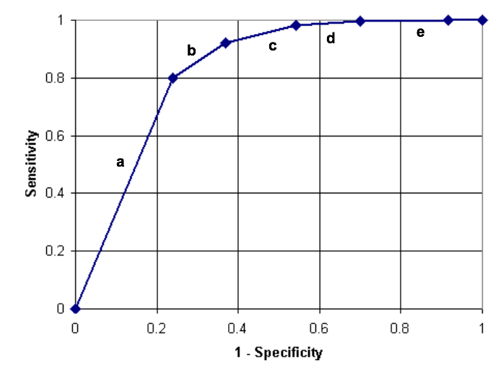
h.1 Which interval (provide the letter) on the curve corresponds to the D-Dimer interval between 500 and 650 μg/L?
h.2 Which D-Dimer levels corresponds to the letter a?
4. Number of Jurors to Convict
Federal courts and most states in the US require that all 12 jurors agree on guilt before a defendant can be convicted. But in Oregon (and Louisiana until 2018), only 10 of the 12 jurors are needed to convict for noncapital cases.(5) (The Oregon legislature will reconsider this policy in 2019.(6)) Meanwhile, the material in Chapter 3 may help clarify some of the issues.
Simplify this problem by ignoring mistrials and considering only two possible verdicts: guilty and not guilty. In this analogy, a truly guilty defendant is like a patient with the disease, and an innocent defendant is like a patient without the disease, and a conviction by the jury is like a positive test.

- If you continue with the diagnostic test analogy, what would you call the proportion of innocent defendants who are acquitted?

- If your only goal were to maximize "sensitivity," would you tend to favor the Oregon approach? Why or why not?

- A key question for this debate is: what is the trade-off between "true positives" and "false positives"? That is, how much do you increase your chance of convicting someone who is innocent in order to convict more people who are guilty? This trade-off can be visualized with ROC curves. Draw two hypothetical ROC curves for this problem. Each curve should have the points labeled "10" and "12" on it for the number of jurors needed to convict. Make the first ROC curve one that would lead you unequivocally to support convictions with only 10 jurors voting guilty, and the other ROC curve one that would lead you unequivocally to oppose such split convictions. (Label the curves "Support" and "Oppose.") Explain your answer.

d) One reason why rational people might disagree on whether to support split jury convictions is that their estimates of the slope of the ROC curve between the 10 and 12 juror points differ. Suppose two people agree completely on that. What are at least two additional reasons why they might still disagree on whether to change the law?

5. Ch03.17.A Grim Reaper’s Walking Speed
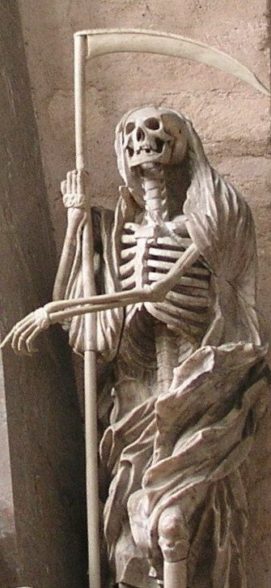
To estimate the walking speed of the Grim Reaper, Stanaway et al(7) studied walking speed as a predictor of mortality in 1705 Australian men at least 70 years old. Of the 1705, 266 died during follow up, so 1705 – 266 = 1439 survived. They treated walking speed (in meters/sec) as a continuous diagnostic test and created the ROC Curve for mortality below: Slower walking speed was a predictor of higher mortality in this study.

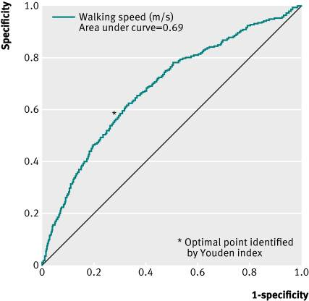
Grim Reaper at the Cathedral of Trier
This image is licensed under the Creative Commons Attribution 3.0 Unported license.
Reprinted from Stnaway et al The BMJ 2011 Dec 15;343:d7679. Open access under a Creative Commons License

- What are two errors in the labeling of this figure?

- What part of the ROC curve refers to the slowest walking speeds?

c) (Extra Credit) The authors found that although there were 266 deaths during follow-up, no one in the cohort who walked faster than 1.36 m/sec (about 3 miles per hour) died. They proposed the following explanation: "This supports our hypothesis that faster speeds are protective against mortality because fast walkers can maintain a safe distance from the Grim Reaper."
About how many men walked faster than 1.36 m/sec? (Again, of the 1705, 266 died during follow up, so 1705 – 266 = 1439 survived.)

REFERENCES for Chapter 3 problems

1. Schroeder AR, Newman TB, Wasserman RC, Finch SA, Pantell RH. Choice of urine collection methods for the diagnosis of urinary tract infection in young, febrile infants. Arch Pediatr Adolesc Med. 2005;159(10):915-22.
2. Newman TB, Bernzweig JA, Takayama JI, Finch SA, Wasserman RC, Pantell RH. Urine testing and urinary tract infections in febrile infants seen in office settings: the Pediatric Research in Office Settings' Febrile Infant Study. Arch Pediatr Adolesc Med. 2002;156(1):44-54.
3. Duriseti RS, Brandeau ML. Cost-effectiveness of strategies for diagnosing pulmonary embolism among emergency department patients presenting with undifferentiated symptoms. Ann Emerg Med. 2010;56(4):321-32 e10.
4. Le Gal G, Righini M, Roy PM, Sanchez O, Aujesky D, Bounameaux H, et al. Prediction of pulmonary embolism in the emergency department: the revised Geneva score. Ann Intern Med. 2006;144(3):165-71.
5. Swenson D. Understanding Louisiana's nonunanimous jury law findings: Interactive, animated slideshow. The New Orleans Advocate [Internet]. April 1, 2018. Available from: https://www.theadvocate.com/new_orleans/news/courts/article_159e7f5a-3459-11e8-b935-e7a91fc85713.html.
6. Wilson C. After Louisiana Vote, Oregon Lawmakers Want To Scrap Non-Unanimous Jury Law. OPB [Internet]. 2018 December 3, 2018. Available from: https://www.opb.org/news/article/non-unanimous-jury-oregon-jim-crow-lousiana-vote/.
7. Stanaway FF, Gnjidic D, Blyth FM, Le Couteur DG, Naganathan V, Waite L, et al. How fast does the Grim Reaper walk? Receiver operating characteristics curve analysis in healthy men aged 70 and over. BMJ. 2011;343:d7679.

We must admit that material in Chapter 3 won't help with the fact that the intention of the just-repealed Louisiana law was overtly racist, which would be a reason to change the law even if one were agnostic about the shape of the ROC curves to be drawn later in the problem.
Hint: ROC "curves" need not be curved! In this case the ROC curves should be made up of straight line segments.

