Epi 204 -- Problem Set #5 (First 3 of 4)
Chapter 6 Problems (Risk Prediction)
Due 10/24/2019 1 pm
NOTE: These are the first 3 of 4 problems. The 4th problem will be posted later.

6.1. Meteorologists on Two Television Channels
During a rainy month, you watch the weather report and decide whether to carry an umbrella. Your decision is irrevocable in that, if you decide not to carry an umbrella and head off to work and it rains, you can’t change your mind.

You have decided that being in the rain without an umbrella is exactly 3 times as bad as carrying an umbrella unnecessarily.

The Channel 2 meteorologist predicts a 33% chance of rain on every single day of the month. The Channel 3 meteorologist predicts a 50% chance of rain on two-thirds of the days and a 100% chance of rain on one third of the days. At the end of the month it turns out that it rained on 10 out of 30 days. It also turns out that every time the Channel 3 meteorologist predicted a 50% chance of rain, it didn’t rain; and every time she predicted a 100% chance of rain, it did.

- What is your threshold probability of rain for carrying an umbrella?

- If you watched and believed the Channel 2 meteorologist, how many days of the month did you carry an umbrella?

- If you watched and believed the Channel 3 meteorologist, how many days of the month did you carry an umbrella?

- What is the average predicted chance of rain for Channel 2? What is it for Channel 3?

- Calculate the Mean Bias, Mean Absolute Error, and Brier Score for each meteorologist and fill out the following table:

 | Mean Bias | MAE | Brier Score
Channel 2
Channel 3

- Assuming discrimination and calibration of each channel’s meteorologist will be similar next month, which channel should you watch and when should you carry an umbrella?

6.2. ABCD2 Score to predict stroke after a transient ischemic attack

The ABCD2 Score was developed to estimate the risk of stroke in patients after a transient ischemic attack (TIA, a brief period of neurological symptoms due diminished blood flow to the brain).[1]

For your information, here is how the ABCD2 score is calculated.
Risk Factor |  | Points
Age
 | ≥ 60 years | 1
Blood Pressure
 | Systolic ≥ 140 mm Hg or Diastolic ≥ 90 mm Hg | 1
Clinical features of the TIA
 | Unilateral weakness (with or without speech impairment) | 2
 | Speech impairment without unilateral weakness | 1
Duration
 | TIA duration ≥ 60 minutes | 2
 | TIA duration 10-59 minutes | 1
Diabetes
 | Diabetes diagnosed by a physician | 1
 | Total ABCD2 Score | 0 – 7

The 2-day risk of stroke by ABCD2 score is shown below:

Score | % of TIA Patients | 2-day Stroke Risk
0-3 | 34% | 1.0%
4-5 | 45% | 4.1%
6-7 | 21% | 8.1%

One of the main reasons for hospitalizing a patient after TIA is to enable rapid treatment with thrombolytics (to dissolve blood clots) if the patient has a subsequent stroke in the next 2 days.

- Assume you are willing to admit 25 patients to the hospital for 2 days unnecessarily in order to avoid discharging one from the emergency department who goes home to have a stroke in the next 2 days. What is your ABCD2 score cutoff for hospitalization?

We will convert the table of 2-day risks above into an ROC table and calculate the area under it.

First, order the results from most to least abnormal:

Score | % of TIA Patients | 2-day Stroke Risk
6-7 | 21% | 8.10%
4-5 | 45% | 4.10%
0-3 | 34% | 1.00%

Next, calculate the individual cell percentages. To get the D+ column, we multiply the proportion of patients in each risk stratum by the 2-day stroke rate in that stratum. Thus, e.g. if we had 10,000 patients, 21% (=2100) would have a score of 6-7 and 8.1% of those 2100 = 170 would have a stroke. So the top D+ cell would be 170/10,000 = 1.70%.

Score | D+ | D- | % of TIA Patients
6-7 | 1.70% | 19.30% | 21%
4-5 | 1.85% | 43.16% | 45%
0-3 | 0.34% | 33.66% | 34%
Total | 3.89% | 96.11% | 100.00%

Then, calculate the column percentages. For example, for the top D+ cell, 1.70%/3.89% = 43.77%.

Score | D+ | D-
6-7 | 43.77% | 20.08%
4-5 | 47.48% | 44.90%
0-3 | 8.75% | 35.02%
Total | 100.00% | 100.00%

Finally, change them to cumulative percentages.

Score | D+ | D-
≥ 6 | 43.77% | 20.08%
≥ 4 | 91.25% | 64.98%
≥ 0 | 100.00% | 100.00%

- Use the above ROC Table to plot the ROC curve on the grid below.

- If you didn’t admit any TIA patients (“No Treat”), what proportion would have a stroke within 2 days? (We will refer to this as P, overall risk, i.e. the proportion of the population who ultimately develop the outcome within the specified time period.)

- If you admitted all TIA patients (“Treat All”), what proportion would you admit unnecessarily?

Remember that an unnecessary admission of a TIA patient who doesn’t have a stroke in the next 2 days is 1/25 as bad as failing to admit someone who does have a stroke in the next 2 days.

- Calculate the Net Benefit of the Treat All strategy relative to treat none. Recall Net Benefit = (Patients Treated Appropriately – C/B × Patients Treated Unnecessarily)/(All Patients) and explain in words what it means.

- Calculate the Net Benefit of a hospitalization strategy using the ABCD2 cutoff in (a). Is it higher or lower than the NB of the “Treat All” strategy?

6.3. Prediction of mortality from community-acquired pneumonia
Schuetz et al [2] compared 3 previously derived rules for predicting mortality in patients with community-acquired pneumonia. The 3 rules were the Pneumonia Severity Index (PSI), the CURB65, and the CRB65. They used each of these 3 rules to predict risk of death in 373 patients with community–acquired pneumonia seen in the emergency department of a Swiss university hospital, of whom 41 died within 30 days. Their calibration plots are shown on the next page.

For all 3 rules, the predicted and observed 30-day mortality rates differed substantially. The authors therefore re-calibrated the prediction rules.

a) Figure (c) is the calibration plot for the CRB65 rule. The open diamonds (◊) represent the original risk predictions prior to recalibration. Prior to recalibration, did the CRB65 rule overestimate or underestimate mortality risk? Explain briefly.

b) Figure (b) is the calibration plot for CURB65 (note the letter “U”). CURB 65 assigned only 3 patients to its highest risk group. How many of them died?

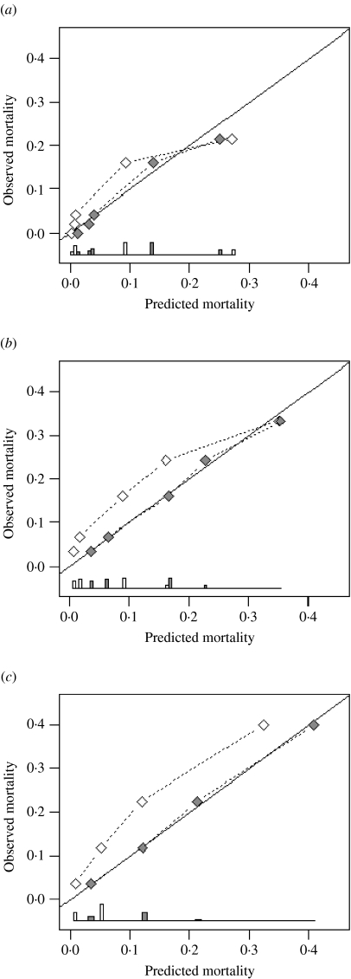

Figure 2: Agreement between predicted and observed 30-day mortality (calibration) for three pneumonia severity prediction rules (a) PSI, (b) CURB65 and (c) CRB65. Observed mortality is plotted according to classes of predicted risk for each prediction rule separately. The solid line of identity represents perfect calibration of predicted risk within new patients. From Schuetz et al[2], used with permission from Cambridge University Press.

◊ Before recalibration
◆ After recalibration

The ROC curves are shown below:

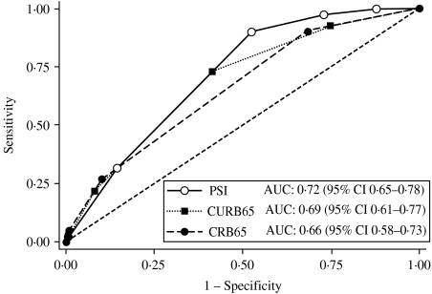

Figure 3. Receiver-operating characteristics analysis for 30-day mortality prediction with three pneumonia severity prediction rules (PSI, CURB65 and CRB65) in 373 patients with community acquired pneumonia. From Schuetz et al[2], used with permission from Cambridge University Press.

c) Do you think the above ROC curves were based on the pre-recalibration or post-recalibration risk predictions? Does it matter? Explain your answer.

d) Below is an enlarged version of the calibration plot for the PSI with 3 risk classes circled. Draw a circle around the part of the ROC curve that corresponds to these 3 risk classes.

e) The authors were interested in a rule that could identify pneumonia patients at such low risk of death that they could be safely discharged from the emergency department. Even after re-calibration, only one of the 3 rules could identify patients at low enough risk to send home. Which of the 3 rules was it? Explain how you know.

REFERENCES

1. Johnston SC, Rothwell PM, Nguyen-Huynh MN, Giles MF, Elkins JS, Bernstein AL, et al. Validation and refinement of scores to predict very early stroke risk after transient ischaemic attack. Lancet. 2007;369(9558):283-92.
2. Schuetz P, Koller M, Christ-Crain M, Steyerberg E, Stolz D, Muller C, et al. Predicting mortality with pneumonia severity scores: importance of model recalibration to local settings. Epidemiol Infect. 2008;136(12):1628-37.
3. Ridker PM, Cook NR. Statins: new American guidelines for prevention of cardiovascular disease. Lancet. 2013;382(9907):1762-5.
4. Cook NR, Ridker PM. Calibration of the Pooled Cohort Equations for Atherosclerotic Cardiovascular Disease: An Update. Ann Intern Med. 2016;165(11):786-94.
5. Ridker PM, Cook NR. The Pooled Cohort Equations 3 Years On: Building a Stronger Foundation. Circulation. 2016;134(23):1789-91.

The CRB65 is just the CURB65 without a lab test called the BUN (blood urea nitrogen).

