Name: In class quiz: Uncertainty
May 20, 2019
Consider the effect estimates below, from Biffi et al’s 2017 meta-analysis of antidepressants and cardiovascular disease. These show study-specific and summary relative risks for the association between use of selective serotonin reuptake inhibitors and acute heart disease (including CHD, AMI, IHD and sudden death). Squares represent study-specific relative risk estimates (size of the square reflects the study-specific statistical weight, that is, the inverse of the variance); horizontal lines represent 95% Cis; diamond represents the summary relative risk estimate and corresponding 95% CI.
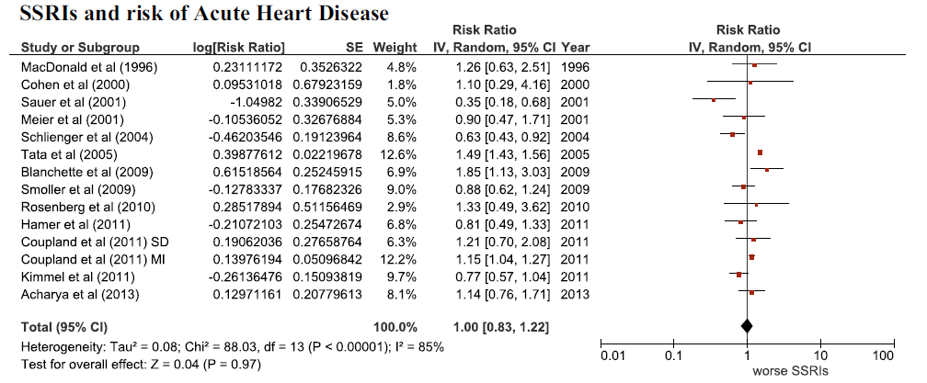
- The first study noted, MacDonald 1996, found no significant evidence of any effect of SSRIs on this outcome, as did the final summary meta-analysis. Was it important to do the meta-analysis?

- Would you consider the results of Meier et al (2001)(RR=0.90; 95% CI: .47, 1.71) inconsistent with the results of Coupland et al (2011) (RR=1.15; 95% CI: 1.04, 1.27)? Explain your reasoning.

- How much larger (in sample size) would you guess the Kimmel et al (2011) study is compared to the Cohen et al (2000) study? Can you calculate the sample size ratio directly from the information here (if not, why not?)

- What are possible explanations for the outlying results of the Sauer et al (2001) study?

- I have an amazing data set and I want to look at this issue just one more time. In my new study of this topic, I have 3,000,000 individuals followed for 10 years. Assume the summary effect estimate from the meta-analysis above is actually correct. What is the probability of rejecting the null and finding an effect in my new study?

- Consider the Acharya (2013) paper included in the meta-analysis. Here is information on the study design:

“SETTING Primary care clinic at a Veterans Affairs hospital. PATIENTS A total of 1136 patients diagnosed with depression who were receiving antidepressant monotherapy (664 patients) or no antidepressant therapy (472 patients [controls]) between June 2009 and December 2010. MEASUREMENTS AND MAIN RESULTS Data on patient demographics, disease diagnoses, laboratory data, and drug therapy profiles were collected through medical record review. Of the 1136 patients, the mean patient age was 61 years, 90% were men, and 77% were smokers. Mean body mass index was 30.4 kg/m2 , blood pressure 126/73 mm Hg, hemoglobin A1c 6%, low-density lipoprotein cholesterol level 106.7 mg/dl, and Framingham score 17.”

What do you think is the most important potential confounder in this study and which direction do you think it might bias the results?

