Lab #8: Unsupervised Learning

Biostat 216: Machine Learning in R for the Biomedical Sciences

Principal Components Analysis
- Read in the breast cancer imaging data “ispy1doctored2.csv” into a data frame called dat
dat <- read.csv("ispy1doctored2.csv")
- Perform principal components on just the variables "pixelVolT0", "pixelVolT1", "pixelVolT2", "pixelVolTfinal", "pixelVolPctChgT0_T1", "ftvPeT0", "ftvPeT1", "ftvPeT2", "ftvPeTfinal", "ftvPePctChgT0_T1", "age", "MRI_LD_T0", "MRI_LD_T1", "MRI_LD_T2", "MRI_LD_Tfinal". Use the command pr.out <- prcomp(~ pixelVolT0 + pixelVolT1 + pixelVolT2 + pixelVolTfinal + pixelVolPctChgT0_T1 + ftvPeT0 + ftvPeT1 + ftvPeT2 + ftvPeTfinal + ftvPePctChgT0_T1 + age + MRI_LD_T0 + MRI_LD_T1 + MRI_LD_T2 + MRI_LD_Tfinal, data = dat, scale=TRUE). The scale=TRUE argument makes all the variables be normalized before performing PCA.
pr.out <- prcomp(~ pixelVolT0 + pixelVolT1 + pixelVolT2 + pixelVolTfinal + pixelVolPctChgT0_T1 + ftvPeT0 + ftvPeT1 + ftvPeT2 + ftvPeTfinal + ftvPePctChgT0_T1 + age + MRI_LD_T0 + MRI_LD_T1 + MRI_LD_T2 + MRI_LD_Tfinal, data = dat, scale=TRUE)
- Look at the center and scale components of pr.out. These correspond to the means and standard deviations of the variables that were used for scaling prior to implementing PCA. E.g. pr.out$center
pr.out$center
## pixelVolT0 pixelVolT1 pixelVolT2
## 0.001337278 0.001271772 0.001307040
## pixelVolTfinal pixelVolPctChgT0_T1 ftvPeT0
## 0.001319201 -2.597529980 25.828501078
## ftvPeT1 ftvPeT2 ftvPeTfinal
## 15.819718095 6.416387467 2.926144333
## ftvPePctChgT0_T1 age MRI_LD_T0
## -33.060239968 48.227769231 65.800000000
## MRI_LD_T1 MRI_LD_T2 MRI_LD_Tfinal
## 58.230769231 43.792307692 29.569230769
pr.out$scale
## pixelVolT0 pixelVolT1 pixelVolT2
## 5.455696e-04 5.046348e-04 5.075021e-04
## pixelVolTfinal pixelVolPctChgT0_T1 ftvPeT0
## 5.148057e-04 2.157583e+01 3.907992e+01
## ftvPeT1 ftvPeT2 ftvPeTfinal
## 2.158310e+01 2.028899e+01 1.025553e+01
## ftvPePctChgT0_T1 age MRI_LD_T0
## 4.253753e+01 9.047455e+00 2.775290e+01
## MRI_LD_T1 MRI_LD_T2 MRI_LD_Tfinal
## 2.792391e+01 2.975864e+01 2.912708e+01
- What is the dimension of the part of the data frame that you performed PCA on? Hint: you can find it as an object in pr.out – check ?pr.out
dim(pr.out$x)
## [1] 130 15
- Now look at the rotation matrix component of pr.out which gives the principal component loading vector. How many PCs are there? Does that agree with what you would expect?
pr.out$rotation
## PC1 PC2 PC3 PC4
## pixelVolT0 0.23499941 -0.43058919 0.045760336 -0.14896734
## pixelVolT1 0.28198315 -0.40013543 -0.052002439 0.19136918
## pixelVolT2 0.27334862 -0.42229813 -0.002142282 0.04233403
## pixelVolTfinal 0.26485372 -0.42744674 -0.005907989 0.03295573
## pixelVolPctChgT0_T1 0.07320258 0.04158706 -0.218116822 0.60668093
## ftvPeT0 -0.26646345 -0.17242729 0.218057337 0.25188759
## ftvPeT1 -0.30287387 -0.22278701 0.045780306 0.18167754
## ftvPeT2 -0.24385157 -0.09257910 -0.531657645 0.04315225
## ftvPeTfinal -0.24027040 -0.10276296 -0.507771678 0.07572300
## ftvPePctChgT0_T1 -0.04901623 -0.11300048 -0.414476342 -0.26404896
## age 0.01519258 0.08783855 0.055429426 0.62224518
## MRI_LD_T0 -0.32046697 -0.19049676 0.319947454 0.01088290
## MRI_LD_T1 -0.32552700 -0.18227543 0.273912354 -0.01011548
## MRI_LD_T2 -0.35049209 -0.22373157 0.024623024 -0.06749089
## MRI_LD_Tfinal -0.31774420 -0.23056117 -0.067726102 -0.06715415
## PC5 PC6 PC7 PC8
## pixelVolT0 0.13333420 -0.205878033 0.095815606 -0.017415116
## pixelVolT1 -0.04855158 0.023353387 -0.103890024 -0.022036833
## pixelVolT2 -0.05681500 0.004421023 0.004061152 0.051840037
## pixelVolTfinal -0.06954453 -0.031143248 0.005327724 0.016175839
## pixelVolPctChgT0_T1 -0.31740435 0.457326468 -0.364420382 -0.006103738
## ftvPeT0 0.55102127 0.074098054 -0.172649400 -0.096552740
## ftvPeT1 0.50483266 0.221559799 -0.003627574 0.005387928
## ftvPeT2 0.02823859 -0.321114767 -0.136001995 0.132665584
## ftvPeTfinal 0.01925239 -0.399588694 -0.131853147 0.051478587
## ftvPePctChgT0_T1 0.10602171 0.579608468 0.418995934 0.405485046
## age -0.02386982 -0.255144104 0.724291153 0.098623574
## MRI_LD_T0 -0.23670210 -0.067844549 -0.107487785 0.422864048
## MRI_LD_T1 -0.32394111 -0.026782648 -0.044171347 0.417975333
## MRI_LD_T2 -0.24609183 0.087458127 0.150728556 -0.359781379
## MRI_LD_Tfinal -0.27940833 0.124712539 0.212361189 -0.556343752
## PC9 PC10 PC11 PC12
## pixelVolT0 1.664792e-01 -0.121597040 0.426760919 -0.09019039
## pixelVolT1 1.552435e-01 -0.181290986 0.450335630 0.04256503
## pixelVolT2 -7.905710e-02 0.313728118 -0.349182242 -0.35977763
## pixelVolTfinal -2.175290e-01 0.017611007 -0.508577700 0.40798663
## pixelVolPctChgT0_T1 5.508080e-02 -0.030269564 0.054141830 -0.03876338
## ftvPeT0 1.540007e-06 -0.054898518 -0.195626441 -0.18048980
## ftvPeT1 -9.765186e-02 0.126718224 0.158326214 0.17384250
## ftvPeT2 2.981823e-02 0.433946990 0.126887653 0.44023546
## ftvPeTfinal -4.167520e-02 -0.408321120 -0.179917734 -0.45155447
## ftvPePctChgT0_T1 4.523253e-02 -0.124535425 -0.032491311 -0.06582404
## age 1.752564e-02 0.003023469 -0.003861423 0.01443236
## MRI_LD_T0 1.636641e-01 -0.483563713 -0.129167213 0.32826126
## MRI_LD_T1 -2.827817e-01 0.381002176 0.236316325 -0.33058049
## MRI_LD_T2 7.007297e-01 0.215849786 -0.168147603 -0.06885642
## MRI_LD_Tfinal -5.284816e-01 -0.193604399 0.133718126 0.07635822
## PC13 PC14 PC15
## pixelVolT0 0.007221046 -0.00641764 -0.657709341
## pixelVolT1 -0.123735312 -0.12797758 0.643117183
## pixelVolT2 0.609787747 0.03058230 0.101866461
## pixelVolTfinal -0.502091465 0.08572695 -0.088011954
## pixelVolPctChgT0_T1 0.011989560 0.02363805 -0.354197852
## ftvPeT0 -0.109392245 -0.59338554 -0.045730839
## ftvPeT1 0.087023096 0.65406752 0.057312446
## ftvPeT2 0.168096480 -0.28060504 -0.036500316
## ftvPeTfinal -0.153408971 0.24064462 0.043449376
## ftvPePctChgT0_T1 -0.049941644 -0.17525383 0.001378595
## age 0.008000843 -0.03264117 -0.011426576
## MRI_LD_T0 0.348950586 -0.01985118 -0.017569720
## MRI_LD_T1 -0.335988337 -0.01468026 0.002685508
## MRI_LD_T2 -0.152922303 0.08234887 0.027778408
## MRI_LD_Tfinal 0.169198812 -0.13786736 -0.020580365
There are 15 PCs. This is what is expected because it matches the number of variables.
- Plot the first two principal components with biplot(pr.out, scale=0). The scale=0 argument ensures that arrows are scaled to represent the loadings.
biplot(pr.out, scale=0)
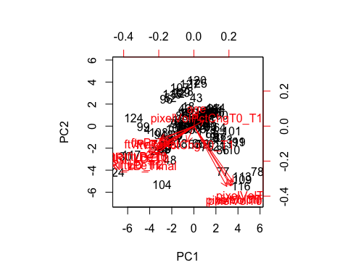
- The red arrows represent the loadings and there contributions to each PC. Why do you think there are many arrows that are almost overlapping?
This is likely due to colinearity (multiple variables explaining the same part of the variance – at least with respect to the first 2 PCs)
- Look at the sdev component of pr.out. This gives the standard deviation of each PC.
pr.out$sdev
## [1] 2.1646749 1.8083891 1.3658213 1.1224987 1.0699259 0.9595897 0.8894578
## [8] 0.6686935 0.4298787 0.3505364 0.3290380 0.2838988 0.2451433 0.1931840
## [15] 0.1436968
- Generate a vector pr.var that is the variance explained by each PC by squaring the standard deviations.
pr.var <- pr.out$sdev^2
pr.var
## [1] 4.68581758 3.27027127 1.86546779 1.26000327 1.14474143 0.92081241
## [7] 0.79113523 0.44715097 0.18479571 0.12287575 0.10826599 0.08059855
## [13] 0.06009522 0.03732005 0.02064877
- Generate a new vector pve that is the proportion of variance explained by each vector. Generate the sum of pve as a confirmation that you are on the right lines.
pve <- pr.var/sum(pr.var)
pve
## [1] 0.312387839 0.218018085 0.124364519 0.084000218 0.076316095
## [6] 0.061387494 0.052742349 0.029810065 0.012319714 0.008191717
## [11] 0.007217733 0.005373237 0.004006348 0.002488003 0.001376585
- Generate plots of proportion of variance explained and cummulative variance explained against PC number. You will need the function cumsum which compute the cumulative sum of elements in a numeric vector, e.g. for a1 <- c(2,1,3,4), cumsum(a1) gives [1] 2 3 6 10
a1 <- c(2,1,3,4)
a1
## [1] 2 1 3 4
cumsum(a1)
## [1] 2 3 6 10
par(mfrow=c(1,2))
plot(1:length(pve),pve, xlab="Principal Component", ylab="Proportion of Variance Explained", ylim=c(0,1), type='b')
plot(1:length(pve),cumsum(pve), xlab="Principal Component", ylab="Proportion of Variance Explained", ylim=c(0,1), type='b')
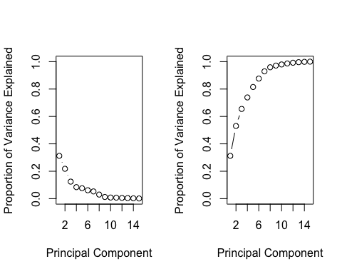
par(mfrow=c(1,1))
- How many PCs do you you need to explain at least 80% of the variance?
5 PCs

K-means clustering
- Subset dat to only the columns "pixelVolTfinal", "ftvPeTfinal", "age", "MRI_LD_Tfinal". Name the new object datsub
datsub <- dat[ ,c("pixelVolTfinal", "ftvPeTfinal", "age", "MRI_LD_Tfinal")]
- Perform $K$-means clustering on the subset of variables for $K=3$. Use 30 random starting configurations.
kmeans3 <- kmeans(datsub, centers=3, nstart=30)
- Output the cluster assignments of the 3 clusters
kmeans3$cluster
## [1] 1 1 3 3 3 1 1 3 3 1 1 3 1 3 3 3 3 1 2 1 3 3 3 2 2 2 1 3 1 2 1 3 1 1 3
## [36] 1 1 2 3 1 1 3 1 1 1 1 1 2 3 1 1 3 1 1 3 2 3 3 1 1 1 3 1 1 3 1 3 2 1 3
## [71] 1 1 3 3 3 3 3 1 3 1 1 1 1 1 1 3 1 1 2 3 1 1 1 2 1 3 1 1 3 1 1 3 3 2 3
## [106] 3 1 2 1 1 1 1 1 1 1 1 2 1 1 1 3 1 1 2 1 1 1 1 3 1
- Generate a table of agreement between the cluster labels and the outcome pathologic complete response pCR. Do you think the cluster allocations are illuminating with respect to pCR?
table(kmeans3$cluster,dat$pCR)
##
## 0 1
## 1 44 28
## 2 14 1
## 3 36 7
There is some information in the clusters with respect to pCR. Patients in cluster 1 appear to have a greater tendency toward pCR than either of the other two clusters.

Hierarchical clustering
- The hclust() function implements hierarchical clustering in R. We will plot the hierarchical clustering dendogram using complete, single, and average linkage clustering, with Euclidean distance as the similarity measure. Start by creating the distance matrix between all pairs of observations using the dist() function: distx <- dist(datsub).
distx <- dist(datsub)
- Generate hierarchical clustering with method="complete". Use the command hc.complete <- hclust(distx, method="complete").
hc.complete <- hclust(distx, method="complete")
- Generate similar objects for average and single linkage.
hc.average <- hclust(distx, method="average")
hc.single <- hclust(distx, method="single")
- Plot each of the dendograms using the plot function.
plot(hc.complete,main="Complete Linkage", xlab="", sub="", cex=.9)
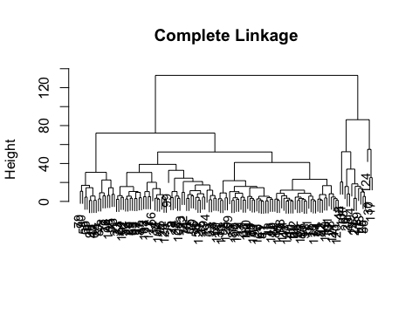
plot(hc.average, main="Average Linkage", xlab="", sub="", cex=.9)
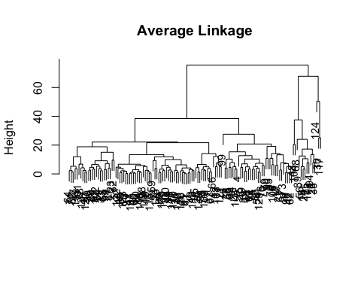
plot(hc.single, main="Single Linkage", xlab="", sub="", cex=.9)
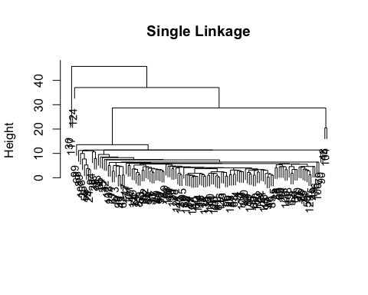
- Determine the cluster labels for each observation associated with cutting the dendogram with 4 clusters using the cutree() function.
cutree(hc.complete, k=4)
## [1] 1 1 1 1 1 1 1 2 2 1 1 1 1 1 1 1 2 1 3 1 2 1 1 3 3 3 1 1 1 4 1 1 1 1 2
## [36] 1 1 3 1 1 1 2 1 1 1 1 1 3 1 1 1 1 1 1 2 3 2 1 1 1 1 2 1 1 2 1 1 3 1 1
## [71] 1 1 2 1 1 2 1 1 2 1 1 1 1 1 1 1 1 1 3 2 1 1 1 3 1 2 1 1 1 1 1 1 1 3 1
## [106] 2 1 3 1 1 1 1 1 1 1 1 4 1 1 1 1 1 1 4 1 1 1 1 1 1
cutree(hc.average, k=4)
## [1] 1 1 1 1 1 1 1 1 1 1 1 1 1 1 1 1 1 1 2 1 1 1 1 2 2 2 1 1 1 3 1 1 1 1 1
## [36] 1 1 2 1 1 1 1 1 1 1 1 1 2 1 1 1 1 1 1 1 2 1 1 1 1 1 1 1 1 1 1 1 2 1 1
## [71] 1 1 1 1 1 1 1 1 1 1 1 1 1 1 1 1 1 1 2 1 1 1 1 2 1 1 1 1 1 1 1 1 1 2 1
## [106] 1 1 2 1 1 1 1 1 1 1 1 3 1 1 1 1 1 1 4 1 1 1 1 1 1
cutree(hc.single, k=4)
## [1] 1 1 1 1 1 1 1 1 1 1 1 1 1 1 1 1 1 1 1 1 1 1 1 1 1 1 1 1 1 2 1 1 1 1 1
## [36] 1 1 1 1 1 1 1 1 1 1 1 1 3 1 1 1 1 1 1 1 1 1 1 1 1 1 1 1 1 1 1 1 1 1 1
## [71] 1 1 1 1 1 1 1 1 1 1 1 1 1 1 1 1 1 1 1 1 1 1 1 1 1 1 1 1 1 1 1 1 1 3 1
## [106] 1 1 1 1 1 1 1 1 1 1 1 2 1 1 1 1 1 1 4 1 1 1 1 1 1

