Take Home Quiz 2, epi265
Name:
Due: June 2, 8pm.
Please spend no more than 1.5 hours on this quiz or note the answers you completed after the 1.5 hour mark. This is open book. If you’re not sure how to answer a question, please write down how you would think about it so I can give you partial credit. Please use a different colored font for your answers, because it makes grading much easier.
A 2016 meta-analysis of blood pressure lowering trials and cardiovascular outcomes reported the results below, summarized based on the number of outcomes reported for each trial.
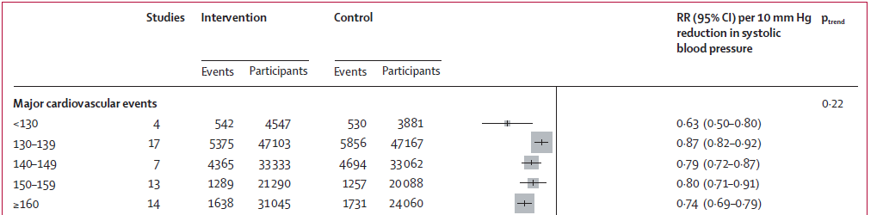

- For the effect estimate based on studies with fewer than 130 events, what is the natural log of the estimated relative risk, the standard error of the ln(RR), and the information associated with that group of studies (hint: natural logs are easy to calculate in excel)?
Ln(RR)=
SE(ln(RR))=
Information=

- Using excel or software of your choice, estimate a fixed effects meta-analysis and confidence bounds of the results shown above.
What is the point estimate for the pooled RR?
What are the 95% confidence bounds for the pooled RR?

- Do you have enough information to estimate a random effects meta-analysis? If not, what additional information would you need?

It has been demonstrated in dozens of studies that middle aged and older adults with clinical depression or even elevated depressive symptoms have a higher risk of subsequent stroke. Consider three alternative hypotheses to explain this association. (1) depression causes stroke by increasing smoking, which is known to increase stroke risk; (2) depression is an early manifestation of the same physiologic process that culminates in stroke; (3) genetics, childhood socioeconomic status, or childhood growth/physiologic development which increase risk of depression also cause stroke.

- Propose a study to evaluate hypothesis (1) (give about the same level of detail as you would in an abstract- but please make it clear why this approach is useful to evaluate the hypothesis)
Sample (you can make this up or use a real study if you can think of one, but regardless, describe the sample design):
Exposure Measures:
Outcome Measures:
Covariate Measures:
Analysis Plan (include the equation you would estimate and specify which coefficient would correspond to the hypothesis:

- Propose a study to evaluate hypothesis (2) (this is the hardest question in the quiz – if you’re running out of time, come back to it at the end)
Sample:
Exposure Measures:
Outcome Measures:
Covariate Measures:
Analysis Plan:

- Propose a study to evaluate hypothesis (3)
Sample:
Exposure Measures:
Outcome Measures:
Covariate Measures:
Analysis Plan:

From: “Mediators of the Effect of Body Mass Index on Coronary Heart Disease Decomposing Direct and Indirect Effects” (Lu et al 2015, Epidemiology)

Background: Previous estimates of direct effects of high body mass index (BMI) on CHD did not consider an interaction between BMI and its mediators and did not include inflammatory biomarkers as potential mediators.
Methods: We analyzed data from 9 prospective cohort studies with 58,322 participants and 9,459 CHD events and decomposed the total effects into natural direct and indirect effects using a 2-stage regression model. We pooled hazard ratios using random-effects models and calculated the percentages of excess relative risk mediated by blood pressure, cholesterol, glucose, fibrinogen and high-sensitive C-reactive protein.

8. Please provide an interpretation (in words or counterfactuals) of the natural direct and natural indirect effect.

9. What are the assumptions necessary to estimate the natural direct and indirect effect?

10. Define the Controlled Direct Effect, and give an example of a situation in which you would prefer to know the controlled direct effect of obesity on CHD, instead of the natural direct effect.

11. Bonus question (no time limit).
Consider the following data generating rules:
C1 is a random variable with mean 0, standard deviation (SD) =1 distribution
C2 is a random variable with mean -2, SD=1 distribution
X = C1+ a random variable with mean 0, SD=3 distribution
M is a binary variable, equal to 1 if the sum of a standard normal variable plus C2 plus X is greater than 3, otherwise M is equal to 0
Y is a binary variable, and the log odds of Y is equals to the sum of X, M, M*C2, X*M, and a random variable with mean 0, SD=1
On the risk difference scale, what is the controlled direct effect of increasing X from 2 to 3 on the outcome Y, setting M to 1?
Please show how you calculated this.

