3 Multilevel and continuous tests

Introduction
To this point, we have discussed the accuracy of dichotomous tests – those that are either positive or negative for the disease in question. Now, we want to consider the accuracy of tests with more than two possible results. As discussed in Chapter 2, the results of such tests can be ordinal if they have an intrinsic ordering, like a urine dipstick test for white blood cells, which can be negative, trace positive, or positive. Test results also can be discrete (having a limited number of possible results, like the dipstick test) or continuous, with an essentially infinite range of possibilities (like a serum cholesterol level or white blood cell count).
In this chapter, we discuss how best to use the information from multilevel or continuous tests, showing that the common practice of dichotomizing these test results into “positive” and “negative,” generally reduces the value of the test. We also introduce Receiver Operating Characteristic (ROC) curves to summarize a multilevel test’s ability to discriminate between patients with and without the disease in question. In evaluating a patient, we must use the patient’s test result to update his or her pre-test probability of disease. In Chapter 2, we learned the 2 × 2 table method for probability updating, but it only applies to dichotomous tests. The LR method will be more useful now that we have moved to tests with more than two results.

Making a continuous test dichotomous
In Chapter 1, we described the case of a 6-hour-old baby whose mother had a fever of 38.7◦ C. The disease we were concerned about was bacterial infection, and the test we were considering was the white blood cell (WBC) count. One possible approach is to make the WBC count into a dichotomous test by choosing a cut-off, such as 10,000/μL, below which the test is considered “positive” (Table 3.1). Note that in newborns, it is low WBC counts that are most concerning for infection, not high WBC counts.
________________________________________________________________
Table 3.1. Dichotomizing the WBC count at 10,000/µL as a test for bacterial infection in newborns ≥ 4 hours old at risk of infection (data from Newman et al, 2011).[1]
WBC count (×1,000/μL) | Bacteremia | No bacteremia
<10 (+) | 56 | 1,123
≥10 (−) | 34 | 23,113
Total | 90 | 24,236
Sensitivity = 56/90 = .622
Specificity = 23,113/24,236 = .954
LR(+) = .622/(1−.954) = 13.4
LR(−) = (1 − .622)/0.954 = 0.40
We can see from Table 3.1 that a WBC count <10,000/μL increases an at-risk newborn's pretest odds of bacteremia by a factor of 13.4.
However, we also might look at Table 3.1 and think, "Yuck! A sensitivity of 0.62 is not very good for a serious illness like bacterial infection in a newborn. Let's try raising the cutoff for an abnormal result to 15,000/µL so more newborns with infection will have ‘positive’ results.”
Results of raising the cutoff for a positive result to <15,000 are shown in Table 3.2. The good news is that we have indeed managed to raise the sensitivity of the test (modestly), from 0.62 to 0.80. However, the bad news is that we paid a price with the specificity; newborns without infection are also more likely to have a WBC count < 15,000 than to have one < 10,000, so specificity declined from 0.95 to 0.77.
________________________________________________________________
Table 3.2. Dichotomizing the WBC at 15,000/µL as a test for bacterial infection in newborns at risk of infection (data from Newman et al, 2011).[1]
WBC count (×1,000/μL) | Bacteremia | No bacteremia
<15 (+) | 72 | 5,518
≥15(−) | 18 | 18,718
Total | 90 | 24,236
Sensitivity = 72/90 = 0.80
Specificity 18,718/24,236 = 0.77
LR(+) = .8/(1-.77) = 3.5
LR(−) = (1 − 0.8)/077 = 0.26

We could try some other cutoffs too. If we were willing to further sacrifice specificity, we could consider any WBC < 20,000 abnormal, which would give a sensitivity of 0.92, but a specificity of only 0.48. On the other hand, if we wanted a much higher LR(+), we could go for a high specificity and set the cutoff at <5,000, which would give a specificity of 0.9956 and LR(+) of 80.5, but a sensitivity of only 0.36. Each possible cutoff is associated with a sensitivity/specificity pair, with one generally decreasing as the other increases.

ROC curves
The trade-off between sensitivity and specificity is summarized in Table 3.3, which we call an ROC (Receiver Operating Characteristic) table. In addition to the sensitivity/specificity pairs previously mentioned, we added two additional cutoffs: 1) lower than the lowest value in the study, which gives sensitivity of 0, since no one with infection had that low a WBC count and specificity of 1, since no one without infection had that low a WBC count; 2) lower than or equal to the highest value in the study, which gives sensitivity of 1, since everyone with infection had that low a WBC count but specificity of 0, since everyone without infection also had that low a WBC count.
Table 3.3: ROC Table showing the effect of changing the cutoff for defining an abnormal result on sensitivity and specificity of the WBC as a test for infection in at-risk newborns
Cutoff for abnormal | Sensitivity | Specificity | 1-Specificity
< Lowest | 0 | 1 | 0
< 5,000 | 0.356 | 0.996 | 0.004
<10,000 | 0.622 | 0.954 | 0.046
<15,000 | 0.800 | 0.772 | 0.228
<20,000 | 0.922 | 0.475 | 0.525
≤ Highest | 1 | 0 | 1
The information in an ROC table like Table 3.3 can be summarized graphically with an ROC curve. (Figure 3.1).

Figure 3.1. ROC curve illustrating the trade-off between sensitivity and specificity at different cutoffs for calling the WBC count positive in newborns at risk of infection
ROC curves were introduced as part of signal detection theory when radar was being developed during World War II [2]. Each point on the ROC curve represents a different cut-off for calling the test positive. The sensitivity (true-positive rate) is plotted on the y-axis against 1 – specificity (the false-positive rate) on the x-axis. The general idea is that you want to get as many true positives as you can (go up the graph) without getting too many false positives (which move you to the right).
If the distribution of test results is similar in people who do and do not have the disease, then no matter what the cut-off is, the proportions of people with and without the disease who are considered “positive” will be about equal. That is, the true-positive rate will about equal the false-positive rate. In that case, the test discriminates poorly, and the ROC curve will approximate a 45-degree diagonal line (Figure 3.2).

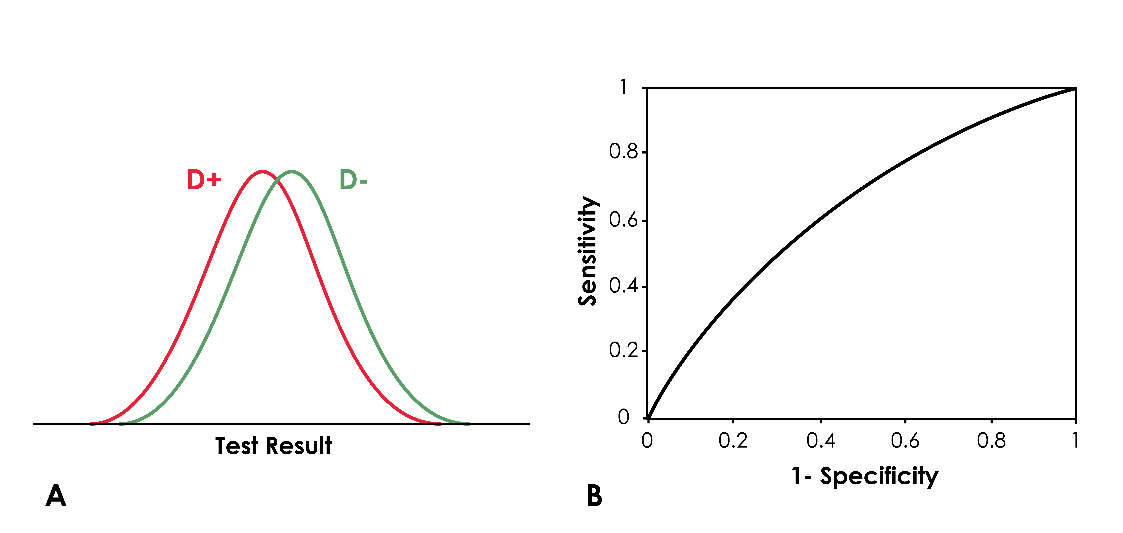Figure 3.2 Test discriminates poorly between patients with disease (D+) and patients without disease (D−). Panel A: The distribution of test results in D+ patients is similar to the distribution in D− patients. Panel B: This rather pathetic ROC curve approaches a 45-degree diagonal line.
If the test results are lower in people who have the disease, the curve will go up faster than it moves to the right. The closer the curve gets to the upper left-hand corner of the graph, the better the test (Figure 3.3).
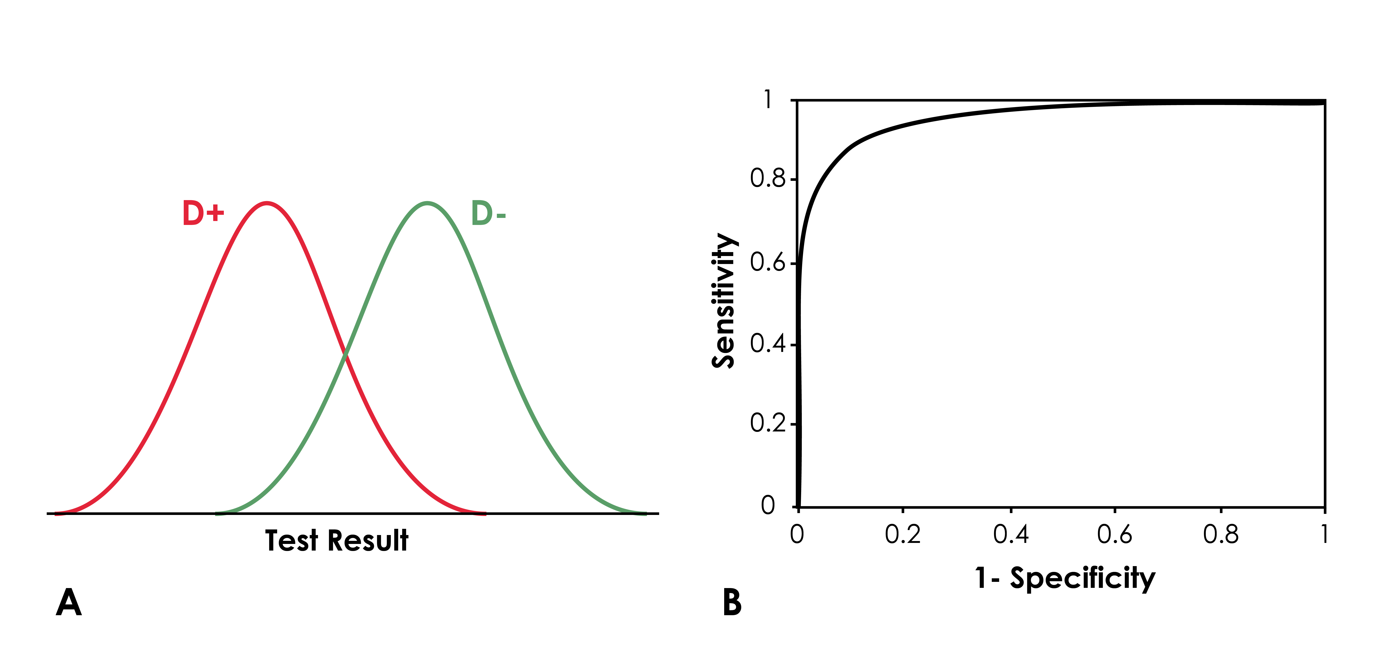
Figure 3.3 Test discriminates better between patients with the disease (D+) and patients without the disease (D−). Panel A: The distribution of test results in D+ patients differs substantially from the distribution in D− patients. Panel B This much better ROC curve nears the upper left corner of the grid.

Area Under the ROC Curve (AUROC)
The area under an ROC curve (AUROC), quantifies the discrimination of the test: 1.0 is perfect discrimination; 0.5 is no discrimination. The AUROC has another interpretation as well: it is the probability that a randomly selected person with the disease will have a more abnormal result on the test than a randomly selected person without the disease.[3]
What if the ROC curve goes under the 45-degree diagonal and AUROC < 0.5? Then results you were calling "abnormal" occur more often in those who do not have the disease, and you just need to switch your definition of what constitutes a more abnormal result (e.g., consider a high WBC count indicative of infection rather than a low WBC count). If you wanted to know the shape of the ROC curve without redrawing it, you could turn it upside down. You would not need to recalculate AUROC; it will be just 1 minus the AUROC that you calculated before.
ROC curves are for tests with multiple possible cutoffs for calling the test “positive”. However, we can draw a one-point ROC curve for a dichotomous test. For example, in Chapter 2, Box 2.3, we treated the urinalysis as a dichotomous test for urinary tract infection with sensitivity 0.8 and specificity 0.85. (Figure 3.4)

Figure 3.4. One-point ROC curve for a test with sensitivity = 0.8 and 1 − specificity = 0.15.
The AUROC for a one-point ROC curve is just the average of sensitivity and specificity, (sensitivity + specificity)/2. The AUROC varies from 0.5 for a worthless test to 1.0 for a perfect test. If you want a measure of discrimination that ranges from 0 for worthless to 1 for perfect, you can subtract ½ from the AUROC and then multiply by 2. For a one-point ROC curve, this works out to sensitivity + specificity - 1, which is also called Youden’s Index.

ROC Curves for continuous tests
The ROC curve illustrated in Figure 3.1 shows just four possible cut-offs, with these few discrete points connected by straight lines. This is the typical appearance of ROC curves for tests with ordinal results or for a test with continuous results categorized by defining a few possible cut-offs, as we have here. On the other hand, if we were to plot the ROC curve for a test with continuous (or many discrete) results (or, preferably, get a computer to do it), it would show what happens when the cut-off is incrementally changed from the most abnormal to the least abnormal value in the sample. Figure 3.5 shows two such ROC curves for two different WBC counts used to help diagnose bacterial meningitis in infants from 3 to 89 days old [4]. Both WBC counts were treated as if higher values were more suggestive of bacterial meningitis. We will return to this figure at the end of this section.
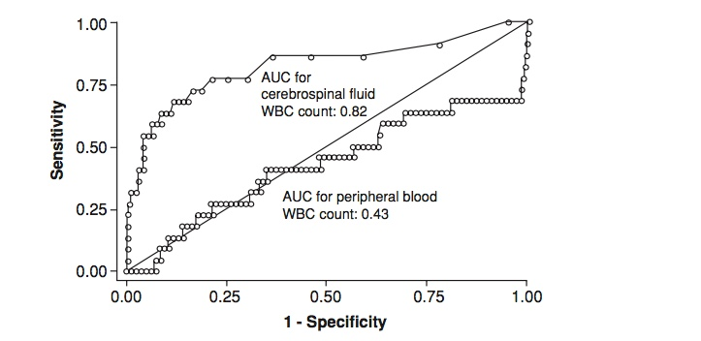
Figure 3.5 Examples of ROC curves drawn for individual test results, rather than grouping results in categories. The cut-off for considering the test “abnormal” is systematically decreased from the highest to the lowest values observed in infants with and without bacterial meningitis. Note that two different WBC counts are considered: the WBC count in the cerebrospinal fluid, which discriminates fairly well between those with and without bacterial meningitis; and the WBC count in the peripheral blood, which discriminates poorly. Both WBC counts were treated as if higher values were more suggestive of bacterial meningitis. (From Bonsu and Harper 2003, with permission.) AUC = Area Under Curve.

The walking man approach to understanding ROC curves
Here is a good way to think about the ROC curves in Figure 3.5. Imagine you have twenty patients, ten of whom have the disease of interest and ten of whom do not. Perform the test on all of them, and then arrange the test results in order from most abnormal to least abnormal, using “N” to indicate someone with no disease, and “D” to indicate someone who has the disease. (Put ties in parentheses.) Then, for a perfect test, the list would look like this (with spaces added only to enhance readability):
D D D D D DD D D D N N N N N N N N N N
Now picture a little man starting at the lower left corner of the ROC curve. That is the corner that represents 0% sensitivity and 100% specificity – when you say no one has the disease. Put another way, if a low result on the test is abnormal, it is when you say the result has to be lower than the lowest value of your sample to be called abnormal. Because there are ten patients in each group, make a 10 × 10 grid. Now start at the beginning of the list above. This little man will take a walk on this grid, tracing out an ROC curve. You are going to read the list above out loud to him. Every time you say “D,” he will take one step up, corresponding to one more patient with the disease being identified (true positive) and a 10% increase in sensitivity. Every time you say “N,” he will take one step to the right, corresponding to one more non-diseased person being identified (false positive) and a 10% decrease in specificity. For every new value of the test, he walks up or over for the number of D or N patients who have that value, then drops a new stone. Each stone represents a point on the ROC curve. You can see, for the perfect test above, he will walk straight up to the upper left-hand corner of the graph, then turn right and walk straight across to the upper right corner, dropping stones all along the way (Figure 3.6, Perfect Test).
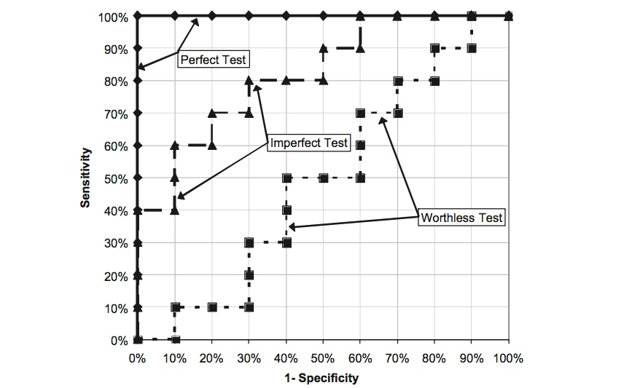
Figure 3.6 Perfect, imperfect, and worthless tests corresponding to the ordered lists of test results given in the text.
Similarly, for a worthless test, the ordering would look something like this:
N D N N D D N D D N N D D N D N D N D N
You can see with this test that he will go up one step about each time he goes over one step, so his path will more or less follow the diagonal line that indicates a worthless test (Figure 3.6, Worthless Test).
If the test actually provides some information but is not perfect, the ordered list might look like this, with more Ds at one end and more Ns at the other (Figure 3.6, Imperfect Test):
D D D D N D D N D N D N N D N D N N N N
You do not need equal numbers of patients per group. If the number of patients is not equal, just divide the vertical scale into d steps, where d is the number with disease, and divide the horizontal scale into n steps, where n is the number without disease. Then just go through your list, going up one step for each D and over one step for each N. (Note: if people with disease have a higher value for the test result, just arrange the values in descending order, again from most abnormal to least abnormal.)
What about ties, that is, when there are both N and D patients with the same test result? The answer is that, when there is a tie, the ROC curve is diagonal. Recall that the little man only drops a stone after he has walked out all the D and N patients for a particular test value. So if there are three Ns and four Ds that all had the same result, he would take three steps over and four steps up (in any order) before dropping his next stone.
Of course what is happening here is that we are creating the ROC curve by taking each result obtained on the test in order, and saying, “a result more abnormal or equal to this is positive for disease.” As we move that number from more abnormal to less abnormal, we first start picking up more and more diseased individuals (increasing sensitivity), and the little man walks mostly vertically. As we lower this threshold further, we start picking up more non-diseased individuals. For results that are equally likely in diseased and non-diseased people, the little man walks at about a 45-degree angle. Eventually, we get to results that are more common among people who do not have the disease than among people who do (normal values of the test), and he walks more horizontally.
Box 3.1: ROC curves and the Wilcoxon Rank Sum test (also called the Mann–Whitney U-test)[3]
If you think about the process of the little man tracing out an ROC curve, you can see that the actual values of the test are not important for the shape of the ROC curve or the area under it – only the ranking of the values. The ranking determines the order of the Ns and Ds, and hence the pattern of the little man’s walk. Thus, it is not surprising that the statistical significance test for the AUROC is the same as that for the Wilcoxon Rank Sum test, a nonparametric alternative to the t-test, used to investigate whether numbers in one group tend to be higher than those in another.
The AUROC and the rank sums can be related as follows. List all of the n patients without disease and d patients with disease in order from most to least abnormal and assign ranks, where 1 is for the most abnormal value and (n + d) is for the least abnormal value. (The way to do ties is assign the average rank to all members of a tie. Thus, if two people are tied for third and fourth, assign both the rank of 3.5; if five people are tied for 7, 8, 9, 10 and 11, assign all of them the rank of 9.) Then take the sum of the ranks of the diseased group; call that S. If the test is perfect, all of the lowest ranks will belong to the diseased group, and S will equal d(d + 1)/2 (this is the minimum value of S, S_{min}). If all of the people with disease test less abnormal, then S will equal S_{max} = S_{min} + dn. The area under the ROC curve, AUROC, is related to these values as follows:
(Note: if this gives a value <0.5, the ranking was in the wrong order, and you can just change your definition of what direction constitutes abnormal, turn the ROC curve upside down, and subtract the area you got from 1.)
Abbreviations:
AUROC area under ROC curve
d | number of patients with disease
n | number of patients without disease
S | sum of ranks in diseased group
S_{min} | minimum possible value of S = d(d + 1)/2
S_{max} | maximum possible value of S = S_{min} + dn

Getting the most out of ROC curves
Take a closer look at the ROC curves in Figure 3.5 and see how much information they contain in addition to the areas under them. First, notice that the points are spread apart on the vertical axis but right next to one another on the horizontal axis. This makes sense if you recall the walking man approach to drawing ROC curves. The grid that the little man walks on is divided into d vertical steps and n horizontal steps, where d and n are the numbers with and without disease, respectively. Because meningitis is rare, we expect d to be much smaller than n, so each time he hears “D,” he takes a pretty big step up, compared with small steps to the right for each “N.” In fact, it is pretty easy to count the number of vertical steps in Figure 3.5 and see that only twenty-two infants in the study had bacterial meningitis.
Now look at the upper right portion of the ROC curve for the peripheral blood WBC count. What is going on there? In that part of the curve, the little man is walking almost straight up. This means that almost all of the patients with what the investigators had considered the most normal (in this case, the lowest) peripheral WBC counts had bacterial meningitis. Although the peripheral WBC count is not a generally good test for meningitis, when it is very low, it does strongly suggest meningitis, that is, the odds of meningitis are substantially increased.
Since the AUROC for the peripheral WBC was <0.5, we might want to turn the ROC curve upside down. Go ahead and do that now with Figure 3.5. What you can see is that, if a low WBC count is defined as abnormal, we can get about 30% sensitivity and close to 100% specificity by using as a cut-off the value at which the ROC curve turns sharply to the right. That sensitivity of about 30% makes sense because you can actually count the little steps and see that seven (32%) of the twenty-two infants with bacterial meningitis had very low peripheral WBC counts.

LRs for multilevel tests
Recall from Chapter 2 that the general definition of the LR for a test result was the probability of the result in patients with disease divided by the probability of the result in patients without disease. Abbreviating result as r, we can write this:
LR(r) = P(r | D+)/P(r | D−)
Because a multilevel test has more than two possible results, it has more than two possible LRs. There are no unique values for LR(+) or LR(−), because there are no clearly defined “+” and “−” results. Similarly, there are no unique values of positive predictive value, PV(+), or negative predictive value, PV(−), only predictive values of specific results, PV(r).
Return to Table 3.3, which we called an ROC table because every row in the table corresponded to a different cutoff for considering the test positive and to a different point on the ROC curve. By subtracting adjacent rows (or using the actual original data, if available, as in Table 3.4), we can create what we call an LR table, in which each row corresponds to a different interval of test results and different line segment on the ROC curve. In an LR table, we can easily see what percent of those with and without disease have a test result in each interval, and take the quotient to get the interval LR.
Table 3.4 LR Table showing distribution of interval test results by disease status. (Data from Newman et al, 2011)
WBC Interval | N with Infection in Interval | % with Infection in Interval | N with No Infection in Interval | % with No Infection in Interval | Interval LR
0 to < 5,000 | 32 | 36% | 107 | 0.44% | 80.5
5,000 to <10,000 | 24 | 27% | 1,016 | 4.2% | 6.4
10,000 to <15,000 | 16 | 18% | 4,395 | 18% | 0.98
15,000 to <20,000 | 11 | 12% | 7,198 | 30% | 0.41
≥ 20,000 | 7 | 7.8% | 11,520 | 48% | 0.16
Total | 90 | 100% | 24,236 | 100%
We already mentioned the LR of 80.5 for the top row of the table, which was LR(+) when we defined a positive test as WBC count <5,000, but the LR of 6.4 (27%/4.2%), for WBC of 5,000 to < 10,000 is one we have not seen before. If our patient had a WBC count of 8,000 and we knew only material in Chapter 2, we might use the LR obtained by dichotomizing the WBC count at 10,000 (Tables 3.1 and 3.3), which was 13.4, because 8,000 is less than 10,000. But that LR is too high for a result of 8,000, because it is calculated from a group in which more than half of the subjects (32/56 actually) had WBC counts < 5,000, which are associated with a much higher risk of infection.
Furthermore, while we could consider a WBC count of 8,000 to be a positive test if we set the cutoff at <10,000, we could consider it to be a negative test if we set the cutoff at <5,000! Then we would calculate LR(−) = (1-Sensitivity)/Specificity = (1−0.36)/0.996 = 0.64. So depending on what cutoff we chose, the LR for the same WBC count of 8,000 could be 0.64 or 13.4!
We have been teaching about interval LRs for decades, and they really are not that hard. However, we are struck by the pervasive persistence in the literature of ROC tables with accompanying LR(+) and LR(−) for each row in the table. No matter how vehemently we warn our students against calculating LR(+) and LR(−) for multilevel tests, they continue to do so on their problem sets and examinations. One possible reason for this is that the LRs calculated from an ROC table look better. Faced with a WBC count of 8,000, we would rather use the LR of 13.4 than the correct LR of 6.4.
After making the switch from dichotomizing test results to calculating interval LRs, one finds that many patients have intermediate results with interval LRs close to 1, so that we did not get much information from testing. But pretending that the LR for a WBC count <10,000 is the right LR to use for someone with a WBC count of 9,900 does not make the result any more informative, it just leads to erroneous probability estimates, and (potentially) worse clinical decisions. The good news is that even if investigators don't know any better and publish their results in an ROC Table, it is easy to obtain interval LRs by subtracting adjacent rows. We will get to this in Box 3.2 right after showing how interval LRs relate to the ROC curve.

How ROC curves relate to LR
There is a simple relationship between the interval LR for a multilevel test, as presented in Table 3.4, and the ROC curve: the LR is the slope of the ROC curve over that interval. Take the interval 15 to <20 as an example (Figure 3.7). The proportion of D+ (infected) infants with WBC counts in this interval is 12%, and the proportion of D− (uninfected) infants with WBC counts in this interval is 30%.
The LR for that interval is P(r | D+)/P(r | D−) = 12%/30%= 0.4. The slope of the ROC curve for that interval is the “rise” of 12% over the “run” of 30%, also 0.4 (Figure 3.7).
The ROC curve shows graphically something we might have noticed from Table 3.4, which is that even when the WBC count is high, it is not particularly reassuring. This reflects the important fact that many infected infants will have totally normal WBC counts. In addition, because you can see that the slope changes very little once the WBC count exceeds 15,000, little would be lost by collapsing those last 2 categories (15,000 to < 20,000 and ≥ 20,000) into a single ≥ 15,000 category. Although there is a slight risk of overfitting (see Chapter 7), if there are places where the slope of the ROC curve seems to change significantly, those are usually good places to create cutoffs for result intervals.
Figure 3.7 The LR for the WBC count interval 15 to <20 is 12%/30% = 0.4, the slope of the ROC curve for that interval.

Box 3.2: Obtaining Interval LRs from an ROC Table (and ROC Curve)
Back when it was a relatively new test, Maisel et al [5] described the performance of B-Type Natriuretic Peptide (BNP) as a test for congestive heart failure in an article in the New England Journal of Medicine. They published the ROC curve and ROC table below, reprinted with permission, except for the part in red, which we added. Now that you know that the slope of the ROC curve is the LR, you can see why we added the red arrow: it would be nice to know the BNP at which the slope seems to change – all we know is that it is a BNP higher than 150 pg/ml --perhaps 400 pg/ml?
Also, for the purpose of deciding how to treat patients presenting to the emergency department with shortness of breath, this ROC curve and the associated table breaks up BNP less than 150 too finely.[6] Note that, in this range, the slope of the ROC curve is not well-behaved, i.e., not monotonically decreasing. The slope between 100 and 125, for example, is a little higher than the slope between 125 and 150, which makes no sense biologically; this is probably just due to chance. So looking at the ROC curve, we might want to have interval LRs for BNP < 50 (corresponding to the flat part of the ROC curve to the right of the 80 pg/ml point), 50 to <80, 80 to <150, 150 to < X (where X is the mystery point at the red arrow, and ≥ X.
Start with BNP of < 50 pg/ml. If the sensitivity of a BNP ≥50 pg/ml is 0.97, then that must mean 3% of those with CHF were falsely negative, and P(BNP<50|CHF)=3%. That will be the numerator of our LR. Because specificity = 62% (and recall specificity means negative in health), 62% of those without CHF had a BNP <50 pg/ml . So our first LR is P(BNP <50 pg/ml|CHF)/ P(BNP <50 pg/ml|No CHF) = 3%/62% = 0.048.
We will skip the interval with BNP of 50 to <80 because Michael does not consider it very relevant and to show that you can get an LR for any interval without having to do all of them. So now consider a BNP from 80 to <150. When we raised the cutoff from 80 to 150 pg/ml, the sensitivity dropped from 93% to 85%. That means that 93%-85%=8% of the CHF patients must have had a BNP in that range, because sensitivity went down when they got converted from true positives to false negatives. So P(BNP 80 to <150|CHF) must be 8%. Similarly, specificity increased from 74% to 83%, so there must have been 83% - 74% = 9% of subjects without CHF who had BNP from 80 to <150 pg/ml, because specificity went up when they converted from false positives to true negatives. So our second LR is P(BNP 80 to <150|CHF)/P(BNP 80 to <150|No CHF) = 8%/9% = 0.89. If we had information for the mystery point X at about 80% sensitivity and 87% specificity, we could compute the LR for the interval 150 to < X the same way. It would be about (85%-80%)/(87%-83%) = 1.25. Above that point, it would be about 80%/13% = 6.2.
All we are doing is subtracting sensitivities and specificities to estimate the slope of the relevant part of the ROC curve.
Don't you feel empowered?
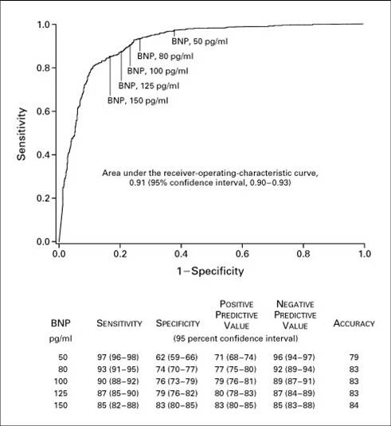
BNP, X?
From Maisel AS, Krishnaswamy P, Nowak RM, McCord J, Hollander JE, Duc P, et al. Rapid measurement of B-type natriuretic peptide in the emergency diagnosis of heart failure. N Engl J Med. 2002;347(3):161-7, reprinted with permission

Posterior Probability for Multi-level tests
LRs for the results of multilevel tests like this are combined with prior odds to get posterior odds the same way as for dichotomous tests. (In fact, we already snuck in an example of this in Chapter 2, Example 2.2, when we used the LR of 100 for a mammogram read as “suspicious for malignancy.”)
Example 3.1 Assume the pre-test probability of infection in a newborn infant is 0.01 (as might be the case in an infant who had a rapid heart and respiratory rate and whose mother had a high fever while in labor). What would be the posterior probability if the WBC count were 17,000/μL?
1. Convert prior probability to prior odds. Odds = P/(1 − P); because prior probability was 0.01, prior odds = 0.01/(1 − 0.01) = 0.010/.99= 0.0101. (When prior probability is this low, converting to odds makes little difference.)
2. Find the LR corresponding to the result of the test. From Table 3.4, the LR for 15,000 to <20,000/μL is 0.41.
3. Obtain the posterior odds by multiplying the prior odds times the LR. Posterior odds = 0.0101 × 0.41 = 0.0041.
4. Convert posterior odds back to posterior probability. P = Odds/(1 + Odds). So this is 0.41(1 + 0.0041) = 0.0041, or about 0.4%.
Example 3.2
When adults present to the emergency department with sudden onset of shortness of breath, one possibility is a blood clot in the lungs, or pulmonary embolus (PE). Although the definitive diagnosis (more or less) is obtained by computed tomographic pulmonary angiogram (CTPA), a blood test called D-Dimer is available that may be sufficiently reassuring to avoid the CTPA in subjects whose prior probability is low or moderate.
Based on pooled data from 5 PE diagnostic management studies [7], LRs for D-Dimer in 4 intervals are
D-Dimer (ng/mL) | Interval LR
>1500 | 4
1000 - 1499 | 1
500 - 999 | 0.4
<500 | 0.04
Consider a patient with a moderate prior probability of PE of 0.14. Figure 3.7 shows an “X” at the point on the scale representing the prior probability of 0.14. We can visualize test results as arrows with a direction and length. The direction is to the left if the LR is <1 and to the right if it is >1. The length depends on how far the LR is from 1. It is on a logarithmic scale, so an LR of 10 has the same length as an LR of 0.1 (see Appendix 3.1). In Figure 3.8, the arrows above the scale show how the posterior probability of PE would change with different results on the D-Dimer.

> 1500 ng/mL
LR=4 ------------------>

1000 – 1499 ng/mL
LR=1 |

500 -999 ng/mL
LR=0.4 <------------

< 500 ng/mL
LR=0.04 <-----------------------------------------

---------|----------------------------|-----------X-----------------|-----
| | | | | | | | | | | |
.005 | .01 .02 .03 .05 .1 | .2 .3 | .5
.006 .14 .39
PROBABILITY

3.8. Likelihood ratios for D-Dimer results. The length and direction of the arrows are proportional to the log of the LR. >1500 ng/mL, LR=4; 1000-1499 ng/mL, LR=1; 500-999 ng/mL, LR=0.4; <500 ng/mL, LR=0.04. The pre-test probability is 0.14.
For example, a D-Dimer in the interval 500-999 ng/mL (LR = 0.4) decreases the probability to 0.06. In our patient with a prior probability of PE of 0.14, you can see that his posterior probability could go as low as about 0.006 or as high as 0.39, depending on the results of the D-Dimer (Figure 3.8).
Note that, in the WBC count and D-Dimer examples above, there are as many LRs as there are test results (actually test-result intervals), and there is no LR(+) or LR(−). If you have the result of a multilevel test, and you find yourself looking for the LR(+) or the LR(−) associated with that test result, you need to revise your thinking.

Optimal cut-off between positive and negative for a multilevel test
The foregoing discussion argued that dichotomizing a multilevel or continuous test by choosing a fixed cut-off to separate positive from negative results entails a loss of information. However, for expediency, we still sometimes choose a cut-off for a continuous diagnostic test to separate abnormal from normal. Examples of cut-offs that separate “positive” from “negative” test results include the body temperature (typically 38.5°C) that identifies intravenous drug users to admit for an endocarditis work-up and the plasma glucose level (typically 180 mg/dL at 1 hour) that defines glucose intolerance in pregnancy.
The purpose of dividing a clinical population into higher risk and lower risk groups is to provide differential care: hospitalization for intravenous drug users with fevers; and diet or insulin therapy for pregnant women with glucose intolerance. However, as we learned in Chapter 2, costs are associated with both types of misclassification. These can be expressed by using C and B from Chapter 2: C = the cost of treating someone with a false positive (a test result that falls on the “high-risk” side of the cut-off value, even though the patient will not benefit from treatment); B = the cost of not treating someone with a false negative (a test result that falls on the “low-risk” side of the cut-off, even though the patient would benefit from treatment). The optimal cut-off exactly balances expected misclassification costs. (As always, we use the term “cost” synonymously with “regret” and intend it to include much more than monetary cost.)
Example 3.2 is about using the D-Dimer blood test result to guide ordering of CT pulmonary angiogram (CTPA) in emergency department patients at moderate risk for pulmonary embolism (PE). We want to know the D-Dimer cut-off above which we will order the CTPA (and below which we will forgo the CTPA). The first question to ask is about the consequences of error. On how many patients without PE are we willing to obtain an ultimately unnecessary CTPA (which entails exposure to intravenous contrast and ionizing radiation) in order to avoid not getting a CTPA on a patient who does have PE? Based on calculations by Lessler et al [8], we will assume the answer is 30, that is C:B = 1:30. This corresponds to a probability of 1/31 or 0.032. We want to obtain CTPA for post-D-Dimer probability of PE ≥ 0.032 and forgo CTPA for post-D-Dimer probability < 0.032. We also need to know the pre-D-Dimer probability of PE. In Example 3.2, we said moderate risk was roughly 0.14 [9]. Figure 3.8 shows that, starting with a pre-test probability of 0.14, only a D-dimer < 500 ng/mL yields a post-D-Dimer probability below 0.03. So for a patient with moderate probability of PE, the D-Dimer threshold for getting a CTPA is 500 ng/mL.
What about a patient with a low pre-D-dimer probability of 5%? Now, a D-dimer in the interval 500-999 ng/mL results in a post-D-Dimer probability of < 0.032. (Figure 3.9) So for a patient with a low probability of PE, the D-Dimer threshold for getting a CTPA is 1000 ng/mL. Several authors have proposed using a D-Dimer threshold of 1000 ng/mL when pre-D-Dimer probability PE is low.[10, 11]

> 1500 ng/mL
LR=4 ------------------>

1000 – 1499 ng/mL
LR=1 |

500 -999 ng/mL
LR=0.4 <------------

< 500 ng/mL
LR=0.04 -------------------------------

-----------------------|------------X-----------------|-------------------
| | | | | | | | | |
.005 .01 .02 .03 .05 .1 |.2 .3 .5
.17
PROBABILITY

Figure 3.9. Post-test probabilities for D-Dimer in different intervals starting with a pre-test probability of 0.05 instead of 0.14 as in Figure 3.7. The length and direction of the arrows are proportional to the log of the LR.

Mathematically, the optimal cut-off r* is the least abnormal r, such that
Pretest Odds × LR(r*) ≥ Threshold Odds (C/B)
As the pre-test probability of disease decreases, the optimal cut-off increases (is more abnormal).

ROC curves and optimal cut-offs
You cannot use an ROC curve alone to choose the best cut-off for a multilevel or continuous test. Substituting P/(1 − P) for pretest odds and C/B for threshold odds, the optimal cut-off r* is the least abnormal r, such that
[P/(1 − P)] × LR(r*) ≥ C/B
Because the LR is the slope of the ROC curve at a particular point, LR(r) may be obtained from the ROC curve. But, the optimal cut-off also depends on the pre-test probability (or odds) of disease and the ratio of misclassification costs, neither of which is depicted in the ROC curve.
Occasionally, someone suggests that the optimal cut-off is the point where the slope of the ROC curve is 1 [i.e., 45°, LR(r*) = 1]. This will only be true if the pre-test odds of disease P/(1 − P) are equal to the treatment threshold odds C/B. For example, if failing to treat a D+ individual is thirty times worse than treating a D− individual unnecessarily and the pre-test odds of disease happen to be 1:30, then the optimal cut-off is where the slope of the ROC curve is 1. This would also be true if misclassification costs were equal (B = C) and the pre-test odds of disease were 50:50. These situations are uncommon, however, so it is seldom true that the optimal cut-off is the point on the ROC curve where the slope is equal to 1.
Equivalent to suggesting that the optimal cutoff r* is where the LR(r) = 1, is suggesting that the optimal cutoff r* is the cutoff that maximizes Youden’s Index: Sensitivity + Specificity - 1. Of course that will also be the point that maximizes Sensitivity + Specificity. Since there is nothing in this process about pre-test probability or threshold odds (C/B), this also is not a valid way to calculate the optimal cutoff.
Another suggestion is to use the point on the curve closest to the upper left-hand corner where sensitivity = 100% and specificity = 100% (1-specificity = 0%). This is called the “Euclidean” or “analytic” method. It is equivalent to minimizing the sum of the squares of (1-sensitivity) and (1-specificity). Again, this calculation fails to account for pre-test probability and misclassification costs, so it generally will not be the optimal cutoff.

Regret Graphs and Multi-Level Tests
In Chapter 2, we introduced a regret graph that showed the expected cost associated with a test/treatment strategy depending on the pre-test probability of disease P(D+). There were only 3 strategies: no treat, test, and treat. One way to look at a multilevel test is to view it as many dichotomous tests, one for each potential cutoff. We return to low WBC count as a test for bacterial infection in a 6-hour-old baby. Requiring a WBC count < 5,000/uL before you treat means you are less worried than requiring a WBC count < 10,000/uL. Figure 3.10 shows expected cost based on pre-test probability for 5 strategies: no treat; test with cutoff < 10 (treat only if WBC count < 10,000/uL); test with cutoff < 15; test with cutoff < 20; treat.

Figure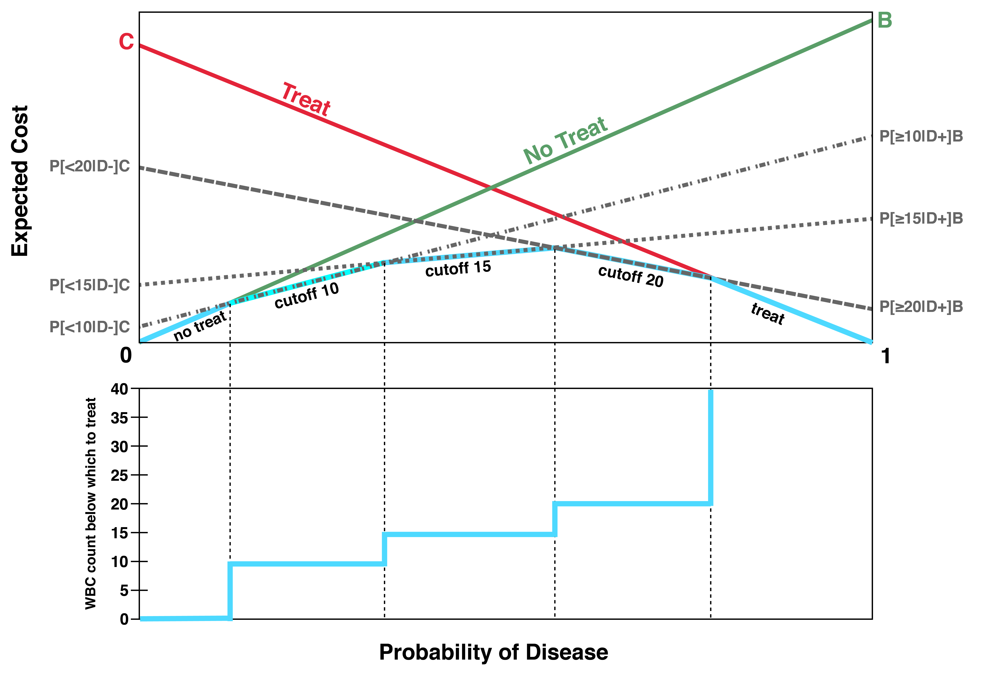 Figure 3.10. Top panel: Expected costs of the “test” strategy using various cutoffs to distinguish positive from negative results. WBC values are in 1000's per uL. Bottom panel: Optimal WBC threshold at which to treat as a function of prior probability of disease. Note for visual clarity Martina has drawn this with B = 1.1 × C, but in clinical practice B would be > 100 × C.

To understand Figure 3.9, recall that the lowest expected cost strategy is the most desirable. Start at the far left end of the probability axis (the x axis) where probability of disease is 0. You can see that, for a range of very low probabilities, the lowest cost strategy is “no treat”, that is, do not even test. Then for another interval of low probabilities, the optimal strategy is to test using a cutoff of 10; you would treat for a WBC count < 10,000/uL. As you move rightward on the axis and the probability of disease increases the WBC cutoff increases to 15 and then 20. Finally, at the far right end of the axis, the probability of disease is so high that you should treat without testing.

As the probability of disease increases, the optimal WBC cutoff increases from 0 (don’t test, don’t treat) to infinity (don’t test, treat). This is shown in the bottom panel of Figure 3.9. The discrete steps in Figure 4.14 result from dividing the continuous range of WBC counts into discrete intervals (0 to <5, 5 to <10, 10 to <15, 15 to <20). Of course, nothing magical happens at the round numbers of 10, 15 and 20,000 WBC/uL. For a similar discussion using smooth curves, see [12].

Although Figure 3.9 does use the sensitivity/specificity data from Table 3.3, for purposes of illustration, we have assumed that the cost of failing to treat a newborn with bacterial infection is only slightly higher than the cost of treating unnecessarily (B = 1.1 × C). If we had used a realistic misclassification cost ratio, the entire graph would be concentrated between pre-test probabilities of 0.00 and 0.03.

Summary of key points
1. For tests with more than two possible results, making a test dichotomous by choosing a fixed cut-off to separate “positive” from “negative” wastes information. Some positive results will be more abnormal than others, and some negative results will be more normal than others.
2. The distribution of test results among those who do and do not have the disease can be presented graphically using an ROC curve.
3. ROC curves allow visualization of the trade-off between sensitivity and specificity as the cut-off for classifying a test as positive changes. They also allow visualization of the LRs for different test results, because the slope of the ROC curve is the LR.
4. The Area Under the ROC Curve (AUROC) provides a summary of how well the test discriminates between those who do and do not have the disease.
5. The LR associated with a particular result on a multilevel or continuous test is the probability of that result in people with the disease divided by the probability of that result in people without the disease. Because nondichotomous tests have more than two possible results, they have more than two LRs.
6. In an individual patient with an individual test result, post-test odds of disease equal pre-test odds multiplied by the LR associated with the test result.
7. The optimal cutoff for considering a test positive and therefore treating the patient will depend on the prior probability of the disease as well as the relative costs of false-positives (C) and false negatives (B).

Appendix 3.1: Logarithms and the likelihood ratio slide rule

How does the LR slide rule work?
The LR slide rule relies on the idea that multiplying two numbers (e.g., the pre-test odds and the LR of a test result) is the same as adding their logarithms. This requires a brief review of logarithms.

Mathematical digression: logarithms
Recall that the common or base-10 logarithm of a number is defined as the power to which 10 is raised to get that number. log(a) = b, where a = 10^{b} : log(100) = 2, log(10) = 1, log(1) = 0, log(0.1) =−1, log(0.01) =−2. If you multiply two numbers, x and y, the logarithm of the product is the sum of the logs: log(xy) = log(x) + log(y). For example, log(10 × 100) = log(10) + log(100) = 1 + 2 = 3. Similarly, if you divide two numbers, the logarithm of the quotient is the difference of the logs: log(x/y) = log(x) − log(y). For example, log(10/100) = log(10) − log(100) = 1 − 2 =−1.
Practice Problems:
1. log(2) = 0.3. What is log(5)?
2. log(3) ≈ 0.5. What is log(1/3)?
Answers:
1. 5 = 10/2, so log(5) = log(10/2) = log(10) − log(2) = 1 − 0.3 = 0.7
2. log(1/3)) ≈−0.5
Natural logarithms
Just as common logarithms are base-10 logarithms, natural logarithms are base-e logarithms, where e is the mathematical constant 2.7183 ... ln(a) = b, where a = e^{b}. The change of base from 10 to e affects the actual numerical value of the logarithm, but nothing else: ln(xy) = ln(x) + ln(y); ln(x/y) = ln(x) − ln(y).
Natural logarithms are “natural” when you are interested in percentage rather than absolute differences, because (x₁ – x₀)/x₀ ≈ ln(x₁/x₀ ) = ln(x₁) – ln(x₀) . For example, if you are more interested in the percentage change in BNP (Box 3.2), a 12.5% increase from 200 to 225 pg/mL should be the same as an increase from 800 to 900 pg/mL.
ln(225) – ln(200) = ln(900)-ln(800) = 0.117
Note that 0.117 is somewhat close to the percentage change of 0.125. The difference in base-10 logarithms would be 0.051.

log(Odds)
You have already become comfortable dealing with odds instead of probabilities. You did this because of the simple relationship between pre-test odds and post-test odds. Now you need to get comfortable with the logarithm of odds, log(Odds), instead of the odds themselves. By taking the logarithms, we can convert the equation for post-test odds from multiplication to addition:
Post-Test Odds = (Pre-Test Odds) × (Likelihood Ratio of Test Result)
Taking logarithms,
log(Post-Test Odds) = log(Pre-Test Odds) + log(Likelihood Ratio of Test Result)
In Example 3.2, we discussed a patient with a 0.14 pre-test probability of pulmonary embolism and a D-Dimer > 1500 ng/mL. The LR associated with that result is 4. Let us calculate the post-test probability using logarithms and show you how this helps to visualize the process of probability updating.
1. Convert prior probability to prior odds. Odds = P/(1 − P). Because prior probability is 0.14, prior odds = 0.14/(1 − 0.14) = 0.14/0.86 = 0.16.
2. Convert prior odds to log(Odds): log(0.16) = −0.79.
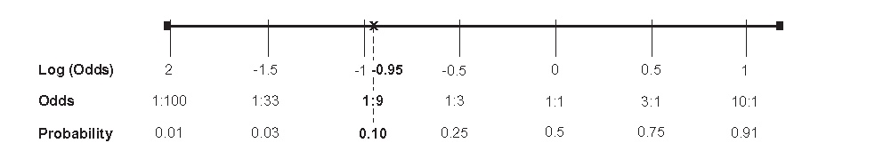
3. Find the log(LR) corresponding to the result of the test. The LR for a D-Dimer > 1500 ng/mL is 4, and log(4) = 0.6.
4. Obtain the posterior log(Odds) by adding the log(LR) to the prior log(Odds): Posterior log(Odds) =−0.79 + 0.60 = −0.19.
5. Convert posterior log(Odds) back to posterior Odds: 10^{−0.19} = 0.65
6. Convert Odds to probability: 0.65/(1 + 0.65) = 0.39.
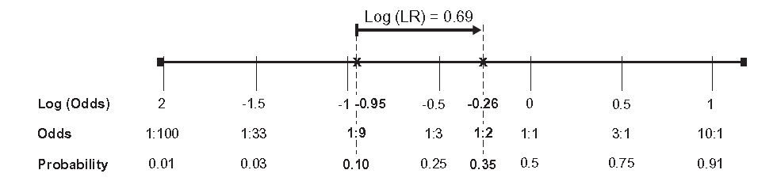
The key advantage of the log(Odds) scale is our ability to display probability updating as a problem of addition. We just lay the back end of the log(LR) arrow at the pre-test probability, and the arrow tip points out the post-test probability.
The LR slide rule does the conversion between log(Odds) and probability for you by spacing the probabilities according to the logs of their corresponding odds.

References
1. Newman TB, Puopolo KM, Wi S, Draper D, Escobar GJ. Interpreting complete blood counts soon after birth in newborns at risk for sepsis. Pediatrics. 2010;126(5):903-9.
2. Swets JA. Signal detection theory and ROC analysis in psychology and diagnostics : collected papers. Mahwah, N.J.: L. Erlbaum Associates; 1996. xv, 308 p.
3. Hanley J, McNeil B. The meaning and use of the area under a Receiver Operating Characteristic (ROC) curve. Radiology. 1982;143:29-36.
4. Bonsu BK, Harper MB. Utility of the peripheral blood white blood cell count for identifying sick young infants who need lumbar puncture. Ann Emerg Med. 2003;41(2):206-14.
5. Maisel AS, Krishnaswamy P, Nowak RM, McCord J, Hollander JE, Duc P, et al. Rapid measurement of B-type natriuretic peptide in the emergency diagnosis of heart failure. N Engl J Med. 2002;347(3):161-7.
6. Kohn MA, Steinhart B. Broadcasting Not Properly: Using B-type Natriuretic Peptide Interval Likelihood Ratios and the Results of Other Emergency Department Tests to Diagnose Acute Heart Failure in Dyspneic Patients. Acad Emerg Med. 2016;23(3):347-50.
7. Kohn MA, Klok FA, van Es N. D-dimer Interval Likelihood Ratios for Pulmonary Embolism. Acad Emerg Med. 2017;24(7):832-7.
8. Lessler AL, Isserman JA, Agarwal R, Palevsky HI, Pines JM. Testing low-risk patients for suspected pulmonary embolism: a decision analysis. Ann Emerg Med. 2010;55(4):316-26 e1.
9. Wolf SJ, McCubbin TR, Feldhaus KM, Faragher JP, Adcock DM. Prospective validation of Wells Criteria in the evaluation of patients with suspected pulmonary embolism. Ann Emerg Med. 2004;44(5):503-10.
10. Char S, Yoon HC. Improving appropriate use of pulmonary computed tomography angiography by increasing the serum D-dimer threshold and assessing clinical probability. The Permanente journal. 2014;18(4):10-5.
11. Kline JA, Hogg MM, Courtney DM, Miller CD, Jones AE, Smithline HA. D-dimer threshold increase with pretest probability unlikely for pulmonary embolism to decrease unnecessary computerized tomographic pulmonary angiography. Journal of thrombosis and haemostasis : JTH. 2012;10(4):572-81.
12. Kohn MA, Newman MP. What white blood cell count should prompt antibiotic treatment in a febrile child? Tutorial on the importance of disease likelihood to the interpretation of diagnostic tests. Med Decis Making. 2001;21(6):479-89.

This may take some getting used to for some readers, but besides being clinical reality, it makes the ROC curve easier to draw; see next section
The question was whether a blip on the radar screen represented a true signal (e.g., an airplane) or “noise.” If a radar operator tried to raise his proportion of true signals identified, he also increased his number of false calls. In other words, lowering the threshold for identifying a signal increased sensitivity but decreased specificity.
This is also sometimes denoted “c” and corresponds to the “c” statistic used to assess the predictive accuracy of a multiple logistic regression model.
ln(1+x) ≈ x for x near 0. We will see this again in Chapter 11 when we discuss the “Rule of 3”.
This log-odds form of Bayes’s Rule was preferred by Alan Turing when deciphering the Enigma messages in 1941 and subsequently by E.T.Jaynes. (Jaynes, E. T. and G. L. Bretthorst (2003). Probability theory : the logic of science. Cambridge, UK ; New York, NY, Cambridge University Press. P. 116.

