4. Critical appraisal of studies of diagnostic test accuracy

Introduction
We have learned how to quantify the accuracy of dichotomous (Chapter 2) and multi-level (Chapter 3) tests. In this chapter, we turn to critical appraisal of studies of diagnostic test accuracy, with an emphasis on problems with study design that affect the interpretation or credibility of the results. After a general discussion of an approach to studies of diagnostic tests, we will review some common biases to which studies of test accuracy are uniquely or especially susceptible and conclude with an introduction to systematic reviews of test accuracy studies.

General approach
A general approach to critical appraisal of studies of diagnostic tests is to break the study down into its component parts and consider strengths and weaknesses of each, as outlined in Table 4.1.[1]
Study design: All study designs have both strengths and weaknesses. Make sure you understand both the timing of measurements (cross-sectional vs longitudinal) and the sampling scheme (e.g., consecutive sample vs case-control type sample). Watch out for studies of diagnostic tests with a case–control sampling scheme, in which subjects with the disease are sampled separately from those without the disease.
We previously mentioned that the separate sampling of those with and without disease cannot provide information about prior or posterior probability. Another problem is that, because studies with this design do not begin with a population with unknown disease status, they tend to select subjects with a clinically unrealistic spectrum of disease (and non-disease), in many cases including subjects in whom true disease status is more clear-cut than it is in clinical practice (spectrum bias, discussed later in this chapter).
Because the ultimate goal of testing is to improve outcomes by enhancing decision making, the ideal study of a diagnostic test would compare outcomes in patients randomized to receive or not to receive the test. This has been done mainly for screening tests (Chapter 10) or tests used to monitor disease, such as natriuretic peptide as a guide for management of chronic heart failure.[2] In this chapter, we limit our discussion to observational studies of diagnostic test accuracy, assuming that a more accurate test will lead to better treatment decisions and therefore better outcomes. We should be clear, however, that this is an assumption.
Study subjects: As in any clinical research study, the extent to which findings can be generalized depends on how the subjects were sampled for the study. Are the prevalence and severity of the disease (and of diseases that could be confused with it) similar to those in your clinical population? If not, in what direction would the differences change the results?
Index test -- In appraising a study, look at exactly how the index test was done. Are there factors, such as freshness or preparation of the sample, skill of those obtaining the sample, those doing or interpreting the test, or the quality of the equipment used, that might affect the results? If so, in what direction would results be affected?
Table 4.1. Step-by-step critical appraisal of studies of diagnostic test accuracy
Study Component | Examples | Issues for consideration
Study design: Timing of measurements and sampling scheme | • Cross-sectional: used to estimate prevalence of disease. Covered in this chapter. | • Are subjects sampled separately by disease status or by test results?
 | • Cohort: used to estimate the incidence of disease and of other outcomes over time (Chapter 6) | • Was the index test done before, at the same time, or after the gold standard?
 | • Case-control study: people with and without disease sampled separately
 | • Randomized trial: compare those who get the test to those who do not (Chapter 10)
Subjects: How the subjects were identified and selected, and the inclusion and exclusion criteria. | • Emergency department patients with spinal epidural abscess and age- and sex-matched controls with spine pain | • Are the subjects (both with and without disease, if sampled separately) representative of those to whom you wish to generalize the results?
 | • Women 35-75 years old presenting for routine Pap smear | • If not, in what direction will differences alter the results?
Index Test: may also include how the test was done. | • 22q11 microdeletion on chromosome 22 | • How difficult is it to do the test?
 | • Results of Pap smears read by 4 cytology technicians and 5 cytologists at 2 academic medical centers | • If it requires skill or training, will the skill and training of those doing the test in your setting be similar to what was studied?
Gold-Standard Determination of Disease Status: | • Influenza diagnosed by viral culture or 2 consecutive positive Polymerase Chain Reaction (PCR) tests | • Is the gold standard really gold?
 | • Pathological diagnosis of appendicitis | • Is it clinically relevant - i.e., how well does the gold standard correlate with what you really want to know?
 |  | • Were those measuring it blinded to results of the test being evaluated?
Results and analysis: What the authors found at the end of the study. May include whether results vary in different subgroups of patients or by center or examiner. | • Sensitivity, specificity, predictive value, LRs, AUROC curve, all with confidence intervals | • Were all the subjects analyzed, or were some (e.g., those with ambiguous or intermediate results or some with negative results) excluded?
 |  | • If sensitivity, specificity, or LRs were reported for ordinal or continuous tests, were standard cut-offs or intervals used?
 |  | • If predictive value is reported, is the prevalence in the study representative of your patient population?
 |  | • Were confidence intervals for relevant quantities included?
Conclusions: The authors’ conclusions regarding the research question, based on the results of the study. | • Authors’ conclusions often go beyond estimates of test accuracy or reliability and address whether or when the test is worth doing. | • Do you believe the results are true in the population studied (internal validity)?
 |  | • Do you believe they apply to patients you see (external validity)?
 |  | • Did the test provide new information, beyond what was available without the test?
 |  | • Given your estimates of prior probability and the costs of false-positive and false-negative results, do you agree with authors’ conclusions on indications for the test?

Gold standard -- Ideally, measurements of the outcome variable should be made by people blinded to the result of the predictor variable, although as will be discussed later, this is not always practical.
Results – Test accuracy is usually presented using the parameters described in Chapters 2–3, sensitivity, specificity, ROC curves, likelihood ratios, etc. Because there is a trade-off between sensitivity and specificity, watch for studies that only highlight one or the other; any test can be 100% sensitive if specificity can be zero or 100% specific if sensitivity can be zero. These parameters should be accompanied by confidence intervals to quantify the precision of the estimates. We will discuss confidence intervals at length in Chapter 11; for now, we will just say that they show the range of values consistent with the study results.
Conclusions -- If a study concludes that a test is useful, pay particular attention to limitations in its methods that would tend to make the test look falsely good. On the other hand, studies that conclude a test is not useful should be scrutinized for biases that will make the test look worse in the study than it might be in practice.
Conclusions about usefulness of tests often require information and judgments that go far beyond the results of the study. For example, a study that estimates only sensitivity and specificity may conclude that a test is or is not worth doing when the answers to that question depend on the prior probability of the disease, the cost of the test, and the consequences of false-negative and false-positive results, all of which may vary in different populations and may depend on which decision the test is supposed to help with. History and physical examination findings, for example, may not be sufficiently accurate to determine treatment, but may be sufficient to tip the balance toward or away from additional tests. An example of this is provided in Box 4.1.
Box 4.1: Example of step-by-step appraisal of a diagnostic test study
As described in Problem 1.4, women with breast cancer often have lymph nodes removed and checked for cancer to assist in staging and to guide treatment decisions. Recent developments in microscopic image scanning have allowed the digitization of pathology slides and the possibility of using computers to read the microscope slides. Bejnordi et al[3] reported results of a contest to develop automated methods for detecting breast cancer metastasis in sentinel lymph nodes. Their research question was how the accuracy of diagnoses from these automated "deep learning" algorithms would compare with the accuracy of pathologists.
The study design was cross sectional.
The subjects were (one slide each from) 399 women undergoing breast cancer surgery at 2 hospitals in the Netherlands. The investigators randomly divided the 399 slides into training (N=270) and test (N=129) sets. They provided the training sets to the contestants; all reported results are from the test set.
The index tests were blinded interpretations of 11 pathologists on a 5-point scale (from "definitely normal" to "definitely tumor") and 32 machine-learning algorithms submitted by 23 teams, which rated the estimated probability of cancer on each slide (from 0 to 1). The 11 pathologists were asked to attempt to review the 129 slides in about 2 hours, which was felt to be clinically realistic, but they were allowed to take longer; the median actual time spent was 120 minutes (range, 72-180 minutes). In addition, a pathologist "without time constraint" spent a total of 30 hours looking at the 129 slides.
The reference standard was the judgment of 1 of 2 expert study pathologists if an "obvious" metastasis was seen or immunohistochemistry in all other (negative and difficult) cases.
Results: Forty-nine of the 129 samples were positive for cancer according to the reference standard. The best algorithm (from Harvard Medical School and the Massachusetts Institute of Technology) had an AUROC of 0.994; the average AUROC of the top 5 algorithms was 0.960. For the 11 pathologists urged to finish in about 2 hours the average AUROC was 0.810 (range 0.738-0.884) and for the pathologist who spent 30 hours reviewing the slides the AUROC was 0.966.
The authors concluded that some deep learning algorithms were more accurate than the pathologists "participating in a simulation designed to mimic routine pathology workflow," but that similar studies in a clinical setting are needed to evaluate clinical utility.
Critical appraisal: This study provides an impressive proof of concept. These sorts of deep learning algorithms have also shown promise for diagnosing diabetic retinopathy[4] and possibly cancerous skin lesions.[5] Approaching the study systematically, the cross-sectional design was appropriate. The authors do not provide much information about the subjects whose nodes were studied so we don't know much about the spectrum of disease and nondisease included. However, in order to invalidate their conclusions, the spectrum could not just be towards slides that were exceptionally easy or difficult to classify. To invalidate their conclusions the spectrum would have to be unrealistically hard for humans but easy for algorithms. The fact that the human pathologist who spent 30 hours got almost all of them right suggests this was not the case.
Part of the index test in this case is the slide preparation, hence the authors provided details on the instruments, magnification, pixel size, etc. used to create the slides. This is important, because the performance of the machine learning algorithms is likely dependent on the quality of the images they are evaluating, and it is likely that they used state-of-the-art technology that may not yet be widely available. Also, many of the algorithms performed poorly; it seems that since the authors averaged results of all of the pathologists but only the 5 best algorithms, the two averages are not truly comparable.
The reference standard was not entirely objective, since a human pathologist judged whether obvious metastases were present. If this is an imperfect gold standard, then it appears that both the errors of the best algorithms and of the pathologist without time constraint closely match the errors of the reference standard, given the AUROCs >0.99 that were achieved. Such correlated errors would be expected, given that the training set would have had the same errors.
Bottom Line: This is both an impressive computing feat and a sobering reminder of the imperfection of human pathologists who normally operate under time constraints. We are likely to see many more such studies in the future. We need to be clear on what decision the tests are intended to guide to determine the value of any increment in accuracy. In this case, it may be that, if it's not worth doing, it's not worth doing well. As described in problem 1.4, once one knows the genetic signature of the primary tumor, the additional prognostic information that can be obtained from examining lymph nodes may be limited, even if the presence of cancer therein could be determined with 100% accuracy.

Important biases for studies of diagnostic test accuracy
The general approach outlined above should help you appraise most clinical research studies of diagnostic tests. In this section, we turn to potential problems that are either unique or particularly important to studies of diagnostic test accuracy. Five important biases in studies of diagnostic test accuracy are incorporation bias, partial verification bias, differential verification bias (double gold standard bias), imperfect gold standard bias, and spectrum bias. These five biases tend to affect the estimates of sensitivity, specificity, and positive and negative predictive value (PPV and NPV) in different but predictable directions, as summarized in Table 4.2. For a discussion focused on examples from emergency medicine, see Kohn et al.[6]

Incorporation bias
In order for a study of a diagnostic test to be valid, the index test must be compared with an independent gold standard. If the gold standard is in any way subjective, it must be applied by observers blinded to the index test results. It is surprisingly common for the index test to be incorporated into the gold standard, leading to falsely high estimates of both sensitivity and specificity. For example, a recent systematic review examined the accuracy of serum amylase and lipase (among other tests) for the diagnosis of acute pancreatitis.[7]. The authors included 10 studies, but found that five were at unclear risk of bias and 5 at high risk of bias due to lack of blinding and/or choice of the reference standard. A commonly used reference standard for pancreatitis was the consensus conference definition, [8] which required presence of at least 2 of 3 features, one of which was either an amylase or lipase level more than three times the upper limit of normal! Obviously, if you are assessing a test’s ability to detect disease, and you define disease partly by a positive test, the test is likely to look good. This does not mean that studies susceptible to incorporation bias are useless. Sometimes, despite the possibility of this bias, a test still does not look very good, in which case the results can be believed.
Sometimes the gold standard that determines disease status is review of clinical information by an expert or panel of experts. We include with incorporation bias the failure to blind the reviewers to the results of the index test, which is also referred to as review bias. In Box 3.2, we mentioned a study by Maisel et al [9] of B-type natriuretic peptide (BNP) as a test for acute heart failure. The gold standard was the consensus diagnosis of two cardiologists who were blinded to the BNP and emergency department diagnosis but who reviewed the patient’s medical records, including the chest x-ray. The chest x-ray was not the index test that the study was designed to evaluate, but the authors incidentally reported on its ability to predict heart failure. Since the reviewers who determined whether the patient had congestive failure were not blinded to the chest x-ray, it is not surprising that “the best clinical predictor of congestive heart failure was an increased heart size on chest roentgenogram [x-ray].” The cardiologists incorporate the chest x-ray into their “gold standard.”
Studies of test accuracy that use the treating physician’s final diagnosis as the gold standard would be subject to incorporation bias if the physician could have used the index test to help determine the final diagnosis. For example, studies of the accuracy of regional wall motion abnormalities on the emergency department echocardiogram for acute cardiac ischemia generally accept the clinician’s diagnosis of “unstable angina” as the gold standard. [10] This means that the diagnostic accuracy (sensitivity and specificity) of the emergency department echocardiogram is overestimated since its result undoubtedly contributed to the final diagnosis of acute ischemia versus another condition. A study of test accuracy that uses the clinician’s diagnosis as the gold standard actually answers a different question: how well does the test result predict the diagnosis of disease? These studies may conflate doctors’ understanding of the disease with the accuracy of the test.

Table 4.2. Biases in Studies of Diagnostic Test Accuracy
Bias Type | General description | Specific situations | Sensitivity is falsely… | Specificity is falsely… | Positive Predictive Value is falsely... | Negative Predictive Value is falsely...
Incorpor-ation bias | Classification of disease status partly depends on the results of the index test. Gold standard incorporates the index test. |  | ↑ | ↑ | ↑ | ↑
Partial verifica-tion bias | Patients with positive index tests are more likely to get the gold standard, and only patients who get the gold standard are included in the study. | Given test result, those who get gold standard are similar to those who do not | ↑ | ↓ | Not affected | Not affected
Partial verifica-tion bias |  | Patients with a negative index test who get gold standard are at higher risk | ↑ | ↓ | Not affected or ↑ | Likely ↓
Differential verification bias (aka double gold standard bias) | Patients with a positive index test are more likely to receive one (often invasive) gold standard, whereas patients with a negative index test are more likely to receive a different gold standard (often clinical follow-up). Bias occurs only if there is a subgroup where the two gold standards give different answers. | For disease that can resolve spontaneously. | ↑ | ↑ | ↑ | ↑
 |  | For disease that becomes detectable during the follow-up period. | ↓ | ↓ | ↓ | ↓
Imperfect Gold Standard Bias | The "gold standard" test result does not always represent the true disease state | No correlation in errors between the two tests (conditional independence) | ↓ (If gold standard < 100% specific) | ↓(If gold standard < 100% sensitive) | Variesª | Variesª
Imperfect Gold Standard Bias |  | Errors between the two tests are (positively) correlated | ↑ | ↑ | Variesª | Variesª
Spectrum bias | Spectrum of disease and nondisease differs from clinical practice. Sensitivity depends on spectrum of disease. Specificity depends on spectrum of nondisease or of diseases that might mimic the disease of interest. | When disease is skewed toward higher severity than in clinical practice – “sickest of the sick.” | ↑ | Not affected | Slight ↑^{b} | ↑
Spectrum bias |  | Disease group includes the "wellest of the sick." | ↓ | Not affected | Slight ↓^{b} | ↓
Spectrum bias |  | When nondisease is skewed toward greater health – “wellest of the well.” | Not affected | ↑ | ↑ | Slight ↑^{c}
Spectrum bias |  | Nondisease group includes the "sickest of the well." | Not affected | ↓ | ↓ | Slight ↓^{c}
Spectrum bias |  | Intermediate or ambiguous group not included in the study. | ↑ | ↑ | ↑ | ↑
ª Hard to predict; see text. ^{b} Positive predictive may change because of more true positives, but tends to be much more affected by specificity. ^{c}Negative predictive value change because of more true negatives, but tends to be much more affected by sensitivity.

Partial verification bias
In a study of a diagnostic test, application of the gold standard should not depend on the result of the index test being evaluated. “Partial verification bias” (also known as verification, referral or work-up bias) occurs when people who are positive on the index test are more likely to get the gold standard, and only those who receive the gold standard are included in the study.

Effects on sensitivity and specificity
To understand our partial verification example (and fully appreciate Figure 4.1) you need a little clinical background on jaundice in newborn babies, one of Tom’s favorite topics. Jaundice is due to increased levels of bilirubin, a yellow chemical breakdown product of heme (from hemoglobin). Before birth the mother's liver handles the fetal bilirubin. After birth the baby's own liver may take several days fully to develop that capability. We pay attention to jaundice because very rarely the bilirubin can get high enough to cause brain damage. We typically estimate how high a baby’s bilirubin level is by how far down the baby’s body the jaundice goes (from the head to the feet) and may use that estimate to decide whether to do a blood test.
To estimate the accuracy of these visual jaundice assessments, Moyer et al [11] asked doctors and nurses caring for newborns to estimate how far down the baby’s body the jaundice reached and compared these estimates with the “gold standard” total serum bilirubin level. The authors reported that the sensitivity of jaundice extending below the nipple line for a blood bilirubin level of ≥ 12 mg/dL was 97%, but the specificity was only 19%.
But here’s the hitch. To make the study more feasible, they included newborns only if they were going to get a bilirubin blood test anyway. Because the people deciding whether to do this blood test were making that decision based partly on their examination of the baby, this almost certainly led to under-representation of babies with no or mild jaundice. Thus while the study might have included all of the newborns with jaundice below the nipple line (“positive” test result), those who had no jaundice or milder jaundice (“negative” test result) were almost surely under-represented. Figures 4.1a and 4.1b show how, compared with the results that would have been obtained in a representative sample of newborns, under-sampling those with a negative test result falsely increases sensitivity (due to the shortage of false-negatives) and decreases specificity (due to the shortage of true negatives).

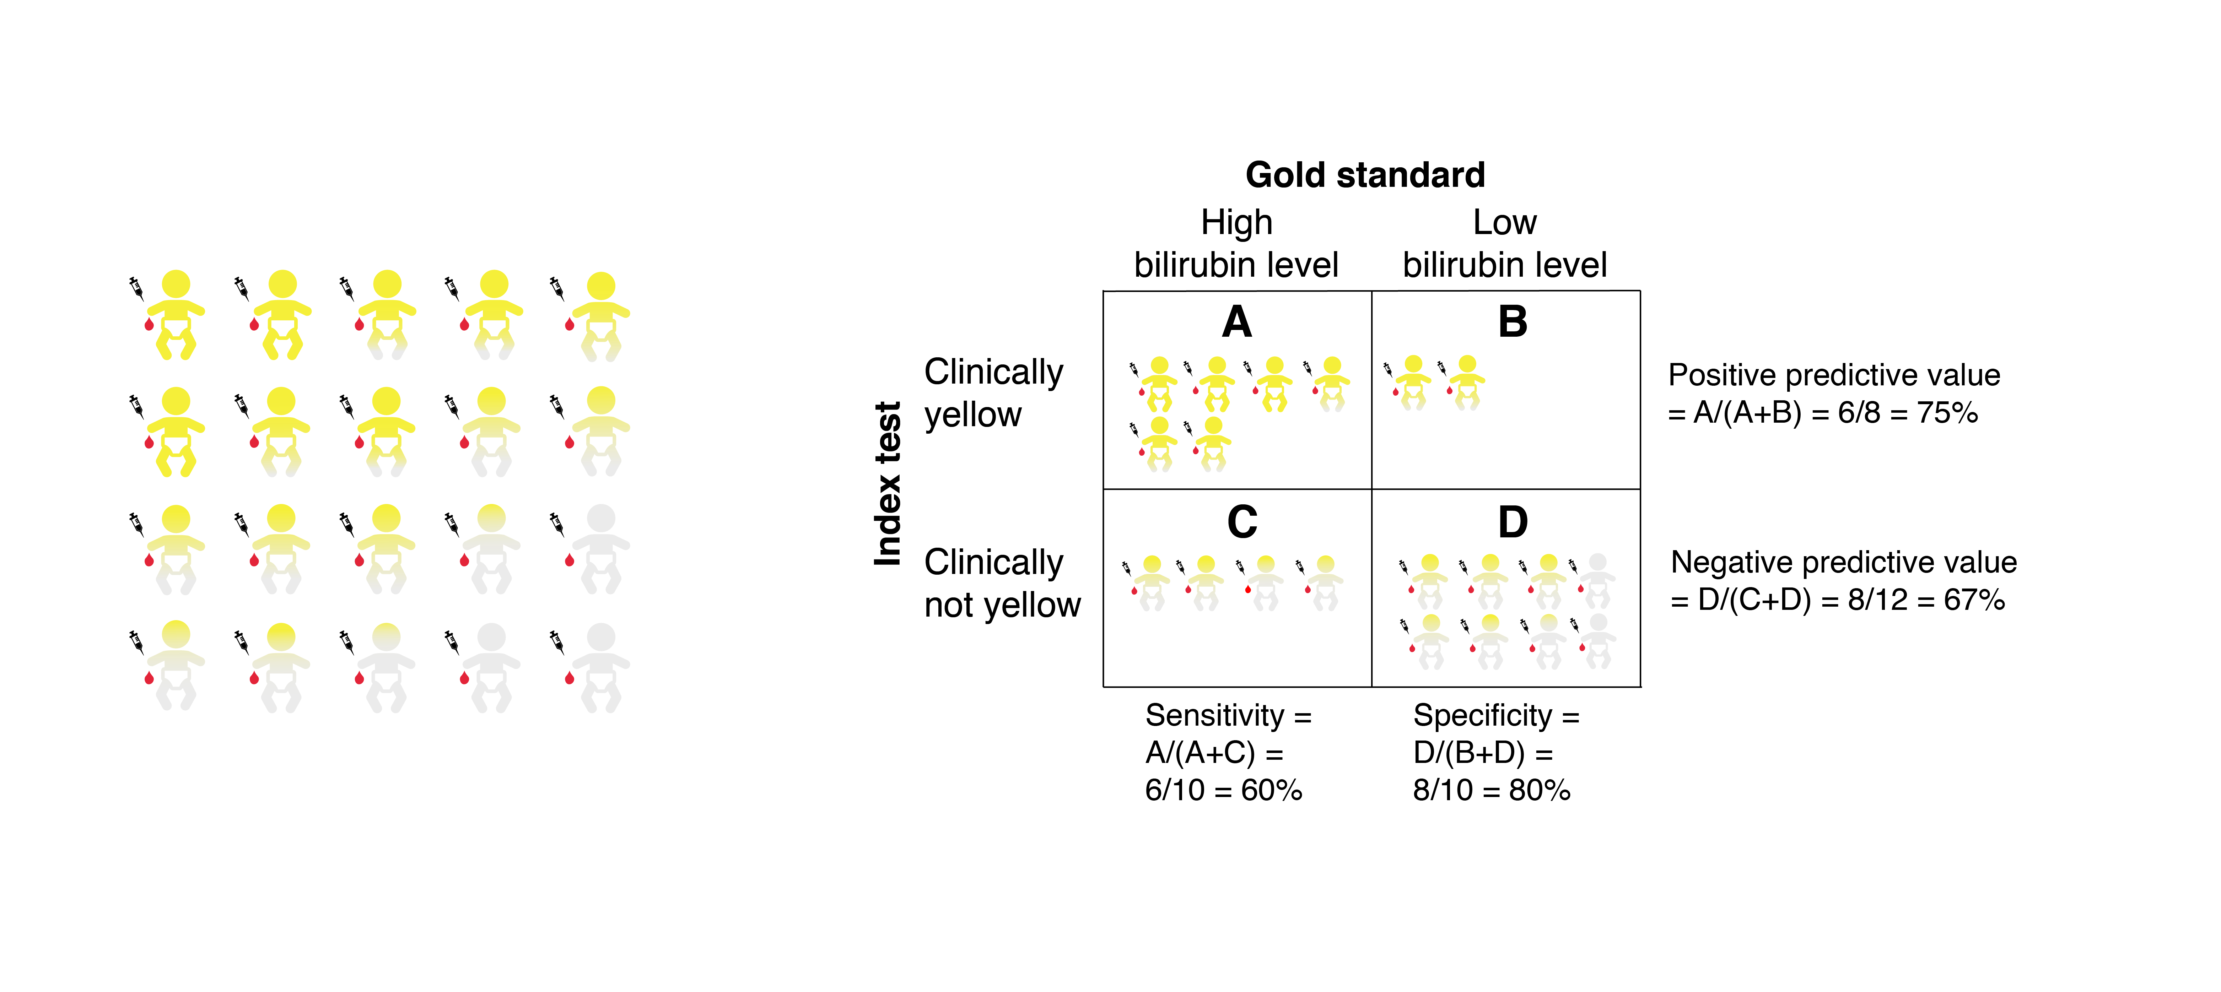
Figure 4.1A. All babies get the bilirubin blood test, regardless of jaundice level. No bias.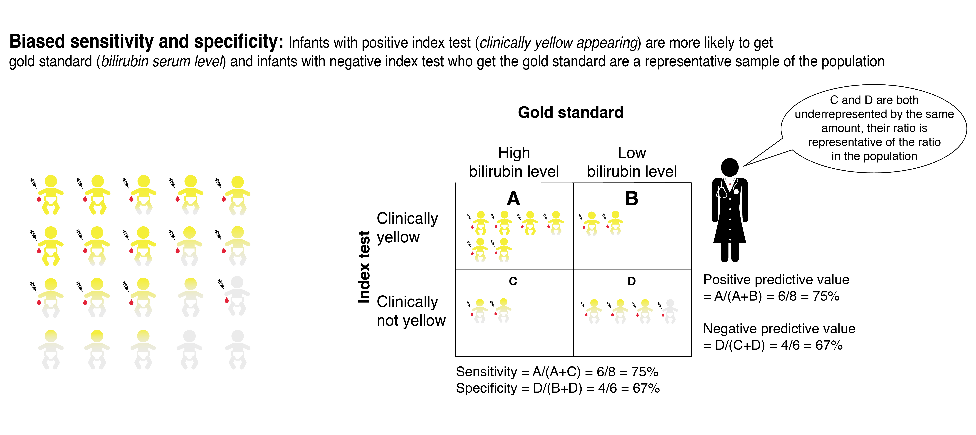Figure 4.1B. All babies with significant jaundice (i.e., a positive index test) get the bilirubin blood test, but only a (representative) sample of those with less or no jaundice (6 of 12) get the blood test. Sensitivity will be biased up and specificity down but predictive values will be unbiased.
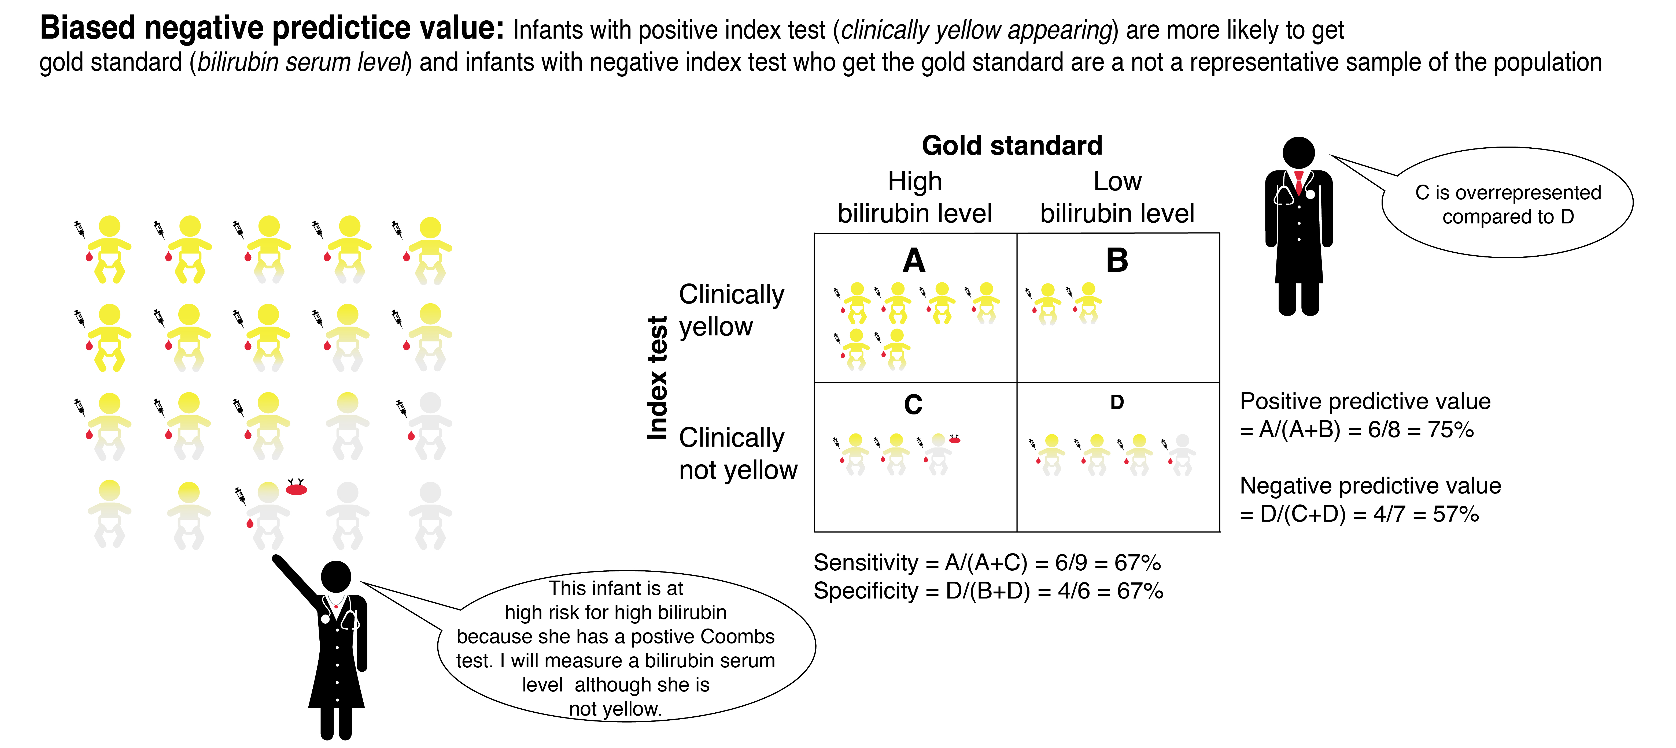
Figure 4.1C All babies with significant jaundice (i.e., a positive index test) get the bilirubin blood test, but those with less or no jaundice who get the blood test may have had another reason (positive Coombs' test). Only positive predictive value is unbiased.
The more the index test affects who gets the gold standard (and hence who is included in the study), the worse the partial verification bias will be. The most extreme example we know is a study of pediatric appendicitis that used the pathologic diagnosis (i.e., microscopic examination of the removed appendix) as the gold standard [12]. That study therefore included only children who had an appendectomy! The 96% sensitivity and only 5% specificity of right lower quadrant (RLQ) pain made that study an outlier compared with more inclusive studies that used other gold standards.[13] The study showed that whether or not they have appendicitis, almost all children who have their appendix removed have RLQ pain. But of course many subjects with no RLQ pain whose treating clinicians therefore thought they did not need to have their appendix out were excluded from the study!

Effects on positive and negative predictive value
If you look at the Test + and Test – (yellow/not yellow) rows of Figure 4.1A and 4.1B, you'll see that positive and negative predictive values were not affected by partial verification bias when entire groups or representative samples of Test + and Test – subjects were studied.

As we discussed in Chapter 2, this separate sampling of T+ and T− subjects is the flip side of the separate "case-control" sampling of D+ and D− subjects. With case-control sampling, we sampled the 2 columns separately. We were able to obtain valid results within columns (sensitivity and specificity), but not across columns (positive and negative predictive value) directly from the 2 × 2 table. However, we showed (Example 2.1) that if we know the prior probability we can use it to obtain the D+ and D− column totals of a 2 × 2 table that reflects the underlying population. We can then use sensitivity and specificity to get the interior cells of the 2 × 2 table, and thereby estimate positive and negative predictive value.

We can do the same thing if we sample T+ and T− separately. If we know what proportion of the target population is T+, we can use that proportion to fill in the T+ and T− row totals of a 2 × 2 table, then use the PPV and NPV to get the individual cells of that table, as in Problem 2.5 (the one about the Rapid Screening Tool for heritable breast cancer). Then, because the T+ and T− totals are now in their proper proportions, we can use the numbers in the D+ and D− columns to obtain sensitivity and specificity. In the example shown in Figure 4.1 Panel B, if we know we took a 50% random sample (6 of 12) of the subjects with mild jaundice, we could undo this verification bias in our estimates of sensitivity and specificity by doubling the numbers in that test-negative row. That would get us back to our original 2 × 2 table, and then allow us to calculate sensitivity and specificity.

What if (as is more commonly the case), the T+ and T− subjects for a study were not randomly sampled from all T+ and T− subjects, but instead were a convenience sample based on having received the gold standard? Now we have a problem, because the PPV and NPV measured from the study will be suspect. How suspect? It depends on what other (nonrandom) factors led to some T+ and T− subjects getting the gold standard (and hence being included in the study).

The most common situation is that the T− subjects who got the gold standard differed from those who did not because they had some other reason to suspect the disease. This is illustrated in Figure 4.1C. A risk factor for neonatal jaundice is increased destruction of the baby’s red blood cells due to the presence of maternal antibodies. A test for this is the Coombs’ test (shown in Figure 4.1C as a red blood cell with antibodies on it). So one reason why a baby without much jaundice might get a bilirubin blood test is if the doctor knew that the baby had a positive Coombs test. Such babies also would be more likely to have a high bilirubin level. In general, we would expect that if the T− group is not representative, it will be because the prior probability in the T− group included in the study is likely to be higher than in the T− group as a whole. Because a higher prior probability leads to lower NPV (Chapter 2), we would expect the reported NPV to be falsely low.

Less commonly (and not shown in Figure 4.1), if the T+ subjects did not all get the gold standard, we might want to ask why not? Was there some other aspect of the history, physical exam or laboratory evaluation that made treating clinicians believe the T+ result was a false positive, and therefore that the patient did not need the gold standard test? (In the case of a jaundiced newborn, maybe the baby was equally jaundiced the day before, and a bilirubin level on that day was fine.) In that case the prior probability (and hence PPV) estimated by the study will be too high. Alternatively, were those findings so indicative of disease that the gold standard test was believed to be unnecessary once the patient was T+? That situation would make the prior probability (and hence PPV) too low. Or maybe both of these phenomena occur, and their effects cancel out!

The bottom line is that unless the samples of T+ and T− subjects who receive the gold standard are representative of the underlying T+ and T− populations (e.g., due to consecutive or random sampling), the only way to estimate the degree and direction of an effect of partial verification bias on PPV and NPV is to have some understanding of the factors that led to some T+ and T− subjects and not others getting the gold standard test (and hence being included in the study).

Differential verification (aka double gold standard) bias
A bias related to partial verification bias occurs when two distinct gold standards exist and the results of the index test affect which one is applied. People who are positive on the index test are more likely to get one gold standard (often one that is more invasive, such as a surgical procedure), whereas people who are negative on the index test are more likely to get a second gold standard (often less invasive, such as clinical follow-up). In some cases, a double gold standard is unavoidable for ethical or practical reasons. For example, a biopsy can be used as the gold standard in people with a positive result on a screening test and is hard to justify in those with negative results. But this application of different gold standards depending on the result of the index test can cause problems.
Differential verification bias is a common problem with cancer screening tests. We will see in Chapter 10 (on screening tests) that many cancers are clinically harmless; they can either resolve spontaneously or just sit there and never cause the patient any problem. Consider a person with such a cancer, or for that matter any currently detectable disease destined to resolve on its own. If he tests positive, he will get the invasive test, we'll find the disease and give the test credit for getting the right answer, a true positive. If he tests negative, he'll get clinical follow-up and remain well, and once again we will give the test credit for getting the right answer, a true negative.
Thus, in this situation of spontaneously resolving disease, double gold standards make the test appear always to give the right answer: both sensitivity and specificity are falsely increased. In Chapter 10, we will show how this not only makes the test appear to be more accurate (our topic here), but also can make the test appear to reduce mortality among people with the disease. In that context, we will refer to this problem of detecting disease that will never cause clinical problems as “overdiagnosis.”
Although it is a much smaller problem, for symmetry we include the other possibility, which is that disease could be missed by the first (invasive) gold standard, but nonetheless detected on follow-up. This could occur if the disease was either not present or not detectable initially, as might occur with a fast-growing tumor that could become detectable and lead to symptoms in a short time. In the case of newly occurring or newly detectable disease, the double gold standards make the test always appear to give the wrong answer: both sensitivity and specificity are falsely decreased. If the test is initially positive, and the patient is referred for the invasive gold standard, the test will look like a false positive because the disease has not yet occurred or is not yet detectable by the gold standard. If the test is negative, the patient will be followed, the tumor will present with symptoms, and the test will be considered falsely negative.
With double gold standard bias, the degree of distortion of sensitivity and specificity depends on how closely correlated the test result is with the choice of which gold standard to use, and on how often the two gold standards give different answers (which depends on the natural history of the disease). Box 4.2 gives a worked example of this type of bias for intussusception, a disease that might resolve spontaneously. For visual learners, Figure 4.2 shows the same example but with smaller numbers to make it easier to see what is going on.
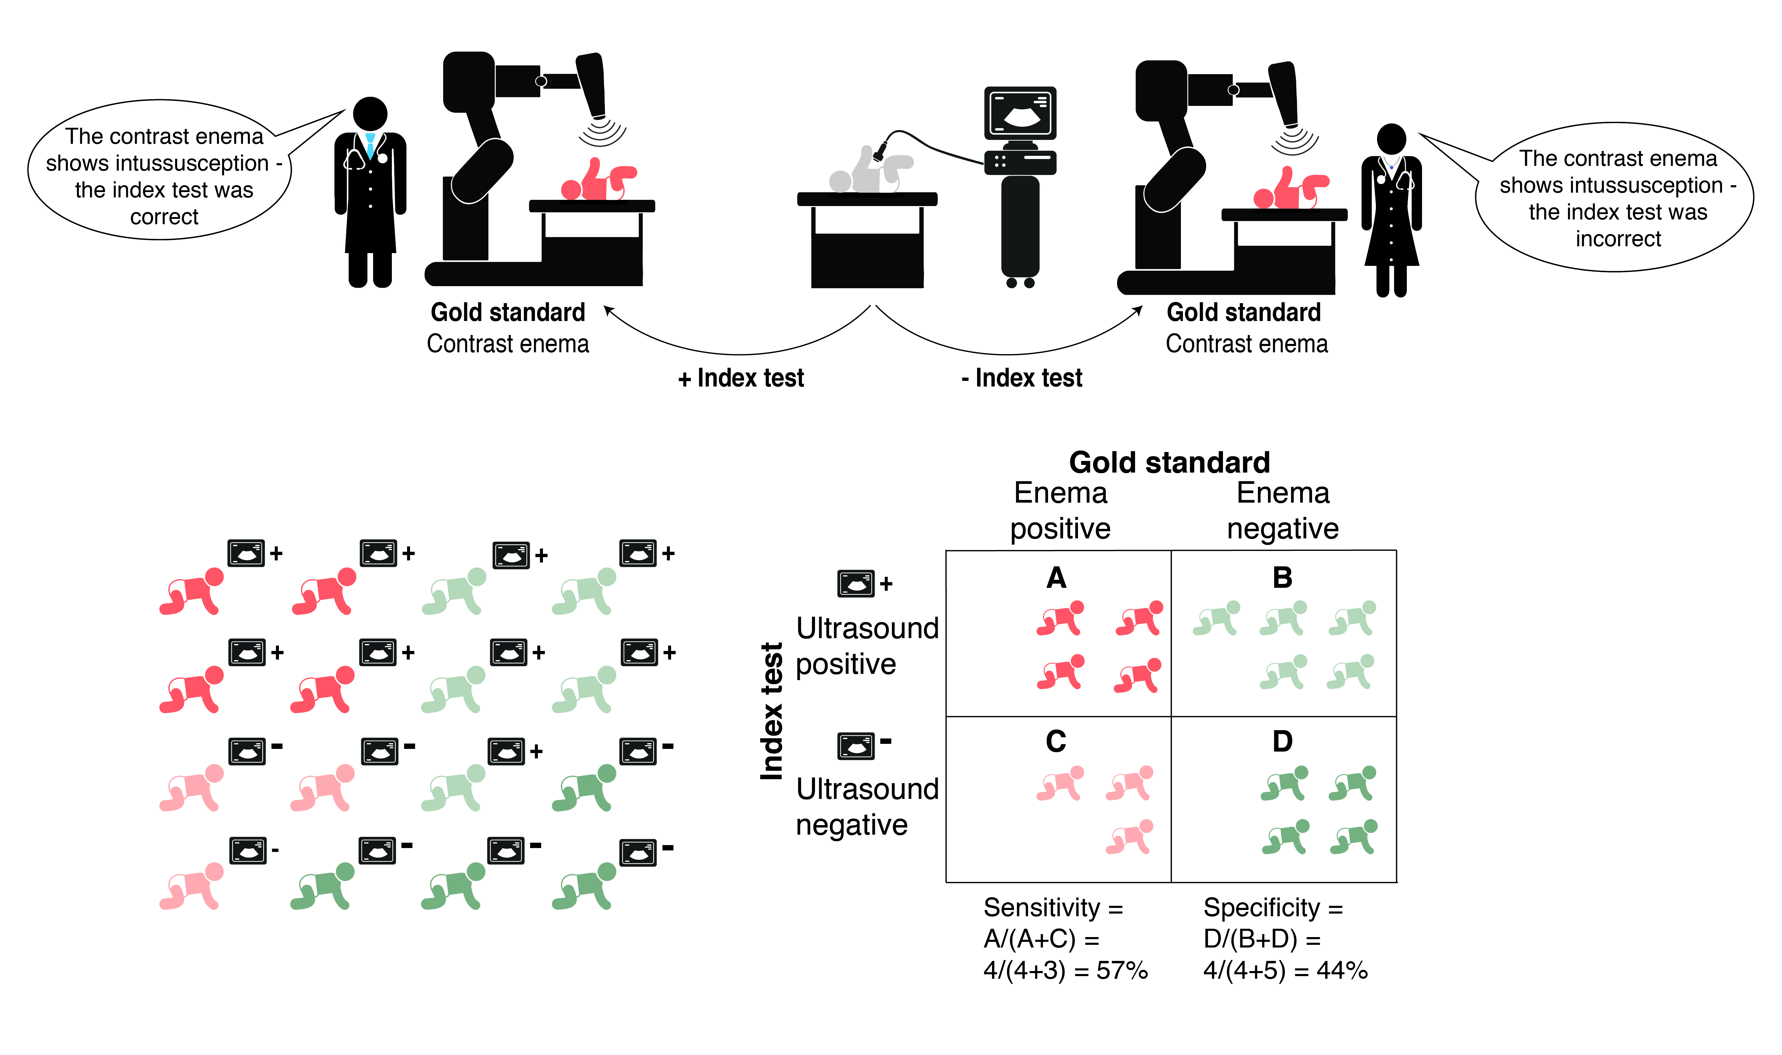
Figure 4.2A. The ultrasound study is followed by the gold standard contrast enema in all cases; there is only one good standard.
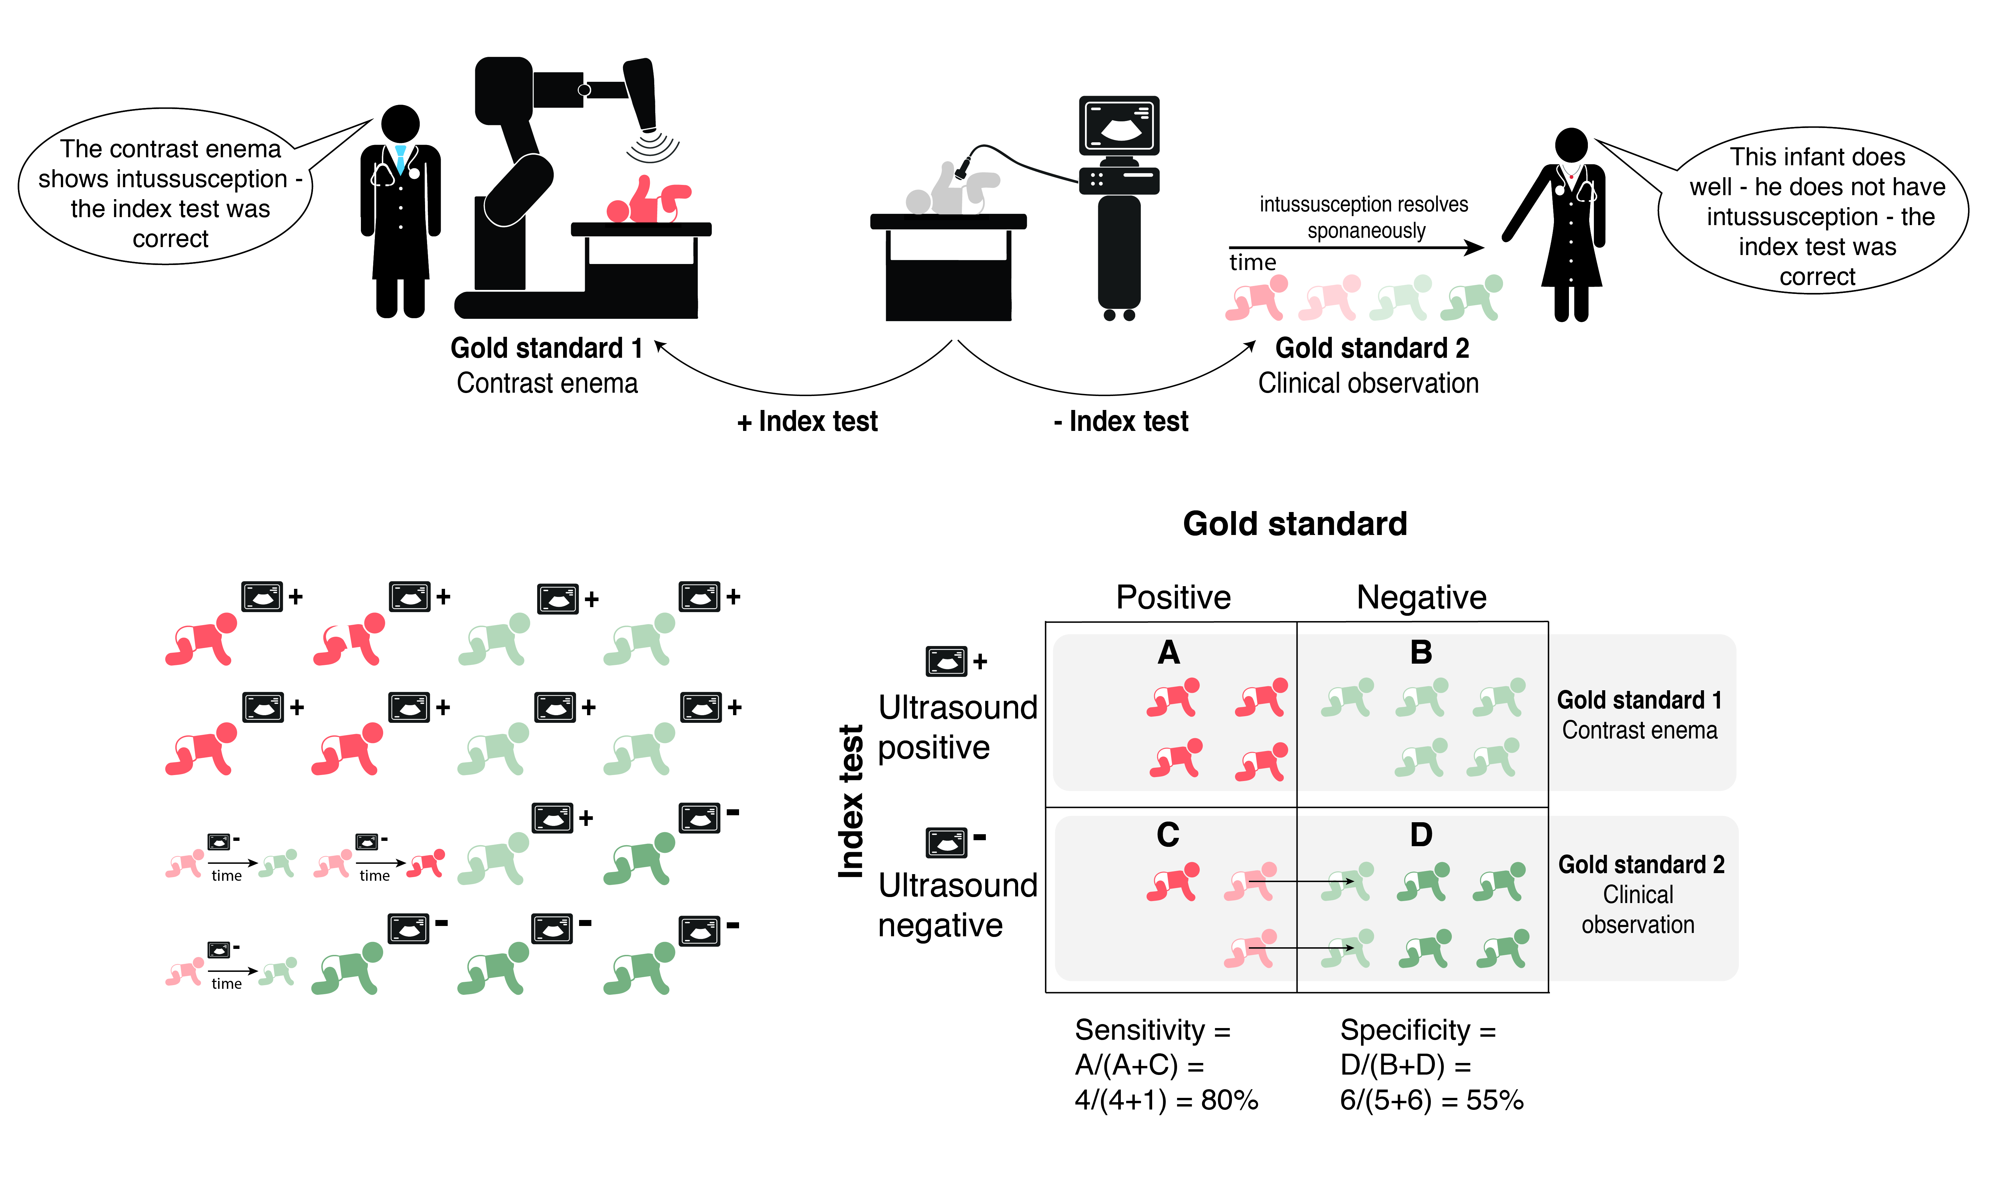
Figure 4.2B. If the ultrasound study is positive, patients are more likely to get the contrast enema, whereas if the ultrasound is negative there may be clinical follow-up only. The ultrasound will always appear to give the right answer in cases with spontaneously resolving disease.

Box 4.2: Numerical example of differential verification bias
In a study of ultrasonography to diagnose intussusception (a telescoping of the intestine upon itself) in young children,[14] all children with a positive ultrasound scan for intussusception received a contrast enema (Gold Standard #1), whereas the majority of children with a negative ultrasound were observed in the emergency department (Gold Standard #2). The results of the study are shown below:
 | Intussusception | No Intussusception
Ultrasound+ | 37 | 7
Ultrasound- | 3 | 104
Total | 40 | 111
 | Sensitivity = 37/40 = 93% | Specificity = 104/111 = 94%
The 104 subjects with a negative ultrasound listed as having “No Intussusception” actually included 86 who were followed clinically and did not receive a contrast enema. If about 10% of these subjects (i.e., 9 children) actually had an intussusception that resolved spontaneously but would still have been identified if they had a contrast enema, and all subjects had received a contrast enema gold standard, those 9 children would be considered false negatives rather than true negatives, with a resulting sensitivity of 37/49 = 76% and specificity of 95/102 = 93%, as shown below:
 | Intussusception | No Intussusception
Ultrasound+ | 37 | 7
Ultrasound- | 3+9 = 12 | 104 − 9 = 95
Total | 49 | 102
 | Sensitivity = 37/49 = 76% | Specificity = 95/102 = 93%
Thus, compared with the single gold standard of the contrast enema, the double gold standard leads to higher estimates of both sensitivity and specificity because it counts as true negatives some of the subjects who would be considered false negatives by the contrast enema.
Now consider the 37 subjects with positive ultrasound scans, who had intussusception based on their contrast enema. Suppose about 10% (i.e., 4) of those intussusceptions would have resolved spontaneously if given the chance. Then, if the single gold standard were clinical observation, four children considered true positives by the contrast enema would become false positives, with a small decrease in specificity from 93% to 90%. The loss of these four true positives also decreases sensitivity a little, from 93% to 92%. Thus, compared with the single gold standard of clinical follow-up, the double gold standard again leads to higher estimates of both sensitivity and specificity because it counts as true positives some subjects who would be considered false positives by clinical follow-up.
 | Intussusception | No Intussusception
Ultrasound+ | 37 − 4 = 33 | 7 + 4=11
Ultrasound− | 3 | 104
Total | 36 | 115
 | Sensitivity = 33/36 = 92% | Specificity =104/115 =90%
Thus, for spontaneously resolving cases of intussusception, the ultrasound scan will appear to give the right answer whether it is positive or negative, increasing both its apparent sensitivity and specificity.

Imperfect gold standard bias
We previously discussed differential verification bias, which arises when different gold standards are used depending on the result of the index test and the different gold standards at least sometimes give different answers. That different gold standards can give different answers implies that not all gold standards are really gold – if they disagree they can't both be right. We might call them "copper standards."[6] Copper standards are a particular problem for new diagnostic tests, which might actually be better than the tests they could replace.[15] If you use the old test as the gold standard, it is impossible to show the new test is better. In fact, the greater the improvement in accuracy, the worse the new test will look!

This is easy to see when the new index test is actually perfect; it correctly classifies disease and should be the gold standard. In testing this perfect index test against the copper standard, we are swapping the roles of the index test and gold standard, which is like turning the 2 × 2 table on its side (Figure 4.3). Assuming cross-sectional sampling, the true prevalence of disease is actually the proportion with a positive index test. What we estimate as the sensitivity of the index test is really the PPV of the copper standard relative to the index test, and what we estimate as the specificity of the index test is really the NPV of the copper standard relative to the index test. The same things that lower PPV of a test relative to a true gold standard will lower the apparent sensitivity of the index test (which is really 100%) relative to a copper standard: lower prevalence and lower specificity (i.e., more frequent false positives) of the copper standard. The same things that lower NPV of a test relative to a true gold standard will lower the apparent specificity of the index test (which is really 100%) relative to a copper standard: higher prevalence and lower sensitivity (i.e., more frequent false negatives) of the copper standard.

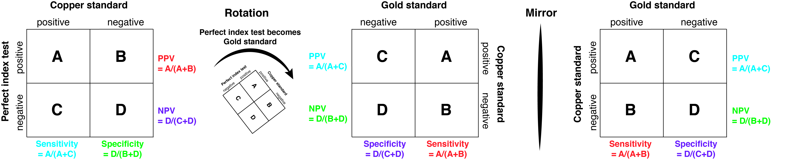
Figure 4.3: If the index test is perfect, the effect of imperfect gold standard bias can be seen by rotating the 2 × 2 table and putting the index test at the top instead of on the side. (Then we still need to take the mirror image if we want D+ on the left.)

If the index test is also imperfect, the effect of comparing it to a copper standard in regard to the measured sensitivity and specificity depends on whether the index test tends to give wrong answers on the same subjects as the copper standard.[6, 16]

Errors are conditionally independent (uncorrelated)
If there is no correlation between the errors on the two tests, we say they are conditionally independent (more on this in Chapter 7) and the effect is to make the index test look worse than it really is.

To understand this, first consider the effect on sensitivity. If the specificity of the copper standard test is less than perfect, then some of the people that the test indicates have disease will really be false positives. In fact, the lower the prevalence of the disease, the more of those testing positive on the copper standard will really be false positives. Now along comes the poor index test, which correctly gives a negative result on these subjects in whom the gold standard was falsely positive. Its true negative result gets counted as giving a wrong answer (false negative) and its sensitivity gets dinged (underestimated). So in the case of conditional independence, the downward bias of sensitivity will increase with decreasing prevalence of the disease and decreasing specificity of the copper standard. Given the low prevalence of many diseases, this effect can be substantial.

Now consider the effect on estimated specificity. If the copper standard is imperfectly sensitive, then some of the people it says do not have the disease will really have it – they will be false negatives. The higher the prevalence of the disease, the more of those testing negative on the copper standard will really be false negatives. If the index test correctly identifies these subjects as having the disease, it will get dinged for a false positive, and estimated specificity will be underestimated. So in the case of conditional independence, the downward bias of specificity will increase with increasing prevalence of the disease and decreasing sensitivity of the copper standard.

The effect of an imperfect gold standard on positive and negative predictive value is a little less intuitive. You might think if both sensitivity and specificity are falsely low, positive and negative predictive value would both be falsely low as well, but this is not always the case. For example, if the true prevalence is very low, there can be enough false positives on both tests to falsely elevate the PPV.[16]

When the assumption of conditional independence is reasonable, a statistical technique called Latent Class Analysis can be used to infer the likelihood of disease from results on two or more diagnostic tests, even when there is no gold standard.[17]

Errors on the gold standard and index test are correlated
Unfortunately, in many cases the assumption of conditional independence is unreasonable. For example, recall that many diseases have a spectrum of severity, and that sensitivity tends to be lower in those with milder disease. The subjects with mild disease are more likely to have false negative results on both the index test and the copper standard. This means that what should have been false negative results get classified as true negatives by both the index test and the copper standard, raising apparent sensitivity (by losing the false negatives) and (usually slightly) increasing specificity (by adding true negatives). Similarly, if results are falsely positive on both the index test and the copper standard, they would be counted as truly positive, increasing apparent specificity (by losing false positives) and increasing sensitivity (by adding true positives). Thus, positively correlated (i.e., in the same direction) errors on both the index test and the copper standard tend to make the index test look falsely good.

In some cases, the problem with the copper standard is thought to be only with sensitivity or specificity. For example, when testing for chlamydia or pertussis, the problem with the copper standard is inadequate sensitivity; when it’s positive, it is correct, but when it is negative, it may be falsely negative. In these cases, it often makes sense to use an “either/or” composite standard consisting of two highly specific reference tests with imperfect sensitivity. If either reference test is positive, the patient is considered D+. For example, if you are looking at an ELISA (index) test for chlamydia, you consider the patient D+ if either the culture or the PCR is positive. Seroconversion can also be used as a 3rd reference test to include in the composite standard.

In practice, the effects of an imperfect gold standard may be hard to predict, because both correlated and uncorrelated errors could occur and bias sensitivity and specificity in different directions.

What if there’s no gold standard?
Diagnosis of some diseases (including many mental health disorders) is inherently subjective. What should investigators do in that case?

A practical approach is to consider what decisions (e.g., treatment decisions) the test is supposed to help with. As discussed in chapter 1, while assigning a name to the entity causing a patient’s illness is comforting, a pragmatic approach to these diagnoses is to identify predictors, not of disease, but of outcome in response to various treatments.

Spectrum bias

Definition and explanation
The best studies of diagnostic tests are those that replicate the conditions of clinical practice, that is, those in which the disease status of the subjects is not known (and is of interest) when the index test is done. Many tests can be made to look good if they only need to distinguish between the very sick and the very well. “Spectrum bias” is the name for the bias that occurs if the subjects for a study of a diagnostic test did not have both a representative spectrum of the disease being tested for and a representative spectrum of the nondisease that may mimic it (Figures 4.4)
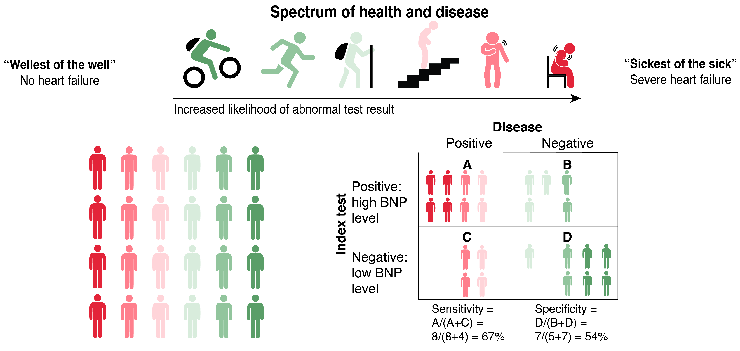Figure 4.4 A. The population has a spectrum from very well (dark green) to very diseased (dark red). If the study includes a representative sample of the full spectrum of disease, there will be no spectrum bias.

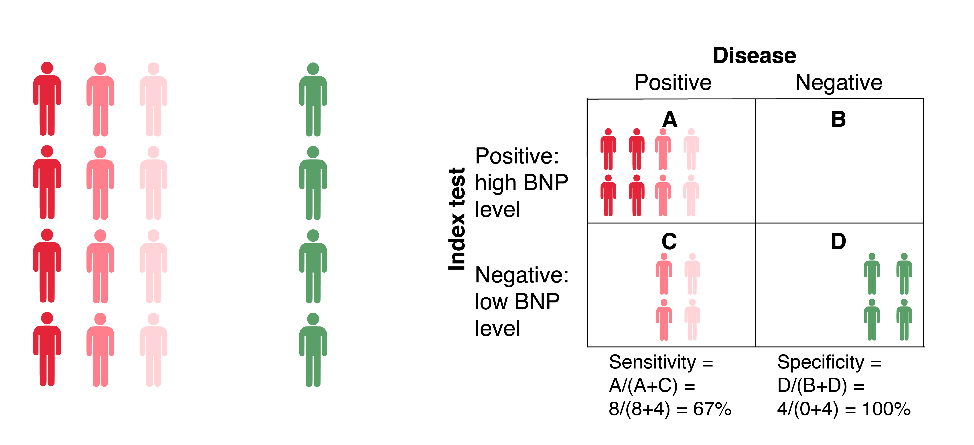Figure 4.4 B. If the spectrum of nondiseased patients included in the study is only the "wellest of the well," specificity will likely be falsely increased.
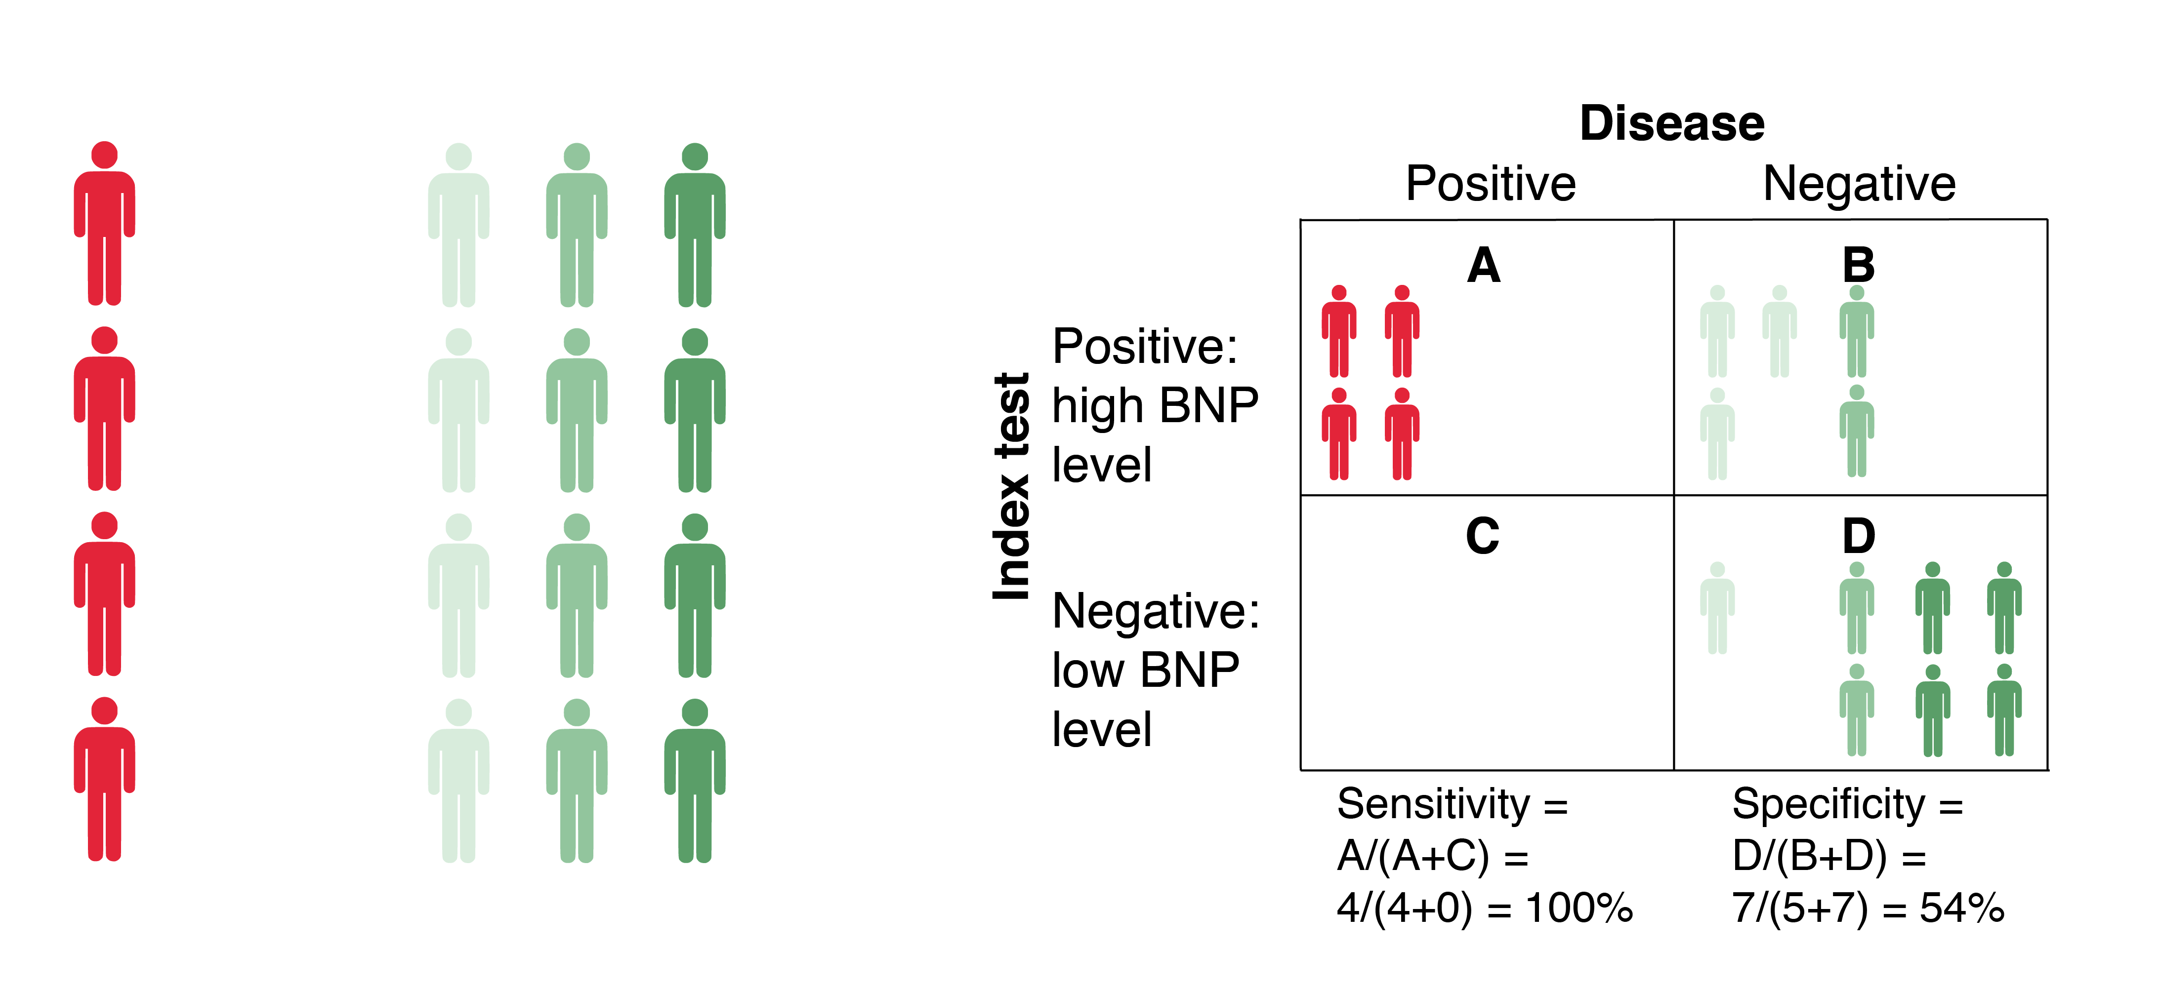Figure 4.4 C. If the spectrum of diseased patients included in the study is only the "sickest of the sick," sensitivity will likely be falsely increased.
We warned you in Chapter 1 that the assumption that disease was dichotomous is an oversimplification and that in real life diseased and nondiseased populations may be heterogeneous. In fact, we can be a bit more specific: sensitivity (or, for non-dichotomous tests, the distribution of test results in the diseased group) will depend on the spectrum of disease, and specificity (or the distribution of results in the nondiseased group) will depend on the spectrum of non-disease.
A study that disproportionately includes patients with more severe disease (the "sickest of the sick") will often have a falsely high sensitivity and negative predictive value, whereas a study that disproportionately includes mild cases of disease (the "wellest of the sick") will have a falsely low sensitivity and negative predictive value. Specificity won't be affected, and the effect the spectrum of disease on positive predictive value will generally be smal, because positive predictive value is usually more affected by specificity and pretest probability (Table 4.2).
Similarly, a study in which the patients without the disease are very healthy or do not have anything resembling the target disease (the "wellest of the well") will give a falsely high specificity and positive predictive value, whereas a study in which the nondisease subjects disproportionately include subjects who almost qualify for the disease or have diseases similar to the target disease ("the sickest of the well") will have a falsely low specificity. Sensitivity will not be affected by the spectrum of nondisease so the effect on negative predictive value will generally be small (Table 4.2).
Sensitivity, specificity, and predictive value will all tend to be falsely high if the investigators exclude subjects whose disease state is still uncertain after application of the gold standard (e.g., if the gold standard pathologists disagree on whether disease is present). Conversely, sensitivity and specificity will be lower the authors intentionally oversample the most difficult cases, the ones in the middle of the spectrum between disease and nondisease or the ones with intermediate test results.
As an example of spectrum bias, suppose you are interested in LRs for the erythrocyte sedimentation rate (ESR; a test for inflammation) for diagnosing appendicitis in patients with abdominal pain. The LR for a particular ESR result is P(result|appendicitis)/P(result|no appendicitis). But P(result|no appendicitis) clearly depends on what the patients who do not have appendicitis actually do have. A study of the ESR in young women with abdominal pain who may have acute salpingitis (inflammation of the fallopian tubes), a disease associated with high values of the ESR, will give different LRs from a study in children or in men. The distribution of ESRs in the no appendicitis groups (and hence the LRs) will differ, even if the distribution of ESRs in subjects with appendicitis is the same.

Spectrum bias vs disease definition
To this point the biases we have discussed have all been systematic errors in which shortcomings in study design cause the results to differ from the ideal, e.g., what would be obtained if a single gold standard were obtained blindly on an entire tested population at risk of the disease. But an issue related to spectrum bias can arise where the results of one study may differ from those of other studies (or your idea of a more relevant study) due to decisions by the authors on how to define the disease, rather than from deviations from a perfect study design.

Underlying continuous disease variable
For example, consider lower extremity arterial stenosis (blockages in leg arteries), which can cause leg pain with walking when the muscles do not get enough blood. Koch et al[18] studied the drop in transcutaneous oxygen pressure during exercise as a test for lower extremity arterial stenosis, using computed tomography angiography (CTA) as the gold standard. But the level of stenosis on CTA at which to define the disease is somewhat arbitrary. In fact, the authors compared 3 different "gold standards" for the disease: ≥ 50% stenosis, ≥ 60% stenosis and ≥ 70% stenosis. Not surprisingly, the test's sensitivity went up (from 73% to 86%) as the degree of stenosis used to define the disease went up and the diseased group increased in average severity. The specificity went down with this increasingly severe disease definition as well (from 83% to 76%), as one would expect, given that the "non-disease" in those with 60-69% stenosis would likely be more difficult to diagnose than in those with less stenosis. Dichotomizing a continuous measure of disease at different cutoffs leads to the same sort of tradeoff in sensitivity and specificity as dichotomizing a continuous test, and also (theoretically) could be summarized using an ROC curve (if the test is dichotomous), though we have not seen this done.

Underlying categorical disease variable
Differences in disease definition affecting sensitivity and specificity can also occur when the disease is a categorical variable, not just when it is a continuous variable with an arbitrary cutoff, like percent stenosis. Consider Clinical Scenario #4 in Chapter 1, concerning prenatal ultrasound screening to detect fetal chromosomal abnormalities. Cicero et al[19] reported on the diagnostic accuracy of absence of the nasal bone at 13 weeks for trisomy 21 (Down syndrome; Table 4.3.)
Table 4.3 Absence of the nasal bone at 13 weeks as a test for Down syndrome, excluding 295 fetuses with other chromosomal abnormalities

 |  | D+ | D-
Nasal Bone | Yes | 229 | 129
Absent | No | 104 | 5,094
Total |  | 333 | 5,223
Sensitivity = 229/333 = 69%.
Specificity = 5,094/5,223 = 97.5%
In Table 4.3 the authors defined the D+ group as including only fetuses with trisomy 21. They excluded 295 fetuses with other chromosomal abnormalities, especially trisomy 18. Their observed sensitivity was 69%.
However, if the purpose of the ultrasound scan is to determine whether to do the more invasive chorionic villus sampling, it makes more sense to include these 295 fetuses with chromosomal abnormalities other than trisomy 21 in the D+ group. Of those 295 fetuses with other chromosomal abnormalities, 95 (32%, not 69%) had absence of the nasal bone (Table 4.4).
Table 4.4 Absence of the nasal bone at 13 weeks as a test for any chromosomal abnormality

 |  | D+ | D−
Nasal Bone | Yes | (229 + 95 =) 324 | 129
Absent | No | (104 + 200 =) 304 | 5,094
Total |  | (333 + 295 =) 628 | 5,223
Sensitivity = 324/628 = 52% (not 69%).
Specificity = 5,094/5,223 = 97.5%
Including these 295 in the D+ group results in a sensitivity of 52%, not 69%, which constitutes a more clinically useful estimate of the sensitivity of nasal bone absence.

Note that the specificity was 97.5% in both Tables 4.3 and 4.4. That is because the fetuses with chromosomal abnormalities other than Down syndrome were not included in the D− group in either table. This is an example of spectrum bias. While investigators can choose to study a particular disease definition (in this case Down syndrome for the D+ group), there is no rationale for excluding the 295 fetuses with other chromosomal abnormalities from the D− group in that case. Including them provides an unbiased estimate of sensitivity and specificity of nasal bone absence for Down syndrome (Table 4.5). Although we do not like the idea of including 295 fetuses with chromosomal abnormalities in the D− group, we do it to show that excluding individuals from the sample who are neither clearly D+ nor clearly D− falsely increases either sensitivity or specificity, depending on the group (D+ or D−) from which they are excluded.
Table 4.5 Absence of the nasal bone at 13 weeks as a test for Trisomy 21. An unbiased estimate includes 295 fetuses with chromosomal abnormalities other than Trisomy 21 in the D− group.
 |  | D+ | D−
Nasal Bone | Yes | 229 | (129 + 95 =) 224
Absent | No | 104 | (5,094 + 200 =) 5,294
Total |  | 333 | (5,223 + 295 =) 5,518
Sensitivity = 229/333 = 69%.
Specificity = 5,294/5,518 = 95.9%

Potential association between prevalence and spectrum of disease
In previous chapters we have assumed that test characteristics like sensitivity, specificity, and LRs do not vary with the prevalence of disease. However, when differences in disease prevalence are associated with differences in disease (and nondisease) spectrum, this assumption may be incorrect.
For example, in the United States, a country of relatively low prevalence of iron deficiency, possible tests for iron deficiency anemia, such as pallor on physical examination, a low hematocrit, or low mean red cell volume, are likely to have lower sensitivity than in Tanzania, where the prevalence of iron deficiency anemia is higher.[20] This is because the severity of iron deficiency in Tanzania is likely to be greater, so that the Tanzanian patients with iron deficiency will be more iron deficient, and the tests above are more likely to be abnormal in those with more severe disease (i.e., have higher sensitivity).
The same considerations apply to specificity, except that in this case, the “nondiseased” populations in the two countries are likely to differ. Specificity does not depend on the prevalence of the disease, but it does depend on the prevalence of diseases that can be confused with the disease in question. Specificity of the tests or findings for iron deficiency anemia could be lower in Tanzania because other diseases (like malaria or HIV) that might make children anemic (and therefore pale) are more common there, and “tests” like pallor will be abnormal with these other diseases as well.
In the iron deficiency example, sensitivity increases with prevalence, because greater prevalence is associated with greater disease severity. But the opposite could also be true. If the (apparent) prevalence of disease depends on the level of surveillance, then an area with high prevalence might also be an area where the average severity of disease is less, because the additional cases picked up by closer surveillance are likely to be milder than those that presented with symptoms. In that case, sensitivity of some tests could be lower in the high-prevalence area. For example, consider the sensitivity of digital rectal examination for detecting prostate cancer. In a place where prostate-specific antigen screening is widespread, the prevalence of prostate cancer would be higher, and the population of prostate cancer patients would presumably include many more in whom no tumor was palpable, leading to a lower apparent sensitivity of digital rectal examination.
When you read a paper that tries to measure sensitivity and specificity, think about whether the spectra of disease and nondisease in the study subjects are similar to those in patients you are likely to see. As a general rule, the more severe the disease in the patients who have it, the greater the sensitivity, whereas the healthier the nondiseased group, the greater the specificity.

Spectrum of Test Results – Exclusion of Intermediate Test Results
Note -- This section is partially excepted from Kohn et al.[6]
We include the bias resulting from exclusion of intermediate or ambiguous test results under the general heading of spectrum bias because this bias results from limiting the study to an unrepresentative spectrum of test results. The effect of excluding intermediate results depends on how they would have been handled if included. Compared with treating intermediate results as positive for disease, excluding them biases sensitivity down and specificity up. Compared with treating intermediate results as negative for disease, the effect of excluding them is the opposite; sensitivity increases and specificity decreases. This is illustrated in Figure 4.5

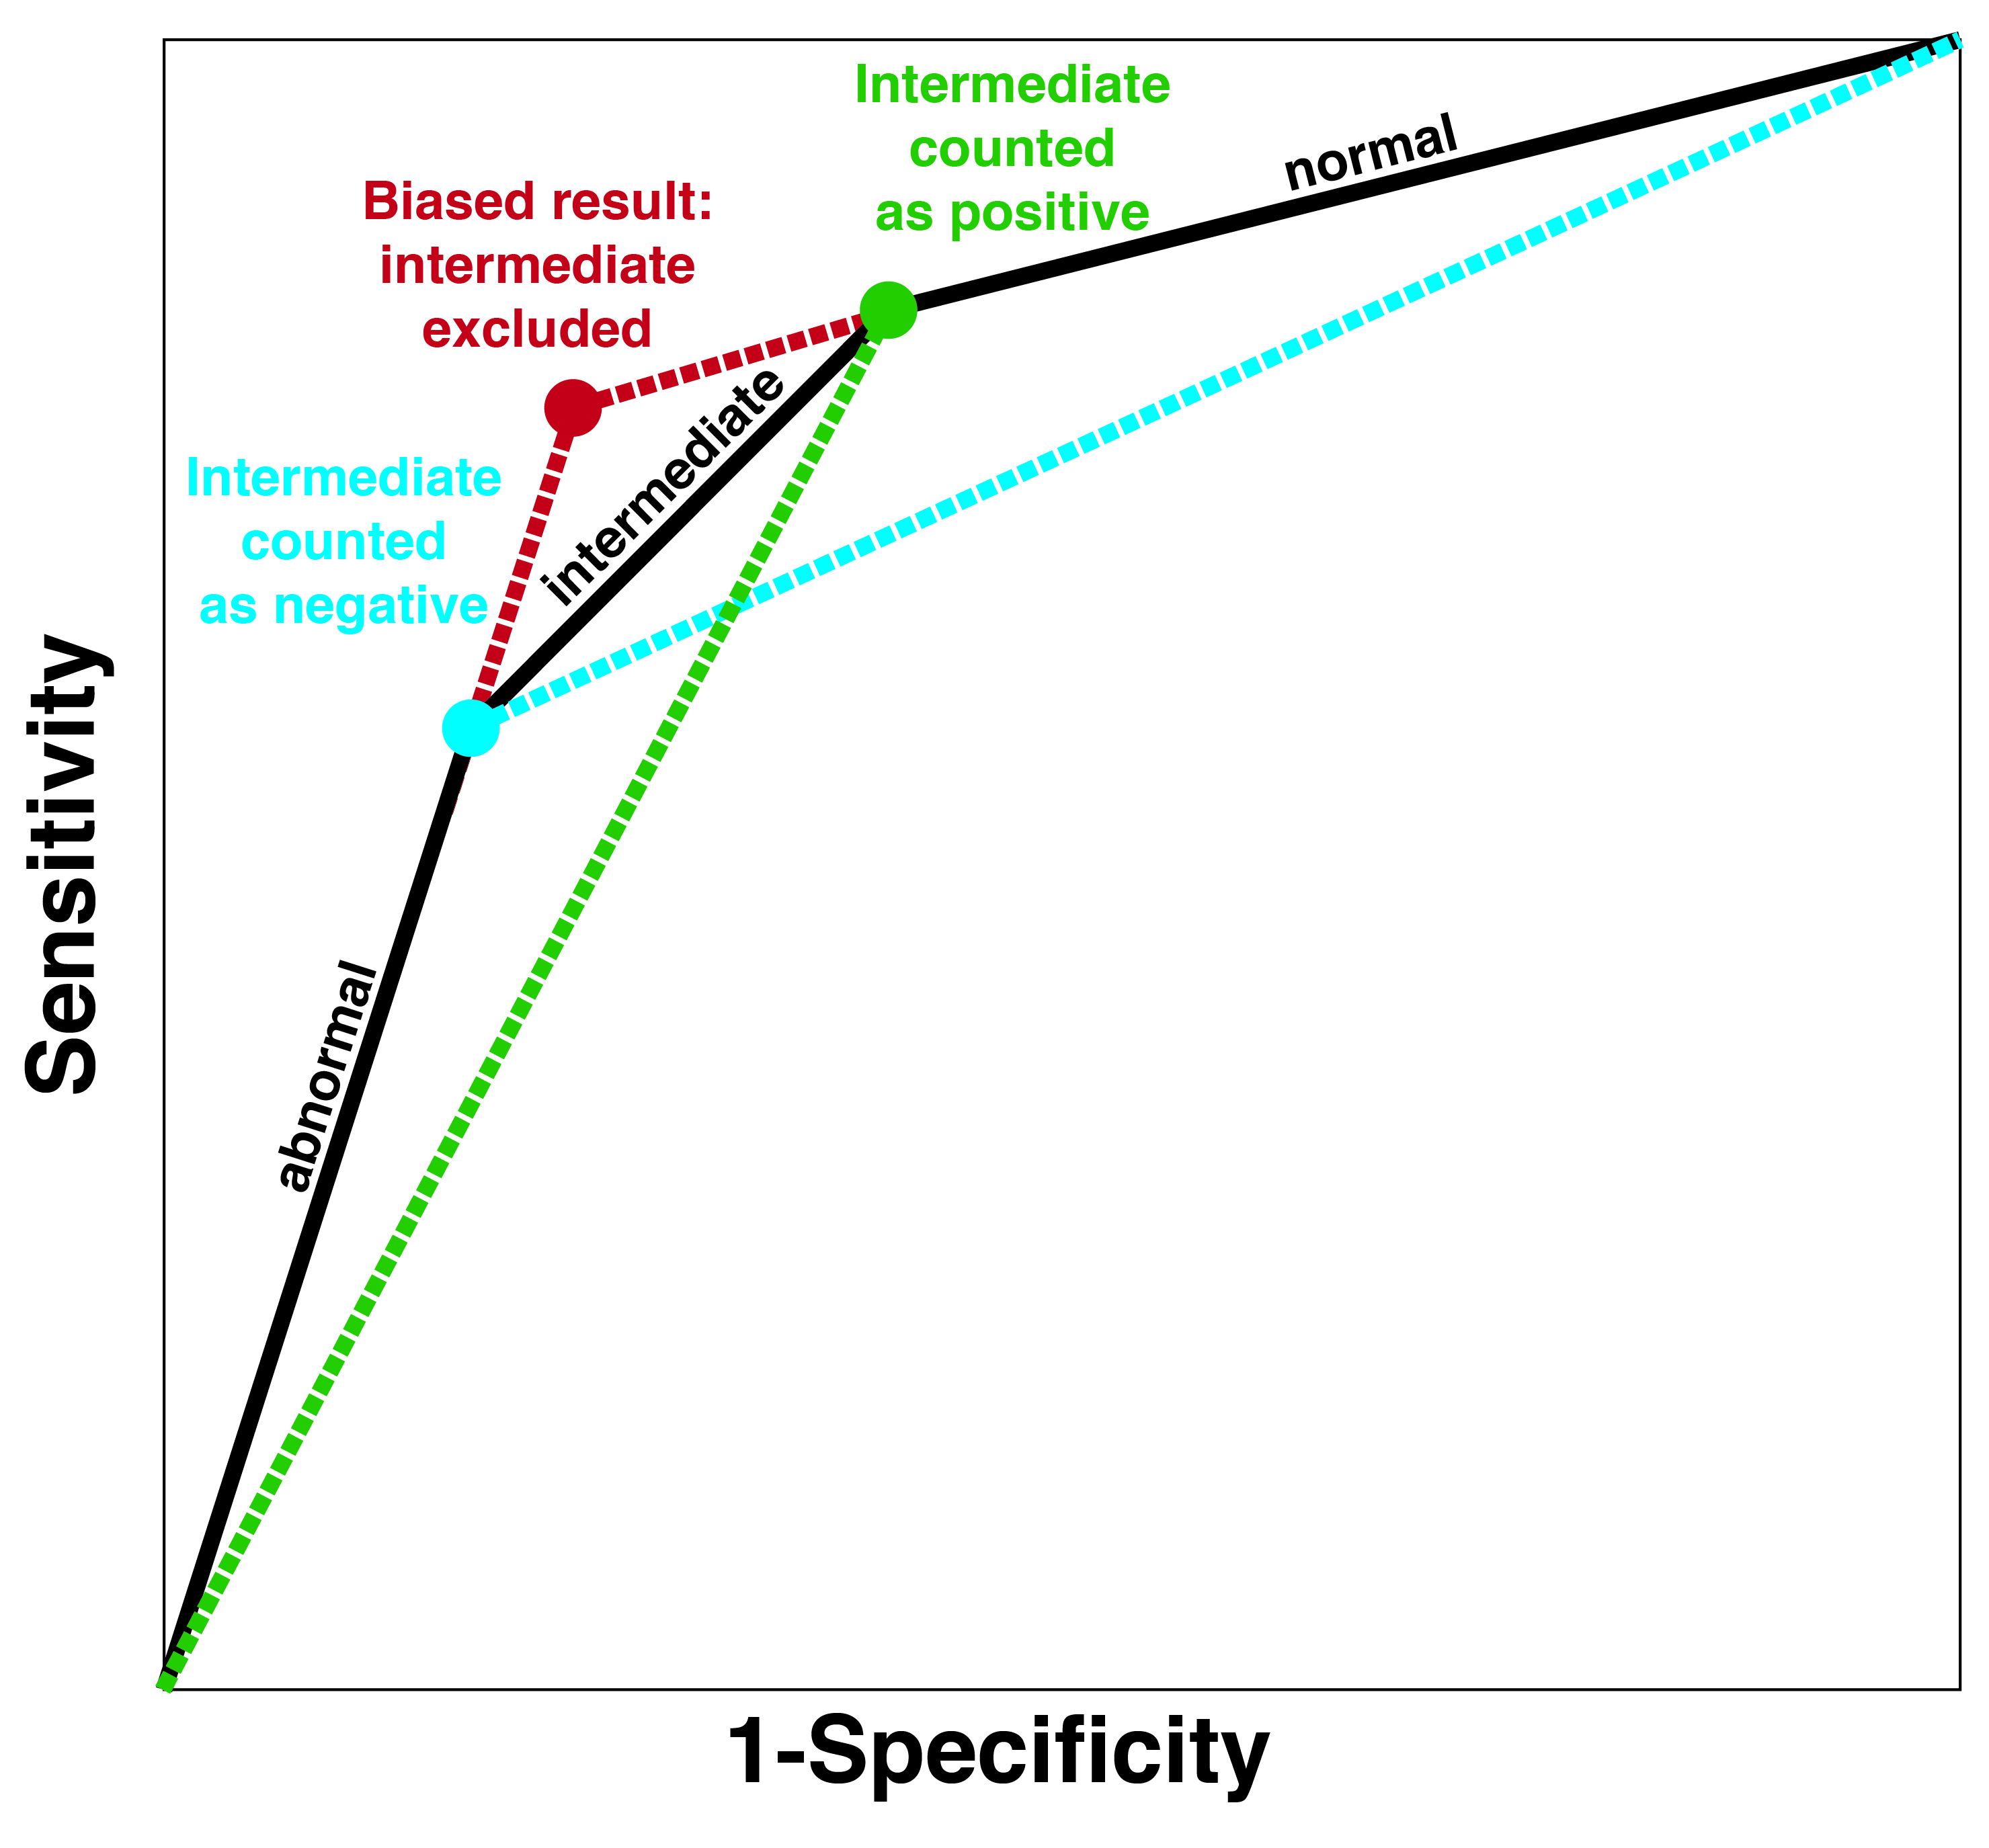
Figure 4.5 Including intermediate results with their own segment on the ROC curve gives a greater area under the ROC curve than treating intermediate results as either positive (green dotted line) or negative (blue dotted line). Excluding intermediate results gives a biased (falsely favorable) estimate of test discrimination (red point and dotted lines).

Rather than classifying all the intermediate results as either positive or negative, the study could force the test reader to make the choice between classifying the result as positive and negative for each patient. Compared with that forced choice, the effect of excluding intermediate results is similar to spectrum bias that excludes D+ patients with mild disease and D− patients with other conditions that look like the disease. Sensitivity and specificity are both likely to be falsely increased. D+ patients with intermediate results may have milder disease that the test reader is more likely to call falsely negative, and D− patients with intermediate results may have more challenging nondiseases that the test reader is more likely to call falsely positive.

Consider the accuracy of the emergency physician-performed bedside compression ultrasound for diagnosis of deep vein thrombosis (DVT). Two studies [21, 22] of a combined 146 patients showed perfect (100%) sensitivity and high specificity (pooled specificity = 95%) for the bedside ultrasound relative to a gold-standard of color-flow duplex ultrasound performed by radiologists blinded to the bedside ultrasound result. Both of these studies used convenience sampling and may have excluded ambiguous results on the bedside ultrasound. A third similar study [23] of 183 patients showed much lower sensitivity (70%) and specificity (89%) relative to the same gold standard. This study used consecutive sampling and included patients with ambiguous ultrasounds, forcing the bedside sonographer to state whether the exam was positive or negative. Assume that the convenience samples excluded patients with ambiguous ultrasounds. The excluded patients with DVT might have been disproportionately false negatives, and the excluded patients without DVT might have been disproportionately false positives. This could explain the higher accuracy in the convenience samples.

Sostman [24] reported on the accuracy of V/Q scans done as part of the larger PIOPED II study [25] for diagnosing PE. Their calculations of sensitivity and specificity excluded intermediate test results. Figure 4.6 uses some of their data to provide a numerical example of how exclusion of intermediate results can falsely increase sensitivity and specificity.
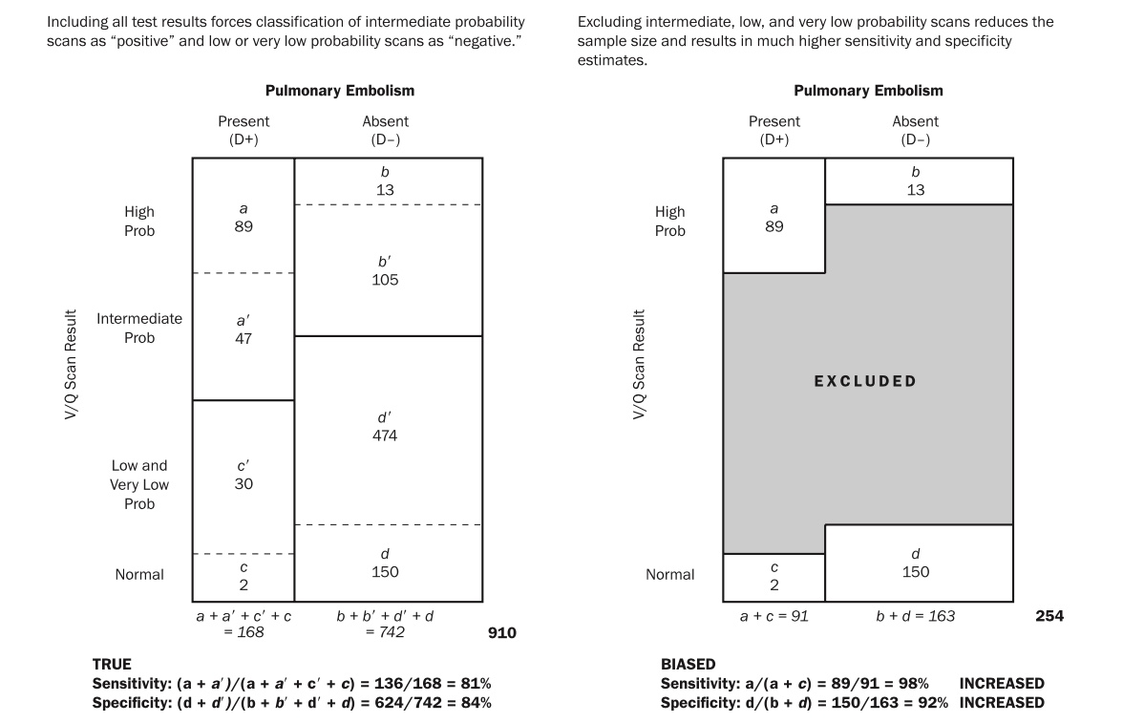
Figure 4.6. Effect of excluding intermediate test results in a study of V/Q scans for pulmonary embolism. Reprinted from Kohn MA, Carpenter CR, Newman TB. Understanding the direction of bias in studies of diagnostic test accuracy. Acad Emerg Med. 2013;20(11):1194-206 with permission. Copyright 2013 John Wiley and Sons.

The best way to handle intermediate results is to report them, replacing the standard 2×2 table with a 3×2 table. [26, 27] The index test is no longer dichotomous (+ or − ); it has 3 possible results (+, ? and −). We learned in Chapter 3 how to handle tests with more than 2 possible results. We abandoned sensitivity and specificity in favor of reporting the probability of each of the 3 results in the D+ and D− populations. The test now has 3 likelihood ratios: LR(+), LR(?), and LR(−), where LR(?) denotes the likelihood ratio of an intermediate result.

Systematic reviews of diagnostic tests
Clinicians wishing to practice evidence-based diagnosis are often faced with a problem: when we look in the literature to find values for sensitivity, specificity, LRs, or other test characteristics, we find studies with varying results. Or, perhaps more commonly, we look in a textbook chapter or a typical review article and find statements like “the XYZ test has sensitivity from 63% to 100% and specificity from 34% to 98%,” followed by a string of references. For many tests, the range of reported estimates for sensitivity and specificity is so large that the resulting LRs could be consistent with either an informative or useless test. What do we do?
One approach is to pull all of the articles and critically appraise them, using the general approach you have learned in this book or by using a quality checklist for test accuracy studies. (See below.) However, most of us do not have time to do this, and even if we did, it would be hard to synthesize the results. To address this problem, more and more systematic reviews of diagnostic tests are being published. As with other systematic reviews, systematic reviews of diagnostic tests should have four key features: 1) a systematic and reproducible approach to finding and selecting the relevant studies; 2) a summary of the results of each of the studies; 3) an investigation seeking to understand any differences in the results (heterogeneity) between the studies; and 4) a summary estimate of results, if appropriate.
A difference between systematic reviews of test accuracy studies and systematic reviews of treatments (Chapter 8) is that reviews of diagnostic tests commonly attempt to estimate two parameters (sensitivity and specificity), rather than one (e.g., a risk ratio). These two parameters are related: as one goes up, the other usually goes down, especially if one of the reasons for differing estimates is a difference in the cut-off (or some underlying hidden threshold) used to define a positive result.
One approach to this is to plot the sensitivity and specificity obtained from different studies on the same axes used to draw an ROC curve (Sensitivity vs. 1 – Specificity; see Chapter 3). This gives a visual representation of the extent to which differences in reported sensitivity and specificity could be the result of differences in the threshold for a positive test. The authors can then use software to draw the best line through these points, considering the sample sizes of diseased and nondiseased subjects in each study.{Littenberg, 1993 #936; Macaskill, 2004 #937} Generally, this is most appropriate for studies with similar designs, in similar populations, and with similar gold standard definitions, making the results more homogeneous. The resulting line is called an sROC curve, where the “s” stands for summary.
For example, Downar et al[28] did a systematic review of the "surprise question" for predicting death in the next 6 to 18 months in seriously ill patients. The index test in this case is for treating clinicians to ask themselves: "Would I be surprised if this patient died in the next 12 months?" An answer of "No" is considered a positive test result. The authors summarized their results with an sROC curve, reprinted in Figure 4.7. Note that each study is represented by a rectangle with dimensions proportional to the standard error of sensitivity and specificity.
Figure 4.7 SROC curve for the surprise question as a predictor of mortality. Reprinted from Downar J, Goldman R, Pinto R, Englesakis M, Adhikari NK. The "surprise question" for predicting death in seriously ill patients: a systematic review and meta-analysis. CMAJ. 2017;189(13):E484-E93. Permission pending

The sROC curve does indeed suggest that some of the variation across studies comes from different thresholds for considering the test positive. Consider the point at the very top of the ROC curve. This corresponds to a study from Ireland in which not one death was surprising to the treating clinicians (sensitivity 100%). However, based on the ~30% specificity, about 70% of the subjects who survived also could have died without surprising their doctors. Clinicians in some places are harder to surprise than others.
It is particularly helpful if characteristics of the studies help explain the location of their points on the ROC plane. For example, Figure 4.8 is taken from a systematic review of magnetic resonance imaging for the diagnosis of multiple sclerosis[29]. It shows that studies with a cohort design (red circles), in which subjects with symptoms concerning for MS were followed to see if they developed clinical criteria for MS, tend to have lower accuracy estimates. Almost all of the points in the upper left corner of the ROC plane (corresponding to the highest estimates of accuracy) came from studies with case-control or cross-sectional designs, in which MS was either already present or not.
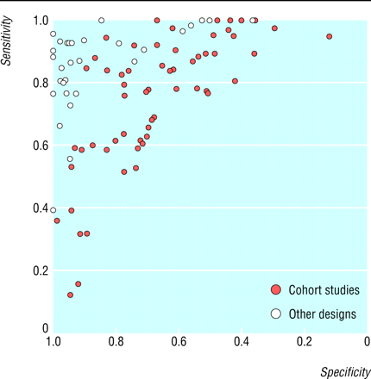
Figure 4.8 Studies of MRI for the diagnosis of multiple sclerosis. Cohort studies (solid red circles) produced lower estimates of accuracy than studies using other designs. (From Whiting et al. 2006,[29] used with permission)
This type of heterogeneity in accuracy estimates can also be investigated statistically, using analyses in which each study constitutes an observation, characteristics of the study (like design, blinding, spectrum of disease, etc.) are the predictor variables, and the results of the study are the outcomes. Whether the review uses these sophisticated methods, or simply identifies and summarizes studies, your goal as the reader of a systematic review of test accuracy is to obtain estimates of test characteristics based on the most valid studies, in populations and under testing conditions that best duplicate the conditions under which you would be using the test.

Individual Patient Data Meta-Analysis
The sROC curve depicts sensitivity/specificity pairs from multiple similar studies of the same index test that may differ in the explicit or implicit threshold for calling the test positive. If the index test gives a numerical result, it is possible to recalculate sensitivity/specificity pairs from each of the studies using a set of common thresholds and create an ROC Table (Chapter 3) using the pooled data. From the pooled ROC table, it is then possible to create an LR table and calculate pooled interval LRs, including confidence intervals. Since the studies will not have reported patient counts, sensitivities, and specificities using the same set of cutoffs, this type of analysis requires the authors of the systematic review to communicate with the study authors and obtain the required data, either counts of D+ and D- subjects in specific test-result intervals, or better yet, subject-level results of both the index test and the gold standard. Pooling subject level results is called individual patient data meta-analysis. [30] For example, Kohn et al used pooled patient-level data from five diagnostic management studies to estimate interval LRs for D-Dimer as a test for pulmonary embolism.[31]

Beyond Checklists
Several authors have proposed checklists of questions to determine whether a study of test accuracy is valid.[32, 33] The QUADAS (Quality Assessment of Diagnostic Accuracy Studies) tool is a 14-item checklist to help in the evaluation of diagnostic accuracy studies primarily for use in preparing systematic reviews.[34] Some of the items on the QUADAS list address the reliability (reproducibility) of the index test outside of the research setting. We discuss reliability of diagnostic tests in Chapter 5. The creators of the QUADAS checklist have released a more complex second version, QUADAS-2[35], which has most of the same questions as the first version but broken into 4 domains: Patient Selection, Index Test, Reference Standard, and Flow and Timing. A checklist is useful in performing a systematic review when multiple reviewers are reading multiple test accuracy studies. It can also be useful in evaluating an individual study to identify potential problems. In Table 4.2, we have provided our own list of questions to help identify the potential biases discussed in this chapter. However, we encourage you to go beyond identification of a potential bias and predict how it will affect the study results.
If a study concludes that a diagnostic test is not useful in a particular situation, and biases in the design of the study would have led to the test looking better than it really is, the study’s conclusion is still likely to be valid. On the other hand, if biases in the study design would tend to make the test look bad, the conclusion that the test is not useful may simply be due to these biases. For example, if a test distinguishes poorly between people with severe disease and healthy medical students, it is likely to do even worse in patients with a more clinically relevant spectrum of disease and nondisease. Similarly, if a study subject to partial verification bias still reports that sensitivity is poor, that conclusion is probably valid. In these examples, the key is to notice that the potential bias would make the test look falsely good. On the other hand, consider the study of ultrasonography to diagnose intussusception.[14] The ultrasonographers were not the world experts; in fact, many of them were junior radiology residents new to the procedure. If the authors had reported poor accuracy, the generalizability of the results to a setting with more experienced ultrasonographers would have been questionable. However, since the reported accuracy was good, this lack of ultrasonographer experience is of less concern.

Summary of key points
- Critical appraisal of a study of diagnostic test accuracy requires identification of the index test, the gold standard used to classify patients into the D+ and D- groups, the sampling scheme, and the characteristics of the study subjects.
- Test accuracy studies are susceptible to incorporation bias, partial verification bias, differential verification bias (double gold standard bias), imperfect gold standard bias (copper standard bias), and spectrum bias.
- Incorporation bias occurs when classification of the patient as diseased depends partly on the result of the index test. It biases both sensitivity and specificity up.
- Partial verification bias occurs when patients who are positive on the index test are more likely to be referred for the gold standard and hence to be included in the study. It biases sensitivity up and specificity down. How partial verification bias affects predictive value depends on whether there are other factors (besides the index test result) that determine who gets the gold standard and is included in the study.
- Differential verification bias (double gold standard bias) occurs when there are two different gold standards applied selectively based on index test results – for example, an invasive test that is applied when the index test is positive and clinical follow-up that is applied when the index test is negative. It biases both sensitivity and specificity up in the case of spontaneously resolving disease, and down in the case of newly occurring or newly diagnosable disease.
- Imperfect gold standard bias occurs when an (often new) index test is compared with a sometimes erroneous "gold standard." It will make the index test look falsely good if errors on it and the imperfect standard are correlated and falsely bad if not.
- Spectrum bias occurs when the spectrum of disease and nondisease in the study population differs from that in the clinical population in which the test will be used. If the group of patients with the disease has severe disease (“the sickest of the sick”), sensitivity will be biased up. If the group of patients without the disease is very healthy (“the wellest of the well”), specificity will be biased up.
- When there are multiple studies of the same test, it may be possible to do a systematic review and develop summary estimates of test sensitivity and specificity and to summarize the results using an sROC curve. Calculating pooled estimates of interval LRs generally requires an individual patient data (IPD) meta-analysis.
- Even ﬂawed studies of diagnostic tests can be useful as long as the ﬂaws affect sensitivity and specificity in predictable ways.

REFERENCES

1. Hulley SB, Cummings SR, Browner WS, Grady DG, Newman TB. Designing clinical research, 4th ed. 4th ed. Philadelphia: Wolters Kluwer/Lippincott Williams & Wilkins; 2013. p. p.
2. Felker GM, Anstrom KJ, Adams KF, Ezekowitz JA, Fiuzat M, Houston-Miller N, et al. Effect of Natriuretic Peptide-Guided Therapy on Hospitalization or Cardiovascular Mortality in High-Risk Patients With Heart Failure and Reduced Ejection Fraction: A Randomized Clinical Trial. JAMA. 2017;318(8):713-20.
3. Ehteshami Bejnordi B, Veta M, Johannes van Diest P, van Ginneken B, Karssemeijer N, Litjens G, et al. Diagnostic Assessment of Deep Learning Algorithms for Detection of Lymph Node Metastases in Women With Breast Cancer. JAMA. 2017;318(22):2199-210.
4. Gulshan V, Peng L, Coram M, Stumpe MC, Wu D, Narayanaswamy A, et al. Development and Validation of a Deep Learning Algorithm for Detection of Diabetic Retinopathy in Retinal Fundus Photographs. JAMA. 2016;316(22):2402-10.
5. Esteva A, Kuprel B, Novoa RA, Ko J, Swetter SM, Blau HM, et al. Dermatologist-level classification of skin cancer with deep neural networks. Nature. 2017;542(7639):115-8.
6. Kohn MA, Carpenter CR, Newman TB. Understanding the direction of bias in studies of diagnostic test accuracy. Acad Emerg Med. 2013;20(11):1194-206.
7. Rompianesi G, Hann A, Komolafe O, Pereira SP, Davidson BR, Gurusamy KS. Serum amylase and lipase and urinary trypsinogen and amylase for diagnosis of acute pancreatitis. Cochrane Database Syst Rev. 2017;4:CD012010.
8. Banks PA, Bollen TL, Dervenis C, Gooszen HG, Johnson CD, Sarr MG, et al. Classification of acute pancreatitis--2012: revision of the Atlanta classification and definitions by international consensus. Gut. 2013;62(1):102-11.
9. Maisel AS, Krishnaswamy P, Nowak RM, McCord J, Hollander JE, Duc P, et al. Rapid measurement of B-type natriuretic peptide in the emergency diagnosis of heart failure. N Engl J Med. 2002;347(3):161-7.
10. Lau J, Ioannidis JP, Balk EM, Milch C, Terrin N, Chew PW, et al. Diagnosing acute cardiac ischemia in the emergency department: a systematic review of the accuracy and clinical effect of current technologies. Ann Emerg Med. 2001;37(5):453-60.
11. Moyer VA, Ahn C, Sneed S. Accuracy of clinical judgment in neonatal jaundice. Arch Pediatr Adolesc Med. 2000;154(4):391-4.
12. Pearl RH, Hale DA, Molloy M, Schutt DC, Jaques DP. Pediatric appendectomy. J Pediatr Surg. 1995;30(2):173-8; discussion 8-81.
13. Bundy DG, Byerley JS, Liles EA, Perrin EM, Katznelson J, Rice HE. Does this child have appendicitis? Jama. 2007;298(4):438-51.
14. Eshed I, Gorenstein A, Serour F, Witzling M. Intussusception in children: can we rely on screening sonography performed by junior residents? Pediatr Radiol. 2004;34(2):134-7.
15. Limmathurotsakul D, Turner EL, Wuthiekanun V, Thaipadungpanit J, Suputtamongkol Y, Chierakul W, et al. Fool's gold: Why imperfect reference tests are undermining the evaluation of novel diagnostics: a reevaluation of 5 diagnostic tests for leptospirosis. Clin Infect Dis. 2012;55(3):322-31.
16. Valenstein PN. Evaluating diagnostic tests with imperfect standards. Am J Clin Pathol. 1990;93(2):252-8.
17. van Smeden M, Naaktgeboren CA, Reitsma JB, Moons KG, de Groot JA. Latent class models in diagnostic studies when there is no reference standard--a systematic review. Am J Epidemiol. 2014;179(4):423-31.
18. Koch C, Chauve E, Chaudru S, Le Faucheur A, Jaquinandi V, Mahe G. Exercise transcutaneous oxygen pressure measurement has good sensitivity and specificity to detect lower extremity arterial stenosis assessed by computed tomography angiography. Medicine (Baltimore). 2016;95(36):e4522.
19. Cicero S, Rembouskos G, Vandecruys H, Hogg M, Nicolaides KH. Likelihood ratio for trisomy 21 in fetuses with absent nasal bone at the 11-14-week scan. Ultrasound Obstet Gynecol. 2004;23(3):218-23.
20. Collaborators GBDMM. Global, regional, and national levels of maternal mortality, 1990-2015: a systematic analysis for the Global Burden of Disease Study 2015. Lancet. 2016;388(10053):1775-812.
21. Farahmand S, Farnia M, Shahriaran S, Khashayar P. The accuracy of limited B-mode compression technique in diagnosing deep venous thrombosis in lower extremities. The American journal of emergency medicine. 2011.
22. Jang T, Docherty M, Aubin C, Polites G. Resident-performed compression ultrasonography for the detection of proximal deep vein thrombosis: fast and accurate. Acad Emerg Med. 2004;11(3):319-22.
23. Kline JA, O'Malley PM, Tayal VS, Snead GR, Mitchell AM. Emergency clinician-performed compression ultrasonography for deep venous thrombosis of the lower extremity. Ann Emerg Med. 2008;52(4):437-45.
24. Sostman HD, Stein PD, Gottschalk A, Matta F, Hull R, Goodman L. Acute pulmonary embolism: sensitivity and specificity of ventilation-perfusion scintigraphy in PIOPED II study. Radiology. 2008;246(3):941-6.
25. Stein PD, Fowler SE, Goodman LR, Gottschalk A, Hales CA, Hull RD, et al. Multidetector computed tomography for acute pulmonary embolism. N Engl J Med. 2006;354(22):2317-27.
26. Schuetz GM, Schlattmann P, Dewey M. Use of 3x2 tables with an intention to diagnose approach to assess clinical performance of diagnostic tests: meta-analytical evaluation of coronary CT angiography studies. BMJ. 2012;345:e6717.
27. Simel DL, Feussner JR, DeLong ER, Matchar DB. Intermediate, indeterminate, and uninterpretable diagnostic test results. Med Decis Making. 1987;7(2):107-14.
28. Downar J, Goldman R, Pinto R, Englesakis M, Adhikari NK. The "surprise question" for predicting death in seriously ill patients: a systematic review and meta-analysis. CMAJ. 2017;189(13):E484-E93.
29. Whiting P, Harbord R, Main C, Deeks JJ, Filippini G, Egger M, et al. Accuracy of magnetic resonance imaging for the diagnosis of multiple sclerosis: systematic review. Bmj. 2006;332(7546):875-84.
30. Stewart LA, Clarke M, Rovers M, Riley RD, Simmonds M, Stewart G, et al. Preferred Reporting Items for Systematic Review and Meta-Analyses of individual participant data: the PRISMA-IPD Statement. JAMA. 2015;313(16):1657-65.
31. Kohn MA, Klok FA, van Es N. D-dimer Interval Likelihood Ratios for Pulmonary Embolism. Acad Emerg Med. 2017;24(7):832-7.
32. Guyatt G, Rennie D, Evidence-Based Medicine Working Group., American Medical Association. Users' guides to the medical literature : a manual for evidence-based clinical practice. Chicago, IL: AMA Press; 2002. xxiii, 706 p. p.
33. Straus S, Ricahrdson W, Glasziou P, Haynes RB. Evidence-based medicine: how to practice and teach EBM. New York: Elsevier/Churchill Livingstone; 2005.
34. Whiting P, Rutjes AW, Reitsma JB, Bossuyt PM, Kleijnen J. The development of QUADAS: a tool for the quality assessment of studies of diagnostic accuracy included in systematic reviews. BMC Med Res Methodol. 2003;3:25.
35. Whiting PF, Rutjes AW, Westwood ME, Mallett S, Deeks JJ, Reitsma JB, et al. QUADAS-2: a revised tool for the quality assessment of diagnostic accuracy studies. Ann Intern Med. 2011;155(8):529-36.

Similarly, those doing the index test must be blinded to the results of the gold standard test, if those results are available at the time the index test is being done or interpreted.
An alternative is an instrument that estimates the blood bilirubin level from a measurement of the yellow color of the skin, a transcutaneous bilirubinometer.
This led us to name the bias “double gold standard bias” in the first edition of this book, but we've since found that it is more commonly referred to as differential verification bias. Others call it “referral bias” or “verification bias” and do not distinguish this type of bias from what we called partial verification bias in the previous section.
Michael wanted to call it a “brass standard”, but Tom thought this was carrying the metallurgic analogy too far.
Of course with small sample sizes chance can play a role, too. In this study the specificity was unexpectedly higher (88%) for the 60% occlusion cutoff than for 50%, but this due to only 5 subjects with 50-59% occlusion, all of whom had negative test results.
If both the index test and the gold standard are continuous measurements, then the problem becomes one of method comparison or calibration, which we discuss in Chapter 5.
Note the biased point will only be at the intersection of the continuation of the high and low result lines when the slope of the intermediate line segment is 1, but the principle of a falsely high area under the ROC curve from excluding intermediate results holds in general.
This is a prognostic test (Chapter 6) rather than a diagnostic test, but the sROC curve is just as appropriate in this context.
The caption to the figure says, "the width of the rectangle is proportional to the standard error (SE) of the sensitivity, and the height is proportional to the SE of the specificity," but this would not make sense; we think they reversed width and height.

