7 Multiple tests and multivariable decision rules

Introduction
At this point, we know how to use the result of a single test to update the probability of disease but not how to combine the results from multiple tests, and we can evaluate risk prediction models but not create them. In making a clinical treatment decision (or any other decision), we usually consider multiple variables. This chapter is about combining the results of multiple tests with other information to estimate the probability of a disease or the risk of an outcome. We begin by reviewing the concept of test independence and then discuss how to deal with departures from independence, which are probably the rule rather than the exception. Next, we cover two common methods of combining variables to predict a binary condition or outcome: classification trees and logistic regression. Finally, we discuss the process and pitfalls of variable selection and the importance of model validation.

Test independence
Definition: Two tests are independent if the LR for any combination of results on the two tests is equal to the product of the LR for the result on the first test and the LR for the result on the second test.
Explanation: What independence means is that, among people who have the disease, knowing the result of Test 1 tells you nothing about the probability of a certain result on Test 2, and that the same is true among people who do not have the disease. When we say the two tests are independent, we mean they are independent once disease status is taken into account. That is why we keep putting that part in italics. This is called “stratifying” on disease status. If we did not do this, then patients with an abnormal result on Test 1 would be more likely to be abnormal on Test 2 simply because they would be more likely to have the disease. Mathematically, the way to express this is to say the tests are conditionally independent, by which we mean they are independent once the condition of having or not having the disease is accounted for.
Using probability notation, independence means that, for every possible result r_{A} of Test A, the probability of a patient with disease having that result, P(r_{A}|D+), is the same regardless of the result that the patient has on Test B. If Tests A and B are dichotomous and the patient actually has the disease, independence requires that a false negative on Test A is no more likely because the patient had a false negative on Test B. It is easy to think of counterexamples – nonindependent tests – where a false negative on Test B makes a false negative on Test A more likely. For example, in problem 4.6 a systematic review compared the accuracy of dermatologists diagnosing melanoma with and without the help of dermoscopy. It is easy to imagine that the same melanomas that look normal with dermoscopy (Test B) would look normal to the naked eye (Test A).
Similarly, in a patient without disease, independence means the probability of the result, P(r_{A}|D−), is the same regardless of the result on Test B. For dichotomous tests on a patient without the disease, independence requires that a false positive on Test A is no more likely because the patient had a false positive on Test B. Again, counterexamples are numerous. A patient with abdominal pain who does not have appendicitis who nevertheless has a fever is also more likely also to have an elevated WBC count because infections other than appendicitis can cause both fever and a high WBC count.
If neither P(r_{A}|D+) nor P(r_{A}|D−) depends on the result of Test B, then the LR for result r_{A}, P(r_{A}|D+)/P(r_{A}|D−), will not depend on the result of Test B. When this is the case, the tests are independent. We can start with any prior odds of disease and multiply by the LR for the result of Test A to get posterior odds of disease. Then, we use these odds as the prior odds for Test B, multiply by the LR for the result of Test B, and get the posterior odds after both Test A and Test B.
Perhaps it is easiest to understand independence by giving some more examples of nonindependent tests. Suppose you are doing a study to identify predictors of pneumonia in nursing home residents with fever and cough. You determine that cyanosis (a blueish tint to the skin due to low oxygen levels) has an LR of 5 and that an oxygen saturation of 85% to 90% has an LR of 6. If the patient is cyanotic and has an oxygen saturation of 87%, does that mean we can multiply the prior odds by 5 × 6 = 30 to get the posterior odds? No. Once we know that the patient is cyanotic, we do not learn that much more about the probability of pneumonia from the oxygen saturation, and vice versa.
There are at least three related reasons why tests can be nonindependent. The first is that they are measuring similar things. The cyanosis and low oxygen saturation example illustrates this. Some patients with pneumonia will have hypoxemia (low oxygen levels) and some will not, and both the patient’s color and the oxygen saturation are giving information on that one aspect of pneumonia: hypoxemia. Jaundice, dark urine, light stools, and a high bilirubin level provide a similar example of tests that are measuring the same basic pathophysiologic manifestation of hepatitis (poor bile flow), and therefore will not be independent.
A second reason is that the disease may be heterogeneous. Pneumonia is heterogeneous in that some cases are associated with hypoxemia and some are not. Similarly, some cases of hepatitis include jaundice and some do not. But disease heterogeneity can lead to test nonindependence even when the tests do not measure the same pathophysiologic aspect of the disease. For example, another cause of heterogeneity is disease severity. We already mentioned this in Chapter 4 when we discussed spectrum bias, and said most tests are more sensitive when the diseased patients are the "sickest of the sick." Similarly, most tests will be more likely to give false-negative results in the diseased patients with less severe disease, the "wellest of the sick."
Varying disease severity is an obvious cause of nonindependence for diseases with an arbitrary definition. For example, if we define coronary heart disease based on at least 70% stenosis of a coronary vessel, patients with 71% stenosis are more likely to have false-negative results on most tests than those with 98% stenosis, regardless of what pathophysiologic alteration is actually being measured.
Third, the nondisease may be heterogeneous. Lack of coronary disease is going to be much more difficult to diagnose in a patient with 69% stenosis than it is in patients with 10% stenosis. Alternatively, the nondisease group could be heterogeneous because it includes patients with other diseases that make the tests falsely positive. For example, as discussed in Problem 4.3, if we were looking at LRs for bacterial meningitis in patients with headache and fever, the comparison group might include both patients with no meningitis at all and patients with viral meningitis. If that were the case, we would expect findings that pointed to meningitis in general (e.g., headache, stiff neck, photophobia, white blood cells in the cerebrospinal fluid) also to be nonindependent, because all of these would be more likely to be falsely positive in the subset of non–bacterial meningitis patients who had viral meningitis.

Test nonindependence and spectrum bias
When we discussed spectrum bias in Chapter 4, we saw that the pre-test probability and LRs of a test may not be independent. If it’s a dichotomous index test, the sensitivity and specificity may depend on pre-test probability. In Chapter 4, our topic was how spectrum of disease and spectrum of non-disease relate to pre-test probability, but we can also think of this as non-independence between the index test and another “test” used to estimate pre-index test probability.
For example, in a classic article on spectrum bias [1], the authors studied the leukocyte esterase and nitrite on a urine dipstick as predictors of a urinary tract infection (UTI), defined as a urine culture with > 10⁵ bacteria/mL. They divided the 366 adults subjects in the study into those with high (>50%) and low (≤50%) prior probability of UTI, based on the signs and symptoms recorded by clinicians before obtaining the urine dipstick result, which was classified as positive if either the leukocyte esterase or nitrite was positive. They found marked differences in both sensitivity and specificity in 2 groups defined by prior probability (Table 7.1).
How can we account for these results? If you think of this as spectrum bias, you say that the patients with higher prior probability of UTI had more severe UTIs. Thus, their UTIs were easier to diagnose, and sensitivity was higher. Similarly, perhaps some of those with high prior probability of UTI had urine cultures with just under 10⁵ bacteria/mL. In that case, their lack of UTI would be harder to diagnose, leading to a lower specificity.
Table 7.1. Differences in test characteristics of the urine dipstick in women at high and low prior probability of UTI, based on signs and symptoms (from Lachs et al. 1992)[1]
 | Sensitivity | Specificity | LR+ | LR−
High Prior | 92% | 42% | 1.6 | 0.19
Prob. Low Prior Prob. | 56% | 78% | 2.5 | 0.56
Alternatively, you could say that the index test (dipstick) is measuring something that has already been measured by another test: in this case, the clinical assessment based on signs and symptoms. Perhaps there is a subset of patients with UTI who have inﬂammation of the lower urinary tract. If this inﬂammation is what leads to both pain with urination and abnormal urine tests, then, in a way, painful voiding (obtained from the history) is measuring the same aspect of the disease (urinary tract inﬂammation) as the inﬂammation identified with the dipstick leukocyte esterase. In that case, we would expect the two tests – clinical assessment of dysuria (painful urination) and a dipstick positive for leukocyte esterase – to be nonindependent. Once you know that a woman has dysuria, you do not learn as much from finding out that she has a positive leukocyte esterase on her urine dipstick. Nonindependence tends to make the sensitivity of the index test appear better, whereas the specificity will generally decrease. The results in Table 7.1 are consistent with this explanation.

Combining the results of two dichotomous tests: an example
Recall Clinical Scenario #4 from Chapter 1, in which we wished to identify fetal chromosomal abnormalities on a prenatal ultrasound at 13 weeks. Two prenatal sonographic tests for trisomy 21 (Down syndrome) are nuchal translucency (NT) and examination for the nasal bone. Nasal bone absence (NBA) constitutes a “positive” nasal bone exam for trisomy 21. NT is the measurement (in mm) of the subcutaneous edema between the skin at the back of the fetal neck and the soft tissue overlying the cervical spine. We pointed out in Chapter 3 that choosing a cut-off to make a continuous or multilevel test into a dichotomous test discards information. However, for purposes of exposition, we will use the cut-off of 3.5 mm to make NT a dichotomous test; we will consider an NT ≥ 3.5 mm “positive” for trisomy 21.
Cicero et al. [2]reported NTs and nasal bone examinations on 5556 fetuses. The tests were done prior to definitive determination of trisomy 21 versus normal karyotype via chorionic villus sampling. The results are shown in Table 7.2.
The screened fetuses had a prevalence of trisomy 21 of about 6% (much higher than the general population because all had been referred for chorionic villus sampling). If a fetus had an NT ≥ 3.5 mm, the post-test probability of trisomy 21 was 31%. Ignoring the NT, if the fetus had NBA, the post-test probability was 64%. See if you can reproduce these calculations. They are displayed in Figure 7.1 on the LR Slide Rule’s log (Odds) scale.
Table 7.2. Nuchal translucency (NT) and nasal bone absence (NBA) in fetuses with and without trisomy 21 among those selected for chorionic villus samplinga
 |  | Trisomy 21
 |  | Yes | No | LR
NT ≥ 3.5 mm | Yes | 212 | 478 | 7
 | No | 121 | 4745 | 0.4
Total |  | 333 | 5223
 |  | Trisomy 21
 |  | Yes | No | LR
NBA | Yes | 229 | 129 | 27.8
 | No | 104 | 5094 | 0.3
Total |  | 333 | 5223
ª From Cicero et al. (2004).[2]
The calculations in Figure 7.1 apply if we consider either the NT ≥3.5 mm or NBA. What if we consider both? First, let us assume the two tests are independent. If the two tests are independent, we can multiply their LRs, so the LR for a combined positive result, NT ≥3.5 mm and NBA, would be 7.0 × 27.8 = 194. Using this LR and a pre-test probability of 6% results in a post-test probability of 92.5%. Figure 7.2 displays this calculation.
Now, rather than assuming independence, let us look at the actual data from the sample. If we consider both NT and the examination for the nasal bone together, there are four possible results. Table 7.2 shows the data and LRs associated with those four results.
Look at the top row of the table, where both tests are positive for trisomy 21. If both tests are positive, the LR is 68.8, not 7.0 × 28.8 = 194. Therefore, if the pre-test probability of trisomy 21 is 6% and both tests are positive, the post-test probability is 81%, not 92.5% (Figure 7.3).
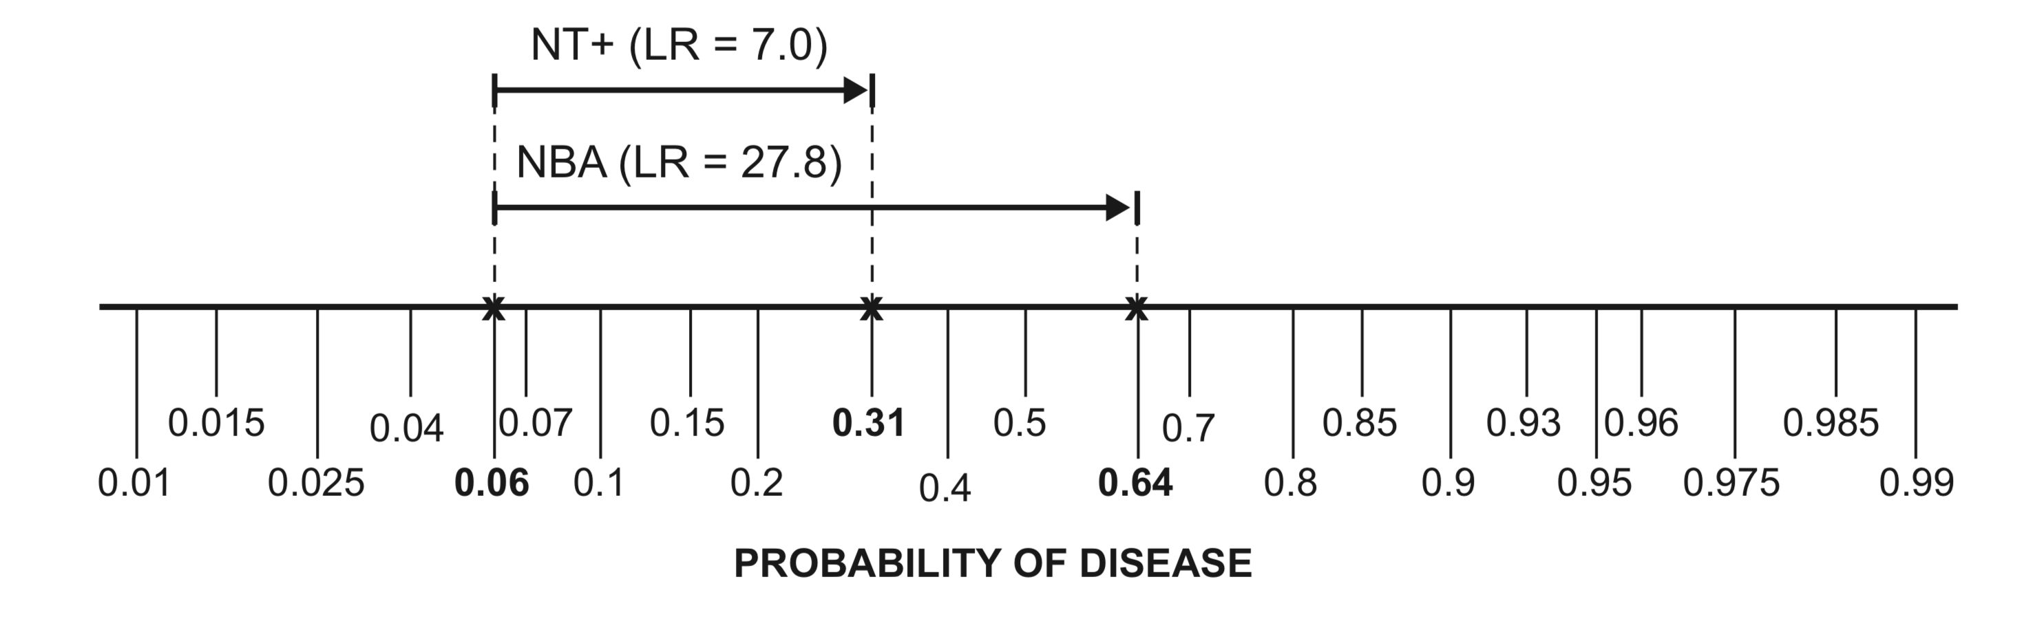
Figure 7.1 Starting with a 6% pre-test probability of trisomy 21, an NT ≥3.5 mm (NT+) increases the probability to 31%; ignoring the NT result, NBA increases the probability to 64%.
Table 7.3. The combination of NT and nasal bone examination results in fetuses with trisomy 21 and chromosomally normal fetuses among those selected for chorionic villus samplingª
 |  |  | Trisomy | 21
NT ≥ 3.5 mm | NBA | Yes | % | No | % | LR
Yes | Yes | 158 | 47.4% | 36 | 0.7% | 68.8
Yes | No | 54 | 16.2% | 442 | 8.5% | 1.9
No | Yes | 71 | 21.3% | 93 | 1.8% | 12
No | No | 50 | 15.0% | 4652 | 89.1% | 0.2
Total |  | 333 | 100% | 5223 | 100%
ª Data from Cicero et al. (2004)[2]
NBA does not tell you as much if you already know that the NT is ≥3.5 mm. Even in chromosomally normal fetuses, greater NT is associated with NBA. Of normal (D−) fetuses with a negative NT (<3.5 mm), only 2.0% had NBA. Of normal (D−) fetuses with a positive NT (≥3.5 mm), 7.5% had NBA. A false-positive NT makes a false positive NBA more likely. Ontologically, narrowing of the nuchal stripe and ossification of the nasal bone both occur as the fetus develops. Some chromosomally normal fetuses may develop more slowly than usual, or their estimated gestational age may be too high resulting in both a false-positive NT and a false-positive NBA.
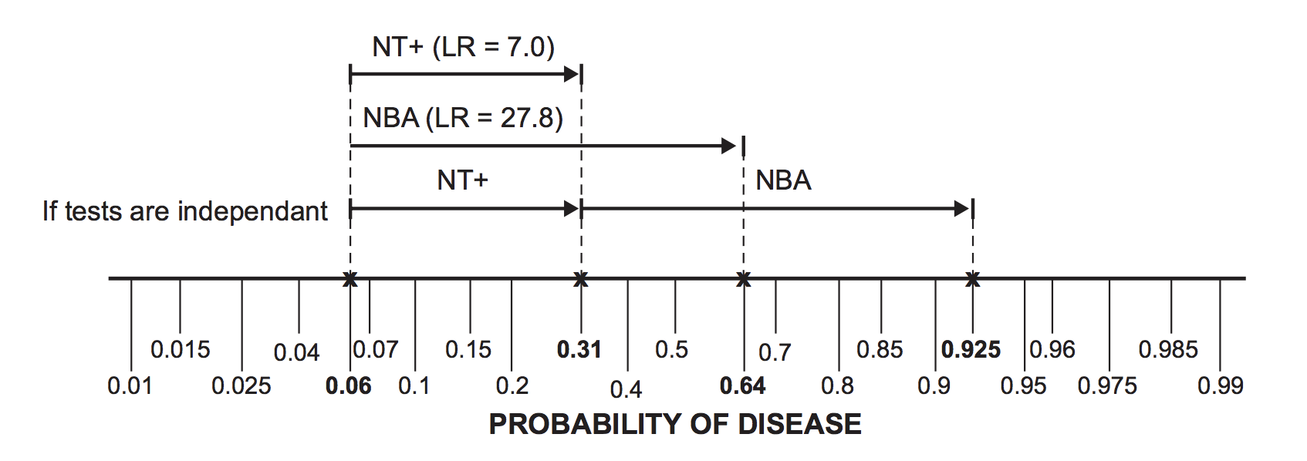
Figure 7.2 If the NT and nasal bone exams are independent, the LR of a combined positive result is the product of the LRs for a positive result on each test. On the log scale, multiplying LRs is the same as laying their arrows end-to-end.
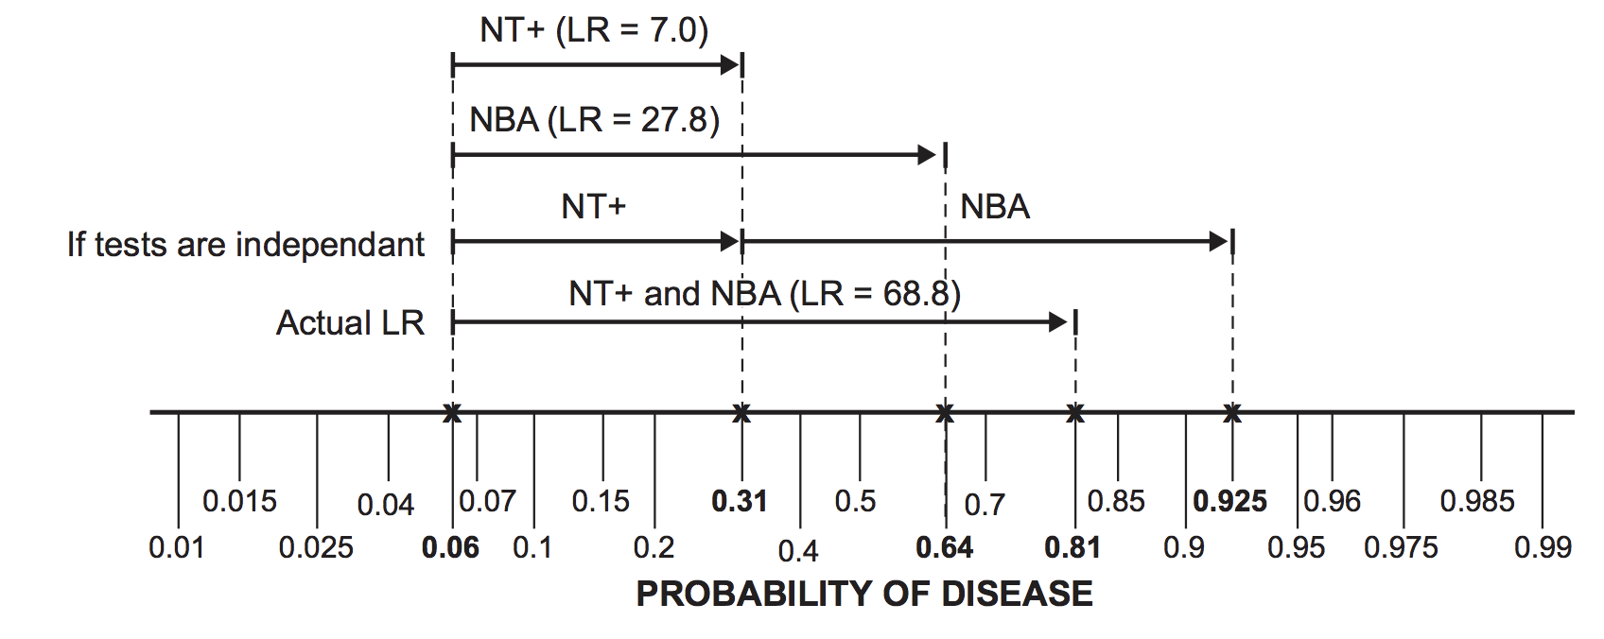
Figure 7.3 The LR associated with the combination of NT ≥3.5 mm (NT+) and NBA is less than the product of the LR for each result individually.

Combining the results of multiple dichotomous tests
We have demonstrated one way to handle the results of multiple tests: gather data to estimate the LR for each possible combination of test results. For two dichotomous tests, as in our example above, there are four possible results (+/+, +/−, −/+, and −/−). For three such tests, there are eight possible results; for four tests, sixteen results; and so on. Even with large samples, you might not have enough data to calculate LRs for the uncommon result combinations.
Another approach is to lump together all discordant results, calculating one LR for this category, while calculating separate LRs for the concordant results (all positive or all negative). In the case of two dichotomous tests, there would be an LR for “positive–positive (+/+),” “negative–negative (−/−),” and “discordant (+/− or −/+).” However, we saw in Chapter 2 that some tests are much more informative when they are positive than when negative, or vice versa. A pathognomonic finding (specificity = 100%) should rule in disease when positive, regardless of other test results. Thus, if the pathognomonic finding is present and all the other tests are negative, it does not make sense to lump this together with other discordant results. Also, a single category for “discordant results” cannot accommodate multilevel or continuous tests.
A variant of the “lumping together” approach is to combine multiple tests into a decision rule that is considered positive if any one of the tests is positive. This approach has been used in the Ottawa Ankle Rule [3]to determine which ankle-injury patients should get radiographs and the NEXUS (National Emergency X-Ray Utilization Study) Rule [4, 5]to determine which neck-injury patients should get cervical spine films. This strategy clearly maximizes sensitivity, though at the expense of specificity. Two issues that arise in the creation of such rules are the selection of which of many candidate tests to include in the rule and the assumption that the decision threshold is the same for all patients – topics to which we will return.

Classification Trees
Another approach is to use classification trees to develop a fixed sequence in which to do the multiple tests. The classification tree approach is also called recursive partitioning, which is just what it sounds like – recursive meaning you do it over and over again, and partitioning meaning you divide up the data in different ways. First, you (or the software) find the single variable and cutoff that best splits the data into two groups. Then for each of the sub-groups, you repeat this process separately, until the subgroups are homogeneous (e.g. all D+ or all D-), further splitting does not result in improvement, or the subgoups reach a specified minimum size (e.g. 5).[7]
In our example of NT and NBA for trisomy 21, which test should we do first? Figure 7.4 shows a tree of probabilities of trisomy 21 after each possible test result: (A) performing the NT test first and (B) performing the NBA test first. The NBA test is unequivocally better than the (dichotomized) NT at discriminating between trisomy 21 and chromosomally normal fetuses; both its positive predictive value (64% vs 31%) and negative predictive value (98% vs 97.5%) are higher. When neither split is unequivocally better, we must consider the relative importance of false positives and false negatives. The software programs that create classification trees, such as the rpart routine in the R statistical package, allow you to specify a loss matrix that assigns costs to different types of errors. When the purpose of the classification tree is to distinguish between two groups (e.g., trisomy 21 and chromosomally normal), specifying a loss matrix is equivalent to specifying our old friends B (the cost of a false negative) and C (the cost of false positive). As we learned in Chapter 2, B and C determine the treatment threshold probability P_{TT}. Just as a dichotomous test is only worth doing if it can move the probability of disease across the treatment threshold, the value of a split depends on how many individuals it moves across the treatment threshold.
Relative to real trees, classification trees are upside down. The top node is the root, a dividing point (e.g., NBA yes vs. no) is a branch, and a terminal node is a leaf. The tree need not display every possible leaf. With two dichotomous tests, there are four possible leaves, but suppose that your threshold probability (P_{TT}) for going on to chorionic villus sampling is 15%. After a positive NBA, a negative NT does not lower the probability of trisomy 21 below 15%, and after a negative NBA, a positive NT does not raise the probability of trisomy 21 above 15%. This suggests that you could stop after the nasal bone exam, because with P_{TT} = 15% the (dichotomized) NT would not affect your management. The classification tree only has two leaves. (Note this example is not perfect because the probabilities of Trisomy 21 from a study of fetuses already selected to receive chorionic villus sampling probably do not generalize to fetuses in whom that decision has not yet been made and because in real life there is little additional risk or expense in measuring the NT after the NBA. In addition, if we did not dichotomize the NT, some very high values of NT might have high enough LRs to be able to move past the 15% threshold.)
If your threshold for chorionic villus sampling is 5% rather than 15% and the initial NBA test is negative, you should continue with the NT test; a positive test will move the probability above the 5% threshold (Figure 7.5). If the initial NBA test is positive, it is not necessary to do the NT test, because (at least as dichotomized here) the result cannot change your decision to proceed with chorionic villus sampling. The tree has three leaves. Note that with this decision threshold, the combination of NBA and NT becomes a two-test rule that is considered positive if either of the tests is positive.
Specifying a decision threshold probability (or equivalently C/B) allows omission of some of the possible branches and leaves of the tree. However, the initially developed tree is often still too complex or “bushy.” This makes the tree impractical to use clinically and raises the problem of over-fitting to which we will return. The tree software allows us to limit the complexity of the tree.

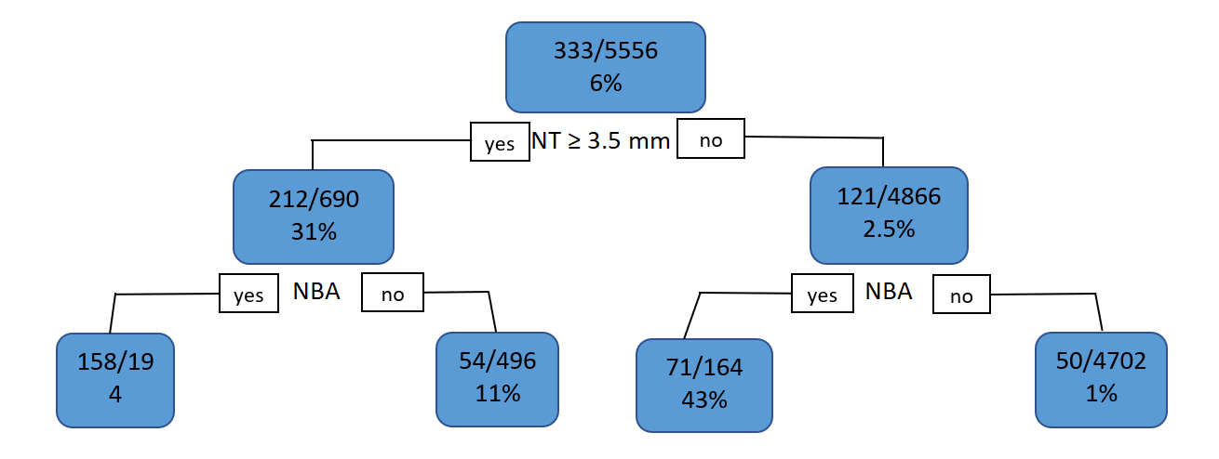
(A)
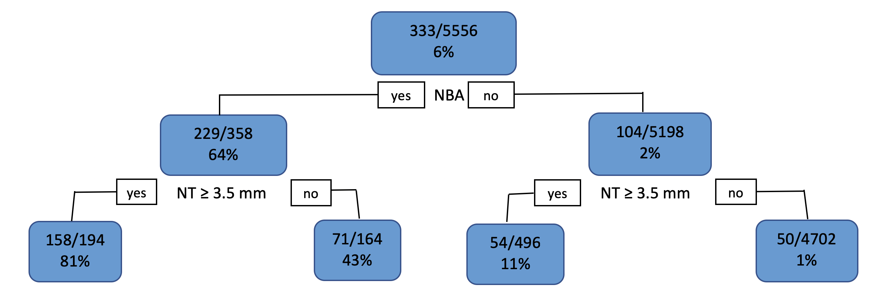
(B)
Figure 7.4 (A) Tree with branch-point probabilities of trisomy 21, assuming the NT test is performed first. (B) Tree with branch-point probabilities of trisomy 21 assuming the nasal bone exam is performed first. D+ = trisomy 21; NT = nuchal translucency; NBA = nasal bone absent.

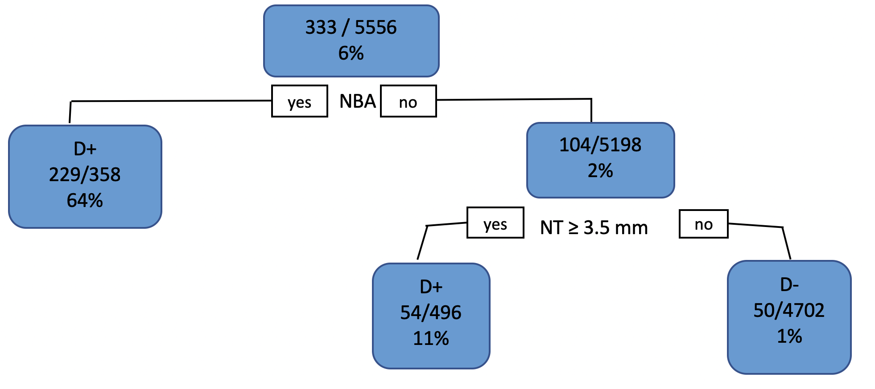

Figure 7.5 If the threshold probability for proceeding to chorionic villus sampling is 5%, the combination of nasal bone exam and NT becomes a two-test rule that is considered positive if either of the tests is positive. D+ = trisomy 21; NT = nuchal translucency; NBA = nasal bone absent.

A famous example of using classification trees to develop a testing algorithm was developed by Goldman et al. to identify myocardial infarction in emergency department patients with chest pain [8](Figure 7.6). The percentages at each branch and leaf in Figure 7.6 represent the proportion of patients with acute myocardial infarction. A much simpler example from the Pediatric Research in Office Settings Febrile Infant Study [9] is shown in Figure 7.7. The percentages next to each branch and in each leaf are the proportions of infants with bacteremia or meningitis.
Figures 7.5 through 7.8 display probabilities rather than LRs. This is common for multivariable models, including classification trees. Instead of providing an LR with which to update a pre-test probability estimate, the models tend to provide the post-test probability estimate directly. As mentioned above, the user is allowed to specify a loss matrix, which in the two-category case is equivalent to specifying the ratio B:C – that is, how much worse it is to have a false-negative than a false-positive result. For the febrile infant study example (Figure 7.7), the tree resulted from an analysis with the ratio of false-negative to false-positive misclassification costs set at 50:1.
Classification trees handle continuous test results by selecting cut-offs to dichotomize the results. Because the software will try every possible cutoff to find the one that performs best, the cutoffs for continuous variables are unlikely to be round numbers. If you see a clinical prediction rule or decision tree with odd-looking cutoffs for continuous variables, it is likely the result of a classification tree analysis and likely to be subject to some degree of overfitting, as will be discussed below. As we often did in Chapter 3, we can convert a continuous variable into an ordinal variable by choosing our own dividing points to break up the range of possible values into a small number of results. Then, the dividing points can be round numbers. Classification-tree algorithms deal well with ordinal variables.
As we discussed in Chapter 3, selecting a fixed cut-off to dichotomize a test reduces the information to be gained from it because a result just on the abnormal side of the cut-off is equated with a result that is maximally abnormal. However, with classification trees, you are not necessarily finished with a variable once you have dichotomized it. For example, an algorithm for predicting bacterial meningitis from CSF findings might first dichotomize the CSF WBC count (per mm³) at 1,000; and then, if it was <1,000, dichotomize again at 100, where patients with CSF WBC count between 100 and 1,000 would be classified as high risk for bacterial meningitis if they had some other finding (e.g., low CSF glucose) as well.
Obviously, using classification trees to combine tests produces trees, not scores, formulas, or nomograms. Our next method for combining tests, logistic regression, does produce scores, formulas, or nomograms. We can still evaluate the predictions from a classification tree using the methods covered in the last chapter, such as calibration plots, ROC curves, net benefit calculations, and decision curves. However, since a classification tree breaks the population into groups with discrete or “lumpy” risk estimates, it is difficult to divide the population into quantiles of risk for the calibration plot, and the decision curves will not be smooth (as in Box 6.3) but piecewise linear as in Figure 6.7. Classification trees do not assume that the risk of disease changes monotonically with a continuous test result. However, if risk does change monotonically with a continuous test result, logistic regression generally provides a more efficient use of the data in predicting the risk of disease.
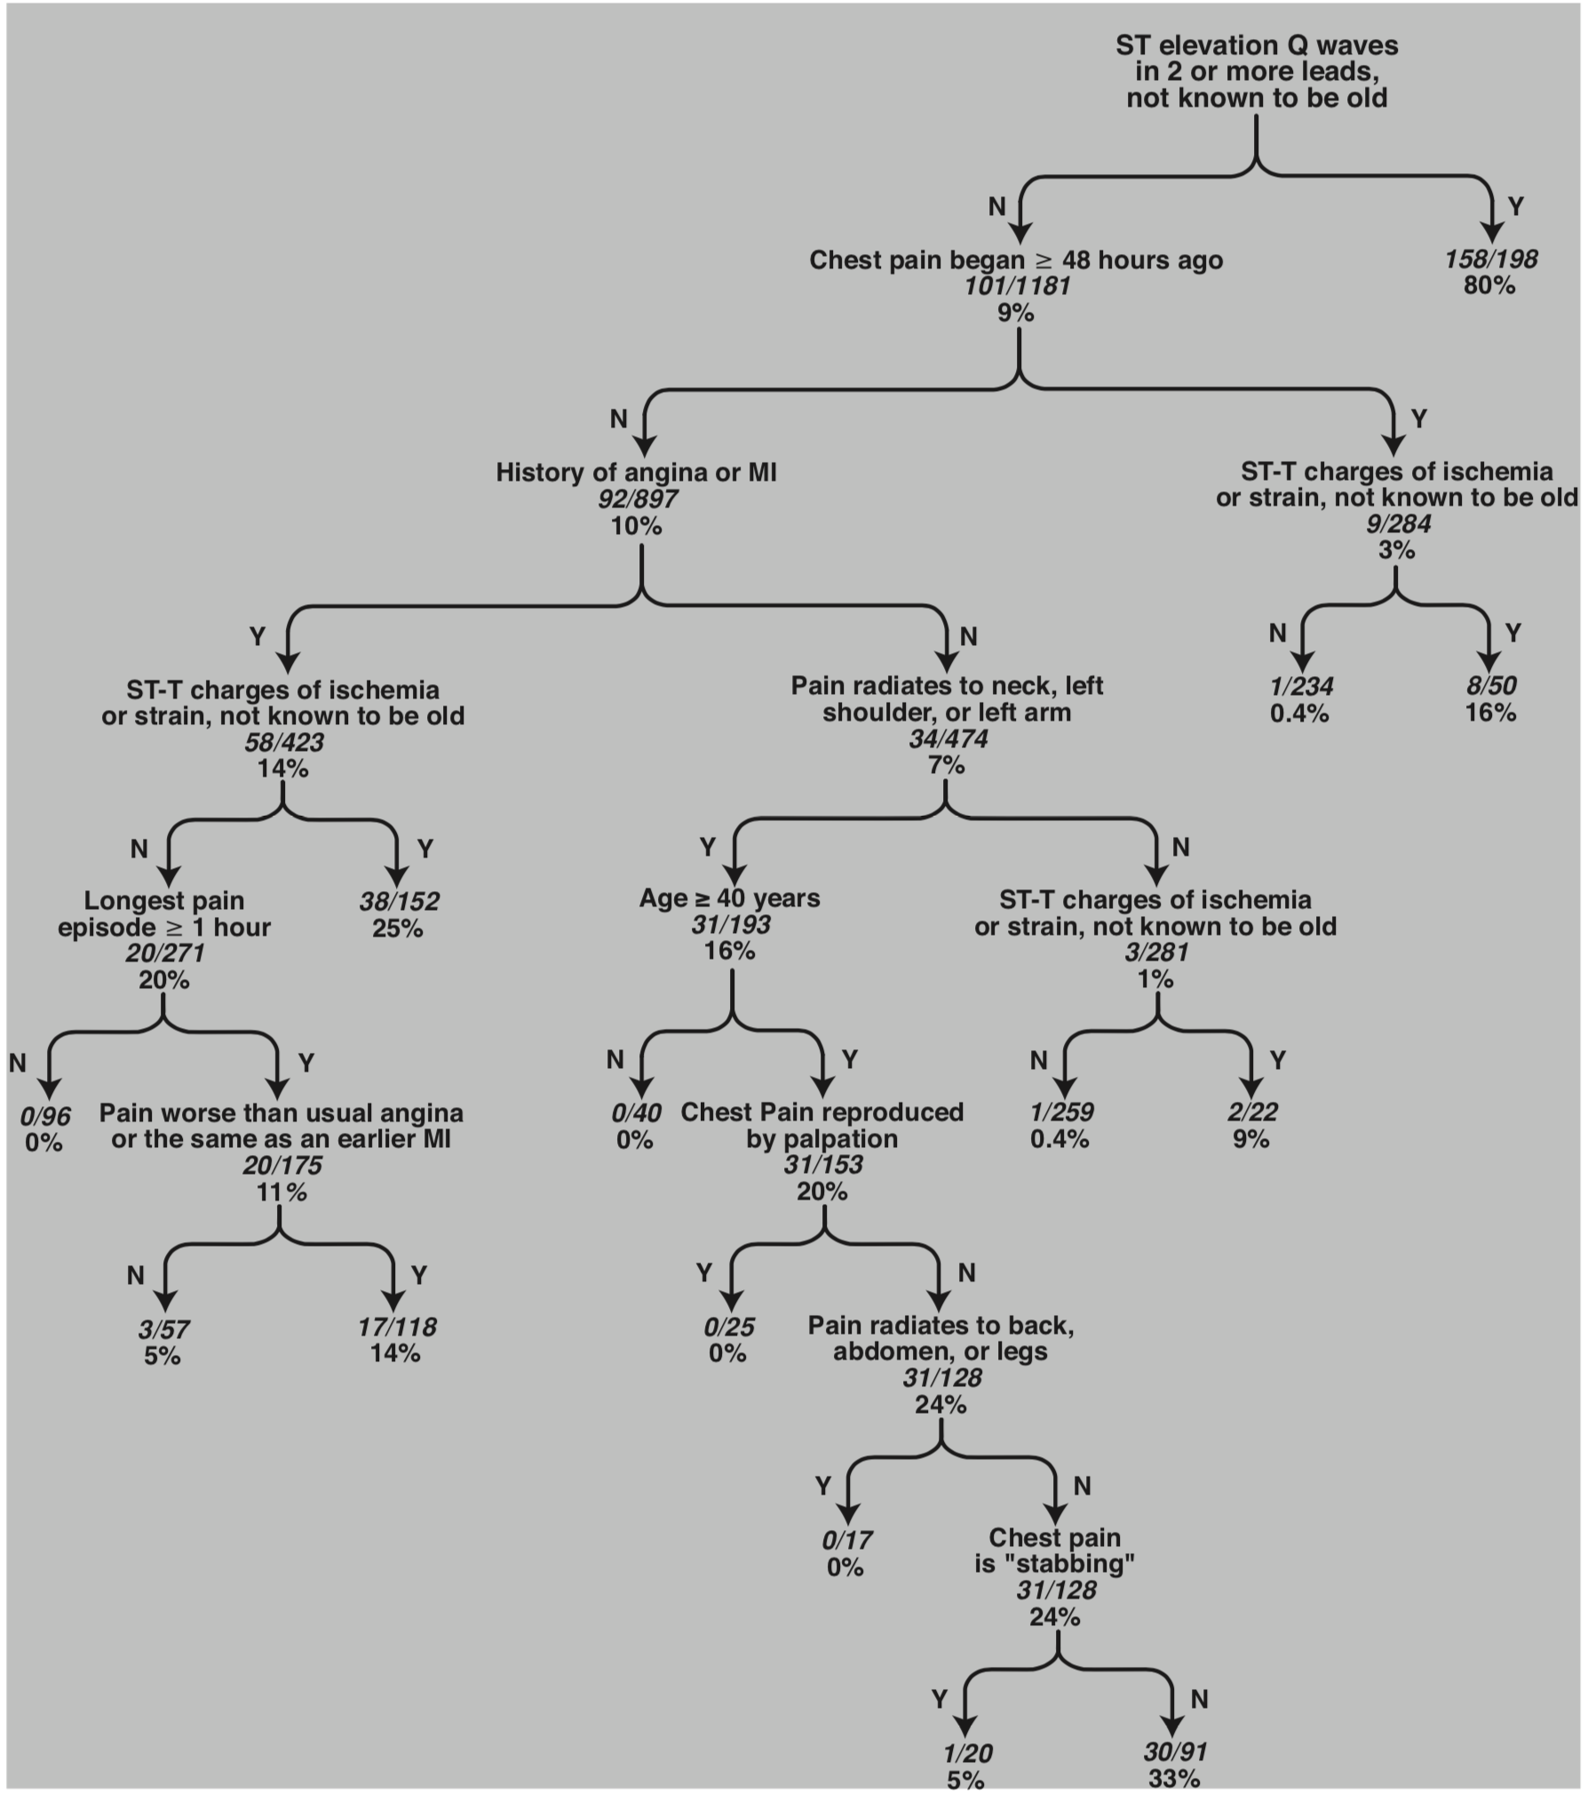
Figure 7.6 Classification tree to predict the likelihood that a chest pain patient has myocardial infarction (Goldman et al. 1988; Lee et al. 1991)[8, 10]. The percentages at each branch-point or terminal node (leaf) represent the proportion of patients with acute myocardial infarction.
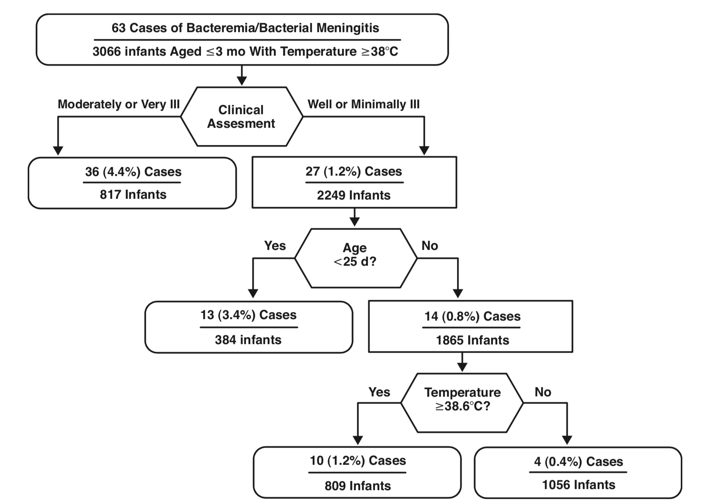
Figure 7.7 Classification tree combining general appearance, age in days, and temperature to determine likelihood of bacteremia or bacterial meningitis in febrile infants ≤ 3 months old. [9]. Used with permission.

Logistic regression
Partially because classification trees deal less efficiently with continuous variables than with discrete variables, a popular way to accommodate the results of multiple tests where at least some results are continuous is multiple logistic regression modeling [11, 12]. In Chapter 2, we used odds instead of probabilities in Bayes’s Theorem. Unlike probabilities, odds do not have an upper bound of 1, and pre-test odds can be multiplied by the LR of a test result to get post-test odds. Also in Chapter 2, we converted this multiplication into addition by replacing odds with their logarithms on the LR slide rule. Unlike both odds and probabilities, logarithms do not have a lower bound of 0. Logistic regression takes advantage of these desirable properties of odds and logarithms (compared with probabilities) and models the natural logarithm of the odds of disease [ln(odds)] as a linear function of the test results.
Box 7.2: How to calculate the odds ratio (OR) for nasal bone absence (NBA) in the diagnosis of trisomy 21.
Here are the data on the nasal bone exam in fetuses with and without trisomy 21:
Trisomy 21
 |  | Yes | No | Odds
NBA | Yes | 229 | 129 | 229/129 = 1.775
 | No | 104 | 5,094 | 104/5,094 = 0.020
 | Odds | 229/104 2.202 | 129/5,094 0.025
The OR is
Because of the symmetry of the odds ratio, this is the same as

Odds ratios
The logistic regression coefficient for each test result is the natural logarithm of its multivariate odds ratio (OR). In Chapter 8, we will return to the OR in the context of quantifying the benefits of a treatment. (The OR is often used inappropriately to quantify treatment effects in randomized trials.) Here, we discuss how ORs are used to quantify the information provided by a positive test result or presence of a risk factor. ORs are easiest to understand when the test is dichotomous; in this case, the OR is the quotient of the odds of disease in those with a positive test divided by the odds of disease in those with a negative test (Box 7.2).
Box 7.2 shows the calculation of the OR for NBA in the diagnosis of trisomy 21. The OR for a dichotomous test is also the LR of a positive result divided by the LR of a negative result. ORs and LRs are frequently confused. For test results, LRs are generally more appropriate to use than ORs, but when assessing risk factors with widely varying prevalences from population to population, the OR may be more useful, as shown in Box 7.3.
When the test is dichotomous, the farther the OR is from 1, the stronger the association between the test result and the disease. For continuous tests, the OR from logistic regression is the amount the odds of disease change per unit increase in the test result. If the units of measurement vary, ORs farther from 1 may not mean a stronger association with disease. The OR for fever per degree will differ depending on whether the temperature is measured in Centigrade or Fahrenheit. (It will be farther from 1 for temperature measured in Centigrade.)
Box 7.3: Understanding the difference between ORs and LRs
If we start with the prior probability of disease, P(D+), we can convert to prior odds, Odds(D+), and then multiply by the LR(+) or LR(−) to get the posterior odds:
Odds of disease given a positive test or exposure = Odds(D+|+) = Odds(D+) × LR(+)
Odds of disease given a negative test or no exposure = Odds(D+|−)
= Odds(D+) × LR(−)
The OR is the ratio of the posterior odds in those who test positive (or are exposed to a risk factor) to those who test negative (or are unexposed). Because the prior odds cancel out of that ratio, the OR is just LR(+)/LR(−).
OR = Odds(D +|+)/Odds(D +|−) = [Odds(D+) × LR(+)]/[Odds(D+) × LR(−)]
= LR(+)/LR(−)
If you want the odds of disease in a patient with a positive test result or exposure to a risk factor, you can either multiply the odds of disease in the overall population by the LR(+), or multiply the odds of disease in the test-negative or unexposed population by the OR. In other words, if you start with the overall odds of disease, you use the LR(+); if you start with the odds of disease in the test-negative or unexposed group, you use the OR.
It makes more sense to use odds ratios (or risk ratios) for risk factors that cause the disease and likelihood ratios for test results that are caused by the disease. A good reason to avoid LRs for causal risk factors is that they will vary with the prevalence of the risk factor.
This is illustrated in Figure 7.8. Consider a disease that has a strong risk factor, the prevalence of which varies widely in different populations. An example one of us has studied is urinary tract infections (UTIs) in young infant boys with fevers. [13] The OR for UTI in uncircumcised boys, compared with circumcised boys, is about 10. What would be the LRs? The answer is that the LRs will depend on the proportion of the boys in the population who are circumcised. In Figure 7.8A, most of the boys in the population are circumcised. Therefore, the prior odds of UTI in a febrile boy will be low, and if he is circumcised (which we are calling being unexposed to the risk factor), the odds will not decline very much because they already start out low. On the other hand, if he is one of the few who is uncircumcised, the LR+ will be high and significantly increase his posterior odds.
Now consider the situation in a population where hardly any boys are circumcised (Figure 7.8B). The prior odds start out much higher, reflecting this high prevalence of a strong risk factor for UTI. However, in this case, the odds change much more if the boy is circumcised than if he is not. For causal risk factors like circumcision, LRs have the disadvantage that they are unlikely to be generalizable from one population to another. No wonder a systematic review of predictors of UTI in febrile infants reported a wide range of LRs for circumcision in different studies.[14]
This is not the case for the sort of predictive factors that LRs were designed for: clinical tests, such as laboratory and imaging tests that are caused by the disease rather than causes of it.
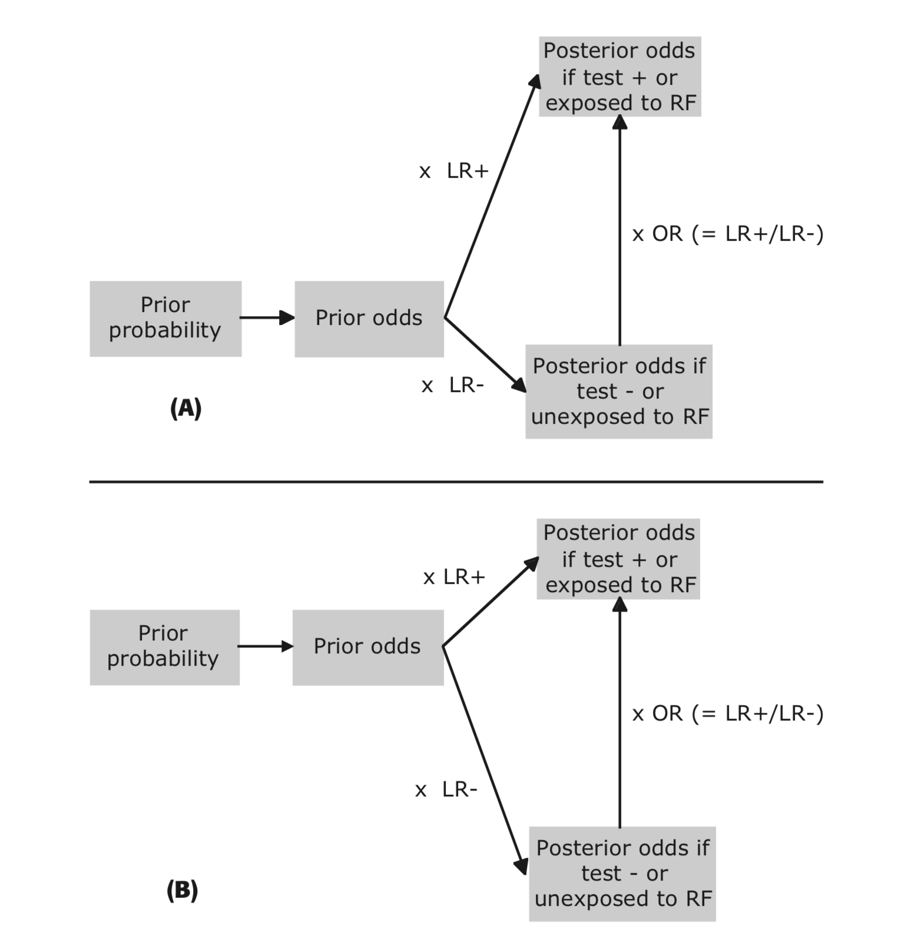
Figure 7.8 Relationship between prior odds, LRs (LR+ and LR−), posterior odds, and the OR. (A) Low prevalence of strong risk factor. (B) High prevalence of strong risk factor. The length and direction of an LR arrow correspond to the logarithm of the LR; the LR− points downward because its logarithm is negative. The LR magnitudes change depending on the prevalence of the risk factor, whereas their ratio, the OR, remains the same.

Logistic regression modeling
We applied a logistic regression approach to the NT and nasal bone exam data, using NT ≥3.5 mm and NBA as dichotomous predictors of trisomy 21. The dataset included 5,556 records, one for each fetus evaluated. The variable for NT was valued “1” for NT ≥3.5 mm and “0” for <3.5 mm; the variable for NBA was similarly valued “1” if the nasal bone was absent or “0” if the nasal bone was present. The binary outcome variable for trisomy 21 was also coded in standard fashion. The results, as they might appear in a journal article, are shown in Table 7.4.
Table 7.4. Multivariate ORs resulting from a logistic regression model using fetal NT and NBA as dichotomous predictors of trisomy 21
 | Multivariate OR trisomy 21 | 95% CI
NT ≥ 3.5 mm | 8.7 | 6.3–11.8
NBA | 53.0 | 38.7–72.7

The multivariate OR for NBA is much greater than the multivariate OR for NT. This allows us to say that, when both are available, NBA is a more important predictor of trisomy 21 than NT.
A multiple logistic regression model adjusts the OR associated with one dichotomous test for the fact that one or more additional tests are performed. Based on the data in Table 7.2, the bivariate OR for NBA is 87.0 (calculated in Box 7.2) and the bivariate OR for NT is 17.4. Because the two tests are not independent, the multivariate ORs are lower when both variables are included together than they are for each variable separately.

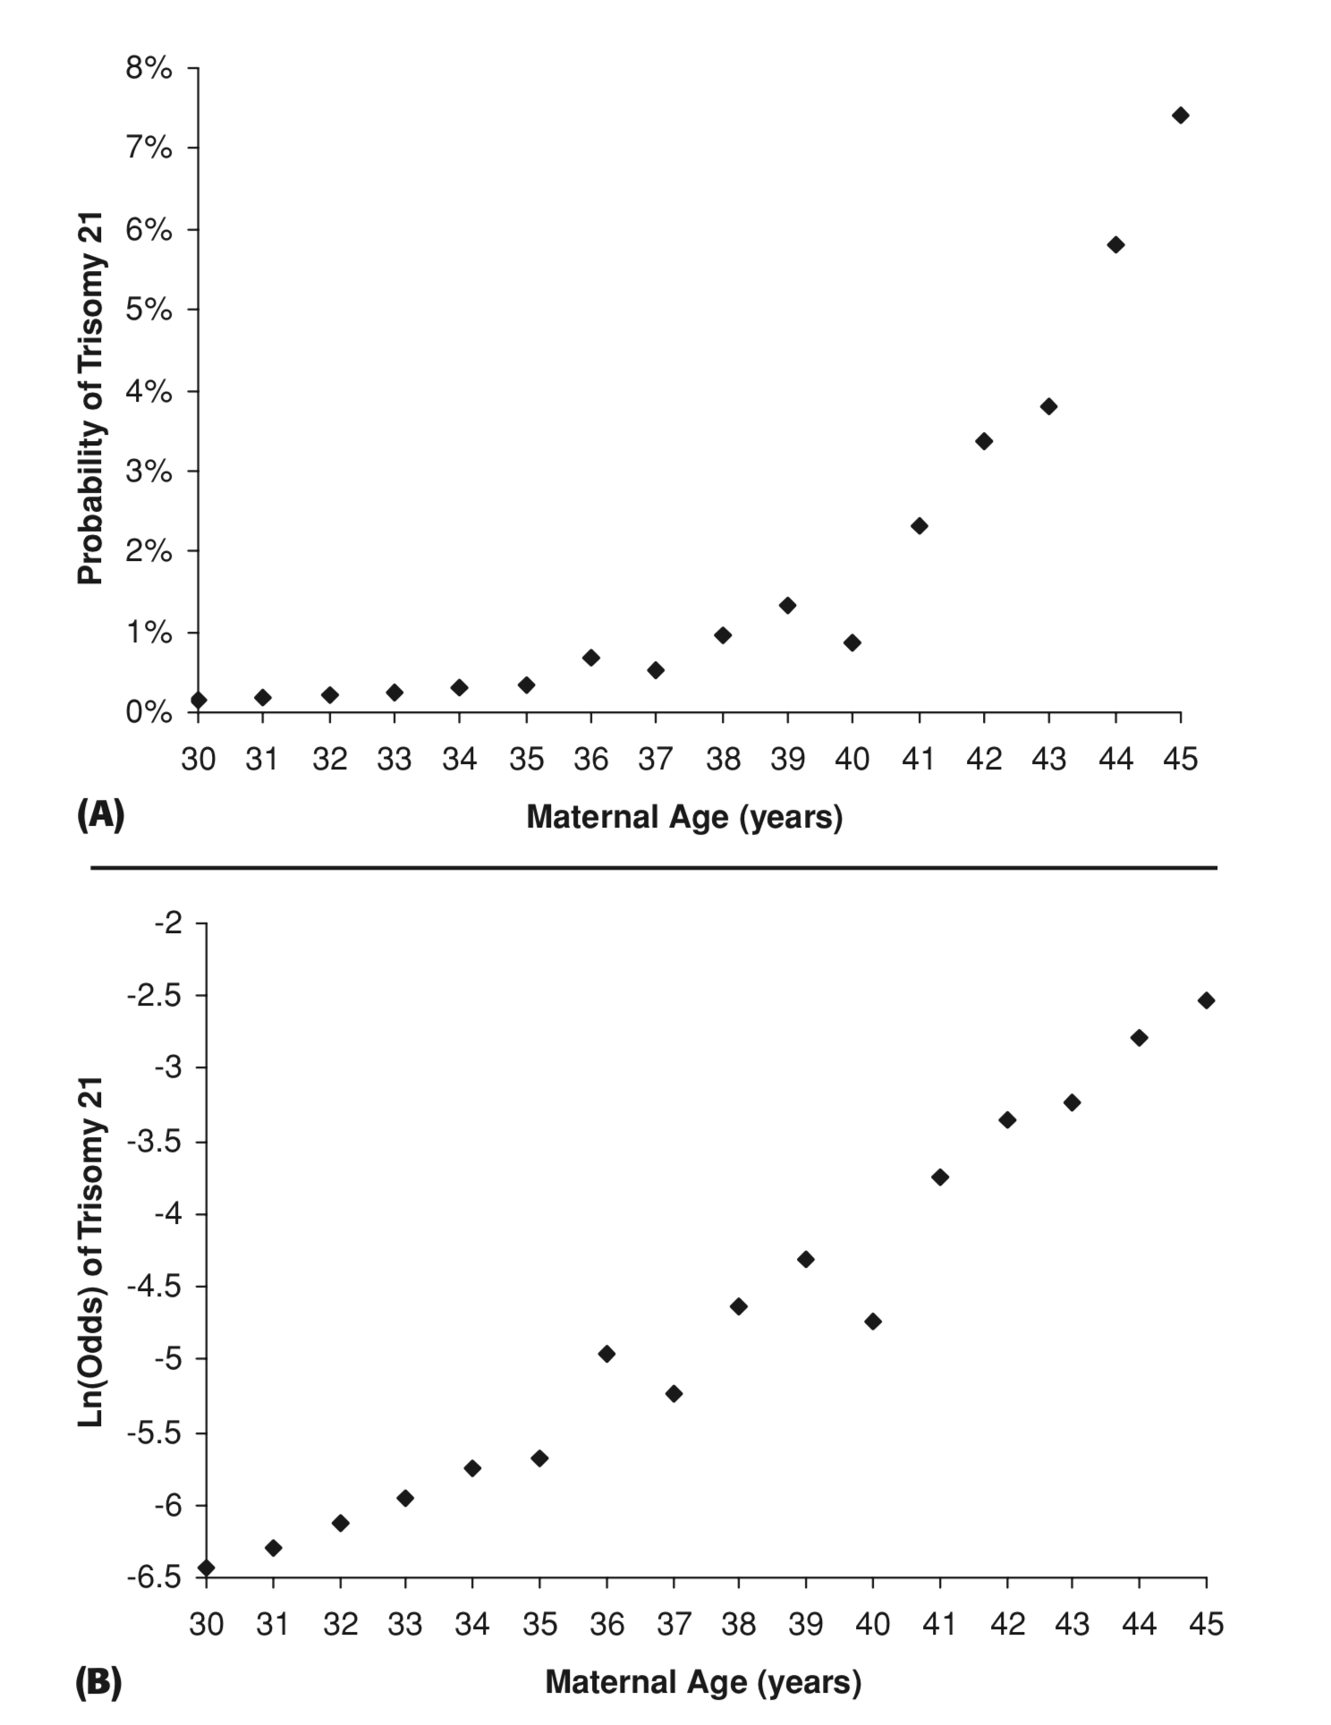

Figure 7.9 Probability of trisomy 21 as a function of maternal age (data from Snijders et al. 1999, Table 1)[15]. (A) Plot of probability versus maternal age. (B) Plot of ln(odds) versus maternal age.

Logistic regression using the results of a single continuous test
So far in this chapter, we have ignored the advice of Chapter 3 and discarded information by dichotomizing NT at 3.5 mm, calling an NT <3.5 mm “negative” and ≥3.5 mm “positive” for trisomy 21. In fact, an NT of 6 mm is much more suggestive of trisomy 21 than an NT of 3.5 mm. One of the main reasons to use logistic regression is to accommodate one or more continuous test results.
To see one reason why logistic regression models ln(odds) instead of probability, consider another predictor of trisomy 21: maternal age. Figure 7.9A shows the probability of trisomy 21 (at 16 weeks gestation) by maternal age.[15] The relationship between probability of trisomy 21 and maternal age is distinctly nonlinear. In fact, like many biological relationships, the relationship is approximately exponential: each additional year of age multiplies the risk by a certain amount rather than adding an amount. If, instead of probability, we graph the ln(odds) as a function of maternal age, as in Figure 7.9B, we get a relationship that is much closer to linear. This is one reason why logistic regression models ln(odds) instead of probability as a linear function of test results.
As discussed in Chapter 3, we sometimes choose a cut-off value for a continuous test to trigger some action. In maternal–fetal medicine, the cut-off for obtaining a fetal karyotype by chorionic villus sampling or amniocentesis has been traditionally arbitrarily set at a 1 in 300 (0.33%) risk of trisomy 21. Based on logistic regression models used to fit data like those displayed in Figure 7.9, the maternal age cut-off would therefore be 35 years.

Logistic regression using the results of two continuous tests
The situation becomes more complex when logistic regression models use more than one continuous test to determine the patient’s probability of disease. For example, a decision rule about proceeding to chorionic villus sampling might consider NT as well as maternal age. Now, we move from a single-variable logistic regression model to a multivariable model. The single cut-off value (35 years old) is replaced by a cut-off line or curve (Figure 7.10). The line represents the NT cut-off at each maternal age. We expect this line to have a negative slope because the NT threshold should decrease as the maternal age increases.
For Figure 7.10, we defined high risk of trisomy 21 as probability greater than 1%. In a 21-year-old woman, a fetus with NT of 3 mm is considered low risk (<1% probability of trisomy 21), but in a 35-year-old woman, a lower NT of 2.5 mm is considered high risk (>1% probability).

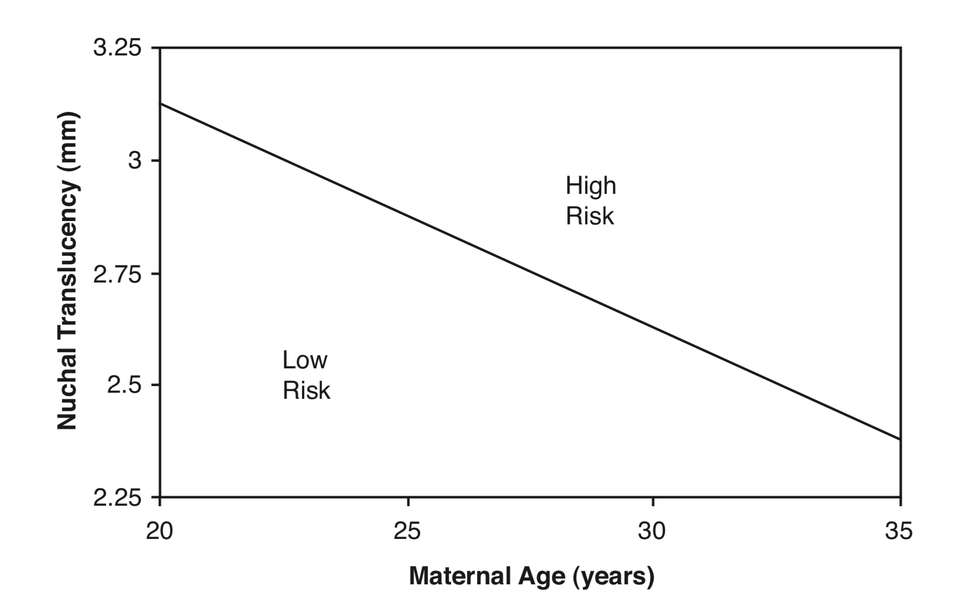
Figure 7.10 A hypothetical nomogram showing the combinations of maternal age and NT that identify fetuses at high risk for trisomy 21. In this nomogram, “high risk” is greater than 1% probability of trisomy 21 (Data abstracted from Nicolaides 2004, Figure 6, page 20)[16].
Box 7.4: Advanced material on logistic regression: interaction terms and goodness of fit
The logistic model presented in Table 7.4 does not include an interaction term. In a model with two dichotomous tests, an interaction term is an additional term that distinguishes when both tests are positive from when only one or the other is positive. In the above model, the interaction term would be NT × NBA, which would equal 1 only if both tests were positive. Since this model now includes 3 variables, we are modelling all 4 possible test result combinations (+/+, +/−, −/+, −/−).
Unless a logistic regression model includes interaction terms, a one-unit change in the result of any given test changes the ln(odds) of disease by the same amount, regardless of how the other tests came out. For this reason, it is important to assess how well the logistic model fits the data – the so-called goodness of fit.
Table 7.5 shows the multivariate odds ratios when an interaction term is included in the logistic model. The OR of 0.51 for the interaction term means that the OR for having both NT+ and NBA+ (compared with neither) is only 0.51 times as high as the product of the NT+ and NBA+ odds ratios obtained when only one of them is positive.
Table 7.5. Multivariate ORs resulting from a logistic regression model using fetal NT and NBA as dichotomous predictors of trisomy 21, including an interaction term
 | Multivariate OR trisomy 21 | 95% CI
NT+ (≥ 3.5 mm) only | 11.4 | 7.6 – 16.9
NBA+ only | 71.0 | 46.9 – 107.7
NBA+ and NT+ (both) | 0.51 | 0.27 − 0.94

Clinical decision rules developed using logistic regression
Like the rule of Goldman et al. for predicting myocardial infarction, developed using classification trees, a famous example of a clinical decision rule developed using logistic regression is also for predicting myocardial infarction, as well as unstable angina. This is the Acute Coronary Ischemia–Time Insensitive Predictive Instrument (ACI-TIPI). [17, 18] The predictors in this logistic model include sex, age, existence/importance of chest pain as a presenting symptom and multiple ECG findings (Table 7.6).
As an example, a 55-year-old man with chest pain as his major symptom and new Q waves on his ECG but no ST or T wave changes would have ln(odds) of acute coronary ischemia of −3.93 + 1.23 + 0.88 + 0.71 + 0.67 − 0.43 + 0.62 =−0.25, so the odds would be e^{−0.25} = 0.78 and the probability would be 0.78/1.78 = 44%.
Table 7.6. Logistic regression coefficients from the ACI-TIPI modelª
Variable | Coefficient | Multivariate OR ^{b}
Intercept^{c} | −3.93
Presence of chest pain | 1.23 | 3.42
Pain major symptom | 0.88 | 2.41
Male sex | 0.71 | 2.03
Age ≤40 | −1.44 | 0.24
Age >50 | 0.67 | 1.95
Male >50 years^{d} | −0.43 | 0.65
ST elevation | 1.314 | 3.72
New Q waves | 0.62 | 1.86
ST depression | 0.99 | 2.69
T waves elevated | 1.095 | 2.99
T waves inverted | 1.13 | 3.10
T wave + ST changes | −0.314 | 0.73
ª From Selker et al. (1991)[18].
^{b} The multivariate OR is obtained by exponentiating the coefficients.
^{c} The intercept is added to the total for all subjects; it is equal to the log of the pretest odds in subjects who have a value of 0 for all variables in the model. For the model above this makes sense because all variables are dichotomous. For models with continuous variables the intercept is what the model would predict if all continuous variables were set to zero, even though in many cases (weight, systolic blood pressure, temperature, etc.), this would make no biological sense.
^{d} This score includes two interaction terms. Male sex has an OR of 2.03 and age >50 years has an OR of 1.95. Without an interaction term, the OR for being both male and over 50 would be 2.03 × 1.95 = 3.96. The OR of 0.65 for being both male and over 50 indicates that 3.96 is too high and that 0.65 × 3.96 = 2.57 is a better estimate.
Although this is not practical for a clinician to calculate, the rule can be programmed into an ECG machine so that, if the technician enters a few items from the history, the estimated probability of acute coronary ischemia can be printed with the automated ECG analysis.
Another famous use of multiple logistic regression was the development of the PORT Pneumonia Score [19] to predict death in patients with pneumonia. The authors used the coefficients from their logistic regression model to create the point scoring system shown in Tables 7.7 and 7.8.
Unlike classification trees, logistic regression models produce formulas, scores, and nomograms. It is generally easy to divide a sample population into quantiles of risk for a calibration plot, and the ROC curves and decision curves can often be smooth, as in Box 6.3.
Table 7.5. Calculation of the PORT score to predict likelihood of death among patients with pneumonia
Characteristic |  | Points assignedª
Demographic factor
Age |  | +Age (years)
Women |  | − 10
Nursing home resident |  | + 10
Coexisting illness
Neoplastic disease |  | + 30
Liver disease |  | + 20
Congestive heart failure |  | + 10
Cerebrovascular disease |  | + 10
Renal disease |  | + 10
Physical-examination findings
Altered mental status |  | + 20
Respiratory rate ≥30/min |  | + 20
Systolic blood pressure <90 mm Hg |  | + 20
Temperature <35°C or ≥40°C |  | + 15
Pulse ≥125/min |  | + 10
Laboratory and radiographic findings
Arterial pH <7.35 | + 30
Blood urea nitrogen ≥30 mg/dL | + 20
Sodium <130 mEq/L | + 20
Glucose ≥250 mg/dL | + 10
Hematocrit <30% | + 10
Partial pressure of arterial oxygen <60 mm Hg | + 10
Pleural effusion | + 10
ª A total point score for a given patient is obtained by summing the patient’s age in years, subtracting 10 for women, and adding the points for each applicable characteristic. The points assigned to each predictor variable were based on coefficients obtained from a logistic-regression model.
^{d} This score includes two interaction terms. Male sex has an OR of 2.03 and age >50 years has an OR of 1.95. Without an interaction term, the OR for being both male and over 50 would be 2.03 × 1.95 = 3.96. The OR of 0.65 for being both male and over 50 indicates that 3.96 is too high and that 0.65 × 3.96 = 2.57 is a better estimate.
Table 7.8. Mortality according to the PORT scoreª
Score | 30-Day mortality
<71 | 0.6%
71−90 | 2.8%
91−130 | 8.2%
>130 | 29.2%
ªFrom Fine et al [19]

Selecting tests to include in a decision rule
Thus far, we have focused on how to combine the results of several tests, not on which tests to include in a clinical prediction rule. We want to include those tests with the greatest ability to discriminate between D+ and D− individuals (at reasonable cost and risk). These are also the tests that we want to do first in a classification tree.
Many candidate variables may be important in determining the probability of disease. In developing a clinical decision rule, we often have to choose just a few of these variables. This variable selection is best done based on biological understanding and the results of past studies.[11] Often, however, research studies measure many predictor variables, and there is no strong basis for narrowing down the large number of candidate variables to the handful that provide the most predictive power. Classification trees can help with this. In the simplified case of using NBA and (dichotomized) NT to identify trisomy 21 fetuses, we saw that a decision threshold of 15% allowed us to drop NT from consideration. After a positive NBA test, a negative NT could not move the probability below 15%, and after a negative NBA test, a positive NT could not move the probability above 15%.
When trying to select variables to include in a logistic regression model, some authors use a stepwise process. They either start with a large number of variables in the model and remove the least statistically significant variables one at a time (backward) or start with no predictor variables and add variables one at a time, each time adding the one that is most significant (forward). More recently, LASSO (Least Absolute Shrinkage and Selection Operator) regression has been used for variable selection;[20] details are beyond the scope of this book.
Whatever technique is used for variable selection, the resulting model may best predict outcome in the particular dataset from which it was derived but generally will do less well in other datasets, as discussed below.

Overfitting and the importance of validation
“ If you torture data sufficiently, it will confess to almost anything.”
– Fred Menger
“Overfitting” refers to use of models that are made overly complicated in order to fit the data that has been collected. It is analogous to gerrymandering of congressional districts, in which legislators choose their voters, rather than vice versa,which provides perhaps the best way to visualize the problem. Just as you can choose boundaries on a map to maximize your party’s congressional seats, you can choose boundaries for dividing your dataset that maximize the degree to which D+ and D- subjects are separated, but since they take advantage of the idiosyncrasies of your current dataset, these boundaries won’t work in a new dataset.
If you are allowed to choose combinations of tests and findings from a large number investigated, and then choose the cut-off that optimizes discrimination, you can often develop a prediction rule that works well in a specific sample (especially if the sample size is small). But this variable selection takes advantage of chance variations in the data that will no longer work to your advantage if you try to validate the prediction rule on a new dataset.
For example, Oostenbrink et al.[21] used four history variables, four laboratory variables, and ultrasound results to predict vesicoureteral reflux among 140 children (5 years and younger) who had their first UTI. Their final prediction rule had an AUROC of 0.78; at the cut-off they chose, it had 100% sensitivity and 38% specificity for Grade III or higher reflux, which was found in 28 subjects in their sample. When another group attempted to validate the rule on a similar group of 143 children, sensitivity and specificity at the same cut-off were only 93% and 13% respectively, neither clinically nor statistically significant [22].
One way to quantify overfitting is to develop a clinical prediction rule on one (generally randomly selected) group of patients, called the “derivation set” and then test it on a second group, called the “validation set.” If overfitting occurred, the performance on the validation set will be substantially worse. If derivation and validation sets came from the same study, the investigator might be tempted to try again, tweaking the prediction rule so it performs better in the validation set. But, of course, this defeats the purpose of the validation set, and, in effect, makes the whole study a derivation set. (There is a subtle example in this chapter’s Problem 1.) Finally, even if a prediction rule performs well in a validation set randomly selected from the study population, additional validation is helpful to determine how well it performs in different populations and different clinical settings.

K-Fold Cross Validation
We can make a multivariable model more complex and flexible by including more predictors, allowing a more complex or “bushier” tree, or for a continuous predictor (x), including a quadratic term (x²) or cubic term (x³). Making a model more complex and flexible always improves its fit in the derivation dataset, but at a certain point, makes performance in the validation set significantly worse due to overfitting. K-fold cross-validation can help identify the appropriate level of complexity.[23] The software randomly divides the dataset into k (typically 5 or 10) equal-sized groups or “folds.” The first fold is used as the validation dataset and the multivariable method (e.g., classification trees or logistic regression) is fit on the remaining k - 1 folds. This is repeated k times holding out a different group each time, resulting in k estimates of the model error. These k estimates are averaged together for a summary estimate of the model error. We can vary the complexity of the model, e.g. the number of included variables, the number of terminal nodes (leaves) in a tree, or the number of quadratic terms, and see how the summary estimate of model error changes. Generally, the estimated model error will decrease when moving from a very simple model (such as assigning the mean probability from the derivation dataset to every point in the validation set) to a more complex model. However, at a certain point, increasing the model complexity increases the error due to overfitting. The purpose of k-fold cross validation is to identify the level of complexity that minimizes model error.

Machine learning
We have discussed classification trees and logistic regression as ways to combine multiple variables to diagnose a disease or predict an outcome. These are two of the most basic algorithms falling under the rubric of machine learning. Machine learning, also known as statistical learning, encompasses a large number of predictive analytic techniques and comes with its own terminology. For example, in machine learning, the derivation dataset is usually referred to as the “training set” and the validation dataset is referred to as the “test set”; predictors are often referred to as “features”. Machine learning is increasingly applied in medical diagnosis and risk prediction.[24, 25] As with the predictions from genetic tests (Chapter 6), the predictions from machine learning are still just risk predictions; we evaluate them using ROC curves, calibration plots, net benefit calculations, and decision curves, but you should know about two important techniques utilized in machine learning: bootstrap aggregation and random forests™. We will describe these by starting with what we already know about classification trees.
A classification tree like the chest pain rule in Figure 7.6 estimates the probability of disease (myocardial infarction in this case) for a subject with a given set of predictor values (e.g., test results). Bootstrap aggregation or “bagging” consists of creating a large number (usually > 1000) of training datasets by randomly sampling with replacement from the original training dataset. The computer algorithm generates a different classification tree for each of these training datasets. When given a new subject with a set of predictor values, each tree produces a probability of disease. For example, if we set the number of bootstrap samples at 1000, then there will be 1000 probability estimates for each subject.
The average of these 1000 probabilities is the bootstrap estimate for the subject’s disease probability and the variance is used to generate a confidence interval around the estimate. We discuss confidence intervals in Chapter 11, but in this context, a confidence interval is the range of disease probabilities for our subject that is consistent with the training data. A bootstrap probability estimate has a narrower confidence interval (is more precise) than the probability estimate from a single classification tree created without re-sampling. Once we have gone to bootstrap aggregation, we are no longer very concerned about the bushiness of the tree. The algorithm becomes more of a “black box” that produces probability estimates (with confidence intervals) based on the training dataset but does not indicate which variables are most important in determining risk.
Bootstrap aggregation differs from k-fold cross-validation. K-fold cross-validation divides the dataset into 5 or 10 non-overlapping groups. Its purpose is to estimate model error as a function of model complexity and determine the appropriate balance between a model that is too simple and one that suffers from overfitting. Bootstrap aggregation involves generating 1000 or more new datasets by sampling with replacement from the original dataset. Its purpose is to generate a more precise estimate of disease probability (or outcome risk).
Bootstrap aggregation entails random sampling of observations from the training dataset. Random forests goes one step further and randomly selects the predictors (or features) to be considered at each branch in the tree. Let’s say we have data on 100 candidate variables on which to split and are going to obtain 1000 bootstrap samples. In each one of the 1000 bootstrap samples, a tree is created, but at each branch point, the candidate split variables are limited to a random subset (e.g., 1/3) of the total number of potential split variables.[26]
As an extension of bootstrap aggregation, random forests also produces black-box probability estimates or classifications rather than a simple comprehensible rule for classifying an observation or estimating disease probability. The advantage of random forests is surprisingly good performance. For example, Guncar et al found random forests to be clearly superior to other machine learning techniques in diagnosing hematologic disorders.[27] Caruana [28] compared 8 different machine learning techniques for binary classification using a variety of performance metrics on 11 different datasets, including 2 medical datasets; random forests performed best in both medical datasets. You are sure to see more applications of random forests to clinical diagnosis and prediction. [28-30]

The clinician versus the decision rule
Because clinical prediction rules are based on large datasets and combine variables in a consistent mathematical way, they generally do better than even experienced clinicians at estimating disease probability. For example, a simple clinical prediction rule called PLAN for predicting death and severe disability on hospitalization for stroke[31] appears to discriminate better than physicians.[32]
But, as we have learned, more goes into decisions than just estimating probabilities. We have reservations about broad application of clinical decision rules that go beyond helping us estimate probabilities and tell us what to do. These rules generally assume that the treatment threshold probability is the same from patient to patient. The clinician can adjust the decision threshold based on differing consequences of error and the patient's values. For example, our threshold for initially treating an infant at risk for bacteremia might be lower if the family lives far from the hospital or has no home telephone. The above-mentioned risk threshold for fetal diagnostic procedures of 1 in 300 does not allow that failing to diagnose trisomy 21 and/or fetal loss due to the chorionic villus sampling may be valued differently by different parents. The ability to account for these differences is a potential advantage of the clinician over the decision rule.

Summary of key points
1. When combining the results of multiple tests for a disease, it is only valid to multiply the LRs for the individual test results if the tests are independent.
2. Tests for the same disease are often nonindependent for three inter-related reasons:
a) they measure the same pathophysiologic aspect of the disease;
b) the diseased group is heterogeneous; and/or
c) the nondiseased group is heterogeneous.
3. The ideal way to use results from multiple different tests would be to empirically define an LR for each possible combination of results. However, the number of possible combinations of test results compared with the number of outcomes often makes this infeasible.
4. Two main methods used to combine results of multiple tests are classification trees and multivariable logistic regression.
5. Developing a decision rule for combining multiple tests often involves variable selection – that is, choosing which tests to include in the rule.
6. The choice of variables when deriving a decision rule is particularly subject to chance variations in the sample (derivation) dataset, and therefore, validation of the rule in a separate, independent population is important.
7. The machine-learning methods of bootstrap aggregation and random forests will be used increasingly to develop decision rules and multivariate risk models but lack transparency regarding which variables are most influential in determining risk.
8. Clinical prediction rules are good for estimating the probability of disease or specific outcomes, but clinicians can incorporate other information as well, including patients' values.

REFERENCES

1. Lachs MS, Nachamkin I, Edelstein PH, Goldman J, Feinstein AR, Schwartz JS. Spectrum bias in the evaluation of diagnostic tests: lessons from the rapid dipstick test for urinary tract infection. Ann Intern Med. 1992;117(2):135-40.
2. Cicero S, Rembouskos G, Vandecruys H, Hogg M, Nicolaides KH. Likelihood ratio for trisomy 21 in fetuses with absent nasal bone at the 11-14-week scan. Ultrasound Obstet Gynecol. 2004;23(3):218-23.
3. Stiell IG, McKnight RD, Greenberg GH, McDowell I, Nair RC, Wells GA, et al. Implementation of the Ottawa ankle rules. JAMA. 1994;271(11):827-32.
4. Hoffman JR, Mower WR, Wolfson AB, Todd KH, Zucker MI. Validity of a set of clinical criteria to rule out injury to the cervical spine in patients with blunt trauma. National Emergency X-Radiography Utilization Study Group. N Engl J Med. 2000;343(2):94-9.
5. Hoffman JR, Wolfson AB, Todd K, Mower WR. Selective cervical spine radiography in blunt trauma: methodology of the National Emergency X-Radiography Utilization Study (NEXUS) [see comments]. Ann Emerg Med. 1998;32(4):461-9.
6. Quinn JV, Stiell IG, McDermott DA, Sellers KL, Kohn MA, Wells GA. Derivation of the San Francisco Syncope Rule to predict patients with short-term serious outcomes. Ann Emerg Med. 2004;43(2):224-32.
7. Therneau T, Atkinson E. An Introduction to Recursive Partitioning Using the RPART Routines [web page/pdf]. cran.r-project.org; 2018 [Available from: https://cran.r-project.org/web/packages/rpart/vignettes/longintro.pdf.
8. Goldman L, Cook EF, Brand DA, Lee TH, Rouan GW, Weisberg MC, et al. A computer protocol to predict myocardial infarction in emergency department patients with chest pain. N Engl J Med. 1988;318(13):797-803.
9. Pantell RH, Newman TB, Bernzweig J, Bergman DA, Takayama JI, Segal M, et al. Management and outcomes of care of fever in early infancy. JAMA. 2004;291(10):1203-12.
10. Lee TH, Juarez G, Cook EF, Weisberg MC, Rouan GW, Brand DA, et al. Ruling out acute myocardial infarction. A prospective multicenter validation of a 12-hour strategy for patients at low risk. N Engl J Med. 1991;324(18):1239-46.
11. Stoltzfus JC. Logistic regression: a brief primer. Acad Emerg Med. 2011;18(10):1099-104.
12. Laupacis A, Sekar N, Stiell IG. Clinical prediction rules. A review and suggested modifications of methodological standards. JAMA. 1997;277(6):488-94.
13. Newman TB, Bernzweig JA, Takayama JI, Finch SA, Wasserman RC, Pantell RH. Urine testing and urinary tract infections in febrile infants seen in office settings: the Pediatric Research in Office Settings' Febrile Infant Study. Arch Pediatr Adolesc Med. 2002;156(1):44-54.
14. Shaikh N, Morone NE, Lopez J, Chianese J, Sangvai S, D'Amico F, et al. Does this child have a urinary tract infection? JAMA. 2007;298(24):2895-904.
15. Snijders RJ, Sundberg K, Holzgreve W, Henry G, Nicolaides KH. Maternal age- and gestation-specific risk for trisomy 21. Ultrasound Obstet Gynecol. 1999;13(3):167-70.
16. Nicolaides KH. The 11-13+6 Weeks Scan. London: Fetal Medicine Foundation; 2004. 112 p.
17. Selker HP, Beshansky JR, Griffith JL, Aufderheide TP, Ballin DS, Bernard SA, et al. Use of the acute cardiac ischemia time-insensitive predictive instrument (ACI-TIPI) to assist with triage of patients with chest pain or other symptoms suggestive of acute cardiac ischemia. A multicenter, controlled clinical trial. Ann Intern Med. 1998;129(11):845-55.
18. Selker HP, Griffith JL, D'Agostino RB. A tool for judging coronary care unit admission appropriateness, valid for both real-time and retrospective use. A time-insensitive predictive instrument (TIPI) for acute cardiac ischemia: a multicenter study. Med Care. 1991;29(7):610-27.
19. Fine MJ, Auble TE, Yealy DM, Hanusa BH, Weissfeld LA, Singer DE, et al. A prediction rule to identify low-risk patients with community-acquired pneumonia [see comments]. N Engl J Med. 1997;336(4):243-50.
20. James G, Witten D, Hastie T, Tibshirani R. Chapter 6 Linear Model Selection and Regularization. An introduction to statistical learning : with applications in R. 103. New York: Springer; 2013.
21. Oostenbrink R, van der Heijden AJ, Moons KG, Moll HA. Prediction of vesico-ureteric reflux in childhood urinary tract infection: a multivariate approach. Acta Paediatr. 2000;89(7):806-10.
22. Leroy S, Marc E, Adamsbaum C, Gendrel D, Breart G, Chalumeau M. Prediction of vesicoureteral reflux after a first febrile urinary tract infection in children: validation of a clinical decision rule. Arch Dis Child. 2006;91(3):241-4.
23. James G, Witten D, Hastie T, Tibshirani R. Chapter 5 Resampling Methods. An introduction to statistical learning : with applications in R. 103. New York: Springer; 2013.
24. Obermeyer Z, Emanuel EJ. Predicting the Future - Big Data, Machine Learning, and Clinical Medicine. N Engl J Med. 2016;375(13):1216-9.
25. Jordan MI, Mitchell TM. Machine learning: Trends, perspectives, and prospects. Science. 2015;349(6245):255-60.
26. Efron B, Hastie T. Chapter 17 Random Forests and Boosting. Computer age statistical inference : algorithms, evidence, and data science. Institute of Mathematical Statistics monographs: Institute of Mathematical Statistics monographs; 2016. p. 324-50.
27. Gunčar G, Kukar M, Notar M, Brvar M, Černelč P, Notar M, et al. An application of machine learning to haematological diagnosis. Scientific Reports. 2018;8(1):411.
28. Caruana R, Niculescu-Mizil A. An Empirical Comparison of Supervised Learning Algorithms. Proceedings of the 23rd International Conference on Machine Learning. 2006.
29. Ozcift A. Random forests ensemble classifier trained with data resampling strategy to improve cardiac arrhythmia diagnosis. Comput Biol Med. 2011;41(5):265-71.
30. Yang F, Wang HZ, Mi H, Lin CD, Cai WW. Using random forest for reliable classification and cost-sensitive learning for medical diagnosis. BMC Bioinformatics. 2009;10 Suppl 1:S22.
31. O'Donnell MJ, Fang J, D'Uva C, Saposnik G, Gould L, McGrath E, et al. The PLAN score: a bedside prediction rule for death and severe disability following acute ischemic stroke. Arch Intern Med. 2012;172(20):1548-56.
32. Reid JM, Dai D, Delmonte S, Counsell C, Phillips SJ, MacLeod MJ. Simple prediction scores predict good and devastating outcomes after stroke more accurately than physicians. Age Ageing. 2017;46(3):421-6.

The leukocyte esterase is a test for white blood cells in the urine; the nitrite test is for bacteria.
See the discussion of spectrum bias in Chapter 4 and Table 4.3. These data exclude fetuses with other chromosomal abnormalities.
Radiographs are recommended if the patient has tenderness of the navicular bone, the base of the fifth metatarsal, or either malleolus or if the patient is unable to bear weight for four steps both at the time of injury and the time of evaluation.
Cervical spine films are recommended if the patient has any of the following: midline posterior cervical spine tenderness, alcohol or drug intoxication, abnormal alertness, focal neurologic deficit, or distracting painful injury.
How "best" is determined depends on parameters selected by the user; e.g., the misclassification costs for false-positives compared with false negatives.
Calculate the negative predictive value as 1 – P(trisomy 21) when the test is negative.
Farther from 1 on a multiplicative scale, in which 0.1 and 10 are equally "far" from 1. Put another way, it's the farther the log(OR) is from zero.
The “ln” part of the ln(odds) transformation is what straightens out the curve at the low end because of the exponential relationship. The “odds” part would straighten out the curve at the high end if probabilities approached 1 because, while probabilities have to be ≤ 1, odds go to infinity. The probabilities in 7.10 are low so simply taking their logarithms would also have straightened out the curve.
A one-unit change in the result of a dichotomous test is just going from negative to positive. But examining the goodness of fit of the logistic model is especially important for tests with continuous or ordinal results, even if there are no interactions, because the model assumes that the effect of a one-unit change in the result is the same across the full range of the results. While the model fits well for maternal age and trisomy 21 in Figure 7.9B, one should not assume that will be the case.
We did not get a response to our request for permission to include a picture of the Illinois 4th Congressional district in this book, but interested readers can find it with Google or here: https://en.wikipedia.org/wiki/Illinois%27s_4th_congressional_district#/media/File:Illinois_US_Congressional_District_4_(since_2013).tif
A quick shortcut: any time sensitivity and specificity sum to 1, the test is useless. In this case the sum is 1.06.
This discussion or k-fold cross-validation assumes that a single modelling approach, such as classification trees or logistic regression, has been chosen and the question is how complex to make the model. K-fold cross-validation can also be used to compare different modelling approaches.
Random Forests is a registered trademark for the software developed by Leo Breiman and Adele Cutler, who use singular verbs with it, so we will, too.
Random forests performed best in the MEDIS dataset and “bagged trees” (which is so similar to random forests that we will not distinguish between them) performed best in the MG dataset.
We'll revisit clinicians' difficulty estimating probabilities in Chapter 12.

