Epi 204 -- Problem Set #5
Chapter 6 ANSWERS (Risk Prediction)
Due 10/24/2019 1 pm
35 POINTS +1 EC

6.1. Meteorologists on Two Television Channels [9 points]
During a rainy month, you watch the weather report and decide whether to carry an umbrella. Your decision is irrevocable in that, if you decide not to carry an umbrella and head off to work and it rains, you can’t change your mind.

You have decided that being in the rain without an umbrella is exactly 3 times as bad as carrying an umbrella unnecessarily.

The Channel 2 meteorologist predicts a 33% chance of rain on every single day of the month. The Channel 3 meteorologist predicts a 50% chance of rain on two-thirds of the days and a 100% chance of rain on one third of the days. At the end of the month it turns out that it rained on 10 out of 30 days. It also turns out that every time the Channel 3 meteorologist predicted a 50% chance of rain, it didn’t rain; and every time she predicted a 100% chance of rain, it did.

- What is your threshold probability of rain for carrying an umbrella? [1]

Threshold odds = 1/3 Threshold probability = ¼ or 25%

- If you watched and believed the Channel 2 meteorologist, how many days of the month did you carry an umbrella? [1]
Every day, because 33% > 25%.

- If you watched and believed the Channel 3 meteorologist, how many days of the month did you carry an umbrella? [1]

Every day, because both 100% and 50% are > 25%.

- What is the average predicted chance of rain for Channel 2? What is it for Channel 3? [2]

Channel 2: 33%
Channel 3: 1/3 × 100% + 2/3 × 50% = 67%

Calculate the Mean Bias, Mean Absolute Error, and Brier Score for each meteorologist and fill out the following table: [3].

 | Mean Bias | MAE | Brier Score
Channel 2
Channel 3

Answer:

 | Mean Bias | MAE | Brier Score
Channel 2 | 0.00 | 0.44 | 0.22
Channel 3 | 0.33 | 0.33 | 0.17

Mean Bias:
Channel 2 –10 rain days with error 0.33 - 1 = -0.67 and 20 no-rain days with error 0.33 – 0 = 0.33. 10/30 × -0.67+ 20/30 ×0.33 ≈0
Channel 3 10 rain days with error 1 - 1 = 0 and 20 no-rain days with error 0.5 – 0 = 0.5. 10/30 × 0+ 20/30 ×0.5 ≈ 0.33

Mean Absolute Error:
Channel 2 –10 rain days with error |0.33 – 1| = 0.67 and 20 no-rain days with error |0.33 – 0| = 0.33. 10/30 × 0.67 + 20/30 ×0.33 ≈ 0.44
Channel 3 10 rain days with error |1 – 1| = 0 and 20 no-rain days with error |0.5 – 0| = 0.5. 10/30 × 0+ 20/30 ×0.5 ≈ 0.33

Brier Score:
Channel 2 –10 rain days with error (0.33 – 1)² = 0.45 and 20 no-rain days with error (0.33 – 0)² = 0.11. 10/30 × 0.45 + 20/30 ×0.11 ≈ 0.22
Channel 3 10 rain days with error (1 – 1)² = 0 and 20 no-rain days with error (0.5 – 0)² = 0.25. 10/30 × 0 + 20/30 ×0.25 ≈ 0.17

We’ve asked that this be graded leniently because for MAE and Brier due to error on earlier version of the slide and some confusion because all groups are equal size in the mastate cancer example.

- Assuming discrimination and calibration of each channel’s meteorologist will be similar next month, which channel should you watch and when should you carry an umbrella? [1]

You should watch the Channel 3 meteorologist and carry an umbrella when she says there is a 100% chance of rain but not when she says the chance is 50%. You are able to re-calibrate and capitalize on the perfect discrimination on Channel 3.
6.2. ABCD2 Score to predict stroke after a transient ischemic attack [10 + 1EC)

The ABCD2 Score was developed to estimate the risk of stroke in patients after a transient ischemic attack (TIA, a brief period of neurological symptoms due diminished blood flow to the brain).[1]

For your information, here is how the ABCD2 score is calculated.
Risk Factor |  | Points
Age
 | ≥ 60 years | 1
Blood Pressure
 | Systolic ≥ 140 mm Hg or Diastolic ≥ 90 mm Hg | 1
Clinical features of the TIA
 | Unilateral weakness (with or without speech impairment) | 2
 | Speech impairment without unilateral weakness | 1
Duration
 | TIA duration ≥ 60 minutes | 2
 | TIA duration 10-59 minutes | 1
Diabetes
 | Diabetes diagnosed by a physician | 1
 | Total ABCD2 Score | 0 – 7

The 2-day risk of stroke by ABCD2 score is shown below:

Score | % of TIA Patients | 2-day Stroke Risk
0-3 | 34% | 1.0%
4-5 | 45% | 4.1%
6-7 | 21% | 8.1%

One of the main reasons for hospitalizing a patient after TIA is to enable rapid treatment with thrombolytics (to dissolve blood clots) if the patient has a subsequent stroke in the next 2 days.

- Assume you are willing to admit 25 patients to the hospital for 2 days unnecessarily in order to avoid discharging one from the emergency department who goes home to have a stroke in the next 2 days. What is your ABCD2 score cutoff for hospitalization? [2+1EC]

Using terminology from Chapter 2, 25C=B, so the treatment threshold of C/(C+B) = 1/26 = 3.8%. Based on the table above, a safe and reasonable answer would be to admit when the score is ≥ 4 and the 2-day stroke risk is 4.1%.

Extra credit answer: With 4 and 5 grouped together it's not possible to tell for sure, but it seems likely that a score of 4 would have a risk <4.1% and a score of 5 would have a risk of >4.1%, because the combined 4 and 5 group has a risk of 4.1%. If that's the case, it might be reasonable to admit when the score is ≥ 5, since the risk is probably <3.8% if the score is 4.

We will convert the table of 2-day risks above into an ROC table and calculate the area under it.

First, order the results from most to least abnormal:

Score | % of TIA Patients | 2-day Stroke Risk
6-7 | 21% | 8.10%
4-5 | 45% | 4.10%
0-3 | 34% | 1.00%

Next, calculate the individual cell percentages. To get the D+ column, we multiply the proportion of patients in each risk stratum by the 2-day stroke rate in that stratum. Thus, e.g. if we had 10,000 patients, 21% (=2100) would have a score of 6-7 and 8.1% of those 2100 = 170 would have a stroke. So the top D+ cell would be 170/10,000 = 1.70%.

Score | D+ | D- | % of TIA Patients
6-7 | 1.70% | 19.30% | 21%
4-5 | 1.85% | 43.16% | 45%
0-3 | 0.34% | 33.66% | 34%
Total | 3.89% | 96.11% | 100.00%

Then, calculate the column percentages. For example, for the top D+ cell, 1.70%/3.89% = 43.77%.

Score | D+ | D-
6-7 | 43.77% | 20.08%
4-5 | 47.48% | 44.90%
0-3 | 8.75% | 35.02%
Total | 100.00% | 100.00%

Finally, change them to cumulative percentages.

Score | D+ | D-
≥ 6 | 43.77% | 20.08%
≥ 4 | 91.25% | 64.98%
≥ 0 | 100.00% | 100.00%

- Use the above ROC Table to plot the ROC curve on the grid below.[2]

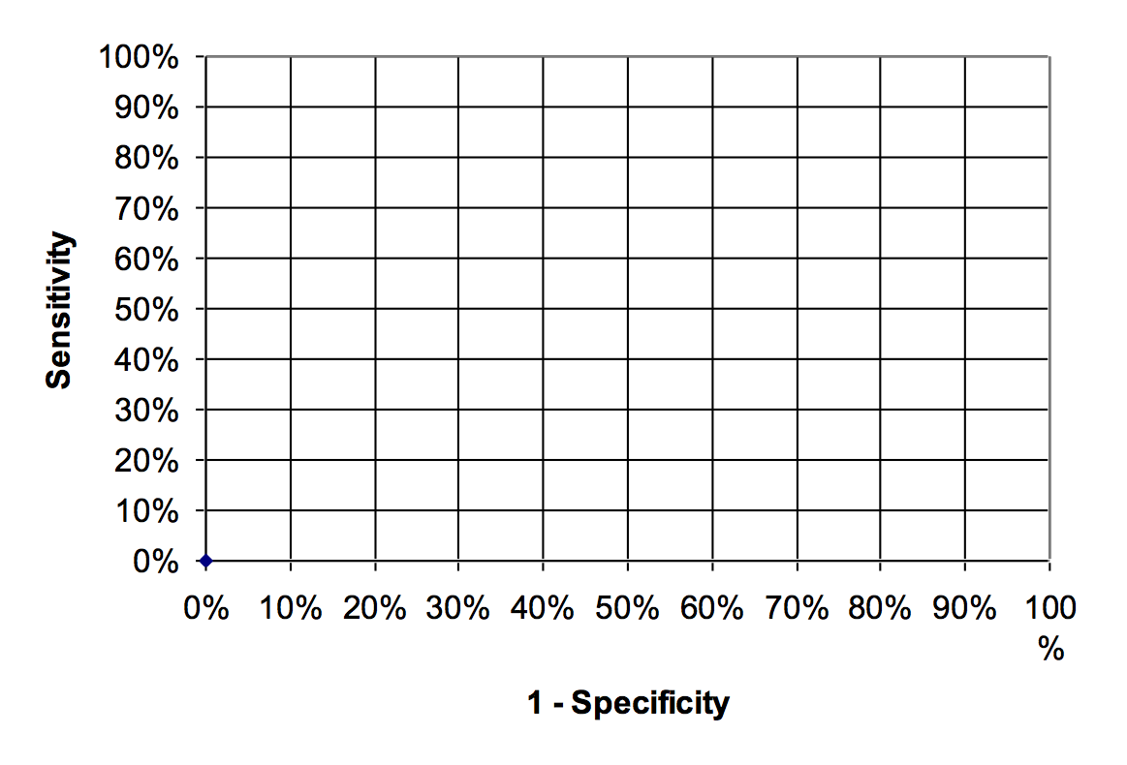
ANSWER:

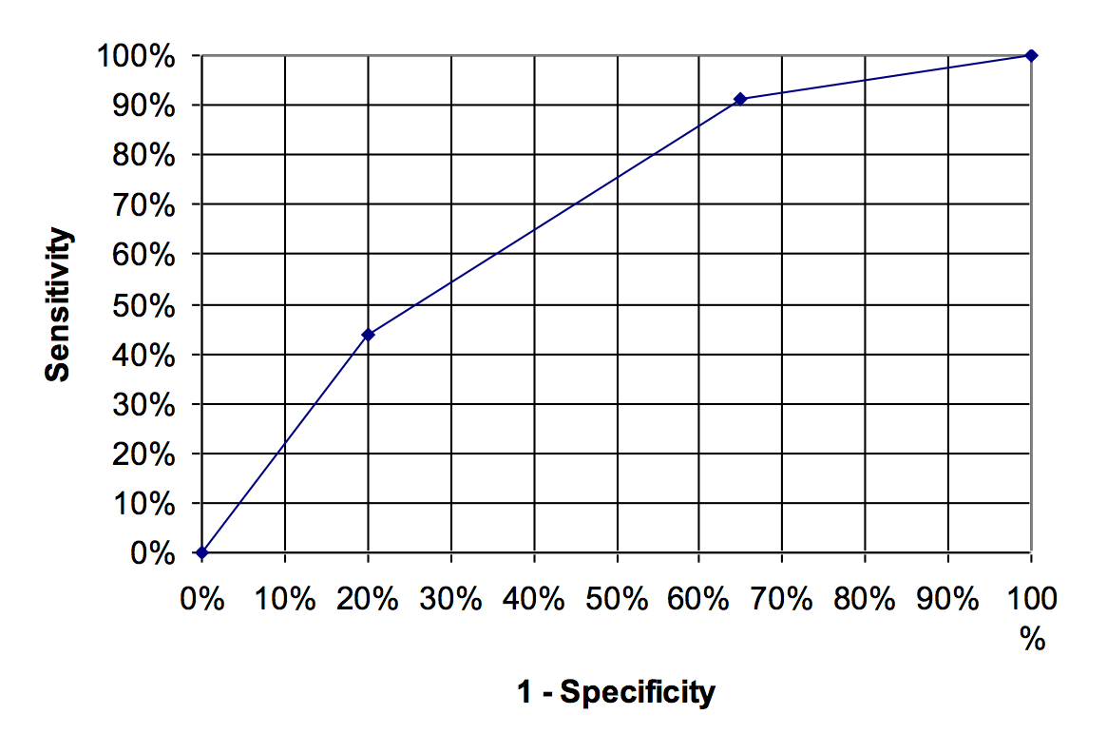
AUROC = 0.68

- If you didn’t admit any TIA patients (“No Treat”), what proportion would have a stroke within 2 days? (In part (h) below, we will refer to this as P, overall risk, i.e. the proportion of the population who ultimately develop the outcome within the specified time period.) [1]

3.89%. From the second table after part B.

- If you admitted all TIA patients (“Treat All”), what proportion would you admit unnecessarily? [1]

100% - 3.89% = 96.11%

Remember that an unnecessary admission of a TIA patient who doesn’t have a stroke in the next 2 days is 1/25 as bad as failing to admit someone who does have a stroke in the next 2 days.

- Calculate the Net Benefit of the Treat All strategy relative to treat none. Recall Net Benefit = (Patients Treated Appropriately – C/B × Patients Treated Unnecessarily)/(All Patients) and explain in words what it means. [2]

.0389 - (1/25)0.9611 = =0.000456, about 0.05%. (The net benefit of "treat none" would be zero: no patients treated appropriately, and no patients treated unnecessarily.)
The low net benefit of 0.05% for treating all means that the harms of unnecessary treatment are almost as great as the benefits of treatment in this case.
This is not surprising because the 2-day incidence of stroke (3.89%) was very close to our treatment threshold of 1/26=3.85%, so we know that the expected utility of treating all and treating none will be very similar. It means for every 1/.05% = 2000 patients we would admit, our benefit would the equivalent of treating one patient who needs treatment without treating anyone who does not.

- Calculate the Net Benefit of a hospitalization strategy using the ABCD2 cutoff in (a). Is it higher or lower than the NB of the “Treat All” strategy? [2]

If we use the cutoff in part (a), according to the ROC table above, we will appropriately treat 91.25% of the 3.89% destined to have a stroke, so the left half of the net benefit calculation is 91.25% × 3.89% = 3.55%. We will unnecessarily treat 64.98% of the (100% − 3.89%=) 96.11% of the subjects destined not to have a stroke, a total of 62.45%, or 0.6245. That's only 1/25 as bad, so we'll multiply by C/B= 1/25 to get .6245/25=2.50%. So our net benefit is 3.55% -2.5% = 1.05%.

This is higher than the treat all strategy, but it's still only about 1/100th as good as being able to admit someone destined to get a stroke without having to admit anyone unnecessarily.

6.3. Prediction of mortality from community-acquired pneumonia [8]
Schuetz et al [2] compared 3 previously derived rules for predicting mortality in patients with community-acquired pneumonia. The 3 rules were the Pneumonia Severity Index (PSI), the CURB65, and the CRB65. They used each of these 3 rules to predict risk of death in 373 patients with community–acquired pneumonia seen in the emergency department of a Swiss university hospital, of whom 41 died within 30 days. Their calibration plots are shown on the next page.

For all 3 rules, the predicted and observed 30-day mortality rates differed substantially. The authors therefore re-calibrated the prediction rules.

a) Figure (c) is the calibration plot for the CRB65 rule. The open diamonds (◊) represent the original risk predictions prior to recalibration. Prior to recalibration, did the CRB65 rule overestimate or underestimate mortality risk? Explain briefly. [1]

The CRB65 underestimated mortality because the graph shows that the observed mortality was higher than the predicted mortality.

b) Figure (b) is the calibration plot for CURB65 (note the letter “U”). CURB 65 assigned only 3 patients to its highest risk group. How many of them died? [1]

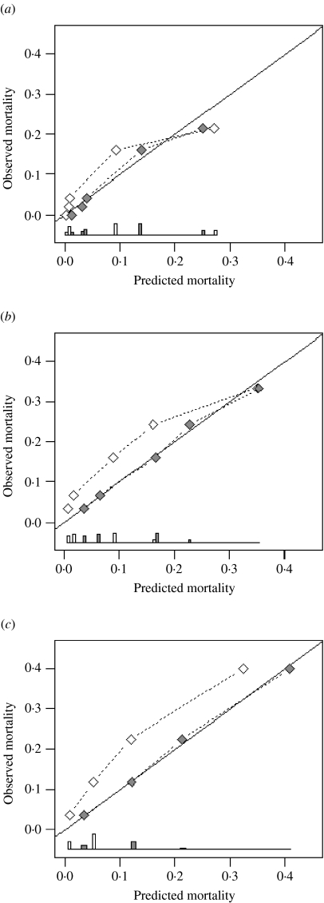
The observed mortality looks like about 33%, so of the 3 patients in the highest risk group one must have died.

Figure 2: Agreement between predicted and observed 30-day mortality (calibration) for three pneumonia severity prediction rules (a) PSI, (b) CURB65 and (c) CRB65. Observed mortality is plotted according to classes of predicted risk for each prediction rule separately. The solid line of identity represents perfect calibration of predicted risk within new patients. From Schuetz et al[2], used with permission from Cambridge University Press.

◊ Before recalibration
♦After recalibration

The ROC curves are shown below:

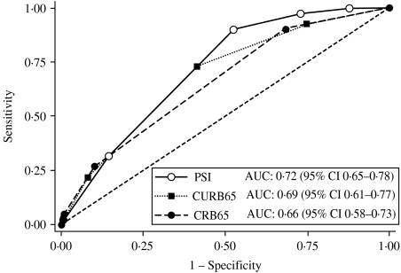

Figure 3. Receiver-operating characteristics analysis for 30-day mortality prediction with three pneumonia severity prediction rules (PSI, CURB65 and CRB65) in 373 patients with community acquired pneumonia. From Schuetz et al[2], used with permission from Cambridge University Press.

c) Do you think the above ROC curves were based on the pre-recalibration or post-recalibration risk predictions? Does it matter? Explain your answer. [2]

It should not matter, because the recalibration would not change the rank order of the predictions, which is what determines the ROC curve.

d) Below is an enlarged version of the calibration plot for the PSI with 3 risk classes circled. Draw a circle around the part of the ROC curve that corresponds to these 3 risk classes. [2]

This is a hard one. The points in the lower left of the calibration plot are those where the predicted mortality is lowest. So those would be the most reassuring results, i.e., those with the lowest likelihood ratios (LR). The lowest LR are those at the upper right of the ROC curve, where the slopes are closest to zero.

Additional notes, not needed for credit:

Note that each point on the calibration plot corresponds to a group of patients, rather than a cutoff, so points on calibration plots correspond to a segments on the ROC curve.
You can't tell from the calibration plot how many subjects are covered by each point, but you can get a sense of that from the ROC curve: longer line segments mean more people. By definition, the vertical distance or “rise” is the proportion of the D+ group in the interval and the horizontal distance or “run” is the proportion of the D- group in the interval. To get the proportion of the entire population in the interval, you have to know the proportion of D+ patients in the sample, P(D+). Then the overall proportion is P(D+)*rise + (1-P(D+))*run.

e) The authors were interested in a rule that could identify pneumonia patients at such low risk of death that they could be safely discharged from the emergency department. Even after re-calibration, only one of the 3 rules could identify patients at low enough risk to send home. Which of the 3 rules was it? Explain how you know. [2]

It would have to be the one that was able to achieve the highest sensitivity, the PSI. You can tell this either from the ROC curve (it reaches sensitivity of 100%) or from the calibration plots: only the PSI has a point with zero observed mortality.

6.4. Prediction of gestational diabetes. [8]
A small proportion of pregnant women develop diabetes during their pregnancy (gestational diabetes mellitus, GDM), increasing the risk of several adverse outcomes, including cesarean delivery, future diabetes in the mother and obesity in the offspring. GDM is typically diagnosed with an oral glucose tolerance test (OGTT), which requires the mother to have a fasting blood glucose test, drink a sugary drink, and then have repeat blood sugars measured after 1 and 2 hours. Because of the time and expense involved in the OGTT, it might be more efficient to target the OGTT to mothers at higher risk of GDM or skip the OGTT in mothers at very low risk).

Lamain-de Ruiter et al[6] compared several predictive models for GDM that could be used to select mothers for an OGTT. They collected the data inputs for the models on a cohort of 3723 pregnant women, and then followed them to determine who developed GDM. The predictors were things like the mother’s body mass index and whether she had previously had GDM. Figure 5 from their paper (below) shows a decision curve analysis for the 4 best GDM predictive models. Answer the following multiple choice questions and briefly explain your answer.

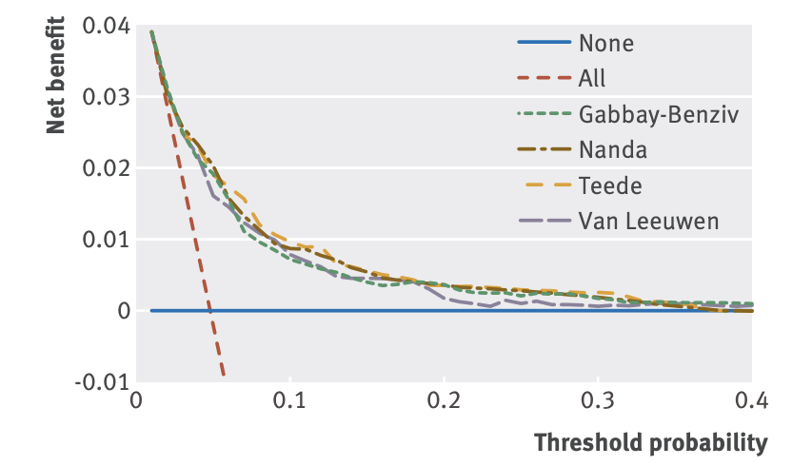

- i. Based on the figure, what proportion (approximate) of the women in this cohort developed GDM? (Don’t forget to explain your choice.) [2]

- 3%
- 5%
- 10%
- 15%
- 20%

Answer: (B) The Treat All curve crosses the horizontal axis at Ptt = 0.05 and the vertical axis at NB = 0.05 – either of these is a way to tell that the proportion that developed GDM is 0.05.
- ii. The authors contemplate using these prediction models to guide which women are tested for GDM with the OGTT. Assume that we are willing to do the OGTT on 20 women to identify one with GDM. Based on these decision curves, which of the following is the best strategy in this population of pregnant women? (Explain.) [2]

A) Do not test any women with the OGTT
B) Test all women with the OGTT
C) Use one of the predictive models and test those with predicted risk > 0.24
D) Use one of the predictive models and test those with predicted risk > 0.05
E) None of the above.

Answer: (D) Step 1 is to realize that Ptt = 1/20 or 0.05. Step 2 is to look at the curves and make sure that the predictive models have NB > Treat All at Ptt = 0.05.

Note sometimes it can be confusing distinguishing between treatment threshold probabilities and treatment threshold odds. Here’s a tip. If the description has the word “unnecessarily” the number given will generally be used to calculate odds; if it’s just a number needed to test or treat it will be a probability.
- Instead of using these prediction models to guide testing, assume that they are used to guide treatment without the OGTT. (It’s hard to come up with a plausible reason to treat for GDM without first doing an OGTT, but please suspend disbelief and assume the OGTT is not available). Also assume that treating a woman who does not have GDM is substantially worse (roughly 6 times worse) than administering the OGTT (if it were available) to her and having it come out negative. This means that your threshold for treating empirically is 0.24. Choose the best strategy. (Explain.) [2]

A) Do not treat any woman for GDM
B) Treat all women for GDM
C) Use one of the predictive models and treat those with predicted risk > 0.24
D) Use one of the predictive models and treat those with predicted risk > 0.05
E) None of the above.

Answer: (C) Look at the curves and make sure that the predictive models have NB > Treat All at Ptt = 0.24. Earlier versions of the problem did not include the treatment threshold probability of 0.24, and were too hard. Although C is clearly the best answer, we decided everyone should get credit for this one.

- iv. The authors evaluated the original models as published as well as recalibrated versions. (The technique they used for recalibration is not something we have discussed and not important for answering this question.) Does this figure display the original or re-calibrated versions of the models? Select the best answer. (Explain.) [2]

- The original versions because there is NO substantial evidence of miscalibration in this figure.
- The original versions because there is substantial evidence of miscalibration in this figure.
- The re-calibrated versions because there is NO substantial evidence of miscalibration in this figure.
- The re-calibrated versions because there is substantial evidence of miscalibration in this figure.
- Unable to tell because decision curves do not reflect calibration, only discrimination.

Answer (C) there is no evidence of miscalibration. The predictive models have 0 ≤ NB ≤ Treat All. Also, the decision curves have no “saw-tooth” appearance, which can also indicate miscalibration.

REFERENCES

1. Johnston SC, Rothwell PM, Nguyen-Huynh MN, Giles MF, Elkins JS, Bernstein AL, et al. Validation and refinement of scores to predict very early stroke risk after transient ischaemic attack. Lancet. 2007;369(9558):283-92.
2. Schuetz P, Koller M, Christ-Crain M, Steyerberg E, Stolz D, Muller C, et al. Predicting mortality with pneumonia severity scores: importance of model recalibration to local settings. Epidemiol Infect. 2008;136(12):1628-37.
3. Lamain-de Ruiter M, Kwee A, Naaktgeboren CA, de Groot I, Evers IM, Groenendaal F, et al. External validation of prognostic models to predict risk of gestational diabetes mellitus in one Dutch cohort: prospective multicentre cohort study. BMJ. 2016;354:i4338.
https://www.bmj.com/content/bmj/354/bmj.i4338.full.pdf

The CRB65 is just the CURB65 without a lab test called the BUN (blood urea nitrogen).

