Epi 204 -- Problem Set #8
Chapters 9 and 11 Problems (P Values and more)
Due 11/14/2019 1 pm

- French cohort study of screening for PDA (9.51.A modified) [10 points +1 bonus]
During fetal life there's no point having all of the blood that the heart is pumping go to the lungs, because the fetus is not breathing. Therefore, in fetal life blood bypasses the lungs through a blood vessel called the ductus arteriosus, which connects the pulmonary artery to the aorta. Once the baby is born, the ductus is supposed to close, but sometimes that doesn't happen, especially in preterm babies, and they have a patent ductus arteriosus (PDA). Whether or not to treat PDAs with medicine or surgery and even whether to look for them is controversial. Roze et al (1) examined whether screening for PDA with ultrasound in the first 3 days affected treatment for PDA and in-hospital mortality among infants born (very prematurely) at 24-28 weeks' gestation.

To start, we are going to deviate somewhat from the actual study by Roze et al to think about screening as an instrumental variable. Assume that the research question is whether treatment for PDA is effective in reducing in-hospital mortality.

- Why not compare in-hospital mortality in babies treated for PDA with in-hospital mortality in babies with PDA who were not treated? [1]

- Would this comparison make treatment for PDA look more or less effective than it really is? [1]

Assume that whether a baby is screened by ultrasound for PDA is unrelated to the likelihood of dying in the hospital. For example, screening could depend on the location and practice of the neonatal unit in which the baby is born, the time of day, or whether the ultrasound machine or technician is available. This makes screening a good instrumental variable.
Screened babies were treated for PDA 55% of the time, whereas unscreened babies were treated for PDA 43% of the time. Screened babies had in-hospital mortality of 14%, whereas unscreened babies had in-hospital mortality of 18%
- What was the absolute risk reduction associated with screening? [1]
- How many babies need to be screened to prevent on in-hospital death? [1]
- Assuming that the only effect of screening on in-hospital mortality is to make PDA treatment more likely, what is the absolute risk reduction associated with PDA treatment? [1]

- Again assuming that the only effect of screening on in-hospital mortality is to make PDA treatment more likely, how many babies need to be treated for PDA to prevent one in-hospital death? [1]

- (Extra Credit) To which subset of treated infants would that estimate apply? [+1]

The following parts of this question involve propensity scores, EBD-2 Chapter 9, pages 8-12.
Now, stop assuming that screening is independent of mortality risk. Because it is possible that sicker babies are both more likely to be screened and more likely to die of PDA, Roze et al actually used propensity matching to compare outcomes among 605 infants who were screened and 605 infants who were not, matching on the propensity score for screening.
- Many infants in both groups did not have a PDA diagnosed. Should diagnosis of PDA have been included in the propensity score? Why or why not? [2]

- Before matching the exposed infants (those who were screened) had higher propensity scores than the unexposed infants. Why would that be the case? [2]
2. Epidural analgesia and C-section rates (adapted from a problem by Susan Lee). (Ch11.12.A). [10 points]
The effect of epidural analgesia on the progress of labor has generated considerable controversy. Previous observational studies have found that women who receive epidurals for labor analgesia have longer labors and higher rates of caesarean sections than women that do not receive epidurals.

Zhang et al. took advantage of a policy change in 1993 within the US Department of Defense requiring the availability of on-demand labor epidural analgesia in military centers to study this concern at the Tripler Army Medical Center. Prior to this policy change, epidural rates for labor analgesia were < 1%. After implementation of the new policy, the epidural rate climbed to > 70% within one year, levelling off at ~70% by 1995. They found no difference in C-section delivery rates in women with delivery in the year prior to policy change (1993) compared with delivery in 1995-6 (after the policy change), as shown in figure 1.

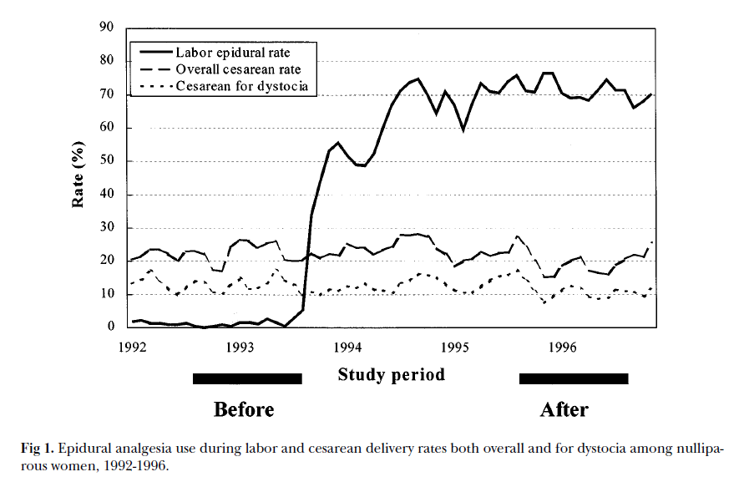
a) We can think of this study as using an instrumental variable to study the effect of a treatment on an outcome. What are the treatment, the instrumental variable and the outcome variable for this study? [3]

b) In order for an instrumental variable to be used to estimate the effect of a treatment, what assumption is required about its relation to the outcome? [1]

c) Suppose a nearby hospital with 5,000 deliveries a year has had a stable epidural rate of 50% for the last 5 years. Why not take advantage of its large sample size and estimate the effect of epidural analgesia on C-section rates by comparing C-section rates among all the women that did vs. did not receive epidural analgesia for labor at this other site? [2]

d) The observed rates of C-section were 14.4% of 507 deliveries before and 12.1% of 581 deliveries after the policy change. Although not provided by the authors, this is an absolute risk reduction of 2.35%, with a 95% CI of (-1.7% to 6.4%). For each of the following statements about this risk difference and 95% CI, read the statement carefully, indicate whether it is true or false and explain.

i. The difference does not appear to be statistically significant at the α =0.05 level. [1]
ii. The 95% CI means that if we could repeat this study many times, we would expect the observed risk difference to fall in this interval about 95% of the time. [1]
iii. The range of changes in C-section rates consistent with this study is between a 1.7% decrease and a 6.4% increase after the policy was implemented. [1]

iv. The observed effect of epidural analgesia on the proportion of women receiving C-sections in this study was a 2.35% decrease (95% CI from a 6.4% decrease to a 1.7% increase). [1]

e. Assume the use of epidurals increased from 1% to 71%. If the change in C-section rate was entirely due to the change in availability and use of epidurals, what effect does using an epidural have on c-section rate? Show your calculation. [2]

3. Prophylactic Penicillin in Sickle Cell Anemia (Ch11.08) [8 points]
Children with sickle cell anemia are treated with penicillin to prevent infections with Streptococcus pneumoniae ("pneumococcus") to which they are particularly susceptible. Review the following abstract excerpt, addressing the question: "when is it safe to discontinue penicillin prophylaxis?" (2)
OBJECTIVE: To evaluate the consequences of discontinuing penicillin prophylaxis at 5 years of age in children with sickle cell anemia who had received prophylactic penicillin for much of their lives.
DESIGN: Randomized, double-blind, placebo-controlled trial….
PATIENTS: Children with sickle cell anemia …who had received prophylactic penicillin therapy for at least 2 years immediately before their fifth birthday and had received the 23-valent pneumococcal vaccine between 2 and 3 years of age and again at the time of randomization. Of 599 potential candidates, 400 were randomly selected and followed for an average of 3.2 years....
INTERVENTIONS: After randomization, patients received the study medication twice daily--either penicillin V potassium, 250 mg, or an identical placebo...
MAIN OUTCOME MEASURES: The primary end point was… bacteremia or meningitis caused by Streptococcus pneumoniae ...
RESULTS: Six children had a systemic infection caused by S. pneumoniae, four in the placebo group (2.0%; 95% confidence interval 0.5%, 5.0%) and two in the continued penicillin prophylaxis group (1.0%; 95% confidence interval 0.1%, 3.6%) with a relative risk of 0.5 (95% confidence interval 0.1, 2.7).
CONCLUSION: Children with sickle cell anemia who have not had a prior severe pneumococcal infection or a splenectomy and are receiving comprehensive care may safely stop prophylactic penicillin therapy at 5 years of age...

- There were 200 children in each group. Use the numbers in the abstract to help you interpret the Stata output below. What was the absolute difference in risk between the groups, and what is its 95% CI? [2]

. csi 2 4 198 196
| Exposed Unexposed | Total
-----------------+------------------------+----------
Cases | 2 4 | 6
Noncases | 198 196 | 394
-----------------+------------------------+----------
Total | 200 200 | 400
| |
Risk | .01 .02 | .015
| |
| Point estimate | [95% Conf. Interval]
|------------------------+----------------------
Risk difference | -.01 | -.0338037 .0138037
Risk ratio | .5 | .0926272 2.69899
Prev. frac. ex. | .5 | -1.69899 .9073728
Prev. frac. pop | .25 |
+-----------------------------------------------
chi2(1) = 0.68 Pr>chi2 = 0.4107

b) The methods section of the paper indicates that they assumed that the S. pneumoniae bacteremia or meningitis rate in the placebo group over 3 years would be about 12%, that they wished to detect a 67% decrease (to 4%) with penicillin, and calculated that a sample size of 200 per group would give about 80% power to detect this decrease at 2-tailed alpha = 0.05.

Assume for this problem that a difference between groups smaller than what the investigators used for their sample size calculation (8%) would not be clinically significant. Did they have enough subjects to conclude that discontinuing penicillin at age 5 is safe? Explain. [4]

c.) The outcome variable was bacteremia or meningitis caused only by S. pneumoniae. What would be a better choice of outcome variable for the study? [2]

4. Month of School Enrollment and Diagnosis and Treatment of Attention Deficit-Hyperactivity Disorder (ADHD)

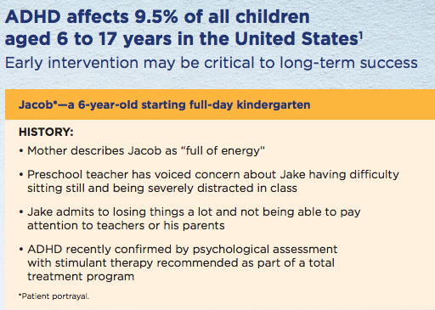
Some children (especially boys) have more trouble sitting still in the classroom and paying attention to the teacher than their classmates. One reason for this might be because they have Attention Deficit-Hyperactivity Disorder (ADHD), but in some cases it may also be because they are younger than their classmates. In states where children must be 5 years old by September 1 to start school, children born in August may be almost a year younger than their classmates born in September, who must wait almost a whole additional year before they are old enough to start school. To investigate whether this age difference contributes to children being diagnosed with and treated for ADHD, Harvard investigators (3) used a large insurance database to compare claims-based ADHD diagnoses and treatment among children born in August with those born in September. As they had predicted, children born in August were significantly more likely to be diagnosed with ADHD.
Excerpt from an advertisement for Evekeo® racemic amphetamine sulfate. From https://www.evekeo.com/pdfs/patient-profiles.pdf, accessed December 5, 2018. Poor Jake would have even more problems if he was born in August and about to start full day first grade.

For each of the next three results, indicate which of the techniques for enhancing causal inference discussed in Chapter 9 it represents.
A. The authors compared ADHD diagnoses in other pairs of adjacent months (Figure 1 from the paper pasted below.) [2]

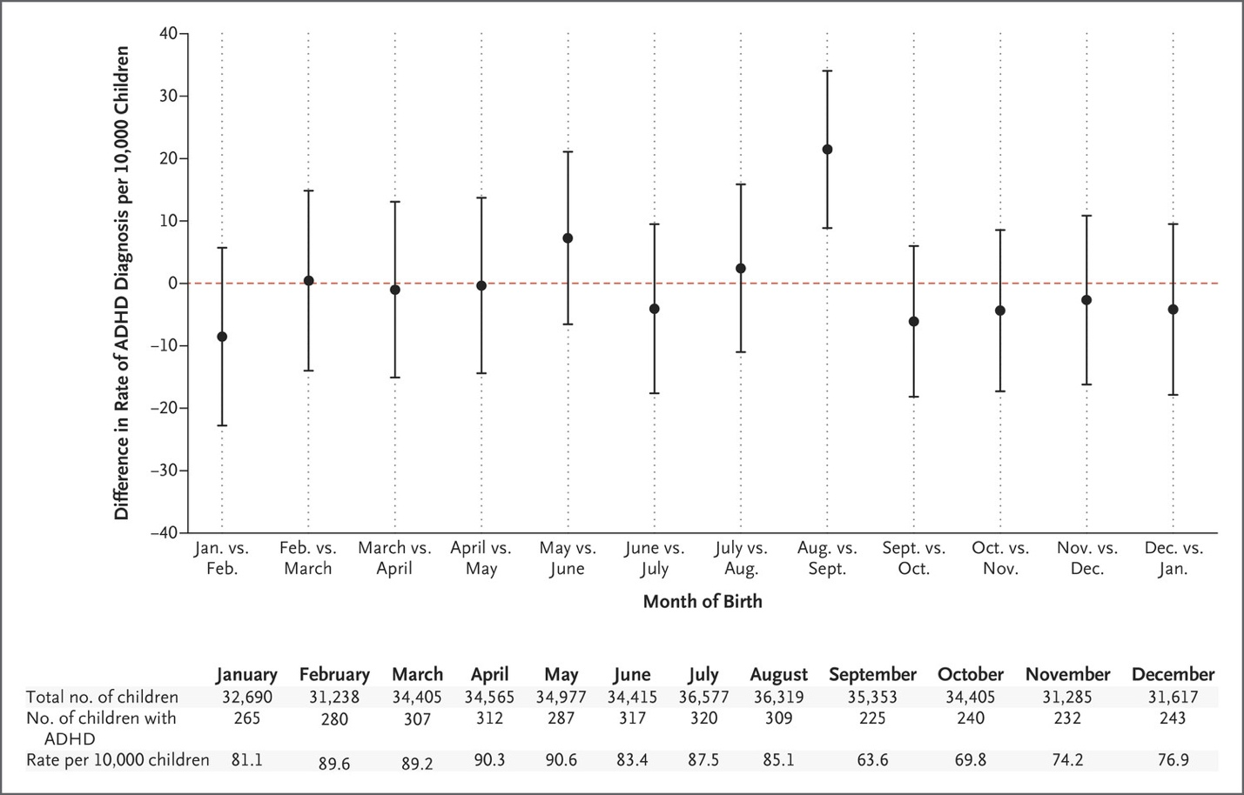

"Figure 1. Differences in Diagnosis Rates of Attention Deficit–Hyperactivity Disorder (ADHD) According to Month of Birth. Each point represents the absolute difference in the rate of ADHD diagnosis per 10,000 children between children born in a given month and children born in the following month…" From Layton TJ, Barnett ML, Hicks TR, Jena AB. Attention Deficit-Hyperactivity Disorder and Month of School Enrollment. N Engl J Med 379:2122-30. Copyright © 2018, Massachusetts Medical Society. Reprinted with permission from the Massachusetts Medical Society.

B.) The authors also compared results between states that do and do not have the September 1 cutoff for starting school (Figure 2). [2]

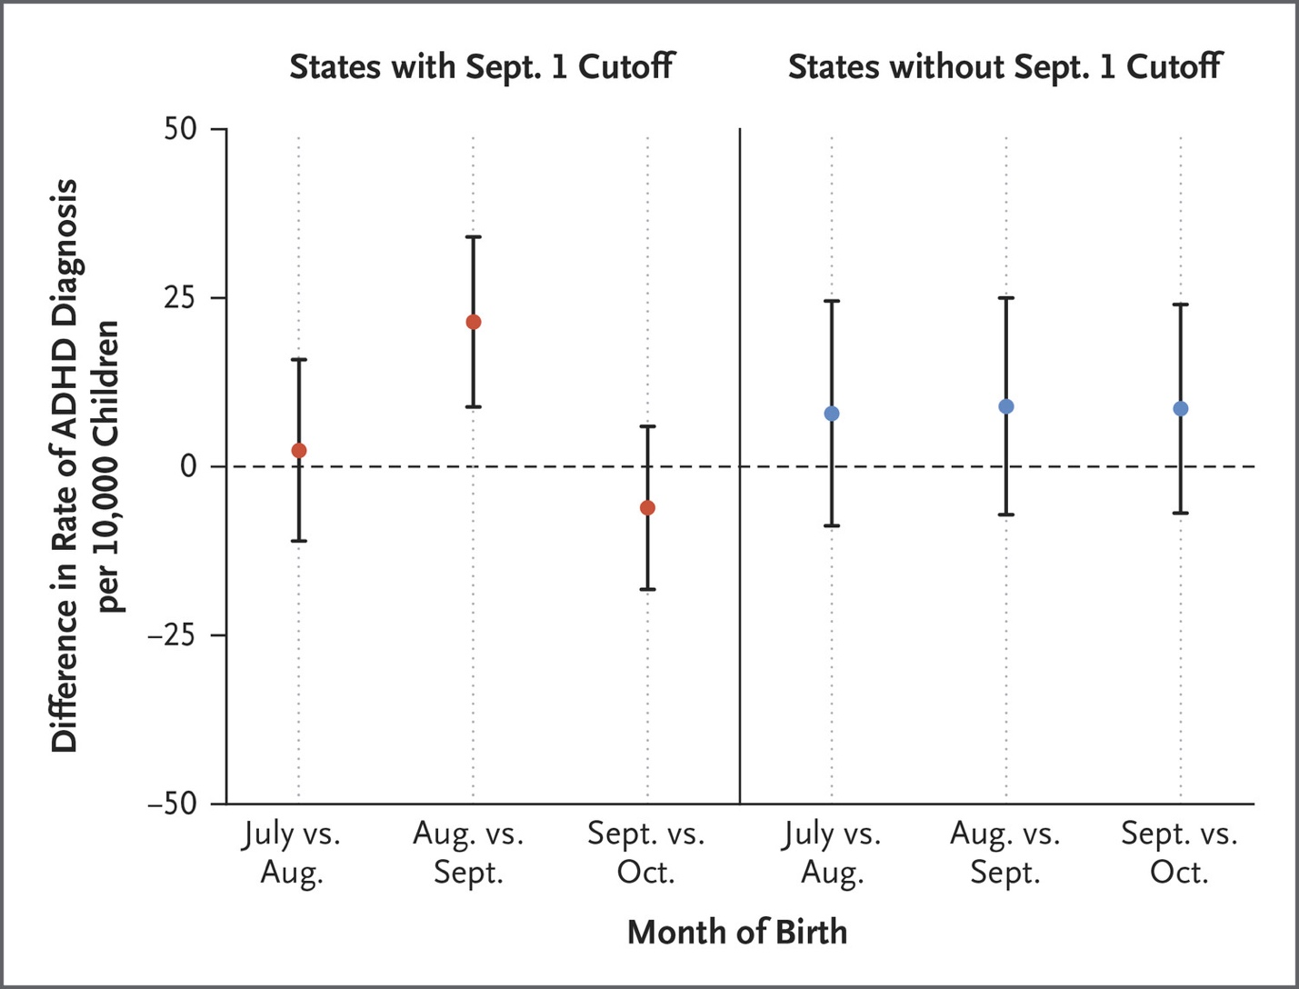

Figure 2. Differences in ADHD Diagnosis Rates According to Month of Birth in States with and States without a September 1 Cutoff. Shown are the differences in ADHD diagnosis rates between children in the 18 states with a September 1 cutoff for kindergarten entry and children in all states without a September 1 cutoff. The dashed line indicates no difference. I bars indicate 95% confidence intervals. ... From Layton TJ, Barnett ML, Hicks TR, Jena AB. Attention Deficit-Hyperactivity Disorder and Month of School Enrollment. N Engl J Med 379:2122-30. Copyright © 2018, Massachusetts Medical Society. Reprinted with permission from the Massachusetts Medical Society.

C.) From the abstract: "In addition, in states with a September 1 cutoff, no significant differences between August-born and September-born children were observed in rates of asthma, diabetes, or obesity." [2]

5. College education and age at first birth

We mentioned in Problem 7.5 that first-time mothers in San Francisco are older than in other parts of the US. Besides geographic location, another predictor of age at first birth mentioned in the New York Times article is education level. (4) According to the article, "Women with college degrees have children an average of seven years later than those without — and often use the years in between to finish school and build their careers and incomes."

The exact methods used by the Times to arrive at this estimate are not included in the article, but it does say the analysis "was of all birth certificates in the United States since 1985 and nearly all for the five years prior."

Suppose for this problem that the only data source for the cited study was birth certificates, (which do include the mother's age and education level) and that the age of the women giving birth for the first time was 7 years higher for women with college degrees than for those without. Does this study allow you to infer that women who choose go to college defer childbearing? Explain, naming any potential biases in this study design. [5]

REFERENCES
1. Roze JC, Cambonie G, Marchand-Martin L, Gournay V, Durrmeyer X, Durox M, et al. Association Between Early Screening for Patent Ductus Arteriosus and In-Hospital Mortality Among Extremely Preterm Infants. JAMA. 2015;313(24):2441-8.
2. Falletta JM, Woods GM, Verter JI, Buchanan GR, Pegelow CH, Iyer RV, et al. Discontinuing penicillin prophylaxis in children with sickle cell anemia. Prophylactic Penicillin Study II. J Pediatr. 1995;127(5):685-90.
3. Layton TJ, Barnett ML, Hicks TR, Jena AB. Attention Deficit-Hyperactivity Disorder and Month of School Enrollment. N Engl J Med. 2018;379(22):2122-30.
4. Bui Q, Miller CC. The Age That Women Have Babies: How a Gap Divides America. New York Times. 2018 August 4, 2018.

Zhang J, Yancey MK, Klebanoff MA, Schwarz J, Schweitzer D. Does epidural analgesia prolong labor and increase risk of cesarean delivery? A natural experiment. Am J Obstet Gynecol 2001;185(1):7-7.

