Epi 204 -- Problem Set #7
Chapter 8 Problems (RCTs) [38 points]
Answer Key
Due 11/7/2019 1 pm
Chapter 8 Problems

8.1. Amoxicillin for Otitis Media with Effusion [8 points total]

Otitis Media with Effusion (OME, fluid in the middle ear) is common in infants and young children. It can cause discomfort (a feeling that the ear needs to "pop"), temporary hearing loss and an increased risk of middle ear infection (acute otitis media).

A controversial clinical trial[1] found that, in children who had had OME for 3 months, resolution rates at 4 weeks were about 30% with 2 weeks of treatment with the antibiotic amoxicillin (with or without an antihistamine/decongestant) and compared with about 14% with placebo.

a. Using the conventions suggested in the chapter (i.e., the risk ratio [RR] is the risk of something bad in the treatment group over the risk in the control group), what are the RR, the relative risk reduction (RRR), the absolute risk reduction (ARR), and the number needed to treat (NNT) with amoxicillin to prevent one persistent effusion at 4 weeks? [4 points]

In general, it's best to use risks to refer to risks of bad outcomes. In this case, the bad outcome is persistence of the effusion. So the risk of persistent effusion is (100% − 30%=) 70% with amoxicillin and (100% − 14% =) 86% with placebo. It's also easiest to do the RR before the RRR:

RR = 0.70 / 0.86 = 0.81
RRR = 1− 0.81 = 0.19 (Or alternatively, RRR = (0.86 − 0.70) / 0.86 = 0.19.)
Those treated with amoxicillin had a 19% lower risk of persistent effusion at 4 weeks.

ARR (Absolute risk reduction)= 0.86 − 0.70 = 0.16 = 16% (Note you can also get this the other way, i.e. 30% − 14%.) Those treated with amoxicillin had a 16 percentage point lower risk of persistent effusion at 4 weeks.

NNT = 1/ARR = 1 / 0.16 = 6.25. So for each 6.25 children we treat with amoxicillin for 2 weeks, 1 fewer will have a persistent effusion at 4 weeks.

b. Why are the RRR and ARR so similar in this case? [2 points]

The RRR and ARR are similar in this study because the risk of persistent effusion in the control group is so high, 86%. ARR = Risk(Placebo) × RRR. If Risk(Placebo) ≈ 1, then ARR ≈ RRR.

The reason why the study was so controversial is that one of the investigators (Erdem Cantekin) so disagreed with the other investigators that he published an alternative report on the same study in JAMA [2-4] after the other investigators reported the results in the New England Journal. One of Cantekin's main points was that blinding was suspect and no benefit was apparent when the outcome was assessed objectively (by tympanometry). After excluding 43 children (13.3% of the placebo group and 7.4% of amoxicillin group; P = .122) who had developed ear infections during the follow-up period, he came up with the following numbers (simplified from his Table 3).

Outcome Measure | Amoxicillin (%) | Placebo (%) | Difference (%) | P
Normal by otoscopy | 35.2 | 19.2 | 16.0 | .004
Normal by algorithm (defined in protocol) | 25.6 | 13.9 | 11.7 | .027
Normal by tympanometry | 17.8 | 10.0 | 7.8 | .121
Normal by hearing test | 21.9 | 18.0 | 3.9 | .611
Hearing improved > 10 dB | 31.5 | 32.5 | -1.0 | .311

c) Do you agree with the decision to exclude children who developed ear infections during the follow-up period? What effect might this have had on the results tabulated above? [2 points]

We don't agree with the decision to exclude children who developed ear infections. These children were probably more likely to have persistent effusions because effusions are a risk factor for infection. Since ear infections occurred more frequently in the placebo group, excluding patients that developed infections will improve the outcome (i.e., reduce the number with persistent effusions) in that group, reducing the observed difference between the amoxicillin and placebo groups in the study. The rule "once randomized always analyzed" (i.e., do an intention-to-treat analysis) applies here. This rule is particularly important when censoring, loss to follow-up or exclusion may be related to treatment, as in this case.

Note: Since 1990, the debate has shifted from treating OME (the topic of this study) to treating apparent ear infections (acute otitis media), because of randomized trials showing that the benefit of treating most ear infections with antibiotics is modest[5] and because of increasing concern that overuse of antibiotics contributes to selection of resistant organisms.

8.2. Masking in a post Lyme syndrome trial [3 points]

Lyme disease is an infection with a spirochete bacterium acquired from a tick bite. Most patients recover after antibiotic treatment of the acute infection, but some can develop chronic symptoms, or "post Lyme syndrome," one symptom of which can be severe fatigue. The STOP-LD trial[6] was a randomized, double-blind trial of a long course of IV ceftriaxone (an antibiotic) to treat post Lyme syndrome.

The results section includes:
Masking. At … 6 months 69% (18/26) of the ceftriaxone vs 32% (7/22) of the placebo group correctly guessed their treatment assignment (p = 0.004).
In the discussion they wrote:
"The observation that more of the ceftriaxone than placebo treated groups correctly guessed their treatment assignment could mean that masking [blinding] may have been compromised."
Does the comparison above (P=0.004) support the authors' concern that masking may have been compromised? Explain. [Hint: think carefully about what is being compared before answering!]

No. In the treatment group, 69% thought they were getting active treatment. In the control group, as many as 100% - 32% = 68% may have thought they were getting active treatment. (We don’t know whether there were just the two options or whether something like "can't tell" was an option.) Comparing the proportions who correctly guessed their treatment means you are comparing the proportion who thought they were on active treatment in one group with the proportion who thought they were on placebo in the other. There is no reason why these should be the same!

That the proportion that thought they were on active treatment in both groups was > 50% also is not surprising. If people in either group improved, they might have thought it was because of treatment. If they had some new symptom they might have thought it was a side effect. In each case, they would be more likely to guess they were on active treatment.

8.3. Anticholinergic Medication for Enuresis [6 points total]

Enuresis (bedwetting) is a common problem in children. One (not very effective) treatment for enuresis is desmopressin (antidiuretic hormone), which helps reduce urine production by making the urine more concentrated. Austin et al [7] studied the effect of adding treatment with tolteridine, a long-acting an anticholinergic (ACh) medication, to desmopressin among children with enuresis not responding to desmopressin.

a.) The results section of the paper includes the following sentence: [2 points]

"After 1 month of therapy, we found a significant reduction in the mean number of wet nights in the combination therapy group receiving long-acting tolterodine, compared with placebo (Fig 2)."

Figure 2 from the paper is reprinted below. Using just that figure, do you agree with how that sentence summarizes the results? If not, how would you correct it?
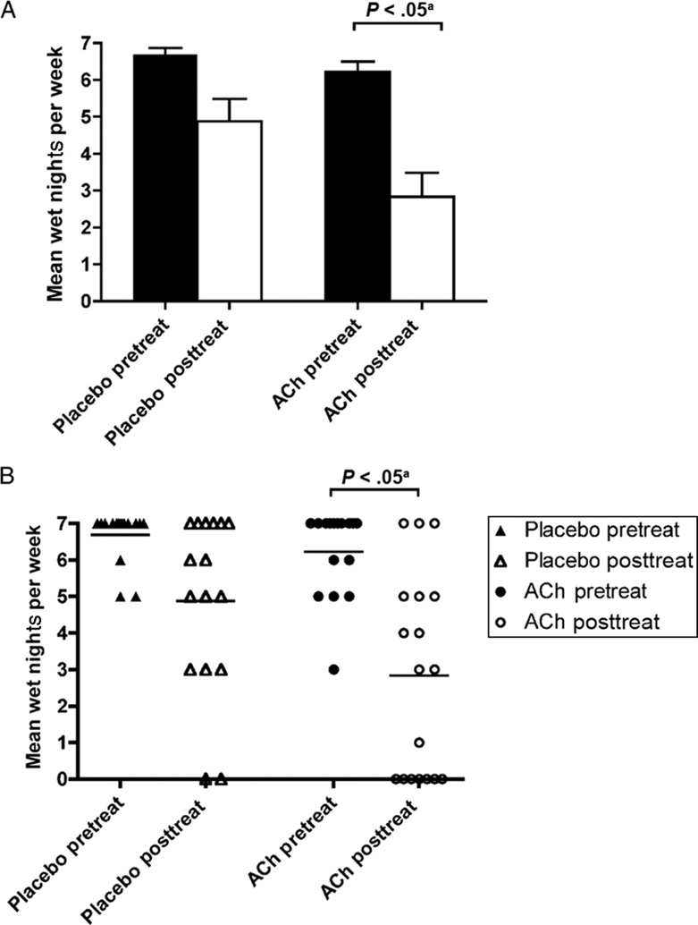
We disagree. The results sentence from the paper suggests that the between groups comparison between tolteridine and placebo was statistically significant, whereas the figure shows only a within groups comparison.
Results for their primary outcome, the proportions with a ≥ 50% reduction in wet nights, were 8/18 (44%) with tolteridine vs 5/16 (31%) for placebo; P = 0.43.

b.) Would you classify this outcome variable (mean wet nights per week) as a surrogate outcome? Explain. [2 points]
No, this is a relevant outcome that patients can notice and measure themselves, so I would not classify it as a surrogate outcome. (An example of a surrogate outcome would be the specific gravity of the urine.)

FIGURE 2: Combination therapy treatment responses. A, Numbers of wet nights before therapy (Pretreat) and after therapy (Posttreat) (mean 􏰆 SE). B, Scattergram of patient results with desmopressin plus placebo (triangles) and desmopressin plus long-acting tolterodine (circles) (open, before treatment; closed, after treatment). ACh indicates anticholinergic agent. (tolterodine).
From Austin PF, Ferguson G, Yan Y, Campigotto MJ, Royer ME, Coplen DE. Combination therapy with desmopressin and an anticholinergic medication for nonresponders to desmopressin for monosymptomatic nocturnal enuresis: a randomized, double-blind, placebo-controlled trial. Pediatrics. 2008;122(5):1027-32, Copyright 2008 American Academy of Pediatrics, reprinted with permission.

c.) Do you agree with the following statement? Explain your answer. [2 points]
"The difference between groups was statistically significant but not clinically significant."
We disagree because they have not shown a statistically significant difference.

8.4. Fremanezumab to prevent migraine headaches [9 points total]

Dr. David Dodick (whose conflict of interest disclosures for this paper run 4.75 column inches in JAMA) and colleagues recently reported results of a randomized, double-blind trial of fremanezumab, a new monoclonal antibody used to prevent migraine headache [8] The investigators compared monthly and quarterly doses of fremanezumab with placebo; for simplicity we will focus only on comparisons of the (more effective) monthly dosing with placebo.

- The proportion of patients who achieved at least a 50% reduction in the number of headache days per month was 47.7% in the monthly fremanezumab group compared with 27.9% in the placebo group. What was the number needed to treat with fremanezumab to get one additional patient with a ≥ 50% reduction in headache days? [2 points]
Although in this case the outcome is phrased as the probability of something good rather than something bad, we can still just take the risk difference to get the number needed to treat 1= 1/(47.7% − 27.9%) = 1/19.8% = ~5.
Following the convention of calculating the risk of a bad outcome is a bit awkward. The bad outcome is < 50% reduction in number of headache days. The risk of that bad outcome was 52.3% in the treatment group and 72.1% in the control group. The ARR is (still) 72.1% - 52.3% = 19.8%, and the NNT is still ~5.
- Fremanezumab costs about $600/monthly dose. It was well tolerated in the trial. If we ignore possible late adverse effects and focus only on the medication cost, what is the approximate cost per month per patient who achieved a 50% reduction in headache days? [2 points]
Since the NNT is 5, it will be about 5 times the monthly cost, or ~$3,000. It may help in (c) to note that this is also $600 / (72.1% - 52.3%) .
- Per the abstract, "From baseline to 12 weeks, mean migraine days per month decreased from 8.9 days to 4.9 days in the fremanezumab monthly dosing group, and from 9.1 days to 6.5 days in the placebo group. This resulted in a difference with monthly dosing vs placebo of -1.5 days/month (95% CI, -2.01 to -0.93 days; P < .001)." If we consider a migraine day a bad outcome, what would be the CBOP, i.e., the approximate cost to prevent one migraine day? [1 point]
It costs about $600 to treat for a month, which will prevent 1.5 migraine days, so the cost to prevent 1 migraine day would be about $600/1.5 = $400.

This is a continuous or at least a count outcome, but the parallel with (b) is clear. In (b), the expected bad outcomes in the control group was 0.721 and in the treatment group was 0.523, so the difference in expected outcomes is 0.721 – 0.523 = 0.198. This costs $600, so we got $600 / 0.198 = ~$3000 per bad outcome (<50% reduction) prevented. Here, the expected decrease in headache days in the control group was 2.6 and in the treatment group was 4. So the difference in the expected number of headache days is 4 – 2.6 = 1.4 (or 1.5 before rounding). This costs $600, so we get $600/1.5 = $400 per headache day prevented.

- Let's suppose that this medication only works for true migraines and that everyone in the trial was sufficiently screened that all of them had true migraines. But out in the "real world" we are considering treating someone with headaches that we think might be migraines, but we are unsure. If we believe it is worth $500 to prevent one headache day, and if there were no other therapeutic options available, at what probability of migraine would the headache reduction benefit of fremanezumab justify the cost? [2 points]
The problem gives you the benefit per bad outcome prevented = BBOP = $500. So the treatment threshold = CBOP/BBOP = $400/$500 = 80%. So if we believe the probability that the headaches our patient is suffering are migraines is at least 80%, then the expected cost of preventing a headache day will be justified by the expected benefit.
- The investigators excluded patients who had previously failed 2 classes of migraine-preventive medicine from the study and compared fremanezumab with placebo. What effect do these study design decisions have on the clinical usefulness of the study results? [2 points]

These design decisions reduce the clinical usefulness of the study because it now answers a question different from what most patients and clinicians want to know. This is an expensive new medication with uncertain long-term safety, so it would not be my first choice medication unless it had been shown to be substantially safer or more effective than existing treatments. So I would either want to see the subjects eligible for the study restricted to those who had failed or could not tolerate existing treatments or have the comparison group be a standard treatment in order to know whether to consider prescribing this medication.

8.5. Randomized trial of evolocumab (Repatha®) plus statin therapy (with thanks to Christopher Groh and Nalini Colaco) [12 points total]

High LDL cholesterol (bad cholesterol) is a well-known risk factor for cardiovascular disease. For many years, the cornerstone of LDL treatment has been statin-based therapy. Statins are one of the few lipid lowering therapies with well-established evidence for decreasing cardiovascular events. However, statins have side-effects including risk of diabetes, myalgias (muscle pain), or rarely, rhabdomyolysis (muscle damage). Recent discoveries have shown that PCSK9 plays an integral role in LDL metabolism. This has spawned a variety of new lipid-lowering therapies called PCSK9 Inhibitors that are more potent in LDL reduction than statins. The clinical outcome performance of this class of drugs has been minimally studied. Evolocumab is one such agent that has been studied in cardiovascular outcomes.

We briefly mentioned the 2017 Amgen-supported FOURIER trial[9] in Chapter 8. It was a randomized trial of evolocumab injections (either 140 mg every 2 weeks or 420 mg every month depending on patient preference) plus a statin vs. placebo plus a statin in high-risk patients who had a previous cardiovascular event. The following outcomes were obtained after an average follow up of roughly 24 months (excerpted from Table 2):

Outcome | Evolocumab | Placebo | Hazard Ratio | 95% CI | P
Primary endpoint: cardiovascular death, myocardial infarction, stroke, hospitalization for unstable angina, or coronary revascularization | 1344 (9.8%) | 1563 (11.3%) | 0.85 | (0.79, 0.92) | <0.001
Key secondary endpoint: cardiovascular death, myocardial infarction or stroke | 816 (5.9%) | 1013 (7.4%) | 0.8 | (0.73, 0.88) | <0.001
Cardiovascular death | 251 (1.8%) | 240 (1.7%) | 1.05 | (0.88, 1.25) | 0.62

Note: myocardial infarction is a heart attack, unstable angina is almost a heart attack, coronary revascularization would imply a coronary stent placement or bypass surgery.

- What is the difference in the definition of the “Primary end point” and the “Key secondary end point”? Which end point do you prefer? Why? [2 points]

The difference is that the key secondary endpoint does not include hospitalization for unstable angina and coronary revascularization.

We prefer the key secondary end point because it seems more relevant to patients and more objective. But the study was blinded, so it would not be wrong to prefer the more inclusive and subjective endpoint. This is a rare example where the ARR is preserved even for the more serious secondary end point (though, as discussed in the next part, not for cardiovascular mortality.

- In the evolucomab group there were 816 key secondary endpoints and 251 cardiovascular deaths. In the placebo group there were 1013 key secondary endpoints and 240 cardiovascular deaths. How could the placebo group have fewer cardiovascular deaths but more key secondary endpoints? Is the difference in the composition of the key secondary endpoints a chance finding? Explain. [2 points]

The small excess in mortality in the treatment group over the control group is easily explicable by chance. On the other hand, cardiovascular death made up about 31% of the “Key secondary endpoints” in the treatment group and only about 24% of them in the control group. This difference is greater than expected by chance; P = 0.0007. The only other outcomes in the key secondary endpoint are non-fatal MI and non-fatal stroke. This suggests that the treatment reduced these two non-fatal secondary endpoints without affecting mortality. As noted in Chapter 8, this fits a consistent pattern that cardiovascular mortality is much harder to reduce than nonfatal cardiovascular events.

- If one considers estimates within the 95% confidence interval to be consistent with the study results, what is the lowest number needed to treat for 2 years to prevent one death from any cause consistent with the study’s results? [2 points]
(Note that we have provided the Stata output; Cases are deaths from any cause and "Exposed" got evolucumab.)

. csi 444 426 13340 13354

| Exposed Unexposed | Total
-----------------+------------------------+------------
Cases | 444 426 | 870
Noncases | 13340 13354 | 26694
-----------------+------------------------+------------
Total | 13784 13780 | 27564
| |
Risk | .0322113 .0309144 | .0315629
| |
| Point estimate | [95% Conf. Interval]
|------------------------+------------------------
Risk difference | .0012969 | -.002831 .0054248
Risk ratio | 1.041951 | .9141891 1.187568
Attr. frac. ex. | .040262 | -.0938655 .1579432
Attr. frac. pop | .0205475 |
+-------------------------------------------------
chi2(1) = 0.38 Pr>chi2 = 0.5380

Confidence intervals that include both benefit and harm can be confusing. We recommend first answering the question, "Which group did better?" then looking at the sign of the risk difference.

In this case the unexposed had lower mortality, so the positive point estimate for the risk difference must favor the unexposed. Therefore, in order to have lower mortality, the risk difference would have to be negative. So the most negative part of the confidence interval is for the most favorable effect consistent with what was observed; in this case a risk difference of -0.002831, so the lowest NNT for two years to prevent one death consistent with this study is 353.

Note that as the risk difference moves towards zero, the NNT increases to infinity and then turns into an NNH. The point estimate from this study is an NNH of 771, and the NNH could be as low as 184.

- Calculate the absolute risk reduction for evolocumab therapy in comparison to placebo for the “Key secondary end point”.[2 points]

ARR = 7.4%-5.9% = 1.5%
Or using raw numbers: 1013/13780 − 816/13784 = 1.43%

- Calculate the number needed to treat for 24 months to prevent one “Key secondary end point”[2 points]

NNT = 1/ARR = 1/0.015 = 66.7 patients need to be treated for 24 months to prevent the “Key secondary end point”
Or 1/1.43% = 70

- Your clinic patient who recently had a myocardial infarction and is already on a statin called pravastatin (40 mg/day) wants to take evolocumab. His insurance is unwilling to cover this new medication and he will have to pay out of pocket. Interestingly, your patient happens also to be an economist and is curious as to the financial burden of such a novel medication. Evolocumab is an injectable monoclonal antibody that is estimated to costs about $1244 per 420mg injection, or $14,928 for an annual set of injections. What is the cost of preventing a “Key secondary end point” at 24 months (CBOP)? [2 points]

The cost of the therapy is $14,928/year × 2 years and we need to treat 70 patients to prevent one key secondary endpoint.

So CBOP = NNT × Cost = $14,928 × 2 × 70 = $2,089,920.

REFERENCES

1. Mandel EM, Rockette HE, Bluestone CD, Paradise JL, Nozza RJ. Efficacy of amoxicillin with and without decongestant-antihistamine for otitis media with effusion in children. Results of a double-blind, randomized trial. N Engl J Med. 1987;316(8):432-7.
2. Cantekin EI, McGuire TW, Griffith TL. Antimicrobial therapy for otitis media with effusion ('secretory' otitis media). JAMA. 1991;266(23):3309-17.
3. Cantekin EI, McGuire TW, Potter RL. Biomedical information, peer review, and conflict of interest as they influence public health. JAMA. 1990;263(10):1427-30.
4. Rennie D. The Cantekin affair. JAMA. 1991;266(23):3333-7.
5. Marmor A, Newman TB. Amoxicillin-clavulanate improves symptoms, reduces treatment failure in select children with acute otitis media and increases risk of diarrhoea. Evid Based Med. 2011;16(5):150-2.
6. Krupp LB, Hyman LG, Grimson R, Coyle PK, Melville P, Ahnn S, et al. Study and treatment of post Lyme disease (STOP-LD): a randomized double masked clinical trial. Neurology. 2003;60(12):1923-30.
7. Austin PF, Ferguson G, Yan Y, Campigotto MJ, Royer ME, Coplen DE. Combination therapy with desmopressin and an anticholinergic medication for nonresponders to desmopressin for monosymptomatic nocturnal enuresis: a randomized, double-blind, placebo-controlled trial. Pediatrics. 2008;122(5):1027-32.
8. Dodick DW, Silberstein SD, Bigal ME, Yeung PP, Goadsby PJ, Blankenbiller T, et al. Effect of Fremanezumab Compared With Placebo for Prevention of Episodic Migraine: A Randomized Clinical Trial. JAMA. 2018;319(19):1999-2008.
9. Sabatine MS, Giugliano RP, Keech AC, Honarpour N, Wiviott SD, Murphy SA, et al. Evolocumab and Clinical Outcomes in Patients with Cardiovascular Disease. N Engl J Med. 2017;376(18):1713-22.

It targets calcitonin gene-related peptide.
Price for Ajovy® 225mg/1.5 ml injection with a free coupon at www.GoodRx.com, accessed 10/24/18.
Cost with a coupon from GoodRx.com, accessed 12/5/18

