# | Pts Possible | Pts missed | Extra Credit
1 | 10
2 | Withdrawn
3 | 15
4 | 18+2
5 | 8
6 | 11
7 | 10
8 | 10+2
9 | 12
10 | 6+2
Total
Score
DUE 12/5/2019 8:30 am

If you attend the final exam review session, please bring a hard copy of your exam to turn in. If you cannot attend, please upload your exam on the course syllabus site. To allow a margin for computer and internet problems, we recommend uploading the exam on 12/4/2018. Remember: you can upload early and then re-upload later.

There is NO Problem 2. We decided the other 9 problems were enough.

Collaboration with others is NOT permitted. Answers must be in your own words. No exceptions. Really.

Questions about the final should be posted on the course forum.

Please show your work.

1. HEART Score History Inter-rater Agreement [10 points]
The HEART Score is one of many clinical prediction tools to identify emergency department (ED) chest pain patients who are at low risk for a short‐term major cardiac event (MACE). The acronym is clever; HEART: History (H), electrocardiogram (ECG, E), Age (A), Risk Factors (R), and Troponin (T). Here we are interested in the ECG, which is scored as 0 for normal, 1 for non-specific, and 2 for abnormal. Gershon (1) compared the scores of an attending emergency physician and an emergency medicine resident on 311 patients. Here are simulated results:

HEART ECG Score
 |  | Attending Emergency Physician
 |  | 0 | 1 | 2
Emergency Medicine Resident | 0 | 117 | 17 | 2 | 136
Emergency Medicine Resident | 1 | 22 | 86 | 4 | 112
Emergency Medicine Resident | 2 | 10 | 43 | 10 | 63
 |  | 149 | 146 | 16 | 311

- Is agreement balanced? If not, was the resident or the attending more easily impressed by the ECG findings (i.e., thought the ECG was more abnormal)? [1]

- Calculate expected agreement for all cells in the table below: [3]
HEART History Score
 |  | Attending Emergency Physician
 |  | 0 | 1 | 2
Emergency Medicine Resident | 0 |  |  |  | 136
Emergency Medicine Resident | 1 |  |  |  | 112
Emergency Medicine Resident | 2 |  |  |  | 63
 |  | 149 | 146 | 16 | 311

- The paper reported observed agreement (unweighted) to be 68.5%. Does this simulated data give the same answer? Show your calculations. [1]

- What is expected percent (unweighted) agreement? [1]

- What is unweighted kappa? [2]

- If the paper reported a “weighted kappa” of 0.52, were they using linear or quadratic weights? Explain your answer. [2]

There is NO Problem 2. We decided the other 9 problems were enough.

3. Diagnosing Peripartum CHF with BNP [15 points]
(Thanks to Stephanie Frazin, Elia Rubio, Jessie Grubman)

One of the leading causes of maternal morbidity and mortality in the United States is congestive heart failure (CHF). The incidence of CHF during pregnancy and shortly after delivery (the peripartum period) has consistently risen in the last decade; however, its diagnosis remains challenging. Symptoms of CHF include dyspnea (shortness of breath), fatigue, and lower extremity swelling, which also happen to be common features of normal pregnancy. Echocardiogram (ultrasound of the woman’s heart) is a very accurate test for CHF but it is often unavailable, especially in emergent situations.

B-type natriuretic peptide (BNP) is a hormone secreted by the myocardium (muscle of the heart) when the chambers of the heart stretch. It is used in non-pregnant people as a test for CHF, but it hasn’t been studied in peripartum women with symptoms suggestive of CHF. BNP is a continuous test.

Malhame et al (2) performed a study to determine the accuracy of BNP in diagnosing heart failure in the peripartum period. The index test was the BNP level and gold standard for peripartum CHF was a consensus diagnosis by two cardiovascular disease experts using echocardiogram and clinical features but blinded to BNP.

The authors reported the sensitivity, specificity, positive and negative LR(+), and LR(-) at multiple possible cutoffs as shown in their Table 3 below. The cutoff of 111 pg/mL was considered “optimal” by the authors because it maximized Youden’s Index.
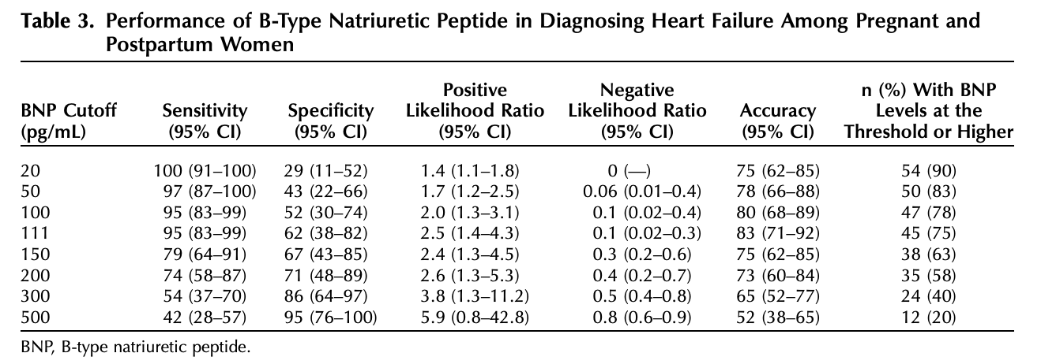

- A patient who presents with pretest probability of 30% for peripartum CHF, and is found to have a BNP of 250 pg/mL. Which of the published LRs should you use to calculate post-test probability? [1]

i) 2.6 because 250 > 200
ii) 0.5 because 250 < 300
iii) 2.5 because 250 > 111 (the “optimal” cutoff)
iv) 0.8 because 250 < 500
v) None of the above

Little is lost by reducing Table 3 above to just 2 rows, the row corresponding to a cutoff of 500 pg/mL and the row corresponding to a cutoff of 100 pg/mL. Ignore the other rows.

To be absolutely clear, here is the simplified table we want you to use for the rest of this problem:

BNP Cutoff (pg/mL) | Sensitivity | Specificity
100 | 95% | 52%
500 | 42% | 95%

- Given the results the simplified 2-row table shown above, calculate the post test probability of CHF in the patient from (a) with a BNP of 250 pg/mL [3]

Somebody who hasn’t taken Epi 204 decides to treat BNP as a dichotomous test with a cutoff of 500 pg/mL, so this person considers a BNP ≥ 500 pg/mL as positive for CHF and a BNP < 500 negative for CHF.

- Repeat part (b) using this dichotomous BNP, i.e. calculate the post-test probability based only on the information that your patient’s BNP result is < 500 pg/mL. If you get a different post-test probability from (b), explain why. [3]

- Use the data in the simplified table above and the grid below to label the axes and plot an ROC curve for BNP as a test for peripartum CHF. If it’s easier, feel free to create your own grid rather than use ours. [3]

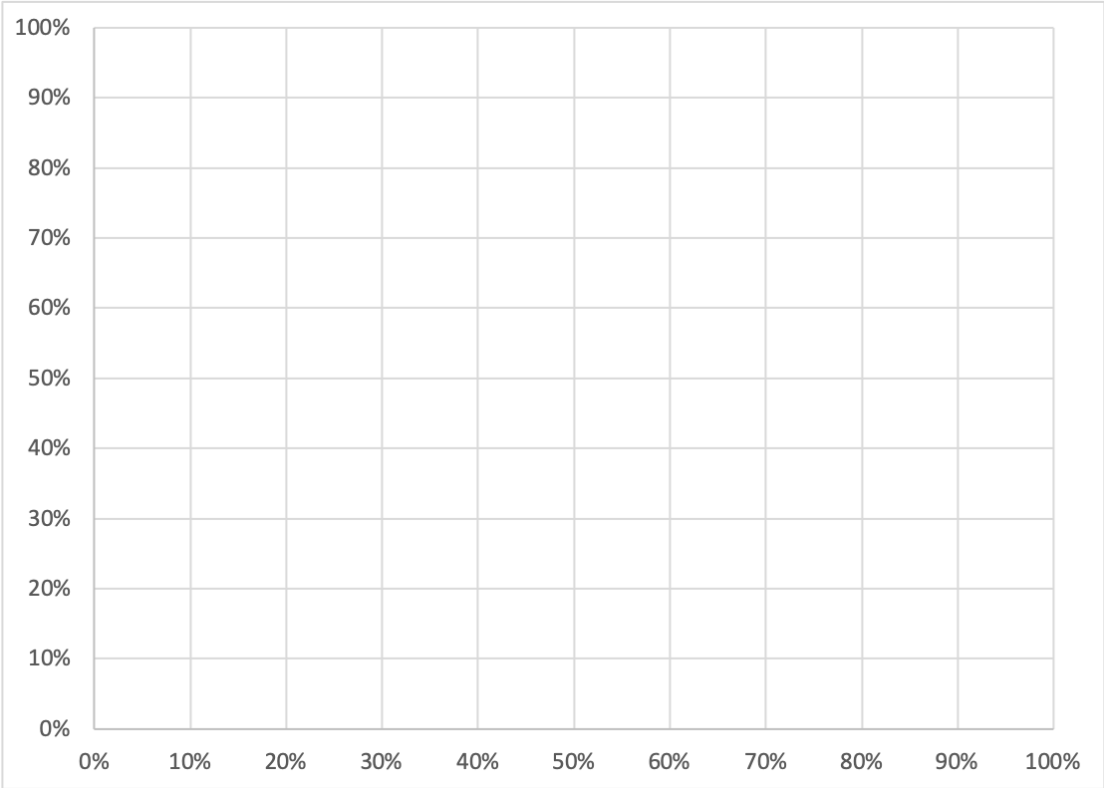

- Indicate the part of the graph that corresponds to a BNP of 100 to 500. [1]

After doing the above calculations, you find the following about study inclusion in the Methods section of the paper. (Underlining and italics added for emphasis.)

A list of all consecutive patients with B-type natriuretic peptide performed at the hospital's reference laboratory from January 1, 2007, to July 30, 2018, was obtained. Women who were currently pregnant or in the postpartum period (within 6 weeks from delivery), aged 18 years and older, and with echocardiography performed within 4 weeks of B-type natriuretic peptide measurement were eligible for inclusion…. [W]omen for whom echocardiography was… not performed… were excluded.

Clinical information: The clinicians ordering the echocardiogram were more likely to order an echocardiogram if the BNP was elevated.

- What potential bias arises from the inclusion criteria for this study. Explain. [2]

- How would this bias sensitivity? Explain. [1]

- How would this bias specificity? Explain [1]
4. Risk model for peri-intubation cardiac arrest in pediatric patients [18 points + 2 bonus]
In the pediatric ED, very sick children sometimes require a breathing tube. In the process of placing this tube, endotracheal intubation (ETI), they occasionally have a cardiac arrest (the heart stops). This is called peri-intubation cardiac arrest (PICA). Investigators at Rady Children’s Hospital in San Diego identified 563 patients who underwent ETI during a 9-year period. Of these, 21 had PICA. These were the cases. From the remaining 542 non-PICA patients they randomly selected 84 controls, that is 4 controls per case.
This problem focuses on 2 important dichotomous predictors of PICA, abnormal or unobtainable oxygen saturation (AbSpO2) and age < 1 year (Age<1yr).
Here is an excerpt from the authors’ unpublished manuscript:
 | PICA (n = 21) |  | Controls (n = 84) |  | p-value
Age < 1 year (Age<1yr) | 9 (42.9) |  | 13 (15.5) |  | 0.009
Hypoxia or unobtainable (AbSpO2) |  | 13 (61.9) |  | 2 (2.4) |  | <0.001
Data are presented as No. (%) unless otherwise indicated
Mann-Whitney-U Test for non-parametric data, Fisher’s Exact Test for categorical data

- Based on all the data given so far, what is the best estimate for the pre-test risk of PICA among those receiving ETI?[1]

- What is the LR(+) for Age < 1 year? [1]
Note: We are only asking about Age < 1 year (Age<1yr), not Hypoxia (AbSpO2)

- What is the LR(+) for AbSpO2.[1]
Note: Now, we are only asking about Hypoxia (AbSpO2), not Age < 1 year (Age<1yr).

- You are about to intubate a patient who is < 1 year old (Age<1yr) and who has an unobtainable oxygen saturation (AbSpO2 = True). Make the “Naïve Bayes” assumption of test independence conditional on disease, i.e. that you can first update the pre-test probability of PICA with the LR for Age<1yr and then use that as pre-test probability to update with the LR for AbSpO2. Based on this calculation, what is your patient’s probability of PICA? Show your work.[3]

Here are the Age<1yr counts for the 15 patients with AbSpO2 = True (abnormal SpO2):
AbSpO2 = True |  | PICA
 | Age<1yr | Case |  | Control |  | Total
 | Yes | 5 | 38.5% | 2 | 100.0%
 | No | 8 | 61.5% | 0 | 0.0%
 | Total | 13 |  | 2 |  | 15

Note that all 8 patients in the sample with abnormal spO2 and Age ≥ 1 year (that’s greater than or equal to, not Age<1yr) were cases. So, we should worry even more when we have an abnormal or unobtainable oxygen saturation in patients ≥ 1 year old.

Here are the Age<1yr counts for the 90 patients with AbSpO2 = False (normal SpO2):
AbSpO2 = False |  | PICA
 | Age<1yr | Yes |  | No |  | Total
 | Yes | 4 | 50.0% | 11 | 13.4%
 | No | 4 | 50.0% | 71 | 86.6%
 | Total | 8 |  | 82 |  | 90

- Combining two dichotomous tests results in 4 possible combinations. We want to build a 4-row LR table from the previous two tables. We will follow the convention of putting the most abnormal result in the top row. The results should be ordered by LR descending. Here’s a start. Fill in the entire table. [4]
Risk Category | AbSpO2 | Age<1yr | Case |  | Control |  | LR
4 | Yes | NO | 8 | 38.1% | 0 | 0.0% | ∞
3
2
1 | No | No | 4 | 19.0% | 71 | 84.5% | 0.23
 |  |  | 21 | 100.0% | 84 | 100.0%

- Repeat part (d) using the appropriate data-driven LR from your table above, not the Naïve Bayes assumption of test independence conditional on disease. Recall that you are about to intubate a patient who is < 1 year old (Age<1yr) and who has an unobtainable oxygen saturation (AbSpO2 = True). Calculate the patient’s probability of PICA. Show your work. [3]

- Compare your answers between (d) and (f). Are they different? If so why? [3]

- Assume the pre-test probability is as you answered in part (a). Your policy is to set up extra equipment and resources when a patient’s risk of PICA exceeds 4%, which combinations of AbSpO2 and Age<1yr justify the extra equipment and resources? [2]

- Extra Credit: Create a classification tree for the prediction rule that you have derived. [+2]

5. Risk prediction for invasive breast cancer [8 points]
(Thanks to Kristen Azar, Shelley DeVost, Safyer McKenzie-Sampson.)

Women at high risk of breast cancer may elect to take selective estrogen receptor modulator, such as tamoxifen, to reduce their risk of breast cancer. McCarthy et al.(3) compared several breast cancer risk prediction models, including the BRCAPRO, Tyrer-Cuzick v7 (TC v7), Gail, and Tyrer-Cuzick v8 (TC v8) models. These four models were developed using different populations and include different risk factors. In particular, the BRCAPRO, TC v7, and TC v8 models included more comprehensive family history, whereas the Gail model focused on reproductive and hormonal factors. All four models were developed using general breast cancer screening populations. For this study, data—including only limited family history information—were extracted from the electronic medical records of 35,921 cancer-free women who underwent screening mammography between 2007 and 2009. The outcome was diagnosis of invasive breast cancer by 6 years post mammogram and occurred in 647 women (cumulative incidence = 1.8%).

Here is Table 3 from the paper:

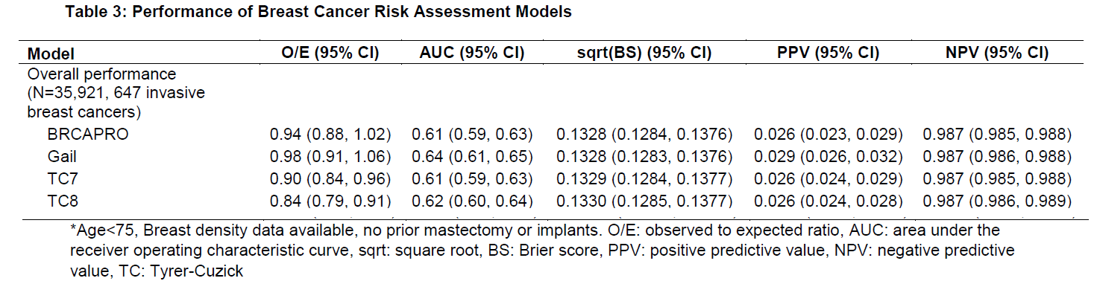

- Admittedly they only differ in the 4th decimal place, but which of the 3 lower models (Gail, TC7, TC8) has the worst Brier Score? [1]

The O/E ratio is a quantity related to the Mean Error or Bias. Recall that if the Bias is positive, the model over-estimates risk and if it is negative the model under-estimates risk. Just subtract O/E from 1 to get the Bias expressed as a percentage of the predicted risk. You could call this the Relative Bias.

r_{k} = predicted risk in group k
p_{k} = proportion with outcome in group k
Bias = r_{k} – p_{k}
O/E = p_{k} /r_{k}
1 - O/E = 1 - p_{k} /r_{k}
1 - O/E = (r_{k} – p_{k})/r_{k}
1 - O/E = Bias/r_{k} = Relative Bias

So. here are the Relative Biases for the 4 models.

 | O/E | Relative Bias
BRCAPro | 0.94 | 6.0%
Gail | 0.98 | 2.0%
TC7 | 0.90 | 10.0%
TC8 | 0.84 | 16.0%

- On average, do these models over-estimate or underestimate risk? Explain. [2]

Here are the calibration plots for each of the 4 models.
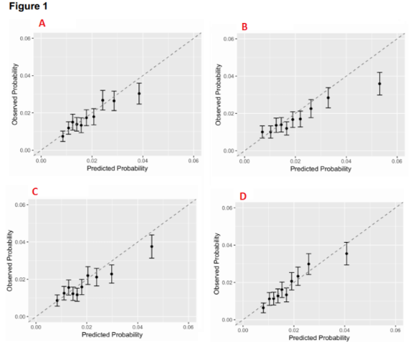

- Which of the above calibration plots A, B, C, or D corresponds to your answer to (a)? Explain [2]

The authors are vague about the decision that these models will guide. They mention more frequent screening with mammography, breast MRI, genetic testing, and chemoprevention, but they state that the decision threshold should be a 2% 6-year risk of invasive breast cancer.

- Using that threshold, will model B lead to overtreatment or undertreatment? Explain.[2]

- Which risk model (BRCAPRO, Gail, TC7, TC8) has the best discrimination as measured by the area under the ROC curve? [1]

6. Diagnosis of Community-Acquired Pneumonia in the Elderly [11 points]
(Thanks to Nader Najafi, 2019)

Community-acquired pneumonia is an infection of the lungs that increases in incidence with age and can result in hospitalization. Typical symptoms (shortness of breath, cough) and signs (fever, elevated heart rate) are often blunted or missing in elderly patients who may instead present with more vague symptoms such as appetite loss or falls. Unfortunately, these vague symptoms are also common in other conditions besides pneumonia. It is therefore difficult to accurately diagnose pneumonia in elderly patients, and this can result in a delay in treatment.

Takada et al. (4) took six diagnostic models for pneumonia that had been previously developed for adults, but not specifically for elderly patients, and applied the models to a small dataset of 109 elderly patients admitted to three teaching hospitals in Japan between 2014 and 2016 with symptoms of cough or mucus production. These patients were prospectively enrolled. The gold standard was chest x-ray from which pneumonia was diagnosed in 27 of the 109 (24.8%).

They assessed the models for calibration and discrimination. Next, they evaluated appetite loss, falls, and disturbance of consciousness for their ability to diagnose pneumonia. Finally, they extended one of the previously developed models with appetite loss in order to try to improve upon the original model’s performance.

Before we get to the diagnostic probability models, let’s look at the first 3 rows of Table 2:

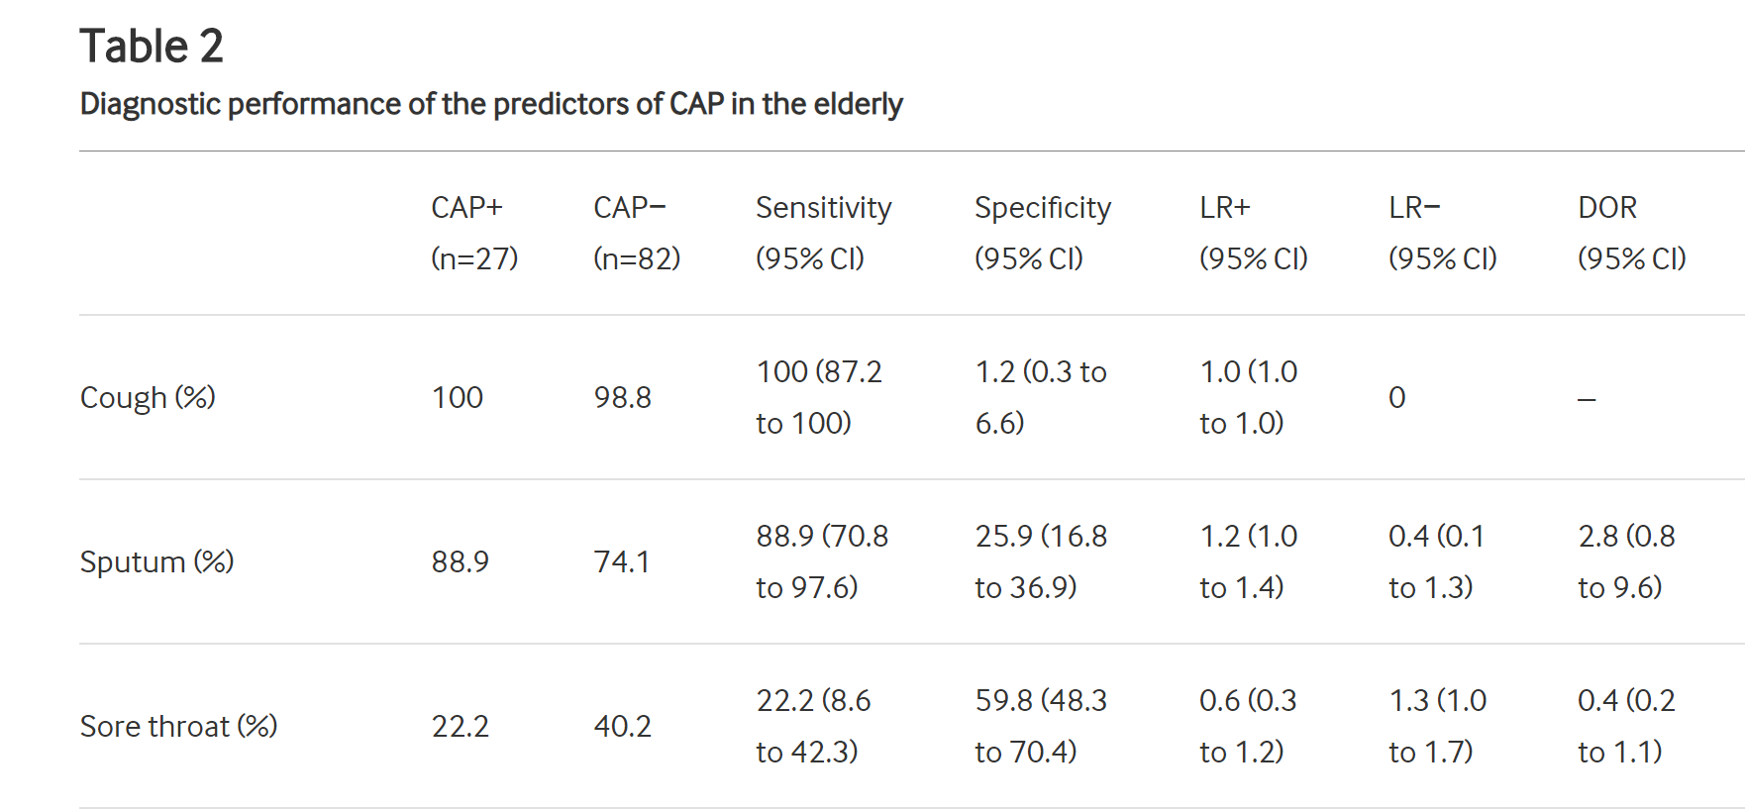

CAP, community-acquired pneumonia; DOR, diagnostic OR; LR+, positive likelihood ratio; LR−, negative likelihood ratio.

- Why is the specificity of Cough only 1.2%? [1]

- How do you interpret the LR+ (0.6) for Sore throat? [1]

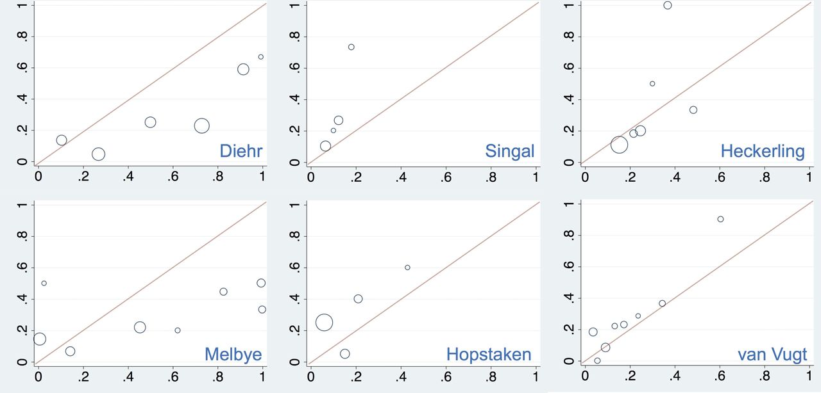
Figure 1 of the paper shows calibration plots (observed proportion with pneumonia on the y-axis) for the six logistic regression models that the authors tested on their dataset.

- Which model consistently underestimates risk? Explain your reasoning.[2]

Of the models depicted above, the authors preferred van Vugt, which considers the following 6 predictors of pneumonia: shortness of breath; absence of runny nose; decreased breath sounds; crackles on lung exam; pulse>100 beats/min; and temperature >37.8°C.

The authors wanted to extend the Van Vugt model by adding “loss of appetite” as a predictor. They asked the patient for an estimate of 24-hour food intake in proportion to usual food intake. If this was less than 50%, the patient was considered to have appetite loss. Appetite loss occurred in 18 of 27 patients with pneumonia and 17 of 82 patients without pneumonia.

- If we have a patient like the ones included in this study who has loss of appetite as defined above, what is this patient’s probability of pneumonia? (You don’t know anything else like whether the patient has shortness of breath, fever, or rapid heart beat.) [2]

- Could the authors have extended the Van Vugt model for loss of appetite by calculating the probability of pneumonia according to that model and then using that as the pre-test probability to update using the likelihood ratio for loss of appetite? Explain why or why not. [2]

The authors calculated the decision curve below.

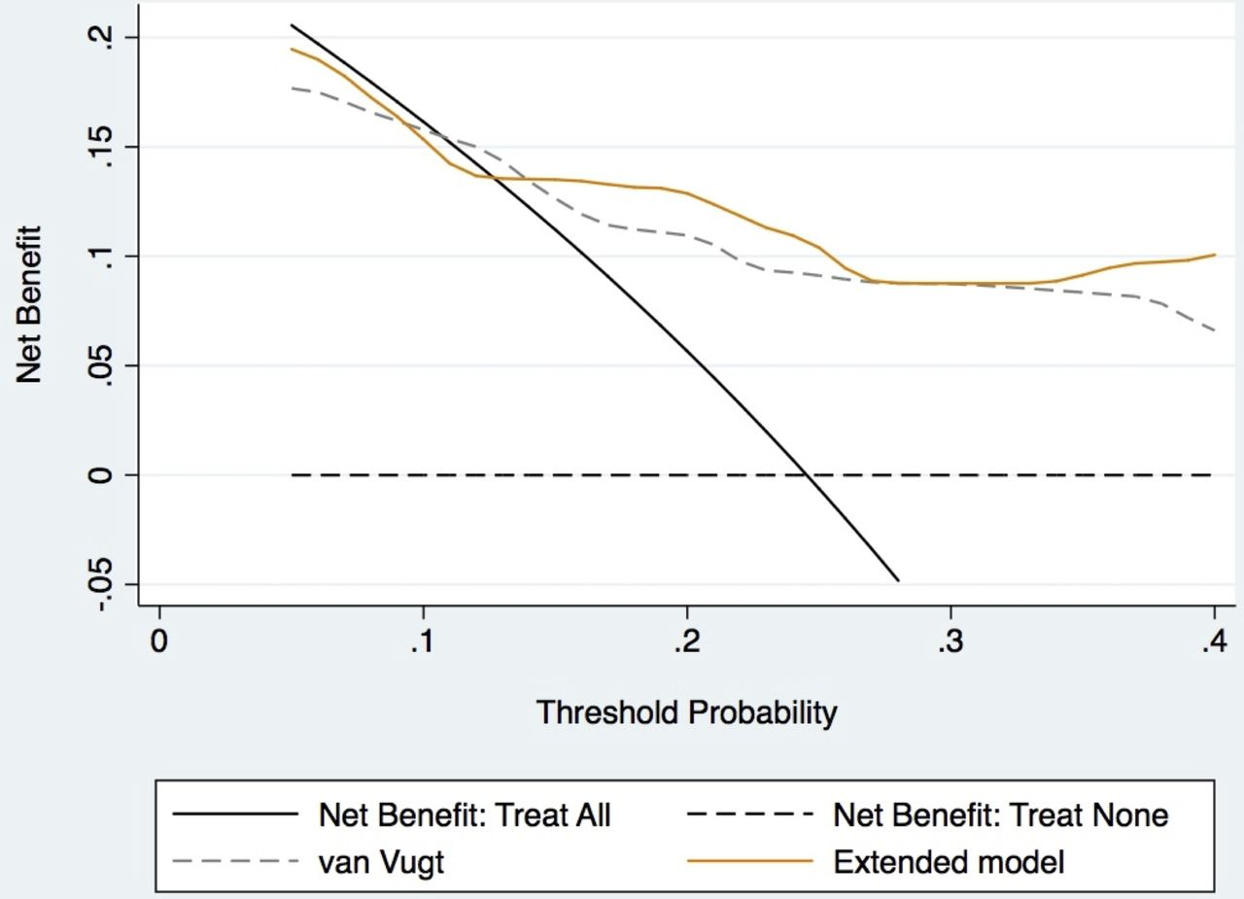

The authors note that, “among the 10 physicians [surveyed], the mean threshold for ordering CXR for the diagnosis of CAP in the elderly was 22.5%.”

- Will the extended model (compared with the unextended model) improve net benefit at a decision threshold 22.5%? Explain your answer. [2]

- The “Treat All” curve crosses the X axis between 0.2 and 0.3. Out to 3 decimal places, what is the threshold probability where it crosses? [1]
  - 0.225
  - 0.238
  - 0.248
  - 0.258
  - Not enough information.

7. Prenuvo Whole Body Screening MRI: Miracle or Menace? [10 points]
(Inspired by a problem submitted by Jonathan Amatruda, Elizabeth Black, Kazem Fallahzadeh and Anna Parks.)

A Canadian startup is offering whole body MRI for cancer “screening.” (https://twitter.com/awilkinson/status/1187102985148461056 & https://www.prenuvo.com/) They are planning to expand to San Mateo, California in 2020.

The website states, “Cancer and other disease[sic] are 5-7x more likely to kill you if detected late.” Assume this means that patients whose cancer (and other diseases) are diagnosed late (at a more advanced stage) are 5-7 times as likely to die from their disease as patients with cancer (and other diseases) who were diagnosed early (at a less advanced stage).

- Indicate whether each of the following statements about that claim is true or false and explain.
i. Even if treatment is completely ineffective, we might still see that people whose cancer is detected late (i.e., at a more advanced stage) are more likely to die from the cancer because of length bias. [2]
ii. The worse prognosis of cancer detected late can’t be due to overdiagnosis, because overdiagnosed disease (pseudodisease) will seldom if ever progress to a late stage. [2]
iii. While so far the claims about Prenuvo screening are based only on observational studies, if a randomized trial showed a statistically significant reduction in breast cancer mortality among women randomized to the Prenuvo whole-body MRI scanning this would be sufficient to recommend population-wide Prenuvo screening in women. [2]

- Regarding the accuracy of the scan, Prenuvo claims to have an unpublished study showing that only 4 out of 1000 patients scanned had a false positive result. However, following the “Doctors” link on the company’s website, under breast cancer, it says: “Prenuvo: Very effective, particularly for screening women with dense breasts. One study found detection with 98.7% sensitivity and 65.8% specificity.”
Suppose the 45 year old economics professor described in Chapter 1, with a prior probability of previously undetected invasive breast cancer of 2.8/1000, were to obtain a Prenuvo scan positive for breast cancer and the sensitivity and specificity of the scan for breast cancer were as advertised on the website. What would be her (posterior) probability of breast cancer? Show your work. [2]

- Suppose you wanted to design a study to independently verify the Prenuvo claims about the accuracy of their scan. Assume those with positive Prenuvo MRI scans would all proceed to definitive diagnosis (usually biopsy), and those with negative scans would receive clinical follow-up.
  - i. What bias would you be most concerned about for this study of test accuracy? [1]
  - ii. What would you need to assume about the diseases being detected in order not to worry about your study overestimating sensitivity and specificity? [1]

8. Extended-release naltrexone (XR-NTX) effect on viral suppression [10 points + 2 bonus]
(based on a problem submitted by Yusuph Mavura, Akansha Batra and Caitlin Turner)
Springer et al(5) examined whether pharmacotherapy to treat alcohol use disorders, extended-release naltrexone (XR-NTX), influences HIV viral suppression (VS) in people living with HIV and alcohol use disorders who are transitioning to the community from prison or jail. They hypothesized that XR-NTX would alleviate the alcohol use, thereby improving adherence to medication and increasing VS.
The abstract states:
Design—A randomized double-blind, placebo-controlled trial was conducted among incarcerated individuals with HIV and alcohol use disorders transitioning to the community from 2010 through 2016.
Methods—Eligible participants (N=100) were randomized 2:1 to receive 6 monthly injections of XR-NTX (n=67) or Placebo (n=33) starting at release and continued for 6 months. The primary and secondary outcomes were the proportion that maintained or improved VS at <200 copies/mL and <50 copies/ml from baseline to 6 months…” ¹

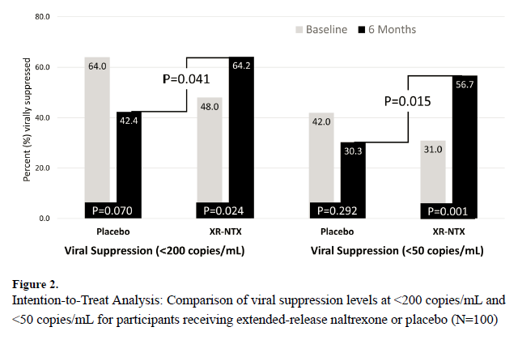
In the results section, the authors state that “at six months, compared to placebo, participants who received XR-NTX were also significantly more likely to have VS for both the primary outcome (<200 copies/mL) (64.2% XR-NTX vs. 42.4% placebo; p=0.041) and secondary outcome (<50 copies/mL) (56.7% XR-NTX vs. 30.3% placebo; p = 0.015).” For the purposes of this problem, focus only on the primary outcome.
  - Assume the bad outcome we are trying to prevent is lack of viral suppression to < 200 copies/ml at 6 months. Using conventions recommended in Chapter 8 and looking at the 6-month data only, what are the RR and RRR comparing XR-NTX to placebo for that outcome? [2]
  - Calculate the ARR and the NNT for that same outcome and explain in words what the NNT means. [2]

  - Is the comparison with the P-value of 0.041 in the figure a within-groups or between-groups comparison? Explain. [2]. (Extra credit +2: How could they have done it better?)

  - The mean cost per XR-NTX injection per person is $704. Calculate the treatment cost per viral non-suppression event prevented using the mean cost per XR-NTX injection and assuming that each patient received 6 injections in six months. [2]

  - The authors state that “Overall, 13% of participants who were randomized had missing HIV-1 RNA data 6 months post-release” and were lost-to-follow-up (LTFU). The authors go on to state that “Consequently, we were able to maintain the most conservative standard ITT assumption that missingness from participant attrition equals viral non-suppression (missing = failure).” In short, all those who were LTFU in the treatment and control group had the event of interest (viral non-suppression). Given how the authors handled losses to follow-up, in which direction would the results of this analysis most likely be biased? [2]

9. Antibiotics and Length of Stay [12 points]
Stefan et al(6) performed a retrospective cohort study using the Premier Inpatient Database to study the effect of antibiotic treatment on length of stay and other outcomes among 19,811 patients hospitalized for asthma and treated with systemic steroids. From the abstract: “Antibiotics were prescribed for 8788 patients (44.4%)…Those treated with antibiotics had a significantly longer hospital stay (median [IQR], 4 [3-5] vs 3 [2-4] days) and a similar rate of treatment failure (5.4% vs 5.8%).” [12 points]

- The authors mentioned that they needed to address confounding by indication. In what direction would you expect uncontrolled confounding by indication to affect the length of stay results? Explain. [3]
- The authors used both propensity matching and an instrumental variable approach to dealing with potential confounding by indication. For the following two statements, indicate whether it is true or false and explain.
- Propensity matching involves matching each subject who received antibiotics to another subject who did not receive antibiotics but had a similar probability of the outcome based on measured covariates. [2]
- In creating the propensity score, one should avoid including predictors known not to be independently associated with outcome, even if they are strong predictors of exposure. [2]

- Variables like those described in part ii above might make good instrumental variables. [2]
- In the methods section, the definition of antibiotic exposure is as follows: “Early antibiotic treatment was defined as antibiotic therapy initiated during the first 2 days of hospitalization and prescribed for a minimum of 2 days.”
They don’t describe how they determined that the antibiotic was prescribed for a minimum of 2 days, but with most administrative inpatient databases this would be determined by data indicating that the patient received (or at least was billed for) antibiotics on at least the next 2 calendar days after the first dose. So, if the first dose was on December 1, there would need to be codes indicating antibiotics were given on December 2 and 3.

Assuming this was the case, and recalling that this is an inpatient database, could this definition of exposure lead to a biased comparison of length of hospital stay between antibiotic exposed and unexposed patients? Explain. [3]
10. Vitamin C for Sepsis. [6 points + 2 bonus]

Experimental data suggest that intravenous vitamin C might reduce the inflammation and vascular injury associated with sepsis. The CITRIS-ALI trial, published last month in JAMA, was a randomized double-blind trial that compared the effects of intravenous Vitamin C with placebo in 167 patients with sepsis and acute respiratory distress syndrome (ARDS).(7). The primary outcomes were change in an organ failure score and plasma biomarkers of inflammation and vascular injury.

The conclusions in the study abstract were: “In this preliminary study of patients with sepsis and ARDS, a 96-hour infusion of vitamin C compared with placebo did not significantly improve organ dysfunction scores or alter markers of inflammation and vascular injury. Further research is needed to evaluate the potential role of vitamin C for other outcomes in sepsis and ARDS.”

Not mentioned in the abstract was an interesting statistically significant result on all-cause mortality, one of their 46 pre-specified secondary outcomes. Per the results section of the paper, “At day 28, mortality was 46.3% (38/82) in the placebo group vs 29.8% (25/84) in the vitamin C group (χ2 = 4.84; P = .03; between-group difference, 16.58% [95% CI, 2% to 31.1%]) (Figure 3).” Figure 3 is show above.

For each of the following, indicate whether the statement is true or false and explain your answer.

- For the total mortality finding, the fact that P=0.03 is consistent with the fact that the 95% confidence interval for the risk difference excludes 0. [2]

- While we cannot be 95% confident that the confidence interval for the risk difference (from 2% to 31.1%) includes the true value, if we were to repeat this study many times, we would expect 95% of the 95% confidence intervals of those studies to include the mortality risk difference of 16.58% found in this study. [2]
- A Bayesian approach to the total mortality finding would consider the prior probability distribution for the total mortality effect rather than the number of secondary outcomes examined. [2]

- The conservative interpretation of the all-cause mortality findings is consistent with excessive concern with avoiding an error related to the first name of the first author of the study. [Bonus +2]

REFERENCES

1. Gershon CA, Yagapen AN, Lin A, Yanez D, Sun BC. Inter-rater Reliability of the HEART Score. Acad Emerg Med. 2019;26(5):552-5.
2. Malhame I, Hurlburt H, Larson L, Poppas A, Nau C, Bourjeily G, et al. Sensitivity and Specificity of B-Type Natriuretic Peptide in Diagnosing Heart Failure in Pregnancy. Obstet Gynecol. 2019;134(3):440-9.
3. McCarthy AM, Guan Z, Welch M, Griffin ME, Sippo DA, Deng Z, et al. Performance of breast cancer risk assessment models in a large mammography cohort. J Natl Cancer Inst. 2019.
4. Takada T, Yamamoto Y, Terada K, Ohta M, Mikami W, Yokota H, et al. Diagnostic utility of appetite loss in addition to existing prediction models for community-acquired pneumonia in the elderly: a prospective diagnostic study in acute care hospitals in Japan. BMJ Open. 2017;7(11):e019155.
5. Springer SA, Di Paola A, Barbour R, Azar MM, Altice FL. Extended-release Naltrexone Improves Viral Suppression Among Incarcerated Persons Living with HIV and Alcohol use Disorders Transitioning to the Community: Results From a Double-Blind, Placebo-Controlled Trial. J Acquir Immune Defic Syndr. 2018;79(1):92-100.
6. Stefan MS, Shieh MS, Spitzer KA, Pekow PS, Krishnan JA, Au DH, et al. Association of Antibiotic Treatment With Outcomes in Patients Hospitalized for an Asthma Exacerbation Treated With Systemic Corticosteroids. JAMA Intern Med. 2019;179(3):333-9.
7. Fowler AA, 3rd, Truwit JD, Hite RD, Morris PE, DeWilde C, Priday A, et al. Effect of Vitamin C Infusion on Organ Failure and Biomarkers of Inflammation and Vascular Injury in Patients With Sepsis and Severe Acute Respiratory Failure: The CITRIS-ALI Randomized Clinical Trial. JAMA. 2019;322(13):1261-70.

“Non-specific” = non-specific repolarization disturbance: No ST depression but LBBB, LVH, repolarization changes; “Abnormal” = significant ST deviation: ST depression/elevation not due to LBBB, LVH, or digoxin.
The authors did not specify what weights they used. Truth be told, the 0.52 that they reported was for agreement on the “History” component of the score, but assume that’s what they reported for the ECG component of the score.

