Molecular and Genetic Epidemiology
Assignment 3

Due by noon on Monday before next class

A. Reading

- The following sections of Genetic Epidemiology chapter (Witte and Thomas):
Association Studies
Analyzing associations
Genome-wide Association studies

- For Discussion: History of Human Disease Genetics

B. Project

1. Power Calculations

For the disease you are interested in studying, use the following online power calculator to determine the sample size required to detect an association with 80% power. Here we assume that your trait is binary (yes/no). If it’s continuous, assume that you will select a cutpoint or extreme tail and turn it into a binary trait (e.g., 90th percentile vs. 10th).

http://csg.sph.umich.edu/abecasis/cats/gas_power_calculator/index.html

You will need to input the following:
- Significance (alpha) level (false positive rate per SNP, type I error, 0.05 for one SNP)
- Disease model (multiplicative = default log additive trend test)
- Disease prevalence (from the literature?)
- Disease allele frequency (common variants > 0.05)
- Genotype relative risk (e.g., odds ratio, usually pretty small).

The website has a nice tutorial stepping through each of these.

- What sample size do you need to have 80% power for testing a single SNP association with your phenotype for a genotype relative risk of 1.5? How about for RR=1.1?
- Now assume you are studying a candidate gene with 50 SNPs. How do the answers to #1 change?
- Not assume that you are undertaking a GWAS with 1 million effective tests. How does your required sample size? Do you think it’s feasible to recruit such a sample size for the trait you’re interested in studying?

C. Problems

1. Suppose we are considering a Mendelian fully penetrant autosomal trait. If two recessive parents have the disorder, than what, if anything, can you say about their children? What if the trait were dominant? Now, suppose a child has a recessive trait, what, if anything, can you say about their parents? What if it were dominant?

2. What can you say about the following families – are they dominant (assuming fully penetrant disease), recessive (assuming fully penetrant disease), neither dominant nor recessive (assuming fully penetrant disease), or impossible to tell?

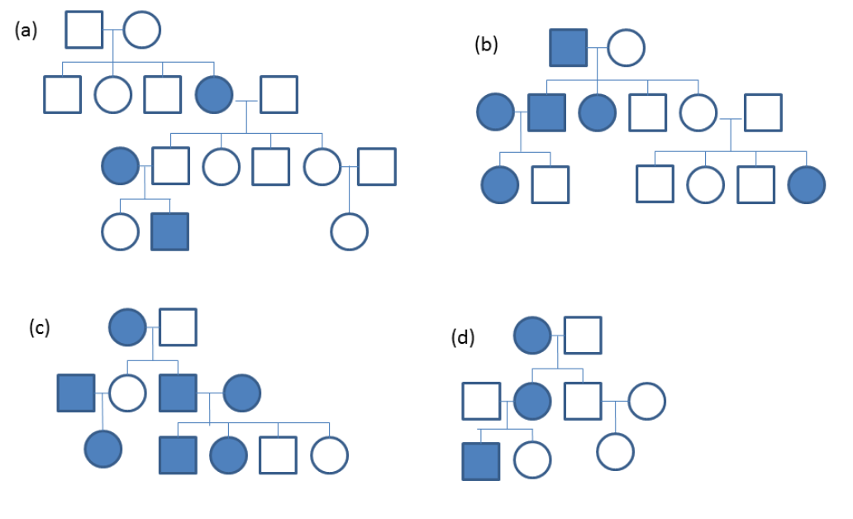

3. Assume that a case/control study has been conducted and a SNP (X) genotyped (with 0, 1, or 2 risk alleles). Compute the odds ratios for the table below and the corresponding confidence intervals. Compute chi square tests for codominant, dominant and recessive modes of inheritance. Discuss the results in terms of plausibility of a model.

X=0 X=1 X=2
Cases 500 350 120
Controls 521 270 130

Note: to get the OR and the CI in STATA, one can use:
. cci (# exposed cases) (# unexposed cases) (# exposed controls) (# unexposed controls)

