Molecular and Genetic Epidemiology
Assignment 5
Due by noon on Monday before next class

A. Readings

1. Witte chapter – Evaluating multiple risk factors

2. A couple of short DTC papers:
https://www.nature.com/scitable/topicpage/dtc-genetic-testing-for-diabetes-breast-cancer-698/
https://www.ncbi.nlm.nih.gov/pmc/articles/PMC1950839/

B. Locuszoom plots and variant characterization

Create a locuszoom plot (see lecture; http://locuszoom.org/) of EITHER:

(a) Use the given LDL dataset we exemplified in the lecture. Try one (you can do more, but need only do one) of the following variants: rs492602, rs1800562, rs3764261

OR: (b) If you happen to have your own data (or want to use a different published GWAS), you are more than welcome to use that for a locuszoom plot.

Note: Please don’t struggle with this too much, and let us know if you are having problems. The updated interface is a little broken.

C. Howework Problems – Revisiting GWAS QC

1. One of the first steps in running a genome-wide association study (GWAS) is doing quality control to remove indivduals and SNPs that are bad. We are showing you a small excerpt – what would you do with the following individuals and why?
Family ID | Individual ID | Father ID | Mother ID | Sex | Affection Status | % Missing
1 | 1 | 2 | NA | F | A | 0.1%
1 | 2 | NA | NA | M | U | 0.1%
3 | 3 | NA | NA | F |  | 0.1%
4 | 4 | NA | NA | M |  | 45.0%

2. Again, we show you a small excerpt. Which of the following SNPs and why? Recall for the HWE test, the null is that they are in Hardy-Weinberg equilibrium, which is a good thing.
SNP | HWE | % missing
rs111 | 0.9 | 40.1%
rs123 | 5x10^-50 | 0.2%
rs456 | 0.05 | 0.3%
rs333 | 0.9 | 0.1%

3. Why do we typically run a GWAS adjusting for principle components?
4. Look at the following QQ-plot. The inflation factor is lambda=1.001. Does it look ok?
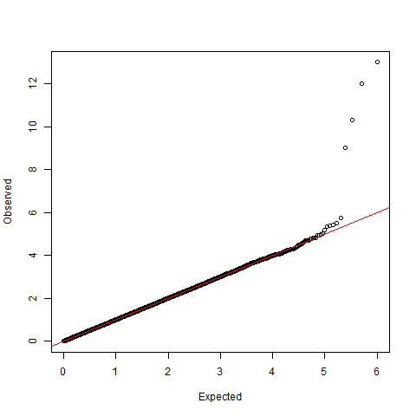
5. Suppose an excerpt of your SNPs were the following. Are any of them significant? (Assume a bonferroni correction of 0.05/1,000,000=5x10⁻⁸). If it is, write out, in words, what the OR means, if this is on the additive genetic scale. Also, if it is, what gene is it in?
SNP | MAF | OR | P-value
rs10417394 | 0.07 | 1.14 | 1x10^-13
rs2 | 0.08 | 1.01 | 0.002
rs3 | 0.33 | 0.99 | 0.00001

6. Look at the Q-Q plot. The smallest p-values observed are the ones along the y-axis; they are sorted by their -log₁₀ p-values. This means that the highest SNP has p-value 1x10⁻¹³, the next has p-value 1x10⁻¹², then 1x10⁻¹¹, then 1x10⁻⁹, before it goes to roughly noise. Suppose I told you that these SNPs were, in fact, all very close to each other. Do you think that you have found multiple different loci, or do you think that you found just one locus, and why (it's possibly both)? [Hint: think about LD.]

7. Suppose that you excluded a variant from the genotyped markers because it had too much missing data. However, now you have tried to impute it using the surrounding markers. Here the r_{info}²=0.98. Can you now test this marker?

8. Suppose that you also excluded another variant, rs222, because it had missingness of 6%. When you imputed it the r_{info}²=0.04. Can you now test this imputed marker? Just for fun (i.e., answer not required), any thoughts on what you might do here?

9. Recall from before rs10417394 had a P-value of 1x10⁻¹³ in the typed markers. Now it has 0.9x10⁻¹⁴ in the imputed markers. Why is this possible? [Hint: The SNPs call rate was probably not 100%.]

