Biostatistics 226, Winter 2020

Homework 5

1. Murphy et al (2012; pp 36+) discuss the ExTENd example presented in Lecture 5. If you were to match this SMART with that on Slide 11 of the lecture notes, would you assign the letter as shown below? If not, recommend more accurate assignment in the right-hand column. Highlight letters corresponding with nonresponders.

Slide 11:

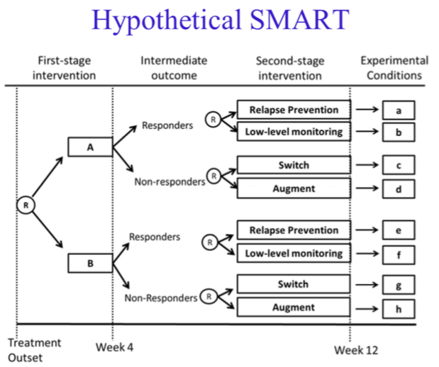 | A | Stringent Resp RP (more intense)
 | B | Stringent Resp LLM (less intense)
 | C | Stringent NonResp Sw (less intense)
 | D | Stringent NonResp Aug (more intense)
 | E | Lenient Resp RP (more intense)
 | F | Lenient Resp LLM (less intense)
 | G | Lenient NonResp Sw (less intense)
 | H | Lenient NonResp Aug (more intense)

HW5: NonResponse AIs are highlighted in green.

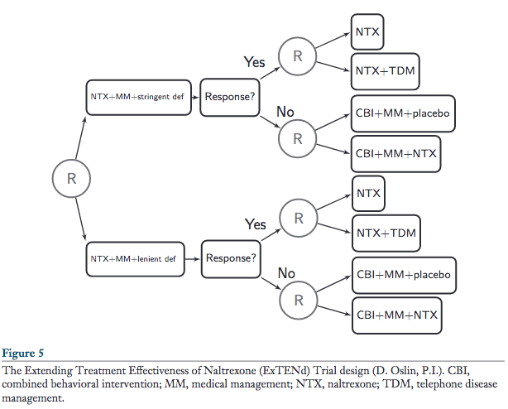 | B | Stringent Resp NTX (less intense)
 | A | Stringent Resp NTX+TDM (more intense)
 | C | Stringent NonResp C+M+P (less intense)
 | D | Stringent NonResp C+M+N (more intense)
 | F | Lenient Resp NTX (less intense)
 | E | Lenient Resp NTX+TDM (more intense)
 | G | Lenient NonResp C+M+P (less intense)
 | H | Lenient NonResp C+M+N (more intense)

2. Murphy et al provide some raw data from this study in Table 3, reproduced here. Here, the column “Adaptive Intervention” includes: a stage 1 arm, then two stage-2 arms – for stage-1 responders then nonresponders. The two stage-2 arms correspond with the two levels of the tailoring variable that could occur for any participant. Thus, two sequences of the 8 possible correspond with each AI tabled below. Assign correct strategy letters from Q1 above to each row below, to link the results to the design.

Row | Stringent | N | # Responders | p2 | Adaptive  Intervention | Strategy Letters  Resp, NonResp
1 | 0 | 60 | 50 | 49% | (Lenient; NTX,  CBI+MM+placebo) | F, G
2 | 1 | 64 | 41 | 76% | (Stringent; NTX,  CBI+MM+placebo) | B, C
3 | 0 | 63 | 53 | 40% | (Lenient; NTX+TDM,  CBI+MM+placebo) | E, G
4 | 1 | 62 | 39 | 64% | (Stringent;NTX+TDM,  CBI+MM+placebo) | A, C
5 | 0 | 64 | 50 | 57% | (Lenient; NTX,  CBI+MM+NTX) | F, H
6 | 1 | 61 | 41 | 71% | (Stringent; NTX,  CBI+MM+NTX) | B, D
7 | 0 | 67 | 53 | 48% | (Lenient; NTX+TDM,  CBI+MM+NTX) | E, H
8 | 1 | 59 | 39 | 58% | (Stringent; NTX+TDM,  CBI+MM+NTX) | A, D

Comment: We see above that a single response rate is reported per pair of AIs, linked by the 3rd decision node. Below, we see how the analysis method controls for common components of AIs to estimate effects associated with differing components.

3. In Table 6, each row compares nonresponders whose stage-1 outcome used the lenient definition with subjects whose stage-1 outcome used the stringent definition. In row 1, nonresponders received CBI+MM+placebo at stage 2. Table 3 shows that stage-2 response rates were 49% and 76% for lenient and stringent stage-1 arms, respectively. For each row of Table 6, calculate the odds ratio comparing the stringent to the lenient stage-1 outcome definition; also calculate the log OR and compare these with the values shown in Table 3. How do the authors interpret the findings across rows?

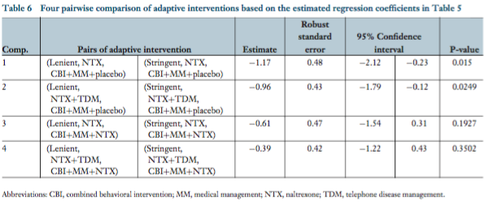 | AI strategies;  Response rates |  | OR | logOR
 | F,G  0.49 | B,C  0.76 | 3.30 | 1.19
 | E,G  0.40 | A,C  0.64 | 2.67 | 0.98
 | F,H  0.57 | B,D  0.71 | 1.85 | 0.61
 | E,H  0.48 | A,D  0.58 | 1.50 | 0.40

Table 3 Explanation (p.41): “Each participant is consistent with two adaptive interventions (i.e., the observed primary outcome of each participant is used in estimating the average primary outcome of two adaptive interventions; for more details, see Nahum-Shani et al. 2011a).”
- “Each participant is consistent with two adaptive interventions…” In this example, after stage-1 outcomes are known, each subject is randomized across two arms. The paired labels show the two possible assignments.
- “… the observed primary outcome of each participant is used in estimating the average primary outcome of two adaptive interventions…” Analysis is based on the observed arms.

Table 6 Results (from p.43): “Table 6 compares four pairs of adaptive interventions in terms of the estimated logitP(Y = 1). The four rows (in Table 6) contrast adaptive interventions that begin with different nonresponse definitions.” … “The results reported in Table 6 indicate that the adaptive interventions in comparisons 1 and 2 are significantly different in terms of achieving drinking abstinence at the end of stage two [estimated logit P(Y = 1) = −1.17; −0.96, p < 0.05, for comparison 1 and 2, respectively]. Notice that comparisons 1 and 2 include adaptive interventions in which nonresponders are offered the less-intensive second-stage intervention (CBI+MM+ placebo). These results indicate that if we are to provide nonresponders with the less-intensive rescue intervention (CBI+MM+placebo), then beginning with the lenient definition of nonresponse (five or more heavy drinking days) will result in better achievement of abstinence at the end of the second stage relative to beginning with the stringent definition of nonresponse (two or more heavy drinking days).
The results reported in Table 6 also indicate that the adaptive interventions in comparisons 3 and 4 are not significantly different in terms of achieving drinking abstinence at the end of stage two [estimated logitP(Y = 1) = −0.61; −0.39, ns, for comparison 3 and 4, respectively]. Notice that comparisons 3 and 4 include adaptive interventions in which nonresponders are offered the more-intensive maintenance intervention (CBI+MM+NTX). These results indicate that we are to provide nonresponders with the more-intensive second-stage intervention (CBI+MM+NTX); it is less clear whether we should begin with the lenient or the stringent definition of nonresponse. ”

4. State the primary objective of the ExTENd study. Following the layout of Table 6, identify two comparisons. Both should test the effect of CBI+MM+NTX vs CBI+MM+Placebo in nonresponders – one row should represent subjects whose stage-1 outcome used the lenient definition and the other should represent subjects whose stage-1 outcome used the stringent definition. For each row, calculate the odds ratio estimating the effect of interest. How do you interpret the findings across rows? Hint: I see no role for the column labeled “# Responders” in addressing these questions.

Primary objective (p.40): “Other SMART designs are sized to address a primary research question concerning the second-stage intervention options. For example, in the ExTENd study, the primary aim was to test the main effect of the rescue intervention options for nonresponders to the first-stage intervention (NTX+MM), that is, to assess whether there is a difference in drinking outcomes for nonresponding participants treated with CBI+MM+NTX versus CBI+MM+placebo.”

Effects of stage-2 interventions CBI+MM+NTX vs CBI+MM+Placebo
in stage-1 nonresponders:
Row | CBI+MM+placebo | CBI+MM+NTX | AI Strategies;  Response rates |  | OR
1 | Lenient; NTX,  CBI+MM+placebo | Lenient; NTX,  CBI+MM+NTX | F,G  0.49 | F,H  0.57 | 1.38
2 | Stringent; NTX,  CBI+MM+placebo | Stringent; NTX,  CBI+MM+NTX | B,C  0.76 | B,D  0.71 | 0.77
3 | Lenient; NTX+TDM,  CBI+MM+placebo | Lenient; NTX+TDM,  CBI+MM+NTX | E,G  0.40 | E,H  0.48 | 1.38
4 | Stringent; NTX+TDM,  CBI+MM+placebo | Stringent; TX+TDM,  CBI+MM+NTX | A,C  0.64 | A,D  0.58 | 0.78
5 | Lenient; Average,  CBI+MM+placebo | Lenient; Average,  CBI+MM+NTX | F,G; E,G  0.44 | F,H; E,H  0.52 | 1.38
6 | Stringent; Average,  CBI+MM+placebo | Stringent; Average,  CBI+MM+NTX | B,C; A,C  0.70 | B,D; A,D  0.65 | 0.78

Comment: The primary research question doesn’t mention the stage-1 outcome definition but we see that the answer depends on this definition. When the Lenient definition is used, CBI+MM+NTX is effective (achieves higher response than CBI+MM+placebo; Rows 1 and 3), whereas it’s ineffective (harmful?) when the Stringent stage-1 outcome definition is used (Rows 2 and 4). [Showing either rows 1 & 2 or rows 3 & 4 is adequate for full points.]

We find identical results whether we condition on either stage-2 arm for Responders – NTX+TDM or NTX. Regardless, we can remove this effect by averaging over its levels (see rows 5-6).

5. Which of the following goals can be addressed by a SMART?
- Within-stage, comparing outcomes between intervention arms
- Across stages, comparing outcomes among adaptive treatment strategies
- Identifying important tailoring variables among those included in the SMART
- Discovering important tailoring variables not included in the SMART

A, b, c

6. Tailoring variables:
- In a SMART, does a tailoring variable serve as a study arm, a covariate, a stratification factor, or a cluster-level experimental unit? Use specific tailoring variables in the ExTENd example to illustrate your answers.
- In place of the tailoring variables used in the ExTENd example, what other variables could work well? If you were designing this SMART study, how would you choose among these options?

A tailoring variable serves as a stratification factor. Stage-1 response is an example here.

7. Some SMARTs incorporate both pharmaceutical and behavioral interventions.
- Following pharmaceutical interventions, should outcomes be laboratory/biological rather than behavioral?
- Following behavioral interventions, should outcomes be behavioral rather than laboratory/biological?

An outcome variable following a pharmaceutical intervention could be either biological or behavioral. An outcome variable following a behavioral intervention could be either biological or behavioral.

8. Most traditional RCTs address a single primary research question, whereas most SMARTs address multiple research questions. What questions are commonly addressed in SMARTs?

SMART Questions (p.27):
- questions may concern the comparison of different intervention options at different stages of the intervention,
- questions may concern the comparison of adaptive interventions that are embedded in the SMART trial, such as the differences between the eight adaptive interventions above
- questions that concern the construction of more deeply tailored adaptive interventions that go beyond those explicitly embedded as part of the SMART design
9. Can you find a published SMART related to your field of research interest?

