Introduction to Causal Inference Methods: Directed Acyclic Graphs (DAGS)
Guest Lecturer: Rebecca Graff
Key Words (or Topics)
Backdoor criterion
Causality
Colliders and collider bias
Conditioning
Confounding
D-separation
Paths
Measurement bias
Selection bias

Objectives
- Understand how to draw and use DAGs and related terminology.
- Apply DAGs to common problems in epidemiology.
- Critically appraise limitations of DAGs.

Assigned Readings
Chapter 12, Rothman, Greenland, & Lash 3rd Edition

Hernán MA, Zhang SM, Rueda-deCastro AM, Colditz GA, Speizer FE, Ascherio A. Cigarette smoking and the incidence of Parkinson’s disease in two prospective studies. Ann Neurol. 2001 Dec;50(6):780-6. PMID: 11761476.

Optional Readings

Ch. 6-9 - Hernán MA & Robins JM, Causal Inference book – What if, online text book (Nov. 2019 version)

"Using Causal Diagrams to Understand Common Problems in Social Epidemiology", M Glymour. chapter 18 in Methods in Social Epidemiology, 2nd edn. (2017) Oakes and Kaufman eds. Wiley (This is an updated and somewhat friendlier version of the chapter in Modern Epi).
http://publicifsv.sund.ku.dk/~nk/epiF14/Glymour_DAGs.pdf

Glymour MM, Weuve J, Berkman LF, Kawachi I, Robins JM. When is baseline adjustment useful in analyses of change? An example with education and cognitive change. American journal of epidemiology. 2005 Aug 1;162(3):267-78. (This is an illustration of a particular problem that could helpfully be represented with DAGs)
https://www.ncbi.nlm.nih.gov/pubmed/15987729

Hernán MA, Hernández-Díaz S, Robins JM. A structural approach to selection bias. Epidemiology. 2004 Sep 1;15(5):615-25. (This was a very influential paper that reconceptualized how we think about selection bias).
https://www.ncbi.nlm.nih.gov/pubmed/15308962

VanderWeele TJ, Hernán MA. Results on differential and dependent measurement error of the exposure and the outcome using signed directed acyclic graphs. American journal of epidemiology. 2012 May 8;175(12):1303-10.
https://www.ncbi.nlm.nih.gov/pubmed/22569106

Assignment – Please answer the following questions after reading the assigned Hernán article. The article discusses several potential explanations for the association found between Parkinson’s disease and cigarette smoking.

- In the first column of page 784, a paragraph begins with “The key question is whether this strong inverse association reflects a truly protective of smoking on the risk of developing PD.” Draw a causal DAG that is consistent with the explanation given in this paragraph. Please label your DAG and explain briefly.
(3 points)

One answer:
Smoking (through direct mechanism)
PD
Neural Protection
Free Radical

Note: Answers may vary and they may just have: A -------> Y which is fine.

The point here is to show the arrow from smoking to PD reflecting a causal pathway, with or without the intermediate mechanisms depicted.

- In the first column of page 785, a paragraph begins with “There are also several versions of the argument claiming the existence of a causal effect of PD on smoking behavior...” Draw a causal DAG that is consistent with the explanation given in this paragraph. Please label your DAG and explain briefly.
(3 points)

Answer:

Reverse causation, Arrow should go from PD to smoking, with or without intermediate explanations.

Y -------------> A

Different options below, answers may vary:
PD patients have pre-existing personality or underlying metabolism that causes PD and makes smoking unrewarding once one has PD

PD
Smoking
PD Dx

Subclinical PD induces aversion to smoking, causing smokers to quit.

Y X A
Y’

A: Smoking status X: Aversion to smoking
Y’: Diagnosed Parkinson’s disease Y: First symptoms of Parkinson’s disease

- In the first column of page 785, a paragraph begins with “Confounding…” Draw a causal DAG that is consistent with the explanations given in this paragraph. Please label your DAG and explain briefly.
(3 points)

Answers may vary:

In the DAG below, lifestyle, ethnicity, and geography are depicted as common causes of both smoking and PD, and thus may confound any association observed.
Smoking
PD
Lifestyle Factors
Ethnicity
Geography
Genes

OR just the standard simple confounding DAG, with L, A, and Y defined as “confounding factor”, “smoking”, and “PD”, respectively.

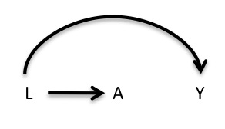
Other possible variations:

Alcohol

U Coffee Y U coffee/alc Y

Smoking Smoking

- In the first column of page 784, a paragraph begins with “The information bias…” Draw a causal DAG that is consistent with the explanation given in this paragraph. Please label your DAG and explain briefly. (3 points)

Answers may vary:
A: smoking
A Y’ or A D Y’ Y: PD (true)
D: any mediating factor
Y Y Y’: diagnosis of PD

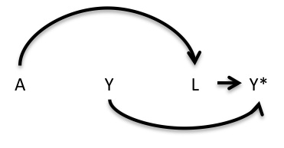
A: smoking
Y: PD (true)
L: smoking-related diagnoses
Y*: diagnosis of PD

The DAGs above highlight the difference between the true biological presence of Parkinson’s Disease and the eventual diagnosis of (or failure to diagnose) Parkinson’s Disease. It is possible that smoking, as an antecedent to smoking-related illness, may decrease the likelihood of having a PD diagnosis recorded in one’s medical records, rather than actually having a biologically protective effect against PD.

- In the second column of page 784, a paragraph begins with “There are a number of variations of the hypothesis that selection bias…” Draw a causal DAG that is consistent with the explanation given in this paragraph. Please label your DAG and explain briefly. (3 points)

Answer option:

PD
Smoking
Smoking-related Death
Genes for PD
PD Dx
Selection

OR the standard selection bias DAG, showing conditioning on a common effect of A and Y.

A D

Y

G Y
D Y’
A

G: genetic factor
D: die young
Y’: diagnosis of Parkinson’s
Y: PD

(Grading Rubric for Q1-Q5: 2 pts for correct DAG with full labelling; 1 pt for brief explanatory sentence on how the DAG depicts the condition of the reference paragraph)

- For each of the paragraphs referred to in Q1-Q5, discuss whether the authors’ explanations can be ruled out because of the study design and explain your reasoning briefly. For those explanations that cannot be ruled out, propose what might be a better study design to help evaluate (or rule out) the alternative explanation (i.e., one that would allow ruling them out in case they are not the true explanation).
Note: There are 5 parts for this question. Please number as 6a-6e, corresponding to Q1-Q5 scenarios.
(10 points)

Answers may vary:

#1 would be better able to answer the question if factors thought to be mechanisms of the protectivity of smoking had data collected to analyze if those factors account for the smoking benefit. Null results from a randomized trial in which smoking is assigned and incidence of PD assessed over a follow-up period would help rule out causation.

#2 can be ruled out by study design since the selection of the subjects was based on those without a prior diagnosis (assuming dx = presence of the disease).

OR

#2 cannot be perfectly ruled out in the current study. If measures of subclinical PD existed (e.g. some sort of biomarker), one may study in a similar longitudinal design whether those with subclinical PD have a greater incidence of smoking compared to those without the subclinical PD (and also without full PD). Without this, one can (disregarding ethical issues) do a randomized control trial with smoking being assigned (therefore the subclinical PD would be expected to be equally distributed by treatment assignment) and the causal association between smoking and the outcome of full PD could be assessed.

#3 similar to # 1 can be better examined by controlling for some of the factors such as race, geography, lifestyle by matching. Many of the possible common causes of smoking and PD can be ruled out in this study, as the authors have measured and adjusted for lifestyle variables like coffee and alcohol intake which, based on subject-matter knowledge, seem to be sufficient to make the assumption of no unmeasured confounding a reasonable one in this study. However, as this assumption can never be verified, confounding can never be fully ruled out, except in a randomized trial (which would not be feasible in this instance). Note: need to have huge bias to account for such a large association--which isn’t that likely.

#4 can also be eliminated by study design since investigators are looking for a diagnosis of PD independent of smoking status or smoking-related diseases. Could be an issue if Parkinson’s disease were under-reported among smokers, due to being overshadowed by the many other health problems associated with smoking. However, in this case as the researchers focus specifically on identifying Parkinson’s disease, in a population of subjects especially likely to be aware of the condition (healthcare professionals), it is unlikely that under-reporting would have occurred in this study. Further, the authors actively tried to verify the information they got from medical records by sending questionnaires to treating physicians to confirm diagnoses, and also check death certificates of deceased patients for unreported PD diagnoses -- both of which would be expected to reduce the likelihood of measurement error.

#5 is also eliminated in a prospective study where PD is diagnosed incidentally and continuously. It would be an interesting study to examine those people who had died due to smoking-related deaths or who were smokers in terms of genes for PD compare to non-smokers or those alive selected into the cohort. Selection bias could be an issue if this were a case-control study, as smokers would expected to be under-represented among cases (subjects with PD) due to increased early mortality from other causes. However, this is a cohort study which identified incident cases of PD, so this would not be expected to be a problem here.

This explanation can largely be ruled out given this study design if we take age and age of death to be associated – when the authors stratify by age, the association is still strong within all age groups, indicating that the association exists even among age groups in which we would not expect differential mortality among smokers and non-smokers.

7. Consider the following hypothetical participant in the Nurses’ Health Study.
Participant: Woman, age 63 at time of analysis, smoked 2 packs a day for 14 years between the ages of 16 and 30.

7a. Please indicate to which exposure category this individual is contributing data in Table 1 and in Table 2 and state what her estimated relative risks would be, separately and according to each Table (you may assume that the results are unbiased and reflect “truth” in the world, for the purposes of this question). (2 points)

Answer: In Table 1, this person contributes data to the exposure category of “Past Smoker, quit more than 10 yrs ago” which has a RR associated with it of: 0.9 (0.6, 1.3)

In Table 2, this person contributes data to the exposure category of “25-44 Packyears” which has a RR associated with it of: 0.4 (0.2, 0.7)

7b. In your own words, specify and contrast the different research questions under investigation in these two Tables. (2 points)

Answer: In Table 1, the authors are focused on timing of smoking, and to some extent dose of smoking among those who are current smokers. In Table 2, it is looking more at a cumulative lifestyle dose of smoking, essentially irrespective of WHEN this occurs. Each of these reflects 2 different underlying biological mechanisms. For example, the first table suggests that the effect may wane over time amongst quitters, whereas the second table is exploring whether the intensity of dose is more critical, irrespective of when it happens.

7c. Do you consider 'pack-years' of smoking (as examined in Table 2) to fulfill the consistency criterion for identifiability? Why or why not? Explain briefly. (2 points)

Answer: No, pack-years reflects a lifetime cumulative dose of smoking, regardless of when it occurred. This does not translate well into a predictable “treatment” for a target trial. Thus, the identifiability criterion of consistency does not seem to be well met for this exposure.

- Use a DAG to depict the following study designs using all provided information. If bias is present, please identify the specific bias and explain how this may influence your study.

  - In an observational study of the effect of antiretroviral therapy (ART) on the development of AIDS, participants were assessed every year at clinic visits with CD4 counts. ART is believed to reduce the likelihood of developing AIDS by increasing CD4 counts. In this setting, ART is not given to every attendee of the clinic, and sicker individuals are more likely to receive ART. Investigators had previously noted that patients of higher socioeconomic status had higher rates of follow-up. At the end of the study, patients who were lost to follow-up were excluded from the analysis and a relationship between ART and SES was found, although researchers believe this may have been due to participants receiving ART being sicker and attrition differing by SES.
(6 points)

A: Antiretroviral therapy
Y: AIDS
C: Lost during follow-up
L: Socioeconomic status
U: CD4 count

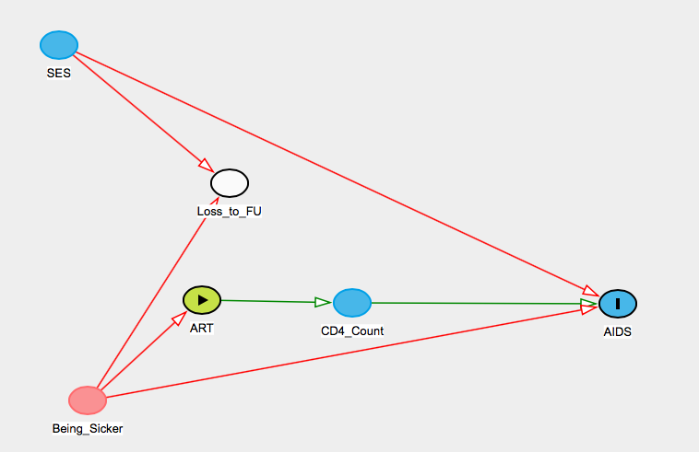

This is an example of selection bias. Because we are unintentionally conditioning on the collider that represents participation in the study, we open the path from ART use to AIDS through study participation and SES. This will either bias our results away from the null if this association is of the same sign as the causal pathway that we care about, or towards the null if this confounding pathway has the opposite sign, assuming no other confounding pathways.

  - In a study examining the association between physical activity and heart disease, investigators chose to study a group of firefighters. It is known that individuals who choose to become firefighters are in good physical shape and have an affinity for physical activity. Furthermore, it is also known that those with parents of high socioeconomic status are less likely to become firefighters and less likely to develop heart disease. (6 points)
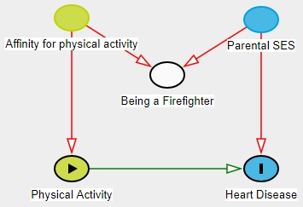
A: Physical Activity
Y: Heart disease
C: Being a firefighter
L: Parental SES
U: Attraction to activities that involve physical activity

This is another example of selection bias – by conditioning on the selection of firefighting as a profession, we confound the relationship between physical activity and heart disease.

- Consider the two 2×2 tables below. They were generated from a prospective study to estimate the average causal effect of treatment A on the risk of outcome Y. A pre-treatment variable L was also measured. We know for sure that either (i) A and Y have no common causes, or (ii) the only common cause of A and Y is L.

 | L=0 |  |  | L=1
 | Y=1 | Y=0 |  | Y=1 | Y=0
A=1 | 60 | 40 |  | 120 | 80
A=0 | 40 | 160 |  | 56 | 224

- Does the variable L confound the effect of A on Y? Why or why not? Please show your work and explain in a few sentences. (3 pts)

Answer:
One option, answers could vary

L is associated with A:
Pr[A=1|L=1] = 200/480 ≠ Pr[A=1|L=0] = 100/300
Pr[A=0|L=1] = 280/480 ≠ Pr[A=0|L=0] = 200/300
Pr[L=1|A=1] = 200/300 ≠ Pr[L=1|A=0] = 280/480
Pr[L=0|A=1] = 100/300 ≠ Pr[L=0|A=0] = 200/480
L is not independently associated with Y (i.e. the association is through A).
Note:
Pr[Y=1|L=1] = 176/480 ≠ Pr[Y=1|L=0] = 100/300
Pr[Y=0|L=1] =304/480 ≠ Pr[Y=0|L=0] = 200/300
These indicate that Y and L are associated. However, when we consider A (i.e., look within stratum of A), then Y and L are no longer associated.

In the exposed: Pr[Y=1| L=1, A=1]= 120/200 = Pr[Y=1|L=0, A=1] = 60/100= 0.6
In the unexposed: Pr[Y=1| L=1, A=0] = 56/280= Pr[Y=1|L=0, A=0] = 40/200 = 0.4
This is how we say that L and Y are not independently associated, their association is through A.
Tying it together:
Using expert knowledge (given) that L precedes A and Y (it’s either a common cause, or A and Y have no common causes), and having shown that L is associated with A but not with Y independent of A, L is not a common cause of A and Y; and since there is no open backdoor path from A to Y through L, adjusting for L will not block any paths (none to block), thus L is not a confounder.

- Draw a causal graph, consistent with the data, that represents L, A, and Y and explain briefly. (2 pts)

DAG (drawn under the assumption that A causes Y):
L ------> A-----> Y

This DAG fulfills the criteria examined above in part a – that is – L is not a common cause of A and Y; L is associated with A; and L is not associated with Y independent of A, and L is not a confounder of A and Y… therefore, this DAG reflects that L is associated with Y only through A.

Total: 48 points

