This is an example of taking a question and converting it to a thorough database search.

What is your question?
Which is better for fever in children Tylenol or Advil?

What are the concepts in your question?
Fever, children, Tylenol, Advil

You can use PICO for this:

PICOTT | Wording | Notes
P problem or population | Fever in children | This is really two concepts in one
I Intervention or Exposure | Tylenol | Remember synonyms
C Comparison | Advil | Remember synonyms
O Outcomes of interest | Duration of fever  Amount of fever  Comfort  Satisfaction of patient/parent  Adverse effects | Multiple outcomes, maybe exclude this one, at least initially…
T Type of question | Therapy | Others are: diagnosis, prognosis, etiology, etc.
T Type of study | RCT preferred | Systematic review done about this?  Is a cohort acceptable?

Qualitative SR?
Use SPIDER rather than PICO:
see http://www.nccmt.ca/knowledge-repositories/search/191

What databases will you search?
This is a biomedical question. PubMed and Embase make the most sense to search.

Will you “handsearch”, this means “cited reference searching” and possibly searching tables of contents of highly relevant journals for a chosen time period. Cited reference searching can largely be done in Web of Science by looking up the title of the articles you have retained for analysis and then looking through the reference list (the cited articles) and the newer articles that have cited the article you looked up (cited by)
Will you search grey literature? The current trend is toward including grey literature.
For emerging fields looking at conference proceedings for relevant conferences for last 2-3 years may be worth doing. You can find additional material using Google with results limited by domain names. To do so, add site: and then a domain to the end of your Google search you can limit to .edu, or .gov, or country website (like co.uk for the UK, .es for Spain, cde.gov). As an example you could limit results to WHO by adding site:who.int to the end of your Google Search.

If not an emerging field, you may omit this type of information. For other topics, it may make sense to search for white papers using Google with domain limits from .gov, .org, .edu.

“Build out” each concept:

Search controlled vocabulary, add the synonyms you know or find, remember quotation marks, and use other punctuation as needed.

For PubMed:
- “Fever”[mesh] OR fever or pyrexia or hyperpyrexia
- Child* OR teen OR teenage* OR adolescen* OR toddler OR infant
- Acetaminophen OR Tylenol OR Panadol OR paracetamol OR…(19 synonyms found in MeSH)
- Ibuprofen OR Motrin OR Advil
Note: Child* (finds child OR children OR childhood)

Assemble your search: Use AND, OR, ( )
(“Fever”[mesh] OR fever or pyrexia or hyperpyrexia)
AND
(Child* OR teen OR teenage* OR adolescen* OR toddler OR infant)
AND
(Acetaminophen OR Tylenol OR Panadol OR paracetamol)
AND
(Ibuprofen OR Motrin OR Advil)
I look at results before limiting to Publication Types.
Emtree is MeSH for Embase
Various search types for Embase

Embase
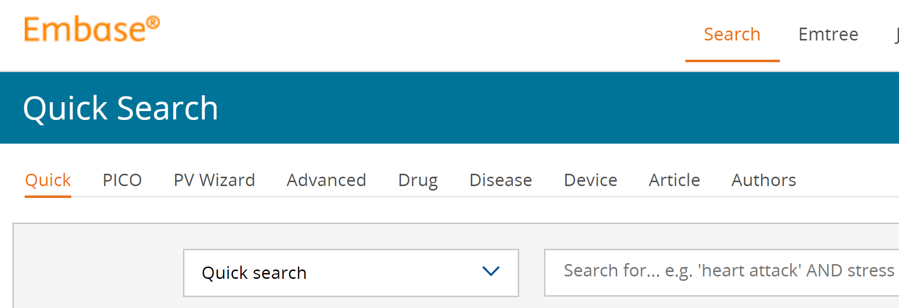
Start with your PubMed search and begin editing…. The Quick Search interface works well.
Find Emtree for each concept and replace MeSH with those. Remove other PubMed punctuation, like [ti], and other things in square brackets. PubMed loves to add parentheses and [all fields] to searches. Embase can be very picky and sometimes you need to replace double quotes with single quotes, eliminate unnecessary parentheses. Emtree uses a different field tag system. For example, PubMed’s [ti] [tiab] [mh] becomes :ti :ab,ti /exp in Embase. Embase does not always handle long search strings gracefully. If you get multiple error messages for a long search string, I suggest you break up the search into shorter bits (a single concept or even less at times). Search each piece in Embase and then reassemble using the Search history and AND and OR options in Embase.

Web of Science
Use your PubMed search, edit to remove PubMed specific wordings, [ti], [tiab], [all fields].

Note: Web of Science ignores [mh] OR [mesh]. Take out all other PubMed specific punctuation (= anything with square brackets)

Also make sure to use WoS as a cited reference search. Copy, paste and search the titles of each of the articles you plain to retain for analysis in your systematic review in WoS. Examine the cited and cited by lists to identify other good articles your search may have missed. If the article is not found in WoS, try shortening the title (occasionally long titles or those with colons will confuse the search engine) and search again. If the article is not found in WoS you can approximate the same result by going more old school to check the reference list of the PDF, and then looking up the article in Google Scholar to look for articles that have cited the one you are looking up.
You will need to make a list of these. To efficiently record this information, you can add the articles you like from Web of Science to a reference manager. If you do the PDF/Google Scholar method, it is a bit more cumbersome. I suggest you copy the reference from the PDF to a Word doc and use this tool (https://citation-finder.now.sh/) to convert Word bibliography into an RIS file you can add to a reference manager. From Scholar it is easy to add things one by one to a reference manager.

Related article functions in databases: Get in the habit of looking at these when you are searching. This can be a nice way to fill in any holes in your search strategy and these would appear in “articles from other sources” in your PRISMA flow diagram

Zotero:
Import results from each database (this is usually done without weeding out results in the reference manager). Put the results from each database in its own folder. Make a note that includes the date of the search, the search strategy and the number of items found.

You will then use Zotero to remove duplicates… Zotero handout here: https://ucsf.box.com/s/lb5pb4klhi3mdtpj9zn8sueezotxvcyl

Covidence, Distiller SR and Rayyan
3 pieces of software which can help with systematic review efficiency.
Covidence $240 for a review, if your review is small and you have less than 500 total articles you can use it for free. It will help organize your project for all steps of the process.There are student discounts. This software has been picked up by Cochrane.
Distiller SR more expensive than Covidence, very helpful software that helps in all steps screening, data abstraction, quality assessment.
Rayyan remains free for use without limits. Designed to help with title and abstract screening.

