Library 101
On Campus: Use UCSFwpa network, not UCSFguest
Off Campus: Use MyAccess, not PulseSecure or remote.ucsf.edu
Bookmark three things in your browser:
library.ucsf.edu
pubmed.ucsf.edu
uptodate.ucsf.edu
Add the “bookmarklet" for off-campus access: https://ucsflibrary.zendesk.com/hc/en-us/articles/360020885033-Using-the-EZproxy-Bookmarklet
UCSF Library Catalog
Use this for electronic books: 1. Go to library.ucsf.edu. 2. From Find Materials tab, select UCSF Library Catalog. 3. Change tab to Keyword. 4. Add terms and Go

Created and maintained by National Library of Medicine and National Center for Biotechnology Information (NLM and NCBI respectively) PM is the grand-daddy of biomedical databases. It is still the world’s standard. It is freely available to all worldwide, unlike its competitors. Commercial databases purchase access to PubMed files and add them to theirs. It contains about >30M articles from over 5.2K journals; growing by about 1 million articles a year. It is organized for intelligent retrieval of information.
New PubMed has arrived! The version of PubMed we are used to is called “legacy” and will likely disappear by the end of 2020. New PubMed is still changing and is not quite fully functional as of April, 2020.
MyNCBI is your personal space at PubMed. Here you can save your work and receives updates by email. Today we will set up an account and set some preferences.
Key Concepts for PubMed:
- Identify concepts within your question. Two or three concepts per search usually work best
- Use MeSH as an index to find good words or phrases for each concept.
- For a comprehensive search you will want to include relevant MeSH terms and all the synonyms you can come up with for each concept.
- OR together the synonyms for each concept and enclose in ( ).
- AND the concepts together
- Use Search Details to improve your search
- Use Advanced to see your search history
- Create alert saves your search and can send new articles
from your saved search.
- Receive tables of contents from favorite journals with NCBI.
Filters and Icons
Publication types
Case reports
Clinical trial
Comparative study
Controlled clinical trial
Evaluation studies
Guideline
Meta analysis
Multicenter study
Observational study
Practice guideline
Randomized control trial
Review
Validation study
Subsets
Systematic Reviews
There are many more!
Set up a MyNCBI account – This section is written for “legacy” PubMed.
Go to: library.ucsf.edu
- Click PubMed.UCSF.edu link in Popular Resources
- Click Sign in to NCBI in upper right
- Create an account if you don’t have one already.
  - Register for an NCBI account, near bottom left of page (add an email)
- Once done Create Account, acknowledge email, and then click MyNCBI (top right)
Set MyNCBI preferences
Once logged into MyNCBI…
- Click on MyNCBI Site Preferences (near upper right of page)
- 4 useful things to modify – there are many others “go shopping” for other useful choices. You can change settings as needed for a project. For instance, Age groups in Properties might be useful for your work.
  - In Common Preferences
    - Highlighting Pick a color. Your search words will be highlighted
  - In PubMed Preferences
    - Abstract Supplemental Data Open
    - Result Display Settings Abstract, 100, Pub Date
    - Filters and Icons – You are allowed a total of 15 filters in MyNCBI
See box on previous page for a suggested group.
  - To move from MyNCBI back to PubMed…
    - Click PubMed link near bottom of page in the center (Popular) column.
You will see MyNCBI in new PubMed as well but not all features of legacy are active in new.
Structure of PubMed and MeSH
MEDLINE (ML) is a highly organized subset of PubMed (PM). ML contains about 90% of the articles in PM. The part of PM NOT in ML is where the newest material lives until it is “indexed” by the by “subject experts” at the NLM.
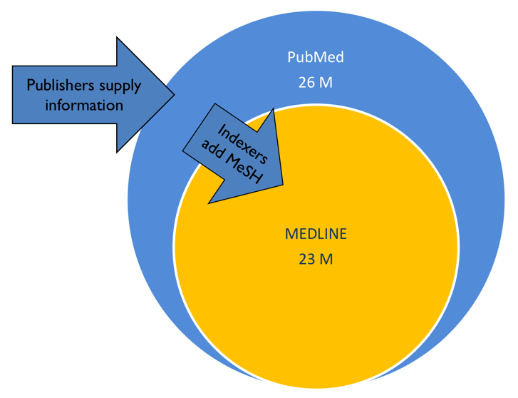
“Indexed” means each article is read and additional information (“metadata”) added to the PubMed record for the article, making it easier for searchers to find what they want.10-15 “tags” are applied to each article. These describe what the article is about. Of those 10-15 Medical Subject Headings (MeSH), 2 or 3 are identified as the most important (MAJOR).
The tags are selected from a standardized set of ~25,000 MeSH by indexers at NLM. Think of MeSH as the index to the book that is MEDLINE/PubMed.
We do not have time today to teach you the details of PubMed searching. There is a lot to learn about PubMed, and there are classes and consultations available at UCSF Library for those who are interested in more depth. Contact us for information.
PubMed uses an algorithm to analyze the words in the search by checking the word(s) against multiple lists of subjects, author names, etc. If a match is found, PubMed will add information to improve the search. PubMed does not always get it right, but does most of the time. The algorithm in the new PubMed appears to work significantly better than legacy PubMed.
PubMed search modifiers – “ ”, [ti], *
fever in children -- each word needs to be somewhere in the entry (any order, together or not)
“fever in children” – searches for exactly what is between quotes anywhere in a PubMed entry
“fever in children”[ti] searches for the word or words in the title
child* - the asterisk is a “truncation symbol” means PM will search for child, children, childhood, etc.

We are going to focus on new PubMed for this part. Lessons from new PM are applicable to old. NML suggests starting your search in new PM by without anything fancy. Take your best guess at words for the concepts in your question without any punctuation (e.g., no “ “, *, or “field tags”). Look at search details and you are off and running.
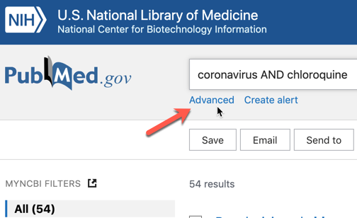
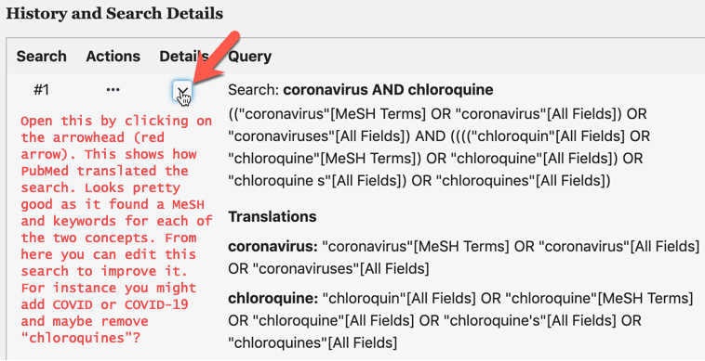
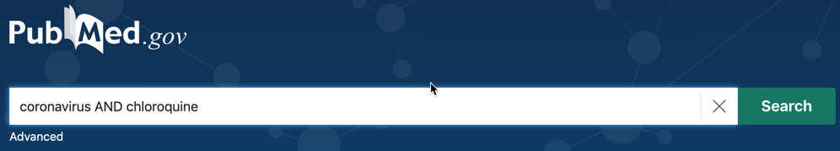
Images show adding a bare search in PubMed (see below) Finding 54 results and opening advanced (see right)
And then how PubMed translated your search. See left and notes.
Punctuation to further tune up your search .
Quotation marks around phrases find exactly what is between the quotation marks and stops PubMed from “translating”. Useful for standard biomedical phrases, can also be used (rarely) for single words which you do not want PubMed to translate. The asterisk is a “truncation symbol”, best shown by example: child* finds child, children, childhood, etc. Use sparingly as the asterisk also stops PubMed translation and may find a lot of words that you are not interested in. Parentheses are used to group the various words you have found for a single concept. We talk of this as grouping synonyms. Square brackets are used by PubMed to designate what fields to look in. Useful examples, coronavirus[ti] looks in the title field for coronavirus. [tiab] looks in title and abstract. [ot] looks in author keywords. PubMed add [MeSH] also written as [mh], and [all fields]. The latter is not useful for us humans using PubMed.
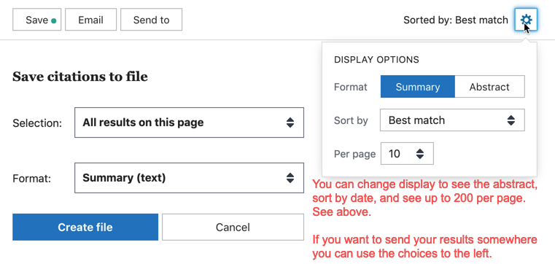
New PubMed results are sorted by best match (=relevance) and shown as snippets by default. This is another area in which new PubMed is not fully developed as of April, 2020. This appearance is modifiable. See image right.

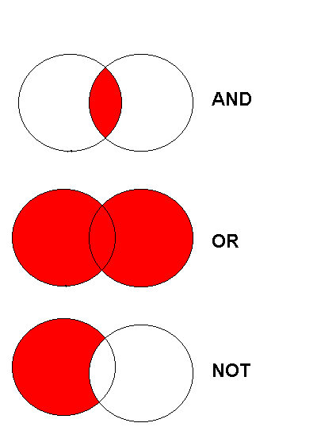
Boolean operators
and Venn Diagrams 1

Do you remember Boolean operators and what they do? See image left. AND joins concepts, OR joins synonyms and try to avoid using NOT unless you have a really good reason to do so. In PubMed you do not need to capitalize AND, OR. I do because it helps me visually see what is going on in a complex search.
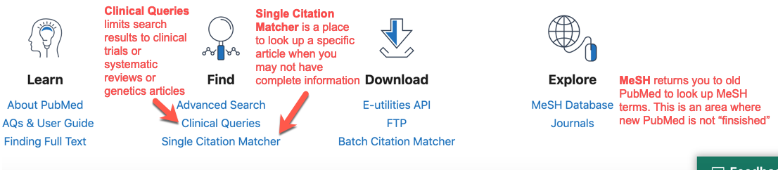
Two Useful PubMed Tools Clinical Queries and Single Citation Matcher
“Pearl growing” uses a good known article to find others. Search article title in PubMed, find the article, notice MeSH and related articles….

Saving your work…so you can get back to it with Create alert.
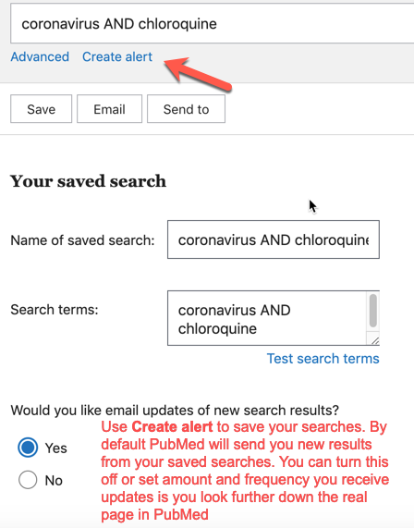

You can temporarily save articles to Clipboard as you work and then permanently save articles to MyNCBI Collections.
Try it using the Send to button, pictured near the bottom of the previous page.

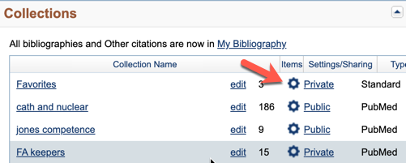
You can share your collections with others by logging into MyNCBI, going into Dashboard, clicking on the gear icon next to the collection you wish to share, changing setting from Private to Public and copying the URL. The recipient can open this collection and save it to their MyNCBI account or reference manager.

Receive tables of contents from favorite journals:
From Single Citation Matcher, type in a journal name PubMed will suggest names, pick the one from the list that matches. Search to find all results for that article in PubMed. Click Create alert, name it something like eTOC (electronic table of contents and the name of the journal, leave “Yes, please” checked. Then set parameters as daily, abstract, 100. Now you will receive any new output from this journal in your email.

Too many results? Too few? Results not on topic?
Too many? | Too few | Not on topic?
For a keyword search: “” (phrase), [ti], [tiab] search  Add concepts with AND.  Use filters (will lose articles that are not indexed). | For a keyword search: Remove terms. Remove “” (phrase), [ti], [tiab].  Add synonyms with OR. | Consider going back to background sources. Learn more and try again…
For a MeSH search:  Move down one level in MeSH “tree” to more specific term. Add filters, subheadings, MeSH terms. Change MeSH to Majr in disease or condition. | For a MeSH search:  Move up one level in “tree” to more general term. Remove filters, subheadings, fewer MeSH terms, substitute MeSH for Majr. | “Pearl grow” find one good article about the topic from a text, Google search, quick PubMed search, etc. In PM, look at MeSH terms, and look at related articles. In Google look for cited articles, related articles.
Consider moving outside of PubMed Web of Science
Education related? ERIC
Sociology? Sociological Abstracts
Psychology? PsycINFO
Nursing/Allied Health? CINAHL
PLAN YOUR SEARCH!
a. One searchable sentence:
Formulate the Search: To use a database effectively, think before you type!

1. After some background reading your original question may need to be reformulated; it may begin to look like several questions or you may answer it with background information. What might be a problem with not looking at foreground sources?
2. Create a simple, searchable question. This is the single most important (and difficult) step!
What does “simple searchable” mean? Avoid unnecessary detail. Carefully choose your words. Be willing to change words if they do not seem to work when you do your search. 4 construction methods to try…
a. Make a simple sentence of your question. Use the subject and object as search terms, avoid the verb as search engines are usually no good with those.
b. Write down a list of all the concepts within your topic. Select two or three as your search terms.
c. Most time consuming, organized and effective method: Create a table of concepts. Select two or three. Think of synonyms for each. String all that together and use that as your search.
d. Use the PICO model. This approach is derived from Evidence-Based Medicine (EBM), or more properly EBP (EB Practice)
See page 6 for examples.

b. Concept List: circle the most important two or three concepts:
1.
2.
3.
4.
5.
c. Concept/synonym table:
OR
OR
OR
 | Synonym A | Synonym B | Synonym C | Synonym D
Concept 1
Concept 2
Concept 3
Concept 4

AND

AND

AND

d. PICO:

P | Population or Problem or Patient
I (or E) | Intervention (or Exposure)
C | Comparison Group (if any)
O | Outcome
Examples of search formulation:
You are asked by a parent which medicine is best to give their 3-year-old boy for a temperature of 102º F, Tylenol or Advil?
What is the one sentence clinical question you might ask based on this vignette?
Probably something like “Which is better for treating fever in children, acetaminophen or ibuprofen?”
Concept list: * = most important concepts for search
parental anxiety
medication side-effect
medication effectiveness
*3 year old (age group)
boy (sex)
*temperature (fever)
102º F
*Tylenol
*Advil
Concept/synonym table:
 | Synonym A | Synonym B | Synonym C | Synonym D
Concept 1 | Tylenol | acetaminophen | Panadol
Concept 2 | Motrin | ibuprofen | Advil
Concept 3 | fever | hyperpyrexia | pyrexia
Concept 4 | children | infants | toddlers | pediatric

PICO or PECO:
P | Population or Problem | Children with fever
I (or E) | Intervention (or Exposure) | Ibuprofen
C | Comparison (if any) | Acetaminophen
O | Outcome | How low, how long T ⬇?

Final search: (Tylenol OR acetaminophen OR Panadol) AND (Motrin OR ibuprofen OR Advil) AND (fever OR hyperpyrexia OR pyrexia) AND (children OR infants OR toddlers OR pediatrics) into the search box.
Why AND between concepts rather than OR? Why OR between synonyms?

Other Databases

The library home page has a search box called Global Search. This searches through all the content to which UCSF Library has access, regardless of whether it comes from a book, chapter, article or dissertation. It is a great place to begin searching for information about a new topic. We usually recommend checking three sources before making important decisions or writing a systematic review. If you plan to use AND or OR in your search, make sure to capitalize them.

See here for more information (https://ucsflibrary.zendesk.com/hc/en-us/articles/360005370714

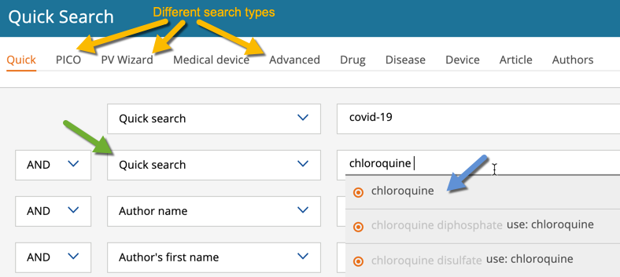
Embase Biomedical database which 8-9 M articles from 2700 journals PubMed does not include. Has a MeSH equivalent named Emtree. Found on library home page just below PubMed.

Suggested method of use:
Quick search interface works well: Type in words for one concept (in image bottom previous page: first concept is covid-19), Embase will begin to suggest terms, click on one on the list to add it to the search box or make up your own if none match.
Move to second search box, change drop down to Quick search (green arrow), start to type, select on of the terms suggested (blue arrow). Repeat for each concept. When finished run search.
PICO search: Use this EBM question format to create your search as an alternative to Quick
Notice there are drug and device searches.

Web of Science (WoS), commercial article database with broad range of content. Find on library home page beneath Embase.
Large database with ~10K journals, >35M articles indexed. More social sciences content than PubMed.
The good:
- If you find an article you like you can look for related articles, PM, Embase, and Google Scholar have a similar feature but this one seems to work very well.
- Three generations of information in one place! Search for the title of article you want to explore.
- WoS will display a list of references used to write an article.
- WoS will display newer articles which have cited the article you want to explore. This is called cited reference searching.
- The bad: A “black box”, you gain simplicity but lose control of your search.
See figure below.
Create a search in this database. Very similar interface to other databases we have discussed. You can copy your PubMed search into Web of Science. WoS ignores [mesh] but you will need to remove [ti] and any other field tags you might have added.
The left column in WoS offers many options to Refine Results.
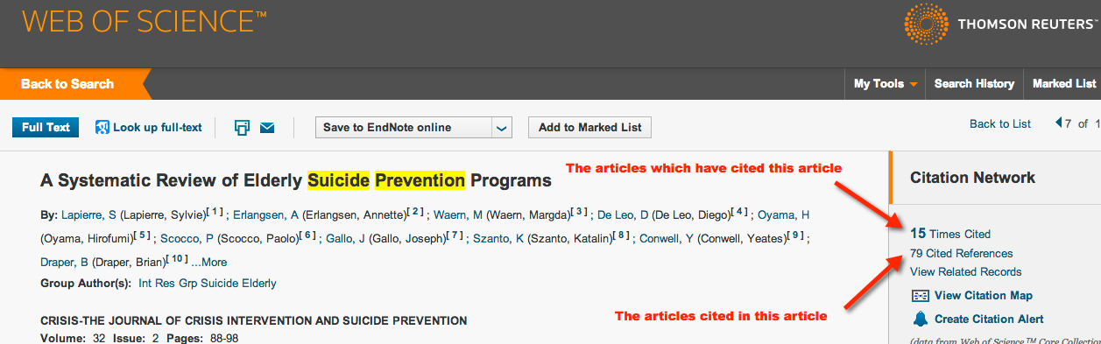
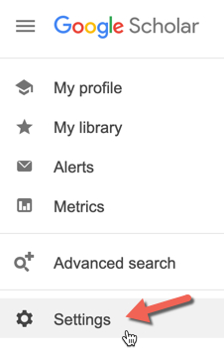
GoogleScholar scholar.google.com
Searches for scholarly output, case law, and patents.
GS is useful especially near the beginning of a search to get an idea what is “out there” and what words might be useful in a search.
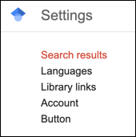
I suggest using it near the end of a search session to see if it finds anything you did not find elsewhere.
TIP: Only look through the first ~50 hits
To make GS most useful: Change 3 Settings (see right)
Library links UCSFadds a UCeLink
Display 20 per page
Reference managerSelect what works for you.
EndNote and RefWorks are main choices.
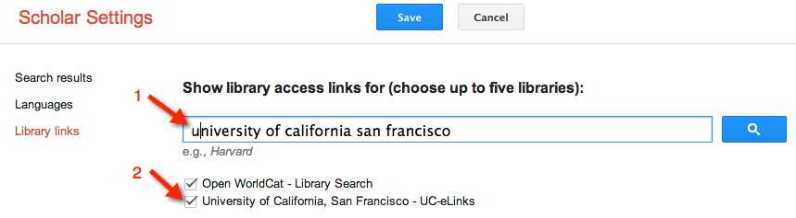

What it is good for?
- When other sources fail. Sometimes you can find one or a few good articles. These articles can be used as “keys” to open up other databases.
- When you are starting to learn about a topic and don’t know the vocabulary yet.
- When your topic has a very unique name that makes for precise searching.
- At the end of your search process, sometimes you will find something not found elsewhere.
Scholar notes:
Boolean operators: You don’t need to use AND. It is assumed between words. Use OR between synonyms, enclose synonyms between parentheses.
Google places limits on search string length so you may have to simplify a long search used in a database. This is also true for regular Google.
What makes it hard to use the usual Google issues…too many results; harder to figure out whether the material is coming from a trusted source.


One last word about

Limit to domain of search to “aim” better and get better quality results.
Examples: Use your Google Scholar search and add domain names at the end:
COVID chloroquine (site:cdc.gov OR site:who.int) searches the CDC and WHO for information about chloroquine treatment of COVID-19.

PsycINFO and Sociological Abstracts The subject area is obvious from titles. Both use a Thesaurus (equivalent to MeSH for MEDLINE) = a place to find good words to search with. Yellow folder icon hides suggested terms. Construct search just like Web of Science.

Anthropology Plus Anthropology database we purchase from EBSCO. Once again it has a MeSH equivalent (“controlled vocabulary”).

ERIC Educational database we purchase from ProQuest

Many more can be found by clicking on the Databases icon on the UCSF Library homepage

Reference Managers – Why would you want one? Store and organize the information you find. Use it to format documents. Use it to share your work with others. They are major time and energy savers! If you do not use one yet or are dissatisfied with what you have, try Zotero or buy EndNote. Zotero is free, and open source and performs all the functions of a reference manager well. EndNote costs $114 for UCSF students and $219 for faculty and staff. It is powerful, the most well known of the products. At this point UCSF Library only teaches and supports EndNote and Zotero:

Class handouts to get started with Zotero and EndNote:
For Zotero https://ucsf.box.com/s/qx4perkhm6045jnwjzb0ehffzgzmwqs3
For EndNote see: https://ucsf.box.com/s/04azavpdc40nafqcxlxyixu7sxunnujx

