At the end of EPI 218, you will submit final project for the class, consisting of
- a data collection system for a clinical research study, and
- a brief data collection and management plan

One example of a final project is the FLiPCUP Study. This example includes:
- A REDCap database, used to collect data on study participants during the course of the study.
- A Microsoft Access database, used as a back end for monitoring, reporting, and formatting for analysis. Queries, data cleaning and reports are all carried out using this back end.
- A data collection and management plan (Part B of the final project).

The class CLE provides an XML file that you can use to recreate the REDCap database used for this example.

To recreate the REDCap database, first download the XML file from the CLE (link: “FLiPCUP - XML file to create the REDCap database”) and save it locally.

Next, log in to REDCap and choose a New Project. Give the new project a title, select “Project/Just for fun” and select “Upload a REDCap project XML file (CDISC ODM format),” as shown below.

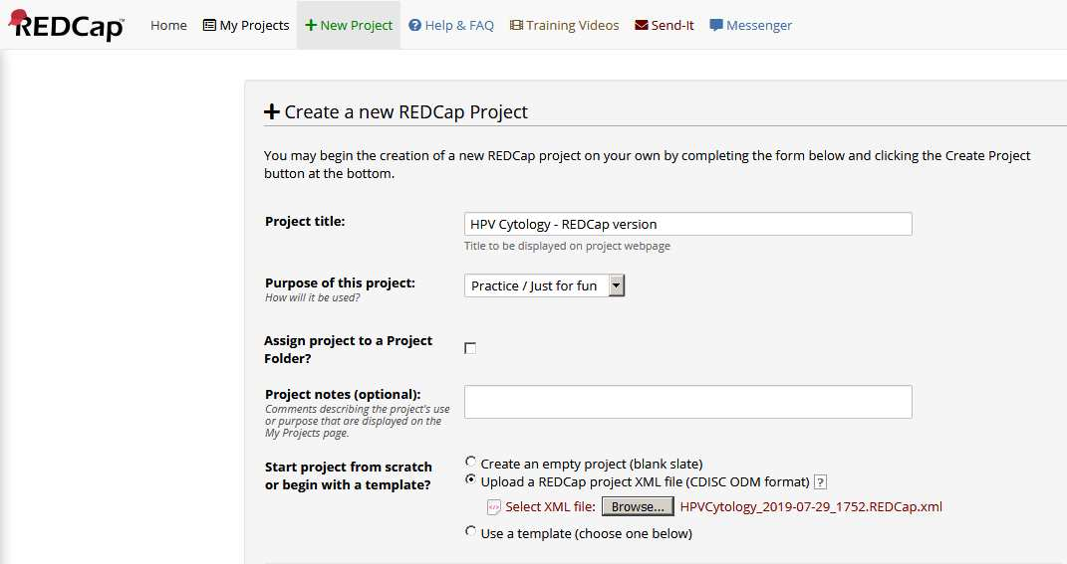

Click the “Browse” button and then select the XML file that you downloaded and saved.

Click the “Create Project” button at the bottom of the screen. You should now have a fully functional version of the REDCap project for the FLiPCUP study.

