Modeling Misclassification
A. Sensitivity and Specificity
The measurements we collect or use in our analyses are subject to measurement error. For classification tasks, or measurement of dichotomous variables, there is a special vocabulary available to describe the possible types of error.
For example, assume the task is to measure or assess exposure for a set of subjects and to label each subject “exposed” or “not exposed”. Let the variable E_{i} represent the true exposure status for subject i, with E_{i}=1 if subject i is exposed, and E_{i}=0 if subject i is not exposed. After examining each subject, we record or report whether or not each subject has been exposed. Let e_{i}=1 if subject i is reported to be exposed, and e_{i}=0 if subject i is recorded as “not exposed”.
Ideally, E_{i} = e_{i} for all subjects i. However, there may be some variability in the method for detecting exposure, leading to misclassification, E not = e, for some subjects. A typical way to describe the probabilities of misclassification is by stating the sensitivity and specificity for the classification method used to assess exposure.
Sensitivity for exposure is the probability that a subject who is truly exposed will be reported as exposed. In the notation used above, sensitivity for exposure is
Pr(e=1 | E=1).
Specificity for exposure is the probability that a subject who is truly not exposed will be reported as not exposed: specificity for exposure = Pr(e=0 | E=0)
Sensitivity and specificity can describe any test or measurement of a variable with two possible values. In particular, these measures can describe the reliability of the assessments of disease status. Let Y represent true disease status, with Y=1 for cases and Y=0 for controls. Let y represent measured disease status, with y=1 for subjects reported to be cases and y=0 for subjects reported to be controls. Then the sensitivity of the method used for detecting disease is Pr(y=1 | Y=1); and the specificity of the method used for detecting disease is Pr(y=0 | Y=0).

B. Tools for Misclassification Bias Analysis
There is a book that provides a quantitative analysis of how measurement and classification errors can corrupt data and affect epidemiological analyses.
Lash TL, Fox MP, Fink AK (2009) Applying Quantitative Bias Analysis to Epidemiologic Data. Springer

Associated with the book, there is a web-site where SAS programs and Excel workbooks are available to allow easy access to calculations covered in the book:
https://sites.google.com/site/biasanalysis/

Among these resources is an Excel worksheet that may be used to examine the effects of misclassification errors:
Ch6_Misclassification_2013_01_31.xls

C. Exposure Misclassification in 2x2 Tables

The “Exposure Misc” worksheet of the Ch6_Misclassification_2013_01_31.xls workbook is a tool that can be used to estimate what the true cell counts in a 2x2 table could be, given some observed data and assumptions about the exposure misclassification rates, as characterized by the sensitivities and specificities for classifying an observation to the “exposed” group.

When you first open this worksheet, the 2x2 table for observed data will be filled with example cell counts taken from the following paper:
Fink AK, Lash TL. (2003) A null association between smoking during pregnancy and breast cancer using Massachusetts registry data (United States). Cancer Causes Control 14:497-503.

The use of this worksheet will be covered in the exercises section.

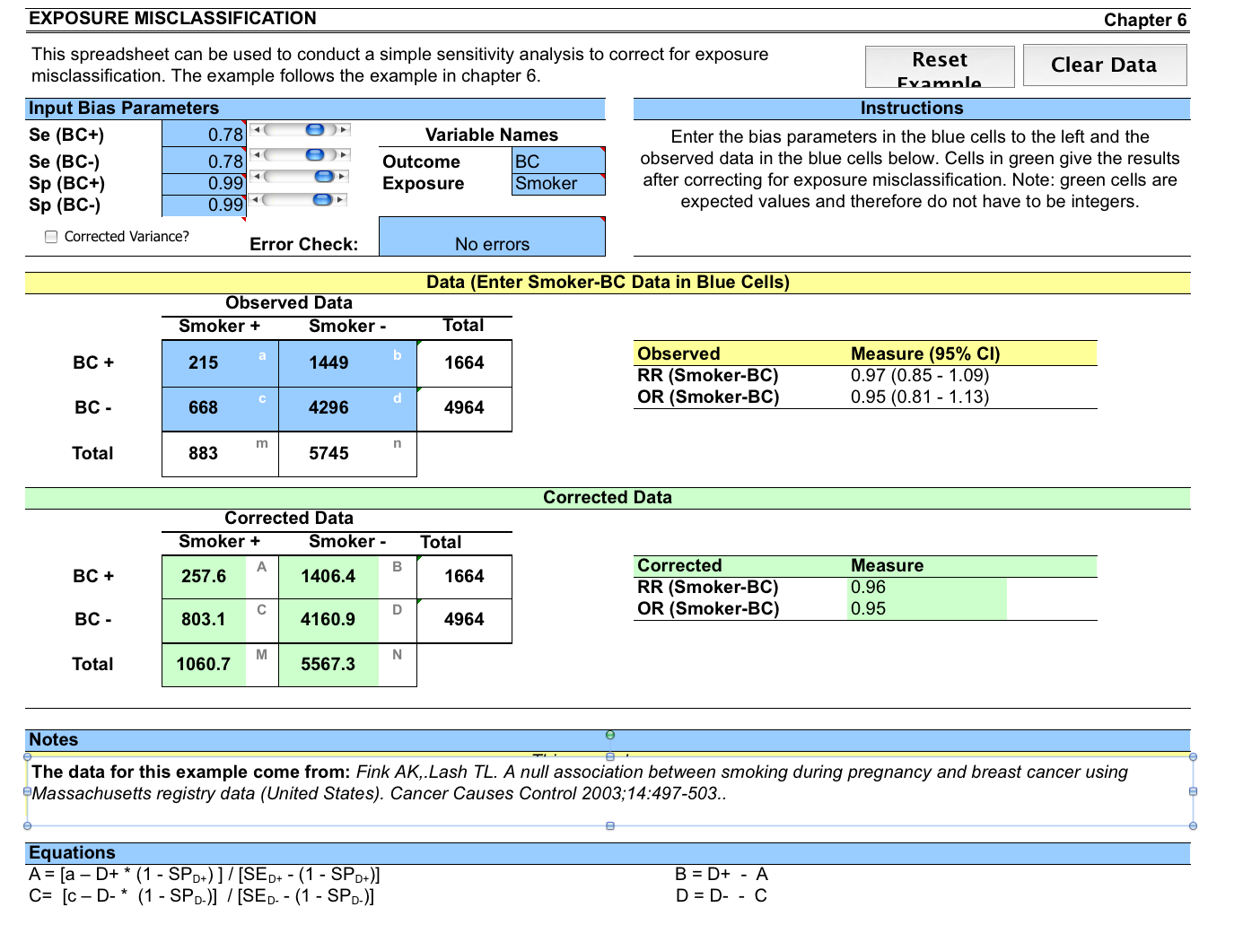

D. Outcome Misclassification in 2x2 Tables

The “Outcome Misc” worksheet of the Ch6_Misclassification_2013_01_31.xls workbook is a tool that can be used to estimate what the true cell counts in a 2x2 table could be, given some observed data and assumptions about the outcome misclassification rates, as characterized by the sensitivities and specificities for classifying an observation to the “Case” group.

When you first open this worksheet, the 2x2 table for observed data will be filled with example cell counts taken from the following paper:
De Henauw S et al. (1998) Misclassification of coronary heart disease in mortality statistics. Evidence from the WHO_MONICA Ghent-Charloroi Study in Belgium. J Epidemiol Com Health 52: 513-1519.

The use of this worksheet will be covered in the exercises section.

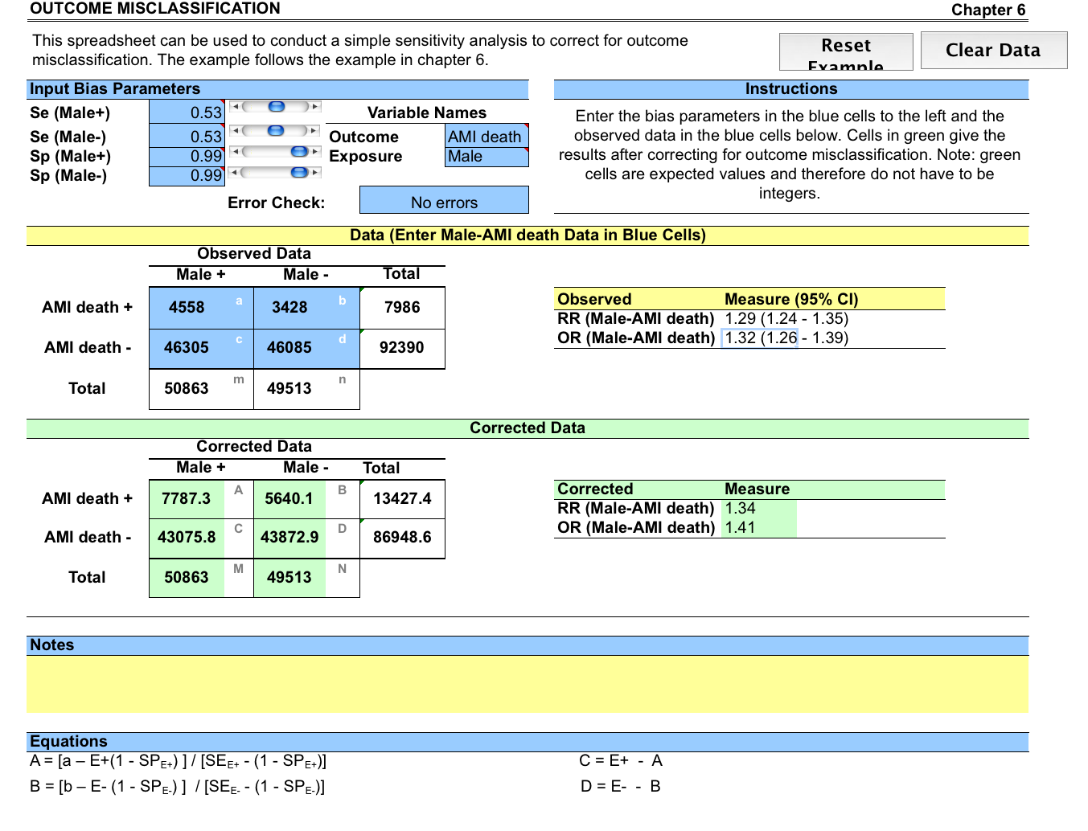

E. Complicated Misclassification Scenarios
The two worksheets above may be used to examine the effects of EITHER exposure misclassification OR outcome misclassification. Of course, there can be misclassification of both exposure and outcome for a single observation. The situation becomes more complicated to analyze or even just describe when there can be misclassification of both exposure and outcome, because one would need to specify whether the two types of misclassification are independent or not; and if not one has to specify what type of dependence they have.

Misclassification analysis can also consider additional covariates besides the exposure variable. For example misclassification rates for the outcome or the exposure of interest may vary across different levels of the additional covariate. And then the additional covariate may be misclassified.

