Amazon Mechanical Turk
https://www.mturk.com/mturk/welcome

What is MTurk?
Amazon Mechanical Turk (or MTurk) is an online marketplace for work. Users can be Workers (or Turkers), who complete tasks or Requesters, who post tasks for others to complete.
Turkers are anonymous and identified only through their worker ID. Turkers need to agree to Amazon’s Terms of Use and anonymity before agreeing to participate. Because studies are anonymous, most IRBs will grant these studies Exempt status after review.

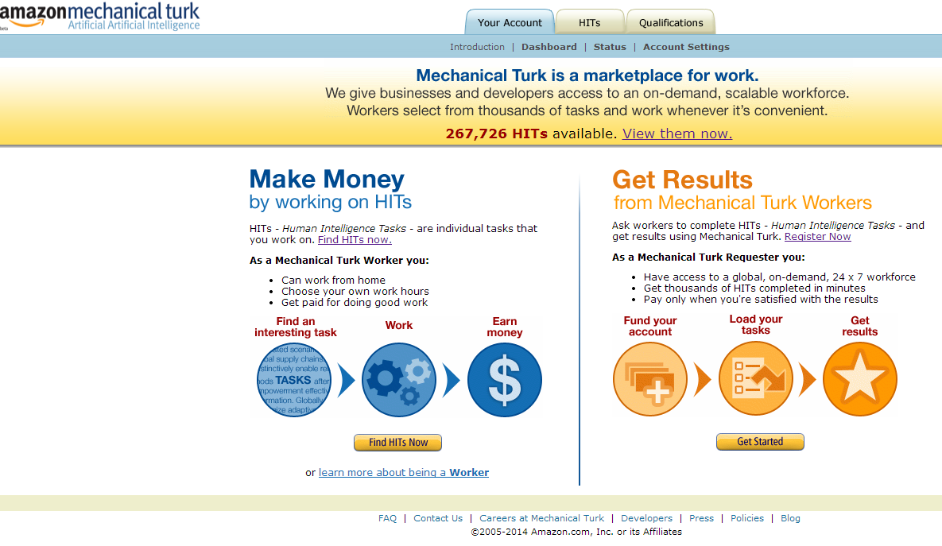

Who are the Workers?
Several papers have been written about who the Workers are. There is some evidence to suggest that a higher proportion of Workers are women and lower-income than the general population. They can come from all over the world. Because they are anonymous, they might be more willing to answer sensitive questions.
If you want higher quality data, you can specify users to have special qualifications, like a high approval rate, large number of previous jobs completed, etc, in order to be eligible to complete your task or participate in your study. You can also restrict it to “Master Turkers,” who have demonstrated a high performance on previous jobs.

Why use it for research?
MTurk may be a good place to obtain pilot data for a grant or if you want to test the properties of a scale. Random-digit-dial telephone surveys have a very low response rate and established national polls are very expensive. MTurk can be a cost-effective and efficient way to reach a broad population. If your study has few eligibility criteria, you can easily get hundreds of participants a day.

Example of what Workers see on MTurk:
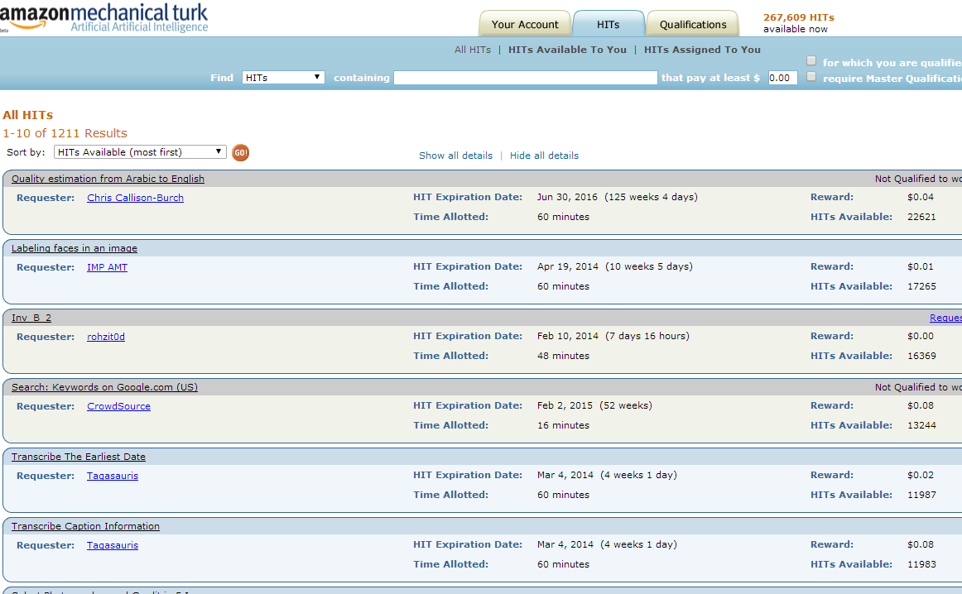

How do I post a job on MTurk?
Jobs are called a Human Intelligence Task (HIT). To post a job, click “Get Started” on the Requester half of the MTurk homepage. Go to “Create” at the top menu and specify the details of your project. Use words like “academic” or “research” in the title to sound more official and words like “short” or “quick” to engage Workers.
A batch is the number of assignments or participants you want to work on your HIT. If you are aiming for 200 participants, you can create one batch of 200 HITs or several batches of 50 or 100 HITs. MTurk only allows Workers to access the HIT once per batch. Multiple batches will allow you to examine your data and tweak your survey or job description if necessary, but participants may access your HIT more than once.

How much should I pay?
Of course, this depends on how much funding you have for your project. Some general rules of thumb are $0.005 per question or $0.01 per minute. If you want clean, quality data, at least $0.20 or $0.50 is generally necessary. Workers receive payment into their Amazon account or their bank account.

Example of a batch once it goes live:
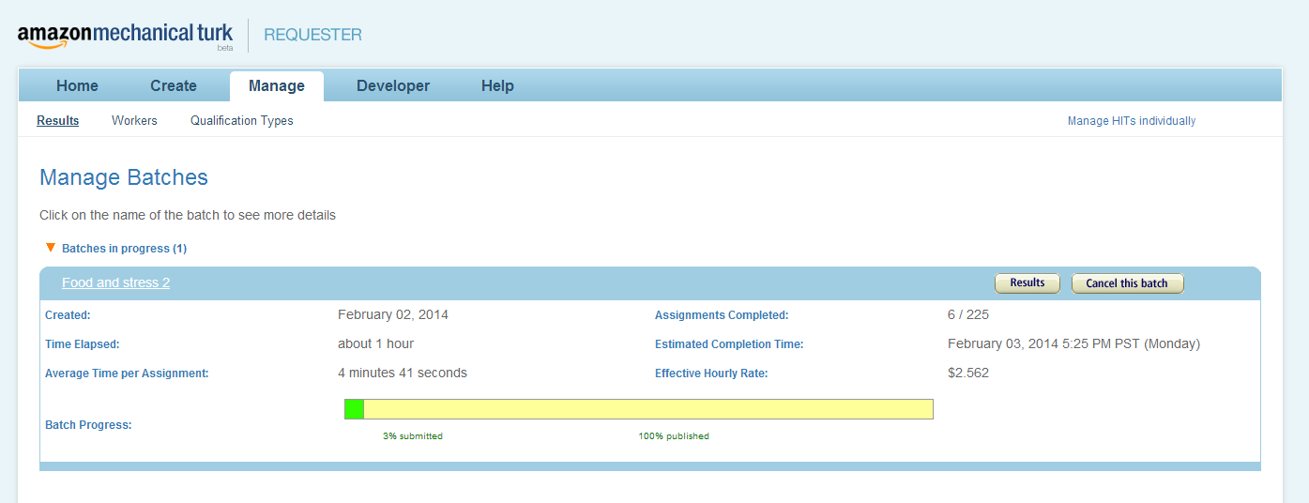

How do I pay Workers?
In general, Workers should enter a payment code into MTurk to receive payment. For example, if using an outside survey client like RedCap or Qualtrics, generate a random payment code for them and ask them to enter their Worker ID. In MTurk, ask them to enter the same payment code and Worker ID. On the MTurk Requester page, go to “Manage Batches” and “Results”. This will allow you to see the Worker IDs and input data (payment code) from the MTurk site. If these data match the data you collected from your survey client, click “Approve” to pay each participant. You can also set up your batch to pay participants automatically after 24 hours or a prespecified period of time.

What are the disadvantages of using MTurk?
It is important to be aware that Turkers may not be representative of the general US population. It is difficult to know who the base population for MTurk is, but there are several studies describing the Turker population. MTurk is also a relatively new technology and has not been widely published in the epidemiologic literature. There are a growing number of studies using Turkers in the psychology literature, though in most cases, researchers use this to test a new instrument or to gather pilot data, which they then verify in a more established population.

