Molecular and Genetic Epidemiology
Assignment 6
Due by noon 2/17 by email to Kirsten Kangelaris, kkangelaris@medicine.ucsf.edu

A. Textbook, Read Austin Chapter 7

B. Project: Genetic Basis of Disease
We will continue to explore the potential genetic basis of “your” disease of interest (defined in Assignment 1). For this assignment, search PubMed for your disease and the terms “genome wide association study” (http://www.ncbi.nlm.nih.gov/entrez/query.fcgi). How many, if any, articles are on medline? If any, briefly glance at some of the abstracts and write a couple of sentences summarizing what has been done.

C. Hands-on Analysis: GWAS
1. One of the first steps in running a genome-wide association study (GWAS) is doing quality control to remove individuals and SNPs that are bad. We are showing you a small excerpt – what would you do with the following individuals and why?
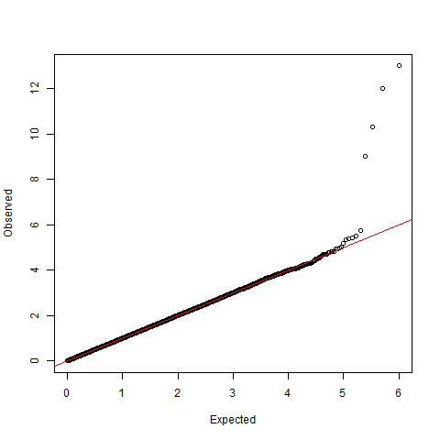
2. Again, we show you a small excerpt. Which of the following SNPs and why? Recall for the HWE test, the null is that they are in Hardy-Weinberg equilibrium, which is a good thing.
3. Why do we typically run a GWAS adjusting for principle components?
4. Look at the following QQ-plot. The inflation factor is lambda=1.001. Does it look ok?
5. Look at the QQ-plot. The smallest p-values observed are the ones along the y-axis; they are sorted by their -log_10 p-values. This means that the highest SNP has p-value 1x10^-13, the next has p-value 1x10^-12, then 1x10^-11, then 1x10^-9, before it goes to roughly noise. Suppose I told you that these SNPs were very close to each other. Do you think that I have found multiple different loci, or do you think that I found just one locus, and why (it's possibly both)? [Hint: think about LD.]

6. What might your next steps be?

7. Suppose an excerpt of your SNPs were the following. Are any of them significant? (Assume a bonferroni correction of α = 0.05/1,000,000=5x10^-8). If it is, write out in words, what the OR means (assuming this is on the log-additive genetic scale). Also, if it is, what gene is it in?

8. Why does a meta-analysis give you a better chance of finding more signals?

D. Extra Credit: Hands on Analysis with Haploview

1. First download and install the Haploview software from
http://www.broadinstitute.org/scientific-community/science/programs/medical-and-population-genetics/haploview/haploview
(it requires java to run).

2. Run the Haploview software on your computer.

3. When the “Welcome to Haploview” window pops up on your screen on initial start-up, click on the “HapMap Download” tab on the left hand side (LHS) of the screen. Change the values to read chromosome 19, from 11,061kb-11,106kb (11,061,132bp-11,105,490bp).

4. Click on the “Check Markers” Tab. How many SNPs are found in this region?
How many are not polymorphic in CEU+TSI?

5. Click on the LD Plot tab.
What gene are we looking at?
By default, we are on “Analysis > Define Blocks > Confidence Intervals (Gabriel et al.)”. How many haplotype 'blocks' did the algorithm find?

6. Finally click on the “Tagger” tab.
Leave things as the default, and click “Run Tagger”.
How many SNPs were needed to capture all of the rest at r-squared >= 0.8?
Mean max r-squared?
How many if you change r-squared >=0.7 (In the “Configuration” tab, change the 'r-squared threshold' box”)?
Mean max r-squared?
How many if you change the r-squared >=0.5?
Mean max r-squared?
What is the overall pattern you are noticing for these two parameter values?

