5M Orientation: EPIC, Resources and Questions Jan 4, 2021

RESOURCES (WHERE TO FIND THEM)
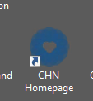
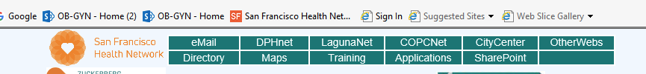


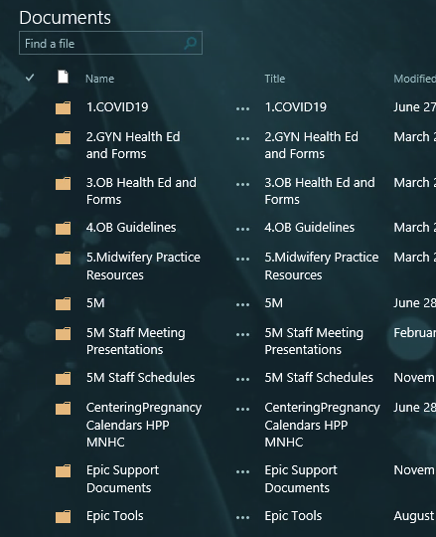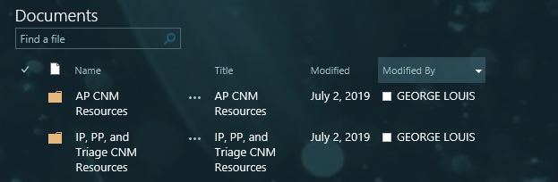
Once you open up the resources or Health Ed forms or both you can minimize and access easily.
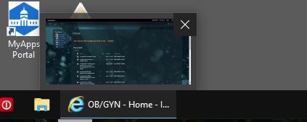

NOW YOU’RE READY FOR CHART REVIEW!
First thing is to make sure you are in the correct “context”
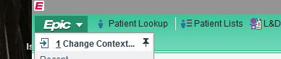

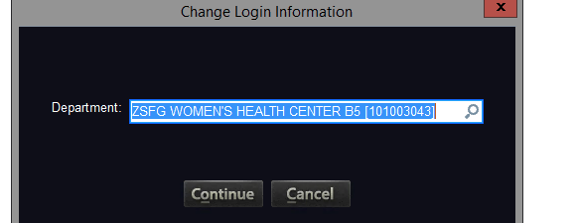
Next find the date that you will be in clinic:
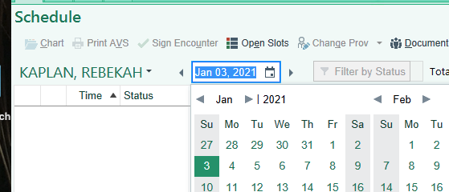

In order to find your preceptor Maximize the ZSFG Women’s Health center and search for your preceptors name:

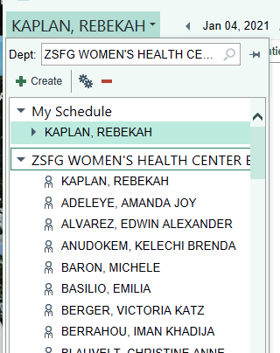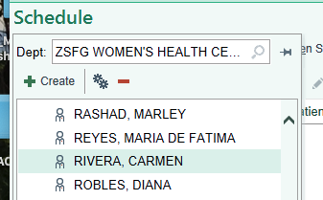

How to Review a chart:
Start with the far left column. Hover over different items and see what happens. Lot’s of important information:

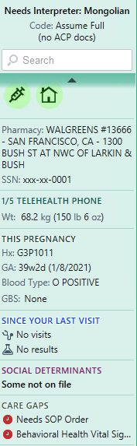
Once you’ve gotten infor like gestational age, parity etc from the column start on the horizontal tabs with chart review :

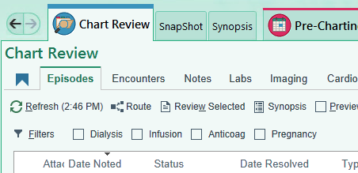
We will look at encounters, notes, labs and imaging:
Patient 1:
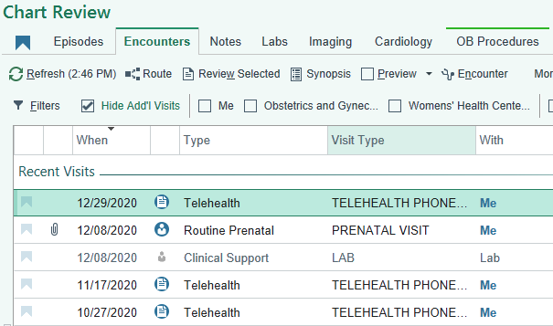
Patient 2:
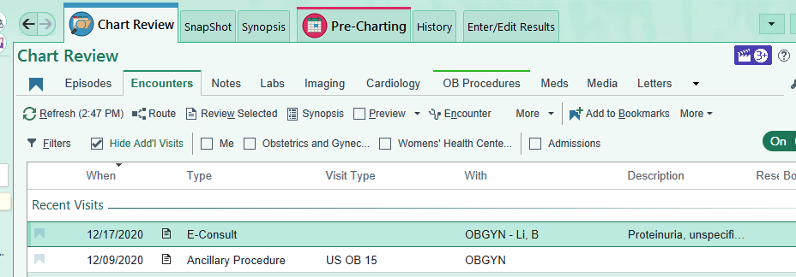

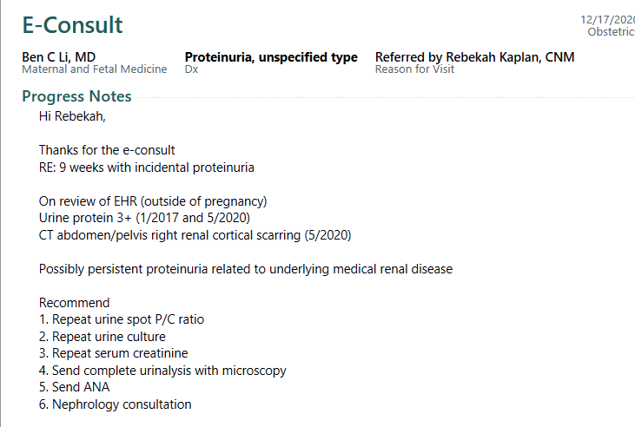
Patient 3:
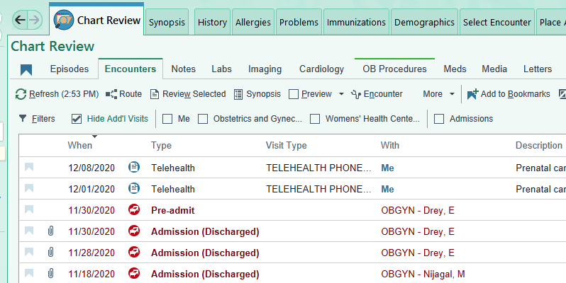

Then you can look at notes that were written (prn).
- Important to note e-consults, L&D drop in visits and other visits (derm etc.)

Note this patient has been to the birth center 3 times 11/18, 11/18, 11/30

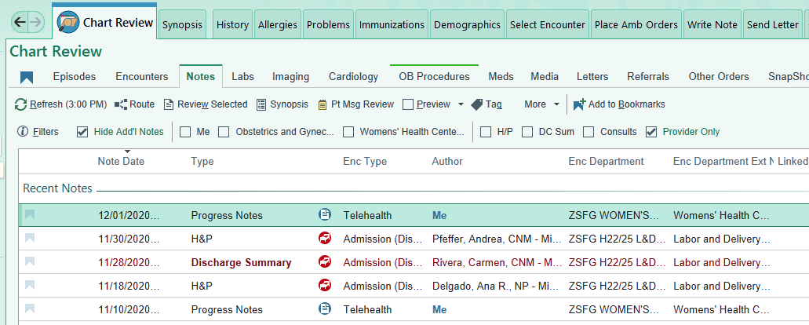

Then look at Labs:
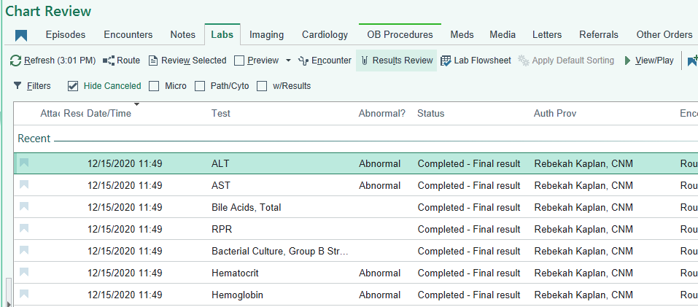

Next look at imaging, has anything been done since the last visit (both ultrasounds and x-rays will be there)
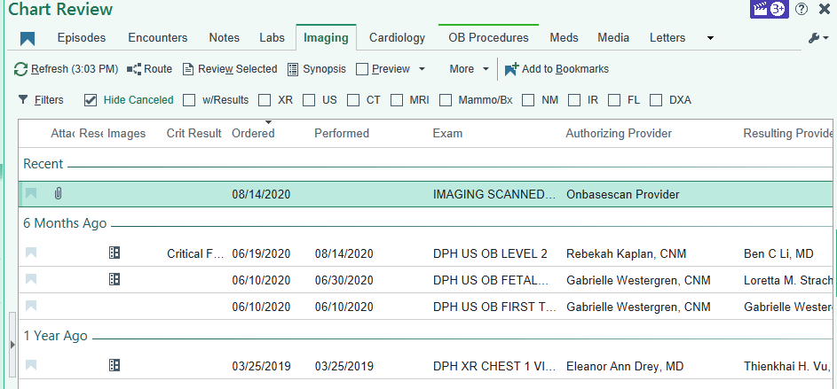

Scanned items you can find in Media, this includes genetic screening results and scanned charts from other sites:
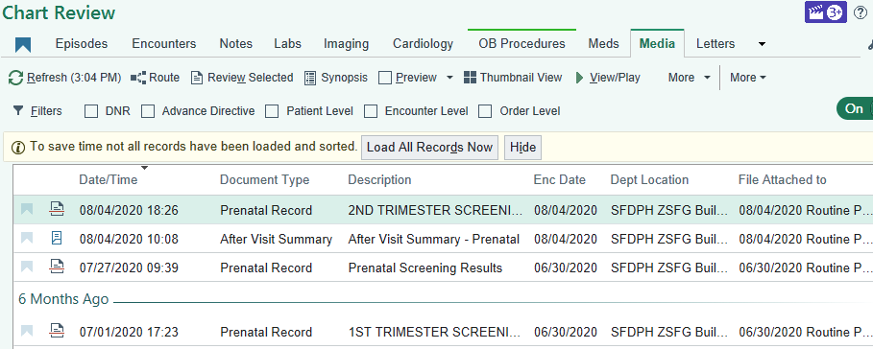
Moving along, snap shot is just that. You may want to scan.

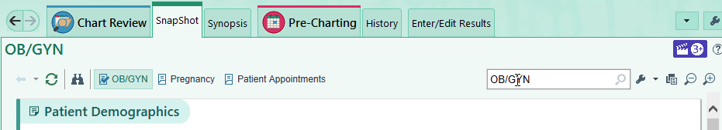

Synopsis has vitals and recent labs:
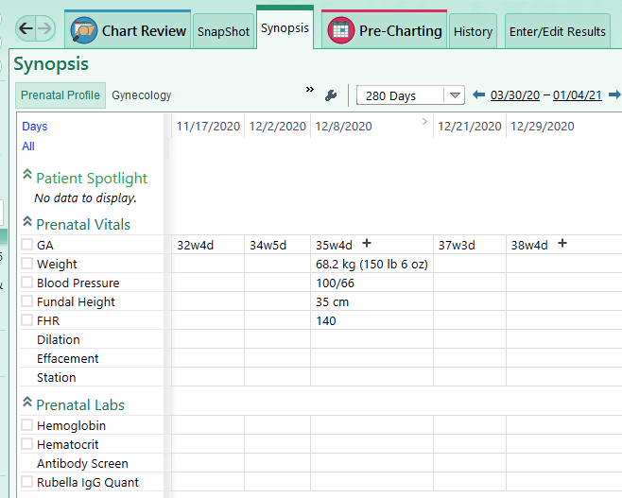

History (Especially if New OB visit):
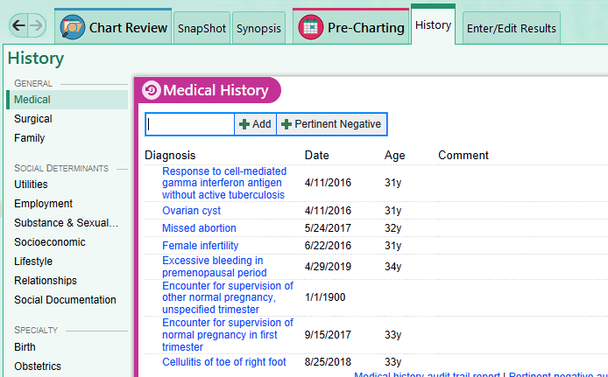

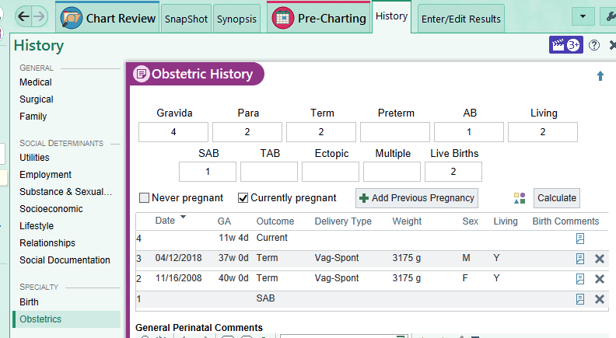

Pre-charting is really that. You can chart some things before you get to clinic as well as order labs. You can open all the tabs on the problem list and add to them prn (e.g. anemia or elevated GLT)

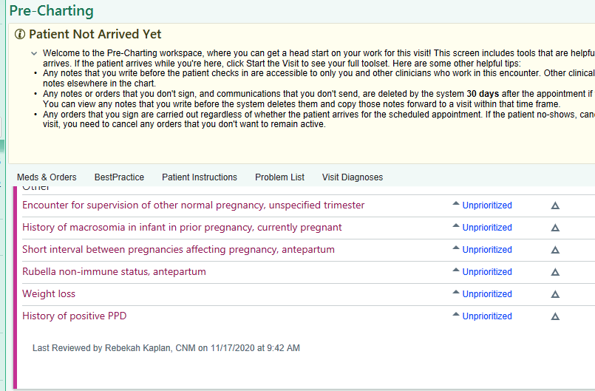

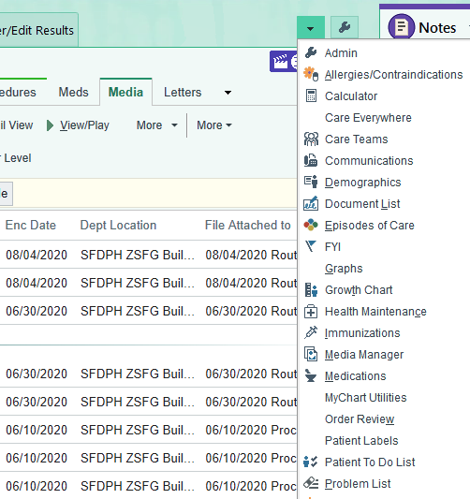
The post-it:
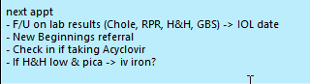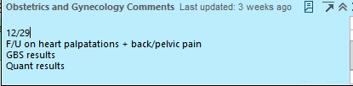

Add orders for Today:

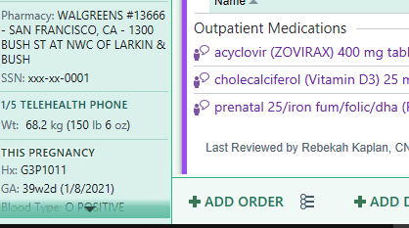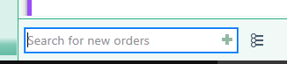

 If you click on this icon you’ll get these order sets which are VERY convenient

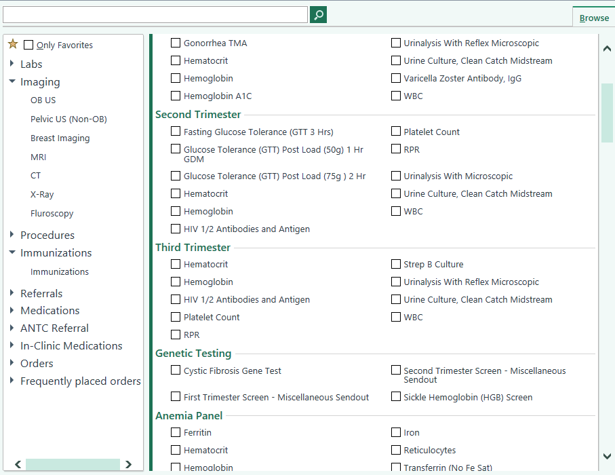

START THE VISIT 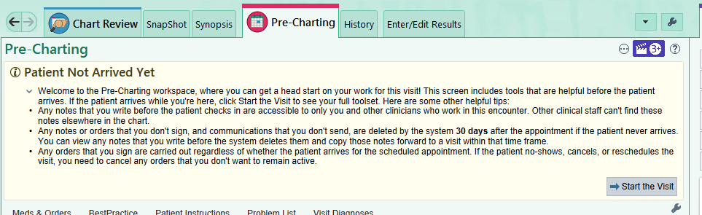

Phone visitis are outgoing calls in the contact section:

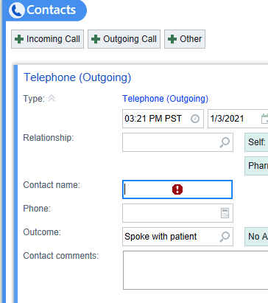

You will always be charting on the normal pregnancy “problem”
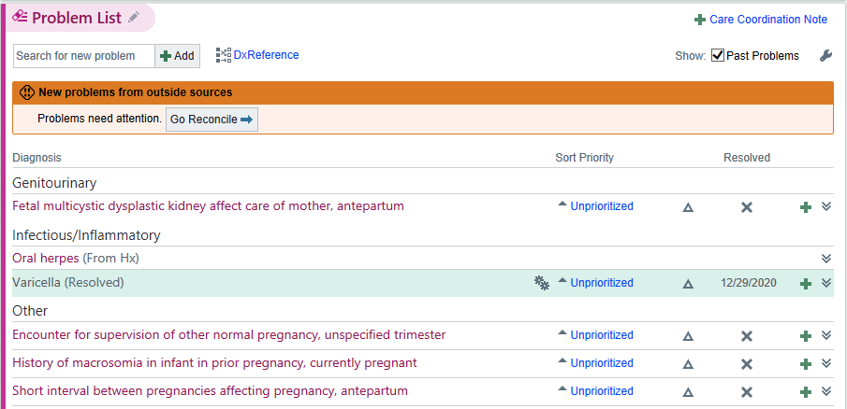

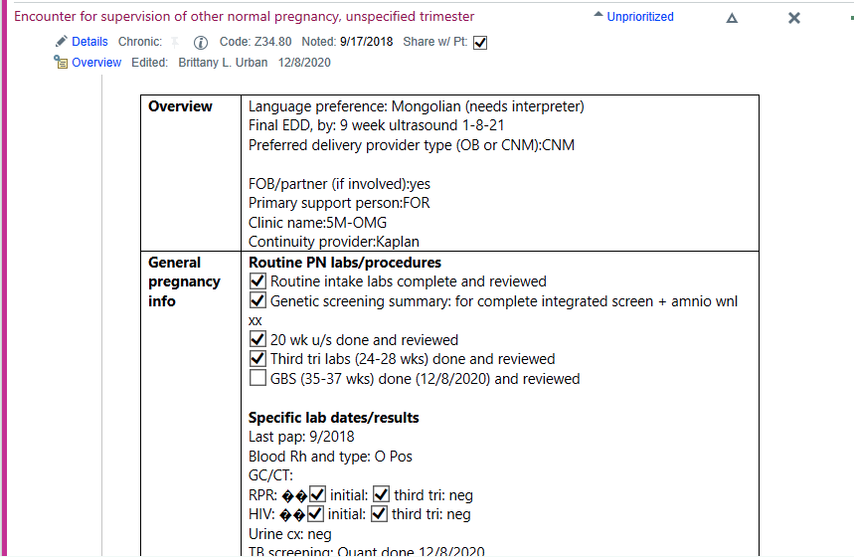
Then write your note:
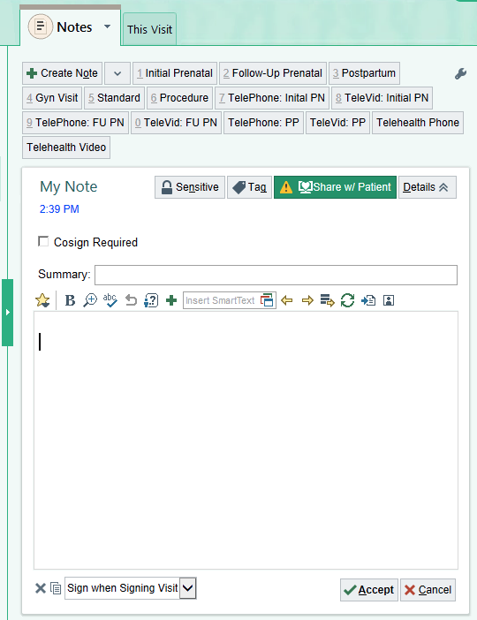
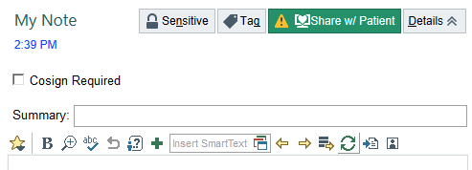

Labs or meds to order (see above for labs). Add the first letters of the med in the order tab and search

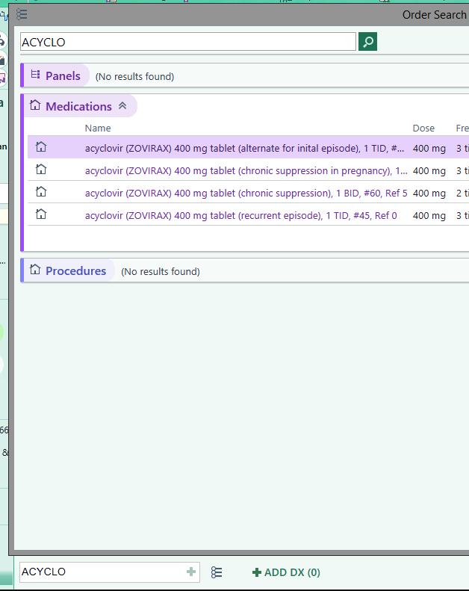

Then check the pharmacy and change prn.

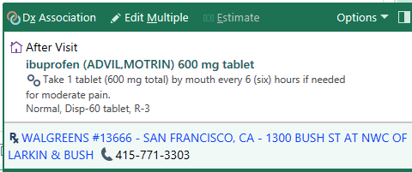

Make your Next times post-it
