Molecular and Genetic Epidemiology
Assignment 3
Answers

C. Problems

1. Suppose we are considering a Mendelian fully penetrant autosomal trait.

If two recessive parents have the disorder, then what, if anything, can you say about their children? [Since recessive, and both parents have the trait, then both parents are homozygous for the deleterious allele, mother-father: AA-AA. Thus so must the offspring must also be homozygous for the deleterious allele, AA, and hence they must also have the trait.]

What if the trait were dominant? [i.e., what if both parents still have the trait, but now it is dominant? Then we could not say for certain. If both parents are heterozygous affecteds (Aa-Aa), an unaffected offspring (aa) is possible. If one or both parents are homozygous affecteds (AA-Aa or AA-AA), then the offspring will have at least one copy and be affected (if the parents are AA-Aa, then the child has one or two copies, and if AA-AA the child will have two copies).]

Now, suppose a child has a recessive trait, what, if anything, can you say about their parents? [Since the child is AA, we know they obtained an A allele from both parents, and so both were at least carriers of the allele, but we cannot say if they were homozygous (e.g., AA, and hence affected) or heterozygous (e.g., Aa, and hence not affected).]

What if it were dominant? [i.e., the child has the trait, but it is now a dominant trait. Then we know that the child is either AA or Aa. At the very least, they got a deleterious allele from one of the parents, and hence that parent is affected. It's possible the other parent could be affected as well, but not necessarily so.]

2. What can you say about the following families – are they dominant (assuming fully penetrant disease), recessive (assuming fully penetrant disease), neither dominant nor recessive (assuming fully penetrant disease), or impossible to tell?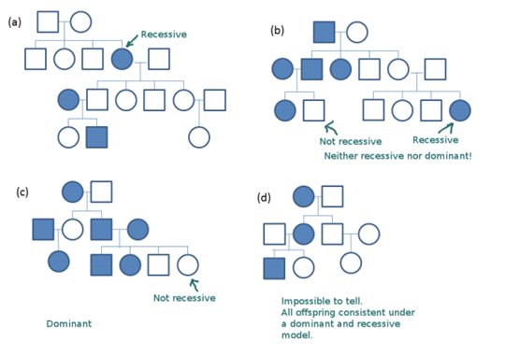

Further explanation

To solve this see if you can come up with a set of genotypes for individuals in the pedigree that will follow the inheritance model in the pedigree. Note that you are not computing any probabilities for any individuals here (to say if dominant or recessive are more likely), you are just seeing if it is possible.

Suppose that we let ‘A’ be the disease causing allele, and ‘a’ be the normal allele.

Under a recessive model, individuals with AA have disease, and individuals with Aa or aa do not.

Under a dominant model, individuals with AA and Aa have disease, and individuals with aa do not.

(a) Starting with the first pedigree. First assume a recessive model. Then the affected individuals have to be AA. That is

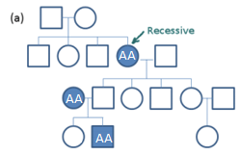

Now let’s see if we can fill in the remaining individuals under a recessive model. All individuals who are unaffected must be either Aa or aa. For a parent to produce an affected offspring, it must be a carrier (because the offspring gets a disease allele from each parent), so we have to fill in those individuals as follows:

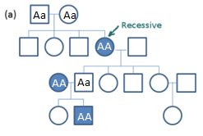

This seems ok so far. Now, what about the remaining individuals? Any of them can be either Aa or aa here, and the pedigree remains possible to be recessive. One example would be the following:

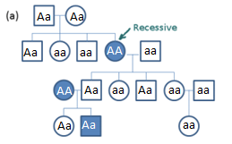

So a recessive model works!

What about a dominant model? Can we find a set of genotypes that works? Affected individuals can be either AA or Aa, and unaffecteds are aa. Let’s try filling in one affected individual with these genotypes.

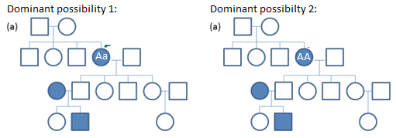

But since all unaffected individuals are aa, the parents of this individual cannot produce either an Aa or an AA offspring!

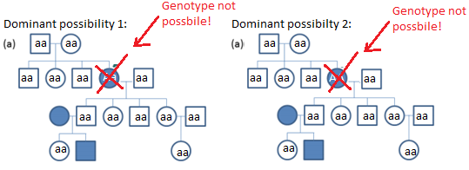

So the dominant model doesn’t work here.

Thus, for (a), the model of a fully penentrant disease must be recessive.

(b) Lets try the same strategy for the second example. First, let’s try a recessive model. Again, then all affecteds must be AA, so let’s start by filling all of them in:

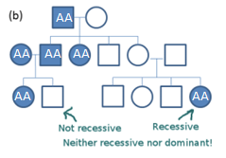
And since recessive, all unaffecteds must be either Aa or aa. But, we immediately see a problem in the lower left pedigree, where two AA-AA parents must produce an AA offspring!

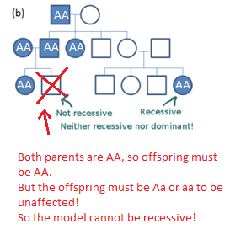
So the model is not recessive.

What about dominant? Then, similar to before, that means that all unaffecteds must be aa, so let’s instead start by filling in all of those individuals, as follows:
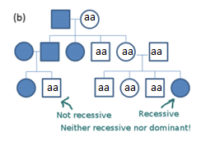
Now, lets see if we can find genotypes that work with this for the affecteds, who must be Aa or AA. We immediately see a problem, here in the lower right hand pedigree:

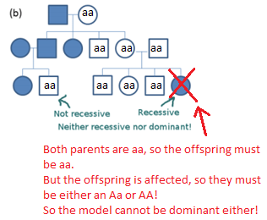
Thus the model cannot be dominant either! And we showed previously it was not recessive.

Hence the pedigree is neither dominant nor recessive!

(c) What about the third pedigree? Lets try the same approach again.

Lets start with recessive again, and fill in all of the diseased individuals with AA.

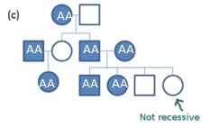
Now unaffecteds must be Aa or aa. Alas, two AA parents must have an AA child, and thus the two unaffecteds in the lower right hand pedigree are impossible!

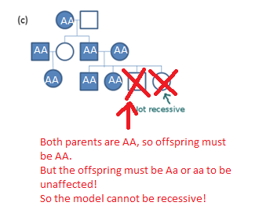

So our model cannot be recessive. What about dominant? Let’s start by filling in all unaffecteds with aa, as they must be that genotype.

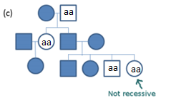
Now, let’s try filling in the affecteds with either Aa or AA and see if we can come up with a pedigree that makes sense. Here’s one that is a possible set of genotypes that would work with the pedigree structure:

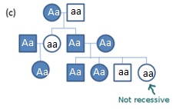
So this is one dominant model that would work. Other possible genotypes are possible, but we just needed to find one that would work!

Since we showed it couldn’t be recessive, and now we showed that it could be dominant, the answer is, dominant.

(d) On to our final pedigree! Let’s see if we can apply the same strategy again.

Let’s start with recessive. Fill in the affecteds with AA.

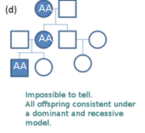

Now, let’s see if we can find a set of Aa and aa that works for the remaining individuals. We can!

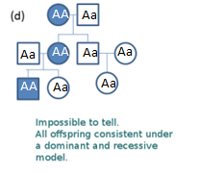
So recessive is possible. Now, what about dominant? Here all the unaffecteds must be aa.

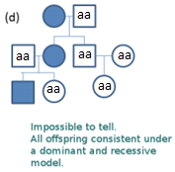

And the affecteds can be either AA or Aa. Can we find a set of genotypes that make sense? We can!

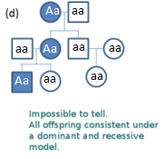
So dominant is possible as well! That is, it could be dominant or recessive with the current pedigree information we have. That is, it is impossible to tell! Maybe if we had more individuals…

3. Assume that a case/control study has been conducted and a SNP (X) genotyped (with 0, 1, or 2 risk alleles). Compute the odds ratios for the table below and the corresponding confidence intervals. Compute chi square tests for codominant, dominant and recessive modes of inheritance. Discuss the results in terms of plausibility of a model.

X=0 X=1 X=2
Cases 500 350 120
Controls 521 270 130

Note: to get the OR and the CI in STATA, one can use:
. cci (# exposed cases) (# unexposed cases) (# exposed controls) (# unexposed controls)

Co-dominant model
 | X_0 | X_1 | X_2 | Total
Case | 500 | 350 | 120 | 970
Control | 521 | 270 | 130 | 921
 | 1021 | 620 | 250 | 1891
Odds Ratios | 1 | 1.35 | 0.96
 |  | Overall Expected
 | 523.7 | 318.0 | 128.2
 | 497.3 | 302.0 | 121.8
Chi-square p-value |  | 7.1E-03
Dominant model
 | X_0 | X_1 | X_2 | Total
Case | 500 | 470 | 0 | 970
Control | 521 | 400 | 0 | 921
 | 1021 | 870 | 0 | 1891
Odds Ratios | 1 | 1.22
 |  | Overall Expected
 | 523.7 | 446.3 | 0.0
 | 497.3 | 423.7 | 0.0
Chi-square p-value |  | 2.8E-02
Recessive model
 | X_0 & X_1 | X_2 |  | Total
Case | 850 | 120 | 0 | 970
Control | 791 | 130 | 0 | 921
 | 1641 | 250 | 0 | 1891
Odds Ratios | 1 | 0.86
 |  | Overall Expected
 | 841.8 | 128.2 | 0.0
 | 799.2 | 121.8 | 0.0
Chi-square p-value |  | 2.6E-01

Based on the test results and the trends in the OR it seems heterozygous disadvantage is a plausible model.

