Molecular and Genetic Epidemiology
Assignment 5
Due by noon on Monday before next class

A. Readings

1. Witte chapter – Evaluating multiple risk factors

2. Gusev et al. Integrative approaches for large-scale transcriptome-wide association studies. Nat Genet, 2017. https://www.ncbi.nlm.nih.gov/pmc/articles/PMC4767558/.

B. Locuszoom plots and variant characterization

Create a locuszoom plot (see lecture; http://locuszoom.org/) of EITHER:

(a) Use the given LDL dataset we exemplified in the lecture. Try one (you can do more, but need only do one) of the following variants: rs492602, rs1800562, rs3764261

OR: (b) If you happen to have your own data, you are more than welcome to use that for a locuszoom plot.

[Locuszoom plot]
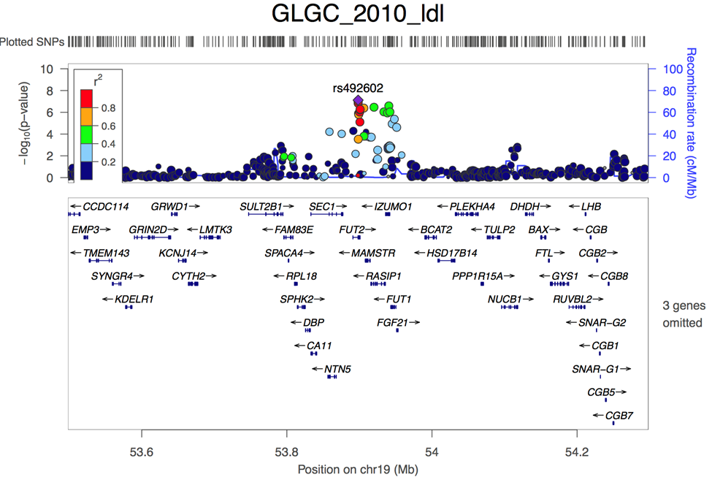

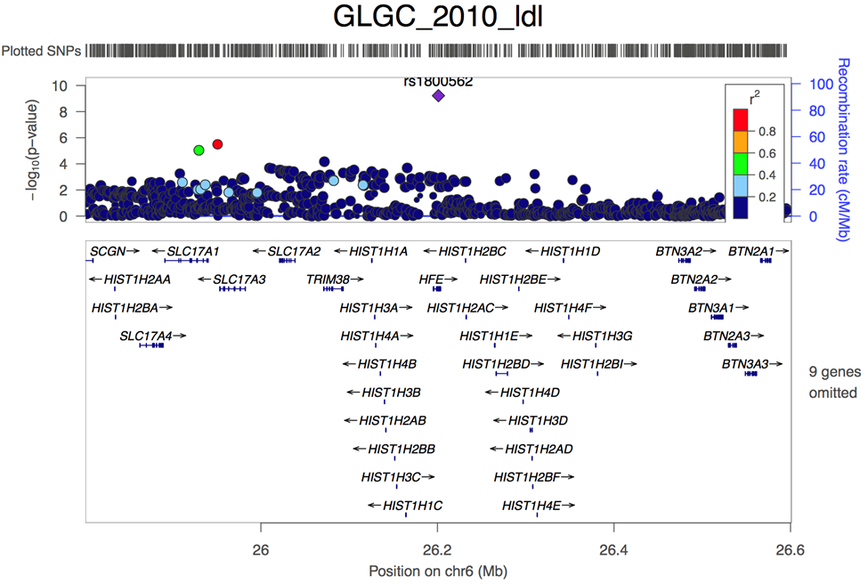

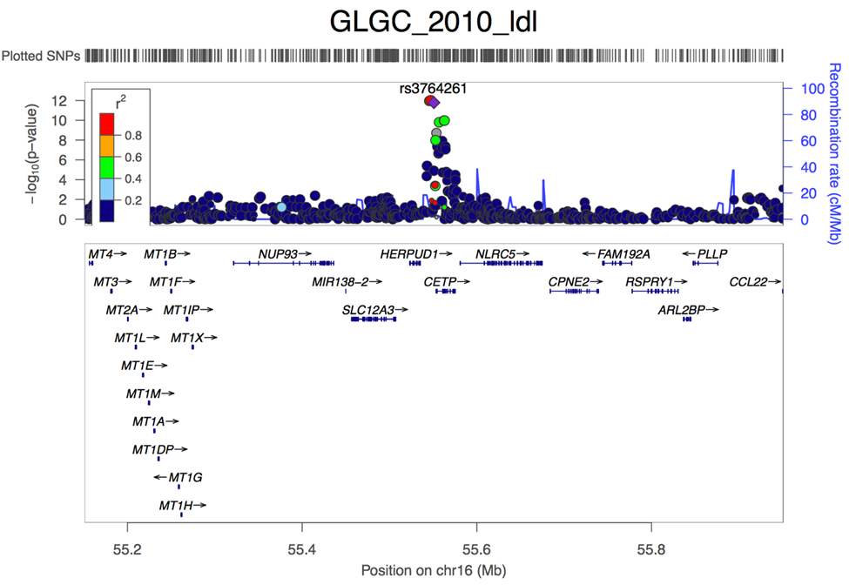

C. Howework Problems – Revisiting GWAS QC

1. One of the first steps in running a genome-wide association study (GWAS) is doing quality control to remove indivduals and SNPs that are bad. We are showing you a small excerpt – what would you do with the following individuals and why?
Family ID | Individual ID | Father ID | Mother ID | Sex | Affection Status | % Missing
1 | 1 | 2 | NA | F | A | 0.1%
1 | 2 | NA | NA | M | U | 0.1%
3 | 3 | NA | NA | F |  | 0.1%
4 | 4 | NA | NA | M |  | 45.0%

Individual (Family ID=4, Individual ID=4) would be removed because it has too much missing data, and so probably something went wrong with them.
[Extra: In addition, either individual (Family ID=1, Individual ID=1) or (Family ID=1, Individual ID=2) would have to be removed, or accounted for the fact that they are related.]
2. Again, we show you a small excerpt. Which of the following SNPs and why? Recall for the HWE test, the null is that they are in Hardy-Weinberg equilibrium, which is a good thing.
SNP | HWE | % missing
rs111 | 0.9 | 40.1%
rs123 | 5x10^-50 | 0.2%
rs456 | 0.05 | 0.3%
rs333 | 0.9 | 0.1%

rs111 fails because there is too much missing data. rs123 fails because of HWE correction.
3. Why do we typically run a GWAS adjusting for principle components?
To control for potential population stratification, i.e., when variants that may have different frequencies in two populations, along with diseases that have different prevalences in the two populations, are tested, a resulting positive result (or inflation thereof) may only indicate they have different ancestry, not a true genetic association.
4. Look at the following QQ-plot. The inflation factor is lambda=1.001. Does it look ok?
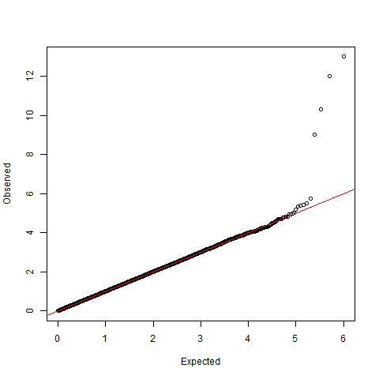
Yes, it looks fine.
5. Suppose an excerpt of your SNPs were the following. Are any of them significant? (Assume a bonferroni correction of 0.05/1,000,000=5x10⁻⁸). If it is, write out, in words, what the OR means, if this is on the additive genetic scale. Also, if it is, what gene is it in?
SNP | MAF | OR | P-value
rs10417394 | 0.07 | 1.14 | 1x10^-13
rs2 | 0.08 | 1.01 | 0.002
rs3 | 0.33 | 0.99 | 0.00001

rs10417394 is significant (p<5x10^-8). The OR of 1.14 means that each additional copy of the risk allele increases your odds of disease by another 1.14. In more detail, we have the regression model
logit{Pr(Y=1|X, …)}
= B₀ + B₁X + B₂PC₁ + …
= B₀ + ln(1.14)X + B₂PC₁ + …
So, if X=0, ln(1.14)X=0; if X=1, ln(1.14)X=ln(1.14). if X=2, ln(1.14)X=2ln(1.14)=ln(1.14²)=ln(1.2996).
X=0 is the baseline, OR=exp(0)=1. For X=1, the OR to the baseline is exp(ln(1.14))=1.14. For X=2, the OR to the baseline is exp(ln(1.2996))=1.2996 (1.14²). Lastly, the OR of X=2 to X=1 is 1.14 (and that is what the additive model means in terms of how the odds ratios work).
It is in the LDLR (LDL Receptor) gene, which you could find out by searching for the rs# on hapmap.org or the UCSC genome browser, amongst others.
The other SNPs are not significant.
6. Look at the Q-Q plot. The smallest p-values observed are the ones along the y-axis; they are sorted by their -log_10 p-values. This means that the highest SNP has p-value 1x10⁻¹³, the next has p-value 1x10⁻¹², then 1x10⁻¹¹, then 1x10⁻⁹, before it goes to roughly noise. Suppose I told you that these SNPs were, in fact, all very close to each other. Do you think that you have found multiple different loci, or do you think that you found just one locus, and why (it's possibly both)? [Hint: think about LD.]

It depends. If the loci are in strong LD, then you probably just found the one locus (and these four SNPs just tag that SNP). If the loci are not in strong LD, then it might not be.

7. Suppose that you excluded a variant from the genotyped markers because it had too much missing data. However, now you have tried to impute it using the surrounding markers. Here the r_{info}²=0.98. Can you now test this marker?

Yes! Imputation recovered it!

8. Suppose that you also excluded another variant, rs222, because it had missingness of 6%. When you imputed it the r_{info}²=0.04. Can you now test this imputed marker? Just for fun (i.e., answer not required), any thoughts on what you might do here?

Alas, no, an r_{info}² quality score of 0.04 is very poor, it was not imputed well at all. Standard QC would eliminate this marker.

Just for fun [i.e., you didn’t need to try this] – I might be tempted to look at some cluster plots of the 6% missingness variant and at least look at the typed SNP there anyway. It is close to a threshold of 95%, which was somewhat arbitrary to begin with.

9. Recall from before rs10417394 had a P-value of 1x10⁻¹³ in the typed markers. Now it has 0.9x10⁻¹⁴ in the imputed markers. Why is this possible? [Hint: The SNPs call rate was probably not 100%.]

Because the SNP call rate was likely less that 100%, this means, that, in the typed markers, some individuals probably had missing data at the variant, and they were not included in the analysis. Now that genotype imputation has been performed, that missing data has been filled in (we fill in both new variants, and fill in any missing data at existing variants). Thus the result may end up slightly more significant (or slightly less can happen as well).

