Biostat 209 Lab

Repeated Measures 2

Lab Summary: In this lab we will learn about the use of mixed for continuous outcomes.

1. Re-analysis of the fecal fat data.

First, load the fecal fat data (fecfat.dta) and reproduce the results in lecture:
mixed fecfat i.pilltype || patid:, reml
Derive the overall pilltype test using the testparm command, testparm i.pilltype. If you are using the menus, this command is under Multilevel mixed effects models (then Mixed effects linear regression) and you need to change the default (on the Model tab) from maximum likelihood (ML) to restricted maximum likelihood (REML).

The fecal fat data can be analyzed using a two-way ANOVA, with factors of pilltype and patient. This can be performed either using the ANOVA commands or regression (as we learned in Biostat 208). Use the regression command to do this:

regress fecfat i.pilltype i.patid

followed by the testparm command. How do the p-values for the overall tests compare? Why are they different?

2. The OAI data

Load the “oai thru 18 months” data. Our goal is to look over 18 months to see if the changes over time in the WOMAC pain score are the same in men and women. First generate some descriptive statistics and a graph:

table visit sex, c(mean womac sd womac n womac)
bysort visit sex: egen mean_womac=mean(womac)
twoway (connect mean visit if sex==1)(connect mean visit if sex==2)

Next fit a model and do a formal test:

mixed womac sex##visit || id:
testparm sex#visit

What are the interpretations of each of the coefficients in the model fit? It may help to get the predicted values and look at the values for the various combinations of sex and visit.

Is there a statistically significant difference in how the pain for men and women change over time?

Next do some residual plots (histogram and standardized residuals versus predicted). Anything to be concerned about?

predict resids, rsta
predict preds
scatter resids preds
histogram resids

3. The mouse weight data

Next, let’s analyze the mouse weight data. Load the data ( mousewght.dta ). First we will get a sense of the relationship between log weight, group and day. To do this generate the mean values by group and day and then plot the results:

bysort group day: egen meanlogw=mean(logw)

The easiest plot to make is by using the Graphics menu: select “Twoway graph”. Then choose “Create” type of “Connected” and fill in the X-variable (day) and the Y-variable (meanlogw) and click on “Accept”.

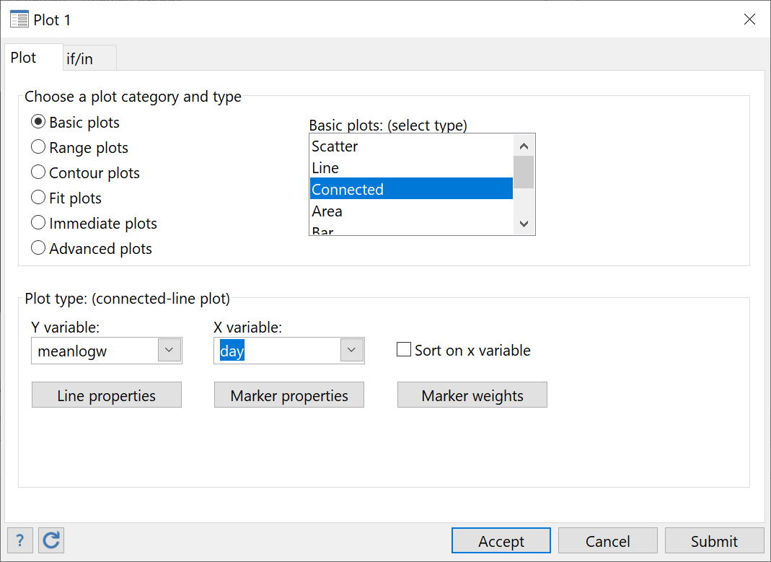

Next go to the “By” tab, click on “Draw subgraphs for unique values of variables” and under “Variables” insert “group”. Then press “Submit” (I like to use “Submit” instead of “OK” so you can change the graph without re-opening the menu).

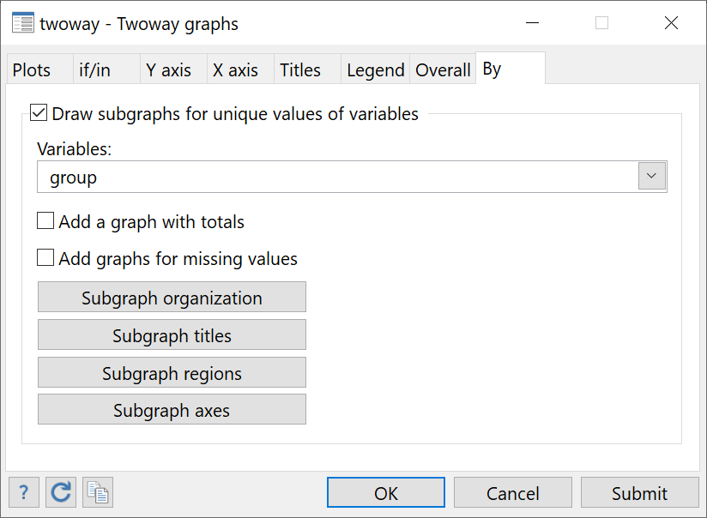

What does the plot tell you about the relationships? How can we accommodate the nonlinearity?

Now formally analyze the data. The mice were randomized to treatment group, so the groups should all have the same intercepts. So the key question is whether the weight gains over time are different by group. Therefore the primary question revolves around the group by time interaction.
We start with an overly simplistic model and work our way up:
mixed logw i.group##c.day c.day#c.day || mouse:, reml
Use the testparm command to test if the group by day interaction is statistically significant. Next we will fit a more realistic model, allowing for mouse-specific slopes over time (as we noted in lecture):
mixed logw i.group##c.day c.day#c.day || mouse: day, cov(un) reml
In the above command we are allowing mouse-specific intercepts and slopes (over day) and the random intercepts and slopes have an unstructured correlation matrix. How does the testparm command compare to the simpler model? Why do you see differences? How could we have checked the results of the simpler model if you hadn’t thought of running the more complicated one?
These models are complicated and it is sometimes hard to figure out what the fitted model is telling you. One way is to plot the predicted values (the sort command is to make the connected points look right and you may want to cut and paste the twoway command into the command window so you don’t have to type it).
predict prd
sort day mouse

twoway (conn prd day if gr==1) (conn prd day if gr==2) (conn prd day if gr==3) (conn prd day if gr==4) (conn prd day if gr==5)

How would you describe the fitted model?
Let’s contrast using the xtgee command:
xtgee logw group##c.day c.day#c.day, i(mouse)
How does the overall test of the interaction compare? Now use the robust option (add robust at the end of the command above) and see if there are changes.

4. Georgia babies

Load the “Georgia babies” data and fit a mixed model

mixed bweight birthord initage || momid:, reml

Check the assumption of linearity in birth order and initial age. Is a linear term adequate?

Obtain the standardized residuals and predicted values. Standardized residuals have the advantage that values outside of 3 in absolute value are pretty extreme.

predict preds
predict std_resids, rsta

Plot the residuals versus the predicted values and generate descriptive statistics of the residuals. Are there outliers? If so, drop them and rerun the analysis and assess if they qualitatively change the results. Hint: in using mixed, if statements go after the fixed effects and before the ||.

