Epi 218

Assignment 2

REDCap: Advantages and Limitations
(Expected time: 60 minutes)

In this assignment and the next, you will use REDCap to create and use online data collection forms for the Infant Jaundice Study. REDCap is an excellent tool for creating data collection forms. However, REDCap is not a relational database platform, which means that there are hard limits on the kinds of data you can manage with a REDCap project.

REDCap

- is web-based (all you need is an internet connection and a browser – no terminal server or remote desktop client);
- is secure and HIPAA-compliant;
- is available at no cost to you, as UCSF is a REDCap consortium partner;
- allows creation of a simple, web-based data-entry system in less than 60 minutes (you will do this today);
- uses forms (data collection instruments) to view, add, and update records;
- offers auto validation, branching logic and calculated fields in forms;
- has a limited query tool called “Report Builder”;
- does not have a full-featured report writer;
- cannot do sophisticated data validation;
- includes access to a REDCap Shared Library which is a repository of REDCap data collection instruments and forms that can be downloaded and used by researchers.

Objectives of today’s assignment
- Create a new REDCap project.
- Create a data collection instrument for participant-specific data
- Create a second data collection instrument for related exam-specific data
- Set up the exam instrument as “repeatable” to make a one-to-many relationship
- Use the forms to enter data for one participant (with multiple exams)
- Use piping to show data from one form on another form
- Create calculated fields
- Add new users to the REDCap project.

- Create a REDCap Project

- Log into REDCap at redcap.ucsf.edu. (Note: it is also possible to log on to REDCap via RAE, if you’ve been given appropriate access; however this isn’t necessary for today’s assignment.)
- Choose the “New Project” tab at the top of the screen.
- Name your project “Assignment2LastName” (where LastName is YOUR last name).
- Purpose of project: “Practice/Just for Fun”
- Select “Use a template.” (Using a template isn’t necessary in REDCap, but it can make set-up quicker.)
- Select the “Basic Demography” template.
- Click “Create Project.”

Create a Data Collection Instrument for Participant-Specific Data

You will start your new REDCap database by setting up an instrument to collect participant information.

- Under “Design your data collection instruments,” click “Online Designer.”
- Because you used a template, a “Basic Demography” form is already created and available for your use. REDCap’s template forms can be a good start, but you will almost always want to tweak them to your own specifications. In today’s assignment you will customize REDCap forms to meet the specific needs of the study we’ve set up for EPI 218.
- Use the Choose Action dropdown control to rename this form to “Participant” and then save it.
- Click the newly renamed form to edit it.
- The first field in the form is “Study ID.” In our illustration study, we call this identifier “Participant ID” instead. Edit the field by clicking the pencil icon for this field. Change the Field Label to “Participant ID,” the Variable Name to “participant_id,” and the Validation to “Integer,” then save the field.
- Underneath Participant ID, you’ll see a cream-colored control named Contact Information. This is a header for a group of fields. Leave this header alone.
- Edit the field “First Name” by clicking the pencil icon. Change the “Required” option to “Yes”; leave the other options as they are. Save this field.
- Edit, delete, and add fields so that you end up with the following fields on the form. (Note: the first two are already done.) Most of these fields already exist, and you can just move them around by dragging and dropping so that they are in this order. Delete any variables that are not needed (i.e. not included in the list below). For example, delete the “Last Name” field.

Field Label | Field Type | Variable Name | Validation | Required? | Identifier?
Participant ID | Text Box | participant_id | integer | (by default) | No
First Name | Text Box | first_name |  | Yes | Yes
Date of birth | Text Box | dob | Date (M-D-Y) (change from “Date (Y-M-D)”) | No | Yes
Ethnicity  (Change the coding - see below.) | Multiple Choice – Radio Buttons (Single Answer) | ethnicity |  | No | No
Race  (Change the coding – See below) | Multiple Choice – Radio Buttons (Single Answer) | race |  | No | No
Sex  (Change from “Gender”) | Multiple Choice – Radio Buttons (Single Answer) | sex |  | No | No
Hyperbilirubinemia* | Yes – No | hyperbili_ind |  | No | No
Comments | Notes Box (Paragraph Text) | comments |  | No | No
*You need to create this field. It is not part of the basic demographic form.

- We’ll change the coding of the Ethnicity field to follow best practices. Edit the text in the “Choices” box so it looks like this:
1, Hispanic or Latino
0, NOT Hispanic or Latino
9, Unknown/Not reported
Can you explain the advantages of this coding over the coding that REDCap set by default? (The link “Coding and Naming Conventions” on the CLE will bring up a document that helps to make the case.)

- Race coding: In this class, we will use “Race” coding similar to (but not the same as) that used by the CDC. Here is how the CDC codes Race:

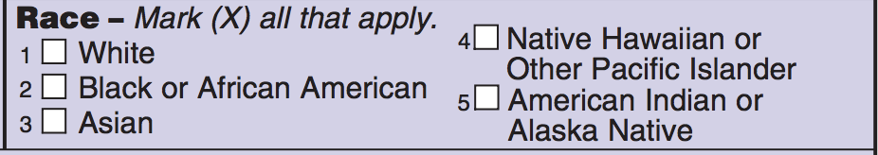

We will mostly follow the CDC’s coding, but we will not treat race as “all that apply” because that would allow 32 distinct combinations. (Can you see why?) Instead, change Field Type to “Multiple Choice – Radio Buttons (Single Answer)” and enter the following to the “Choices” box, to create a set of 7 mutually exclusive and collectively exhaustive options:
1, White
2, Black or African American
3, Asian
4, Native Hawaiian or Other Pacific Islander
5, American Indian or Alaska Native
8, More Than One Race
9, Unknown/Not Reported

- Choose any field, edit it, and type in a brief “Field Note” just to see how it works. (The note you type here will show up as a prompt underneath the field when it is in the form view.) For example, edit the “Hyperbilirubinemia” field and add the following “Field Note”: “Neonatal Bilirubin >= 25 mg/dL”.

- Save and click the “Preview instrument” button at the top right to see how the data entry screen will look. Feel free to enter sample data here to test the form; it will not be saved.

- Create the Data Collection Instrument for Exam-Specific Data

In our illustration study, every participant is given physical and neurological exams at regular intervals. So you will need to create a new Exam instrument to collect the relevant Exam data. This time you will create the instrument without the help of a template.

- Click the “Online Designer” tab (towards the top of the page) and create a new instrument from scratch. Click “Add new instrument here” to start. Name the new instrument “Exam,” Create, and click on the new instrument to edit it.
- Now add new fields to your instrument (see below). All fields except “PEDS Rating” will have a Field Type of “Text Box.”
NOTE: When you choose the “Field Type” of Text Box for the first field, you will see a checkbox “Enable auto naming of variable based on its Field Label?.” Check the box (and click “Enable auto naming,” when it appears, to dismiss the warning). As you type in a field label, you’ll see how this option has REDCap automatically create a variable name.
The fields to add are:

Field Label | Field Type | Variable Name (auto) | Validation | Required? | Identifier?
ExamID | Text Box | examid | Integer | No | No
ExaminerID | Text Box | examinerid | Integer | No | No
ExDate | Text Box | exdate | Date (M-D-Y) | No | No
ExWeight | Text Box | exweight | Number (1 decimal place) | No | No
ExHeight | Text Box | exheight | Integer | No | No
ExScore | Text Box | exscore | Integer | No | No
PEDS_Rating | Multiple Choice – Radio Buttons (Single Answer) | peds_rating | -- | No | No

Since PEDS_Rating is a multiple choice field type, you have to tell REDCap what options should be offered as values for this field. To save time, just copy and paste this text into the “Choices” field for PEDS_Rating:

A1, High Risk - Need for speech and language evaluation
A2, High Risk - Need for testing by a developmental psychologist
B1, Moderate Risk - Non-developmental concerns
B2, Moderate Risk -Behavioral issues and at least 1 developmental concern
C1, Elevated Behavioral/Mental Health Risk - >= 4.5 years
C2, Elevated Behavioral/Mental Health Risk - < 4.5 years
E, Low Risk for Developmental or Behavioral Problems

- Designate Repeatable Instrument

Since each individual participant receives multiple exams, you will need to make the “Exam” instrument “repeatable.” Repeatable instruments allow the same instrument to be filled out any number of times for a single participant. For example, you can (and will) enter several exam records for a single participant.

Choose “Project Setup” in the navigation area on the left, then under “Enable optional modules and customizations”, enable “Repeatable instruments” and make “Exam” your repeatable instrument.

“Repeatable instruments” is just one feature that makes REDCap more appropriate for managing clinical research data than Excel. By making the Exam instrument repeatable, you are freed from clumsy fields like ExDate1, ExWeight1, ExDate2, ExWeight2, etc. However, there’s a limit to repeating instruments in REDCap. You cannot nest repeatable instruments within other repeatable instruments. For example, if this study included multiple labs at the time of each exam, you would still have to create fields like Lab1, Result1, Lab2, Result2, and so on.

Your simple REDCap project is now set up and ready for data entry.

- Use the forms to enter data

- Click “Add/Edit Records” in the navigation area on the left. You will be entering participant and exam data for two participants, Honoria and Rubeus, using the forms at the end of these assignment instructions. Start by entering Honoria’s participant data. Enter her Participant ID to “Enter a new or existing Participant ID” and press the “Enter” key; open her Participant form by clicking on the gray “Status” circle for Participant; then add the rest of her participant data. Honoria did not have hyperbilirubinemia at birth/in the neonatal period.
- The paper form records participant and exam data on the same page. Your REDCap project (more correctly) separates them. In order to enter Honoria’s exam data, choose “Save & Go to Next Form.” REDCap helpfully takes you to the next form on the list (the Exam form) for the same participant. Note that you don’t have to re-enter Honoria’sparticipant data for each exam, as you did in the “long” version of our Excel spreadsheet. As long as the exam form references Honoria’s Participant ID, the exam is attached to all her existing Participant data, such as DOB, sex, etc.
- Now enter all three of Honoria’s exams. “Save & Add New Instance” works to add more exams for the same participant, but there are other ways too. On completing the third exam, use “Save & Exit Record” to return to the Add/Edit Records page.
- Now enter Participant and Exam records for Rubeus’s data. Rubeus did have hyperbilirubinemia at birth/in the neonatal period.

F. Piping

The Exam form, as it now stands, does not display any data from the Participant form other than the Participant ID. In practice, you might want to view the participant’s name, sex, or date of birth while entering exam data (if only to confirm that you’re entering the exam data to the right participant). At the moment, there’s no way to do this besides closing the Exam form and returning to the Participant form. To fix this, you can use a REDCap feature called “piping” to display information from one form on another.

  - Return to Project Setup and the Online Designer (under “Design your data collection instruments”). Edit the “Exam” instrument.
  - Add a field at the top of your Exam form. Use Field Type: “Begin New Section (with optional text)”.
  - Add the following as the Field Label:
Name: [first_name]
DOB: [dob]
  - By including a field name in square brackets (e.g. [first_name]), you tell REDCap to display the data in that field for that record. This is piping. Save the new field and take a look at an exam form (using “Add/Edit Records”) for one of your two study participants. You’ll see the name and date of birth piped in from the participant form.
  - REDCap does not allow you to run calculations in piped data. But it does allow you to change the formatting of the data with some basic HTML tags. We will use this to make the section header with piping more prominent.
  - Modify the Field Label (section header), replacing the Field Label that you just entered with this:
<H2 ALIGN=CENTER> Name: [first_name]</H2>
<H2 ALIGN=CENTER> DOB: [dob]</H2>

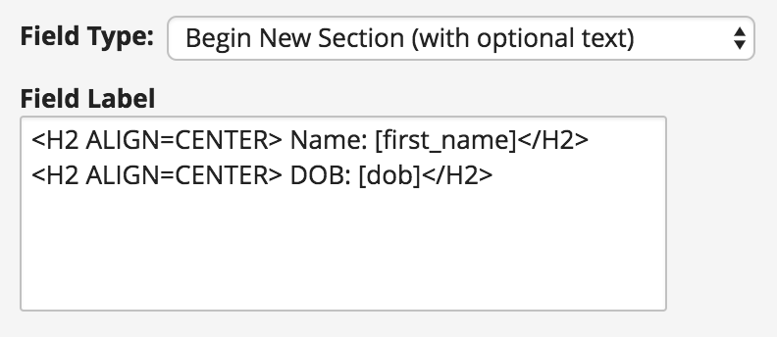

  - Now when you view Rubeus’s exam form it should look like this:

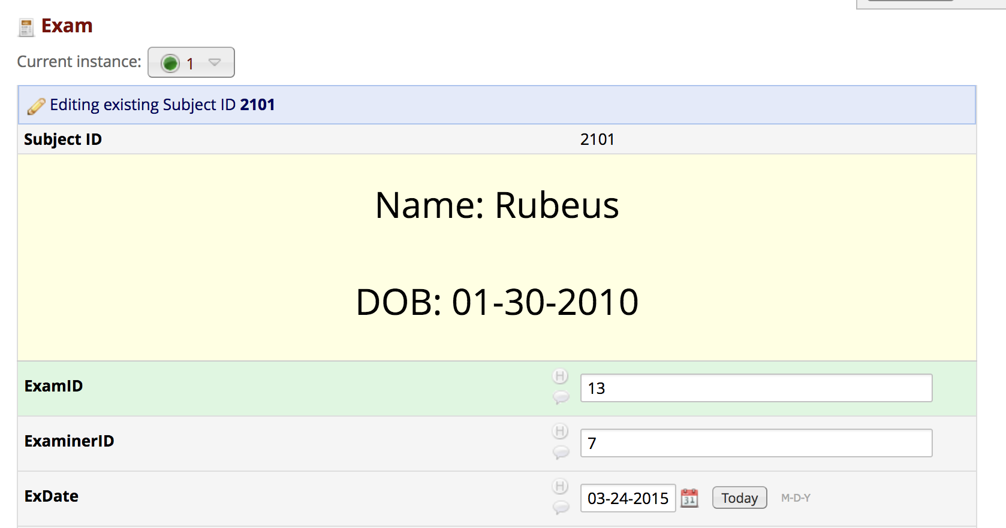

G. Create calculated fields

- REDCap can run calculations on fields (including fields from other instruments) with a useful feature called “calculated fields.”
- Return to Project Setup and the Online Designer. Edit the “Exam” instrument.
- Add a new field under the ExDate field. Set its Field Type to “Calculated field” and its Field Label to “Age in Months.”
- For this field, enter the following Calculation Equation exactly:
rounddown(datediff([dob],[exdate],"M","mdy"))
Depending on your system, you may be able to copy and paste that equation right into the field. If not, you’ll have to type it out exactly as given above. If you entered it correctly, when you exit the field you will see a confirmation (check mark and “Valid”) in green. (Of course, the equation could be valid and still be incorrect.)
- Save the field, then return to Honoria’s three Exam forms to make sure the calculated field is working properly. Be sure to check all three, since some errors might not appear on all forms.
- If you get an error (or an incorrect number of months) from the Age in Months field, the Calculation Equation may have been entered incorrectly, or one of the names or validations specified in these instructions may have been entered incorrectly. Review the instructions and troubleshoot until the calculated field is working correctly.
- Edit the Exam Instrument again and add another calculated field labeled “BMI” (to be placed under the ExHeight field).
- For this field, enter the following Calculation Equation:
round(([exweight]*10000)/(([exheight])^(2)),1)
Save, then check the exam records as needed to be sure that the field is working correctly.

H. Add New Users to the Project

- REDCap lets you share your project with a team, with many advanced options for sharing. You will now use this feature to share this project with your section leader for grading purposes.
- In the REDCap window’s left-hand panel under “Applications,” choose “User Rights”.
- Add your section leader as a user on this project (“Add new user” and “Add with custom rights”), using their REDCap ID below. Please be sure to give your section leader “User Rights” (check the box that says “User Rights”) and any other user privileges you feel are appropriate.

Epi 218 section leaders:
Hannah Hoban - hhoban
Pallavi Chaudhary - pchaudhary
Matt Durstenfeld - mdurstenfeld
Sujata Mathur - smathur2
Josie Urbina - jurbina

- Once you add your section leader to your REDCap project, you have completed the assignment. This week there is no quiz and nothing to hand in.

You now know how to set up a REDCap database.

This completes Assignment 2. We will receive an email when you add us as users on your Assignment 2 REDCap project. We need to get this email by midnight on the assignment due date.

Infant Hyperbilirubinemia Study

Examination Data Form
DO NOT WRITE IN BOX
Child's Name Honoria ParticipantID 130294
ExamID 203
Child's DOB 03/15/2013 Examiner ID 1
Child's Sex F
Latino/Hispanic? Yes No

Child’s Race Asian Black White Amer. Indian Other

Date of Exam 03/11/2016 Examiner's Name Koop
Weight in kg 16.0
SCORE ____

Height in cm 98

PEDS Year: __3____ PEDS Rating: C-2
PEDSRating | PEDSRatingTxt
A-1 | High Risk - Need for speech and language evaluation
A-2 | High Risk - Need for testing by a developmental psychologist
B-1 | Moderate Risk - Non-dvelopmental concerns
B-2 | Moderate Risk -Behavioral issues and at least 1 developmental concern and
C-1 | Elevated Behavioral/Mental Health Risk - >= 4.5 years
C-2 | Elevated Behavioral/Mental Health Risk - < 4.5 years
E | Low Risk for Developmental or Behavioral Problems

Infant Hyperbilirubinemia Study
Examination Data Form
DO NOT WRITE IN BOX
Child's Name Honoria ParticipantID 130294
ExamID 583
Child's DOB 03/15/2013 Examiner ID 2
Child's Sex F
Latino/Hispanic? Yes No

Child’s Race Asian Black White Amer. Indian Other

Date of Exam 04/04/2017 Examiner's Name Antonia Coello Novello
Weight in kg 18.0
SCORE _______
Height in cm 104

PEDS Year: __4____ PEDS Rating: C-2

PEDSRating | PEDSRatingTxt
A-1 | High Risk - Need for speech and language evaluation
A-2 | High Risk - Need for testing by a developmental psychologist
B-1 | Moderate Risk - Non-dvelopmental concerns
B-2 | Moderate Risk -Behavioral issues and at least 1 developmental concern and
C-1 | Elevated Behavioral/Mental Health Risk - >= 4.5 years
C-2 | Elevated Behavioral/Mental Health Risk - < 4.5 years
E | Low Risk for Developmental or Behavioral Problems

Infant Hyperbilirubinemia Study
Examination Data Form
DO NOT WRITE IN BOX
Child's Name Honoria ParticipantID 130294
ExamID 814
Child's DOB 03/15/2013 Examiner ID 7
Child's Sex F
Latino/Hispanic? Yes No

Child’s Race Asian Black White Amer. Indian Other

Date of Exam 03/18/2018 Examiner's Name Lushniak
Weight in kg 21.4
SCORE 125
Height in cm 112

PEDS Year: __5____ PEDS Rating: E

PEDSRating | PEDSRatingTxt
A-1 | High Risk - Need for speech and language evaluation
A-2 | High Risk - Need for testing by a developmental psychologist
B-1 | Moderate Risk - Non-developmental concerns
B-2 | Moderate Risk -Behavioral issues and at least 1 developmental concern and
C-1 | Elevated Behavioral/Mental Health Risk - >= 4.5 years
C-2 | Elevated Behavioral/Mental Health Risk - < 4.5 years
E | Low Risk for Developmental or Behavioral Problems

Examination Data Form
DO NOT WRITE IN BOX
Child's Name Rubeus ParticipantID 2101
ExamID 13
Child's DOB 01/30/2010 Examiner ID 7
Child's Sex M
Latino/Hispanic? Yes No

Child’s Race Asian Black White Amer. Indian Other
Date of Exam 03/24/2015 Examiner's Name Novello
Weight in kg 17.0
SCORE 94
Height in cm 106

PEDS Year: __5____ PEDS Rating: __

PEDSRating | PEDSRatingTxt
A-1 | High Risk - Need for speech and language evaluation
A-2 | High Risk - Need for testing by a developmental psychologist
B-1 | Moderate Risk - Non-dvelopmental concerns
B-2 | Moderate Risk -Behavioral issues and at least 1 developmental concern and
C-1 | Elevated Behavioral/Mental Health Risk - >= 4.5 years
C-2 | Elevated Behavioral/Mental Health Risk - < 4.5 years
E | Low Risk for Developmental or Behavioral Problems

