Infant Hyperbilirubinemia Study
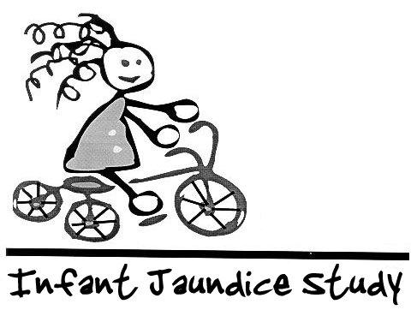
Examination Data Form
DO NOT WRITE IN BOX
Child's Name Honoria ParticipantID 130294
ExamID 203
Child's DOB 03/15/2013 Examiner ID 1
Child's Sex F
Latino/Hispanic? Yes No

Child’s Race Asian Black White Amer. Indian Other

Date of Exam 03/11/2016 Examiner's Name Koop
Weight in kg 16.0
SCORE ____

Height in cm 98

PEDS Year: __3____ PEDS Rating: C-2
PEDSRating | PEDSRatingTxt
A-1 | High Risk - Need for speech and language evaluation
A-2 | High Risk - Need for testing by a developmental psychologist
B-1 | Moderate Risk - Non-dvelopmental concerns
B-2 | Moderate Risk -Behavioral issues and at least 1 developmental concern and
C-1 | Elevated Behavioral/Mental Health Risk - >= 4.5 years
C-2 | Elevated Behavioral/Mental Health Risk - < 4.5 years
E | Low Risk for Developmental or Behavioral Problems

Infant Hyperbilirubinemia Study
Examination Data Form
DO NOT WRITE IN BOX
Child's Name Honoria ParticipantID 130294
ExamID 583
Child's DOB 03/15/2013 Examiner ID 2
Child's Sex F
Latino/Hispanic? Yes No

Child’s Race Asian Black White Amer. Indian Other

Date of Exam 04/04/2017 Examiner's Name Antonia Coello Novello
Weight in kg 18.0
SCORE _______
Height in cm 104

PEDS Year: __4____ PEDS Rating: C-2

PEDSRating | PEDSRatingTxt
A-1 | High Risk - Need for speech and language evaluation
A-2 | High Risk - Need for testing by a developmental psychologist
B-1 | Moderate Risk - Non-dvelopmental concerns
B-2 | Moderate Risk -Behavioral issues and at least 1 developmental concern and
C-1 | Elevated Behavioral/Mental Health Risk - >= 4.5 years
C-2 | Elevated Behavioral/Mental Health Risk - < 4.5 years
E | Low Risk for Developmental or Behavioral Problems

Infant Hyperbilirubinemia Study
Examination Data Form
DO NOT WRITE IN BOX
Child's Name Honoria ParticipantID 130294
ExamID 814
Child's DOB 03/15/2013 Examiner ID 7
Child's Sex F
Latino/Hispanic? Yes No

Child’s Race Asian Black White Amer. Indian Other

Date of Exam 03/18/2018 Examiner's Name Lushniak
Weight in kg 21.4
SCORE 125
Height in cm 112

PEDS Year: __5____ PEDS Rating: E

PEDSRating | PEDSRatingTxt
A-1 | High Risk - Need for speech and language evaluation
A-2 | High Risk - Need for testing by a developmental psychologist
B-1 | Moderate Risk - Non-developmental concerns
B-2 | Moderate Risk -Behavioral issues and at least 1 developmental concern and
C-1 | Elevated Behavioral/Mental Health Risk - >= 4.5 years
C-2 | Elevated Behavioral/Mental Health Risk - < 4.5 years
E | Low Risk for Developmental or Behavioral Problems

Examination Data Form
DO NOT WRITE IN BOX
Child's Name Rubeus ParticipantID 2101
ExamID 13
Child's DOB 01/30/2010 Examiner ID 7
Child's Sex M
Latino/Hispanic? Yes No

Child’s Race Asian Black White Amer. Indian Other
Date of Exam 03/24/2015 Examiner's Name Novello
Weight in kg 17.0
SCORE 94
Height in cm 106

PEDS Year: __5____ PEDS Rating: __

PEDSRating | PEDSRatingTxt
A-1 | High Risk - Need for speech and language evaluation
A-2 | High Risk - Need for testing by a developmental psychologist
B-1 | Moderate Risk - Non-dvelopmental concerns
B-2 | Moderate Risk -Behavioral issues and at least 1 developmental concern and
C-1 | Elevated Behavioral/Mental Health Risk - >= 4.5 years
C-2 | Elevated Behavioral/Mental Health Risk - < 4.5 years
E | Low Risk for Developmental or Behavioral Problems

