Epi 218 Assignment 5
Second Access SQL Assignment

Filtering by Form, Queries, and Reports
(Expected Time: 50 minutes)

In Assignment 4, you created a database with two dynamic tables, and you entered information from paper data collection forms into the two dynamic tables – both directly and via a form/subform. In this assignment, you will make a copy of an existing database and use it to filter data by form. You will also learn how to create a query and a report based on that query. Finally, you will learn to import new subject records into the database and append them to the subject table.

Before you begin, be sure to watch the associated Lecture (Lecture 5) which is posted on the CLE in four segments. Fair warning: there is a clue in Lecture 5 which will give you an opportunity for extra credit.

This assignment is associated with an online CLE quiz. For your notes, the quiz questions are also on the last 2 pages of these instructions, but please make sure to transcribe your answers into the online CLE quiz. At two points in the quiz, you are asked to upload a file reporting on subject counts by race. The first file is made before importing a new group of subjects, and the second file is made after the import. The counts will therefore be different.

Objectives
- Filter by form.
- Design a simple query.
- Design a query using grouping/totals.
- Create a report based on a query.
- Import subject records from an Excel spreadsheet.
- Append (INSERT) new subject records to the subject table.

Apply “Filter by Form” to the subjects in a copy of the Infant Jaundice Study database

- In today’s assignment you will be working with a sample Access file.
- If you are working on Microsoft Access in the RAE, use the RAE File Explorer to copy the file “InfantJaundiceStudyLab5.accdb” from the shared class folder (subfolder “Assignment 5”) to your personal RAE folder.

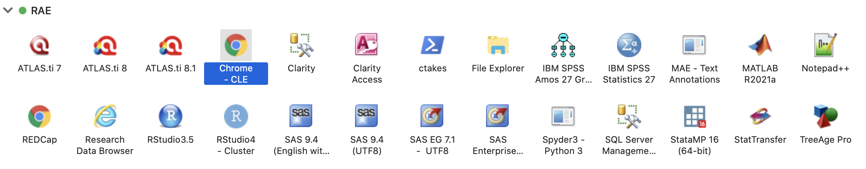

  - (Depending on your settings, you may not see the “.accdb” extension.) Rename your copy (not the original!) as “InfantJaundiceLab5_Lastname.accdb,” where Lastname is your last name.
  - If you are working on Microsoft Access installed on your own local computer, download a copy of the file “InfantJaundiceStudyLab5.accdb” from the CLE. (Depending on your settings, you may not see the “.accdb” extension.) Rename your copy as “InfantJaundiceLab5_Lastname.accdb” (where Lastname is your last name).
- Normally, you would be able to double-click on an Access file to open it, but on the RAE you must launch Access 2016 first.
- Open Microsoft Access (on your own computer or on the RAE) and open the file “InfantJaundiceLab5_Lastname.accdb” (not the copy in the shared folder!).



- A “Main” form opens. (If you see a security warning with an option to “Enable Content,” enable content now. If you see a prompt “Make this a trusted document?”, choose “Yes.”)

Note: The database you have just opened is a slightly simplified (and of course deidentified) version of the actual Access database that was used to manage data for the JIFEE study.

- Click on the button on the “Main” form labeled “Database Master Form”. The Master Form shows all the subjects in the database, including their “excluded/non-excluded” status, “hyperbili” (yes/no), “status” within the study protocol, and other fields.
- A record count appears at the bottom of the “Master” form’s window.

Quiz: How many subject records are there in the database? (Note: for convenience, you can record your answers in the worksheet at the end of this document.)

- There are many ways to select groups of records in Access. To start with we will filter using a form; specifically, we will limit the master list to show only those subjects who were not excluded from the study. In the “HomeSort & Filter” section of the Ribbon, click on the “Advanced” button and select “Filter by Form”.

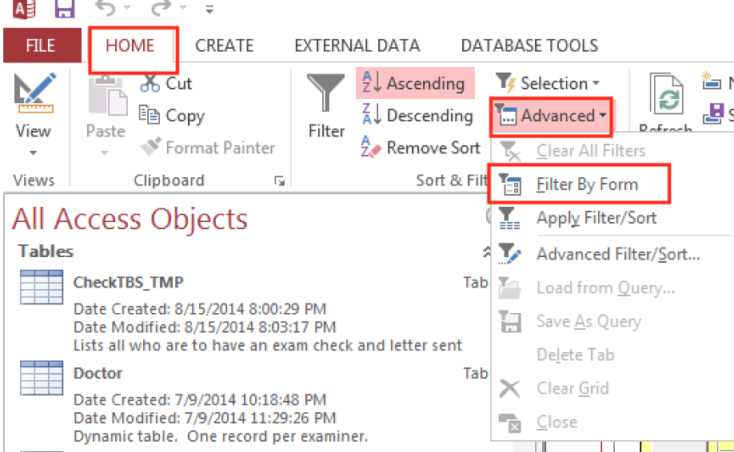

- You now see what looks like a copy of your previous form, but without any records. From the title (“Filter by Form”) you can see that this isn’t actually a data entry form: rather it’s a place to enter the criteria you want for your filter.
- On the filter form, check and then uncheck the “Excluded” box. You want to filter for records where “Excluded” is false. For a checkbox field:
  - Gray means “display records regardless of the value of this field”
  - Checked means “display records only where this field is true”
  - Unchecked means “display records only where this field is false”.
You could add further criteria to your filter, but for now one is enough. Apply the filter by clicking “Toggle Filter” in the “HomeSort & Filter” section of the Ribbon.
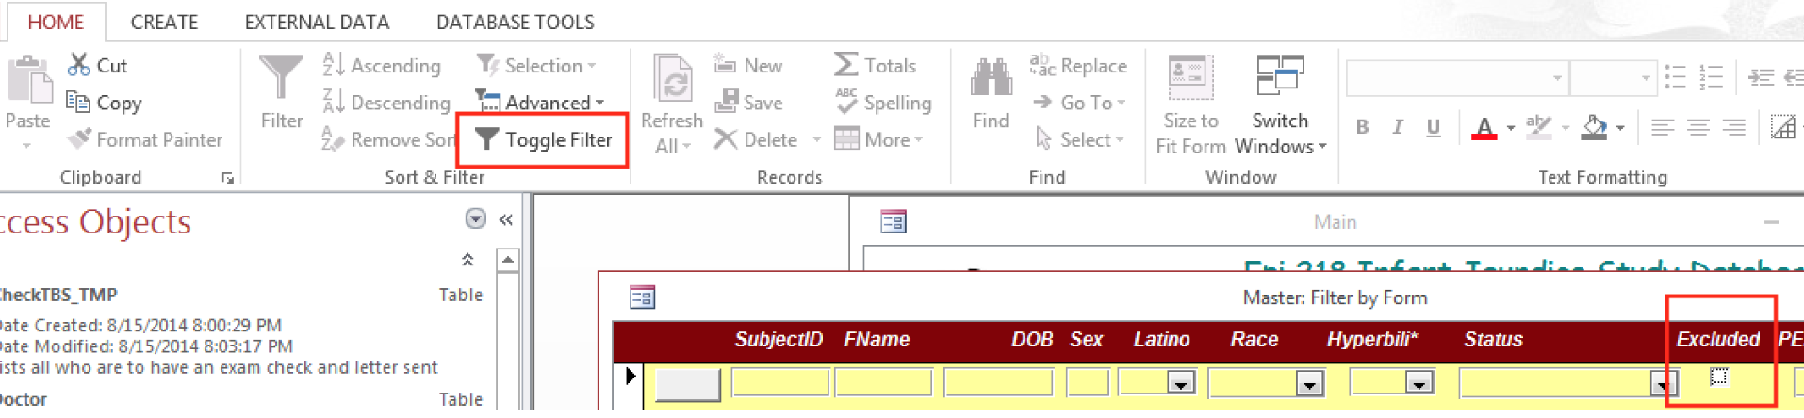

The form now shows only the records meeting your criteria. Notice that the funnel icon appears at the bottom of the form, showing that this form has an applied filter.

Quiz: How many included (“Excluded”=False) subjects are there in the database?

Note: As noted in the last assignment, when designing your own forms, use checkbox controls sparingly if at all.

- Add a second filter criterion. Again, click on “Advanced” and select “Filter by Form”, but in addition to requiring “Excluded” to be false, require “Hyperbili” to be “Yes”.

Quiz: How many included subjects were exposure-positive (hyperbili = yes)?

- Modify your filter so that it shows included exposure-positive subject(s) with race categorized as “Other”.

Quiz: List the SubjectIDs and first name(s) of included exposure-positive subject(s) with race categorized as “Other”.

Note: Filtering by form is easy to understand, but its power is extremely limited. In Part B, we will introduce a much more powerful tool: SQL queries.

- Now, remove the filter by de-selecting “Toggle Filter”.
- Close the “Master” form. Close the “Main” form. Do not close the database or Access.
- The Navigation Pane is on the left side of the screen. (If it is closed, click on the “>>” button. The F11 key also works.)

Design a Simple Query
Access uses SQL (Structured Query Language—usually pronounced “sequel”), the standard language for querying relational databases. Other SQL-based programs include Oracle, MySQL, MariaDB, SQL Server, and PostGreSQL. Access is the only integrated desktop database that is relational and SQL-based. It also provides an elegant graphical query design tool that enables you to write SQL statements without having to know the language!

- In our first query, we will simply list all subjects with Race categorized as “Other” (RaceCode=8). We are no longer restricting this to included exposure-positive subjects.
- On the Ribbon’s “Create” tab, click “Query Design.” In the “Show Table” dialog box, add the “IJSSubject” table (equivalent to “Subject” in previous assignments) and close the dialog box.
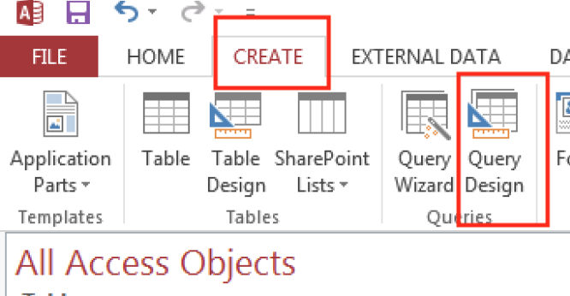

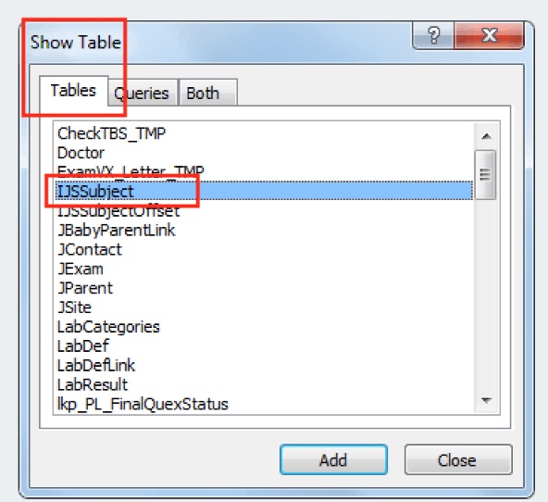

- You are now looking at the Access Query Designer, the nice graphical tool that obviates the need for you to learn command-line SQL. The upper panel should show you the “IJSSubject” table. Below you see the query design grid, with rows labeled “Field”, “Table”, “Sort”, “Show”, and “Criteria”.
- Move the asterisk (“*”) from the “IJSSubject” table onto the grid by either double-clicking on it or dragging and dropping. (The asterisk appears at the very top of the table, before any of the named fields.) The asterisk means you have chosen to display all the table’s fields in the query.
- Move the “Race” field from the “IJSSubject” table to the “Field” row of the grid by either double-clicking on it or dragging and dropping. Limit “Race” to “Other” by typing “8” (no quote marks) in the criteria row of the grid under the “Race” field. (The table “lkpRace” keeps track of numeric codes for race categories. (The prefix “lkp,” an abbreviation for “lookup,” is often used for such tables.) If you examine the “lkpRace” table, you will see that “8” corresponds to “Other”.)
- Uncheck the “Show” box under “Race”. (This field will already be displayed as part of the asterisk “*”; there is no reason to display it twice.) The query will look something like this:

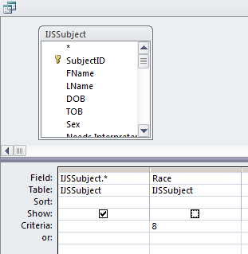

- From the Design option on the ribbon, select the “Datasheet View” (View Datasheet View) or click the “Run” button (which looks like an exclamation mark). This executes the query you just created.
- Be sure the query displays the included exposure-positive subject(s) that you found in section A10 above (Question 4 on the quiz), plus any other potential subjects with Race = Other.

Quiz: If you created the query correctly, you should see at least one additional study subject besides the subject(s) you identified earlier. His name is Christopher Boone (SubjectID #37330). Examine his data in the query. (You will need to scroll to the right to see all the fields.) Which of the following accurately describes this subject?
- He was included in the study but was not exposure-positive (no neonatal hyperbilirubinemia).
- He was included in the study and was exposure-positive (yes neonatal hyperbilirubinemia), but his Race wasn’t “Other”.
- He was excluded.
- None of the above

- You created the query by dragging, dropping, and clicking in the visual Query Designer, but behind the scenes Access turned this definition into a statement in SQL (Structured Query Language). View the SQL for your query by choosing HomeViewSQL View.

Note: One quirk of the Access query builder is that it can insert a lot of unnecessary parentheses. In this query, you could remove all of the parentheses in the statement and the query would still work fine.

Quiz: What SQL statement will select all fields for all subjects with Race of “Other,” like the query you just created? (Select one of the options given.)

- Close the query and save as “qryLastnameOtherSubjects”. (The only reason to save it is because you might want to come back to it at some point. You will not need to turn it in.)

Note: You just saved a SQL command of the form “SELECT [fields] FROM [table] WHERE [conditions].” You did not save data. A SQL SELECT Query is not data; it is a recipe for filtering, sorting, and combining existing data from the tables in your database, and as we will see later, for doing calculations based on existing data. People who use statistical packages sometimes have trouble understanding that a SQL query simply displays data from one or more existing tables; it does not create or store a new table. If the data in the underlying table (e.g., IJSSubject) were to change, re-running the query will display results based on the new data.

Build a “SELECT/GROUP BY” Query

- Now you want to break down the numbers of included subjects by race. You will create a new SELECT Query using the SQL “GROUP BY” statement to do this.
- Create a new query in “Design View”. In the “Create” ribbon, click on “Query Design” again. Next, in the “Show Table” dialog box, add the “IJSSubject” table and close the dialog box. Once again, you are looking at the Access Query Designer.
- Move the “Race”, “SubjectID”, and “Excluded” fields from the “IJSSubject” table to the “Field” row of the grid (much as you did before). Be sure to have “Race” on the left, “SubjectID” in the middle, and “Excluded” on the right in the grid.
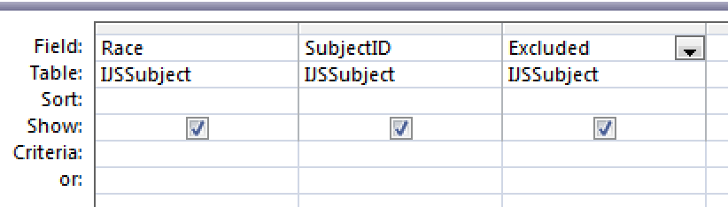
- This time, you do not want a list of the records; instead, you want a breakdown of the number of included subjects by race. To get this, click “Design → ∑ Totals” on the ribbon. You will see a new “Totals” row in the query design grid.
- In the “Totals” row of the query design grid, leave “Group By” in the “Totals” row of the “Race” column. (This will summarize the data for each race in the study.)
- In the “SubjectID” column, change “Group By” to “Count”. (This will count the number of subjects for each race.)
- In the “Excluded” column, change “Group By” to “Where” and type “False” (without quotes) in the “Criteria” row. The ‘Show’ box in the “Excluded” column should be unchecked. This will limit the query to subject records for which the subject was not excluded.

- To view the results of your query, click “Design” on the ribbon and either change to datasheet view or “run” the query (by clicking on the exclamation mark “!”). If you get an error, check to be sure that your query options are set up like this:

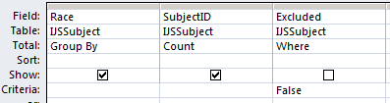

Quiz: How many subjects had the Race field blank? (More on this later.)

- Once again, view your SQL code by choosing “SQL View.” Note the “Group By” clause at the end of the SQL statement.

Quiz: What SQL statement gives the counts of included subjects by race, like the query you just created? (Select one of the options given.)

- Close and save the query as “qryLastnameCountsByRace.” You will use this query again in just a moment.

Create a Report

- In the Navigation Pane, select the query you just created (qryLastnameCountsByRace) and be sure it is highlighted. (You may need to scroll far down the Navigation Pane to find the section for Queries. These queries are sorted by date, so yours will be the last of the queries.)
- On the Ribbon’s “Create” tab, select “Report.” Access makes a guess at the kind of report you want, based on the query you selected, and shows it in Report View.
- The default report is a little cryptic. What if you want to see the names of the races instead of their numeric codes? What if you want to see a total of subjects over all races? To make changes like these, switch the report to Design View. (Much as with forms and queries: go to the ribbon and select: Home | Views | Design View)
- As you may remember from working with forms last week, a “control” in Access is (usually) a defined space where data is displayed. By default, Access put a report control containing “=Count(*)” in the “Report Footer”. This just counts how many distinct races exist in the dataset (there are five of them). That’s not very useful. What you want is the total number of subjects in the dataset instead.
- Click on the control (a white rectangle) in the Report Footer. You need to access the properties of this control, so you can change them. If you don’t see the Access “Property Sheet” panel, select Design | Tools | Property sheet. Select the “Data” tab of the Property Sheet. Now find the ‘Control Source’ and change it from “=Count(*)” to “=Sum([CountOfSubjectID])” (no quotation marks). This will now show the sum of all the individual race counts.

- As noted, the “Race” control on this report displays the numeric code for race, not the English equivalent. You can make it display the text instead by changing the properties of the control. Select the control for Race (in the “Detail” section of the report). In the property sheet panel’s Format tab change the “Column Widths”.
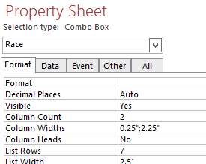

Set the first column width to 0 instead of 0.25.

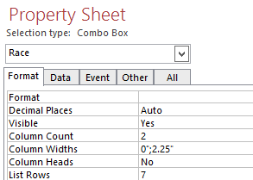

If you are thinking that it isn’t obvious why this change would make the control display text instead of numeric code—you’re right. (Short answer: the Race field in this table was set up as a lookup field with two columns, and you only want to see the second one.) For the moment, it’s enough just to make the change and make the control look right.
- Change back to Report view. Note any other design changes that would make the report better-looking and easier to use. For example, you would probably agree that the report would look better if it had:
  - A meaningful title like “Subject Counts by Race” instead of the cryptic “qryLastnameCountsByRace”
  - The total number of subjects displayed directly under the individual subject counts by race
  - A label (such as “Number of Subjects”) to explain the control you just modified.
- Switch back to Design View and make the changes described above, plus any other changes that you think would improve the report. Some tips:
  - As you saw in Assignment 4, Access likes to create a constraining “Layout” in its automatic forms and reports. To move the “total number of subjects” control freely, first remove the layout. Select the control in the Report Footer (the one that you changed to show “=Sum([CountOfSubjectID])”). You will see a thick colored outline outline around the control, indicating that it has been selected. Then select Arrange | Remove Layout from the ribbon. You can now move the selected control with the arrow keys or (if you move the cursor until you get a four-headed arrow) by dragging and dropping. Line up the total control under the second column, where it belongs.
  - To add a label (such as “Number of Subjects”) to explain this control: choose the “Label” button (it looks like Aa) from the Design section of the Ribbon. Now you can click on the Report footer and get a new cursor (it looks like ⁺A), which you can click and drag to define the area for your label to appear on the report. Once the label is created you can type in a text description such as “Number of Subjects.” Of course you can move and/or resize this label to make it look right in your design.
- Go back and forth between “Design View” and “Form View” to see how your changes affect the finished report. Try to make the report look good enough to submit as part of a quarterly submission to the NIH or another funding agency. (It’s fine to leave the blank “Race” caption for the count of subjects who had no race entered; fixing that is slightly beyond the scope of today’s class.)

Note: Where did those blank “race” values come from? NIH’s standards on race and ethnicity (taken from the 1997 OMB revised minimum standards) include two ethnic categories (Hispanic or Latino, and Not Hispanic or Latino) and five racial categories (American Indian or Alaska Native, Asian, Black or African-American, Native Hawaiian or Other Pacific Islander, and White). However, the original registration system that provided the data for this study did not follow those standards. Instead, it categorized “Hispanic/Latino” as a race. So, once we updated the ethnicity field, we had nothing to enter for race, since it was not one of the 5 OMB categories. Instead of categorizing these subjects as “Other” or “Unknown,” we just left the “Race” field blank.

- Once your report is in final form, close it and save it as “rptLastnameCountsByRace.”
- To complete this assignment, you must save the report as an “RTF” (rich text format) file. RTF is a common standard used by many different vendors, not just Microsoft. It provides a compact file that displays text with a modest amount of formatting.
- To export to RTF: select your report “rptLastnameCountsByRace” (not your query “qryLastnameCountsByRace”) in the navigation pane.
- From the Ribbon’s “External Data” tab, choose Export | More | Word (NOT “Word Merge”).
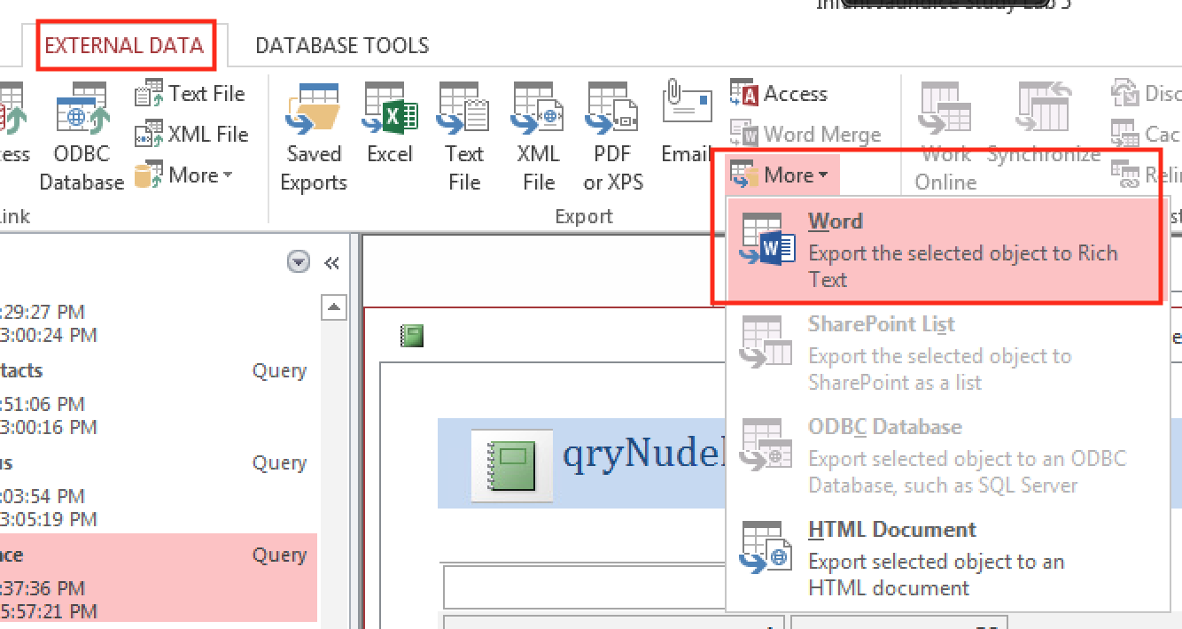
Name the file LastnameCountsByRace1.rtf. Be sure to note the folder in which you saved this file.
- If you are using RAE, be sure to save the file in your personal RAE folder, not the shared class folder. When you are ready to complete the CLE quiz, you will use RAE’s Chrome browser to upload this file to the appropriate section of the quiz.

Quiz: Upload LastnameCountsByRace1.rtf within the CLE quiz (Question D13). (In the File Picker, click Choose File and browse to the correct folder. If you saved in the RAE, you will pick “This PC” and then your personal RAE folder to find the RTF file.)

E. Import Subject Records from an Excel Spreadsheet

- Your database InfantJaundiceLab5Lastname.accdb came pre-loaded with a number of subject records. Now suppose you receive an Excel spreadsheet from the health system’s registration system containing the subject-specific information on 124 additional study subjects born in 2012 and 2013 to include in the study. You need to import this Excel file and append the 124 subject records to the “IJSSubject” table.
- The file holding data for these new subjects is called “Baby2012-13.xlsx.”
- If you are using Access on your own machine, you’ll need to download the file from the syllabus area of the course website. Note the folder name to which you saved the file.
- If you are using Access on the RAE, you will find this file is already saved in the shared class folder under “Assignment 5.”
- Import the file into the Access database. On the Ribbon’s “External Data” tab, in the “Import” section, choose “Excel”. Browse to “Baby2012-13.xlsx” (see the paragraph above for its folder location), select “Open,” and select the “Import the source data into a new table in the current database” option (which may already be selected). Click “OK” to continue.
- An “Import Spreadsheet Wizard” should open up. The spreadsheet you downloaded is structured nicely with columns and column headers that closely resemble a database table; because of this, the import wizard will have no problem detecting how the dataset is laid out. Keep clicking “Next” until you get to where it suggests letting Access add a primary key. Instead, select “Choose my own primary key” and specify “SubjectID” (this may already be selected). Then click “Next” and “Finish.” Access now imports the 124 new subject records from Baby2012-13.xlsx into a new table “Baby2012_13.” Close the Wizard without checking the “Save Import Steps” option.
- View the data you’ve imported. In the Navigation Pane, choose “Tables.” You should be able to find and open the table Baby2012-13. The table should contain records for 124 subjects born in 2012 and 2013. By sorting on the “hyperbili” column (click arrow on column header; sort largest to smallest), you can determine how many of the new subjects had neonatal hyperbilirubinemia (hyperbili = 1). (Note that a record count appears at the bottom of the window. If you click into a record, you can see where it is in the record count.)

Quiz: How many of the new 124 study subjects had neonatal hyperbilirubinemia (hyperbili = 1)?

Close the “Baby2012-13” table without saving changes to the table design.

F. Append (INSERT) New Records to the Table of Study Subjects
You have now brought the new study subjects into the database, but you imported them to a new table; they are not yet in the database’s Subject table. In this step, you will add the records you just imported from Excel into the main subjects table by creating an “Append Query” (aka SQL “INSERT” statement) which copies records from one table to another.
- Create a new query in “Design View.” (From the ribbon: Create | Queries | Query Design.) Add the “Baby2012-13” table that you just imported. Close the “Show Table” dialog.
- The default query type, shown in the ribbon, is a “Select” query, which reads data from existing table(s). Here, you want an “Append” query (which adds records to an existing database table) instead. On the Ribbon’s “Design” tab, in the “Query Type” section, choose “Append.” For “Table name” choose “IJSSubject,” which is the target for the new records. Click “OK” to continue.

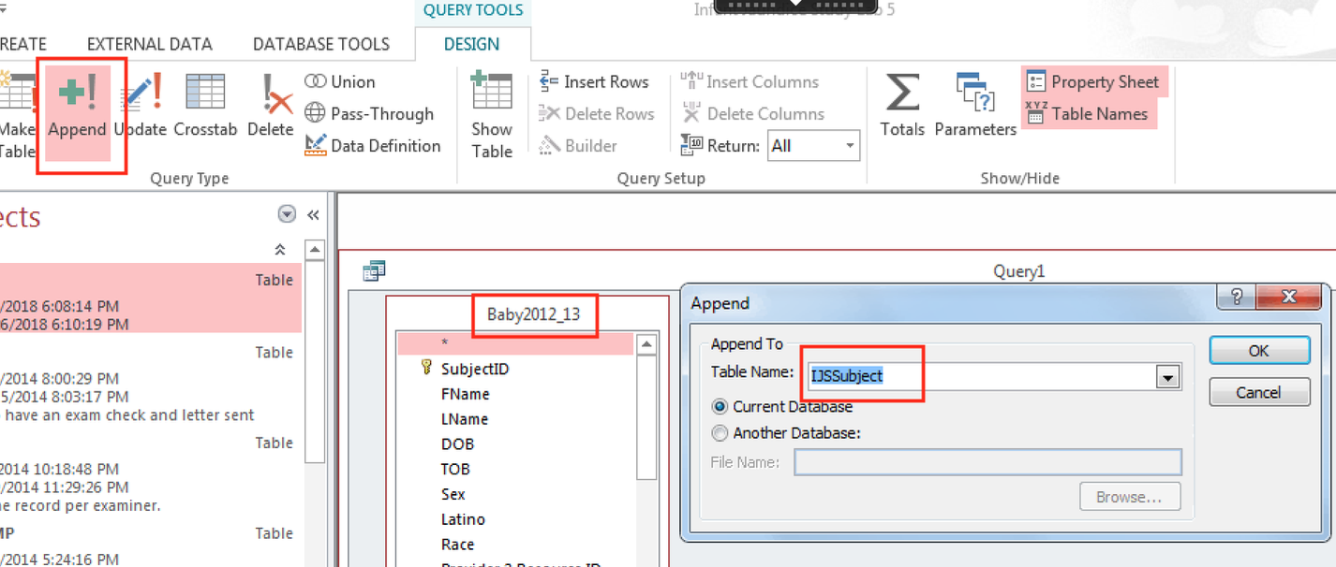

- Move the “*” from the table Baby2012_13 into the Field row of the Access Query Design grid, either by double-clicking or dragging and dropping. This means that you want to append all the fields from the “Baby2012-13” table to the “IJSSubject” table. (Fortunately, the field names from the spreadsheet match the field names in the database table; otherwise, you’d have to do a bit of work to rename the fields in this query.)
- Run the query by clicking on the exclamation mark “!” in the Design section of the ribbon, then confirming with OK when asked if you want to append. This should append 124 rows. (Note: If you get an error message saying that you can’t append the records due to key violations, then you already appended the new subject records. It is nice that Access won’t allow you to append them again, otherwise you might keep adding duplicate records to the dataset.)
- View the query in SQL View to see the actual SQL statement that Access created to cary out this query. Append queries always use the INSERT keyword.

Quiz: Based on the INSERT statement you just wrote, select the option that best fits the syntax of a SQL statement that imports records from one table to another, when the fields in both tables have the same names and definitions.

- Close the query. Save it under qappLastnameBaby2012-13 only so that it will be available if you need it later.

G. Re-Run the Report After Adding the New Records

- Re-run the report “rptLastnameCountsByRace” that you created in Part D of this assignment. (In the Navigation Pane, view Reports, and double-click on the report you want to run.)

Notice that the numbers have changed since the last time you ran the report. You did not have to change anything in the report design. It will summarize the data as updated. This is one of the beauties of database queries and reports; they are dynamic.

- Export this report to an RTF file as you did in Part D, but this time name the RTF file “LastnameCountsByRace2.rtf.” If you are using the RAE, save the new RTF file in your personal RAE folder.

Quiz: Upload “LastnameCountsByRace2.rtf,” made after importing the new records, into the CLE quiz (Question G2).

This completes Assignment 4. Be sure you have completed the online quiz. Don’t forget to “Submit all and finish” on page 2 of the quiz. If you are using the RAE version of Access, you’ll probably want to complete the quiz using the RAE version of Chrome.
Assignment 5 Worksheet

A. Filter by Form

5. How many subject records are there in the database? _____________

8. How many included (“Excluded”=False) subjects are there in the database?
_____________

9. How many included subjects were exposure-positive (hyperbili = yes)? __________

10. List the SubjectIDs and first name(s) of included exposure-positive subject(s) with race categorized as “Other”. For the online quiz, you just need the SubjectIDs, sorted in ascending order. To leave a field blank, enter “999999” (six nines).
_________________________________________________

_________________________________________________

_________________________________________________

B. Simple SELECT Query

8. Which of the following accurately describes Christopher Boone (SubjectID #37330)?
  - He was included in the study but was not exposure-positive (no neonatal hyperbilirubinemia).
  - He was included in the study and was exposure-positive (yes neonatal hyperbilirubinemia), but his Race wasn’t “Other”.
  - He was excluded.
  - None of the above

9. What SQL statement will select all fields for all subject with Race of “Other,” like the query you just created?
- SHOW ME ALL IJSSubject FIELDS
WHERE (((Race)=Other));

- SELECT ALL FIELDS
FROM IJSSubject
WHERE (((Race)=Other));

- SELECT IJSSubject.*
FROM IJSSubject
WHERE (((Race)=Other));

- SELECT IJSSubject.*
FROM IJSSubject
WHERE (((IJSSubject.Race)=8));

C. SELECT/GROUP BY Query

8. How many subjects had the Race field blank? ____________________

9. What SQL statement gives the counts of included subjects by race, like the query you just created?

- COUNT AND GROUP Race
FROM IJSSubject
WHERE (((Excluded)) is False)

- SELECT IJSSubject.Race, Count(IJSSubject.SubjectID) AS CountOfSubjectID
FROM IJSSubject
WHERE (((IJSSubject.Excluded)=False))
GROUP BY IJSSubject.Race;

- SELECT Race, Count(SubjectID) AS MyCount
FROM IJSSubject
WHERE Not Excluded
GROUP BY Race;

- FROM IJSSubject
SELECT IJSSubject.Race, Count(IJSSubject.SubjectID) AS CountOfSubjectID
GROUP BY IJSSubject.Race
WHERE (((IJSSubject.Excluded)=False));

Create a Report

13. Upload LastnameCountsByRace1.rtf within the CLE quiz.

Import New Records

5. How many of the new 124 study subjects had neonatal hyperbilirubinemia (hyperbili = 1)? __________________

F. Append (INSERT) New Records to the Table of Study Subjects
5. Based on the INSERT statement you just wrote, select the option that best fits the syntax of a SQL statement that imports records from one table to another, when the fields in both tables have the same names and definitions.

- INSERT INTO target table
SELECT fields
FROM source table;

- INSERT fields
FROM source table
INTO target table;

- SELECT target table
FROM source table
INSERT INTO fields;

- INSERT INTO source table
SELECT fields
FROM target table;

G. Re-Run the Report After Adding the New Records

2. Upload “LastnameCountsByRace2.rtf,” made after importing the new records, into the CLE quiz.

Extra Credit question:
The answer to the Extra Credit question should be easy to provide if you watched all of Lecture 5. See the online quiz.

We wouldn’t normally include the subject’s name here, but this is a de-identified database. Christopher Boone is the protagonist in “The Curious Incident of the Dog in Nighttime” by Mark Haddon.

