Epi 218 Assignment 6

Creating SQL Queries to Summarize Results and Export to Stata (or another statistical package)
(Expected Time: 55 minutes)

In this assignment, you will use SQL queries to summarize your study results and export query results to a statistical analysis package. These instructions assume that you’re using Stata, but it’s possible to complete this assignment with another statistical package, such as SAS or SPSS.

- Note: In this assignment, you must have both Access and Stata open at the same time, so you can transfer data between the two. The RAE allows you to have both systems open at once (and transfer data between the two). (Of course, if you have a PC that runs both Access and Stata, you won’t need the RAE at all.) It would be wise to ensure that you can open Access and Stata simultaneously before proceeding with this assignment.

Reminder: As you have undoubtedly learned to do, watch your DUO device closely when opening applications in the RAE.

Note: As with several previous assignments, you will complete a quiz on the class CLE with answers from your work. You may find it convenient to note your answers in the worksheet at the end of this document, then transfer them all to the CLE when you’re done.

Note: If you’re accessing the RAE, copy is Ctrl-C and paste is Ctrl-V, even if you’re using a Mac.

Objectives
- Create an Access “Select” query to summarize the study results for a continuous outcome.
- Export the results of the query to a statistical analysis package.
- Analyze the data.
- Repeat for a categorical outcome, using an Access “Crosstab” query.

In the Epi 218 lectures, we have stressed the importance of using a relational database (such as Microsoft Access) for storing, managing and querying your data. However, Access does not have sophisticated built-in statistical analysis functions. Therefore, when you need to analyze data in an Access database, you will often a) write a query to extract exactly the raw data you want, and then b) export that data to a statistical analysis package (like Stata) to run your analyses.

In this assignment you will carry out both steps, first with a continuous variable and then with a categorical variable. In doing so, you should find that some of your analysis exactly matches the analysis of the same raw data as given in a paper published in the New England Journal of Medicine.

Obtain, rename and open the completed database
- Download or copy the database for this assignment:
- If you are going to use Access on your own computer, download the file IJSDatabaseComplete.accdb from the course website (just as you did with a different database in Lab 5). This database has the complete raw data set that was used in the Infant Jaundice Study written up in the referenced paper.
- If you are using the RAE, you can find the database in the shared class RAE folder (Assignment 6 subfolder). Copy it to your personal RAE folder, so that you don’t accidentally modify the shared copy. Do this using the Windows File Explorer before opening Access. (Don’t forget to watch DUO.)

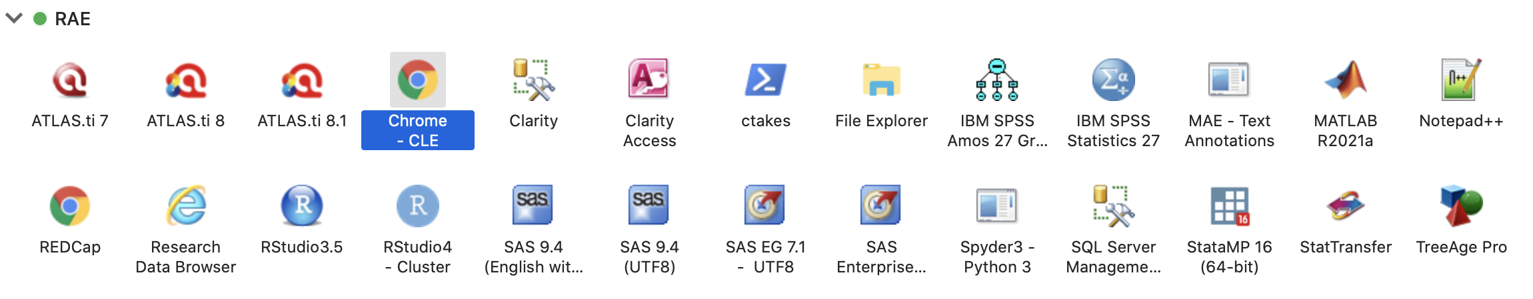

You shouldn’t be able to change the Access file in the shared folder, but you might be able to, so please don’t.
- Rename the downloaded to IJSDatabaseComplete_lastname, where lastname is your last name. (Again, if you’re using the RAE, be sure that this is the file in your personal RAE folder.)
- Now open the file you just renamed. You may be able to open the file just by clicking or double-clicking it in the File Explorere. If not, you must launch Access first. (If you are using the RAE, select “Access 2016” and don’t forget to watch DUO.)
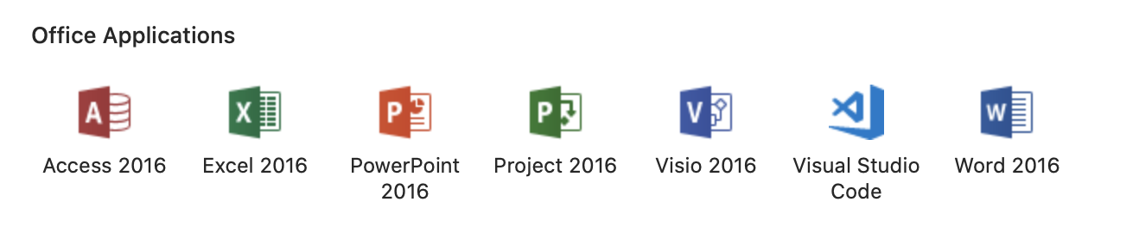

- Within Access, open the database InfantJaundiceDatabaseComplete_lastname.accdb (not the copy in the shared folder!). The “Main” form opens automatically.
- When you open the database, you may get a “Security Warning” just under the ribbon that says, “Certain content in the database has been disabled.” Choose Options | Enable this content or just click the “Enable content” button. If you are prompted, make this a “Trusted Document.”
- Close the “Main” form. In this assignment, you will be using queries rather than forms to view and filter data.

Create a query to summarize IQ by hyperbili

Your first task is to investigate the relation of one of the outcomes (IQ measured at age 5, a continuous variable) to the exposure (hyperbilirubinemia). This will be a simple summary (using only mean, standard deviation, minimum and maximum), so it can be done entirely within Access.
- Create a new query in Design View. On the Ribbon’s “Create” tab, choose “Query Design.”
- Add the “IJSSubject” and “WPPSI” tables to the upper panel of the Access Query Designer. (You need the subject table because it includes the exposure; you need the WPPSI table because it contains the IQ field.) Close the “Show Table” box.
- From the “IJSSubject” table, add the “Hyperbili” field to the query design grid (near the bottom of the table’s field list) either by double-clicking on it or by dragging and dropping it on the grid.
- From the “WPPSI” table, add the “IQFullEntered” field (near the bottom of the table’s field list) to the grid. Repeat this 4 more times so you have 5 copies of the “IQFullEntered” field in your query. You will soon see why.
- Make this a “Totals” (aka “SELECT/GROUP BY”) query using Show/Hide | ∑ | Totals (located on the Ribbon’s “Design” tab).
- In the “Totals” row of the query design grid, leave “Group By” in the “Hyperbili” column.
- In the 5 “IQFullEntered” columns, change “Group By” to “Count”, “Avg”, “StDev”, “Min”, and “Max”. Your query should now look something like this:

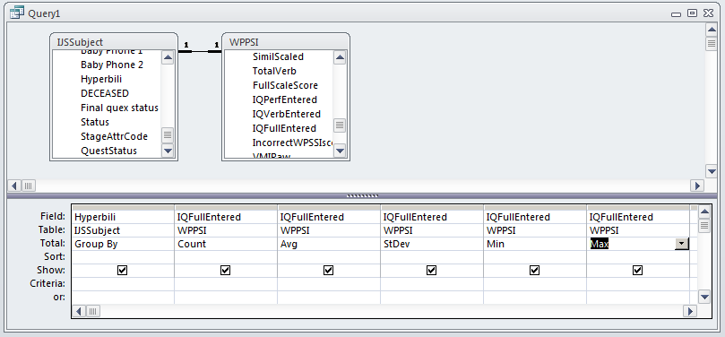

- Switch from query design view to datasheet view, using Home | View | Datasheet. You should see the same mean IQ results presented in Table 3 of the Newman NEJM paper, which is posted in the section for this assignment on the CLE.

Quiz: Enter these results in table form into the worksheet at the end of this document or directly into the online quiz.

- Save the query as “qryLastnameLab6Table3.”
- Use the query’s “SQL view” to view the SQL behind the query.

Quiz: Select the SQL statement that matches the query you just created. (You can paste the SQL into the worksheet at the end of this document for later use in the quiz.)

- Close the query.

Note: The Access query design grid is very useful for building up SQL statements visually. Unfortunately, some other RDBMS systems require you to know SQL and type it out manually. If you are forced to learn to write SQL, a good reference is:
Rockoff, L. (2016). The language of SQL. Indianapolis, IN, Addison-Wesley Professional.

A good online tutorial is available on LinkedIn Learning (free for UCSF students) at https://www.linkedin.com/learning/sql-for-non-programmers/filtering-on-multiple-conditions-in-sql?u=52912684 . The course is called SQL for Non-Programmers.

At UCSF, we have free access to Linkedin Learning, which has thousands of courses across all disciplines, from programming to design to leadership. To get free access, you have to connect your UCSF account to your LinkedIn account (instructions here).

Create a “Select” query to export to Stata for analysis
You will now do a similar summary within Stata. However, by using Stata’s t-test you will also get a p-value and confidence intervals for the statistics, which is something Access cannot give you without additional tools.
- Create a new query in Design view. You will want this query to return a listing of all subjects, with the ID, exposure status and IQ score for each.
- Add the “IJSSubject” and “WPPSI” tables to the upper panel of the Access Query Designer. Close the “Show Table” box.
- From the “IJSSubject” table, add the “SubjectID” and “Hyperbili” fields to the grid.
- From the “WPPSI” table, add the “IQFullEntered” field to the grid.
- This time you will NOT set up a “Totals” row, because you want to export individual records, not grouped totals. Save this query as “qryLastnameLab6C” in case you need it later.
- Switch from query design view to datasheet view. You should see as many records as there are subjects with measured IQ outcomes.
- With the query in datasheet view, highlight all the data by clicking the square at the top, left-most corner of the screen (next to the SubjectID column heading). When the entire datasheet is selected, copy the data (Home | Clipboard | Copy or Ctrl+C).
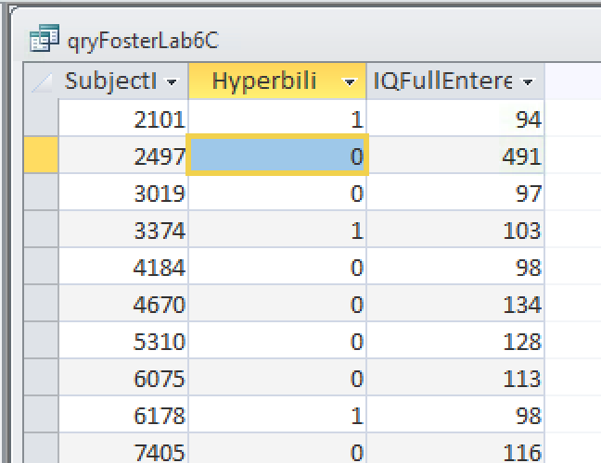

- Leave Access open but minimize it so you can start working with your statistical package. Now you need to open Stata. (If you’re using Stata within the RAE, use StataMP 16, and don’t forget to watch your DUO device.). If Stata prompts you to check for updates, say “Check in 7 days”.
- In Stata, open the Editor Window (Window | Data Editor or Ctrl+8).

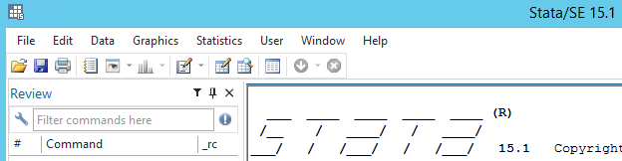

Paste the data into the data editor (“Ctrl+v” on a PC or Remote Desktop). If prompted by Stata, select the option to treat the first row as “Variable names.” Now close the Data Editor Window, and the Command Window should re-appear. You have successfully exported data into a statistical package.

Note on copying SQL query output and pasting it into a statistical program: This is one of the most valuable things you will learn in this course because it’s so quick and easy. However, in other situations you may need to export to csv first and then import, or else use an ODBC connection to the database.

Statistical Analysis (Continuous Outcome Measure)
- You can now perform your analysis using the “ttest” command. Using the menus: Statistics | Summaries, tables, & tests | Classical tests of hypotheses | t test (mean-comparison test). Click the option “Two-sample using groups”. “Variable name” = “iqfullentered”; “Group variable name = “hyperbili”; Press “OK.”

-- Or --

Using Stata command syntax:
ttest iqfullentered, by(hyperbili)
(Note: Stata—unlike Access—is case sensitive.)

- You now want to write a brief summary of study results which would be appropriate for the “Results” section of an abstract.

Quiz: Fill in the blanks in the quiz, including the most appropriate option (was significantly higher/was significantly lower/was not significantly different). (You can use the template in the worksheet for later entry to the quiz.)

The important question to answer is whether babies with neonatal hyperbilirubinemia, when evaluated at age 5 and compared with unexposed babies from the same birth cohort, had worse IQ scores, better IQ scores, or the same IQ scores. Note that the answer above includes group sizes, effect direction, effect size, variability of the outcome, statistical significance and confidence intervals.

Create a “Crosstab” query to summarize neuro exam impression by hyperbili
You are now going to carry out a similar process, this time to analyze a categorical outcome (the neurological exam).
- Return to the Access database that you minimized earlier.
- Close any open queries.
- Create a new query in Design View. You will design this query to give frequencies of neuro exam results, broken down by exposure.
- Add the “IJSSubject” and “NeuroExam” tables to the upper panel of the Access Query Designer. (Can you explain why these are the right tables for this query?)
- From the “IJSSubject” table, add the “SubjectID” and “Hyperbili” fields to the query design grid.
- From the “NeuroExam” table, add the “Overall5” and “Overall” fields to the grid. (These fields are about ¾ of the way down the table’s field listing.) Make sure “Overall5” is to the left of “Overall.” (“Overall5” stores the numerical code (1-4) for the overall impression of the neurologist. “Overall” stores the text description that corresponds to that code. Since the same code always has the same description, the field “Overall” is redundant and wasn’t necessary for this table; but it does make things more convenient for this assignment.)
- View the query in datasheet view. So far, the query has one row for each subject who received a Neuro Exam.
- View the query in design view agan. Make it a “Totals” (aka “SELECT/GROUP BY”) query using Design | Show/Hide | ∑ | Totals (as you did in part B).
- In the “Totals” row of the query design grid, change “Group By” to “Count” in the “SubjectID” column. Leave “Group By” in the “Hyperbili”, “Overall5”, and “Overall” columns. It should look like this:

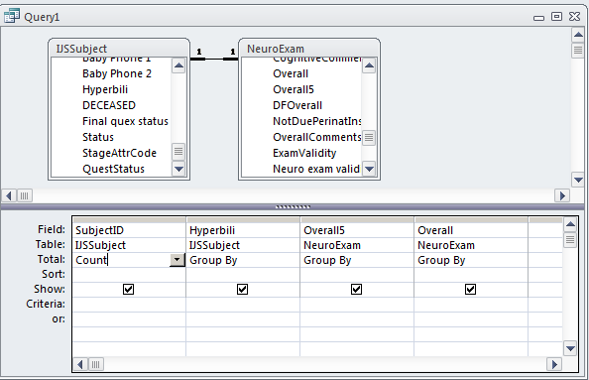

- View this query in Datasheet view to see how the data is presented so far. You can see the outcomes of neuro exams for both exposed and unexposed subjects, but the data would be clearer if presented in a more tabular form. You will use a “Crosstab” query for this purpose.
- Return to Design view. Make this a “Crosstab” query using Design | Query Type | Crosstab.
- In the “Crosstab” row of the query grid, enter “Value” in the SubjectID column; “Column Heading” in the Hyperbili column; and “Row Heading” for the Overall5 and Overall columns. Your query should now look like this:
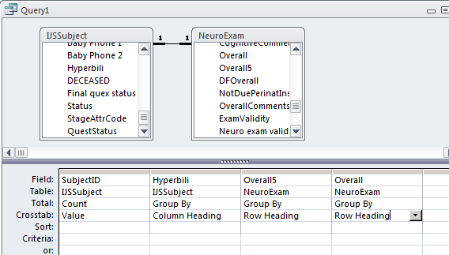

- Switch from query design view to datasheet view. You should see the same neuro exam results presented in Table 4 of the Newman NEJM paper.

Quiz: Enter the data from the cross-tab table to the online quiz. (You can use the worksheet for later entry to the quiz.)

- Save the query as “qryLastnameLab6Table4”.
- Optional: View the SQL behind the query. (We are not asking you to copy it for the quiz.) Note the “TRANSFORM” and “PIVOT” keywords. These will work in some versions of SQL, like Oracle and MSSQL Server, but not in R.
- Close the query.

Create a “Select” query to export to Stata for analysis
Another way of analyzing your data is to export data from Access to a statistical package like Stata. You will now repeat (and extend) the analysis from the last query by using this approach.
- As before:
- Create a new query in Design view.
- Add the “IJSSubject” and “NeuroExam” tables to the upper panel of the Access Query Designer. Close the “Show Table” box.
- From the “IJSSubject” table add the “SubjectID” and “Hyperbili” fields to the query.
- From the “NeuroExam” table, add the “Overall5” and “Overall” fields to the grid.
- You now want a new calculated field on the grid. To create it, copy and paste these characters (or type them manually) into the “field” cell at the top of the first empty column on the grid:
NotNormal: -([Overall5]<>1)
The operator “<>” (typed using the angle bracket keys “<” and “>”) means “not equal to.” The - sign is used to change the sign of the result. Therefore, the calculation you just entered means: “Return 1 if the exam is not normal, otherwise return 0.” (The sign change is needed because Access uses -1 to mean “true”; virtually every other system in the world, including Stata, uses 1 to mean “true.”)
- You will NOT set up a “Totals” row in this query, because you will be exporting individual records, not grouping for analysis. The query will look like this:

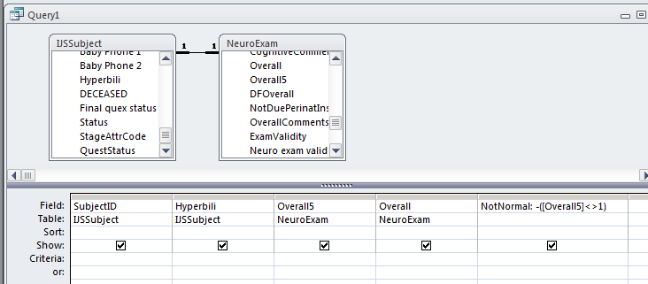

- Switch from query design view to datasheet view. You should see as many records as there are subjects with measured neuro exam outcomes. You should also see the NotNormal column displaying 0 for Normal exams and 1 for all others.
- Save this query as “qryNeuroExamResults”. (Make sure to save the query before trying to export it.)

Export using CSV
- Highlight the query that you just saved.
- External DataText File
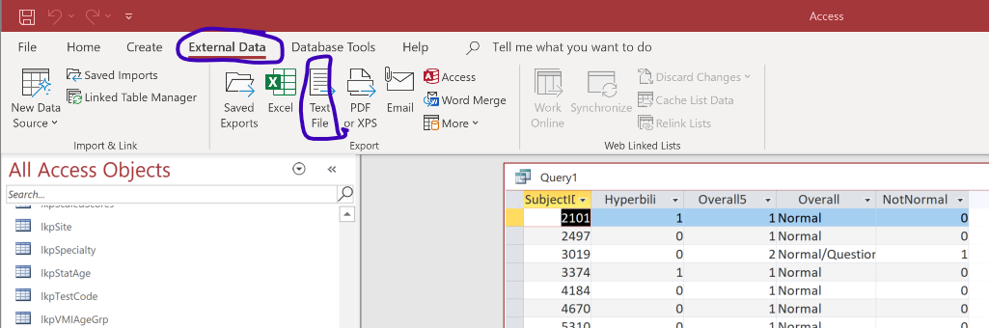

- Change the file extension from “.txt” to “.csv”. Remember where you are saving it! Uncheck “Export Data with Formatting and Layout”. Click “OK”

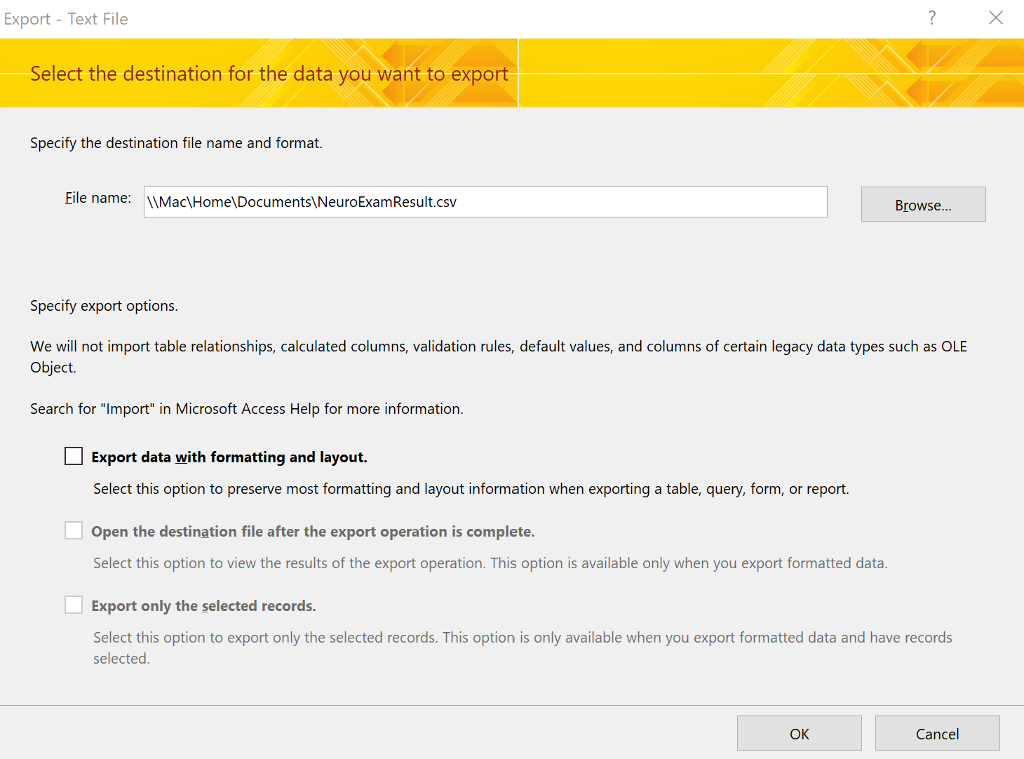

- Choose “Delimited”

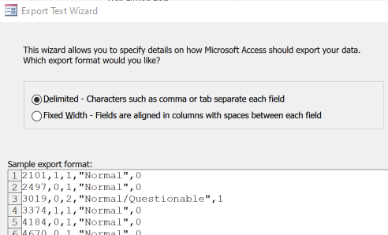
- delimiter = “Comma”. Include Field Names on First Row. Text Qualifier = “””
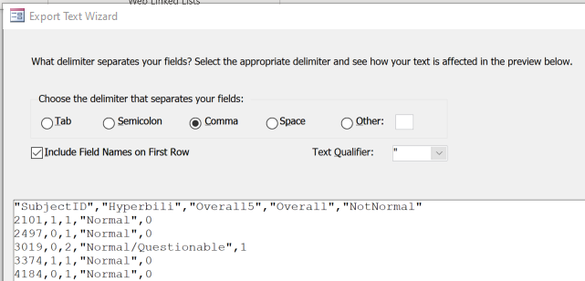
- Leave Access open, but minimize it so you can start working with your statistical package.
- Return to Stata. Clear your previous data from the Stata Data Editor window: type ‘clear’ into the command line and hit Enter.
- In Stata, FileImportText data (delimited)
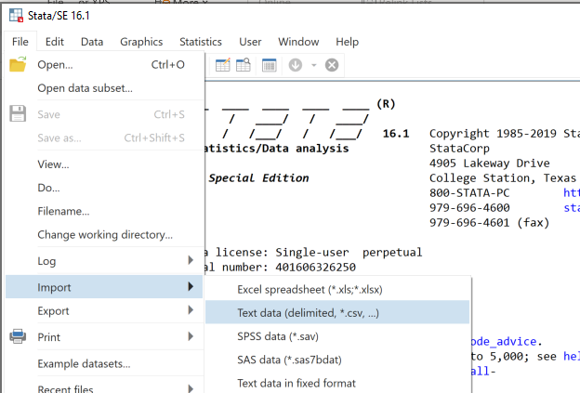
- Navigate to the csv file that you named in (8) above and Submit.

Exporting using quick Copy/Paste
Note: The quick copy/paste method (below) for moving data from Access to Stata is easier, but it can create problems. For example, when you use it for date fields, they come in as strings and not as dates.
- With the query in datasheet view, highlight all the data by clicking the square at the top, left-most corner of the screen (next to the SubjectID column heading). Copy the data (Home | Clipboard | Copy or Ctrl+c ).
- Leave Access open, but minimize it so you can start working with your statistical package.
- Return to Stata. Clear your previous data from the Stata Data Editor window: type ‘clear’ into the command line and hit Enter.
- Open the Data Editor window and paste in the new data. Remember to “treat the first row as variable names.”
- Now close the Stata Editor Window, and the Command Window should re-appear.

Statistical Analysis (Categorical Outcome Measure)
You can now perform your analysis using the “tab” command. You can do this using menus or using the command line.

- Using the menus:
- Statistics | Summaries, tables, & tests | Frequency tables | Two-way table with measures of association. Set “Row variable” = “overall5”; “Column variable” = “hyperbili”. Check the box “Pearson’s chi-squared” under “Test statistics”.
- Check the box "Within-column relative frequencies" under "Cell contents."
- Press “OK.”

- Using Stata command syntax:

tab overall5 hyperbili, chi2 column
(Note: Stata—unlike Access—is case sensitive.)

Quiz: Copy these results to the online quiz. (You can use the worksheet for later entry to the quiz.)

- Specifically test the hypothesis that the proportion with “NotNormal” differs between the exposed and unexposed groups. Again, you can do this using menus or using the command line.
- Using the menus:
- Statistics | Epidemiology and related | Tables for rpidemiologists | Cohort Study Risk-Ratio etc
- Set “Case variable” = “notnormal”; “Exposed Variable” = “hyperbili”. Then click OK.
- Using Stata command syntax:
cs notnormal hyperbili
- On the quiz, you will report the risk ratio of “NotNormal.” This is the risk ratio in the exposed group (with “hyperbili” = 1) versus the unexposed group. You will also provide the 95% confidence interval.

Quiz: Use these results to complete the table in the online quiz. (You can use the worksheet for later entry to the quiz.)

Again, the important question to answer is whether babies with neonatal hyperbilirubinemia, when evaluated at age 5 and compared with unexposed babies from the same birth cohort, had worse neurologic outcomes, better neurologic outcomes, or the same neurologic outcomes.

This completes Lab 6. You now know how to create Access queries and export to Stata. Make sure you have completed the Lab 6 Quiz on the CLE Syllabus site.
EPI 218 Lab 6 Worksheet

This worksheet is to help you keep track of your answers. Don’t forget to complete the online quiz.

B8. Create a query to summarize IQ by hyperbili.
Results of qryLastnameLab6Table3 query (enter numbers to one decimal place, e.g. 14.3, not 14.27 or 14):

Hyperbili | Count | Avg | StDev | Min | Max
0
1

B11. What is the SQL you created that gives these results?

D2. Statistical Analysis (Continuous Outcome Measure)
(Enter numbers to one decimal place, e.g. 14.3, not 14.27 or 14)

WPPSI IQ scores were obtained on ________ (N) subjects at age 5 years, ____ exposed and _____ unexposed. The mean (+SD) IQ score in the exposed group, ____ (mean)+/- ____ (SD) was statistically significantly higher/was statistically significantly lower/was not statistically significantly different from the mean in the unexposed group, ____ (mean) + ____ (SD) — difference _____ (95% CI ____ – _____).
p-value = __________ (to three decimal places)

E13. Create a query to summarize neuro exam impression by hyperbili
Results of “qryLastnameLab6Table4” query:
Overall5 | Overall | 0 | 1
1
2
3
4

G2. Tab with Chi Squared
Fill out this table or paste from Stata. For the quiz you will only enter percentages, and only to one decimal place (e.g. 14.3, not 14.27 or 14):

Neurological Outcome | No Neonatal Hyperbilirubenima  n (%) | Yes Neonatal Hyperbilirubenima  n (%)
1 Normal
2 Normal or questionable
3 Abnormal with minimal disability
4 Abnormal with moderate disability

p-value = __________ (to three decimal places)

G6. Risk Ratio of Not Normal
Report the risk ratio of “NotNormal” in the exposed group (with “hyperbili” = 1) versus the unexposed group and provide the 95% confidence interval.) Enter numbers to two decimal places.

Risk Ratio for NotNormal: _______ (95% CI _____ - ________)

