Example Final Project Part B FLiPCUP

REDCap Project: DEID -- FLIPCUP FOR DEMO

Description of Study

The FrontLine Providers Covid Underlying Prevalence (FLiPCUP) Study is a cross-sectional and cohort study to determine the sero-prevalence of antibodies to SARS-Cov-2 in UCSF emergency department physicians, nurses, advanced practice providers (APPs), and emergency medicine technicians (EMTs). Study participants will have 3 study visits at intervals of 3 months, in which they will answer questions about exposure and be tested for COVID-19 antibodies. The study visits occur in the ED ACU-2 tent outside the Parnassus ED. The test requires a venous blood specimen. Venipuncture is performed by clinician members of the study team.

All full-time attending physicians, residents, nurses, and APPs who work at the Parnassus or Mission Bay EDs were sent an email inviting them to participate. The invitation email contained a link to a screening survey and eConsent form. If the provider consented, s/he received a baseline demographic/contact info survey with a link to an online schedule with a list of open appointments for testing. (We did not use REDCap’s built-in scheduling module.) Approximately 8 weeks after the initial test, participants are sent a link that allows them to sign up for the first follow-up test. This is repeated 8 weeks after the first follow-up for the second follow-up.

The actual number of invited ED providers was 312, but in the de-identified REDCap project there are only 250 potential participants. We substituted the ED provider names with the names of book characters and changed the birth dates, phone numbers, emails, and MRNs. The sample REDCap project, DEID -- FLIPCUP FOR DEMO, contains no identifying information.

Data Collection System/Back-End Data Repository

The data collection system for this study is a REDCap project and the back-end repository database is an Access database that we update periodically using Josh Senyak’s REDWrap utility. The Access database has 4 dynamic tables. By “dynamic”, we mean that they are not static lookup tables that contain codes for the provider’s position (“attending”, “resident”, “nurse”, “other”), the site s/he works at (“Parnassus”, “Mission Bay”, “Both”), or response options. The 4 tables are: a Subject table with 43 subject-specific fields; an Exposure Survey table with 34 fields that contain information on exposure collected from each subject at baseline and the two follow-up visits; and a COVID Serology Result table with 9 fields collected for each time an antibody test is done on the study participant. (We expect most subjects to ultimately have 3 records in the Serology Result table.) The 4th dynamic table is the survey invitation log, which is imported from REDCap separately, not using from the REDWrap utility. There is also a _lookups table that translates all response codes into text values. (See Appendix 1 for the Access relationships diagram, field list, and _lookup table). There are 5 REDCap instruments, 3 of which are enabled as surveys:

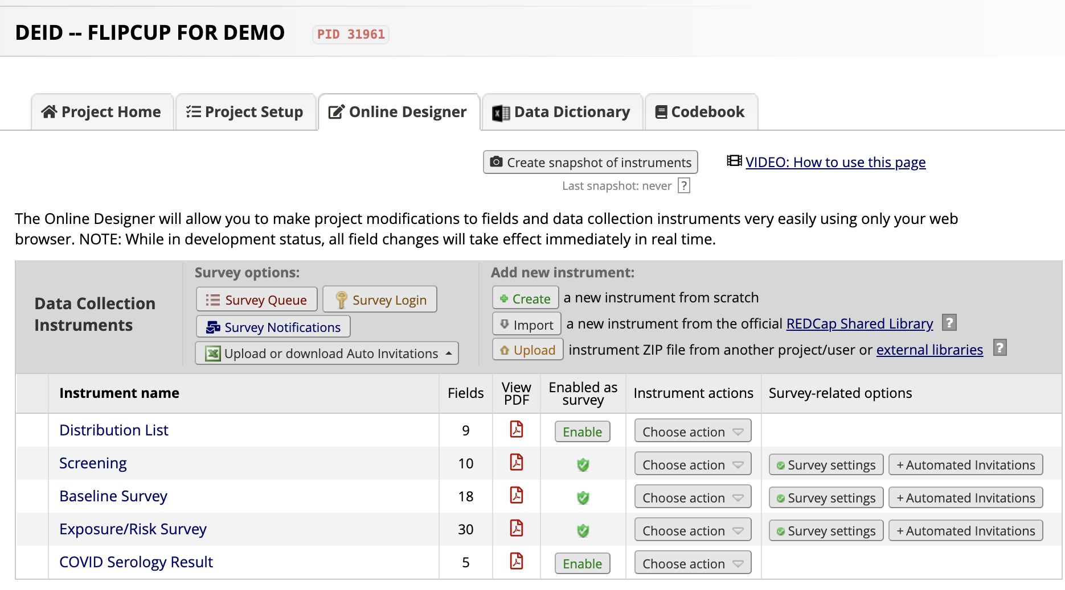
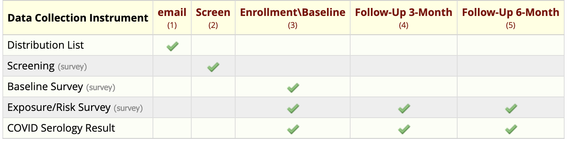

Distribution List: Not a survey. We imported names, positions, and emails from an external email list into this instrument. We were then able to send the Screening survey to all potential study participants. (Note: Make sure that your email field is formatted as an email in REDCap, otherwise the Survey Distribution Tool won’t work.)

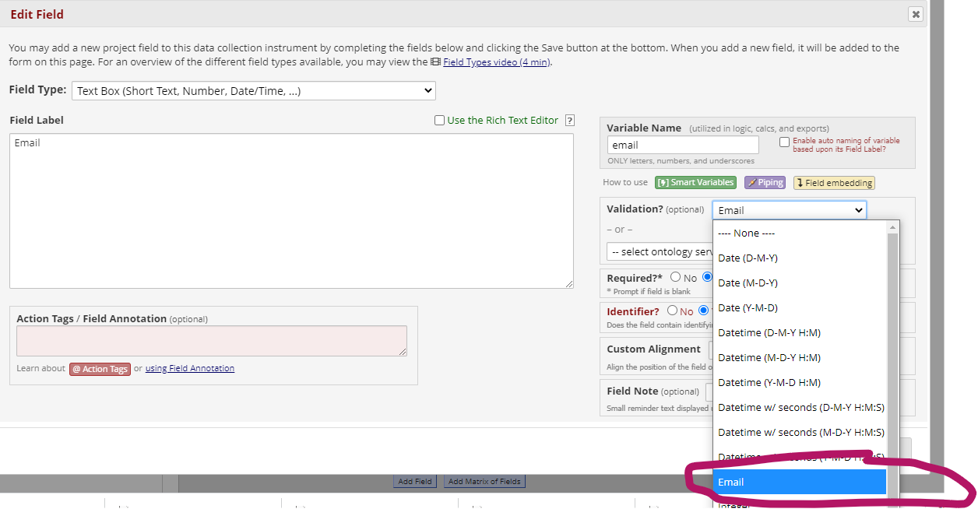

Screening Survey: The Screening survey asks if any of the exclusions apply. If the answer to all of them is no, it takes advantage of REDCap’s convenient eConsent feature, and allows the respondent to consent.

Baseline Survey: Once the participant has consented, we send the baseline survey that collects demographic and contact information; it also provides a link that allows her/him to sign up for a time to be tested.

Exposure/Risk Survey: This is a survey about exposures to COVID-19 that the participant fills out at baseline as well as at the two follow-up visits.

COVID Serology Result: Not a survey. The CRC for the study looks up results in Apex and enters them here.

(See Appendix 2 for the REDCap codebook.)

Data Collection and Entry

We imported the names, positions, and emails from an external list. The screening for exclusion and consent is done by the study participant online via the Screening Survey. The baseline demographics and contact information are also entered by the participant online via the Baseline Survey. We decided not to use REDCap’s scheduler but instead used an online scheduling system called Acuity (https://acuityscheduling.com/). Acuity produces csv exports of scheduled appointments that are easily imported into the study’s back-end Access database. Approximately 8 weeks after the initial test, participants are sent a link that allows them to sign up for the first follow-up test. This is repeated 8 weeks after the first follow-up for the second follow-up. We use Access queries to identify participants who are ready for the follow-up test. It is possible that this can be done with REDCap’s scheduler, but we didn’t figure it out.

The COVID exposure and risk information is provided in the Exposure/Risk Survey at the time of the study visit. When the participant presents for the antibody test, the CRC registers her/him in Apex and provides the online survey in one of 3 ways: 1) via a scannable QR code, 2) emailing a link, 3) pulling up the survey on a computer or iPad in the ACU-2 tent and allowing the participant to complete it.

The study research assistant looks up test results in Apex and enters them in the Result instrument.

Data Checking and Validation

One problem has been people making the appointment for their antibody test without filling out their demographic and contact information. We now use branching logic to display the appointment link only after the subject has provided the demographic and contact information.

Another problem has been people having their blood drawn and getting their antibody test result prior to filling out the exposure/risk factor survey. This raises the risk of incomplete data or recall bias. We now require all participants to complete the exposure/risk factor survey prior to getting their blood drawn. (No survey, no blood draw.)

We frequently export the data to Access to query for outliers and missing data. Some of this can also be done using the Data Quality Tools in REDCap. However, most monitoring, reporting, and analysis is/will be done with Access queries and some export to Stata.

Reporting

The “consented but not invited” report is displayed in Appendix 3. We get a survey invitation log from REDCap that tells us which participants have received the survey that includes a link to the appointment scheduling site. This report is based on a query that identifies all patients who have consented but have not been sent the survey. The query is “qryInvitation”.

Security and Confidentiality

The REDCap data collection system is secure and accessible only to members of the study team. The back-end Access database is maintained in secure folder in UCSF Box accessible only by members of the study team. When data is exported to Stata, patients are identified by a ParticipantID that has no meaning external to the database. No dates are exported.
Administration/Back Up
REDCap is backed up regularly by Academic Research Systems. We periodically back-up the Access database.
Budget/Cost:
The initial REDCap project was created by a clinical research coordinator (CRC) but help from the CTSI was required. The CTSI consulting hours have totaled 20. Typically, this would cost $125 per hour, so $2500. It is difficult to cost out a CRC, but here’s a rough estimate:

For salary:
https://hr.ucsf.edu/hr.php?function=tpp&subfunction=search
CRC (Job Code 9335) Step 1: $63,036 /12 months = $5,253/month

For benefits:
https://brm.ucsf.edu/cbr/resources/benefit-rate-by-job-code-lookup
CRC (Job Code 9335)
43.5% * $63,036 = $27,421/12 months = $2,285/month
Salary plus benefits = $90,457/12 months = $7,538/month

If the project funds the CRC at 25% for 1 year, that is $22,614.

I generally assume a CRC will cost a project $100k per year.

These calculations do not include indirect costs of 61.5% which are taken off the top by UCSF.

So, for this project, I estimate the data management costs to be $22,614 for the CRC, plus $2,500 for the CTSI consulting, which totals $25,114.

Clinical Research Coordinator (TC: 9335) | FY21
Annual Salary (1.0 FTE) | $ 63,036.00
CBR | 43.5%
Salary + Benefits (1.0 FTE) | $ 90,457
Monthly Salary + Benefits | $ 7,538.06
Total Salary + Benefits | $ 90,456.66
Funding Split | FY21
25% on FLiPCUP | $ 22,614
Other Identified Funding Source - TBD (If needed) | $ 67,842
CTSI Consulting (20 hours at $125/hour) | $2,500
Total FLiPCUP data management | $ 25,114

Appendix 1 Access Repository Database
Relationships
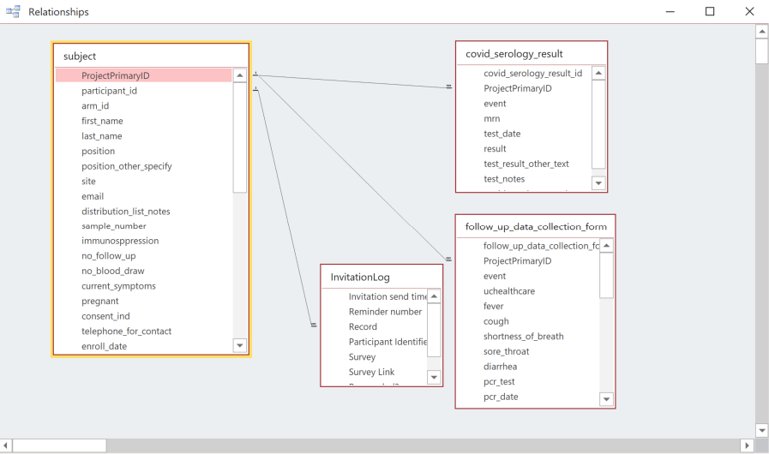
Note: the table called “follow_up_data_collection_form” actually contains exposure data collected at baseline and both follow-up visits. The invitation log is imported separately, not using the REDWrap utility.

Field List
MAK Note: The requirement to submit a data dictionary is left over from a time when people were submitting data collection systems that were not in REDCap or Access. If you are doing a REDCap project or an Access database and you have made it available to your section leader, you do not need to include your REDCap project’s codebook or your Access table/field list, but know that we will check your project or database to make sure that you have properly formatted your fields (REDCap) or set your data types (Access). Dates should be formatted/typed as dates. In REDCap, formatting your email field properly is important. In both platforms, real numbers (e.g. a baby’s weight in kg) should not be formatted/typed as an integer.

Subject Table
Columns
Name Type Size
ProjectPrimaryID Long Integer 4
participant_id Short Text 50
arm_id Long Integer 4
first_name Short Text 255
last_name Short Text 255
position Short Text 255
position_other_specify Short Text 255
site Short Text 255
email Short Text 255
distribution_list_notes Short Text 255
sample_number Long Integer 4
immunosppression Short Text 255
no_follow_up Short Text 255
no_blood_draw Short Text 255
current_symptoms Short Text 255
pregnant Short Text 255
consent_ind Long Integer 4
telephone_for_contact Short Text 255
enroll_date Date With Time 8
birth_date Date With Time 8
phone Short Text 255
phone2 Short Text 255
contact___1 Integer 2
contact___2 Integer 2
contact___3 Integer 2
gender___1 Integer 2
gender___2 Integer 2
gender___3 Integer 2
gender___4 Integer 2
hispanic___1 Integer 2
hispanic___2 Integer 2
hispanic___3 Integer 2
hispanic___4 Integer 2
race Short Text 255
multiracial Short Text 255
other_race Short Text 255
appointment_ind Long Integer 4
appointment_date Short Text 255
appointment_time Short Text 255
no_appointment_reason Short Text 255
no_appointment_reason_other Short Text 255
distribution_list_complete Integer 2
screening_complete Integer 2
baseline_data_collection_form_complete Integer 2
Exposure/Risk Table
Columns
Name Type Size
follow_up_data_collection_form_id Long Integer 4
ProjectPrimaryID Long Integer 4
event Short Text 255
uchealthcare Long Integer 4
fever Short Text 255
cough Short Text 255
shortness_of_breath Short Text 255
sore_throat Short Text 255
diarrhea Short Text 255
pcr_test Long Integer 4
pcr_date Date With Time 8
pcr_result Short Text 255
tested_at_ucsf Long Integer 4
travel Long Integer 4
travel_outside_us Long Integer 4
high_prevalence_state Long Integer 4
diagnosed_covid_2 Long Integer 4
antibodies_2 Short Text 255
live_with_someone_with_covid Long Integer 4
date_contact_with_covid Date With Time 8
contact_covid_pt Short Text 255
no_ppe Long Integer 4
papr Long Integer 4
n95_respiratory_codes Long Integer 4
n95_high_risk_pt Long Integer 4
reuse_n95 Long Integer 4
decontaminated_ppe Long Integer 4
intubations Short Text 255
swabbed Short Text 255
receiving_nebs Long Integer 4
positive_pressure_ventilation Long Integer 4
receiving_cpr Long Integer 4
date_time_of_fu_form Date With Time 8
follow_up_data_collection_form_complete Integer 2

COVID Serology Result Table
Columns
Name Type Size
covid_serology_result_id Long Integer 4
ProjectPrimaryID Long Integer 4
event Short Text 255
mrn Short Text 255
test_date Date With Time 8
result Short Text 255
test_result_other_text Short Text 255
test_notes Short Text 255
covid_serology_result_complete Integer 2

Table: InvitationLog
Columns
Name Type Size
Invitation send time Short Text 255
Reminder number Short Text 255
Record Long Integer 4
Participant Identifier Short Text 255
Survey Short Text 255
Survey Link Short Text 255
Responded? Short Text 255
Errors (if any) Short Text 255

Lookup List

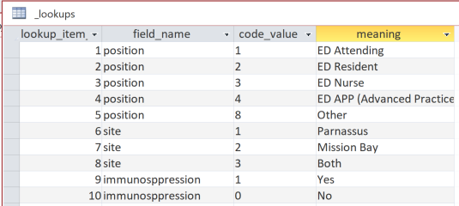

This table actually has 114 records, but this is enough to show how it works.

Some of the code values were chosen before a graduate of Epi 218 got involved. See below.

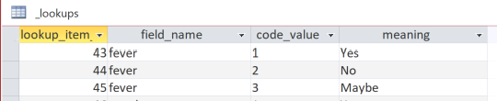

Always code Yes as 1 and No as 0 (not 2!) . We prefer 9 for Maybe, but that is not as important.

Appendix 2 DEID FlipCup Codebook

0 | Incomplete
1 | Unverified
2 | Complete

MAK Note: You should know how to make a pdf of your REDCap Project codebook, but you should not turn it in for your final project. The requirement to submit a data dictionary is left over from a time when people were submitting data collection systems that were not in REDCap or Access. If you are doing a REDCap project or an Access database and you have made it available to your section leader, you do not need to include your REDCap project’s codebook or your Access table/field list, but know that we will check your project or database to make sure that you have properly formatted your fields (REDCap) or set your data types (Access). Dates should be formatted/typed as dates. In REDCap, formatting your email field properly is important. In both platforms, real numbers (e.g. a baby’s weight in kg) should not be formatted/typed as an integer.

DEID -- FLIPCUP FOR DEMO
− Codebook
− Data Dictionary Codebook 09/02/2020 5:26pm
⬥ Collapse all instruments

 | # | Variable / Field Name | Field Label  Field Note | Field Attributes (Field Type, Validation, Choices, Calculations, etc.)
Instrument: Distribution List (distribution_list)  Collapse
 | 1 | participant_id | Participant ID | text
 | 2 | first_name | First Name | text, Required, Identifier
 | 3 | last_name | Last Name | text, Required, Identifier
 | 4 | position | Position | radio
 | 5 | position_other_specify  Show the field ONLY if: [position] = '8' | Position Other Specify | text
 | 6 | site | Which site do you work at? | radio, Required
 | 7 | email | Email | text (email), Required, Identifier
 | 8 | distribution_list_notes | Distribution List Notes | text
 | 9 | sample_number | Sample Number | text (integer)
 | 10 | distribution_list_complete | Section Header: Form Status  Complete? | dropdown
Instrument: Screening (screening)  Enabled as survey  Collapse
 | 11 | contact_info | Contact Information[email_arm_1][first_name] [email_arm_1][last_name][email_arm_1][position] [email_arm_1][site][email_arm_1][email] | descriptive
 | 12 | immunosppression | Section Header: FLiPCUP- Screen and Consent  Do you have any medical conditions that cause immunosuppression or do you take any medications that suppress your immune system? (known or suspected): | radio (Matrix), Required  1 Yes  0 No

Appendix 3 – Report: Consented but not yet sent invitated to be tested

Consented but Not Invited
participant_id last_name first_name email telephone_for_contact
12 Bond James James.Bond@fictional.org (555) 555-5555
33 Bennet Jane Jane.Bennet@fictional.org (555) 555-5555
76 Petowker Henrietta Henrietta.Petowker@fictio (555) 555-5555
117 Finching Laura Laura.Finching@fictional.org (555) 555-5555
128 Black Sirius Sirius.Black@fictional.org (555) 555-5555

This report shows subjects who have consented but have not been invited to make an appointment for testing.

