EPI 218 Database Management
Example Assignment 1B
CT Syndesmosis Database

The Study
The purpose of this study is to assess the reliability and validity of six different methods to measure rotational malreduction of the syndesmosis on axial CT scans. The hypothesis of this study is that the measurement of a novel CT-scan analyzing method, the tibiofibular angle is more sensitive to subtle rotational malreductions of the fibula within the insicura and has a higher inter-observer reliability than other CT-scan analyzing methods. The axial CT-images used in this study were obtained from a biomechanical research on cadaveric specimens. The CT Syndesmosis study is a reliability study with 3 raters testing 6 different measurements. Outcomes of the measured indices are in angles (degrees) and distances (mm) and measurements on images with malrotated syndesmotic injuries will be compared to measurements on non-malrotated (neutral) images (surrogate for non-injured site). The sample size 52 images, with neutral position images and images with various degrees of malrotation (10, 20, 30 internal and 10, 20, 30 external rotation)

Study Database

The CT Syndesmosis Study uses a simple desktop Access 2010 database with 3 dynamic tables (Specimen, Image and Measure) and 3 static “Lookup” tables. The CT images are included in an OLE object field. The program to measure the indices (Image J) is launched from the data entry screen. A diagram of the relationships and the table descriptions are attached in Appendix I. The database also includes a StartForm to select the observer, a DataEntryForm for data entry and display, and a progress report.

Data Collection and Entry
The axial CT images will be de-identified and presented to 3 independent representative raters. All raters will complete the evaluations in similar test settings. Image J (Image Processing and Analysis in Java) will be used to measure and calculate the six different methods. Images of each of the 6 distinct positions (10˚, 20˚ and 30˚ of internal rotation, and 10˚, 20˚ and 30˚ of external rotation) will be presented to the raters. The neutral (0˚) images will serve as a control. The raters will be given an instruction sheet with a detailed description of the different methods for measuring and calculating the rotational malreduction of the syndesmosis and an example of the different methods in a schematic drawing in one of the axial CT scans.

Data results obtained with the Image J measurements will be entered directly from the Image J measurement output screen into the DataEntryForm. For some of the Methods there are 2 indices that need to be measured and entered with decimals.

Error Checking and Validation
The DataEntryForm shows only Measurement 1 when the Method requires measurement of 1 index only and shows both Measurement 1 and 2 when two indices need to be measured. The results are graphed and compared to check for data entry errors and outliers. Significant outliers are identified and the raters are asked to repeat the measurements independently, that is without knowing the other raters’ results.

Reporting
A progress report is available from the StartForm and shows number of measurements by specimen and condition for each of the 3 raters.

Analysis
The database will be queried and datasets will be exported to Stata. The statistical tests will be performed in Stata.

Security/Confidentiality
The data handled in this study do not contain any patient identifiers. Different versions of files for the each observer will be handled carefully.

Back-up
The Access file is stored on a network drive that is backed up nightly. The research associate keeps a back up as well.

Budget
There is no formal departmental funding for this research project.
Appendix I
A presentation of the tables and their relationships in a diagram of the CT Syndesmosis database.

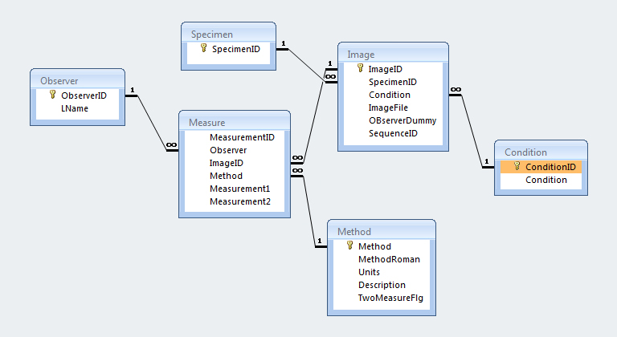

Observer table: 3 unique Observer ID’s
One-to-many relationship with Measure table
Static “Lookup” table

1 | Observer 1
2 | Observer 2
3 | Observer 3

Specimen table: 9 unique Specimen ID’s
One-to-may relationship with Image table
Static “Lookup” table

5 | Specimen 5
6 | Specimen 6
7 | Specimen 7
8 | Specimen 8
9 | Specimen 9
10 | Specimen 10
11 | Specimen 11
12 | Specimen 12
14 | Specimen 14

Condition table: 7 unique Condition ID’s
One-to-many relationship with Image table
Static “Lookup” table

-3 | 30 degrees IR
-2 | 20 degrees IR
-1 | 10 degrees IR
0 | Control
1 | 10 degrees ER
2 | 20 degrees ER
3 | 30 degrees ER

Methods table: 6 unique Methods
One-to-many relationship with Measure table
Static “Lookup” table
Each Method has a Roman numeral, Units, Description and Flag if the observer needs to do 2 measurements

1 | Method I
2 | Method II
3 | Method III
4 | Method IV
5 | Method V
6 | Method VI

Image table: 52 unique Image ID’s
One-to-many relationship with Measure table
Static “Lookup” table
One record for each Image
Each Image has a Specimen ID, Condition and Image File (.jpeg)

Measure table:
One record for each Measurement
Dynamic table
Each Measurement has an Observer ID, Image ID, Method and Measurement 1 and Measurement 2

