Assignment #3
Biostat 202

Supervised Machine Learning – Linear and Logistic Regression
(due 8/12/2021 at 11:55 PM)

Description: For assignment we will use the “framingham.csv” dataset available on the CLE. The data we will examine is a subset of data produced by the ongoing Framingham Heart Study which began in 1948 as a study to assess cardiovascular health in the city of Framingham, Massachusetts. The study is unique for its duration and substantial impact on our knowledge of heart disease and associated risk factors. For more information or to request access to other publicly available data sets, please see https://www.framinghamheartstudy.org/.

Skills:

- Explore marginal associations
- Fit linear regression models
- Fit logistic regression models
- Perform regularization of linear and logistic regression models
- Calculate evaluation metrics for continuous and categorical data

File: download from CLE

- framingham.csv

Steps: Please follow the steps below and answer questions marked in bold in a separate document. Include a screenshot of your final workflow.

Data description

Male 0 = female;
1 = male
Age age at exam time (continuous)
Education 1 = some high school;
2 = high school or GED;
3 = some college or vocational school;
4 = college
currentSmoker 0 = nonsmoker;
1 = smoker
cigsPerDay number of cigarettes smoked per day (estimated average)
BPMeds 0 = not on blood pressure medications;
1 = is on blood pressure medications
prevalentStroke 0 = has not experienced a stroke;
1 = has experienced a stroke
prevalentHyp 0 = has not experienced hypertension;
1 = has experienced hypertension
diabetes 0 = no;
1 = yes
totChol cholesterol (mg/dL)
sysBP systolic blood pressure (mmHg)
diaBP diastolic blood pressure (mmHg)
BMI body mass index calculated as weight (kg) / height (meter-squared)
heartrate beats/min (ventricular)
glucose blood glucose (mg/dL)
TenYearCHD 0 = not diagnosed with coronary heart disease in the last 10 years; 1 = diagnosed with coronary heart disease in the last 10 years

Data Import, Cleaning, and Marginal Associations:

- Import the framingham.csv file using the “File” widget. For the moment, keep all variables as features since we will fork our workflow to deal with either continuous or categorical outcomes. Using the variable definitions above, select the appropriate Types for the variables (e.g. numeric or categorical).

- Add a “Edit Domain” widget and label the numerical proxies for the categorical variables male, currentSmoker BPMeds, prevalentStroke, prevalentHyp, diabetes, and TenYearCHD. This will make our interpretation of the summary statistics and results easier. Click apply. See below for an example.

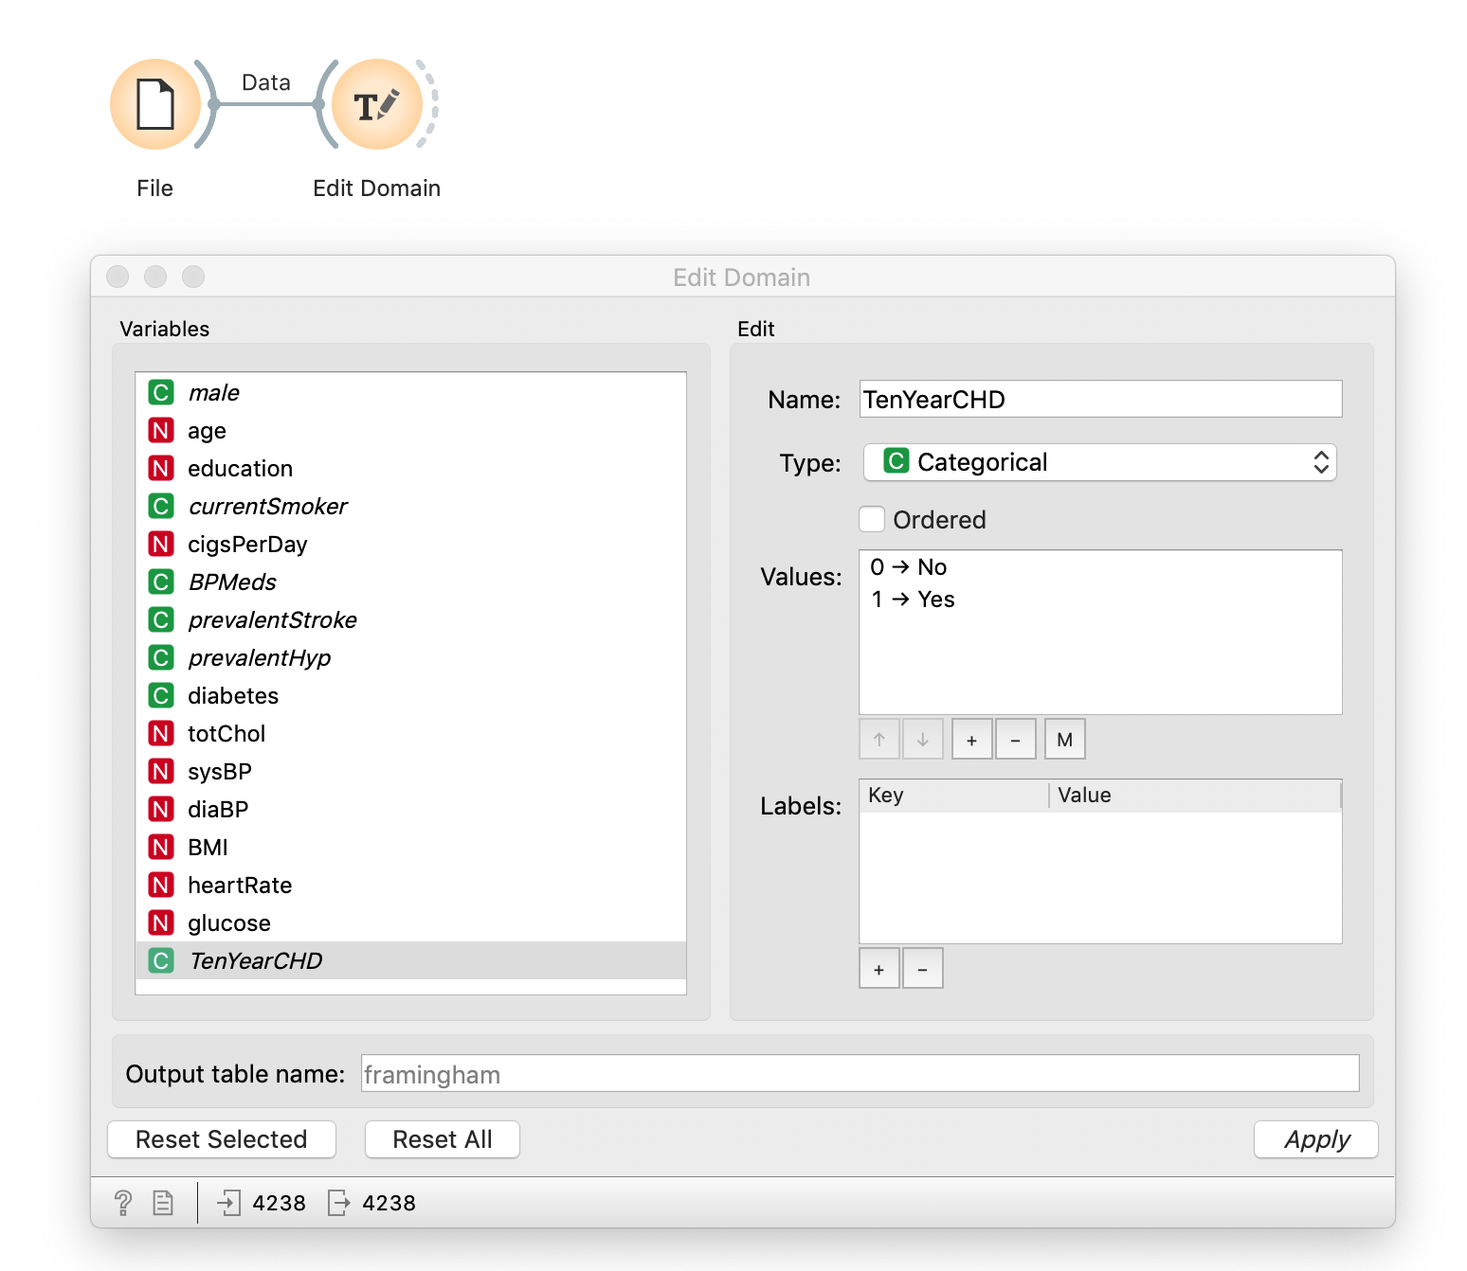

- Add a “Feature Statistics” widget. For the remainder of lab we will build linear and logistic regression models to predict body mass index (BMI) and the probability of experiencing coronary heart disease in the last 10 years (TenYearCHD). Q1: What is the mean (center) BMI and do the remaining summary measures for BMI look reasonable (e.g. min/max)? Are there any missing values across variables?

- Add “Distribution” widget. One at a time, try stratifying across various categorical variables via the “Split by” option and selecting “Stack columns” to see if you can find any risk factors for either target variables BMI or TenYearCHD. See the screenshot below for an example. Q2: What risk factors did you identify for either target variable?

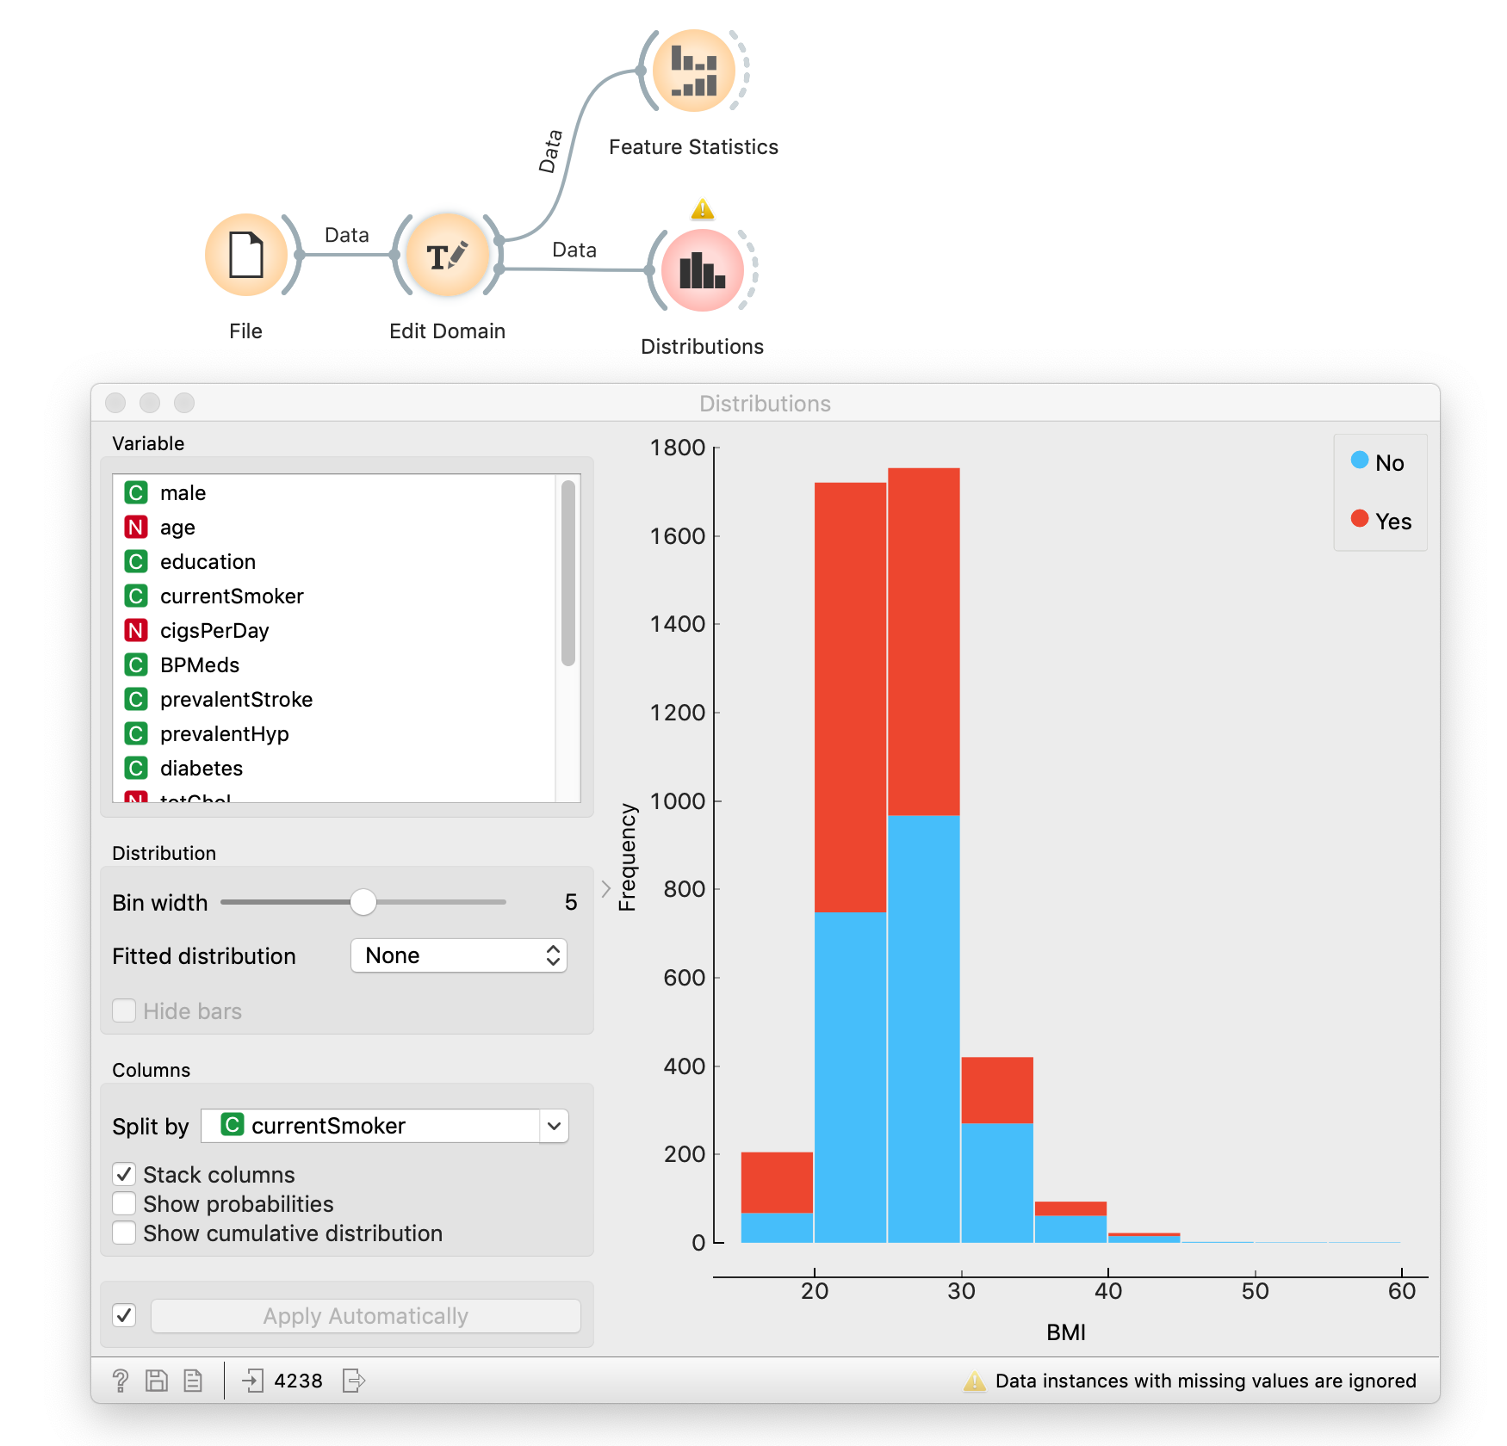

- Add a “Pivot Table” widget. For whatever reason, Orange cannot seem to calculate the proportion of observations within each class of a category so we will have to do this manually to explore the TenYearCHD variable. Select TenYearCHD for the Row variable and the other configurations as below, making sure to check off Count for Aggregations. Q3: Calculate the overall proportion of individuals who were diagnosed with coronary heart disease in the last 10 years. Stratify by one of your risk factors that you identified in step 4 via the Columns tab and calculate the proportion within each group. Q3: Do you see a difference in the proportion TenYearCHD between the two stratified subgroups? See the example below for an example.

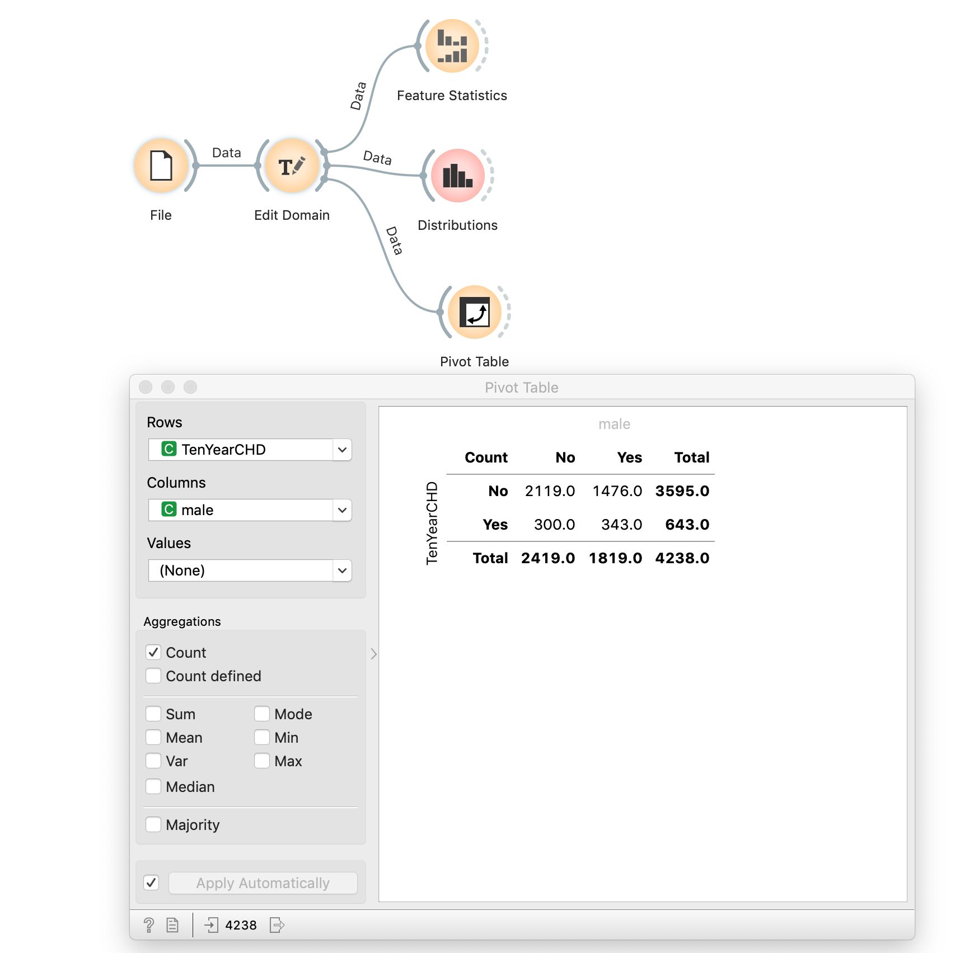

- Now we are done exploring the data. For our final data cleaning step, add an “Impute” widget and select Average/Most frequent for the Default Method. We will keep it simple today. Your workflow should look like the screenshot below.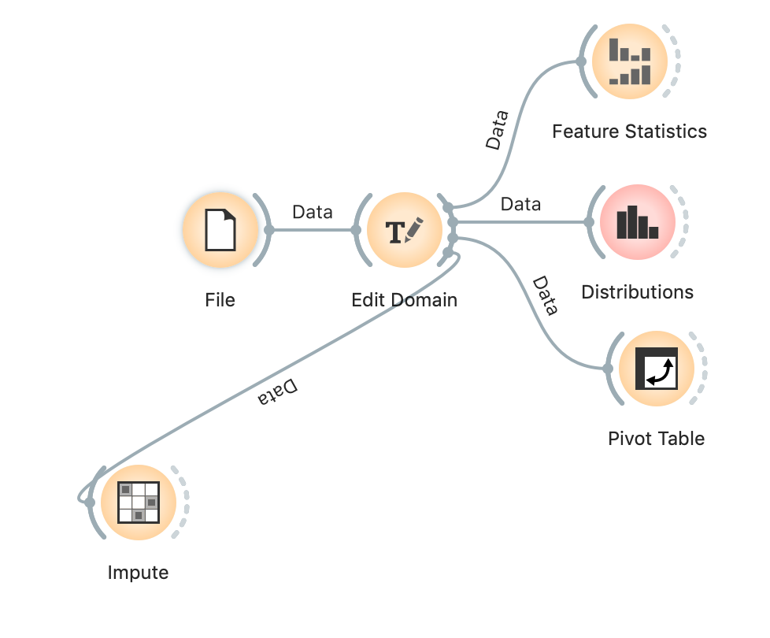
Linear Regression:
- We now begin our linear regression fork of the workflow. Add a “Select Columns” widget and identify BMI as the target. Then use the “Data Sampler” to divide the data into training and testing sets so we can perform validation. Next, add a “Test and Score” widget. Make sure the testing and training data channels are appropriately identified. Connect a “Linear Regression” widget to the “Test and Score” widget so we can perform train our first linear regression model. Your workflow should look like the screenshot below.

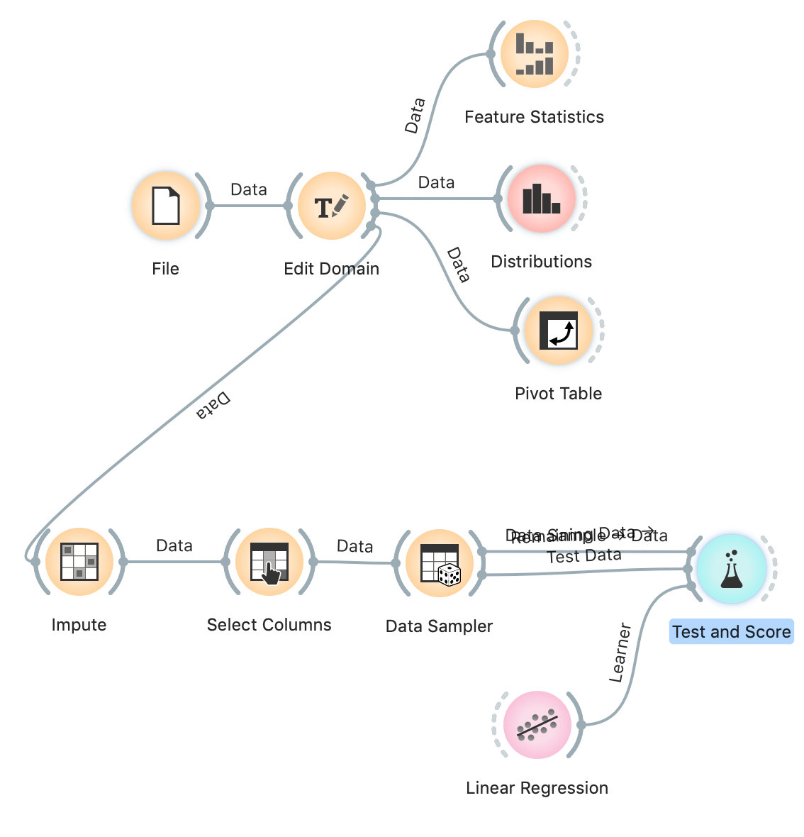

- Open the “Linear Regression” widget. You will see several options for linear regularization. In general, regularization refers to constraining our model to a simpler form. For both linear and logistic regression, this means shrinking the parameter (coefficients) towards zero. We will not go into specifics of the mathematical operation, but the general interpretation is offered below.

- Regularization for linear and logistic regression.
  - Alpha: the strength of regularization. Higher means more shrinkage.
  - No regularization: linear regression is free to estimate parameters unhindered. Produces the “least squares” estimate of your parameters.
  - Ridge regression (L2): shrinks parameters towards zero but does not set them to zero.
  - Lasso regularization (L1): shrinks some coefficients to zero. Operates as a form of variable selection by shrinking parameters for “unimportant variables” to zero.
  - Elastic net regularization: a combination of ridge and lasso regression. Generally, the preferred method. The elastic net mixing option refers to the proportion of L1 vs L2 regularization. Keep at 50:50.

- We will begin with no regularization. Label your widget within the controls appropriately. Q4: What is the testing and training MAE and R2? Begin to fill in the table below. How would you interpret these evaluation metrics (i.e. what do these measures mean and how would you compare their performance between test and training)? Do you find these errors acceptable?

- Add a second “Linear Regression” widget but this time select elastic net regularization with alpha = 1. Label this widget appropriated, e.g. “elastic net regression”. Q5: Compare the evaluation metrics for testing and training between regular regression and elastic net (fill in table below). Which linear regression model did better? Select the testing data option and exit the “Test and Score” widget. Regularization is a good way to prevent overfitting for complex models with not a lot of data. However, in this case we have a lot of data (several thousands of observations) and a simple model such as linear regression, the regularized method is not guaranteed to have better predictive performance in the test set.

 | Regular regression | Elastic net regression
MAE | Train/test | Train/test
R2 | Train/test | Train/test

- Add a scatter plot to the “Test and Score”. Select BMI and the regression prediction for the x-axis and y-axis respectively. You can visually compare the observed target with the predicted target to get a sense of how well the model is doing. This helps anchor the evaluation metrics that are numerical summaries. For an example, see the figure below.
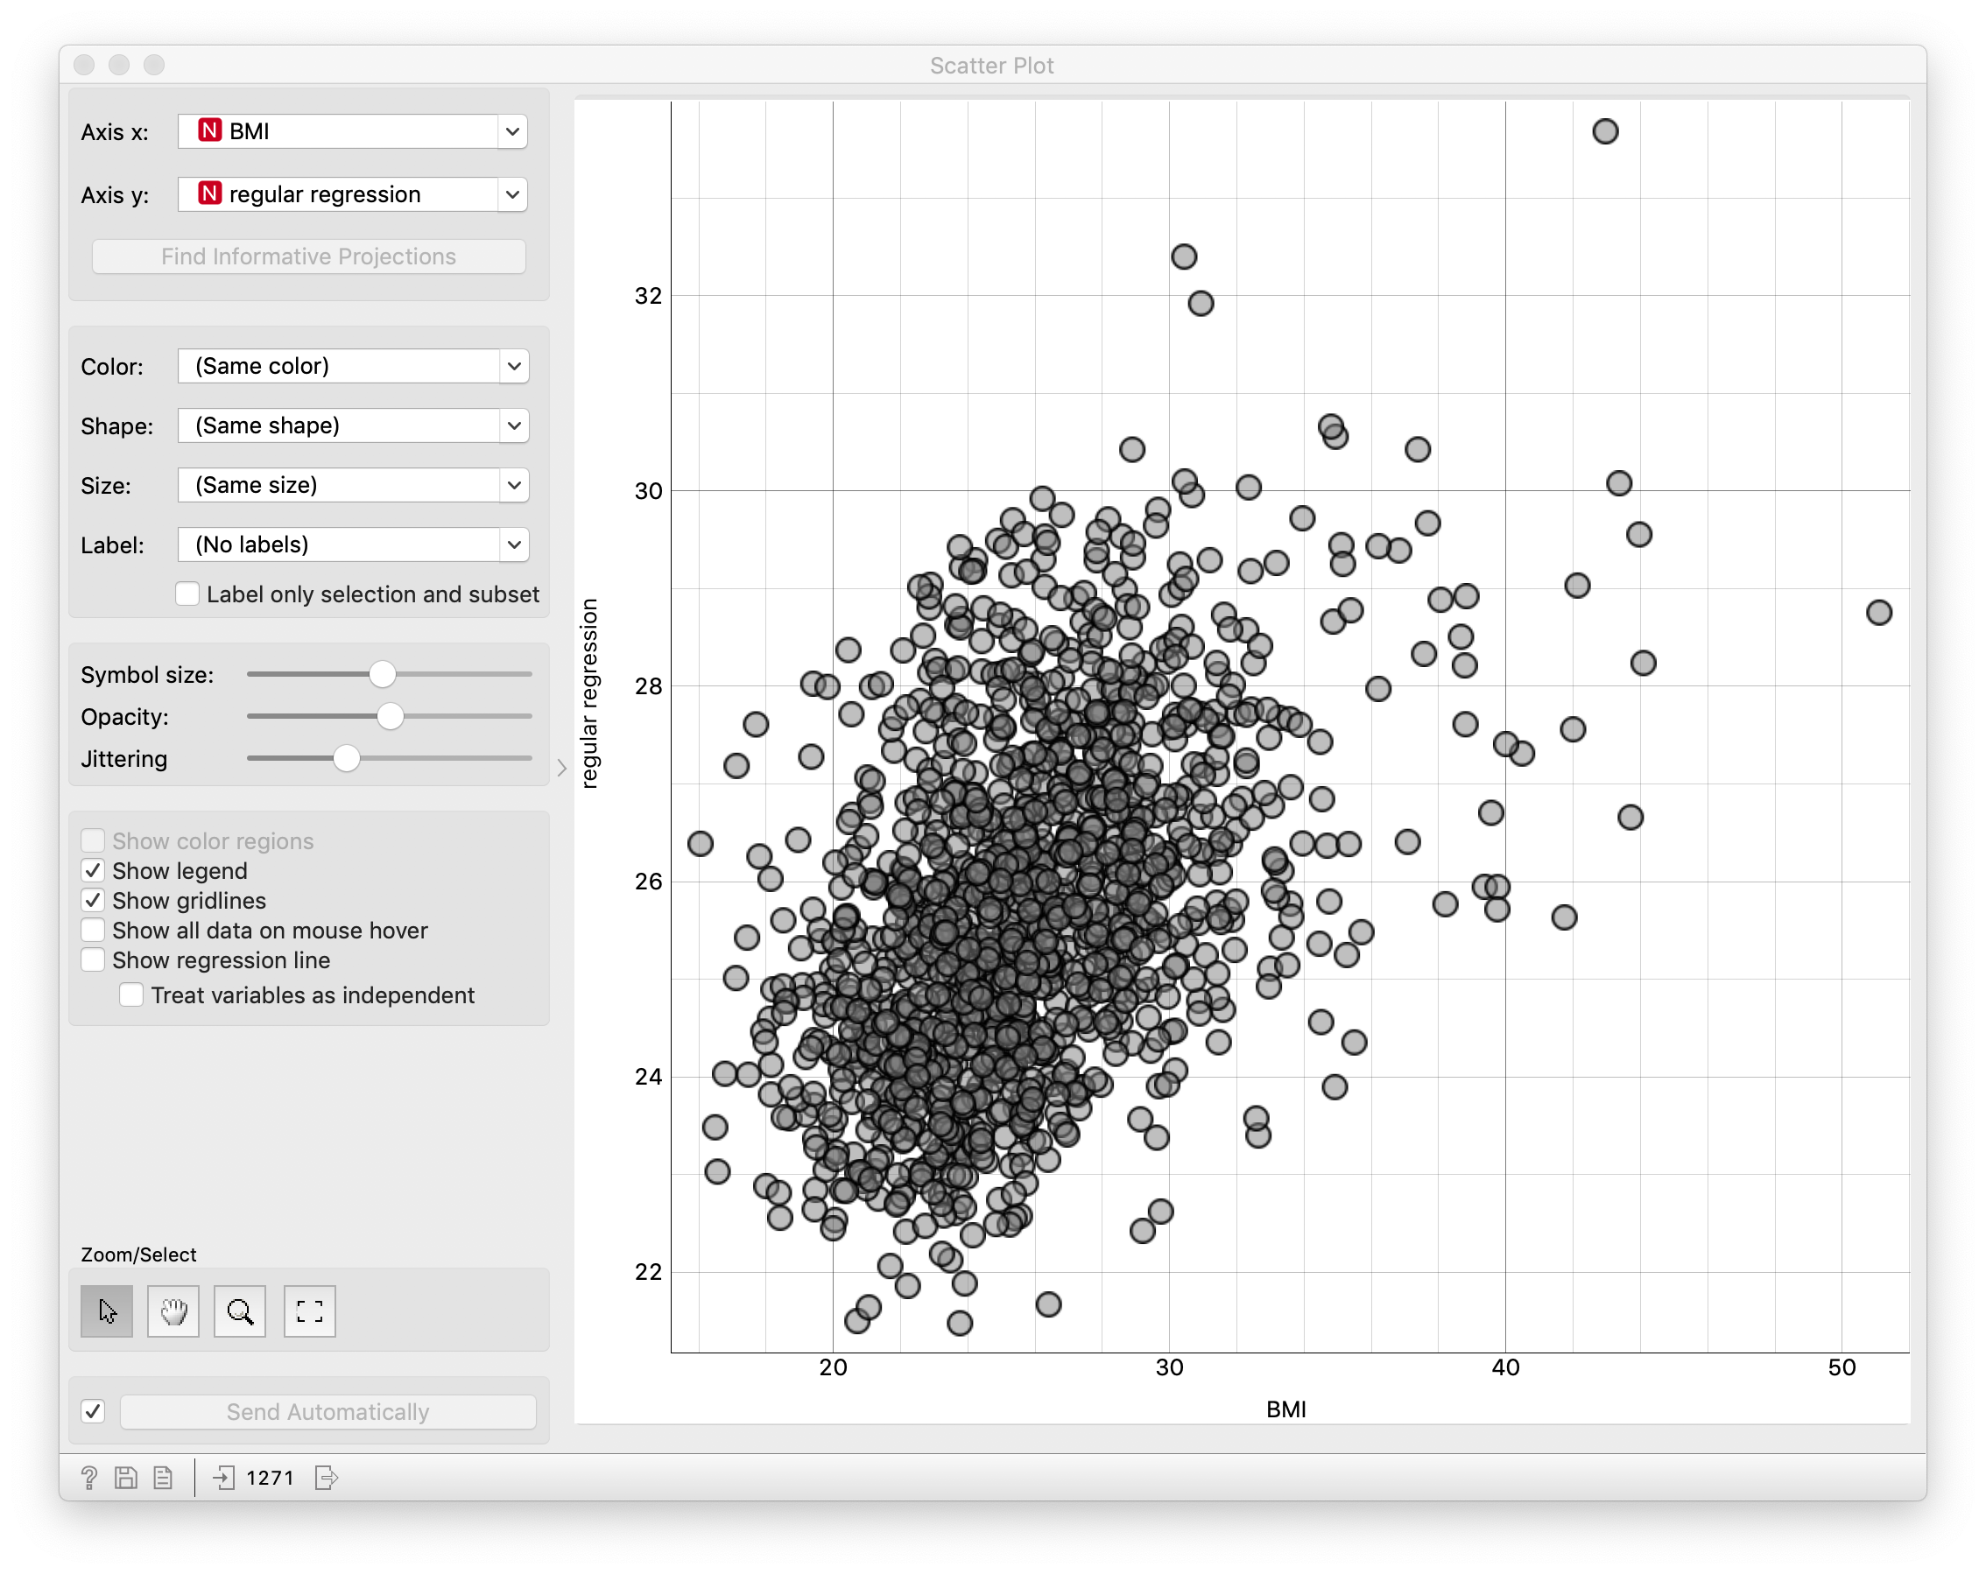

- Connect the “Data Sampler” to the left-hand side of the “Linear Regression” widget with elastic regularization. Then connect a “Data Table” to the right-hand side of the “Linear Regression” widget. Inspect the coefficients. Q6: Which variables have non-zero coefficients (parameters)? Describe the direction of the association for each, that is are the features negatively or positively associate (negative or positive parameter values) with our outcome of BMI. Do any results surprise you?

Your workflow should look like the figure below:
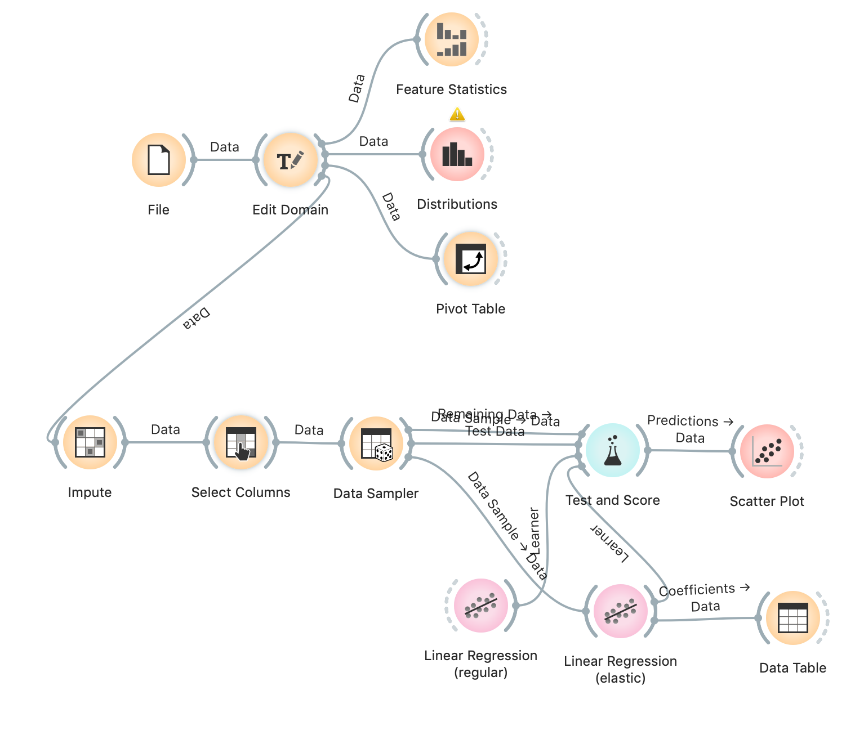

Logistic Regression:
- Repeat steps 7-11 but this side select TenYearCHD as your target and “Logistic Regression” widgets.

- Logistic regression in Orange is finicky. It will only let you perform Lasso regularization or Ridge regularization but no regular logistic regression or elastic net logistic regression. To emulate a regular logistic regression, set strength C to the largest value (C is big i.e. very little regularization). For your regularized model, select Lasso. When you reach the “Test and Score” widget, select Yes as the target class (this identifies Yes as the positive class in our evaluations. Remember this bean counting is important for interpretation!) Q7: Compare the evaluation metrics listed below for testing and training between regular logistic regression and Lasso logistic regression (fill in table below). Which did better? Interpret each measure once in a sentence. What is the “grade” for the AUC? Overall, do you find these errors acceptable?
 | Regular regression | Lasso regression
AUC | Train/test | Train/test
CA | Train/test | Train/test
Sensitivity (Recall) | Train/test | Train/test
Precision | Train/test | Train/test

- Add a “Confusion Matrix” widget to the “Test and Score” widget. Q8: Where do the logistic regression models appear to be making mistakes in predictions? What evaluation metric captures this well?

- Lastly, repeat the process described above in Step 13 to identify the coefficients (parameters) for the logistic regression (lasso). Q10: Pick two or three coefficients (parameters) and explain their association with the probability of TenYearCHD = Yes. Do these results make sense?

Your final workflow should look as below:

