Assignment #4
Biostat 202

Supervised Machine Learning – “Kaggle” Style Competition
(due 8/19/2021 at 11:55 PM)

Description: For this assignment you will compete in a “Kaggle” style competition. These are competitions in data science where teams try to maximize some evaluation metric in training/validation data and submit their top performing model to an arbitrator who assesses the performance on a test data set. In this way, multiple teams compete to build a “winning model”. In this competition, we will work to predict whether those who are readmitted to hospital return >30 or <30 days after discharge. The sample considers patients who experienced a diabetic encounter. If in lab, you will be assigned to a team and if working on this assignment outside of lab hours, you will compete as a “team of one”.

Skills (practiced):

- Exploratory data analysis
- Model training, selection, and evaluation
- Team communication

File: download from CLE

- diabetic_data_train_validate.csv
- diabetic_data_test.csv [DO NOT LOOK AT UNTIL YOU SELECT A WINNING MODEL!!!]
- diabetic readmission paper.pdf

Steps: Please follow the steps below and answer questions marked in bold in a separate document. Include a screenshot of your final workflow and save your final workflow. If working in teams, you can generate a common writeup/model but please distribute copies and submit individually to allow for grading. You will have one hour to complete this task.

- First, decide on a team name. Share your e-mail addresses so you can share your final report for submission.
- With your team, review the data and description of variables found in the paper. You are dealing with a subset of the total patient sample (those are were readmitted) and your goal is to predict time to readmission, >30 or <30 days (readmitted).
- Your goal is to maximize the AUC (average over classes) (see below). You final models performance will be assessed on a test dataset. I will not provide any instruction on how to clean your data, format your variables, select your models, tune hyperparameters, or train/validate. The only guideline is that you want your model to maximize the AUC in the withheld test data set. This means you will have to be principled in your model training and confident in your final model!
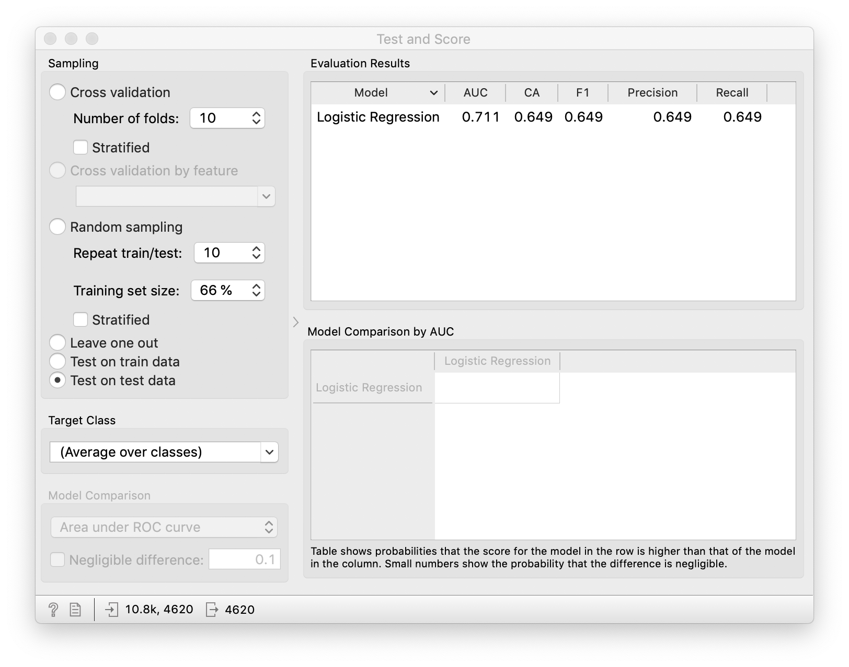
- A key part of this exercise is communication (if with a team) and formulating a plan to build the best model that you can “transport” into the test data.
- YOU WILL NEED TO PRODUCE A WORKFLOW WITH A “WINNING MODEL”. AS SUCH, TRY TO MAKE AS MUCH OF YOUR MODEL TRAINING REPRODUCIBLE BY TRAINING YOUR MODELS IN A REPRODUCIBLE MANNER, I.E. CHECK OFF ANY BOX MARKED “REPRODUCIBLE”. I will highlight this detail in class (Lecture 7) if you need to reference the lecture before staring your assignment.
- Answer the following questions in generating your report.
  - Did your group make any general observations about the data structure or distribution?
  - What models did you consider and why?
  - What validation scheme did you settle on and why?
  - How did you make your modeling approaches and evaluation reproducible?
  - Was there variability in AUC among candidate models?
  - What was your winning model and its performance for AUC via validation (either train/validate or cross-validation)? Fill in table below.
  - Describe EXACTLY the hyperparameter values you used for your winning model. If possible, take a screen shot in Orange.
  - Evaluate your winning model’s performance on the testing data. Make sure the variable roles and types agree between the training/validation data and the test data. Fill in table below.
  - Use a confusion matrix and Test and Score widget to characterize how your winning model got predictions wrong in the test data.

Winning model
Validation AUC | Test AUC

- Lastly, save your workflow and submit along with your answer to the questions above. If you are submitting as a group, e-mail the workflow and answered questions to your teammates. We will gather and compare our results.

