Assignment #5
Biostat 202

Unsupervised Machine Learning – Clustering and Dimension Reduction
(due 8/26/2021 at 11:55 PM)

Description: For this assignment we will use the “breastcancer.csv” dataset available on the CLE. The Wisconsin Diagnostic Breast Cancer (WDBC) dataset contains features that are computed from a digitized image of a fine needle aspirate (FNA) of a breast mass. The features describe characteristics of the cell nuclei present in the image.

Skills:

- Perform k-means and hierarchical clustering
- Perform principal components analysis dimension reduction
- Perform t-distributed stochastic neighborhood embedding dimension reduction

File: download from CLE

- breastcancer.csv

Steps: Please follow the steps below and answer questions marked in bold in a separate document. Include a screenshot of your final workflow.

Data description: The dataset consists of a Record ID (idno) in the first column followed by image features each graded from 1 to 10: ClumpThickness, CellSizeUniformity, CellShapeUniformity, MarginalAdhesion, SingleEpithelialCellSize, BareNuclei, BlanChromatin, NormalNucleoli, Mitoses. The final variable indicates the diagnosis Class as to whether the sample is “benign” or “malignant”.

Data Import

- Import the breastcancer.csv file and set idno and Class as meta. For the moment we do not want to directly model the tumor status (benign or malignant). Rather, we want to learn substructures that might me related to this outcome later. The remaining variables should all be numeric features.

Clustering
- Attach a “k-Means” widget to the data and Select “Normalize columns”. Assess the Silhouette measure for cluster sizes ranging from 2 to 8. Q1: Which number of clusters produces the best silhouette measure (recall higher is better)? How can you use the silhouette measure to select the optimal number of clusters? Select the optimal number of clusters once you have settled on an answer (you can select sub-optimal cluster numbers later if you wish).

- Attach a “Silhouette Plot” widget to the “k-Means” widget. You can visualize the silhouette scores for the individual patients. These are aggregated to form the average silhouette scores you inspected in Q1.

- Attach a “Scatter Plot” widget to the “k-Means” widget. Select Cluster as the Color variable and select “Find Informative Projections” and click “Start”. Orange will try to find the pair of variables that best explain the cluster behavior. Select the highest ranked projection in the Score Plot window that excludes Sihouette (the Silhoutte measure is output with your data but should not be considered a feature of the cancer data). Q2: Which pair of variables are identified as the most informative for the cluster assignment in the Score Plots window? Describe how these two variables behave with respect to the clusters and take a screenshot. My example is shown below.

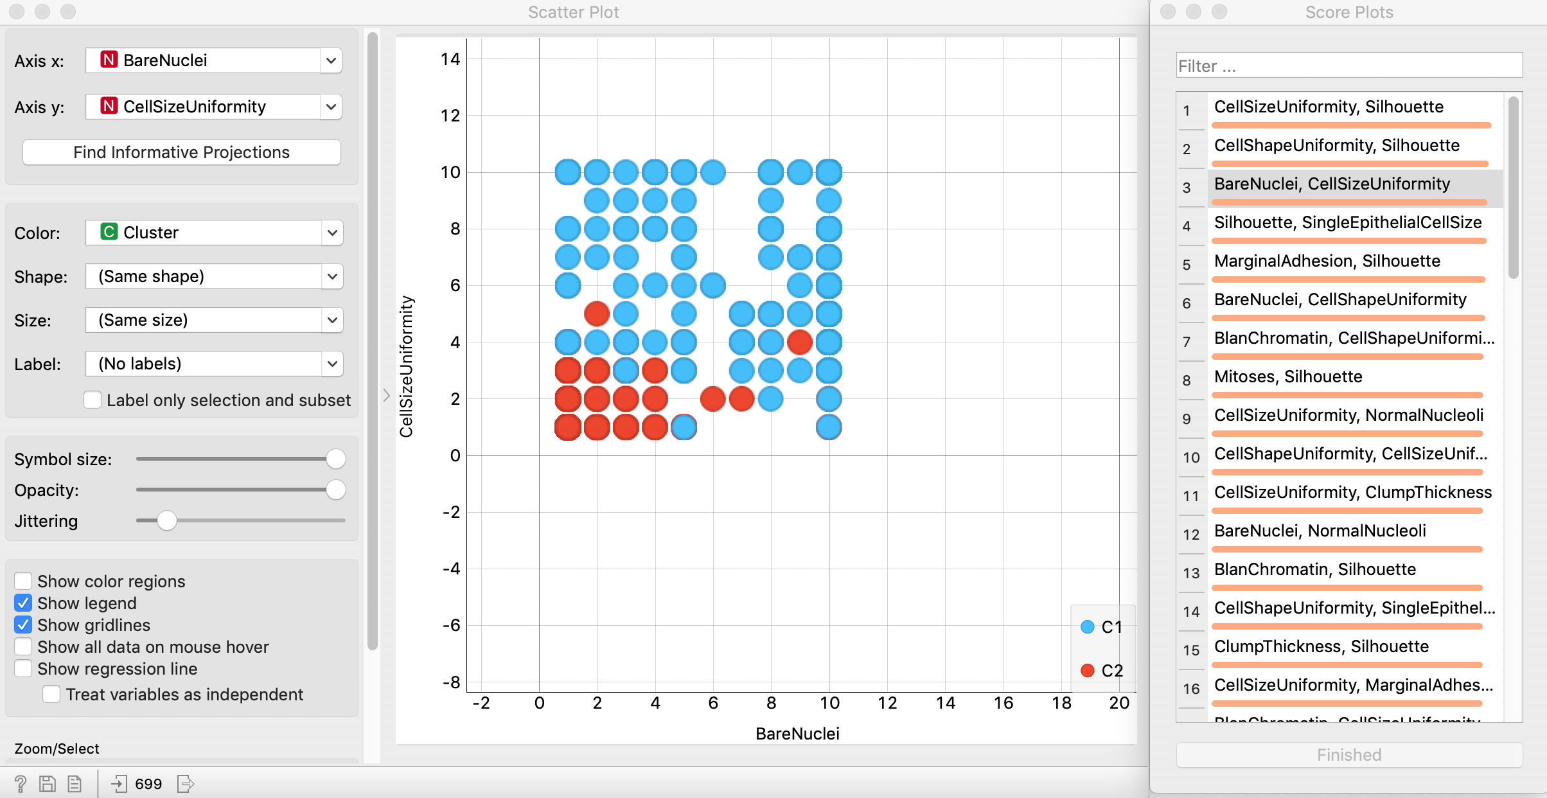

- Lastly, attach a “Distribution” widget to the “k-Means” widget and examine the relationship between cluster assignment and the Class variable. Q3: Does the assigned cluster structure reflect a latent characteristic that is related to tumor status (i.e. benign or malignant)? It is essential that you perform your unsupervised clustering WITHOUT variables that might be future outcomes of interest. Otherwise it is difficult to argue that the outcome variables are reflected in some latent structure.

- My workflow looks like this so far:

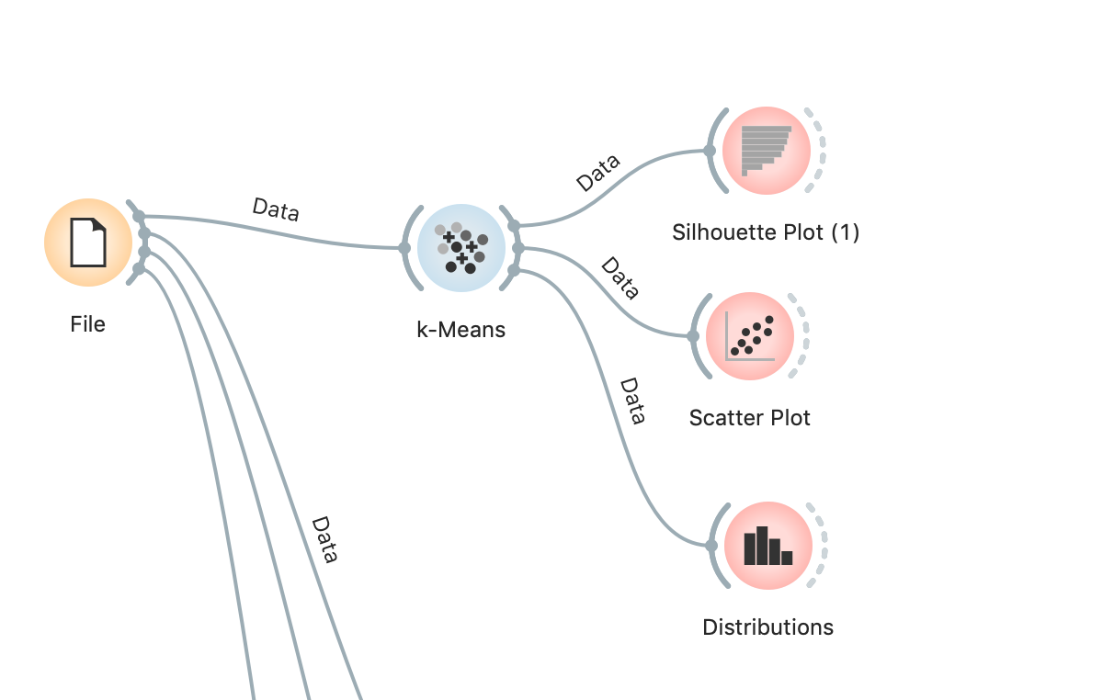

- Next, we will perform hierarchical clustering. To do this, we first need to calculate distances among our observations using the “Distance” widget which you can attach to your “File” widget. Because we wish to calculate distances between our observations for subsequent clustering, select Distances between Rows and use a normalized Euclidean distance metric.

- Attach a “Hierarchical Clustering” widget to your “Distance” widget. Clusters are formed in an agglomerative manner (i.e. right to left). The resulting denodgram shows how subclusters are merged to form larger and larger groupings of the data. Final cluster assignment is determined by drawing a vertical line in the dendogram. You can do this by clicking on the dendogram directly. Find the vertical cut that forms two clusters.

- Repeat the “Scatter Plot” and “Distribution” widget procedures you applied for k-means above. Q4: Repeat your evaluations performed in Q2/Q3.

Dimension Reduction

- The first dimension reduction technique we will explore is principal components analysis (PCA). Add a “PCA” widget to the “File” widget. When you open the widget, you will see a proportion of variance plot with the ordered principal components labeled on the x-axis. The components are ordered by the proportion of variance (information) they explain in the data. Q5: How much variation is explained in the first component, second component and in six components? Select components that explain at least 90% of the variation in the data and close the widget.

- Add a “Data Table” widget to the “PCA” widget. Look inside. You will see all the original variables along with columns labeled “PC”. These PC scores are the coordinates of our data in the transformed principal component space. These coordinates on longer relate to individual features of the cancer data but summarize the information in lower dimensions. Add a “Scatter Plot” widget and select Class for color. Select “Find Informative Projections” and click Start. Q6: How many of the top variable pairing contain principal component scores? While not always the case, it is not surprising that the principle directions of variation encoded in these principal component scores contain highly relevant information related to tumor class.

- We will now explore another dimension reduction technique called t-distributed stochastic neighborhood embedding (t-SNE). Add a “t-SNE” widget to the “File” widget. Unlike PCA, t-SNE has many parameters that can be tuned and is semi-random in its performance. We will ignore much of these with the exception of the following: select “Preserve global structure” and “Nomralize” data, select hit start. t-SNE will now find a two-dimensional embedding that preserves the high dimensional neighborhood structure as best as possible (i.e. with high probability).

- In Orange, t-SNE will allow us to represent our high-dimensional data in a two-dimensional space. View this by adding a “Data Table” to the “t-SNE” widget. Add a “Scatter Plot” widget and color by Class. Q7: Do the two tumor classes stratify well in the t-SNE space?

***OPTIONAL***

- Now let’s merge our t-SNE and PCA data reduced data sets using a “Merge” widget. Use a “Select Column” widget to identify the original features, PC components, and t-SNE components as features and Class as the target. Everything else should be a meta variable.

- Rank all the measures now using some of our feature importance metrics we discussed in the “Rank” widget. Q8: What features are ranked highest? Are you surprised?

My final workflow looks like this:
