Requesting a RAE Student and a REDCap Account for EPI 218

This document explains on how to request a RAE account and a REDCap account for use in EPI 218, which begins Thursday, July 22, 2021 at 8:45AM.

Please be sure to request the access you need no later than Friday, July 15, 2021. This gives you enough time to verify that your access to both applications is working.

RAE ACCOUNT REQUEST

- Click the RAE Request form link to open the RAE – Research Analysis Environment request form.

The Requester Name, Requester Email, and Requester Phone fields auto-populate with your information.

- In the Account Information section, select the radio button for the New Student RAE (limited to 5 GB storage) option.
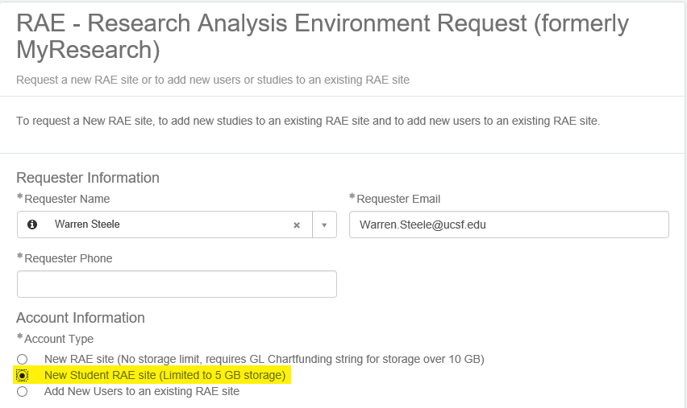
IMPORTANT:
Make sure you select the New Student RAE site (Limited to 5GB Storage option. Selecting any other option will cause your request to be rejected.

The Add Row screen displays.

The Add Row screen displays.

- In the Add Row section, enter your username (entering your name populates a list for you). Once done, click the Add button on the bottom right-hand side of the form.

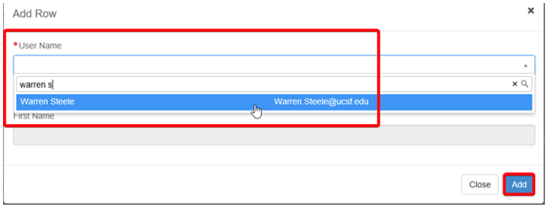

- In the Comments section, add the comment “Please expedite request for the mkohn class beginning 07/22/2021”.

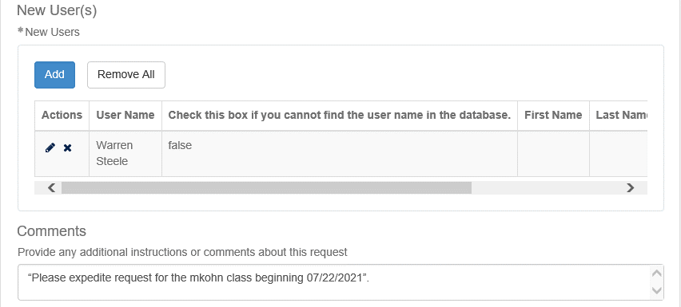

- Click the “If the individual for whom I am requesting…” checkbox and then click the Submit button.

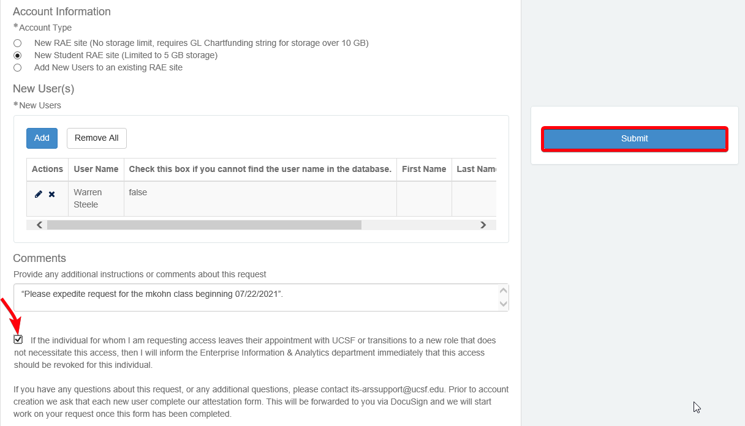

REDCAP ACCOUNT REQUEST

Use the link below to submit your REDCap account request.

https://wiki.library.ucsf.edu/display/MKB/How+to+Apply+for+a+RedCap+Account

PLEASE NOTE:

- It can take 3-4 business days to process your request and grant you access to your RAE account. Please submit your RAE request and verify that you can access RAE account by July 15, 2021.

- If you have not received your access:

  - Be sure if you were sent a DocuSign Attestation form (the Subject line is ‘Statement of Responsibility for Requester of PII and/or PHI’, not DocuSign Attestation form) you have e-signed this required document. A RAE and/or REDCap account cannot be created until you have a signed/valid DocuSign Attestation form on file.

- For any issues contact the ARS team via email or call the IT help desk at 415-514-4100

