Chapter 19
<TITLE> Data Management
Michael A. Kohn
Thomas B. Newman

<H1>Introduction
Undertaking a clinical research project requires choosing a study design, defining the target population, and specifying the predictor and outcome variables. Ultimately, most information about the participants and variables will reside in a database that will be used to store, update, and monitor the data, as well as format it for statistical analysis. The study database may also store administrative data, such as call logs, visit schedules, and reimbursement records.

In many clinical trials, especially those preparatory to application for regulatory approval of a drug or device, the specialists who create data entry forms, manage and monitor the data collection process, and format and extract the data for analysis are referred to as clinical data managers (1). Pharmaceutical companies devote substantial resources and personnel to clinical data management. Although the scale is smaller, beginning investigators also need to attend to data management issues. After all, the conclusions of a study depend on the accuracy, completeness, and security of the study data.

A simple study database consisting of a single data table can be maintained using a spreadsheet or statistical program. More complex databases use database management software to define the data tables, develop the data entry system, and monitor the data.

<H1>Data Tables
All computer databases consist of data tables with rows that correspond to individual records (which may represent participants, events, or transactions) and columns that correspond to fields (attributes of those records). For example, the simplest study database consists of a single table in which each row represents a study participant and each column contains a participant-specific attribute, such as name, date of birth, sex, and outcome status. In general, the first column in a data table is a unique participant identification number (such as “ParticipantID”). Assigning each participant a unique identifier, such as sequential integers (e.g., 1, 2 ,3…), with no intrinsic meaning makes it easier to maintain participant confidentiality.

Figure 19.1 shows a simplified data table for a hypothetical cohort study (inspired by a real study (2)) of the association between elevated neonatal bilirubin levels and IQ score at 5 years of age. Each row in the table corresponds to a study participant and each column corresponds to an attribute of that participant. The binary predictor is whether the participant had hyperbilirubinemia (“Hyperbili_ind”), and the continuous outcome is “IQ,” which is the participant's IQ on exam at age 5.
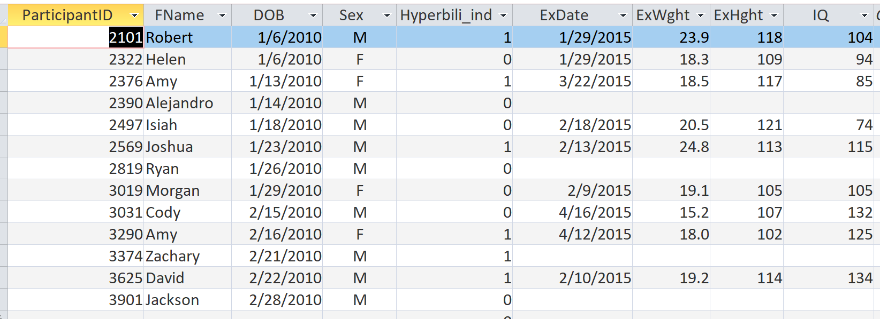
Figure 19.1 Simplified data table in “datasheet view” for a cohort study of the association between neonatal hyperbilirubinemia and IQ score at age 5. The binary predictor is “Hyperbili_ind”, defined as whether the total bilirubin rose to 25 mg/dL or more in the first 10 days after birth, and the continuous outcome is “IQ”, the participant’s IQ score at age 5. Participants 2390, 2819, 3374, and 3901 were not examined at age 5.
If the study data are limited to a single two-dimensional table, like the one in Figure 19.1, they are easily accommodated in a spreadsheet or statistical package, and often referred to as a flat file.

Database tables should store raw data fields, not calculated values. For example, the database should store birthdate and exam date, not age at exam -- height and weight, not BMI. Database queries (see below) can calculate values based on the raw data fields. Given birthdate and exam date, the database can calculate age at exam in years, months, weeks, or days. But given age in years, it can’t calculate age in months, weeks, or days. Correcting an error in the exam date will automatically correct the calculated age at exam. Similarly, if the database stores weight and height but calculates BMI, correcting an erroneous weight automatically corrects the erroneous BMI.

If a study tracks multiple lab results, medications, or other repeated measurements for each participant, a single data table will not be adequate. Rather, data management software will be required to store those repeated measurements in separate tables distinct from the table of study participants. Each row in one of these separate tables corresponds to an individual measurement including what was measured, its date and time, and the result. One field in the row includes the participant identification number to link the measurement back to the participant table. In this relational database, since one participant can have many measurements, the relationship between the participant table and the measurement table is termed one-to-many. The first column in each of the measurement tables should be a unique record identifier, called the table's primary key. In Figure 19.2, the primary key is ExamID.

Although the participants in the infant jaundice study had only one IQ test, most had other examinations during which, for example, height and weight were assessed and used to calculate BMI and growth curve percentiles. (See “Extracting Data [Queries]” later in this chapter.) This type of data is best accommodated in a separate Exam table in which each row corresponds to a discrete examination and the columns represent examination date, examination results, and the participant identification number (Figure 19.2). Since a participant can have several examinations, the relationship between participant and exam tables is one-to-many. The field that links the exam-specific data to the participant-specific data is called a foreign key; in the Exam Table of Figure 19.2, ParticipantID serves as the foreign key that links each measurement to a specific participant.

In a two-table database structure with a participant and an exam table, locating all exams performed within a time period requires searching just a single exam date column. Changes to a participant-specific field, like date of birth, are made in one place, and consistency is preserved. Fields holding personal identifiers, such as name and date of birth appear, only in the participant table; the exam table links back to this information via the ParticipantID. The database can still accommodate participants (such as Alejandro, Ryan, Zachary, and Jackson) who have no exams.

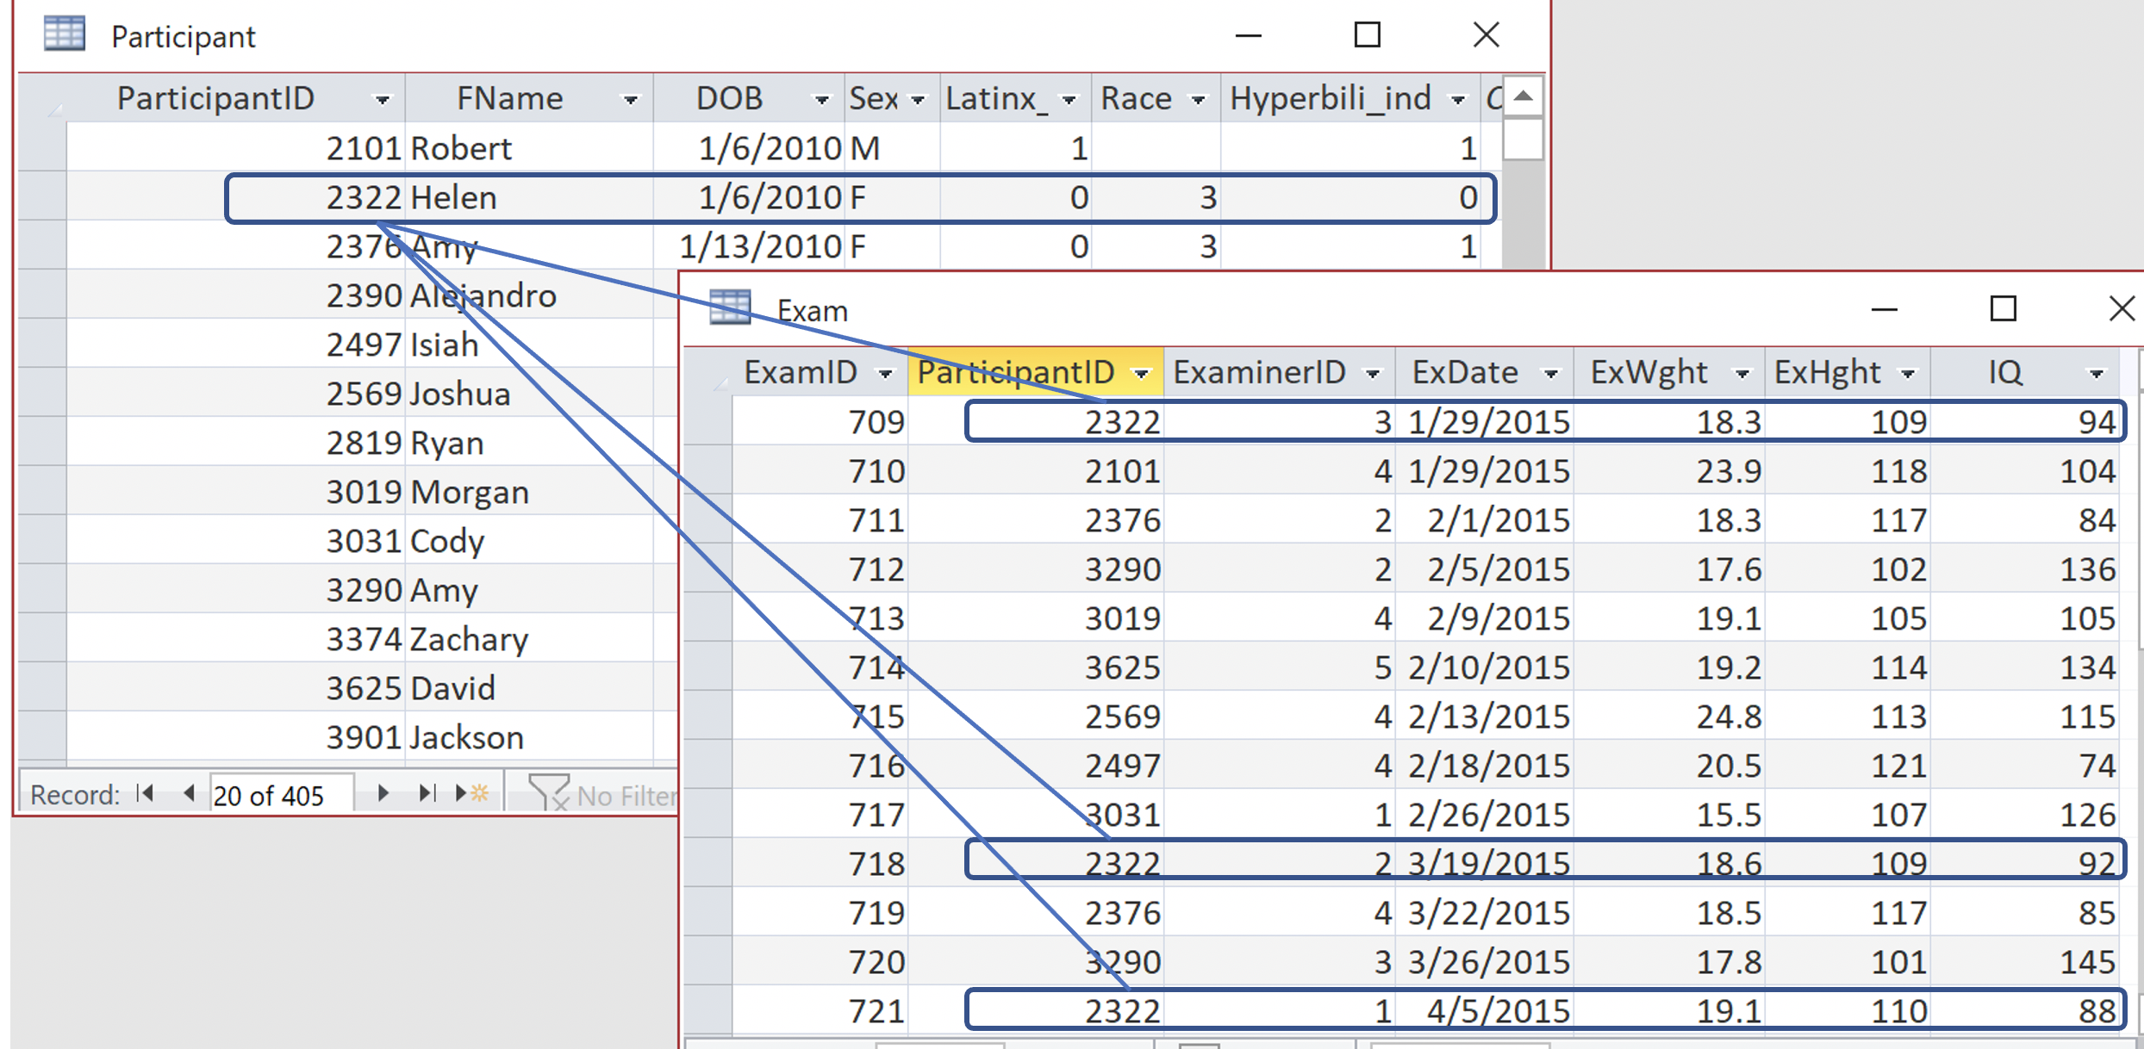
Figure 19.2 A two-table infant jaundice study database with a table of study participants (in which each row corresponds to a single study participant) and a table of examinations (in which each row corresponds to a particular examination). For example, Participant 2322 is identified as Helen, date of birth 1/6/2010, in the first table, and has 3 exams in the anonymous second table. Note that ExWght and ExHght are entered in the exam table, not the participant table.

Detailed tracking of lab results would require a separate table. For example, if the investigators needed the entire trajectory of bilirubin levels after birth, then the database should include a separate lab result table with one record per lab result and fields for date/time of lab test, lab test type (total bilirubin), test result (bilirubin level), and ParticipantID, the foreign key for linking back to the participant-specific information, as in Figure 19.3.
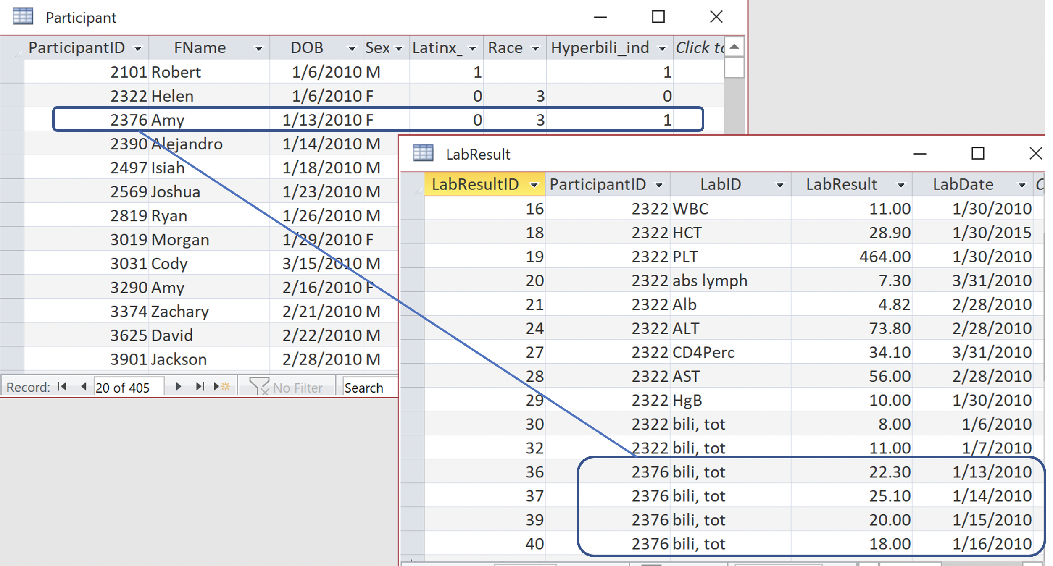
Figure 19.3. The linkage between the table of participants and the table of lab results. The lab results capture the trajectory of Amy’s total bilirubin levels during the first 4 days after birth.

A study's administrative data, such as call logs, visit schedules, and reimbursement records, also require separate tables. In the infant jaundice study, just a few calls were made to the parents of some study participants, but 50 or more calls were made to those who were harder to reach. It would be difficult to track these calls in a data table with one row per study participant, because such a table would need to have enough columns to accommodate the participant with the highest number of calls, and those columns would be empty for most participants. It is much easier to have a separate table with one row per call; ParticipantID links the data to the study participant about whom the call was made.

The process of putting fields for which each participant has only a single value in one table (such as birth date, birth weight and sex assigned at birth) and fields that take on multiple and variable numbers of values per participant in another table (such as phone calls or bilirubin levels) is part of database normalization. A key feature of normalization is that the only participant-specific field in new tables should be the ParticipantID to link back to the participant record. All other participant-specific fields (such as date of birth and sex) are stored in a table with only one record per participant. Normalization eliminates redundant storage and the opportunity for inconsistencies. Relational database software can be set to maintain referential integrity that will not allow creation of an exam, lab result, or call record for someone who is not already listed in the participant table. Similarly, it prevents deletion of a participant unless all that participant's exams, lab results, and calls have also been deleted.

<H2>Data Dictionaries, Data Types, and Domains
Each column or field in a database must have a name, data type, and definition. For example, in the participant table of Figure 19.2, “FName” is a text field that contains the participant's first name, “DOB” is a date field that contains the participant's birth date, and “Hyperbili_ind” is a yes/no field that indicates whether the bilirubin exceeded 25 mg/dL. In the exam table, “ExWght” is a (continuous) number field for weight in kilograms and “IQ” is a (discrete) integer IQ score. The data types and definitions should be made explicit for every field in a data dictionary. The data dictionary is referred to as metadata, since it contains information about the database itself.

Figure 19.4 shows the participant and exam tables in table design (or “data dictionary”) view. The data dictionary is itself a table, with rows for each field and columns for the field name, data type, and field description, as well as a range of allowed values. For example, in the infant jaundice database, the allowed values for the “Sex” field were “M” and “F”; other values cannot be entered in this field. Similarly, the “IQ” field allowed only integers between 40 and 200. Data managers often refer to validation rules as “edit checks” (1), since they afford some protection against data entry errors. Some data types come with automatic validation rules; for example, database software will always reject a date of April 31.

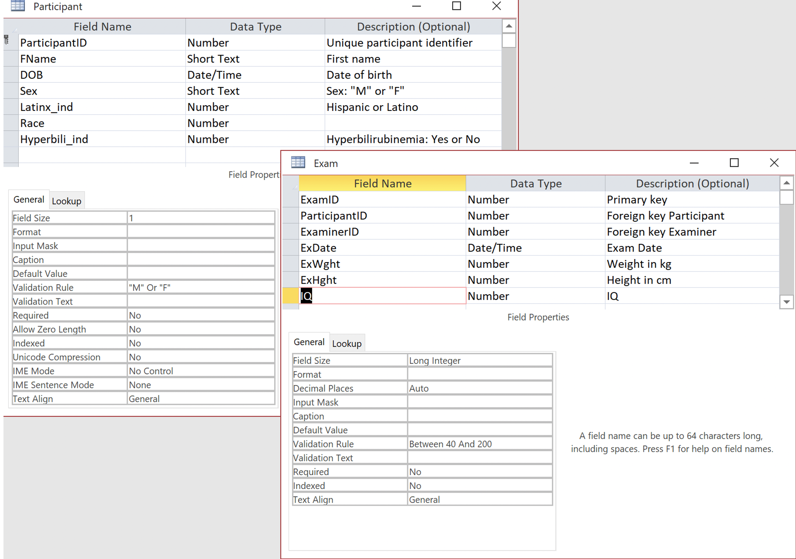
Figure 19.4. Table of study participants (“Participant”) and the table of measurements (“Exam”) in “data dictionary view.” Each variable has a name, a data type, a description, and a domain or set of allowed values.

<H2>Variable Names and Coding Conventions
Variable names should be short enough to type quickly, but long enough to be self-explanatory. Avoid using spaces and special characters; separate the words in a variable name either by using (aptly named) “InterCaps” or “camelCase,” or with an underscore character. Binary indicator variables should be named for the yes or present condition (e.g., “EverSmoker_ind”) and valued as 1 for yes or present and 0 for no or absent. With this coding, the average value of the variable is simply the proportion with the attribute. Appending “_ind” to binary indicator variables allows them to be identified readily. Most software packages allow users to designate a longer, more descriptive, and easier to read variable label to use on data entry forms and reports instead of the compact variable name.

In coding response options, one convention is to use the digit 9 (or 99) for “Unknown,” “Does Not Apply,” “Not Answered,” etc. and 8 (or 88) for “Other (Specify).” Coding sex, ethnicity, and race often uses the approach of the National Center for Health Statistics (5), which has been incorporated into several electronic health records.

For sex, use the following standard codes:

0 Female
1 Male
4 Transgender Female to Male
5 Transgender Male to Female
8 Non-binary
9 Unknown

For ethnicity and race, the standardized approach is to ask two questions:

Question 1: Do you consider yourself Hispanic/Latino?
Question 2: Which of the following five racial designations best describes you?

American Indian or Alaska Native
Asian
Black or African American
Native Hawaiian or Other Pacific Islander
White

This approach allows multiple responses to Question 2 (Figure 19.5); it is also possible to add options for “Other (includes more than one race)” and “Unknown/Not Reported,” and then allow only one response.

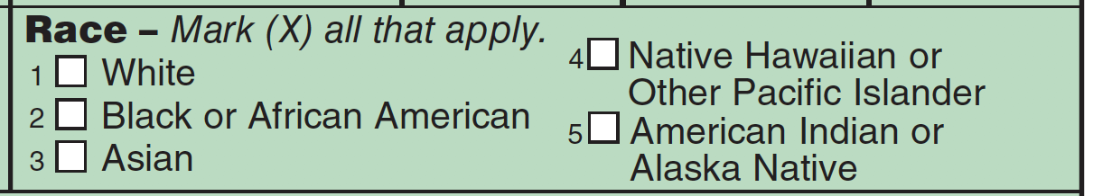
Figure 19.5. Coding of Race on the National Hospital Ambulatory Medical Care Survey (6) of the National Center for Health Statistics.

The ethnicity field “EthnLatino_ind,” has allowed values of 0 (not Hispanic/Latino), 1 (Hispanic/Latino), and 9 (Unknown/Decline to state). For the race field, “Race” has the following codes:

- White
- Black or African American
- Asian
- Native Hawaiian or Other Pacific Islander
- American Indian or Alaska Native
8. Other (includes more than one race)
9. Unknown/Not Reported

<H2>Common Data Elements
Several funding and regulatory organizations, including the National Institute for Neurologic Disorders and Stroke (NINDS) (7), the National Cancer Institute (8), the United States Food and Drug Administration (9), the European Medicines Agency. and nongovernmental, nonprofit associations such as the Clinical Data Interchange Standards Consortium (CDISC) (10) have launched initiatives to develop common data elements for study databases.
Standardizing record structures, field names/definitions, data types/formats, and data collection forms (case report forms) will eliminate the problem of “reinventing the wheel” for every new study, and enable sharing and combining data across studies. This entails establishing a data dictionary and a set of data collection instruments with accompanying instructions that all investigators in a particular area of research are encouraged to use.

<H1>Data Entry
Whether the study database consists of one or many tables, or whether it uses spreadsheet, statistical, or database management software, a way to populate the data tables (enter the data) is needed. In the past, the most common method for populating a study database was to collect data on a paper form, called a case report form (CRF) in clinical trials. Study personnel then transcribed the information into computer tables, preferably using on-screen forms that make data entry easier and include automatic data validation checks.

<H2>Electronic Data Capture
Hand-writing data onto a paper form is increasingly rare. In general, research studies should collect data primarily using online forms, in clinical trials called electronic case report forms (eCRFs). Online forms may be viewed, and data entered on portable, wireless devices such as a tablet (iPad), smartphone, or notebook computer. Data entry via online forms has many advantages:

- The data are keyed directly into the data tables without a second transcription step, removing that source of error.
- The computer form can include validation checks and provide immediate feedback when an entered value is out of range.
- The computer form can also incorporate skip logic. For example, a question about packs per day appears only if the participant answered “yes” to a question about cigarette smoking.

When using online forms for electronic data capture, it sometimes makes sense to print a paper record of the data immediately after collection that can be verified by the study participant. It may be used as the original or source document if a paper version is required for auditing purposes.

Although the online form should prevent invalid entries, it should allow users to save an incomplete record. To prevent missing data, some database managers create required fields and “hard stops” that prevent saving a record if even a single value is missing. The result, however, is that a user who has entered nine values will lose them all if the tenth isn’t available—and may decide to fabricate or approximate that last value. Required fields prevent missing data but increase the risk of invalid data. The only missing fields that should prevent saving a record are those (like ParticipantID) that identify it. A form should also include a “Complete?” field that triggers an automatic error checking routine.

If the person entering data needs to know a calculated value based on entered fields (e.g., age in months or BMI), then the form should calculate and display it. As mentioned above, data tables should store raw data fields, not calculated values.

Online data collection forms provide two main formats for displaying mutually exclusive (no overlap) and collectively exhaustive (all-encompassing) response options: drop-down list or option group (Figure 19.6 A and B). These formats will be familiar to any research participant or data entry person who has worked with an online form.

A
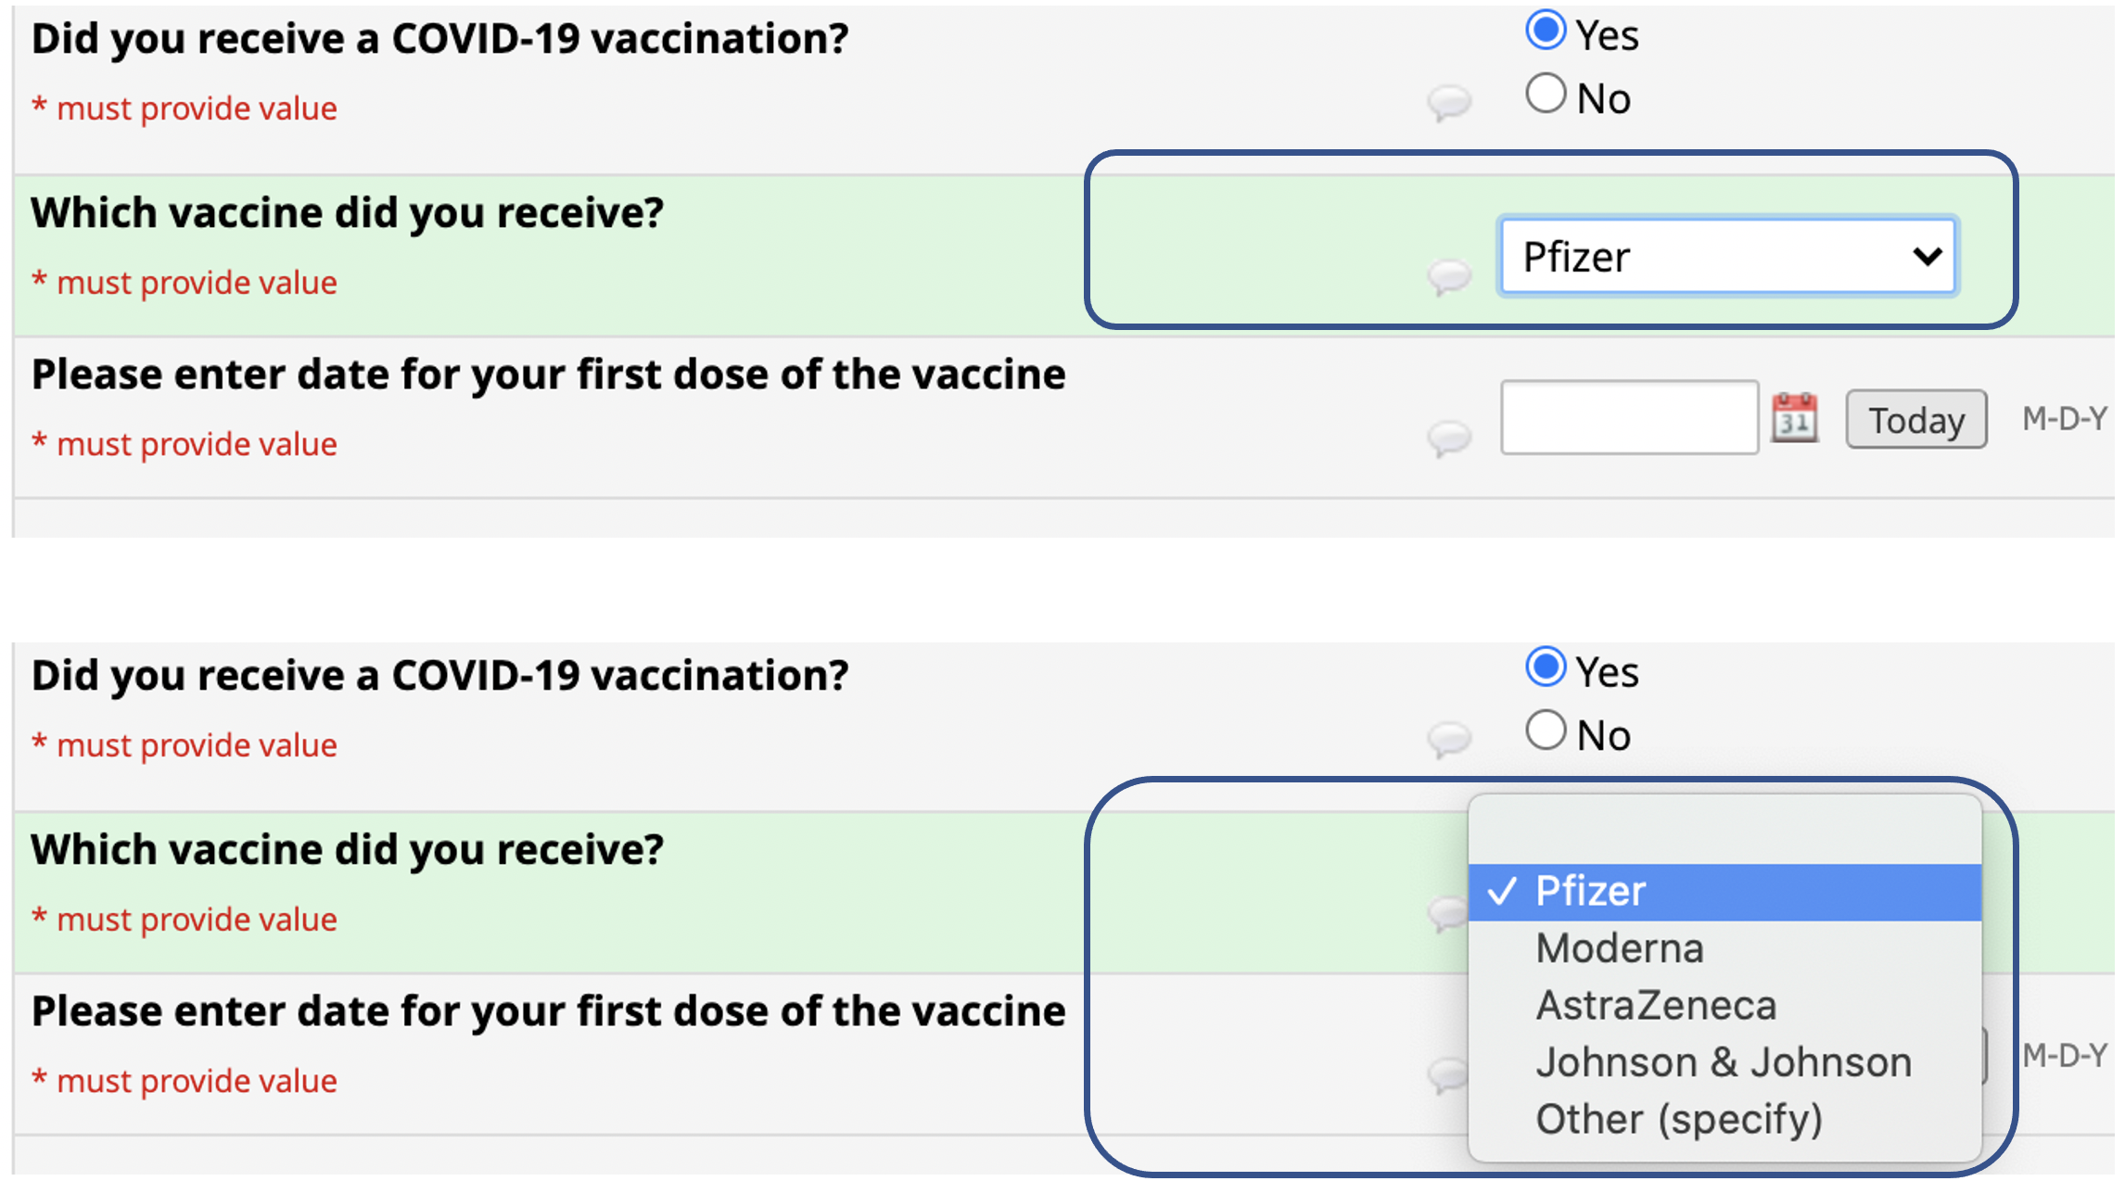

B
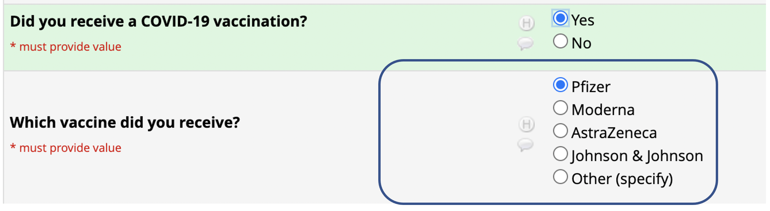

Figure 19.6. Formats for entering from a mutually exclusive, collectively exhaustive list of responses. The drop-down list (A; dropped down in lower panel) saves screen space but will not work if the screen form will be printed to paper for data collection. The option group (B) requires more screen space, but will work if printed.

A question with a set of mutually exclusive responses corresponds to a single field in the data table. In contrast, the responses to an “All that apply” question are not mutually exclusive; rather, they correspond to as many yes/no fields as there are possible responses. By convention, response options for “All that apply” questions use square check boxes rather than the round radio buttons used for mutually exclusive responses. “All that apply” questions should be avoided; requiring a yes or no response to each item is preferable. Otherwise an unmarked response could either mean “does not apply” or “not answered.”

<H2>Importing Measurements and Laboratory Results
Much study information, such as baseline demographic information, lab results, and measurements made by dual energy x-ray absorptiometry (DEXA) scanners and Holter monitors, is often already in digital format. Whenever possible, these data should be imported directly into the study database to avoid the cost and potential transcription errors of re-entering data. Computer systems can almost always produce comma-separated-value (csv) files or fixed-column-width text files that the database software can import. In clinical trials, this type of batch-uploaded information is referred to as “non-CRF data” (1).

<H2>Data Management Software
The back end of a study database consists of the data tables themselves. The front end (or interface) consists of the online forms used for entering, viewing, and editing the data. Study databases consisting of multiple data tables require relational database software (Table 16.1) to maintain the back-end data tables. If the data are collected on paper forms, entering the data will require transcription into online forms.

<TAB16.1>

As discussed in Chapter 17, there are several tools, including SurveyMonkey, Zoomerang, Qualtrics, QuesGen, and REDCap for developing online surveys to e-mail to study participants or post on a website. All these tools provide several question format options, skip logic, and the capability to aggregate, report on, and export survey results. Some statistical packages, such as SAS, have developed data entry modules. Integrated desktop database programs, such as Microsoft Access and Filemaker Pro, also provide extensive tools for the development of on-screen forms.

Many research studies use integrated, Web-enabled, research data management platforms, such as REDCap (Research Electronic Data Capture), which was designed specifically for clinical research by an academic consortium based at Vanderbilt University. It enables researchers to build data entry forms, surveys, and surveys with attached data entry forms. REDCap, which is available to investigators at many academic institutions, is an outstanding “do-it-yourself” tool for beginning investigators. It also provides access to a repository of data collection instruments. However, options for customization and advanced functionality are limited. A REDCap database consists of a single table with one column for every field in the database and one row for every data collection event, and can be exported easily into statistical packages. REDCap does not permit detailed tracking of a large and variable number of repeated measurements per study participant, and it cannot do sophisticated data validation or reporting, nor can it be queried as a relational database can (see below).

Full-featured, Web-based research data management platforms, such as QuesGen, MediData RAVE, or Oracle InForm, can accommodate complex data structures and provide sophisticated data validation, querying, and reporting. The companies that provide these tools also provide support and configuration assistance.

<H1>Extracting Data (Queries)
Once the database has been created and the data entered, the investigator will want to organize, sort, filter, and view (“query”) the data. Database queries are used for monitoring data entry, reporting study progress, and analyzing the results. The standard language for manipulating data in a relational database is called Structured Query Language or SQL (pronounced “sequel”). Many relational database programs also provide a graphical interface for building queries. The R statistical program supports SQL but also offers an alternative set of commands in the dplyr library (11).

A query can join data from two or more tables, display only selected fields, and filter for records that meet certain criteria. Queries can also calculate values based on raw data fields from the tables. Figure 19.7 shows the results of a query on the infant jaundice database that filtered for boys examined in February and calculated age in months and BMI. (The query also used a sophisticated table-lookup function to calculate growth curve percentile values for the child's BMI). One of the tenets of the relational database model is that operations on tables produce table-like results; thus, the result of a query that joins two tables, displays only certain fields, selects rows based on special criteria, and calculates certain values still looks like a table. The data in Figure 19.7 are easily exported to a statistical analysis package.

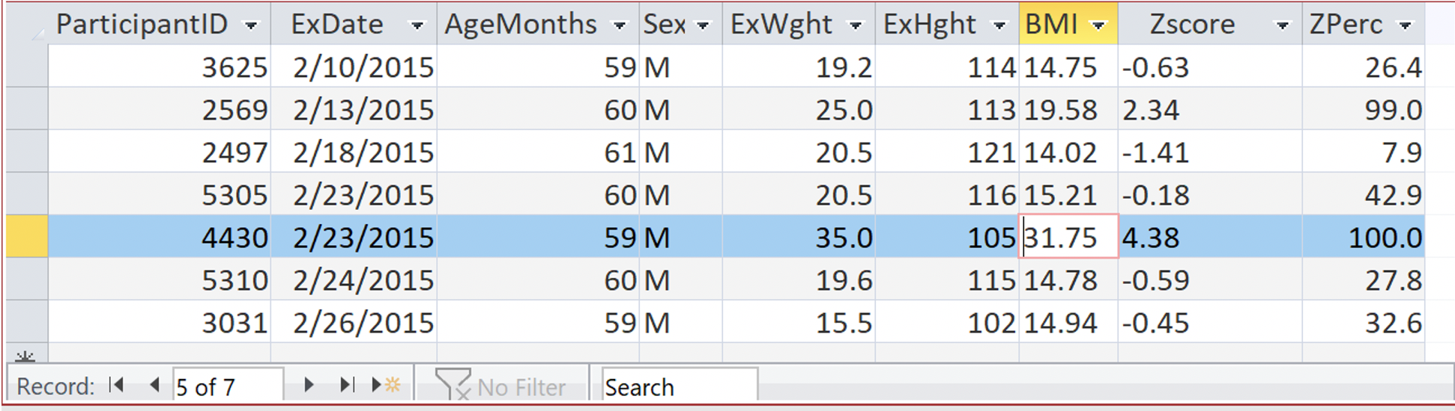
Figure 19.7. A query in datasheet view that filtered for boys examined in February and calculated age in months and BMI. The query also used a sophisticated table-lookup function to calculate growth curve percentile values for the child's BMI. For ParticipantID 4430, the 100th percentile value associated with the BMI of 31.75 should have triggered investigation of the outlier as a possible data entry error.

<H2>Identifying and Correcting Errors in the Data
The entire data management system (data tables, data entry forms, and queries) should be tested using dummy data. For clinical trials that will be used in an FDA submission, this is a regulatory requirement (12).

Once data collection begins, values that are outside the pre-set permissible range should not get past the data entry process. However, the database should also be queried for missing values and outliers (extreme values that are nevertheless within the range of allowed values). If data are collected by investigators at different locations, means and medians should be compared across investigators and sites. Substantial differences by investigator or site can indicate systematic differences in measurement or data collection.

Many data entry systems are incapable of doing cross-field validation, which means that the data tables may contain field values that are within the allowed ranges but inconsistent with one another. For example, it would be highly unlikely for a 5-year-old who weighed 35 kg to be only 105 cm tall. While the weight and height values are both within the allowed ranges, the weight (extremely high for a 5-year-old) is inconsistent with the height (extremely low for a 5-year-old). Such an inconsistency can be identified using a query like the one in Figure 19.7.

Missing values, outliers, inconsistencies, and other data problems that are identified by queries should be communicated to the study staff, who can respond by checking original source documents, interviewing the participant, or repeating the measurement. If the study relies on paper source documents, any resulting changes to the data should be highlighted (e.g., in red ink), dated, and signed. As discussed later in this chapter, electronic databases should maintain an audit log of all data changes.

Data editing is an iterative process; after errors are identified and corrected, editing procedures should be repeated until very few important errors are identified. At this point, for some studies, the edited database may be declared final or “locked” and no further changes are permitted (1).

<H1>Analysis of the Data
Analyzing the data often requires creating derived variables based on the raw values in the database. For example, continuous variables may be made dichotomous (e.g., a new variable called “overweight” can be defined as a BMI > 25 kg/m²), new categories created (e.g., antibiotics grouped by type), and calculations made (e.g., pack years defined as number of packs of cigarettes per day × years of smoking). Missing data should be handled consistently. “Don’t know” may be recoded as a special category, combined with “no,” or excluded as missing. If the study uses database software, queries can be used to derive the new variables prior to export to a statistical analysis package. That said, many investigators are more familiar with statistical packages than database programs, and prefer to calculate derived variables after export.

<H1>Confidentiality and Security
An investigator is obligated ethically and legally to protect participants’ confidentiality. If participants are clinic or hospital patients, their identifying information is also protected under the Privacy Rule of the Health Insurance Portability and Accountability Act (HIPAA). To ensure confidentiality, the database should assign each participant a unique participant identifier (e.g., ParticipantID) that has no meaning external to the study database (i.e., it should not incorporate the participant's name, initials, birth date, or medical record number)—and thus cannot be used on its own to identify the participant. If a database has multiple tables, personal identifiers should be kept in a separate table.

Study databases that contain personal identifiers must be maintained on secure servers accessible only to authorized members of the research team, each of whom will have a user ID and password. Database fields that do contain personal identifiers should not be exported. Dedicated Web-based research data management platforms such as REDCap and QuesGen allow designation of fields containing participant identifiers. Different user roles can allow or prohibit exporting, changing, or even viewing these specially designated fields.

The database system should audit all data entry and editing. Auditing allows determination of when a data element was changed, who made the change, and what change was made. This is a regulatory requirement for pharmaceutical and device trials (12). The study database also must be backed up regularly; the back-up procedure should be tested periodically. Web-based data management platforms provide user validation, auditing, backups, and data security automatically.

At the end of the study, the original data, data dictionary, final database, and the study analyses should be stored securely. This allows the investigators to respond to questions about the integrity of the data or analyses, perform further analyses to address new research questions, and share data with others.

<H1>Summary
- The study database consists of one or more data tables in which the rows correspond to records (e.g., study participants) and the columns correspond to fields (attributes of the records).
- Identifying study participants with a unique ParticipantID that has no meaning external to the study database enables the “de-linking” study data from personal identifiers to maintain confidentiality. Databases that contain personal identifiers must be stored on secure servers, with access restricted and audited.
- Accommodating a variable number of repeated measurements per study participant, such as lab results or medications, requires normalization of the measurement data into separate tables in which each row corresponds to a measurement rather than an individual study participant.
- The study database may also store administrative data such as call logs, exam schedules, and reimbursement records.
- The data dictionary specifies the name, data type, description, and range of allowed values for all the fields in the database.
- The data entry system is the means by which the data tables are populated, usually by electronic data capture using online forms.
- A spreadsheet or statistical package is adequate only for the simplest study databases; complex databases require the creation of a relational database using database management software based on Structured Query Language (SQL).
- Database queries sort and filter the data as well as calculate values based on raw data fields. Queries are used to monitor data entry, provide reports on study progress, and format the results for analysis.
- Loss of the database must be prevented by regular backups, and by storing and securing a final copy of the database for future use.

<H1>References
- Prokscha S. Practical guide to clinical data management, 3rd ed. Boca Raton: CRC Press, 2012.
- Newman TB, Liljestrand P, Jeremy RJ, et al. Outcomes among newborns with total serum bilirubin levels of 25 mg per deciliter or more. N Engl J Med 2006;354(18):1889–1900.
- Codd EF. A relational model of data for large shared data banks. Communications of the ACM 1970;13(6):377–387.
- Date CJ. An introduction to database systems. 8th ed. Boston: Pearson/Addison Wesley; 2004.
- FDA. Collection of Race and Ethnicity Data in Clinical Trials (10/26/2016), available from: https://www.fda.gov/regulatory-information/search-fda-guidance-documents/collection-race-and-ethnicity-data-clinical-trials , accessed 3/20/2021.
- NHAMCS. Sample 2020 Emergency Department Patient Record, available from: https://www.cdc.gov/nchs/data/nhamcs/2020-NHAMCS-ED-PRF-sample-card-508.pdf , accessed 3/20/2021.
- NINDS. Common Data Elements. Available from: https://www.commondataelements.ninds.nih.gov/, accessed 3/20/2021.
- NCI. NIH CDE Repository Available from: https://cde.nlm.nih.gov/home/, accessed 3/20/2021.

FDA. CDER Data Standards Program. Available from: https://www.fda.gov/drugs/electronic-regulatory-submission-and-review/cder-data-standards-program, accessed 3/20/2021.
- CDISC. The Clinical Data Interchange Standards Consortium Study data tabulation model. 2012. Available from: http://www.cdisc.org/sdtm, accessed 3/20/2021.
- Wickham H, Grolemund G. R for data science: import, tidy, transform, visualize, and model data. First edition. ed. Sebastopol, CA: O'Reilly; 2016.
- DHHS. Guidance for industry: computerized systems used in clinical trials. May, 2007. FDA. Use of Electronic Records and Electronic Signatures in Clinical Investigations Under 21 CFR Part 11 – Questions and Answers, June 2017. Available from: https://www.fda.gov/regulatory-information/search-fda-guidance-documents/use-electronic-records-and-electronic-signatures-clinical-investigations-under-21-cfr-part-11, accessed 3/20/2021.

Table 16.1. Some Software Used in Research Data Management
Spreadsheet
Microsoft Excel
Apple Numbers
Google Sheets*
Apache OpenOffice Calc*
Statistical Analysis
Statistical Analysis System (SAS)
Statistical Package for the Social Sciences (SPSS)
Stata
R*
Integrated Desktop Database Systems
Microsoft Access (for Windows only)
Filemaker Pro
Relational Database Systems
Oracle
SQL Server
MySQL*
PostgreSQL*
Integrated Web-Based Platforms for Research Data Management
Research Electronic Data Capture (REDCap—hosted by many academic institutions)
QuesGen (primarily academic, vendor hosted)
MediData RAVE (primarily non-academic corporate, vendor hosted)
Oracle InForm (non-academic corporate, company hosted)
Datalabs EDC (corporate, vendor hosted)
OnCore
OpenClinica
EpiInfo*

Online Survey Tools
SurveyMonkey
Zoomerang
Qualtrics
*Free

A more inclusive way to code sex is 0 – female; 1 – male; 4 – transgender female to male; 5 – transgender male to female; 8 non-binary; 9 unknown.

