EPI 203: Epidemiologic Methods Name:
Problem Set 3: Disease Occurrence II

Due: October 5, 2021 at 1:30 pm section
Possible points: 29 (plus 2 extra credit)

Note: For the questions marked “FOR DISCUSSION IN SECTION ONLY:”, please familiarize yourself with these items before section such that we can have a rewarding discussion. Also, please be sure to complete all of the required problem set questions. The “FOR DISCUSSION” question does not mark the end of the required problem set.

1. PRACTICE QUESTIONS (please attempt to answer these practice questions 1a-c, but it is not required that you type your answers into this document).

(a) Among the persons in the table below, recently diagnosed with lung cancer, calculate the mortality rate (per person-month; an average mortality rate). Use the following data, which represent individual-level observations. The study began in August 2010 (8/10), ended in May 2016 (5/16), and all patients still in follow-up were administratively censored on that date. Dates are in month/year.

Person # Date of entry Date of Last Follow-up Date of death person-time
1 8/10 5/16 -- 69 mos
2 9/10 6/15 6/15 57 mos
3 1/11 8/15 -- 55 mos
4 8/10 4/11 4/11 8 mos
5 2/11 3/16 3/16 49 mos
6 10/10 5/16 -- 67 mos
7 9/10 4/14 -- 43 mos
8 10/11 9/12 9/12 23 mos
9 12/10 6/12 6/12 18 mos
10 12/10 7/11 -- 7 mos
11 10/10 3/14 3/14 41 mos
12 8/10 11/14 -- 51 mos
13 9/10 4/16 4/16 67 mos
14 8/10 9/14 -- 49 mos
15 1/11 5/16 -- 63 mos
16 12/10 6/13 -- 30 mos
17 8/10 1/12 1/12 16 mos
18 8/10 2/16 -- 66 mos
19 1/11 5/16 -- 64 mos
20 9/10 11/11 11/11 14 mos
Total 857 mos

Practice question; click to see answer

(b) Calculate the 95% confidence interval for the lung cancer death rate.

Practice question; click to see answer

(c) Convert the rate to events per 100 person-years.

Practice question; click to see answer

2. The Greater Bay Area Cancer Registry* (which used to be called the Northern California Cancer Center registry) recorded 128 new cases of gastric cancer in adults (age 18 years and older) in Alameda county (a county in Northern California) in 2011. For each cancer case, age, sex, and race were recorded.

* NOTE: Reporting of cancer diagnoses is mandatory by law throughout the state of California. The Greater Bay Area Cancer Registry is part of the comprehensive state-wide cancer surveillance program.

(a) Is the population that gave rise to these 128 cases a fixed or dynamic cohort? (1 pt)

(b) If you are given the information that the 2010 U.S. Census* counted 1,385,000 adults (age 18 and older) living in Alameda county at the end of the year 2010 and also estimated from its Current Population Survey (a monthly demographic survey, also conducted by the Census Bureau) that the adult county population grew by 2% by the end of 2011, are you able to calculate gastric cancer incidence among adults in Alameda county for 2011? If yes, what was the incidence (and please show all of your steps in your calculation)? If yes, is this an average or instantaneous incidence rate? If you believe more information is needed, what would you need to calculate incidence? Note: Assume the age, sex, and race distribution of the population is also available from the census. (1 pt)

* NOTE: The U.S. Census is a nationwide count of persons dwelling in the U.S. This includes U.S. citizens, non-citizen legal residents, non-citizen long-term visitors and undocumented immigrants. The Census occurs every 10 years (e.g., it took/will take place in 1980, 1990, 2000, 2010, 2020, 2030, etc.). There remain questions about whether COVID-19 disrupted the accuracy of the 2020 census.

(c) Assume that the Firefighters Union in Alameda County is concerned about the incidence of gastric cancer in their firefighters. The union has individual-level data (age, sex, race, date of gastric cancer occurrence) on 5000 firefighters over 8 years (2008-2015) and presents you with cumulative incidence estimates for the occurrence of gastric cancer. Assuming you have access to the individual-level data from the firefighters, how could you compare their data with the Alameda-wide cancer registry results (above) to assess if being a firefighter is causing a higher incidence of gastric cancer? Explain in detail how you would perform the calculation. (1.5 pts)

(d) What measure of association are you calculating in the answer to question 2c? What is it called? (0.5 pts)

3. A researcher at Kaiser (a community-based medical care system in the U.S. with a well enumerated and characterized patient base and a well-maintained and accurate electronic medical record and pharmacy database) is interested in using the Kaiser database to investigate the effect of Plavix use on the incidence of a second stroke in persons who have a history of one stroke. (Plavix is the proprietary name for clopidogrel, an inhibitor of platelet aggregation whose effects in the body end within 5-7 days of discontinuation of the drug. It is only available by prescription.) Upon examining several patients’ records, the researcher realizes that some patients have intermittent use of Plavix, with some periods where the medication is used and other periods where it is not. (Subject matter note: “Only available by prescription” means that patients need physicians to prescribe the drug for them and that the drug can only be obtained after submitting a prescription to a pharmacy.)

- Assume that the Kaiser patient database contains accurate information on medical history, the diagnosis of stroke in Kaiser members, and also accurately records prescription drug dispensing from the pharmacy. How would you go about estimating the incidence of second stroke in Plavix users and the incidence of second stroke in non-users? Can the same patient be counted in the user and non-user groups? (1 pt)

(b) In a separate analysis, the researcher also wants to assess the relationship between oral steroid use (defined as equal to or greater than 5 mg of Prednisone daily or the equivalent dosage of another oral steroid medication) and second stroke. All steroid prescriptions are accurately recorded in the Kaiser pharmacy database. Discuss whether second stroke incidence in steroid users and non-users can be measured using the same method you proposed for Plavix users and non-users. Can the same patient be counted in the user and non-user groups? Explain your answer. Clinical note: Side effects from steroids can be long-lasting, well after the last dose of steroids has been used. (2 pts)

4. Losses to follow-up (drop-out) are always a source of potential bias (error) in fixed cohort studies with descriptive objectives. Because we rarely know what happens to those who are lost, whether bias occurs or the direction of the bias cannot be directly evaluated.

- Using the Stata dataset “Epi203survival.dta” (posted last week on the class website), calculate the average incidence rate for AIDS and the 95% confidence interval. Remember that in this cohort study, assume that all the participants started on the same day (January 5, 1984). (1 pt)

(b) Earlier you were told to assume no competing events in this population, but let’s now assume, for a moment, that there were deaths (e.g., from a car collision) that occurred which were not due to HIV infection (i.e., cause of death is not AIDS-related). Assume also that these persons who died contributed person-time to the analysis up until their death. Given that competing events did occur, what is the formal interpretation of the AIDS incidence rate that you calculated in (a)? In other words, explain in detail what the rate means. (Note: we are not looking for a detailed explanation from a clinical perspective, but instead want to see a methodologic understanding/explanation.) (1 pt)

(c) Determine the possible magnitude of bias that loss to follow-up could have introduced in the cohort’s AIDS incidence rate. To begin this process, calculate the maximum AIDS incidence rate that could have occurred (and hence the maximal underestimate represented by the estimate in part (a)) if you could have observed the experience of all those who dropped out of the study (recall that this is defined as having no final study visit, which occurred at or after 9.75 years). Assume for this problem that there were no competing events. (2 pts)

(d) To continue the analysis, calculate the minimal AIDS incidence rate that could have occurred (and hence the maximal overestimate represented by the estimate in part (a)) if all those who were loss to follow-up could have been observed. (2 pts)

(e) The incidence rate calculated in part (a) is also known as an “average” incidence rate. Yet, it cannot necessarily be assumed that this rate is constant throughout the period of observation. Use Stata to view the instantaneous rate, also known as the hazard, for the study population of HIV-infected men. Show the hazard plot and label both axes. Comment upon the pattern of the hazard over time (the ‘hazard function’) (i.e., interpret it). What are the units of the y axis of this plot? Is the incidence rate you calculated in part (a) a meaningful way to depict the AIDS incidence experience of this population over the 10 years of observation? (1 pt)

(f) If you could choose one figure (i.e., plot, graphic) to show in a publication to best represent incidence of AIDS among this population, which would you choose and why? (1 pt)

5. The following plots represent four different scenarios of mortality hazard (Y-axis) by age (X-axis) in the U.S. general population. The four different scenarios are all-cause mortality; suicide among men (in this plot, only the general male population is used); death from being struck by lightning; and death from firearm homicide. Match the plot to the scenario. (1 pt)

(a) | (b)
(c) | (d)

(e) Which of these scenarios could be meaningfully depicted with an average incidence rate? (1 pt)

6. There are many descriptive measures of occurrence regarding the illness known as COVID-19 (short for Coronavirus disease 2019), infection with the virus (SARS-CoV-2) that causes COVID-19, and the manifestations of COVID-19 that are industriously reported by health departments, media outlets (e.g., The New York Times), and academic websites (e.g., the Johns Hopkins Coronavirus Resource Center; https://coronavirus.jhu.edu/map.html).

One of the most popular metrics is termed “cases per 100,000”. In the table below from the New York Times, the first column is the number of new SARS-CoV-2 diagnoses (“cases”) made during the course of clinical care per day in the geographic region. It is derived by taking the average value of cases over the past 7 days, resulting in the “daily average”. The second column takes the daily average and divides by the total population in the region to form “cases per 100,000”.

 | 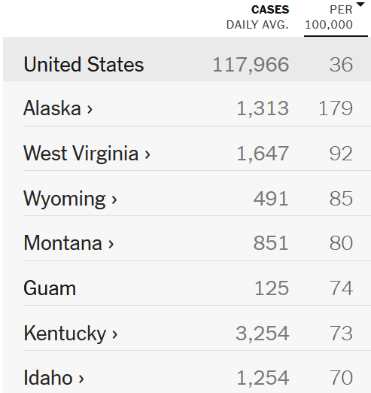

https://www.nytimes.com/interactive/2021/us/covid-cases.html

- What kind of measure of disease occurrence is “cases per 100,000”? Prevalence or incidence? If prevalence, what type of prevalence is it? If incidence, what type of incidence is it? Explain your answer. (1 pt)

- FOR DISCUSSION IN SECTION ONLY:
Given what we know about the clinical course of SARS-CoV-2 infection and COVID-19, describe some of the limitations in interpreting this metric of “cases per 100,000” to compare across regions.

(c) The following example describes what is popularly termed in the lay press as “case fatality rate”, or as stated in the figure “the ratio between confirmed deaths (from COVID-19) and confirmed cases (diagnoses of SARS-CoV-2).”

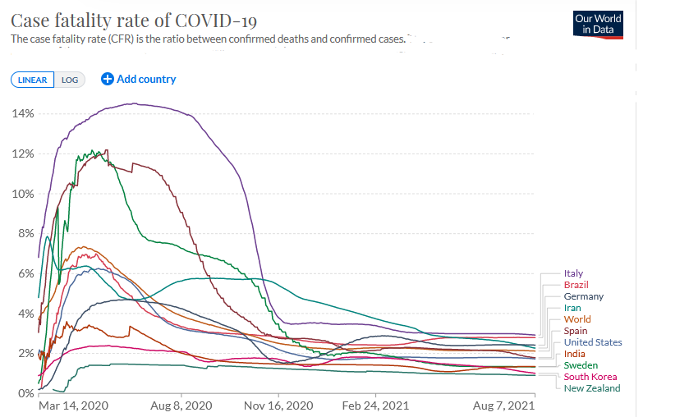

https://ourworldindata.org/mortality-risk-covid

What kind of measure of disease occurrence is this? Prevalence or incidence? If prevalence, what type of prevalence is it? If incidence, what type of incidence is it? Explain your answer. (1 pt)

- FOR DISCUSSION IN SECTION ONLY:
Given what we know about SARS-CoV-2 infection and COVID-19, describe some of the limitations in interpreting this metric of “case fatality rate” to compare across countries, as is depicted in the figure.

7. Read the following text from a manuscript describing an analysis of data from the Nurses Health Study, a fixed cohort study of women who had trained as nurses:

“We examined incidence rates of pancreatic cancer in a prospective cohort study of women. During follow-up (1976-1998), there were 2,476,165 years of person-time, and 243 new cases of pancreatic cancer were identified.”

Methodologic note: Information from participants was obtained by serial questionnaire sent to the participants’ homes.
Clinical note: Virtually all cases of pancreatic cancer get diagnosed prior to death, and, unfortunately, most cases die shortly after diagnosis.

(a) From the information provided above, calculate the incidence of pancreatic cancer in this study population. What type of incidence measure is this? (1 pt)

(b) Assume that the incidence determined in part (a) was constant throughout the experience of the cohort. An advocacy group approaches you for help in translating this number into metrics that lay people can better understand. They ask you to determine the 20-year cumulative incidence of pancreatic cancer in the Nurses Health Study population (starting at time of enrollment) with the numbers provided in the italicized statement above. Can you make a valid estimate? Discuss why or why not? (1 pt)

(c) During the study, there were 8172 deaths (from all causes) in 2,723,815 person-years of observation. Assuming the rate of death was constant throughout the period, determine the 20-year cumulative incidence of all-cause death and make sure to show your work. (1 pt)

(d) What other information about the study and its follow-up do you need to know in order to determine the validity of the estimate of the average incidence rate of pancreatic cancer among the women who were initially enrolled in the study? (1 pt)

(e) If you learned that the study had missed 47 cases of pancreatic cancer among women after they had been lost to follow-up, bias might be a concern. What result are you concerned could be biased, in which direction, and what is the strength of your conviction? Briefly explain your answer. (1 pt)

(f) FOR DISCUSSION IN SECTION ONLY:
If you were the authors of this study, what kind of specific things could you do to obtain the least biased estimate of the incidence rate of pancreatic cancer in this study population?

8. You have been asked to estimate the observed incidence of breast cancer recurrence among elderly women diagnosed and treated with early-stage breast cancer. The objective is to inform just how aggressive follow-up should be and whether more aggressive treatments in this population might be needed. There were 423 women studied for up to 5 years, contained in the dataset called “brcarecurrence.dta”, which is found on the course’s website. The variable time indicates the observation time (in months) for each woman, and the variable status depicts whether the woman developed breast cancer recurrence (status=1), was censored (status=0), or died from something other than breast cancer (status=2).

- You first give the dataset to your young research assistant and ask him to determine the 5-year cumulative incidence of breast cancer recurrence. He is new to the job but works fast and comes up with 59%. Prior to submitting the work as an abstract to a conference, you decide to recheck the work yourself and you come up with 24%. Why do you think your answers differ? (1 pt)

- How would you interpret, in a few sentences, the 59% your assistant estimated (i.e., what does it mean when applied to a population)? (1 pt)

(c) Using Stata, plot your best estimate of cumulative incidence of breast cancer recurrence. Label the x-axis and y-axis. Show your Stata commands with your plot. (2 pts extra credit)

9. Refer again to the Journal Club article by Ondrusova and Ondrus titled “Epidemiology and treatment delay in testicular cancer patients: a retrospective study”. The questions below are focused on their examination of testicular cancer mortality.

(a) In figure 1, it is not entirely clear what the authors are showing with respect to mortality. Considering the different formal possibilities for the numerator and denominator in the calculation of mortality, what are the formal possibilities as to what the authors are describing in their mortality calculation? Name at least two possibilities. (1 pt)

- Let’s assume, for a moment, that for the mortality calculation in figure 1, the numerator (i.e., the event) refers to “testicular cancer-specific deaths” and the denominator refers to the person-time of the general male population. Is this measure a good way of understanding whether treatment for testicular cancer has improved over time? Explain your answer. (1 pt)

- If you are interested in knowing how much treatment for testicular cancer has improved over calendar time, how would you approach the analysis (assume you had access to the same data from the Ondrusova and Ondrus analysis)? In other words, what would you calculate and report? (1 pt)

10. FOR DISCUSSION IN SECTION ONLY:
Consider the disease, health condition, or exposure that you are working on in your research or plan to work on. What measure of occurrence (incidence, prevalence, etc.) is used to best characterize the burden of this entity in relevant populations? Explain mechanically how this measure is obtained/performed. If there is no current method or process that achieves this, explain how you might undertake this.

11. FOR DISCUSSION IN SECTION ONLY:
Two groups of investigators set out to measure HIV incidence among women age 18 to 25 years in an urban community in South Africa. The community was chosen, in part, because it has a door-to-door census undertaken every 5 years (2005, 2010, and 2015 etc.) where all residents are enumerated (age, sex, and a variety of socioeconomic questions) and their HIV status is determined (this is offered free and is accepted by 99% of residents). The community also has a very active free HIV testing service that is available to all residents at several local community-based testing sites. To address the research question, one group of investigators used a fixed cohort study approach. They used the census from 2010 to identify all HIV-uninfected women age 18 to 25 years, drew a random sample of 2500 of them, and then asked them to participate in a 5 year cohort study in which they were then tested every year for HIV (amongst several other things) by the investigators. There were no refusals to participate. The women were given no special advising or counseling about HIV prevention. Because the women were tracked and tested even when they left the community, there was no loss to follow-up. The women in the cohort were censored when they reached 26 years old. This study estimated that HIV incidence was 5 cases per 100 person-years during the period from 2010 to 2015. The other group of investigators estimated the HIV incidence rate in the 2010 to 2015 period by using a dynamic cohort approach. They identified all HIV new diagnoses in women ages 18 to 25 as they were determined at the community testing sites (only women residing in the area were counted). Some of women found to have an incident HIV infection at the community testing sites were also in the dedicated 5-year cohort study described above. These latter investigators estimated the HIV incidence rate using the group method for person-time. This was done by taking the average of the total number of HIV-uninfected women between age 18 and 25 in 2010 and 2015 and then multiplying by 5 to get the total person-years experienced by HIV-uninfected women. The average incidence rate in this study (using the dynamic cohort approach) was 8 cases per 100 person-years, which was significantly greater than the 5 per 100 person-years estimated by the other research group (p<0.001), even after age adjustment for any differences in age structures. Both studies underwent rigorous peer review and were found to be conducted well (in particular, an individual-level person-time ascertainment of time spent while being HIV-uninfected was done in the dynamic cohort and found to closely match the group-level estimate). Aside from differences in behavioral modification caused by closer attention paid to the women in the fixed cohort (which is unlikely given the way the study was conducted), why might the dynamic cohort study approach estimate a higher incidence than the fixed cohort approach?

ANSWERS TO PRACTICE QUESTIONS 1a-c:

(a) Answer: Person-month rate = 9/857 person-months = 0.0105 per person-month.

(b) Answer: Using the Poisson table in Appendix A.2 in the Szklo and Nieto textbook: 9 events lower limit factor = 0.458 and upper limit factor = 1.90. 95% CI = (9 x 0.458)/857 and (9 x 1.90)/857 = 0.0048 to 0.0199 per person-month (or, with rounding to one significant digit, 0.005 to 0.02). Using Stata’s immediate command “cii means 857 9, poisson” yields an interval from 0.0048021 to 0.0199356. This command can be found in the lecture slides. [NOTE: if you are using an older version of Stata (pre-version 14), the immediate command would be as follows: “cii 857 9, poisson”]

(c) Answer: 857/12 = 71.4167; 9/71.4167 person-years = 0.126 per person-year = 12.6 per 100 person-years

