EPI 203: Epidemiologic Methods NAME: __________________________
Problem Set 8: Measurement Bias

Due: November 9, 2021 at 1:30 pm
Possible points: 30 (plus 3 extra credit)

Note: As always, when answering these questions please use the precise terminology introduced in lecture (e.g., misclassification of exposure/outcome; differential/non-differential misclassification; independent/dependent error) where appropriate.

1. PRACTICE QUESTIONS (please attempt to answer practice questions 1a-b, but it is not required that you type your answers into this document for the practice questions).

The following two graphs depict the impact of sensitivity and specificity in the measurement of the outcome in a randomized clinical trial with a dichotomous treatment assignment and a dichotomous outcome classification. Assume that treatment classification (i.e., measurement) is perfect. When the outcome is perfectly measured (100% sensitivity and specificity), the risk ratio (after 5 years) is 0.45. In the graphs, the y axis shows the risk ratio and 95% confidence interval; a risk ratio of 1.0 is shown with a dotted line for reference. In one graph, sensitivity of outcome measurement is varied and specificity is perfect. In the other graph, sensitivity of outcome measurement is perfect and specificity is varied.

(a) Label each graph appropriately to describe which scenario is being depicted.
Risk ratio and
confidence interval
confidence interval

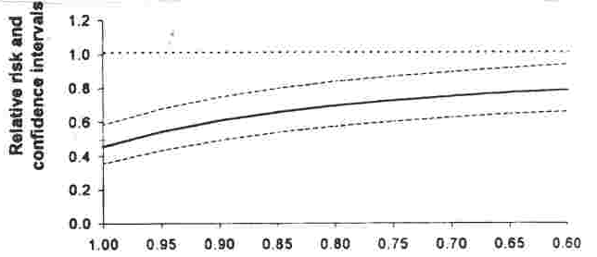 | 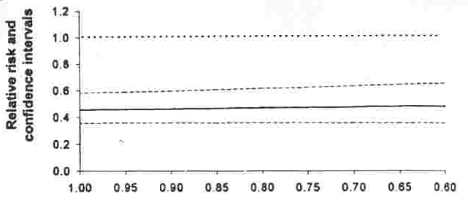  Risk ratio and  confidence interval  confidence interval

Practice question; click to see answer

(b) In clinical trials where the outcome measurement has perfect specificity, but imperfect sensitivity, describe the bias (i.e., direction of bias) in the risk ratio versus the bias in the risk difference and the number needed to treat (assume perfect measurement of the treatment used).

Practice question; click to see answer

2. PRACTICE QUESTION (please attempt to answer practice question 2, but it is not required that you type your answer into this document for the practice question).

When considering the effects of misclassification of either exposure or outcome, the prevalence of exposure or the incidence of outcome must also be considered in addition to sensitivity and specificity of the measurement. The following graph illustrates the effect of imperfect specificity of outcome measurement in a clinical trial where the true risk ratio is 0.5 and there is perfect sensitivity of outcome measurement. The horizontal dashed line denotes a risk ratio of 1.0 (no effect). Which of the lines represent a study with a cumulative disease incidence of 10% over 1 year in the placebo group and which line represents a study with a 1-year cumulative incidence of 40% in the placebo group?

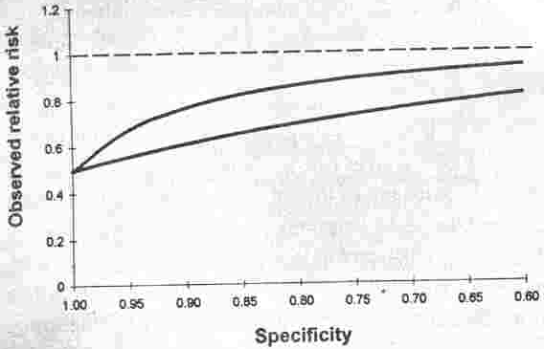
Observed Risk Ratio

Practice question; click to see answer

3. PRACTICE QUESTION (please attempt to answer practice question 3, but it is not required that you type your answer into this document for the practice question).

The U.S. National Institutes of Health has been interested in the impact COVID-19 has had on the professional lives of the researchers that it supports. To address this, all NIH-supported researchers were invited, via e-mail, to complete a questionnaire. The text of the e-mail is as follows.

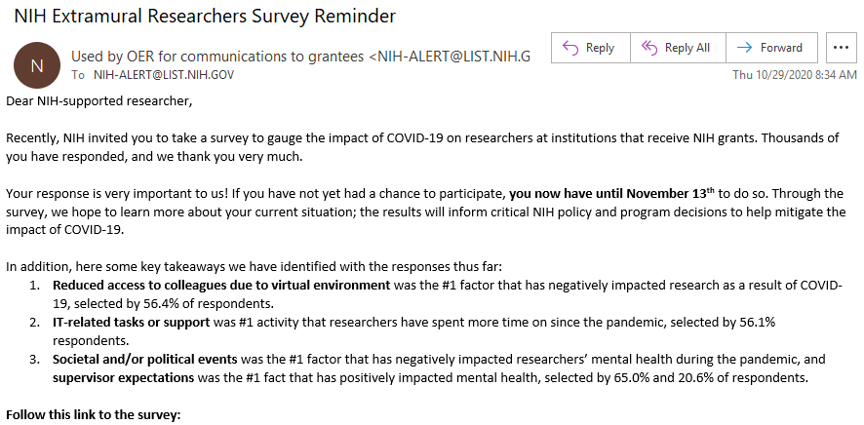
The source population is all researchers supported by the NIH. Do you perceive any threats to validity in the descriptive measures that will be inferred by using the responses to the questionnaire? Explain your answer.

Practice question; click to see answer

4. The following study evaluated whether antidepressant medication use is a cause of breast cancer. The source population is adult women in Canada. Clinical note: We will assume for this problem that women who are diagnosed with breast cancer either obtain this diagnosis because of an abnormal finding from a screening mammogram (x-ray of the breasts) or because they have developed symptoms which have caused them to seek medical attention. These diagnoses are 100% specific. The purpose of screening mammography is to detect breast cancer at a time when it does not yet cause any symptoms. Screening mammography requires interest by a woman and a medical provider to order the test. Not all women routinely undergo screening mammography, and thus some instances of incident breast cancer will not get detected until they manifest symptoms, which could, in some cases, take several years.

Abstract:
Experimental and epidemiologic studies suggest that antidepressant medication use may be associated with breast cancer risk. This hypothesis was investigated using a population-based case-control study; incident cases diagnosed in 2015 were identified using the Ontario Cancer Registry, and controls were randomly sampled from the Ontario census database. Data were collected using a self-administered questionnaire, and multivariable conditional logistic regression was used to estimate odds ratios and 95% confidence intervals. Compared with no anti-depressant use, use of prescription tricyclic antidepressants for greater than 2 years’ duration was associated with an elevated odds of breast cancer (OR=2.1).

Methods:

Cases: women aged 25 to 74 years, diagnosed with breast cancer (pathology report confirmed) during 2015 and recorded in the population-based Ontario Cancer Registry (whose goal is to capture all newly diagnosed cancer in the region). Cases were identified within a month of pathologic diagnosis.

Controls: women aged 25 to 74 years, randomly sampled from the census of Ontario and matched to index cases based on age, using incidence density sampling. Controls were identified within a month of each index case. Women provisionally sampled as controls were asked if they were ever diagnosed with breast cancer (to confirm outcome status) and if confirmed as having no diagnosis, they were included as controls. (Cases could be chosen as their own controls but this never occurred.)

Exposure data were collected through mailed self-administered questionnaires, which were distributed within a week of participant identification, to both cases and controls. Participants were told that this was a general study about breast cancer, but they were not told about any specific aspects of the underlying hypotheses. As is always the case in research, participation was voluntary. Prescription antidepressant use included information on duration, dosage, timing and type of medication prior to the breast cancer diagnosis (or prior to the selection date for the controls). Eleven examples of prescription antidepressant agents were included.

(a) An apparent association was found between tricyclic antidepressant (TCA) use for greater than 2 years’ duration (prior to breast cancer diagnosis) and breast cancer (OR=2.1). Explain a way that measurement bias could have accounted for the apparent association if, indeed, there truly is not an association. (1 pt)

(b) If you were conducting this case-control study, how would you perform the tricyclic antidepressant use measurement to avoid bias? (1 pt)

(c) Using the measurement bias “box and arrow” diagrams described in lecture (template below), depict how bias may be occurring. Please be sure to label the cells. (1 pt)

5. A study in Finland evaluated life satisfaction and 20-year mortality:

Abstract:
The authors investigated the role of self-reported life satisfaction in influencing mortality with a prospective cohort study. A nationwide random sample of healthy adults (18-64 years) responded to a questionnaire about life satisfaction (LS) in December 1995. A summary score for LS, a composite of interest in life, happiness, loneliness, and general ease of living (scale range 4-20), was determined and used as a two-category variable: the satisfied (LS = 4-11) (86%), and the dissatisfied (LS = 12-20) (14%). Mortality data (obtained through a national registry, deemed to be fully sensitive and specific), through 2015, were analyzed with Cox regression. Dissatisfaction was associated with increased mortality. The age-adjusted hazard ratios comparing dissatisfied individuals to satisfied individuals (reference group) for the occurrence of all-cause mortality, disease-related mortality, and injury-related mortality were 2.11 (95% CI, 1.68-2.64), 1.93 (95% CI, 1.40-2.39) and 3.01 (95% CI, 1.94-4.69), respectively. The authors conclude that self-reported life satisfaction may influence mortality and serve as a general health risk indicator.

Methods:
- Baseline questionnaire sent by mail in 1995.
- 31,133 participants responded. Eligibility for this study: deemed by self-reporting on a questionnaire as being healthy at baseline.

(a) If the entity of life satisfaction was measured with perfect accuracy and reproducibility and assuming no losses to follow-up, the following data would result at the end of 2015. Consider this the truth for this study population (although it is not adjusted for age):

Exposure | Outcome
Life satisfaction | Death (all cause) | No Death
(Exposed) Dissatisfied | 67 | 1673
(Unexposed) Satisfied | 187 | 9412

If you were the study author and had the data in the table above, what measure of association (between life satisfaction and mortality) would you report? Explain your choice and calculate the value of your preferred measure of association. (1 pt)

(b) For the actual study, measurement of life satisfaction was performed by self-report by using 4 short questions. Assume that a team of behavioral scientists assessed the validity of the 4 questions (versus a gold standard qualitative interview) and found it to be 90% sensitive for detecting dissatisfaction and 85% specific. How would this change the cells in the 2 x 2 table? Fill in the “observed” data table below. (1 pt)

Exposure | Outcome
Life satisfaction | Death (all cause) | No Death
(Exposed) Dissatisfied
(Unexposed) Satisfied

(c) Calculate the measure of association in the new “observed” table. (1 pt)

(d) Is this differential or non-differential misclassification? Of exposure or outcome? (1 pt)

(e) What is the direction of this measurement bias on the estimate of the measure of association? (1 pt)

(f) Is there dependency between the errors in the exposure and outcome measurement? Explain your answer. (1 pt)

(g) The Discussion section of a manuscript is where authors should describe the various threats to validity in their study and ramifications/manifestations of these threats. If you were writing the Discussion section for this paper, how would you describe the threat to validity (and the ramification/manifestation of this threat) posed by the imperfect validity of the measurement tool for life satisfaction (i.e., the 4 short questions) on the measures of association relating life satisfaction to mortality? Provide one or more well-written sentences. (2 pts)

(h) Using the measurement bias “box and arrow” diagrams described in lecture (template below), depict how bias may be occurring in this study. Remember to label the cells. (1 pt)

6. Prior to its withdrawal in 1983 the morning sickness drug Bendectin was widely used throughout the
world to treat nausea and vomiting (which is known as “morning sickness”) in pregnancy. Bendectin was first marketed in the U.S. in 1956, and it is estimated that the drug was used in 33 million pregnancies by 1983. Bendectin use ended in June 1983, when Merrell Dow Pharmaceuticals voluntarily withdrew the drug from the market because of an overwhelming number of lawsuits claiming that the drug caused some specific birth defects (congenital malformations).
One of the scientific studies that evaluated Bendectin is described in this abstract from the U.K:

Methods:
Bendectin exposure was ascertained by identifying all pregnant women residing in Leeds and Liverpool who filled prescriptions for Bendectin in one calendar year. These women were compared to all pregnant women from Leeds and Liverpool who did not fill prescriptions for Bendectin in the same calendar year. The primary outcome was defined as any congenital malformation (i.e., birth defect, in any organ system) as documented on physical examination by a certified pediatrician. All offspring were examined, including non-live born.

Results:
Among all pregnant women who used Bendectin, 1.9% (n=35) delivered a child with a congenital malformation. Among all pregnant women who did not fill prescriptions for Bendectin during this time period, 1.8% delivered a child with a congenital malformation. The difference between the groups was not statistically significant.

Conclusion:
We found no strong evidence to suggest that Bendectin is teratogenic (i.e., causes congenital malformations) in humans.
Assume that the method of ascertaining Bendectin prescription filling was 100% sensitive and specific for ascertaining Bendectin use (and that adherence was 100% after the prescription was filled) and that the measurement of all individual cases of congenital malformations was also 100% sensitive and specific. Comment on how the creation of the outcome variable in the analysis might have caused bias in addressing the research question of whether Bendectin is safe (i.e., whether it causes any single type of congenital malformation). Assume no selection bias and no confounding. (2 pts)

7. Consider the major finding from the following paper:
Jick H et al. Vaginal spermicides and congenital disorders. JAMA 1981;245:1329-32.

Among 763 liveborn infants of white women enrolled in the Seattle Group Health Cooperative who had obtained a vaginal spermicide in the ten months before conception, the prevalence of certain major congenital anomalies was 2.2%. The prevalence of such anomalies in a comparison group of 3,902 infants born to women presumed not to be users of vaginal spermicides (also enrolled in Seattle Group Health) was 1.0% (p = 0.002).

Methods:
Spermicide use was ascertained by assessment of computerized records of prescriptions filled at outpatient pharmacies. This information, as well data on congenital anomalies (which came from clinical examinations of all births), was obtained by the Seattle Group Health Cooperative computer system.

Following publication of this report, there were several letters to the JAMA editor:

Felarca LC et al. JAMA 246:2677, 1981.
To the Editor.-We have reviewed the article by Jick et al. As with another reviewer, we have found a disturbing number of flaws in the methodology.

The authors designate as a spermicide “user” any woman who filled a prescription for a spermicide within 600 days of delivery or abortion. This interval is extremely arbitrary. Moreover, no evidence is provided that “users” have been classified correctly. How many of the “nonusers” have used vaginal spermicides in the past and how many of the “users” used their spermicides infrequently or not at all? These questions are of critical importance.

Oakley GP. JAMA 247:2405, 1982.
Last year Jick and colleagues reported a cohort study of 4,665 patients from the Group Health Cooperative (GHC), Seattle, suggesting that presumed spermicide users had infants with a higher prevalence of malformations than presumed nonusers. They found a twofold increase in major malformations and specific increases for Down’s syndrome, limb reduction deformities and hypospadias.

One must have reservations about the accuracy with which infants were classified as exposed or unexposed. An infant was considered exposed if his mother had had a prescription filled by the GHC pharmacy within 600 days of birth. Although this definition is free of recall bias, as stressed by the authors, it has other serious problems. One cannot, for example, know whether or when the spermicides were used in relationship to a particular pregnancy.

The authors argue that the vast majority of GHC members who used spermicides obtained them from the GHC pharmacy. Their argument is not based on direct data, but rather on a study that showed that 98% of GHC women who took hormones, available only by prescription, obtained them from the pharmacy. The argument is weak, since spermicides are relatively cheap and widely available without prescription. I believe it likely that GHC members did purchase spermicides “on the outside,” perhaps a substantial proportion of them.

(a) If you were the author of the original article, how would you respond to these letters to the editor (i.e., do you agree that their concerns impact the validity of the study’s inference)? Draft a short paragraph response and make sure to provide justification. (2 pts)

(b) Do you see a role for dependency in error in the exposure and outcome measurements as a potential explanation for the findings? Explain you answer. (1 pt)

8. A new interval scale metric for sedentary lifestyle has been developed, and its ICC is estimated in adults age 40 to 65 years old (sampled from 4 US metropolitan areas) to be 0.74. Higher values on the new scale (which is completed via self-report) mean more sedentary lifestyle. The new measurement is then used in a cross-sectional study of inflammation (as measured by C-Reactive Protein (CRP) level in blood, a continuous variable). The authors found that, via a linear regression analysis, the mean CRP level was 0.30 units higher per each unit increase in the sedentary lifestyle measurement. (The 0.30 value, which is a measure of association, is derived from an ordinary least squares (OLS) regression coefficient in the linear regression analysis.) Calculate the expected true measure of association (sampling error aside) between sedentary lifestyle (as measured with this tool) and inflammation (as measured by CRP). Assume no selection bias, confounding, or sampling error, and assume that CRP is measured accurately and with full reproducibility. Note: subject matter knowledge regarding CRP is not necessary to answer this question.
(2 pts)

9. There is considerable interest in determining the prevalence of past infection with SARS-CoV-2, the causative viral agent of COVID-19. Knowledge of what fraction of a given population has been infected in the past provides valuable information as to how close a given community is to “herd immunity”. (Herd immunity refers to the presence of a sufficient fraction of people who are immune to a given infectious agent such that the agent cannot effectively be transmitted in the community.) Prevalence of past infection is determined by testing blood specimens for antibodies to SARS-CoV-2; such investigations are called “seroprevalence” studies. A variety of community-based seroprevalence studies for SARS-CoV-2 have been performed to date around the world. One such study of 1000 participants observed a seroprevalence of 9.9%, but it was criticized for using a test for SARS-CoV-2 antibodies that was far less accurate than other assays. The test had a sensitivity of 92.5% (based on 492 positive results among 532 patients with RNA-positivity-confirmed COVID-19) and a specificity of 96.8% (based on 633 negative results on 654 patients with blood specimens collected and banked in 2018). Assuming the assessment of the sensitivity and specificity of the antibody assay is unbiased, estimate the true seroprevalence (and accompanying 95% confidence interval) of SARS-CoV-2 in the study population. (2 pts)

10. The Heart Outcomes Prevention Evaluation (HOPE) study, a randomized double-blind clinical trial of the medication called ramipril (an angiotensin-converting enzyme inhibitor), reported that ramipril use significantly reduced the rates of all-cause death, heart attack, and stroke compared to placebo. A total of 9297 patients were randomized in this trial. In addition to the main outcomes of death, heart attack, and stroke, the paper also reported that significantly fewer patients in the ramipril group than in the placebo group developed a new diagnosis of diabetes (102 vs. 155; rate ratio = 0.66, p<0.001). Follow-up was described in the Methods section and was limited to the following text: “Follow-up visits occurred at one month after randomization and every six months thereafter. At each follow-up visit, data were collected on the main outcome events (death, heart attack, and stroke – all measured through comprehensive and systematic examination) … and any other self-reported diagnoses and side effects.” In other words, except for the death, heart attack, and stroke outcomes, the study depended upon self-report from the participants for the other outcomes.

a) Discuss how measurement bias could account for the finding that ramipril prevents development of diabetes when, in truth, it does not. (1 pt) (Clinical note: the diagnosis of diabetes requires testing of the blood or urine by a health care provider. Assume diagnosis of diabetes is 100% specific.)

b) Do you believe there can be dependency between the errors in the assigned exposure and outcome in this study? (1 pt)

11. In a case-control study of the association between heavy cell phone use and brain cancer, investigators observed the following data.

 | Brain cancer | No brain cancer
Heavy cell phone use | 46 | 118
Less than heavy cell phone use | 154 | 482

Heavy cell phone use was defined as use for average of 28 hours or more each week; this represents exposed individuals, while those with less than 28 hours were termed unexposed (i.e., the reference group). Cell phone use was recorded by a participant’s self-report. For a random sample of participants, however, in both the cases and controls, the self-report of cell phone use was able to be compared to actual daily cell phone billing records. This resulted in self-report of heavy cell phone use being determined to have a sensitivity of 70% amongst the cases and 85% in the non-cases; the specificity of the exposure measurement was 90% in both the cases and non-cases.

- Estimate the observed measure of association and, using the episensi command in Stata (instructions can be found in lecture slide notes), what the measure of association in the case-control study would have been (chance aside) if heavy cell phone use was measured without systematic error. Assume brain cancer was measured accurately and that there is no selection bias or confounding. Assume also that error in cell phone use measurement was independent of any other measurement errors. (3 pts)

- Being certain about the values of the sensitivity and specificity of the exposure measurement in the cases and controls and back-calculating to the expected truth is known as a deterministic sensitivity analysis. The word deterministic is used to depict a feeling of certainty and no randomness. It may be the case, however, that one is not quite certain about knowing the exact values and instead one would like to evaluate a range of sensitivity and specificity values. This is known as a probabilistic sensitivity analysis, and it can also be performed with the episensi command in Stata. Perform a probabilistic sensitivity analysis for this study. Assume that the sensitivities and specificity of exposure measurement (cell phone use) that are stated above are the most likely values but values plus or minus 10% (e.g., specificity ranges from 80% to 100%) are also possible. Assume a triangular distribution of the sensitivities and specificities. (3 pts extra credit)

12. A cross-sectional study was performed to evaluate the association between a new serum-based biomarker of inflammation (the exposure) and serum cholesterol (outcome). The biological samples used for the testing of both analytes were residual frozen specimens from a previously performed (in 2013) population-based study of HIV prevalence amongst adults age 18 years and over who lived in San Francisco Country. Because funding for that study had ended, the residual stored biological specimens had to be distributed to freezers of 5 different investigators who had available freezer space. In some cases, the specimens had to be handled and moved several times until available space was found. After having dichotomized the measurement of both the new biomarker and cholesterol, the researchers found a positive association between the two. Subsequently, several other groups of investigators, this time using fresh blood specimens from new population-based studies in 4 different cities in 2018 (including San Francisco) could not replicate the results; they saw no association. When performed on spiked saline samples (i.e., adding a known fixed amount of each analyte to salt water), the tests for both the new biomarker of inflammation and cholesterol are highly reproducible and accurate. In addition, the presence of either high or low levels of one of the analytes does not affect the ability to measure the other analyte. Other than chance, can you explain why the original study found an association between the new serum biomarker of inflammation and cholesterol while the later studies did not? (2 pts) (Note: assume no confounding or selection bias.)

13. The relationship between having an induced abortion (to be distinguished from a spontaneous abortion) and development of breast cancer has been hotly debated in the past with some studies finding an association but others not finding an association. This was further investigated in the Journal Club article for this week: Rookus et al. Induced Abortion and Risk for Breast Cancer: Reporting (Recall) Bias in a Dutch Case-Control Study. JNCI 1996.

The Introduction states that 12 prior studies have been performed evaluating the association between induced abortion and breast cancer. Eleven of these were case-control studies and one was a cohort study.

(a) Between case-control and cohort studies, which is least likely to suffer from independent differential (with respect to outcome) misclassification of exposure? Explain your answer. (1 pt)

(b) Using the measurement bias “box and arrows” diagrams described in lecture, depict the authors’ hypothesis as to why prior studies have shown an association between induced abortion and breast cancer. Remember to label the cells. (1 pt)

ANSWERS TO PRACTICE QUESTIONS 1a-b, 2, and 3:

1.
(a) Label each graph appropriately to describe which scenario is being depicted.
Risk ratio and
confidence interval
confidence interval

Risk ratio and
confidence interval
confidence interval

Answer: x axis is specificity Answer: x axis is sensitivity
Sensitivity is perfect, but specificity varies Sensitivity varies, but specificity is perfect

The graph on the right illustrates the important scenario of when specificity is perfect (100%), there is no bias in the risk ratio, regardless of the sensitivity of the outcome measurement (as long as any defects in sensitivity are non-differential with respect to exposure and independent with respect to any other measurements). This indicates the importance of choosing outcome measurements that have high specificity when the ratio measure is the desired measure of association. Adapted from Rodgers and MacMahon Thrombosis Haemostasis 1995.

(b) Answer: As is illustrated in the right panel above, when the outcome is measured with perfect specificity, the risk ratio is unbiased. However, even when specificity is perfect, if sensitivity is not perfect, the absolute risk difference will be biased towards the null hypothesis (i.e., biased towards zero). Therefore, the number needed to treat (NNT), which is 1/(risk difference) will be upwardly biased. The magnitude of bias in the risk difference is directly related to the imperfect sensitivity. The formula is: observed risk difference = (true risk difference)(sensitivity). This mathematical relationship can also be exploited after an analysis is complete. If we knew the value of sensitivity and that specificity was 100%, we could take the observed risk difference and back calculate to the truth (sampling error and other error notwithstanding). Such a back calculation (or correction) is a form of quantitative bias analysis.

2. Answer: The top line, which is closer to a risk ratio of 1.0 for every level of specificity, depicts the study with a lower cumulative incidence (10%) in the placebo group. This illustrates how problems in outcome measurements are magnified when disease incidence is lower. Adapted from Rodgers and MacMahon Thrombosis and Haemostasis 1995.

- Answer: We are told that the source population is all NIH-supported researchers and this work has a descriptive objective. Because the objective is descriptive, we are concerned about potential threats from selection bias and measurement bias. Confounding is not relevant in descriptive work. We immediately see threats to validity from selection bias and measurement bias. These threats are both caused by the leaders of this study showing potential respondents (those who have not yet participated) the interim findings of the study (e.g., increased burden from IT-related tasks). Regarding selection bias, being exposed to the interim results may influence one’s decision to participate. If one sees that one’s view has already been stated by others, this may influence the person to not bother to respond. Similarly, if one’s view has not already been represented, this may influence participation more so than other individuals. Unequal selection probabilities in a descriptive study may lead to bias. Regarding measurement bias, even if all NIH-supported researchers ultimately complete the questionnaire (i.e., no selection bias), seeing the interim results may influence the answers of those who responded later. For example, they may not have even thought of some of the factors that have impacted them during the COVID-19 pandemic (either because the issue is truly not bothering them or because they have, perhaps, suppressed it or have not recognized it). Seeing what others have stated may influence them to answer differently than if they had not seen other’s responses. We are now left with some persons who responded without any exposure to other’s answers and some persons who have responded after being exposed to other answers. While one could make an argument that we are interested in both, we likely do not have an unbiased measurement of either. The learning point here is that one should not show interim results of a study to future participants.

