Name:
Email:
Section Leader:

Epi 204 -- Problem Set #3
Chapter 3 Problems (Multi-level and continuous tests)
Upload to CLE by
10/7/2021 1:15 pm

46 points possible (+4 EC)
Do problems #1 – #5 below. Some of the problems are in Evidence-Based Diagnosis, 2nd Edition (EBD-2) with answers in the back of the book.
You may use whatever tools you like, including Excel, an online calculator, and Stata. Please respond clearly and directly to the questions.
(1, 5 in Book)
- Septic arthritis of the knee and WBC count in the joint fluid [10 points]
Septic arthritis is a bacterial infection in a joint. Patients with septic arthritis of the knee present with a painful, swollen, warm knee, but other conditions such as gout or pseudogout can cause a similar presentation. One test for septic arthritis is to insert a needle into the joint space, withdraw fluid, and send it to the lab for a white blood cell (WBC) count. Septic arthritis tends to cause higher WBC counts than the non-septic arthritis conditions. Patients with septic arthritis need IV antibiotics and a procedure to “wash out” the joint. Patients with gouty arthritis need anti-inflammatory medications.

You study 15 consecutive patients who presented to the emergency department with a painful, swollen, warm knee, and who had joint fluid WBC counts. On all 15 patients, a final diagnosis was established by an independent, valid gold standard. Five had septic arthritis, ten had something else. Here are the joint fluid WBC counts:

Septic Arthritis Not Septic Arthritis
30 0
37 6
64 7
112 8
128 12
12
23
37
48
71

We are going to ask you to draw the ROC curve, so we are doing you the favor of sorting the test results from most abnormal to least abnormal:

Septic Arthritis | No Septic Arthritis
128
112
 | 71
64
 | 48
37 | 37
30
 | 23
 | 12
 | 12
 | 8
 | 7
 | 6
 | 0

a. Draw an ROC curve for this test. [3]

b. Estimate the area under the ROC curve. (Hint: Count boxes below the ROC Curve and divide by the total number of boxes in the graph: 5 ×10 = 50 .) [2]
TP (Sensitivity)
(Sens

c. Now assign ranks to each distinct result. The highest result gets Rank = 1. Assign the average rank to ties. For example, if the same result appears twice after the result ranked 5, assign both occurrences the average rank (6 + 7)/2 = 6.5. If the same result occurs 3 times after the result ranked 2, assign all 3 occurrences the rank 4 (the average of 3, 4 and 5). You can write the ranks next to the values in the sorted list above. (Hint: you can check your answer by remembering that the sum of all of the ranks should = N × (N+1)/2, where N is the total number of subjects.) [3]

d. Now calculate the RANK SUM, S, as well as S_{min} and S_{max}. [1]

e. Now use the formula given in Chapter 3 to determine the area under the ROC curve from these ranks. You should get the same answer you got for part b above. Isn't that satisfying? [1]

2. CT Intracranial Mass Effect – Natural Language Processing [10 pts + 2 Extra Credit]
Since the brain is enclosed by the skull, swelling due to bleeding, infection, or inflammation is dangerous. This is called intracranial mass effect (IME). According to the Mortality Probability Model (EBD-2, Box 6.2), IME is an important predictor of mortality in ICU patients.

IME is diagnosed by CT scan of the brain, but the results of the CT appear in the electronic health record (EHR) as a free-text report dictated by the radiologist; there isn’t a <positive/inconclusive/negative> field dedicated to IME. Natural Language Processing (NLP) is a tool which may be used to extract <positive/inconclusive/negative> results from free text in the EHR.

In the CTIME Study trained reviewers assigned <yes/no> labels for IME to 1557 head CT reports on ICU-bound emergency department patients. An NLP algorithm was trained on 1202 and tested on 355 reports. The algorithm assigns a score between 0 and 1 to each report. The authors created 3 score ranges: positive, > 0.5; inconclusive, 0.05 to 0.5; negative, < 0.05. The test-set (validation) performance of the algorithm is summarized in the following table:

NLP Algorithm Category | Score Range | Average Score | CT IME+ by trained reviewer |  | CT IME− by trained reviewer |  |  | NLP Algorithm Pos/Inconclusive/Neg Category
NLP Algorithm Category | Score Range | Average Score | N | % | N | % | LR | Total N | %
Positive | >0.50 | 0.886 | 85 | 78.7% | 8 | 3.3% | 24.20 | 93 | 26.2%
Inconclusive | 0.05 -0.50 | 0.204 | 19 | 17.6% | 44 | 17.9% | ? | 63 | 17.7%
Negative | <0.05 | 0.008 | 4 | 3.7% | 195 | 78.9% | 0.05 | 199 | 56.1%
 | Total |  | 108 | 100.0% | 247 | 100.0% |  | 355 | 100.0%

  - In the test set of CT reports, what proportion were labelled by the trained (human) reviewers as IME+? [1]

  - What is the LR for the NLP “Inconclusive” result category? [1]
  - What proportion of reports categorized by the NLP algorithm as “Inconclusive” were IME+ by the trained reviewer? We are asking for P(IME+|”Inconclusive”). [2]

We are willing to accept the NLP categorization for IME when it is either “Positive” or “Negative”, but we must manually review all reports categorized as “Inconclusive”.

  - What proportion of reports require manual review? We are asking for P(“Inconclusive”). [1]
  - Does this depend (significantly) on the prevalence of IME+ in the sample? Please explain. [2]

The table above is what we call an LR table. Here is the corresponding ROC table, partially completed. We are assuming the human trained reviewers are the gold standard.

 | IME+ | Sensitivity | IME- | 1 - Specificity
>0.50 |  |  | 8 | 3.2%
>=0.05 |  |  | 52 | 21.1%
>=0 | 108 | 100.0% | 247 | 100.0%

  - Finish completing the ROC table. [2]
  - How many line segments will there be in the resulting ROC curve? [1]

  - Extra Credit) What is the AUROC corresponding to the table in (f)? [ +2 Extra Credits]

3. Platelet Count as test for Invasive Bacterial Infection [10 points]
Cruz et al (1) did a cross-sectional study to investigate using the platelet count to identify febrile infants < 60 days old with invasive bacterial infections (IBI) and reported these results.
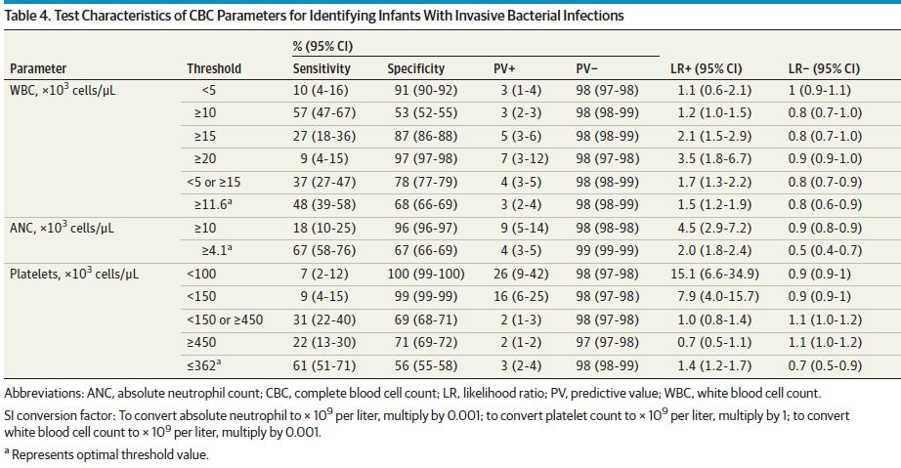
Here is the data table that gave rise to the above:
Platelet Count  × 10³ cells/μL | IBI+ | IBI- | Total
<100 | 7 | 16 | 23
100-<150 | 2 | 26 | 28
150-<450 | 67 | 2909 | 2976
450+ | 21 | 1265 | 1286
 | 97 | 4216 | 4313

- Admittedly some of the numbers are small, but what is the interval likelihood ratio for a platelet count of 100 - < 150 ×10³? (Show calculation.) [2]

- You are working with a population of patients whose prior probability of IBI you believe is very similar to the prevalence reported in this study. Your current patient is a febrile infant < 60 days old with a platelet count of 125 × 10³ cells/μL. Based on this study and the platelet count, what is your best estimate for the probability of IBI? Explain and show calculations.[2]

- Of the 4 platelet count intervals in the table above, which is most concerning for IBI? [1]

- What is the LR for a platelet count in that interval?[1]

- If your treatment threshold probability for IBI is 1% and the only test you were considering was the platelet count, what pre-test probability would allow you to skip the test and forgo treatment? [2]

- In Table 4 from the paper, the authors report an LR of 1.0 for platelets < 150 or ≥ 450. What is the LR for a platelet count 150 - < 450 ? [2]

4. Abbott Antibody Test for COVID-19 [10 points]
The Abbott Architect SARS-CoV-2 IgG test is a chemiluminescent immunoassay for IgG antibodies to the nucleocapsid antigen of the SARS-CoV-2 virus, used as a test for past SARS-CoV-2 infection. Vaccinated persons do not develop antibodies to the nucleocapsid antigen, so this test is used to determine whether someone has been previously infected with SARS-CoV-2, not vaccinated (but see the update at the end of this problem). For chemiluminescent assays, the strength of the light signal is a continuous variable directly related to the quantity of antibodies in the specimen. It is converted to a binary test result (positive or negative) by comparing to a cutoff. The manufacturer’s quantitative cutoff for calling this assay positive is 1.4. (The units of this measurement are not relevant to this problem; they are sometimes referred to as optical density units.)
An independent study by Public Health England (2)assessed the sensitivity of this test in 536 samples drawn 20 or more days after symptom onset from patients with PCR-documented SARS-CoV-2 infection. The sensitivity was 92.7% (497/536 95% CI 90.2 - 94.8%). The specificity was assessed in 994 pre-COVID era samples and was 99.9% (993/994 95% CI 99.4% - 100.0%).
The study published the following ROC curve:
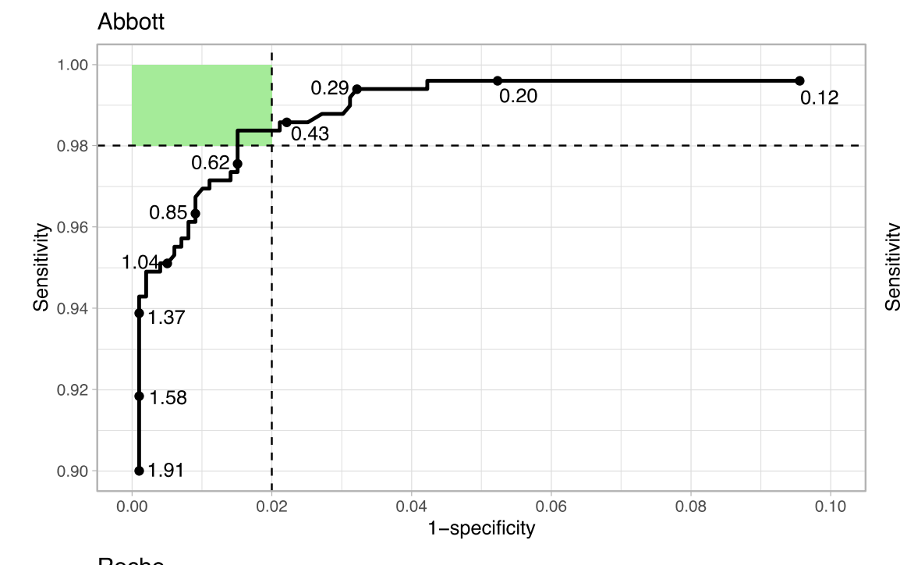
ROC curve for the Abbot assay. Assay values associated with 10 “exemplar points” on the ROC curve are shown. (536 D+ samples and 994 pre-pandemic D- samples.)
Note: We do not know how the 10 “exemplar points” (1.91, 1.58, 1.37, 1.04, …) were chosen.

- Mark and label the point on the ROC curve corresponding to the manufacturer’s cutoff that separates positive from negative. [2]

The authors of the Public Health England Study recommended 0.49 as an alternative to the manufacturer’s cutoff of 1.4. Here are the sensitivity and specificity at the 2 cutoffs:

 | D+ | Sensitivity | D- | 1 - Specificity
≥ 1.4 | 497 | 92.7% | 1 | 0.1%
≥ 0.49 | 526 | 98.1% | 15 | 1.5%
 | 536 | 100.0% | 994 | 100.0%

The lab starts reporting results as “negative” (< 0.49), “indeterminate” (0.49 - <1.4), and “positive” (≥ 1.4).

- What is the likelihood ratio for an indeterminate result? (Show your calculations.) [4]

The pre-test probability of past COVID infection of a random person in the San Francisco is about 5%. (3)
- If a randomly chosen person has an indeterminate result on the Abbott test, what is the probability of past infection? (Show your calculations.) [2]

- On the ROC curve above, draw a line segment corresponding to the indeterminate result. [2]

Update: This problem is based on data gathered within the first 6 months of the pandemic. It turns out that IgG levels decrease rapidly after their initial peak. Someone with an initial test result of 3 two months after infection will frequently decrease to below 1.4 within 6 months.

5. Number of Jurors to Convict [8 points + 2 Extra Credits]
Federal courts and most states in the US require that all 12 jurors agree on guilt before a defendant can be convicted. But in Oregon (and Louisiana until 2018), only 10 of the 12 jurors are needed to convict for noncapital cases.(3) (The Oregon legislature will reconsider this policy in 2019.(4)) Meanwhile, the material in Chapter 3 may help clarify some of the issues.
Simplify this problem by ignoring mistrials and considering only two possible verdicts: guilty and not guilty. In this analogy, a truly guilty defendant is like a patient with the disease, and an innocent defendant is like a patient without the disease, and a conviction by the jury is like a positive test.

- If you continue with the diagnostic test analogy, what would you call the proportion of innocent defendants who are acquitted? [1]

- If your only goal were to maximize "sensitivity," would you tend to favor the Oregon approach? Why or why not? [2]
- A key question for this debate is: what is the trade-off between "true positives" and "false positives"? That is, how much do you increase your chance of convicting someone who is innocent in order to convict more people who are guilty? This trade-off can be visualized with ROC curves. Draw two hypothetical ROC curves for this problem. Each curve should have the points labeled "10" and "12" on it for the number of jurors needed to convict. Make the first ROC curve one that would lead you unequivocally to support convictions with only 10 jurors voting guilty, and the other ROC curve one that would lead you unequivocally to oppose such split convictions. (Label the curves "Support" and "Oppose.") Explain your answer. [4]

d) One reason why rational people might disagree on whether to support split jury convictions is that their estimates of the slope of the ROC curve between the 10 and 12 juror points differ. Suppose two people agree completely on that. What are at least two additional reasons why they might still disagree on whether to change the law?
[1, +2 EC]

REFERENCES for Chapter 3 problems

1. Cruz AT, Mahajan P, Bonsu BK, Bennett JE, Levine DA, Alpern ER, et al. Accuracy of Complete Blood Cell Counts to Identify Febrile Infants 60 Days or Younger With Invasive Bacterial Infections. JAMA Pediatr. 2017 Nov 6;171(11):e172927.
2. Ainsworth M, Andersson M, Auckland K, Baillie JK, Barnes E, Beer S, et al. Performance characteristics of five immunoassays for SARS-CoV-2: a head-to-head benchmark comparison. Lancet Infect Dis. 2020 Dec;20(12):1390–400.
3. Routledge I, Epstein A, Takahashi S, Janson O, Hakim J, Duarte E, et al. Citywide serosurveillance of the initial SARS-CoV-2 outbreak in San Francisco using electronic health records. Nat Commun. 2021 Dec;12(1):3566.
4. Swenson D. Understanding Louisiana’s nonunanimous jury law findings: Interactive, animated slideshow. New Orleans Advocate [Internet]. 2018 Apr 1; Available from: https://www.theadvocate.com/new_orleans/news/courts/article_159e7f5a-3459-11e8-b935-e7a91fc85713.html
5. After Louisiana Vote, Oregon Lawmakers Want To Scrap Non-Unanimous Jury Law [Internet]. opb. [cited 2021 Sep 29]. Available from: https://www.opb.org/news/article/non-unanimous-jury-oregon-jim-crow-lousiana-vote/

The algorithm combined “term frequency–inverse document frequency” (tf-idf) vectorization with XGBoost, a tree-based ensemble machine learning method.
We must admit that material in Chapter 3 won't help with the fact that the intention of the just-repealed Louisiana law was overtly racist, which would be a reason to change the law even if one were agnostic about the shape of the ROC curves to be drawn later in the problem.
Hint: ROC "curves" need not be curved! In this case the ROC curves should be made up of straight line segments.

