Epi 204 -- Problem Set #4
Chapter 4 Problems (Studies of Diagnostic Test Accuracy)
Total Points: 41
Due 10/14/2021 1:15 pm

Do problems #1 – #5 below. You may use whatever tools you like, including Excel, an online calculator, and Stata. But please respond clearly and directly to the questions.

Question 1: Lyme Arthritis [5 points]

1. We introduced you to septic arthritis in adults last week. Children can also get hot, swollen, painful joints (acute arthritis), and as in adults, the most serious concern in children is a bacterial infection in the joint or septic arthritis. However, in areas where the tick-born illness Lyme disease is endemic, an acute arthritis can also be caused by systemic Lyme disease, which is different from septic arthritis. So, we are considering 3 different diagnoses: 1) septic arthritis, 2) Lyme arthritis, 3) neither (inflammatory arthritis). The C6 enzyme immunoassay (EIA) is a blood test for Lyme disease. Nigrovich et al (1) studied its performance as a test for Lyme arthritis in 911 children with acute arthritis. Here is the Methods portion of the abstract. (We underlined the 3 different diagnoses.):

Methods: We enrolled children with acute arthritis undergoing evaluation for Lyme disease presenting to a participating Pedi Lyme Net emergency department (2015-2019) and performed a C6 EIA test. We defined Lyme arthritis with a positive or equivocal C6 EIA test result followed by a positive supplemental immunoblot result. [We] defined septic arthritis as a positive synovial fluid culture result or a positive blood culture result with synovial fluid pleocytosis [lots of white blood cells in the fluid]. Otherwise, children were considered to have inflammatory arthritis. We report the sensitivity and specificity of the C6 EIA for the diagnosis of Lyme arthritis.

a) What was the reference (gold) standard for D+ in this study? [1 point]

b) We are not giving you the Results section of the abstract, but there were 211 D+ patients in this study. Again, without looking at the Results, can you determine what proportion of the 211 D+ patients were positive or equivocal on the index test, i.e. the sensitivity of the C6 EIA? If you can determine it, what is it? If you can’t determine it, what else do you need to know? [2 points]

c) Because none of the 250 children whose C6 EIA was positive or equivocal had septic arthritis, the authors concluded, "In the appropriate clinical scenario, children with a positive or equivocal C6 EIA result could safely avoid arthrocentesis [putting a needle in the joint to withdraw fluid] …" Assuming that ruling out septic arthritis is the only reason to do an arthrocentesis, would that estimate (0/250) be the appropriate statistic to guide that arthrocentesis decision in children with a positive or equivocal C6 EIA? Explain. [2 points]

2. Fecal Calprotectin for Organic Intestinal Disease [11 points]. Fecal calprotectin is a stool biomarker used to distinguish inflammatory bowel disease (Crohn’s disease and ulcerative colitis) and other organic intestinal diseases from so-called functional gut disorder (irritable bowel syndrome). Other organic intestinal disease is everything else, including celiac disease (severe gluten intolerance), infectious colitis, and (rarely) colon cancer.

Walker et al.(2) reported on 789 consecutive adults aged 18-46 years who presented to primary care providers with diarrhea or abdominal pain and were considered for referral to a specialist. All of the patients had a fecal calprotectin level obtained. They reported the following results.

 |  | Inflammatory Bowel Disease | Other Organic Intestinal Disease | Functional Gut Disorder | Total
Calprotectin µg/g | ≥ 100 | 43 | 21 | 68 | 132
Calprotectin µg/g | < 100 | 7 | 29 | 621 | 657
 | Total | 50 | 50 | 689 | 789

Assume that the assignment to the 3 disease groups was accurate. According to the paper, the purpose of the calprotectin test is to identify patients with functional gut disorder and avoid referring them to a specialist. Patients with inflammatory bowel disease and other organic intestinal disease should be referred.

- How should we define D+ and D- in this study? [2 points]

- Use you answer to Part a to fill in the 2×2 table below and calculate prevalence, sensitivity, specificity, PPV, and NPV. [5 points]
 |  | D+ | D-
Calprotectin µg/g | ≥ 100 |  |  | 132
Calprotectin µg/g | < 100 |  |  | 657
 |  |  |  | 789

The authors' calculations were as follows: Sensitivity 86%, Specificity 90%, Positive predictive value 38%, Negative predictive value 99%.

- How do these numbers compare to what you calculated in (b)? Which is the same and why? [2 points]

- If you did (b) correctly, your estimate of sensitivity was lower than 86%. Explain how this is due to spectrum bias. [1 point]

- You are a primary care provider like the ones in this study and your patient has a calprotectin < 100 ug/g. What is his probability of functional gut disease? [1 point]
3. Headache as a Sign of Hemorrhagic vs. Ischemic Stroke [4 points]. Based on a classic paper by Panzer et al(3), but some details have been modified.

Consider a study of the accuracy of headache in differentiating between hemorrhagic stroke (due to bleeding) and ischemic stroke (due to not enough blood flow, usually from a clot) in 179 patients with an acute neurologic deficit. The index test is current or recent headache (yes/no) and the gold standard is brain CT scan (hemorrhage – yes/no; everyone who does not have hemorrhage can be assumed to have an ischemic stroke):

 |  | Hemorrhage on CT
 |  | Yes | No
Headache | Yes | 23 | 87
Headache | No | 14 | 55
 |  | 37 | 142 | 179
There were an additional 195 patients with acute neurologic deficits who would have been eligible for inclusion but did not receive a CT (the gold standard) and therefore could not be included in the table above. None of these patients had a current or recent complaint of headache. Assume that 13 of these 195 excluded patients had a hemorrhagic stroke (further explanation for interested readers after part (c)):

No CT (and No Headache)
 |  | Hemorrhagic Stroke
 |  | Yes | No
 |  | 13 | 182 | 195

- Create a 2×2 table that includes these excluded individuals: [1 point]

- Based on all the information presented above, what is the best estimate of the sensitivity of headache for hemorrhagic stroke? [1 point]

- Exclusion of potential study subjects with negative index test results because they did not receive the gold standard as part of their clinical care has what effect on specificity? [2 points]

Further information for interested readers: In fact, Panzer et al had an unbiased sample in which the gold standard CT was obtained on all stroke patients regardless of headache and other (for the time) standard indications (vomiting and altered mental status) to obtain a head CT. They then simulated a biased sample by excluding from the original sample all patients without one of the indications. This left the initial table above. The excluded patients by definition did not have a headache and 13 of them had a hemorrhage. You recreated their unbiased sample in Part (a).

4. PoopMD [9 points]. Biliary atresia, (which we first met in PS#2) is a disease in which the bile ducts gradually close off and block the flow of bile from the liver. It is the most common reason for children to need a liver transplant. Although it is rare (about 4.5/100,000 births), its incidence appears to be increasing.(4) The disease process begins before or soon after birth, leading to a relapse or prolongation of the jaundice that is normal just after birth. There is evidence that earlier diagnosis and treatment improves outcome, hence there is interest in finding ways to make the diagnosis sooner. (5)

Because bile supplies color to the stools, one sign of biliary atresia is that the baby's stools become acholic. i.e., gray or clay-colored rather than the normal yellow, green or brown. Investigators from Johns Hopkins University(6) recently reported on a mobile phone app they call PoopMD, which parents can use to take and interpret photographs of dirty diapers to see whether the stools look acholic (Figure). (If you have a baby < 6 months old and want to participate in their study, you can download the free PoopMD+ app from Apple or Google stores.)

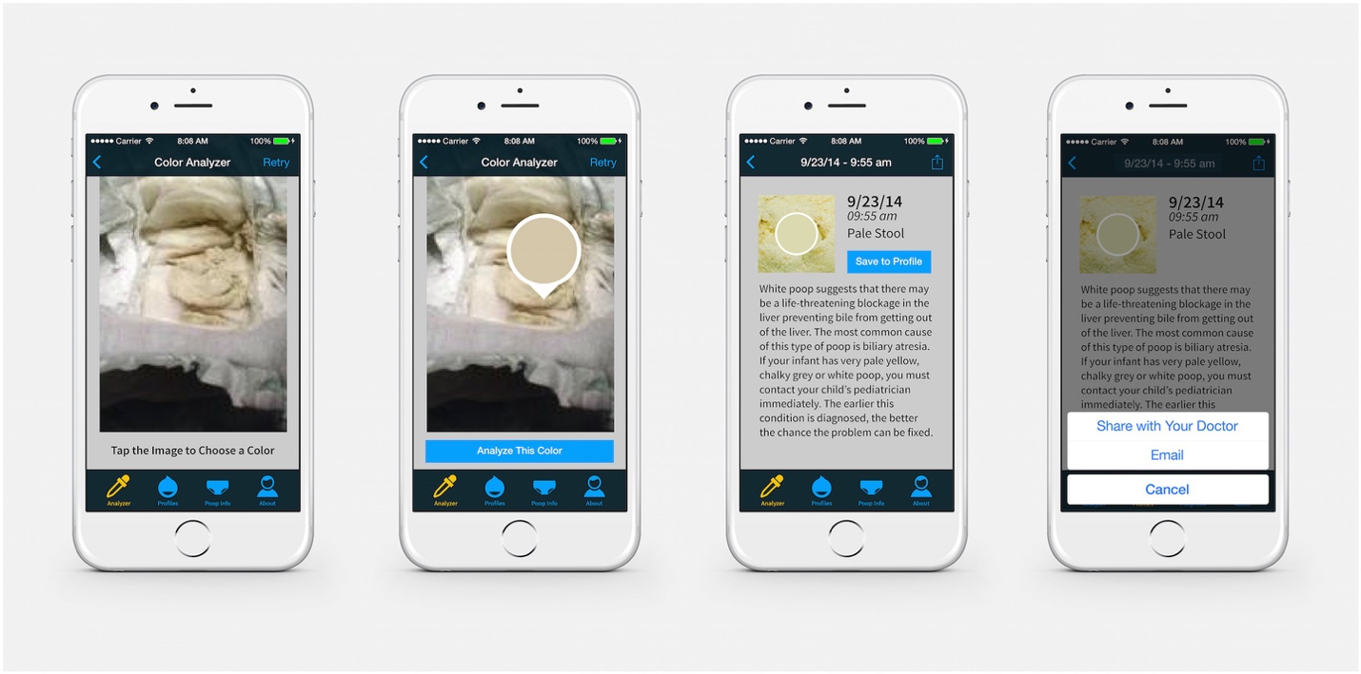Fig 2. Screenshots demonstrating PoopMD analytic functionality.

From the abstract: "In order to define the gold standard regarding stool color, seven pediatricians were asked to review 45 photographs of infant stool and rate them as acholic, normal, or indeterminate. Samples for which 6+ pediatricians demonstrated agreement defined the gold standard, and only these samples were included in the analysis."

Table 1 from their paper is shown below.
 | Gold Standard
PoopMD | Acholic | Normal | Indeterminate
Acholic | 7 | 0 | 0
Normal | 0 | 24 | 0
Indeterminate | 0 | 3 | 0
Total | 7 | 27 | 0
- Counting the "Indeterminate" PoopMD rating as false positives, as the authors did, and assuming (for now) that the gold standard was accurate for biliary atresia, what would be the positive predictive value of a positive PoopMD screen in the general population, assuming a prevalence of 4.5/100,000? Show your work. [2 points]

- You can see that only 34 of 45 photographs were included in the analysis. Would this be likely to bias the results? If so, name the bias and state how it would be likely to affect sensitivity and specificity. [4 points]

- The gold standard here was a consensus of pediatricians about the color of the stool, which is presumably an imperfect gold standard for the actual presence or absence of biliary atresia. If that is the case, in what direction do you think it would bias the estimates of sensitivity and specificity? Explain your answer. To get full credit you must commit yourself, not hedge. [3 points]

5. Elbow Extension Test for Elbow Fracture (EBD-2 4.2) [12 points]. Appelboam et al.(7) studied the elbow extension test (inability to fully extend the elbow) as a predictor of elbow fracture in 960 adult emergency department patients. All 647 patients who had a positive test (were unable to extend fully) received an x-ray (gold standard #1), but only 58 of the 313 patients with a negative test received an x-ray, of whom 2/58 = 3.5% showed fractures. The remaining 255 received clinical follow up for subsequent elbow problems (gold standard #2); only 3/255 = 1.2% had problems on follow up.
- Of the 647 patients with inability to fully extend the elbow (a positive test), 311 (48.1%) showed an elbow fracture. This 48.1% represents which index (Sensitivity, Specificity, Positive Predictive Value, Negative Predictive Value, etc.) of test accuracy? [1 point]

- As above, of the 313 patients who had a negative elbow extension test, 2 had a positive x-ray, and 3 had problems on clinical follow-up and should be interpreted as false negatives. Assuming that x-rays and clinical follow-up always give the same answer, what was the negative predictive value (NPV) of the elbow extension test? [1 point]

- Again, assuming that x-rays and clinical follow-up always give the same answer, create a 2x2 table using the numbers from part b above, and calculate sensitivity and specificity. [2 points]

- Now re-create the 2x2 table in (c) above but assume that the rate of x-ray positivity among those with normal elbow extension who did not receive x-rays would have been the same as among those who did. Under this assumption, 9 of the 255 patients receiving clinical follow-up would have had positive x-rays if all patients in the study received an x-ray as a single gold standard. Combined with the 2 patients with positive x-rays from among the 58 who actually received an x-ray, there would be a total of 11 patients with normal elbow extension and a positive x-ray. Calculate sensitivity, specificity, PPV, and NPV. [4 points]

- Under the assumption of Part (d) that 6 patients with negative index tests and negative clinical follow-up would have had a positive x-ray, how did using a differential gold standard in the actual study affect sensitivity and specificity relative to a study in which all patients received x-rays? [2 points]

- If you were willing to do up to 19 negative X-rays to find one elbow fracture, would the possibility of differential verification bias significantly affect your decision to trust the elbow extension test based on this study (assuming the observed prior probability is similar to yours)? [2 points]

REFERENCES

1. Nigrovic LE, Bennett JE, Balamuth F, Levas MN, Neville D, Lyons TW, et al. Diagnostic Performance of C6 Enzyme Immunoassay for Lyme Arthritis. Pediatrics. 2020;145(1).
2. Walker GJ, Moore L, Heerasing N, Hendy P, Perry MH, McDonald TJ, et al. Faecal calprotectin effectively excludes inflammatory bowel disease in 789 symptomatic young adults with/without alarm symptoms: a prospective UK primary care cohort study. Aliment Pharmacol Ther. 2018;47(8):1103-16.
3. Panzer RJ, Suchman AL, Griner PF. Workup bias in prediction research. Med Decis Making. 1987;7(2):115-9.
4. Hopkins PC, Yazigi N, Nylund CM. Incidence of Biliary Atresia and Timing of Hepatoportoenterostomy in the United States. J Pediatr. 2017;187:253-7.
5. Lien TH, Chang MH, Wu JF, Chen HL, Lee HC, Chen AC, et al. Effects of the infant stool color card screening program on 5-year outcome of biliary atresia in Taiwan. Hepatology. 2011;53(1):202-8.
6. Franciscovich A, Vaidya D, Doyle J, Bolinger J, Capdevila M, Rice M, et al. PoopMD, a Mobile Health Application, Accurately Identifies Infant Acholic Stools. PLoS One. 2015;10(7):e0132270.
7. Appelboam A, Reuben AD, Benger JR, Beech F, Dutson J, Haig S, et al. Elbow extension test to rule out elbow fracture: multicentre, prospective validation and observational study of diagnostic accuracy in adults and children. BMJ. 2008;337:a2428.

