Epi 204 -- Problem Set #5
Chapter 6 ANSWERS (Risk Prediction)
Due 10/21/2021 1:15 pm

Note: Both 1 and 2 below have versions with answers in the book, but the versions in the book are different. Make sure to do the versions below. #4 was submitted by students for last year’s final exam. If you would like incorrect answers to be considered for partial credit, please show your work.

TOTAL: 45 pts (+6 Extra Credit)

- Meteorologists on Two Television Channels [11 points + 6 EC points] During a rainy month, you watch the weather report and decide whether to carry an umbrella. Your decision is irrevocable in that, if you decide not to carry an umbrella and head off to work and it rains, you can’t change your mind. You have decided that being in the rain without an umbrella is exactly 3 times as bad as carrying an umbrella unnecessarily.

The Channel 2 meteorologist predicts a 33% chance of rain on every single day of the month. The Channel 3 meteorologist predicts a 50% chance of rain on two-thirds of the days and a 100% chance of rain on one third of the days. At the end of the month, it turns out that it rained on 10 out of 30 days. It also turns out that every time the Channel 3 meteorologist predicted a 50% chance of rain, it didn’t rain; and every time she predicted a 100% chance of rain, it did.

- What is your threshold probability of rain for carrying an umbrella? [1]
Threshold odds = 1/3 à Threshold probability = ¼ or 25%
P_{TT} = C / (C + B) = C / (C + 3C) = C / 4C = ¼

- If you watched and believed the Channel 2 meteorologist, how many days of the month did you carry an umbrella? [1]
Every day, because 33% > 25% (if you were acting perfectly rationally based on your threshold probability)

- If you watched and believed the Channel 3 meteorologist, how many days of the month did you carry an umbrella? [1]
Every day, because both 100% and 50% are > 25% (if you were acting perfectly rationally based on your threshold probability)

- What is the average predicted chance of rain for Channel 2? What is it for Channel 3? [2]
Channel 2: 33%
Channel 3: 1/3 × 100% + 2/3 × 50% = 67% (weighted average)

- Calculate the Mean Bias, Mean Absolute Error, and Brier Score for each meteorologist and fill out the shaded cells in the following table: [5 pts total, 1 pt per answer]

Note: In calculating mean bias, MAE, and Brier Score, previous students assumed the risk groups were equal in size, but one risk group has two-thirds of the observations. So, we are giving you the mean bias for Channel 3. This is the weighted mean of the bias in the two risk groups. r = risk prediction; o = outcome (1 for rain, 0 for no rain). The error for the 50% risk group is r – o = 0.5 – 0 = 0.5. The error for the 100% risk group is r – o = 1 – 1 = 0, so the weighted mean is 20/30 × 0.5 + 10/30 × 0 = 0.333.

Predicted |  | Actual |  | Error (Predicted-Actual)
Channel 2
Risk  prediction | N | Rained | Proportion rained | Rain  day | No-rain  day | Mean  bias | Mean absolute error | Brier score
0.33 | 30 | 10 | 0.333 | -0.67 | 0.33
Channel 3
0.50 | 20 | 0 | 0 |  | 0.50
1.00 | 10 | 10 | 1 | 0
Total | 30 | 10 | 0.333 |  |  | 0.333

Channel 2 calculations
Mean Bias: 10 rain days with error 0.33 – 1 = –0.67 and 20 no-rain days with error 0.33 – 0 = 0.33.
10/30 × –0.67 + 20/30 × 0.33 ≈ 0
MAE: 10 rain days with error |0.33 – 1| = 0.67 and 20 no-rain days with error |0.33 – 0| = 0.33
10/30 × 0.67 + 20/30 ×0.33 ≈ 0.44
Brier Score: 10 rain days with error (0.33 – 1)² = 0.45 and 20 no-rain days with error (0.33 – 0)² = 0.11
10/30 × 0.45 + 20/30 × 0.11 ≈ 0.22

Channel 3 calculations
Mean Bias: 10 rain days with error 1 - 1 = 0 and 20 no-rain days with error 0.5 – 0 = 0.5.
10/30 × 0 + 20/30 × 0.5 ≈ 0.33 (given in question prompt)
MAE: 10 rain days with error |1 – 1| = 0 and 20 no-rain days with error |0.5 – 0| = 0.5
10/30 × 0 + 20/30 × 0.5 ≈ 0.33
Brier Score: 10 rain days with error (1 – 1)² = 0 and 20 no-rain days with error (0.5 – 0)² = 0.25.
10/30 × 0 + 20/30 ×0.25 ≈ 0.17

Predicted |  | Actual |  | Error (Predicted-Actual)
Channel 2
Risk  prediction | N | Rained | Proportion rained | Rain  day | No-rain  day | Mean  bias | Mean absolute error | Brier score
0.33 | 30 | 10 | 0.333 | -0.67 | 0.33 | -0.003 | 0.444 | 0.222
Channel 3
0.50 | 20 | 0 | 0 |  | 0.50
1.00 | 10 | 10 | 1 | 0
Total | 30 | 10 | 0.333 |  |  | 0.333 | 0.333 | 0.167

Stata code
expand count /*This command duplicates each observation "count" times, to create a 1-record per day dataset for each channel*/
drop if count==0
sort channel predict rain
list channel predict rain
brier rain pred if channel==2
brier rain pred if channel==3

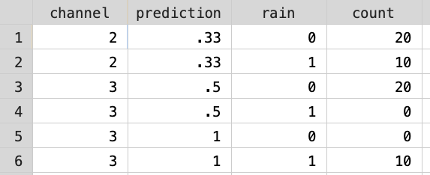

. brier rain pred if channel==2

Mean probability of outcome 0.3333
of forecast 0.3300

Correlation .
ROC area 0.5000 p = .

Brier score 0.2222
Spiegelhalter's z-statistic 0.0388 p = 0.4845
Sanders-modified Brier score 0.2222
Sanders resolution 0.2222
Outcome index variance 0.2222
Murphy resolution 0.0000
Reliability-in-the-small 0.0000
Forecast variance 0.0000
Excess forecast variance 0.0000
Minimum forecast variance 0.0000
Reliability-in-the-large 0.0000
2*Forecast-Outcome-Covar 0.0000

. brier rain pred if channel==3

Mean probability of outcome 0.3333
of forecast 0.6667

Correlation 1.0000
ROC area 1.0000 p = 0.0000

Brier score 0.1667
Spiegelhalter's z-statistic . p = .
Sanders-modified Brier score 0.1667
Sanders resolution 0.0000
Outcome index variance 0.2222
Murphy resolution 0.2222
Reliability-in-the-small 0.1667
Forecast variance 0.0556
Excess forecast variance 0.0000
Minimum forecast variance 0.0556
Reliability-in-the-large 0.1111
2*Forecast-Outcome-Covar 0.2222

- Assuming discrimination and calibration of each channel’s meteorologist will be similar next month, which channel should you watch and when should you carry an umbrella? [1]
You should watch the Channel 3 meteorologist and carry an umbrella when she says there is a 100% chance of rain but not when she says the chance is 50%. You are able to re-calibrate and capitalize on the perfect discrimination on Channel 3.

- (Extra Credit) [+6 pts total, 0.5 pts per answer] The Brier Score can be decomposed into “Calibration Error” and “Refinement Loss” as follows:
r_{k} = predicted risk in group k
p_{k} = proportion with outcome in group k
f_{k} = fraction of population in group k

f_{k}-weighted averages:
Brier Score = ∑ f_{k} × [p_{k}(1 - r_{k} )² + (1 – p_{k}) (0 – r_{k})²]
Calibration Error = ∑ f_{k} × (r_{k} – p_{k})²
Refinement Loss = ∑ f_{k} × p_{k}(1-p_{k})
Brier Score = Calibration Error + Refinement Loss

Fill in the following table and state which channel has better calibration, and which has better discrimination.
 | Risk Prediction  (r_{k}) | N | Rained | Proportion Rained  (p_{k}) | Calibration Error  (r_{k}-p_{k})² | Refinement Loss  p_{k}(1-p_{k}) | Squared Error (Brier Score)
Channel 2
 | 33% | 30 | 10 | 0.333
Channel 3
 | 50% | 20 | 0 | 0.000
 | 100% | 10 | 10 | 1.000
 | Total | 30

Begin Answer:
 | Risk Prediction  (r_{k}) | N | Rained | Proportion Rained  (p_{k}) | Calibration Error  (r_{k}-p_{k})² | Refinement Loss  p_{k}(1-p_{k}) | Squared Error (Brier Score)
Channel 2
 | 33% | 30 | 10 | 0.333 | 0.00 | 0.222 | 0.222
Channel 3
 | 50% | 20 | 0 | 0.000 | 0.25 | 0.000 | 0.250
 | 100% | 10 | 10 | 1.000 | 0.00 | 0.000 | 0.000
 | Total | 30 |  |  | 0.167 | 0.000 | 0.167

Channel 2 has better calibration (calibration error = 0), and Channel 3 has better discrimination (refinement loss = 0).

Note that Channel 2’s error is entirely due to Refinement Loss (lack of discrimination) and Channel 3’s error is entirely due to poor calibration.

Channel 2
Calibration error = (0.33-0.33)²=0
Refinement loss = 10/30(1-0.33)=0.22
Squared error = 0 + 0.22 = 0.22

Channel 3

50% risk prediction
Calibration error = (0.50-0)²=0.25
Refinement loss = 0/30(1-0)=0
Squared error = 0.25+0=0.25

100% risk prediction
Calibration error = (1-1)²=0
Refinement loss = 30/30(1-1)=0
Squared error = 0

Total Channel 3
Calibration error = 20/30(0.25) + 10/30(0) = 0.167
Refinement loss = 0
Squared error 20/30(25) + 10/30(0) = 0.167

- ABCD2 Score to predict stroke after a transient ischemic attack [10 points] The ABCD2 Score was developed to estimate the risk of stroke in patients after a transient ischemic attack (TIA, a brief period of neurological symptoms due to diminished blood flow to the brain).(1) (EBD-2 Problem 6.2)

For your information, here is how the ABCD2 score is calculated.
Risk Factor |  | Points
Age
 | ≥ 60 years | 1
Blood Pressure
 | Systolic ≥ 140 mm Hg or Diastolic ≥ 90 mm Hg | 1
Clinical features of the TIA
 | Unilateral weakness (with or without speech impairment) | 2
 | Speech impairment without unilateral weakness | 1
Duration
 | TIA duration ≥ 60 minutes | 2
 | TIA duration 10-59 minutes | 1
Diabetes
 | Diabetes diagnosed by a physician | 1
 | Total ABCD2 Score | 0 – 7

The 2-day risk of stroke by ABCD2 score is shown below:
Score | % of TIA Patients | 2-day Stroke Risk
0-3 | 34% | 1.0%
4-5 | 45% | 4.1%
6-7 | 21% | 8.1%

Throughout this problem, you may assume that these 2-day stroke risks are accurate, i.e., that they are perfectly calibrated.

One of the main reasons for hospitalizing a patient after TIA is to enable rapid treatment with thrombolytics (to dissolve blood clots) if the patient has a subsequent stroke in the next 2 days.

- Assume you are willing to admit 30 patients to the hospital for 2 days unnecessarily in order to avoid discharging one from the emergency department who goes home to have a stroke in the next 2 days. What is your ABCD2 score cutoff for hospitalization? [2]
Using terminology from Chapter 2, 30C=B, so the treatment threshold of C/(C+B) = 1/31 = 3.2%. Based on the table above, a safe and reasonable answer would be to admit when the score is ≥ 4 and the 2-day stroke risk is 4.1%.

With 0-3 and 4-5 grouped together, you might ask if a score or 3 might get the risk above 3.2% or a score of 4 might get the risk below 3.2%. We can’t tell from this data.

We will convert the table of 2-day risks above into an ROC table and calculate the area under it. First, order the results from most to least abnormal:
Score | % of TIA Patients | 2-day Stroke Risk
6-7 | 21% | 8.10%
4-5 | 45% | 4.10%
0-3 | 34% | 1.00%

Next, calculate the individual cell percentages. To get the D+ column, we multiply the proportion of patients in each risk stratum by the 2-day stroke rate in that stratum. Thus, e.g. if we had 10,000 patients, 21% (=2100) would have a score of 6-7 and 8.1% of those 2100 = 170 would have a stroke. So the top D+ cell would be 170/10,000 = 1.70%.
Score | D+ | D- | % of TIA Patients
6-7 | 1.70% | 19.30% | 21%
4-5 | 1.85% | 43.16% | 45%
0-3 | 0.34% | 33.66% | 34%
Total | 3.89% | 96.11% | 100.00%

Then, calculate the column percentages. For example, for the top D+ cell, 1.70%/3.89% = 43.77%.
Score | D+ | D-
6-7 | 43.77% | 20.08%
4-5 | 47.48% | 44.90%
0-3 | 8.75% | 35.02%
Total | 100.00% | 100.00%

Finally, change them to cumulative percentages.
Score | D+ | D-
≥ 6 | 43.77% | 20.08%
≥ 4 | 91.25% | 64.98%
≥ 0 | 100.00% | 100.00%

- Use the above ROC Table to plot the ROC curve on the grid below.[2]
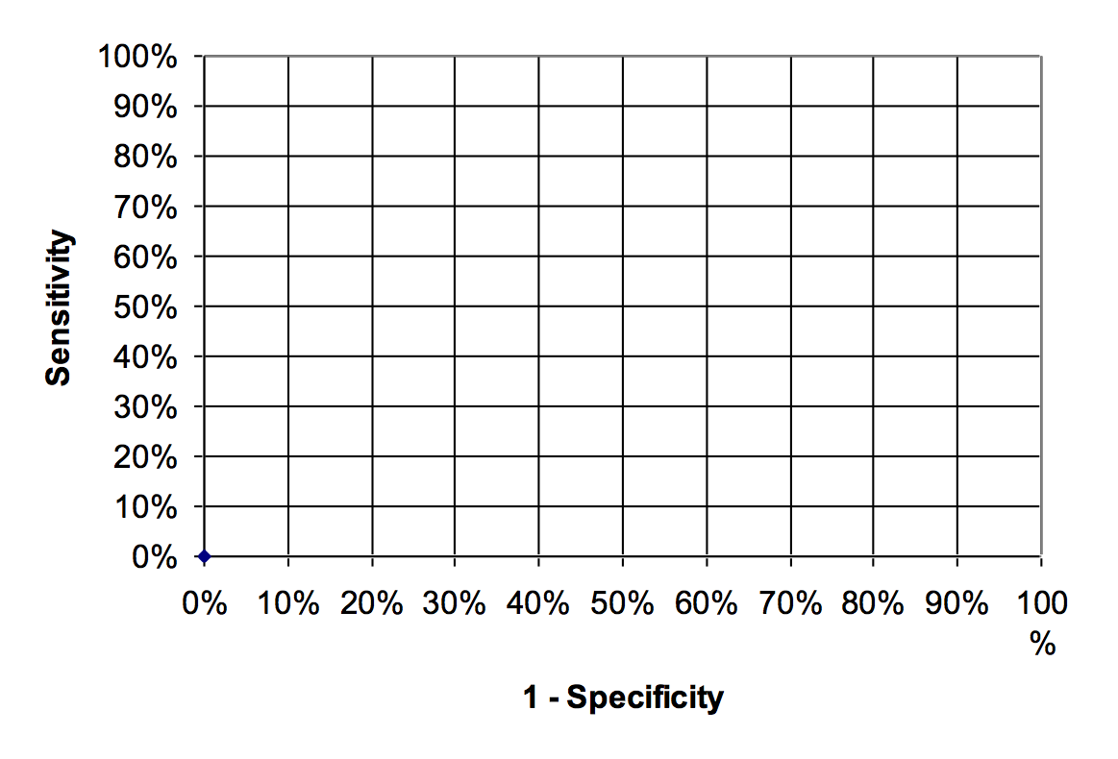

ANSWER
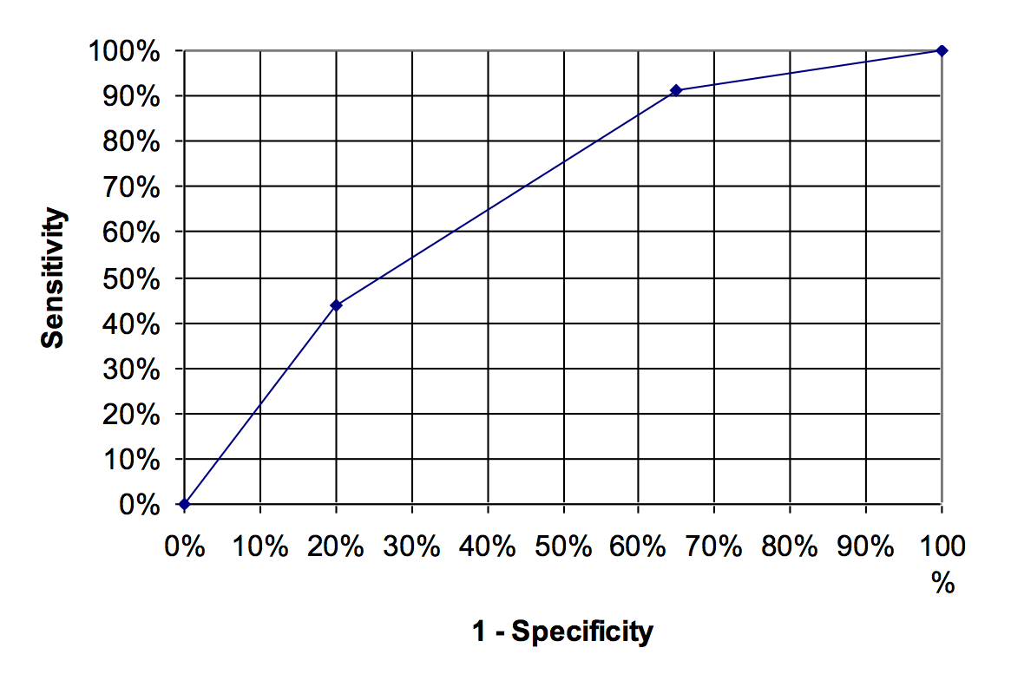
AUROC = 0.68

- If you didn’t admit any TIA patients (“No Treat”), what proportion would have a stroke within 2 days? (In part (h) below, we will refer to this as P, overall risk, i.e. the proportion of the population who ultimately develop the outcome within the specified time period.) [1]
3.89% (from the second table after part B)

- If you admitted all TIA patients (“Treat All”), what proportion would you admit unnecessarily? [1]
100% – 3.89% = 96.11% (the proportion of those that did not develop stroke within 2 days and thus had unnecessary admissions)

Remember that an unnecessary admission of a TIA patient who doesn’t have a stroke in the next 2 days is 1/30 as bad as failing to admit someone who does have a stroke in the next 2 days.

- Calculate the Net Benefit of the Treat All strategy relative to treat none. Recall the equation for Net Benefit (shown below), and explain in words what it means. [2]

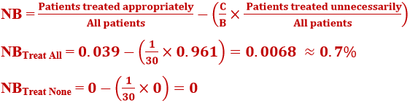
If you could just treat the patients destined to have a stroke, the NB would be 3.9%. But in order to treat them, you are admitting 96.1% unnecessarily at a “cost” of 96.1%/30 = 3.2%. The net benefit is 3.9% - 3.2% = 0.7%. The expected net benefit per TIA patient is 0.007 times the benefit of admitting someone who has a stroke within 48 hours.

One of the problems with NB calculations is that even the maximum NB is very low when the outcome is rare.

- Calculate the Net Benefit of a hospitalization strategy using the ABCD2 cutoff in (a). Is it higher or lower than the NB of the “Treat All” strategy? [2]
If we use the cutoff in part (a), according to the ROC table above, we will appropriately treat 91.25% of the 3.89% destined to have a stroke, so the left half of the net benefit calculation is 91.25% × 3.89% = 3.6%. We will unnecessarily treat 65% of the (100% − 3.89%=) 96.11% of the subjects destined not to have a stroke, a total of 62.5%. That's only 1/30 as bad, so we'll multiply by C/B= 1/30 to get .6245/30=2.1%. So our net benefit is 3.6% – 2.1% = 1.5%. The expected net benefit per TIA patient tested is 0.015 times the benefit of admitting someone who has a stroke within 48 hours.

This is higher than the treat all strategy, and it’s roughly 1/4 as good as a “clairvoyant” strategy to admit only patients destined to have a stroke.

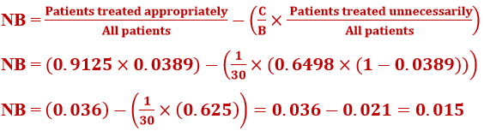

- Testing the NLST Lung-Cancer Mortality Risk Model [15 pts] The National Lung Screening Trial (NLST) was a randomized trial of low-dose CT scanning for the early detection of lung cancer. It was used to create the NLST Lung-Cancer Mortality Risk Model to predict the risk of dying from lung cancer in the next 5 years among current and former heavy smokers (in the control group, which was screened with annual chest x-rays).(2) It was tested (validated) in a dataset of 15,114 NLST-eligible smokers between the ages of 55 and 74 years who were enrolled in the chest x-ray group of the Prostate, Lung, Colorectal, and Ovarian (PLCO) Cancer Screening Trial.

The table below shows the predicted risk and outcomes in 5 equal-sized groups. Assume that the Predicted Risk (r) applies to all individuals in the group.
Risk Group | Predicted (r) | n in risk group | Deaths | Survived | Observed (p)
5 | 4.04% | 3023 | 137 | 2886 | 4.53%
4 | 1.71% | 3023 | 59 | 2964 | 1.95%
3 | 1.07% | 3023 | 40 | 2983 | 1.32%
2 | 0.64% | 3023 | 14 | 3009 | 0.46%
1 | 0.29% | 3022 | 6 | 3016 | 0.20%
Total | 0.0155 | 15114 | 256 | 14858 | 1.69%

The purpose of this risk model is to guide whom to enroll in a CT-screening program.

- Assume CT scanning one D+ individual (who would die of lung CA in the next 5 years in the absence of screening) is worth CT scanning 100 D- (who would not die). What are the treatment threshold odds (C/B) and probability (P_{tt})? [1]
C/B = 1/100. P_{tt} = 1/101 = 0.99%

- According to the risk model, which groups should be screened? [1]
Groups 3,4, and 5 (since all have predicted risk > P_{tt} of 0.99%)

- How many true positives (D+ screened) and false positives (D– screened) would there have been if screening had been done according to your answer in part b? [2]
True positives: deaths in the top 3 quintiles = 137 + 59 + 40 = 236 D+ screened
False positives: people in the top 3 quintiles who survived= 2886 + 2964 + 2983 = 8833 D– screened

- What is the Net Benefit of using the model, assuming the C/B calculated in (a)? [2]
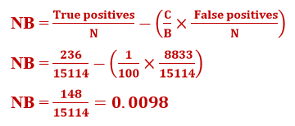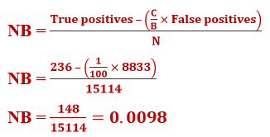

I (MAK) prefer the 148 to the 0.0098. Understanding the 148 means knowing that the total number of individuals in the sample was 15114. This means that if you apply the risk model to the 15114 in the sample, you will get 148 true-positive “equivalents.” You can compare this to the maximum number of true positives you could get if you discriminated perfectly and screened only those 256 destined to die without screening. The standardized NB (sNB) is 148/256 = 0.58.

The 0.0098 does not require knowing the sample population size. For every person to whom you apply the risk model, you get 0.0098 of the benefit of “treating” (screening) a D+ individual. You can compare this to the best you could do if the model perfectly identified D+, but you need to know that the probability a person is D+ is 1.69%. The sNB is 0.0098/0.0169 = 0.58. Of course, the sNB is the same either way; I just prefer thinking in terms of 148 out of 15114 instead of 0.0098. One represents a count of individuals. The other represents the fraction of an individual.

- What is the Net Benefit of screening all individuals? What is the Net Benefit of screening nobody? [3]
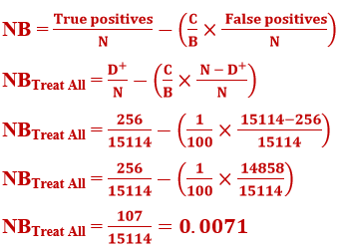
I (MAK) prefer the 107 to the 0.0071

NB(Treat None) = 0 by definition

- Now calculate the Net Benefit of using the risk model if screening a D– individual unnecessarily is twice as bad. In other words, you would only be willing to screen 50 D – to avoid missing one D+. [3]
C/B = 1/50, so P_{tt} = 1/51 (1.96%)

The key is to realize that now you would only screen Risk Group 5.
TP = 137 and FP = 2886 (from first row of table in question prompt)

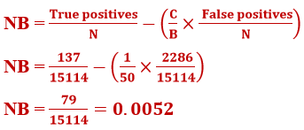
I (MAK) prefer the 79 to the 0.0052

- On the decision curves below, label the Net Benefits calculated in (d), (e), and (f). [3]

ANSWER:

d. P_{tt} = 1/101 = 0.99% ; 148
e. P_{tt} = 1/101 = 0.99%; 107, and 0 (not shown).
f. P_{tt} = 1/51 (1.96%); 79

- Risk prediction for invasive breast cancer [9 points] (Thanks to Kristen Azar, Shelley DeVost, Safyer McKenzie-Sampson, Epi 204 2019.) Women at high risk of breast cancer may elect to take a selective estrogen receptor modulator, such as tamoxifen, to reduce their risk of breast cancer. McCarthy et al.(3) compared several breast cancer risk prediction models, including the BRCAPRO, Tyrer-Cuzick v7 (TC v7), Gail, and Tyrer-Cuzick v8 (TC v8) models. These four models were developed using different populations and include different risk factors. In particular, the BRCAPRO, TC v7, and TC v8 models included more comprehensive family history, whereas the Gail model focused on reproductive and hormonal factors. All four models were developed using general breast cancer screening populations. For this study, data—including only limited family history information—were extracted from the electronic medical records of 35,921 cancer-free women who underwent screening mammography between 2007 and 2009. The outcome was diagnosis of invasive breast cancer by 6 years post mammogram and occurred in 647 women (cumulative incidence = 1.8%).

Here is Table 3 from the paper:

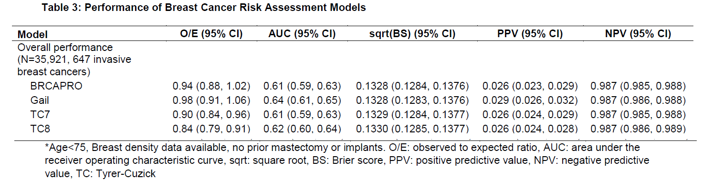

- Admittedly they only differ in the 4th decimal place, but which of the 3 lower models (Gail, TC7, TC8) has the worst Brier Score? [1]
Brier Scores are worse when high, so it must be TC8.

The O/E ratio is a quantity related to the Mean Error or Bias. Recall that if the Bias is positive, the model overestimates risk and if it is negative the model underestimates risk. Just subtract O/E from 1 to get the Bias expressed as a percentage of the predicted risk. You could call this the Relative Bias.
r_{k} = predicted risk in group k
p_{k} = proportion with outcome in group k
Bias = r_{k} – p_{k}
O/E = p_{k} /r_{k}
1 - O/E = 1 - p_{k} /r_{k}
1 - O/E = (r_{k} – p_{k})/r_{k}
1 - O/E = Bias/r_{k} = Relative Bias

So, here are the Relative Biases for the 4 models.
 | O/E | Relative Bias
BRCAPro | 0.94 | 6.0%
Gail | 0.98 | 2.0%
TC7 | 0.90 | 10.0%
TC8 | 0.84 | 16.0%

- On average, do these models overestimate or underestimate risk? Explain. [2]
O/E < 1 means Relative Bias > 0 for all models. (O/E < 1 indicates that predicted (expected) risk is higher than actual (observed) risk, which means that all models overestimate risk.) (If you just look at the figures below, you can also see they overestimate risk.)

Here are the calibration plots for each of the 4 models.
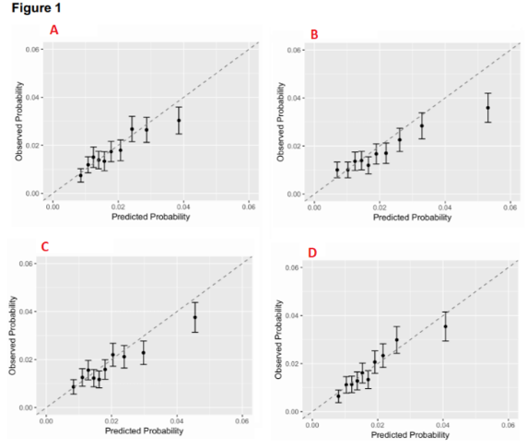
- Which of the above calibration plots A, B, C, or D corresponds to TC8. Explain [2]
TC8 has the worst Brier Score, the worst O/E (0.84) and therefore mean relative error (16%). The worst calibration plot is B, so the answer must be B.
- BRCAPRO
- TC8
- TC7
- Gail

It appears that the authors would start a woman on a preventative medicine if her 6-year risk of invasive breast cancer is > 2%.
“The recognized clinical threshold for elevated 5-year risk of breast cancer for chemoprevention is 1.67%. For our study, we considered a corresponding 6-year risk threshold of 2.0% (ie, 1.67% × 6/5). Positive and negative predictive values of the models were calculated relative to this risk threshold.”

- Using the 2% treatment threshold, will model B lead to overtreatment or undertreatment? Explain.[2]
For Model B, at predicted risk = 2%, actual proportion with the outcome is 1.7%. So it will lead to overtreatment.

- To create decision curves for these 4 risk models, you would need more information than is provided here, but all decision curves are compared to the “Treat All” curve, which you can create based on information provided above. At a 2% treatment threshold, is the net benefit of “Treat All” greater or less than 0? [2]
Less than 0. The “Treat All” curve crosses the X axis at the P, the proportion with the outcome in the population. That is 1.8% (from the question prompt, where 647 out of 35,921 developed breast cancer). Since 2% > 1.8%, the “Treat All” curve is below the X axis.
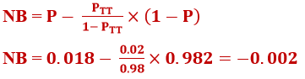

REFERENCES

1. Johnston SC, Rothwell PM, Nguyen-Huynh MN, Giles MF, Elkins JS, Bernstein AL, et al. Validation and refinement of scores to predict very early stroke risk after transient ischaemic attack. Lancet. 2007;369(9558):283-92.
2. Kovalchik SA, Tammemagi M, Berg CD, Caporaso NE, Riley TL, Korch M, et al. Targeting of low-dose CT screening according to the risk of lung-cancer death. N Engl J Med. 2013;369(3):245-54.
3. McCarthy AM, Guan Z, Welch M, Griffin ME, Sippo DA, Deng Z, et al. Performance of breast cancer risk assessment models in a large mammography cohort. J Natl Cancer Inst. 2019.

