Epi 204 -- Problem Set #7 -- Chapter 8 Problems (RCTs)
Due 11/4/2021 @ 1:15 pm [39 points plus 4 extra credit]

Collaboration with your classmates is fine but answer the question in your own words and acknowledge your colleagues. For questions with numerical answers, show your calculations, so we can consider giving partial credit, even if the final answer is incorrect.

- (EBD-2, Problem 8.2) Masking in a post Lyme syndrome trial [3 points]
Lyme disease is an infection with a spirochete bacterium acquired from a tick bite. Most patients recover after antibiotic treatment of the acute infection, but some can develop chronic symptoms, or "post Lyme syndrome," one symptom of which can be severe fatigue. The STOP-LD trial(1) was a randomized, double-blind trial of a long course of IV ceftriaxone (an antibiotic) to treat post Lyme syndrome.

The results section includes:
Masking. At … 6 months 69% (18/26) of the ceftriaxone vs 32% (7/22) of the placebo group correctly guessed their treatment assignment (p = 0.004).
In the discussion they wrote:
"The observation that more of the ceftriaxone than placebo treated groups correctly guessed their treatment assignment could mean that masking [blinding] may have been compromised."
Does the comparison above (P=0.004) support the authors' concern that masking may have been compromised? Explain. [Hint: think carefully about what is being compared before answering!]

- (Modified from EBD-2, Problem 8.4) Fremanezumab to prevent migraine headaches [12 points +2 EC]
Dr. David Dodick (whose conflict of interest disclosures for this paper run 4.75 column inches in JAMA) and colleagues recently reported results of a randomized, double-blind trial of fremanezumab, a new monoclonal antibody used to prevent migraine headache (2) The investigators compared monthly and quarterly doses of fremanezumab with placebo; for simplicity we will focus only on comparisons of the (more effective) monthly dosing with placebo.

- The proportion of patients who achieved at least a 50% reduction in the number of headache days per month was 47.7% in the monthly fremanezumab group compared with 27.9% in the placebo group. What was the approximate number needed to treat with fremanezumab to get one additional patient with a ≥ 50% reduction in headache days? [2 points]

- The average price for Fremanezumab is about $660 per monthly dose. It was well tolerated in the trial. If we ignore possible late adverse effects and focus only on the medication cost, what is the approximate cost per month per patient who achieved a 50% reduction in headache days? [2 points]
- Per the abstract, "From baseline to 12 weeks, mean migraine days per month decreased from 8.9 days to 4.9 days in the fremanezumab monthly dosing group, and from 9.1 days to 6.5 days in the placebo group. This resulted in a difference with monthly dosing vs placebo of -1.5 days/month (95% CI, -2.01 to -0.93 days; P < .001)." If we consider one migraine day a bad outcome, what would be the CBOP, i.e., the approximate cost to prevent one migraine day, given the above and the monthly cost of the drug? [2 point]

- Let's suppose that this medication only works for true migraines and that everyone in the trial was sufficiently screened that all of them had true migraines. But out in the "real world" we are considering treating someone with headaches that we think might be migraines, but we are unsure. If we believe it is worth $750 to prevent one headache day (BBOP), and if there were no other therapeutic options available, at what probability that the headaches of the patient in front of you are migraines would the expected headache reduction benefit of fremanezumab justify the cost? [2 points]

- What if we believe it is worth less to prevent one headache day, $400 rather than $750. Then at what probability of migraine would the headache reduction benefit justify the cost? [2 points]

- The investigators excluded patients who had previously failed 2 classes of migraine-preventive medicine from the study and compared fremanezumab with placebo. What effect do these study design decisions have on the clinical usefulness of the study results? [2 points]

- (Extra Credit 2 points) Pick an opinion leader from your own field or an expert quoted in the media about a medical issue. What is the name of this person, and how much did they receive in payments from the pharmaceutical industry in the latest year for which data are available (2018 at this writing)? [EC 2]. (Hint: it is easier if they have an uncommon name, like Aaron Caughey, who got $0.)

- Extended-release naltrexone (XR-NTX) effect on viral suppression [10 points + 2 extra credit] (based on a problem submitted by Yusuph Mavura, Akansha Batra and Caitlin Turner in 2019)

Springer et al(3) examined whether extended-release naltrexone (XR-NTX), a treatment for alcohol use disorders, influences HIV viral suppression in people living with HIV and alcohol use disorders who are transitioning to the community from prison or jail. They hypothesized that XR-NTX would alleviate the alcohol use, thereby improving adherence to medication and increasing viral suppression.
The abstract states:
Design—A randomized double-blind, placebo-controlled trial was conducted among incarcerated individuals with HIV and alcohol use disorders transitioning to the community from 2010 through 2016.
Methods—Eligible participants (N=100) were randomized 2:1 to receive 6 monthly injections of XR-NTX (n=67) or Placebo (n=33) starting at release and continued for 6 months. The primary and secondary outcomes were the proportion that maintained or improved viral suppression at <200 copies/mL and <50 copies/ml from baseline to 6 months…” ¹

In the results section, the authors state that “at six months, compared to placebo, participants who received XR-NTX were also significantly more likely to have viral suppression for both the primary outcome (<200 copies/mL) (64.2% XR-NTX vs. 42.4% placebo; p=0.041) and secondary outcome (<50 copies/mL) (56.7% XR-NTX vs. 30.3% placebo; p = 0.015).” For the purposes of this problem, focus only on the primary outcome.
  - Assume the bad outcome we are trying to prevent is lack of viral suppression to < 200 copies/ml at 6 months. Using conventions recommended in Chapter 8 and looking at the 6-month data only, what are the RR and RRR comparing XR-NTX to placebo for that outcome? [2]

  - Calculate the ARR and the NNT for that same outcome and explain in words what the NNT means. [2]
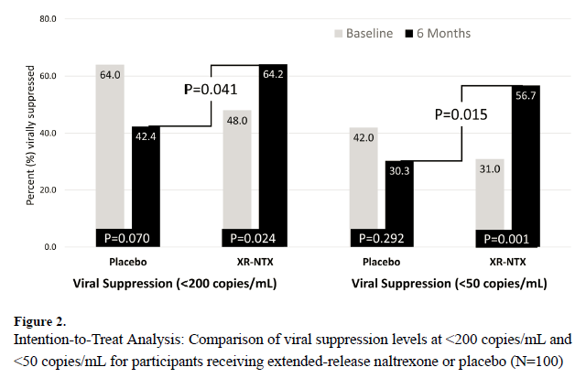
  - Is the comparison with the P-value of 0.041 in Figure 2 a within-groups or between-groups comparison? Explain. [2]. (Extra credit +2: How could they have done it better?)

  - The mean cost per XR-NTX injection per person is $704. Calculate the treatment cost per viral non-suppression event prevented using the mean cost per XR-NTX injection and assuming that each patient received 6 injections in six months. [2]

  - The authors state that “Overall, 13% of participants who were randomized had missing HIV-1 RNA data 6 months post-release” and were lost-to-follow-up (LTFU). The authors go on to state that “Consequently, we were able to maintain the most conservative standard ITT assumption that missingness from participant attrition equals viral non-suppression (missing = failure).” In short, all those who were LTFU in the treatment and control group were assumed to have had the event of interest (viral non-suppression). Given how the authors handled losses to follow-up, in which direction would the results of this analysis most likely be biased? [2]

- Prenatal probiotics for colic. [14 points]

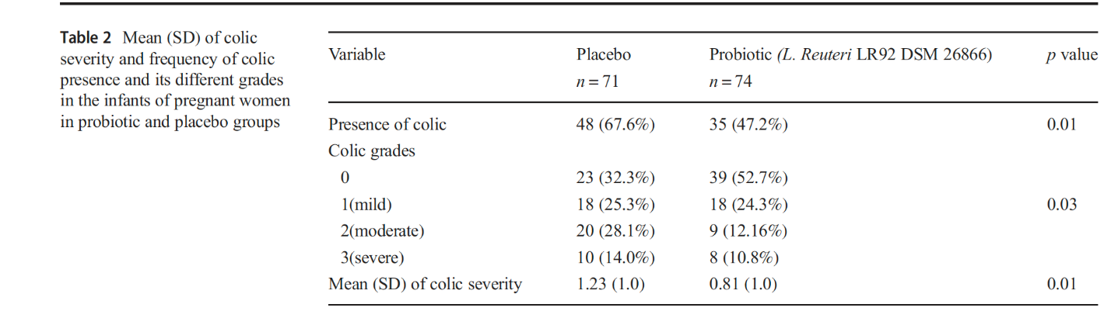
We introduced the possibility of treating young infants with colic (unexplained crying) with the probiotic Lactobacillus reuteri in EBD-2 Problem 1.2. Recently investigators from Isfahan University of Medical Sciences in Iran tried a different approach: treating mothers with L. reuteri during the last 4 weeks of pregnancy to try to prevent colic in the offspring. (4). The results of their randomized, double-blind trial are summarized in Table 2 below:

- What are the relative risk (RR), relative risk reduction (RRR), and odds ratio (OR) for treating mothers with L. reuteri to prevent colic? Use the Chapter 8 convention of dividing the risk or odds of the bad outcome (colic) in the treatment group by the risk or odds of the back outcome in the control group. [3]

- What is the number of pregnant women that need to be treated to prevent one case of colic in the offspring? [2]
- In the results section, the authors wrote: "A dichotomous logistic regression was performed to ascertain the effects of feeding mode, delivery mode, gestational age, and intervention in the patient (on the likelihood of infantile colic in infants). Mothers who received placebo were 2.36 times more likely to have infants exhibiting infantile colic than mothers in the L. reuteri LR92 DSM26866 group (OR = 2.36; CI 95%, 1.18–4.73). The other three mentioned variables were not associated with an increased likelihood of exhibiting colic symptoms."
i) Give two reasons why the authors' use logistic regression analysis to adjust for feeding mode, delivery mode and gestational age was probably not needed to control for confounding in this study. [3]
ii) Note that the authors didn’t follow the convention of odds in the treatment group divided by odds in the control group. Don’t worry about the logistic regression model; use the same counts that you used in (a) to calculate the odds ratio the way they did and compare it to their multivariate odds ratio. [1]

iii) Calculate the relative risk the same way – placebo vs. active treatment. [1]

iv) Is this statement correct? “Mothers who received placebo were 2.36 times more likely to have infants exhibiting infantile colic than mothers in the L. reuteri LR92 DSM26866 group (OR = 2.36; CI 95%, 1.18–4.73).” Explain why or why not. [2]
- The incidence of colic in the placebo group of this study was high (67.6%), partly because only the "severe" group met the definition of colic provided in Problem 1.2. If they had not counted infants with Colic grade 1 (mild) as having colic, about how much would this have affected the NNT? Note you do not have to do any calculations for this, just look at the results table above and explain your reasoning. [2]

REFERENCES

1. Krupp LB, Hyman LG, Grimson R, Coyle PK, Melville P, Ahnn S, et al. Study and treatment of post Lyme disease (STOP-LD): a randomized double masked clinical trial. Neurology. 2003;60(12):1923-30.
2. Dodick DW, Silberstein SD, Bigal ME, Yeung PP, Goadsby PJ, Blankenbiller T, et al. Effect of Fremanezumab Compared With Placebo for Prevention of Episodic Migraine: A Randomized Clinical Trial. JAMA. 2018;319(19):1999-2008.
3. Springer SA, Di Paola A, Barbour R, Azar MM, Altice FL. Extended-release Naltrexone Improves Viral Suppression Among Incarcerated Persons Living with HIV and Alcohol use Disorders Transitioning to the Community: Results From a Double-Blind, Placebo-Controlled Trial. J Acquir Immune Defic Syndr. 2018;79(1):92-100.
4. Pourmirzaiee MA, Famouri F, Moazeni W, Hassanzadeh A, Hajihashemi M. The efficacy of the prenatal administration of Lactobacillus reuteri LR92 DSM 26866 on the prevention of infantile colic: a randomized control trial. Eur J Pediatr. 2020;179(10):1619-26.

It targets calcitonin gene-related peptide.
Price for one 225mg/1.5 ml injection with a free coupon at www.GoodRx.com, accessed 10/26/2.

