Epi 204 -- Problem Set #9 -- Chapters 9 and 11 Problems (P Values and more)
Due 11/18/2021 1:15 pm
Total Points (40 + 2 extra credit)

Do problems #1 – #5 below. Collaboration with your classmates is fine but answer the question in your own words and acknowledge your colleagues. For questions with numerical answers, show your calculations, so we can consider giving partial credit even if the final answer is incorrect.

1. Multicenter Aneurysm Screening Study [12 points] Problem 10.1 of EBD-2 was about the Multicenter Aneurysm Screening Study (MASS). The MASS was a randomized trial of the effectiveness of ultrasound screening for abdominal aortic aneurysms (AAA) in reducing aneurysm-related mortality. Men aged 65-74 were randomized to either receive an invitation for an abdominal ultrasound scan or not. AAA-related death and overall mortality in the two randomization groups are reported in the first table below. The authors also did a within groups analysis in the invited group only, comparing those who did and did not get the ultrasound scan; these data are reported in the second table below. Note that the first table displays data from the ITT analysis (invited/not invited), and the second table displays the data from the as-treated analysis of the invited group

MASS Study (ITT analysis)
 | Total  N | AAA Deaths |  | Total Deaths
 | Total  N | N | % | N | %
Invited | 33,839 | 65 | 0.19% | 3,750 | 11.08%
Not Invited | 33,961 | 113 | 0.33% | 3,855 | 11.35%
Total | 67,800 | 178 |  | 7,605

MASS Study – Invited group only (as-treated analysis)
 | Total  N | AAA Deaths |  | Total Deaths
 | Total  N | N | % | N | %
Scanned | 27,147 | 43 | 0.16% | 2,590 | 9.54%
Not Scanned | 6,692 | 22 | 0.33% | 1,160 | 17.33%
Total | 33,839 | 65 |  | 3,750

- Suppose we wanted to use an instrumental variable (IV) approach to estimate the causal effect of being scanned on AAA mortality from this trial. What would be the instrument? [2]

- What would we need to assume about the instrument to have the IV estimate of the causal effect of scanning be valid? What makes this a good instrument? [2].

- Assume that no one in the uninvited group received a scan. What would be the IV estimate of the causal effect of ultrasound scanning on AAA mortality (as a risk difference). Hint: we are looking for the Complier Average Causal Effect. [4]

- To which group of patients would the estimate in part c apply? [2]

- How does your answer to part C compare with the as-treated risk difference in the invited group? What can you conclude from this about the importance of volunteer effect in the as-treated analysis? Explain. [2]

- Month of School Enrollment and Diagnosis and Treatment of Attention Deficit-Hyperactivity Disorder (ADHD) [6 points]
Some children (especially boys) have more trouble sitting still in the classroom and paying attention to the teacher than their classmates. One reason for this might be because they have Attention Deficit-Hyperactivity Disorder (ADHD), but in some cases it may also be because they are younger than their classmates.

In states where children must be 5 years old by September 1 to start school, children born in August may be almost a year younger than their classmates born in September, who must wait almost a whole additional year before they are old enough to start school.

To investigate whether this age difference contributes to children being diagnosed with and treated for ADHD, Harvard investigators (1) used a large insurance database to compare claims-based ADHD diagnoses and treatment among children born in August with those born in September. As they had predicted, children born in August were significantly more likely to be diagnosed with ADHD.

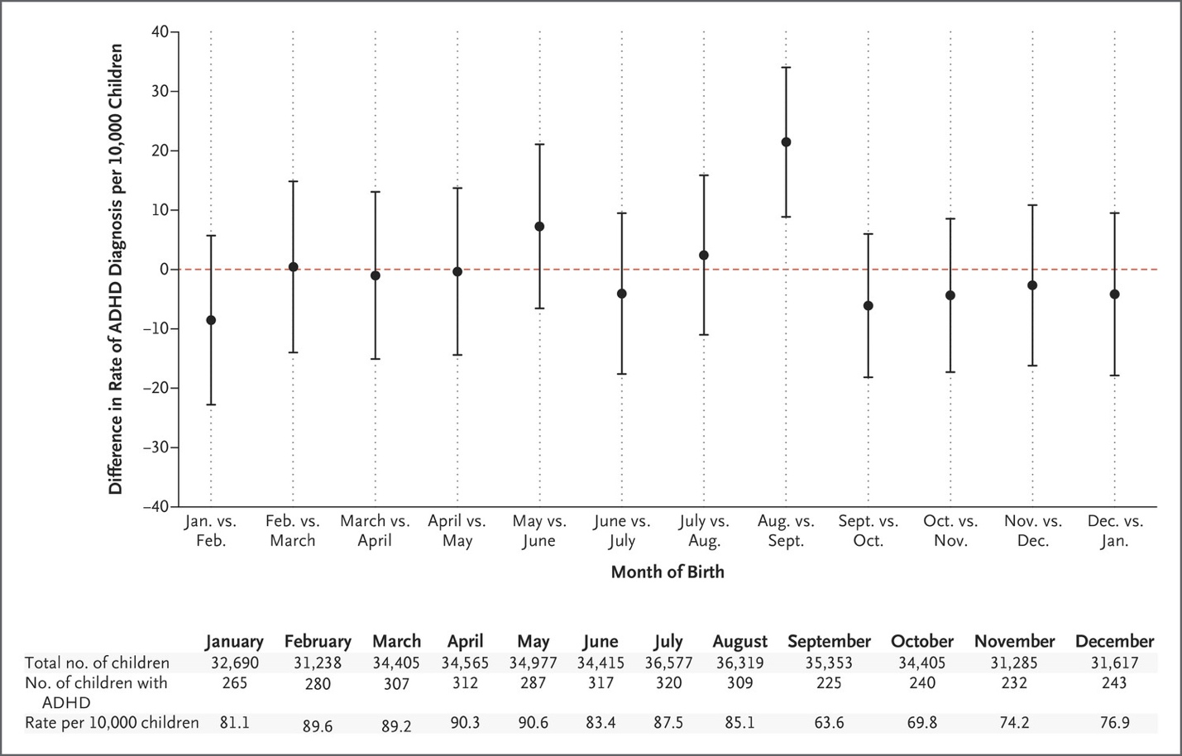  Figure 1. Differences in Diagnosis Rates of Attention Deficit–Hyperactivity Disorder (ADHD) According to Month of Birth. Each point represents the absolute difference in the rate of ADHD diagnosis per 10,000 children between children born in a given month and children born in the following month…" From Layton TJ, Barnett ML, Hicks TR, Jena AB. Attention Deficit-Hyperactivity Disorder and Month of School Enrollment. N Engl J Med 379:2122-30. Copyright © 2018, Massachusetts Medical Society. Reprinted with permission from the Massachusetts Medical Society. | 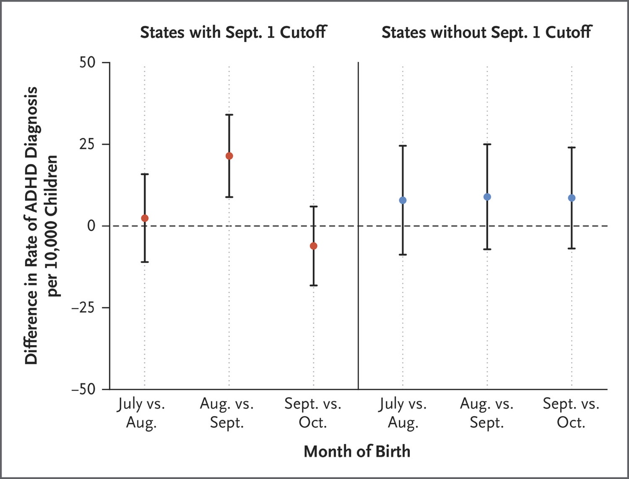  Figure 2. Differences in ADHD Diagnosis Rates According to Month of Birth in States with and States without a September 1 Cutoff. Shown are the differences in ADHD diagnosis rates between children in the 18 states with a September 1 cutoff for kindergarten entry and children in all states without a September 1 cutoff. The dashed line indicates no difference. I bars indicate 95% confidence intervals. ... From Layton TJ, Barnett ML, Hicks TR, Jena AB. Attention Deficit-Hyperactivity Disorder and Month of School Enrollment. N Engl J Med 379:2122-30. Copyright © 2018, Massachusetts Medical Society. Reprinted with permission from the Massachusetts Medical Society.

For each of the next three results, indicate which of the techniques for enhancing causal inference discussed in Chapter 9 it represents.
- The authors compared ADHD diagnoses in other pairs of adjacent months (Figure 1 above.) [2]

- The authors also compared results between states that do and do not have the September 1 cutoff for starting school (Figure 2 above). [2]

- From the abstract: "In addition, in states with a September 1 cutoff, no significant differences between August-born and September-born children were observed in rates of asthma, diabetes, or obesity." [2]

Vestri trial [10 points, +2 extra credit] Both the text and lecture mention the AUSTRI trial of the safety and efficacy of fluticasone + salmeterol vs fluticasone alone for children with asthma. Glaxo-Smith-Kline also sponsored the VESTRI randomized, double-blind trial of the same research question. It included 3107 children assigned to fluticasone-salmeterol and 3101 assigned to fluticasone alone. Excerpts from the abstract are pasted below:

METHODS: …The primary safety end point was the first serious asthma-related event (death, endotracheal intubation, or hospitalization)… The statistical design specified that noninferiority would be shown if the upper boundary of the 95% confidence interval of the hazard ratio for the primary safety end point was less than 2.675…

RESULTS: Among the 6208 patients, 27 patients in the fluticasone–salmeterol group and 21 in the fluticasone-alone group had a serious asthma-related event (all were hospitalizations); the hazard ratio with fluticasone–salmeterol versus fluticasone alone was 1.28 (95% confidence interval [CI], 0.73 to 2.27), which showed the noninferiority of fluticasone–salmeterol (P = 0.006).
Results of the csi command in Stata are pasted below; you can see that the point estimate and 95% CI for the risk ratio are almost identical to those for the hazard ratio:
. csi 27 21 3080 3080,ex

| Exposed Unexposed | Total
-----------------+------------------------+------------
Cases | 27 21 | 48
Noncases | 3080 3080 | 6160
-----------------+------------------------+------------
Total | 3107 3101 | 6208
| |
Risk | .0086901 .006772 | .007732
| |
| Point estimate | [95% Conf. Interval]
|------------------------+------------------------
Risk difference | .001918 | -.0024389 .006275
Risk ratio | 1.283231 | .7270865 2.264769
Attr. frac. ex. | .2207173 | -.3753522 .5584538
Attr. frac. pop | .1241535 |
+-------------------------------------------------
1-sided Fisher's exact P = 0.2367
2-sided Fisher's exact P = 0.4692

- Indicate whether each statement below is true or false and briefly explain your answer:
- The 2-sided P-value of 0.47 for the table above indicates that if in fact there were no difference in the hospitalization rates of the two groups, we would see a difference (or, more precisely, a value of the test statistic) this large or larger with a probability of about 0.47. [2]

- Based on the results of this study, we can estimate that if we were to repeat this study 100 times, the point estimate for the risk difference for hospitalizations over 6 months would be between −0.24% and + 0.63% for about 95% of those studies. [2]
- What is the lower limit of the 95% CI for the number needed to treat for 6 months with fluticasone + salmeterol vs fluticasone alone to prevent one hospitalization (the NNT)? [2]

- What is the lower limit of the 95% CI for the number needed to treat for 6 months with fluticasone + salmeterol vs fluticasone alone to cause one hospitalization (the NNH)? [2]

- Suppose that there had been only about half as many events in each group as were observed, resulting in a risk difference only about half as large as was observed and a smaller upper limit its 95% CI (0.41% vs 0.63%), as shown in the Stata output below. According to their pre-specified analysis plan, what would be the conclusion (assuming the hazard ratio and its 95% CI corresponds to the risk ratio and its 95% CI shown in the Stata output below)? [2]
. csi 14 11 3093 3090

| Exposed Unexposed | Total
-----------------+------------------------+------------
Cases | 14 11 | 25
Noncases | 3093 3090 | 6183
-----------------+------------------------+------------
Total | 3107 3101 | 6208
| |
Risk | .004506 .0035472 | .0040271
| |
| Point estimate | [95% Conf. Interval]
|------------------------+------------------------
Risk difference | .0009587 | -.0021916 .0041091
Risk ratio | 1.270269 | .5775882 2.793659
Attr. frac. ex. | .2127655 | -.7313374 .6420465
Attr. frac. pop | .1191487 |
+-------------------------------------------------
chi2(1) = 0.36 Pr>chi2 = 0.5509

d. Explain in words the meaning of the P-value of 0.006 reported in the results section. [Extra credit +2]

- Prophylactic Penicillin in Sickle Cell Anemia (Ch11.08) [6 points] Children with sickle cell anemia are treated with penicillin to prevent infections with Streptococcus pneumoniae ("pneumococcus") to which they are particularly susceptible. Review the following abstract excerpt, addressing the question: "when is it safe to discontinue penicillin prophylaxis?" (2)

OBJECTIVE: To evaluate the consequences of discontinuing penicillin prophylaxis at 5 years of age in children with sickle cell anemia who had received prophylactic penicillin for much of their lives.
DESIGN: Randomized, double-blind, placebo-controlled trial….
PATIENTS: Children with sickle cell anemia …who had received prophylactic penicillin therapy for at least 2 years immediately before their fifth birthday and had received the 23-valent pneumococcal vaccine between 2 and 3 years of age and again at the time of randomization. Of 599 potential candidates, 400 were randomly selected and followed for an average of 3.2 years....
INTERVENTIONS: After randomization, patients received the study medication twice daily--either penicillin V potassium, 250 mg, or an identical placebo...
MAIN OUTCOME MEASURES: The primary end point was… bacteremia or meningitis caused by Streptococcus pneumoniae ...
RESULTS: Six children had a systemic infection caused by S. pneumoniae, four in the placebo group (2.0%; 95% confidence interval 0.5%, 5.0%) and two in the continued penicillin prophylaxis group (1.0%; 95% confidence interval 0.1%, 3.6%) with a relative risk of 0.5 (95% confidence interval 0.1, 2.7).
CONCLUSION: Children with sickle cell anemia who have not had a prior severe pneumococcal infection or a splenectomy and are receiving comprehensive care may safely stop prophylactic penicillin therapy at 5 years of age...

- There were 200 children in each group. Use the numbers in the abstract to help you interpret the Stata output below. What was the difference in risk between the groups, and what is its 95% CI? [2].
. csi 2 4 198 196
| Exposed Unexposed | Total
-----------------+------------------------+----------
Cases | 2 4 | 6
Noncases | 198 196 | 394
-----------------+------------------------+----------
Total | 200 200 | 400
| |
Risk | .01 .02 | .015
| |
| Point estimate | [95% Conf. Interval]
|------------------------+----------------------
Risk difference | -.01 | -.0338037 .0138037
Risk ratio | .5 | .0926272 2.69899
Prev. frac. ex. | .5 | -1.69899 .9073728
Prev. frac. pop | .25 |
+-----------------------------------------------
chi2(1) = 0.68 Pr>chi2 = 0.4107

- The methods section of the paper indicates that they assumed that the S. pneumoniae bacteremia or meningitis rate in the placebo group over 3 years would be about 12%, that they wished to detect a 67% decrease (to 4%) with penicillin, and that they calculated that a sample size of 200 per group would give about 80% power to detect this decrease at 2-tailed alpha = 0.05. Assume for this problem that a difference between groups smaller than what the investigators used for their sample size calculation (8%) would not be clinically significant. Did they have enough subjects to conclude that discontinuing penicillin at age 5 is safe? Explain. [4]

- Length of stay with antibiotics for asthma [6 points]. Stefan et al (3) performed a retrospective cohort study using the Premier Inpatient Database to study the effect of antibiotic treatment on length of stay and other outcomes among 19,811 patients hospitalized for asthma and treated with systemic steroids. From the abstract: “Antibiotics were prescribed for 8788 patients (44.4%)…Those treated with antibiotics had a significantly longer hospital stay (median [IQR], 4 [3-5] vs 3 [2-4] days) and a similar rate of treatment failure (5.4% vs 5.8%).”

- The authors mentioned that they needed to address confounding by indication. In what direction would you expect uncontrolled confounding by indication to affect the length of stay results? Explain. [3]
- In the methods section, the definition of antibiotic exposure is as follows: “Early antibiotic treatment was defined as antibiotic therapy initiated during the first 2 days of hospitalization and prescribed for a minimum of 2 days.”
They didn’t describe how they determined that the antibiotic was prescribed for a minimum of 2 days in their original paper, but it has subsequently become clear that this measure was defined as receiving antibiotics on at least 2 calendar days while in the hospital, including the day of the first dose. So, for example if a patient was admitted on December 1, got the first dose of antibiotics on December 2 there would need to be a charge for antibiotics on December 3 in order or the patient to be included in the group exposed to antibiotics.
Recalling that this is an inpatient database, could this definition of exposure lead to a biased comparison of length of hospital stay between antibiotic exposed and unexposed patients? Explain. (Hint: to answer this question, compare the design of this retrospective cohort study to an ideal randomized clinical trial examining the same research question.) [3]

REFERENCES
1. Layton TJ, Barnett ML, Hicks TR, Jena AB. Attention Deficit-Hyperactivity Disorder and Month of School Enrollment. N Engl J Med. 2018;379(22):2122-30.
2. Falletta JM, Woods GM, Verter JI, Buchanan GR, Pegelow CH, Iyer RV, et al. Discontinuing penicillin prophylaxis in children with sickle cell anemia. Prophylactic Penicillin Study II. J Pediatr. 1995;127(5):685-90.
3. Stefan MS, Shieh MS, Spitzer KA, Pekow PS, Krishnan JA, Au DH, et al. Association of Antibiotic Treatment With Outcomes in Patients Hospitalized for an Asthma Exacerbation Treated With Systemic Corticosteroids. JAMA Intern Med. 2019;179(3):333-9.

