# | Pts Possible | Pts missed | Extra Credit
1 | 7
2 | 10
3 | 10
4 | 14
5 | 14
6 | 15 + 4
7 | 8
8 | 12
9 | 10
Total | 100 + 4
Score
Note: We may not enter all points for individual problems in this grid (which was designed for grading paper exams). Your scores will be within the individual questions.

DUE 12/6/2021 AT 11:59 PM. Please upload your exam on the course syllabus site.

To allow a margin for computer and internet problems, remember: you can upload early and then re-upload later.

Collaboration with others is NOT permitted. Answers must be in your own words. No exceptions. Really.

Questions about the final should be posted on the course forum.

Please show your work.

F1. Investigation of patient and observer agreement on description of seizures at initial clinical visit [7 points]
Saleem et al. (1) performed a study investigating the extent to which patients and observers agree on seizure descriptions obtained during the initial clinical visit for seizure care. Both patients and observers completed structured questionnaires about patients’ seizure signs and symptoms. Inter-rater reliability between patients’ and observers’ responses was assessed using Cohen’s kappa. Table 1 from the publication is below.

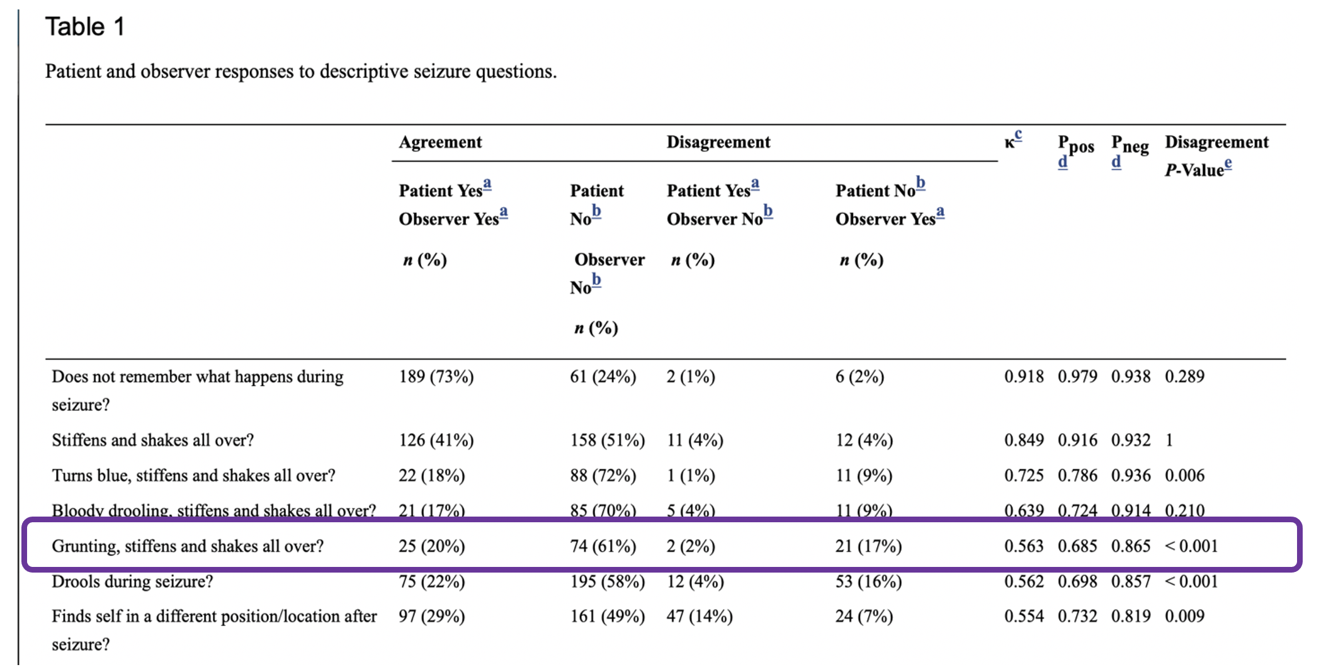

- Make a 2x2 table for “Grunting, stiffens and shakes all over?” [1]

- Using your 2x2 table, calculate the observed agreement for “Grunting, stiffens and shakes all over?” [1]

- Using your 2x2 table, calculate the expected agreement for “Grunting, stiffens and shakes all over?” [1]

- Calculate kappa for the question “Grunting, stiffens and shakes all over?” Does this match the kappa reported in the publication? [2]

- In part (a), is disagreement balanced? Explain your answer. [2]

F2. Levonorgestrel-Releasing Intrauterine System Compared to Low Dose Combined Oral Contraceptive Pills for Idiopathic Menorrhagia: A Randomized Clinical Trial [10 points] (Submitted by Agwang Winne, Frank Mulindwa, Allan Buzibye, Jane Gakuru, Mucunguzi Atukuna, Karugaba Patrick, Christopher Nsereko, and Sharon Muhimbo, EPI204 2020)

Menorrhagia (abnormally heavy or prolonged menstrual periods) is a common complaint and reason for women to seek medical advice. There are several treatment options, but we don’t know which is the most effective. A single center, open-label, randomized clinical trial was conducted to compare two treatments for menorrhagia – levonorgestrel releasing intrauterine system (LNG-IUS) and low dose combined oral contraceptive pills (COC).(2) One hundred-twelve women complaining of excessive menstruation who desired contraception were randomized to receive either LNG-IUS (n=56) or COC (n=56) and were followed up for 12 months. The authors concluded that LNG-IUS is more effective than COC in reducing bleeding. This problem focuses on a secondary outcome, a measure of the blood iron level called ferritin. Low ferritin levels are an indicator of iron deficiency, suggestive of worse blood loss.
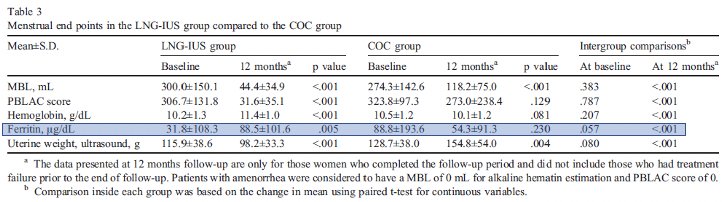
Repeating the Ferritin results for clarity:
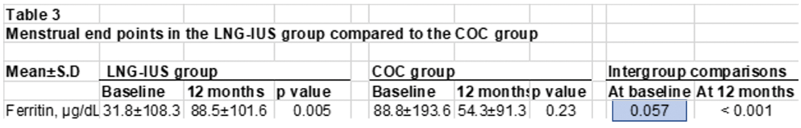

The Stata code and output below, shows that you can trust the p-value of 0.057 highlighted above:

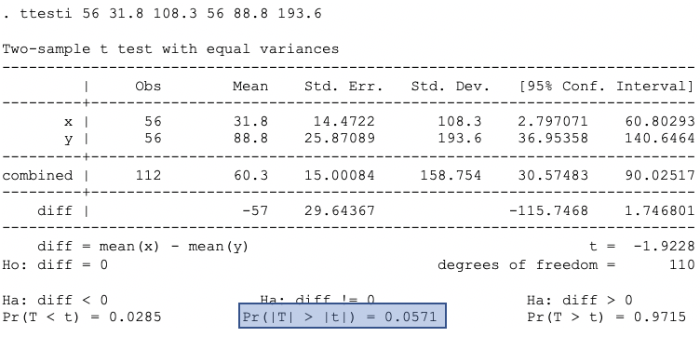

- Explain in words, what the p-value of 0.057 at means. [2]

- What two numbers are being compared? [2]

- Can the comparison of these two numbers be an indication that LNG-IUS is more or less effective than COC? Explain. [2]

The p-value for “intergroup comparisons” at 12 months is < 0.001. The Stata code and output below shows that this p-value cannot correspond to a comparison of the 12-month ferritin levels of 88.5 and 54.3 ug/dL.
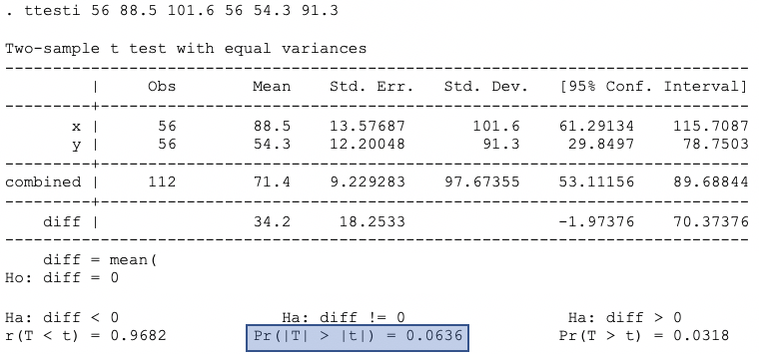

- In (a) and (b), you saw that there were baseline differences between the two groups. What two number should the authors have compared? (Hint: they likely did the correct comparison and reported its p-value as < 0.001.). Explain your answer. [4 points].

F3 Predicting delivery within 7 days after preterm premature rupture of membranes
Adapted from a submission by Nasim Sobhani
[10 points]

Preterm premature rupture of membranes (PPROM) occurs in only 3% of pregnancies but is associated with 30% of preterm births (PTB) and thus contributes to significant neonatal morbidity and mortality. The time from PPROM to delivery (known as the latency period) is quite variable (as short as hours for some and as long as months for others) and predicting the length of latency remains a clinical challenge. Mehra and colleagues(3) reported on the use of two continuous sonographic measurements, transvaginal cervical length (TVCL) and amniotic fluid index (AFI), in predicting latency ≤ 7 days following PPROM.

The authors simplified (oversimplified?) the problem dramatically by making the time-to-delivery outcome dichotomous (≤ 7 days vs. > 7 days) and both tests dichotomous, TVCL ≤ 2 cm vs. > 2 cm and AFI ≤ 5 vs. > 5. For this problem, we will focus on the combination of a “positive” TVCL ≤ 2 cm and a “negative” AFI > 5. We are not being tricky by focusing on a positive TVCL and negative AFI; it is this combination of results that is most interesting.

The study was a prospective cohort study of 106 women with PPROM, but 1 woman was missing AFI data, so we are reporting the results on N = 105.

Ignoring AFI for the moment, here is the data on TVCL:

 | Latency ≤ 7 Days
TVCL ≤ 2 | Yes (D+) |  | No (D-)
Yes (+) | 26 | 52% | 16 | 29% | 42
No (-) | 24 | 48% | 39 | 71% | 63
 | 50 | 100% | 55 | 100% | 105

- What is the likelihood ratio for a positive TVCL result? Show your calculation. [1]

Now, ignoring TVCL, here is the data for AFI

 | Latency ≤ 7 Days
AFI ≤ 5 | Yes (D+) |  | No (D-)
Yes (+) | 36 | 72% | 26 | 47% | 62
No (-) | 14 | 28% | 29 | 53% | 43
 | 50 | 100% | 55 | 100% | 105

- What is the likelihood ratio for a negative AFI result? Show your calculation. [1]

- If these two tests were independent conditional on D+/D-, what would the LR be for the combination of TVCL positive and AFI negative? Show your calculation.[1]

Here are the results (taken from Table 5 of the paper) on the combination of TVCL and AFI results.

 |  | Latency ≤ 7 Days
AFI ≤ 5 | TVCL ≤ 2 | Yes (D+) |  | No (D-)
Yes | Yes | 15 | 30% | 11 | 20.0% | 26
Yes | No | 21 | 42% | 15 | 27.3% | 36
No | Yes | 11 | 22% | 5 | 9.1% | 16
No | No | 3 | 6% | 24 | 43.6% | 27
 |  | 50 | 100% | 55 | 100.0% | 105

- There were only 16 patients with TVCL+ and AFI-, so your confidence interval on the likelihood ratio would be wide, but what is the likelihood ratio for this combination of results? Show your calculations. [1]

- If the point estimates in parts a, b and d are close to the true values, are TVCL and AFI independent tests for delivery latency ≤ 7 days (D+)? Explain your answer. [2]

Here is the data from Table 5 in the form of a classification tree.

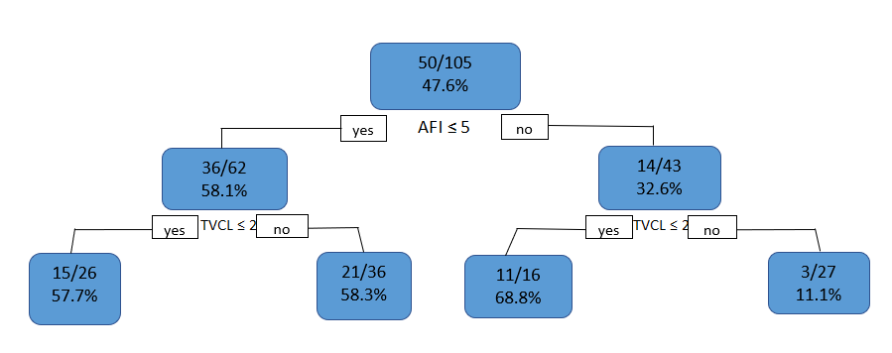

For (f) and (g), assume you are taking care of a patient just like the ones in this cohort and your treatment threshold probability P_{tt} is 0.4.

- If AFI is negative, i.e. > 5, would you treat? Does your answer depend on the TVCL? [2]

- If AFI is positive, i.e. ≤ 5, would you treat? Does your answer depend on the TVCL? [2]

F4. COVID and and D-Dimer for PE [14 points] (Submitted by Ilana Garcia-Grossman, Melanie Molina, Sean McClellan)

Coronavirus Disease 2019 (COVID-19) is associated with an increased risk of blood clots, including increased risk of pulmonary embolism (PE). Recall from EBD-2 Problems 3.3 and 7.3 that a PE is a blood clot that forms in a vein (often in the thigh), breaks off, and ends up in the lung arteries. PEs can cause shortness of breath, chest pain, a drop in blood pressure, and death. Recall also that D-dimer is a blood test for PE. For this problem, assume that it is a binary test – the only possible results are “positive” or “negative”. If all emergency department (ED) patients suspected of having PE receive a D-Dimer test, approximately 50% of those tests are positive.(4)

Elberts et al. (5) sought to measure the accuracy the D-dimer test in COVID-positive ED patients. The reference standard used to determine PE present vs. PE absent was CT pulmonary angiogram (CTPA). As in Problem 7.3, you may assume that CTPA is a perfectly accurate test. However, ED physicians can’t and don’t obtain a CTPA on every ED patient with symptoms that are slightly suggestive of PE. For example, in patients with a low pre-test probability of PE, they usually won’t order a CTPA unless the patient has a positive D-Dimer.

The following excerpt is taken from the “study protocol” section about the selection criteria:

“All ED patients who underwent CTPA and had D-dimer and COVID-19 testing ordered in a single encounter were included in the study. Patients were excluded if they did not have a CTPA scan with adequate interpretation, did not undergo D-dimer testing, or did not have a D-dimer test performed within 24h of the CTPA scan.”

Test characteristics of D-dimer for PE were calculated for patients with and without COVID-19.

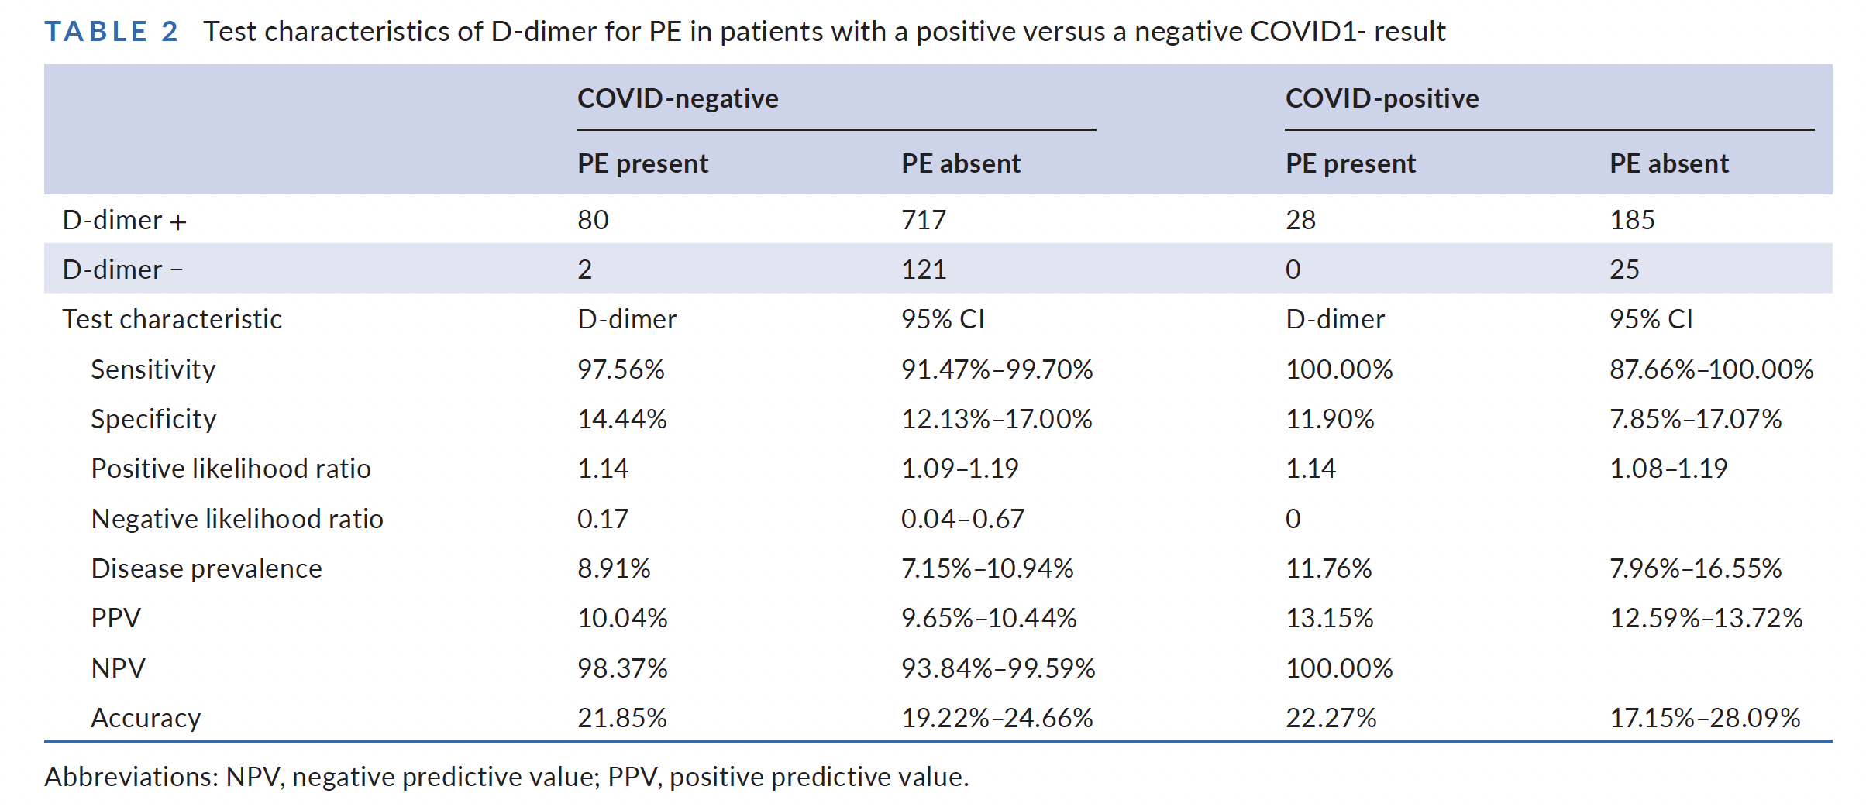

- Among COVID-negative patients, what proportion had a negative D-Dimer test? (Show your calculation) [1]

- Repeat (a) for COVID-positive patients. What proportion of COVID-positive patients had a negative D-Dimer? (Show your calculation) [1]

- As mentioned in the stem of this question, if all ED patients with possible PE are tested, about 50% will have a positive D-Dimer and 50% will have a negative D-Dimer. In this study, why is the proportion with a negative D-Dimer so much lower in both (a) the COVID-negative and (b) the COVID-positive patients? [2]

- In the table above, the specificity of the D-Dimer test was 14.44% in the COVID-negative patients and 11.90% in the COVID-positive patients. Why are these specificities so low? [2]

- We calculated the expected likelihood ratios assuming that the sensitivity and specificity of the D-Dimer test does NOT depend on the result of the COVID test. They are listed in the rightmost column (highlighted) of the table below. Fill in the rest of the table and calculate the observed likelihood ratios for the 4 combinations of COVID and D-Dimer test results. [4]

 |  |  | Pulmonary Embolism
 | COVID | D-dimer | Yes | % | No | % | Likelihood Ratio | LR Expected
 | + | + | 28 | 25.5 | 185 | 17.7 |  | 1.45
 | + | - | 0 | 0.0 | 25 | 2.4 |  | 0.17
 | - | + |  |  |  |  |  | 1.06
 | - | - |  |  |  |  |  | 0.12
Total |  |  | 110 | 100 | 1048 | 100

- Do the results of this study suggest non-independence between the COVID test result and the D-Dimer Test result? Explain why or why not. [4]

F5. The utility of the d-dimer test in patients with COVID-19 [14 points] (Submitted by Katie Kentoffio , Joyce Njoroge, Joseph Bayne)

In F4, we discussed D-Dimer as a binary test for pulmonary embolism (PE) in emergency department patients with and without COVID-19. In this problem, we will discuss D-Dimer as a multi-level test for PE in patients hospitalized for COVID-19.

Logothetis et al (1) considered 1541 consecutive individuals admitted to the hospital with COVID-19. For the moment, assume that 287 of the patients had a D-Dimer measured and received computed tomographic pulmonary angiography (CTPA), which as we saw in F4 is the reference standard for PE. In other words, assume that the result of the D-Dimer did not influence the decision to obtain the CTPA. Of the 287 CTPAs, 37 showed PE.

The authors provide the following ROC table and ROC curve to describe the effect of increasing cutoff values for a positive d-dimer test on the test characteristics for PE.

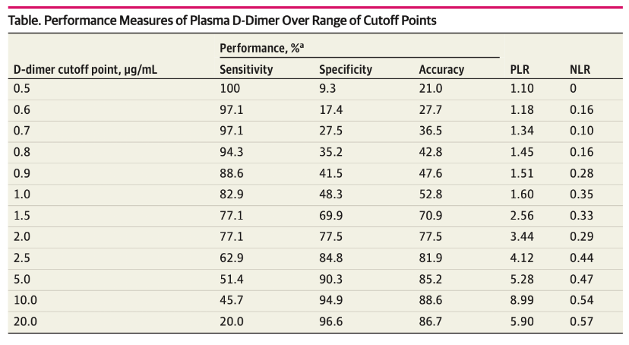
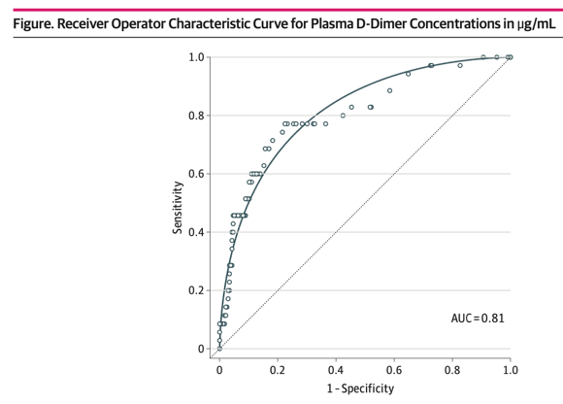

- Recall that that you cannot use the ROC curve alone to determine the optimal cutoff for a continuous or multi-level test. This is because the ROC curve cannot account for 1) the pre-test probability of disease or 2) the cost/benefit ratio of treating or failing to treat. But some will argue that the “best” cutoff point for a diagnostic test can be determined by choosing the upper leftmost point on the ROC curve (the so-called Euclidian method). Which d-dimer cutoff (from among those listed in the table above) best corresponds to this point? [1]

- Now, follow the best practices in Epi 204, and transform the ROC table above into an (abbreviated) interval likelihood ratio (iLR) table. Recall that the overall prevalence of PE in this sample was 37/287 = 12.9%. Thus, pre-test odds of PE are 0.129 / (1-0.129) = 0.148. We have started the table below. [5]

D-dimer Range | % D+ | % D- | iLR | Post-Test Prob
0 –< 0.5 | 0 | 9.3 | 0 | 0
0.5 – <2.0 | 22.9 | 68.2 | 0.34
2.0 – <5.0
5.0+

- We have said in previous problems (and in Evidence-Based Diagnosis) that we would be willing to do 30 negative CTPAs in order to identify 1 PE. Calculate P_{TT}. What is the optimal D-dimer cutoff from among those in the table you created in part B above based on your result for P_{TT}? [2]

The authors reported that 265 of the 287 participants had a positive d-dimer at cutoff of 0.5 μg/mL, including all patients with a positive CTPA. Using a cutoff of 0.5 μg/mL as a “positive” d-dimer, we can create a 2×2 table and calculate sensitivity and specificity as follows:

 | + CTPA | - CTPA
+ D-dimer | 37 | 228 | 265
- D-dimer | 0 | 22 | 22
 | 37 | 250 | 287

Sensitivity: 37/37 = 1 = 100%
Specificity: 22/250 = 0.088 = 8.8%

- In the stem, we told you to assume that the D-Dimer result did not influence the decision to obtain a CTPA, but it clearly did; there is no way that only 22 out of 1541 hospitalized COVID patients had a negative D-Dimer. What bias is this and how would it affect sensitivity and specificity? [2]

- Assume that the 1541 - 287 = 1254 excluded patients all had a negative D-Dimer (< 0.5 μg/mL) and did NOT have a PE. What is the sensitivity and specificity of D-Dimer for PE at a cutoff of 0.5 μg/mL when you include these additional 1254 patients? [2]

- Under the assumption in (e), the pre-test probability of PE is only 37/1541 = 2.4%, not 12.9% as in (b) above. Explain how this would change your answer to (c) about the optimal cutoff? (You do not need to show calculations. Just say whether it would raise or lower the cutoff and why.) [2]

F6. “CCCC” (4C) Mortality Score [15 points +4 EC]

Knight et al (6) developed and validated the Coronavirus Clinical Characterisation Consortium Mortality Score (“CCCC” = 4C Score) to predict 30-day mortality in patients hospitalized with COVID-19. (We wrote out “CCCC” = 4C to make it clear that this has nothing to do with Problem 4, Part C.) For your interest only (not needed for this problem), here is how the 4C Score is calculated:

Age Group (years) | 18 - 49
 | 50 - 59 | + 2
 | 60 - 69 | + 4
 | 70 - 79 | + 6
 | 80+ | + 7
Sex at birth | Female
 | Male | + 1
Comorbidities* | 0
 | 1 | + 1
 | 2 + | + 2
Respiratory rate (breaths/minute) | < 20
 | 20 - 29 | + 1
 | ≥ 30 | + 2
Oxygen saturation, room air (%) | ≥ 92
 | < 92 | + 2
Altered mental status † | No
 | Yes | + 2
BUN (mg/dL)§ | < 20
 | 20 - 39 | + 1
 | ≥ 40 | + 3
C-reactive protein (mg/dL)§ | < 5.0
 | 5.0 - 9.9 | + 1
 | ≥ 10.0 | + 2

The possible 4C Scores are grouped into four 30-day mortality risk categories:
- Low (0-3 points) 1.2%
- Intermediate (4-8 points) 9.5%
- High (9-14 points) 28.6%
- Very High (≥15 points) 56.8%

The 4C Score was developed and validated in a UK cohort. In the US, it has turned out that the 4C Score’s risk predictions are more accurate without the C-reactive protein (CRP) component, so in this problem, we will consider the 4C Score without the CRP component. In the US, the score was applied to 6802 SARS-CoV-2+ hospitalized patients within the RECOVER (REgistry of suspected COVID-19 in EmeRgency care) Network.

4C Mortality Risk Group  (Score Range) |  |  | RECOVER dataset without CRP
4C Mortality Risk Group  (Score Range) | Mortality Predicted by 4C | N | Deaths within 30 days |  | Observed Mortality | Prediction Error
Overall | 17.6% | 6802 | 1149 |  | 16.9% | 0.7%
Low (0-3 points) | 1.2% | 1098 | 18 |  | 1.6% | -0.5%
Intermediate (4-8 points) | 9.5% | 2774 | 242 |  | 8.7% | 0.8%
High (9-14 points) | 28.6% | 2648 | 725 |  | 27.4% | 1.2%
Very High (≥15 points) | 56.8% | 282 | 164 |  | 58.2% | -1.4%
 | AUROC |  |  | √Calibration Error |  |  |  | √Brier Score
RECOVER dataset without CRP | 0.776 (0.762 - 0.79) |  |  | 0.017 |  |  |  | 0.346

We will use the calibration table above to do a Net Benefit calculation. Then, we will ask you about the AUROC, √Calibration Error, and √Brier Score.

Assume that your mortality risk threshold (P_{TT}) for admitting a SARS-CoV-2+ patient to the ICU is 1/6 or 16.7%.

- What is your threshold odds (aka “exchange ratio” or C/B)? [1]

- What is the Net Benefit associated with not treating anybody (i.e. not admitting anybody to the ICU)? [1]

- What is the Net Benefit associated with treating all (i.e., admitting all to the ICU)? (You may show your calculation or take the shortcut of recognizing that P_{TT} = 16.7% ≈ P = 16.9%, the overall 30-day mortality.) [2]

- Based on the “CCCC” = 4C Score’s predicted mortality, which risk groups should be treated (admitted to the ICU)? [1]

- Using the 4C Score to decide who should be treated (as in part d), how many D+ individuals would be treated (admitted to the ICU)? In other words, how many true positives would there be based on the 4C Score model with P_{TT} = 16.7%? [2]

- Using the 4C Score to decide who should be treated (as in part d), how many D- individuals would be treated (admitted to the ICU)? In other words, how many false positives would there be based on the 4C Score model with P_{TT} = 16.7%? [2]

- What is the Net Benefit associated with treating (admitting to the ICU) based on the 4C Score risk model? [2]

- Mark the NB(Treat All) and NB(Model) points on the decision curves below. These correspond to your answers to (c) and (g). [2]

Just to check your understanding of the AUROC, √Calibration Error, √Brier Score, pretend (completely unrealistically) that a 4C Score of 8 or lower identified all hospitalized COVID patients who survived and a score of 9 or higher identified all who died within 30 days.

4C Mortality Risk Group | RECOVER dataset without CRP
(Score Range) | Mortality Predicted by 4C | N | Deaths within 30 days | Observed Mortality | Prediction Error
Overall | 16.76% | 6802 | 1149 | 16.89% | -0.14%
Low (0-8 points) | 10.00% | 5653 | 0 | 0.00% | 10.00%
High (≥9 points) | 50.00% | 1149 | 1149 | 100.00% | -50.00%

i) What would the AUROC be for this new (unrealistic) result? [2]

j) Extra Credit Calculate the √Calibration Error and √Brier Score. [+4 EC]

F7. Screening for Atrial Fibrillation [8 points]

Atrial fibrillation is an irregular heartbeat that increases the risk of stroke. It is treated with blood-thinning medications (oral anticoagulation therapy). Svennberg et al (7) did a randomized trial of screening for atrial fibrillation in Swedish adults aged 75-76 years. Although the primary outcome of the study was a composite of stroke, embolism, bleeding, and death, we will focus initially on death from any cause (all-cause mortality). The intervention group (N=13979) was invited to screening, and the control group (N=13996) was followed without invitation to screening. All participants were followed for at least 5 years and the median follow-up was 6.9 years. Here are the results:

 | Death From Any Cause | Survived | Total | All-cause Mortality
Invited to Afib Screening | 3177 | 10802 | 13979 | 22.73%
Control (Not Invited) | 3287 | 10709 | 13996 | 23.49%
 |  |  | Risk Difference | -0.76%

Of the 13797 invited to screening, 7165 (51.3%) participated in screening. Here are the results comparing mortality within the intervention (invited) group, between those who participated and those who didn’t:

 | Death From Any Cause | Survived | Total | All-cause Mortality
Invited to Afib Screening and participated | 1025 | 6140 | 7165 | 14.31%
Invited to Afib Screening and didn’t participate | 2152 | 4662 | 6814 | 31.58%
 | 3177 | 10802 | 13979
 |  |  | Risk Difference | -17.28%

Question I. We want to distinguish between the effect of being invited to screening and the effect of participating in screening. We know that 51.3% of those invited were screened. You may assume that none of those in the control (uninvited) group were screened. Which of the following is the best estimate of the effect of screening as a result of being invited to be screened? [1]

Choose one:

- 31.58% − 14.31% = 17.28%
- 23.49% − 22.73% = 0.76%
- 0.76%/0.513 = 1.48%
- 23.49% − 14.31% = 9.18%
- None of the above

Question II. Now explain your answer to Question I. [1]

Now, let’s look at the primary outcome, which is a composite of stroke, embolism, bleeding, and death. Here is Figure 2 from the paper:

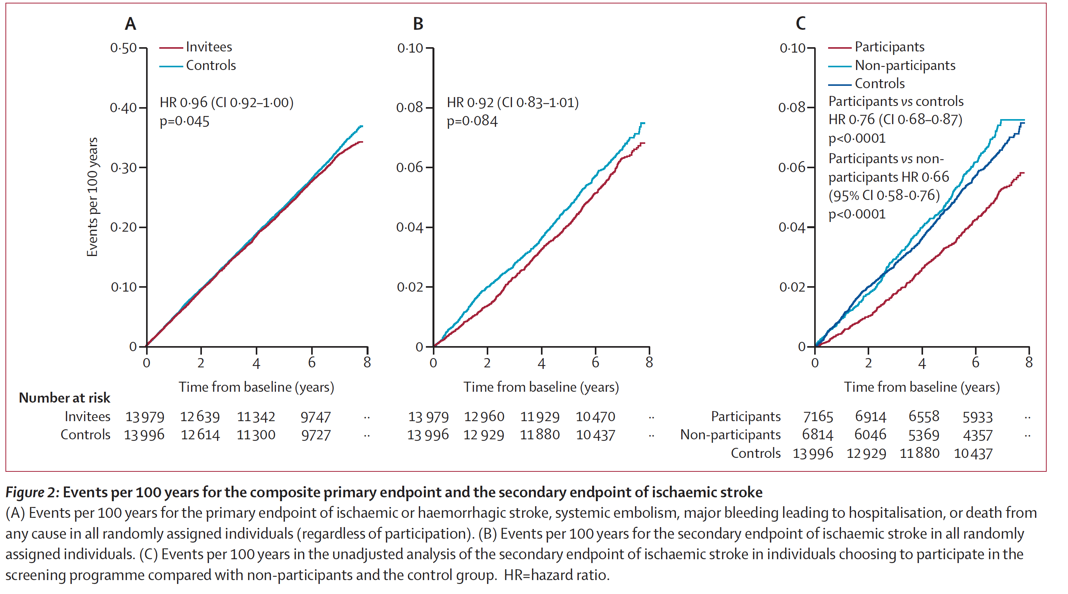
Repeating from the caption for clarity:
Panel (A) Events per 100 years for the primary endpoint of ischaemic or haemorrhagic stroke, systemic embolism, major bleeding leading to hospitalisation, or death from any cause in all randomly assigned individuals (regardless of participation).
Panel (B) Events per 100 years for the secondary endpoint of ischaemic stroke in all randomly assigned individuals.
Panel (C) Events per 100 years in the unadjusted analysis of the secondary endpoint of ischaemic stroke in individuals choosing to participate in the screening programme compared with non-participants and the control group.

Question III. In Panel (C), for each possible bias below, indicate whether it could explain why the light blue line for “non-participants” shows a higher event rate than the dark blue line for “controls”, and explain your answer for each possible bias.

Yes/No for each, with explanation:

- Pseudodisease (overdiagnosis) [2]
- Sticky diagnosis [2]
- Volunteer effect [2]

F8. Effect of Exenatide on Cardiovascular Outcomes in Type 2 Diabetes [12] (Submitted by Erin Ferguson, Nita Mukand, & Maia Scarpetta)

Exenatide (Brand Name: Bydureon) is an injectable drug used to treat type 2 diabetes. In 2017, a double-blind, placebo-controlled, randomized trial was published in the New England Journal of Medicine looking at the effect of weekly injections of exenatide on cardiovascular outcomes in patients with type 2 diabetes.(8)

The authors write in their abstract, “The primary composite outcome was the first occurrence of death from cardiovascular causes, nonfatal myocardial infarction, or nonfatal stroke.”

RESULTS
In all, 14,752 patients (of whom 10,782 [73.1%] had previous cardiovascular disease) were followed for a median of 3.2 years (interquartile range, 2.2 to 4.4). A primary composite outcome event occurred in 839 of 7356 patients (11.4%; 3.7 events per 100 person-years) in the exenatide group and in 905 of 7396 patients (12.2%; 4.0 events per 100 person-years) in the placebo group (hazard ratio, 0.91; 95% confidence interval [CI], 0.83 to 1.00),…
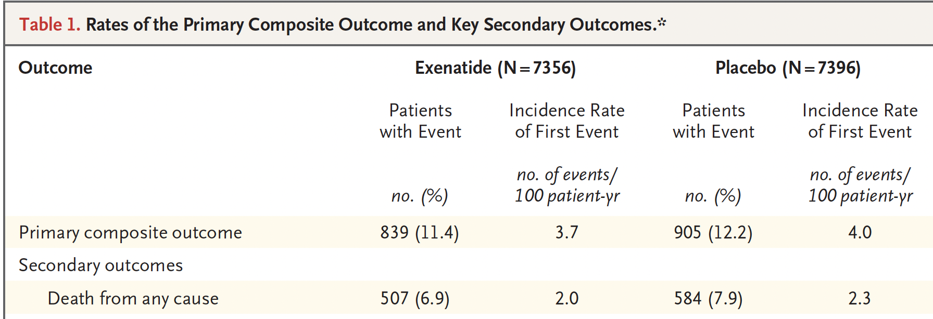
- What are the relative risk (RR) and relative risk reduction (RRR) when comparing exenatide to placebo for developing a primary composite outcome over the ~3 years of follow-up in this study? (Show your calculations.) [4]

B. What is the number needed to treat with exenatide to prevent one additional patient from having a primary composite outcome over ~3 years? (Show your calculations.) [2]

C. The average annual price for exenatide is $9522 (2 mg, injected once weekly, from GoodRx.com, with a coupon for an 18% discount)) (9). What is the approximate treatment cost per primary composite outcome prevented? (Assume that the follow-up time in this study was 3 years.) (Show your calculations.) [2]

Since this study was supported by Amylin Pharmaceuticals, which produces and sells Bydureon, you want to check whether the study’s use of a composite endpoint (death from cardiovascular causes, nonfatal myocardial infarction, or nonfatal stroke) conceals a smaller difference (or even an increase) in all-cause mortality.

D. Does Table 1 (above) indicate that using a composite endpoint instead of all-cause mortality made exenatide look better? Explain. [2]

E. The authors' conclusion was, "Among patients with type 2 diabetes with or without previous cardiovascular disease, the incidence of major adverse cardiovascular events did not differ significantly between patients who received exenatide and those who received placebo." Is this conclusion consistent with the 95% CI for the hazard ratio they reported for their primary outcome? Explain. [2]

F9. Month of School Enrollment and Diagnosis and Treatment of Attention Deficit-Hyperactivity Disorder (ADHD), Revisited [10 points]

Recall that in Problem Set 9 we reviewed some results from Layton et al (10), who reported that children born in August had higher rates of ADHD diagnosis and treatment than children born in September, but only in states with a September 1 cutoff for entering school. All results were reported in terms of month of birth, but the proposed mechanism for this difference is that children born in August will be the youngest in their classes, and those in September the oldest when they start school.

The authors reported the rate of claims-based ADHD diagnosis among children in states with a September 1 cutoff was 85.1 per 10,000 children among those born in August and 63.6 per 10,000 among those born in September, an absolute difference of 21.5 per 10,000 children.

We would like to estimate the effect of the actual exposure of interest (age at school entry), rather than just month of birth. We want to express this effect as the additional number of ADHD diagnoses per 10,000 children for each month younger the child is compared with the oldest students in the class (that is, we are assuming the causal effect is linear).
- Given the absolute difference above, what would be the estimated number of additional ADHD cases per month of age younger than the oldest students in the class, if the average age at enrollment for those born in September was 6 years, 0 months and the average age at enrollment for those born in August was 5 years 1 month, as would be expected with a school start date of September 15 and perfect adherence to the policy? [2]

The authors used an insurance claims dataset, so they did not have the actual dates the children started school. However, as they pointed out in their discussion of limitations, "Parents may delay school entry for children born in August, which would mean that those children start school at 6 years of age rather than 5 years of age." (They pointed out that this would tend to attenuate the effect they observed.)

- Suppose you have access to a separate dataset that includes actual dates of school entry in the states with September 1 cutoffs, as well as dates of birth, and that you find that the average age at enrollment for those born in August was 5 years 3 months (and still 6 years, 0 months for those born in September). What would be your new estimate of the causal effect of being younger than the oldest children in the class (per month)? [2]

- In order for your estimate in part b to be the causal effect of being younger at school entry to be valid (rather than just the effect of being born in August vs September), what else do you need to assume? [3]
- If the assumption in part c is valid, to which students would it apply? [3]
REFERENCES

1. Saleem MN, Arencibia CA, McKenna K, Cristofaro S, Detyniecki K, Friedman D, et al. Investigation of patient and observer agreement on description of seizures at initial clinical visit. Ann Clin Transl Neurol. 2019 Dec;6(12):2601–6.
2. Shabaan MM, Zakherah MS, El-Nashar SA, Sayed GH. Levonorgestrel-releasing intrauterine system compared to low dose combined oral contraceptive pills for idiopathic menorrhagia: a randomized clinical trial. Contraception. 2011 Jan;83(1):48–54.
3. Mehra S, Amon E, Hopkins S, Gavard JA, Shyken J. Transvaginal cervical length and amniotic fluid index: can it predict delivery latency following preterm premature rupture of membranes? Am J Obstet Gynecol. 2015 Mar;212(3):400.e1-400.e9.
4. Dunn KL, Wolf JP, Dorfman DM, Fitzpatrick P, Baker JL, Goldhaber SZ. Normal d-dimer levels in emergency department patients suspected of acute pulmonary embolism. J Am Coll Cardiol. 2002 Oct;40(8):1475–8.
5. Elberts SJ, Bateman R, Koutsoubis A, London KS, White JL, Fields JM. The impact of COVID‐19 on the sensitivity of D‐dimer for pulmonary embolism. Acad Emerg Med. 2021 Oct;28(10):1142–9.
6. Knight SR, Ho A, Pius R, Buchan I, Carson G, Drake TM, et al. Risk stratification of patients admitted to hospital with covid-19 using the ISARIC WHO Clinical Characterisation Protocol: development and validation of the 4C Mortality Score. BMJ. 2020 Sep 9;m3339.
7. Svennberg E, Friberg L, Frykman V, Al-Khalili F, Engdahl J, Rosenqvist M. Clinical outcomes in systematic screening for atrial fibrillation (STROKESTOP): a multicentre, parallel group, unmasked, randomised controlled trial. The Lancet. 2021 Oct;398(10310):1498–506.
8. Holman RR, Bethel MA, Mentz RJ, Thompson VP, Lokhnygina Y, Buse JB, et al. Effects of Once-Weekly Exenatide on Cardiovascular Outcomes in Type 2 Diabetes. N Engl J Med. 2017 Sep 28;377(13):1228–39.
9. https://www.goodrx.com/bydureon-bcise, accessed 11/29/21.
10. Layton TJ, Barnett ML, Hicks TR, Jena AB. Attention Deficit–Hyperactivity Disorder and Month of School Enrollment. N Engl J Med. 2018 Nov 29;379(22):2122–30.

