Assignment 7: Queries and analysis using R (Optional, Extra Credit)

In this optional, extra credit assignment you will run some simple queries and analysis using R, a powerful and flexible statistical analysis package. For the sake of familiarity, we will repeat some of the same analysis that we did in Assignment 6. Have your Assignment 6 answers on hand for comparison. This assignment includes 2 quiz questions. The quiz is worth 5 extra credit points (25% of a regular assignment, extra credit).

Using R on the RAE: You can run R on your own computer or on the RAE. Most (not all) of this assignment can be run on the RAE version. If you’re using R on the RAE, you’ll want to open these instructions on the RAE (using the shared class RAE folder, or RAE’s Chrome to the class CLE), so that you can copy and paste commands from here to R.

A. Reading Files into R
- If you’re using R on your local computer, ensure you have R installed and have access to RStudio. If not, you can download these for free at the following locations:
- R: https://cran.r-project.org/
- RStudio: https://www.rstudio.com/products/rstudio/download/#download

- Or, if you are using the RAE, choose RStudio4 – Cluster.

- Open RStudio.

- As in Assignment 6, you are going to perform analyses on IQ and Neuro Exam outcomes for a predictor of hyperbilirubinemia. To do this, you need three datasets: IJSSubject.txt, NeuroExam.txt and WPPSI.txt. If you’re using R on your local computer, download these from the CLE (and remember where you saved them). If you’re using R on the RAE, you can find these files in the shared class folder under the “Assignment 7” subfolder.

- In the “Environment” tab of the top right pane of R Studio, select “Import Dataset” and choose the option “From Text (base).” Find and select the IJSSubject file.

- Ensure that the Name field is set to “IJSSubject.” Set the Heading field to “Yes,” and unselect Strings as factors. The data frame should look good (as in the image below), so click “Import.”

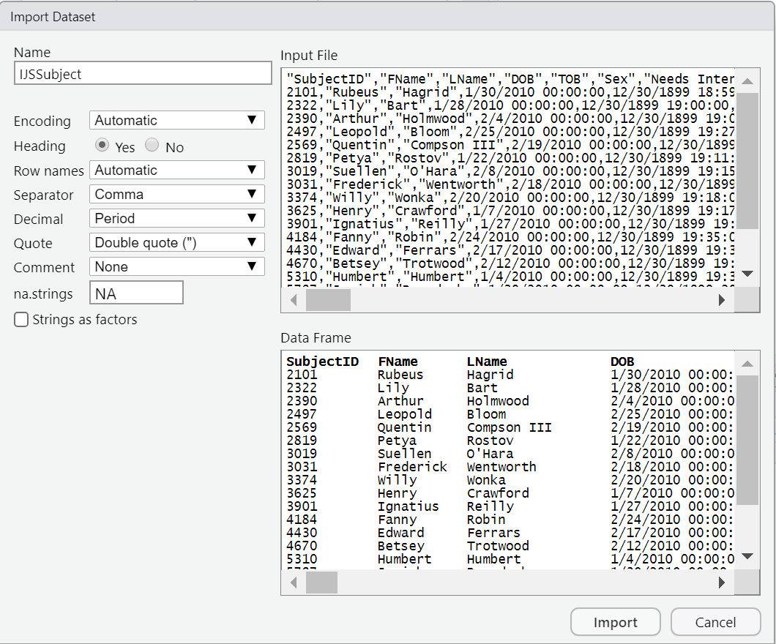

- The data you imported will appear in a new tab in the upper left pane.

- Repeat steps 3 and 4 for the WPPSI and NeuroExam files. You should see each of these data tables open in the top left window of RStudio.

B. Running SQL Queries in R
- Open a new R Script by selecting File | New File | R Script.

- R needs an extra software package (called “sqldf”) to run SQL queries. If you are using the RAE, or if you have already installed sqldf on your local computer in the past, that package is already installed. Otherwise (or if you aren’t sure), install it by entering the following to the new script:

install.packages("sqldf")
library(sqldf)

Highlight both lines of code and click “Run” in top left panel of RStudio. This will install and load the “sqldf” package.

- Now, you can use the “sqldf” package to run queries on the data frames you imported. This can be accomplished by wrapping the query you’d like to run in quotation marks and passing it the sqldf() function.

Note: The queries available in SQLDF are specific to the package itself. Not all queries generated in MS Access will run in SQLDF.

- In Assignment 6, Part B, you wrote a query to summarize basic IQ results (count, mean, standard deviation, minimum, maximum) by hyperbilirubinemia status, Run the following to replicate your IQ summary query from earlier:

sqldf(
"SELECT Hyperbili, Count(IQFullEntered) AS Count,
Avg(IQFullEntered) AS Avg, StDev(IQFullEntered) AS StDev,
Min(IQFullEntered) AS Min, Max(IQFullEntered) AS Max
FROM IJSSubject INNER JOIN WPPSI ON IJSSubject.SubjectID = WPPSI.SubjectID
GROUP BY Hyperbili"
)

Note that this is the same SQL that you used to create this table in MS Access. Also, note that you’re running a query on two joined tables at once. (What are the two tables?) R understands SQL (with the help of the sqldf package). Stata can pass SQL to other software, but it cannot query multiple tables within Stata. (Stata is a single-table application.)

- You should see the output from this code appear in the console in the bottom left of RStudio. Use this output to answer the first question on Quiz 7.

C. Running T-Tests in R
- Your next task is to run a t-test on the IQ results. In Assignment 6, you extracted data from Access to a csv file, then analyzed the csv file in Stata. Here it can be done a bit more simply.

R can store the values (including the full results of a query) in a “vector.” You can think of a variable as a flexible space in which to store all kinds of data. In R, almost everything is a vector You can store the result of any of your queries as a vector in R by using a leftward arrow. Try running the following code to assign the result of your query from Assignment 6 Part C to a vector qryLab6Table3. (Of course you could name the vector almost anything you like.) The query here has the same SQL as the query you created to extract data in part 6C. of Assignment 6.

qryLab7Table3 <- sqldf(
"SELECT IJSSubject.SubjectID, Hyperbili, IQFullEntered
FROM IJSSubject INNER JOIN WPPSI ON IJSSubject.SubjectID = WPPSI.SubjectID;"
)

- If you wanted to see all the data stored in the new variable qryLab7Table3 (243 rows), you could just run “qryLab7Tables3” now as if it were a command. Or you can just print the first few lines of the data table it contains by using the head() function. Run the following line of code, and confirm that these entries match up with the output of the query you generated in Part C of Assignment 6

head(qryLab7Table3)

- Now, you can use R’s built-in functions to perform statistical analysis. The following line of code will run a t-test to compare IQs at age 5 (IQFullEntered) between those with and without exposure (the Hyperbili variable of qryLab7Table3).

t.test(IQFullEntered ~ Hyperbili, data = qryLab7Table3)

- You should see the following output:

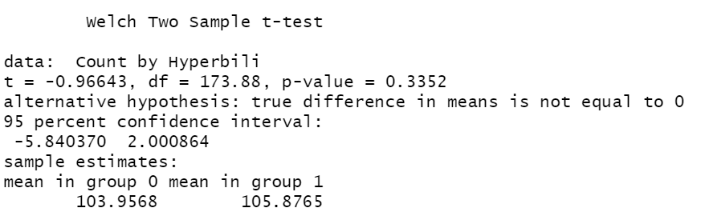

- Here is Table 3 from Newman et al. Can you find your result?
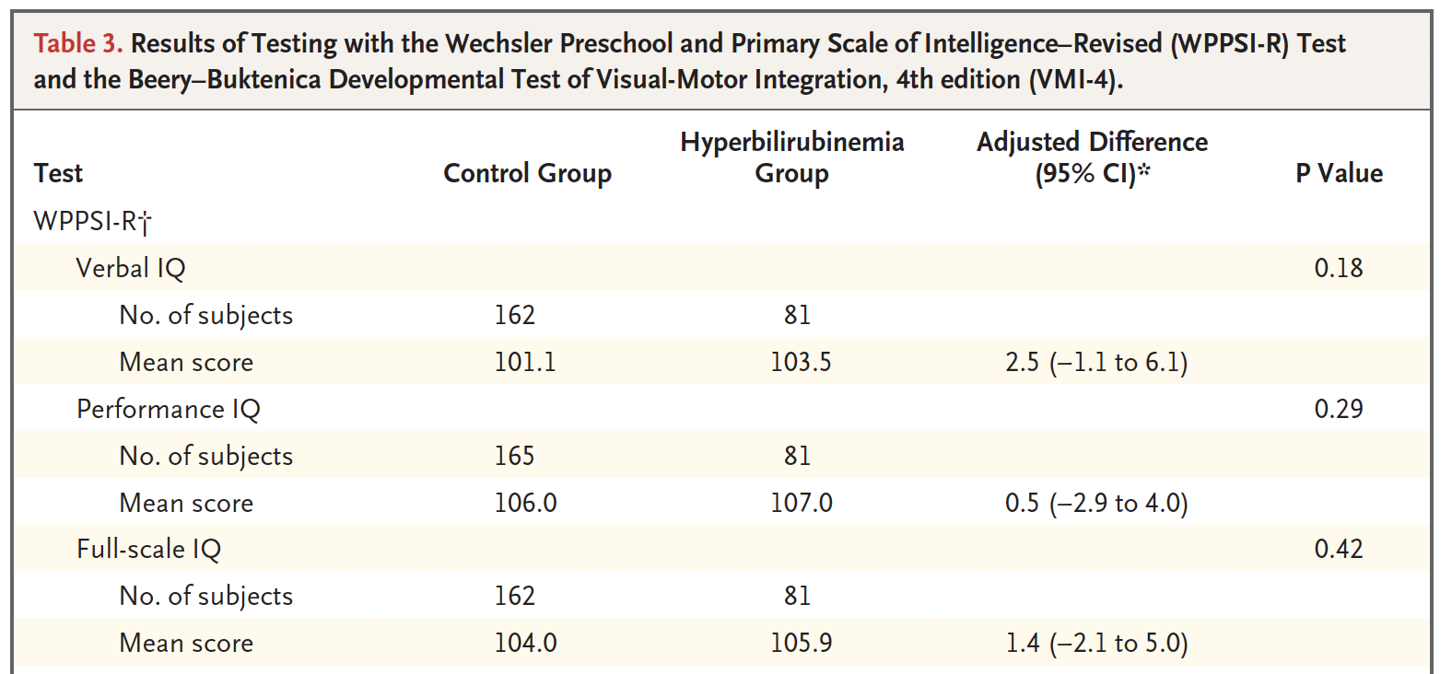

Advanced question: Does your p-value agree with theirs? If not, why not?

Hint: Table 3 has this footnote
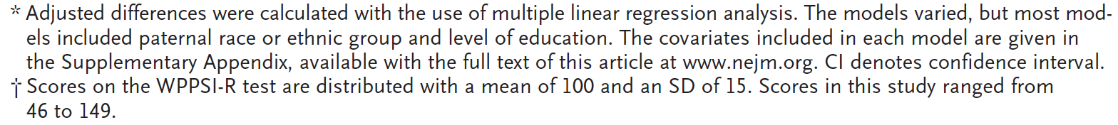
D. Running Chi-Squared Tests in R
- Run the following code to store your query from Part F of Assignment 6 into a new variable qryLab7Table4.

qryLab7Table4 <- sqldf(
"SELECT IJSSubject.SubjectID, Hyperbili,
Overall5, Overall, ([Overall5]<>1) AS NotNormal
FROM IJSSubject INNER JOIN NeuroExam ON IJSSubject.SubjectID = NeuroExam.SubjectID;"
)

- Display the head of qryLab7Table4 and confirm that it matches up with the output of the query you generated in Part F.
- Now let’s look at the frequencies, which we did not attempt to do in the Access/Stata lab. The first line below creates the table of frequencies, and the second displays it.

rawtable <- table(qryLab7Table4$Overall5, qryLab7Table4$Hyperbili,
dnn = c("Neuro Exam", "Hyperbili"))
rawtable

This syntax will become familiar to you if you continue to work with R. The “table” command in R creates a table, similar to the “tabulate” command in Stata. The “dnn” argument creates the row title and the column title. (“dnn” stands for “dimnames names”, and “dimnames” means “dimension names.”) When you type “c("Neuro Exam", "Hyperbili"))”, you are creating a 2-element vector consisting of character strings to use as the row title and the column title for your table. The “c” stands for “concatenate”.

- We see the counts. Now let’s see the proportions.

proportiontable <- prop.table(rawtable, 2)
proportiontable

The “2” means to calculate column proportions. A “1” would indicate row proportions.

- Convert to percentages and round.

round(proportiontable*100,1)

- You should see the following output:

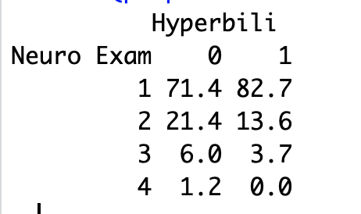

- Here is the table from Newman et al. Did they get it right?

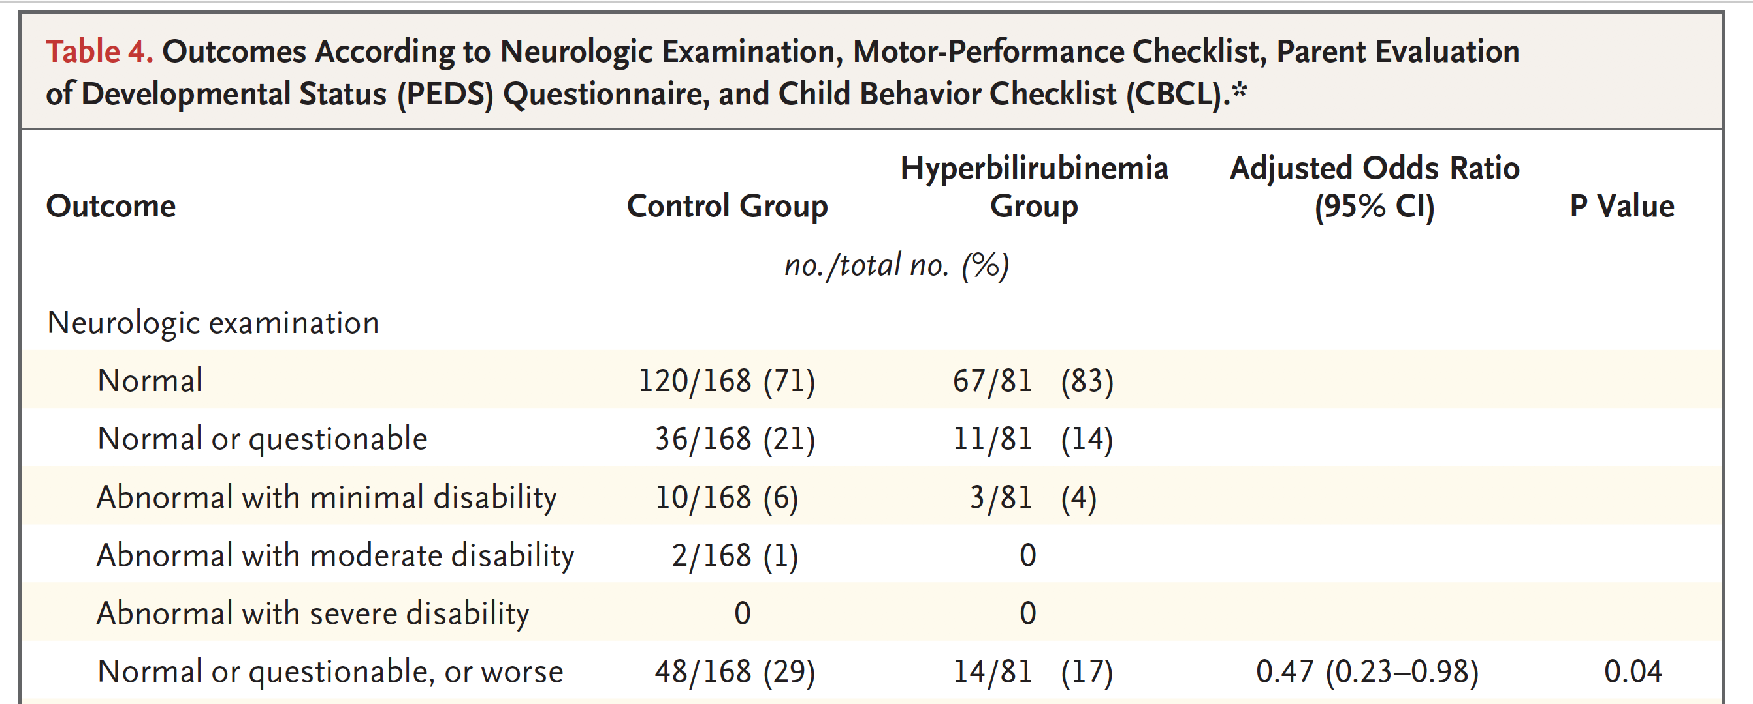

- Run the following code to perform a Chi-Squared test of independence between the Overall5 and Hyperbili columns of qryLab7Table4, as in Section G of Assignment 6. This will allow you to determine whether the distribution of exam results differs between exposed and unexposed groups.

chisq.test(qryLab7Table4$Overall5, qryLab7Table4$Hyperbili)

- You should see the following output.
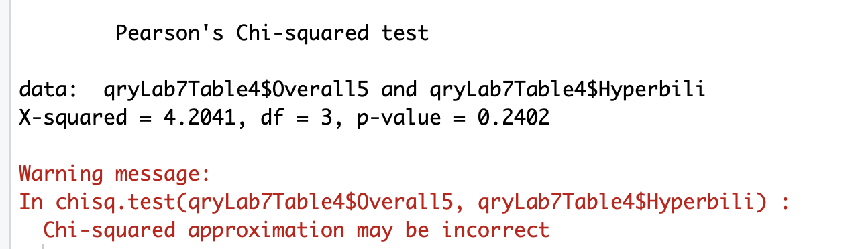

The warning is because of the low frequencies in cells some of the cells. You will be taught not to use Chi-Square when the expected frequency in a cell is < 5.

We blocked out the p-value because it’s the answer to Quiz 7 Question #2

E. Calculating Risk Ratios in R
- You can also use R to confidence interval for the risk ratio of “NotNormal” between exposed and unexposed groups. To do this, you will need to install and load the package “epitools.”

NOTE: Currently, the package “epitools” isn’t available in the RAE’s version of R. If you want to do this part of the assignment, you’ll need to run R from your own computer or another computer that will allow you to install packages.

install.packages("epitools")
library(epitools)

- Next, run the following function to analyze risk ratios using the Hyperbili column of qryLab7Table4 as the predictor variable and the NotNormal column of qryLab7Table4 as the outcome variable.

riskratio(qryLab7Table4$Hyperbili, qryLab7Table4$NotNormal)

- You should see the following output, which displays confidence intervals for each group when compared against the unexposed group. For this reason, the value for Hyperbili = 0 is exactly 1, since it is the unexposed group. The value for Hyperbili = 1 provides the ratio we are looking for, with p-values corresponding to three different kinds of tests for statistical significance.
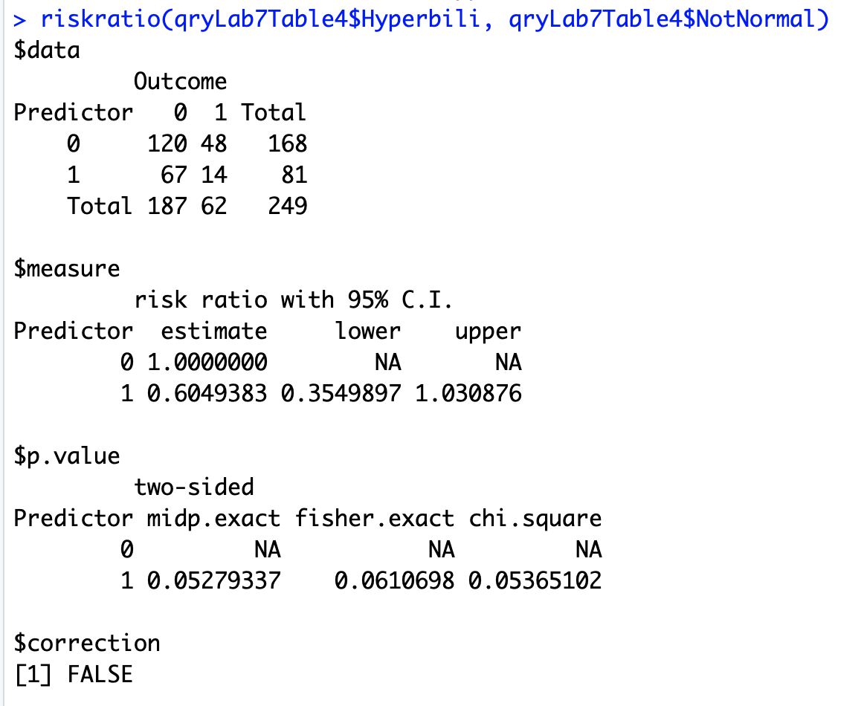
- The counts will agree with Newman et al, but the confidence interval and p-value will not agree. However, the confidence interval and p-value for the RR will agree with what you calculated using Stata in Assignment 6.

