Epi 204 -- Problem Set #2
Chapter 2 Problems (Dichotomous tests)
Upload to CLE by
Upload to CLE by 9/30/21 1:15 pm

44 points possible + 2 points extra credit
Do problems #1 – #6 below. Some of the problems are in Evidence-Based Diagnosis, 2nd Edition (EBD-2) with answers in the back of the book. Please do them on your own before looking at answers!
You may use whatever tools you like, including Excel, an online calculator, and Stata, but please respond clearly and directly to the questions. The more work you show, the easier it is for graders to figure out what you did wrong and give partial credit if your answer is not right.

1. (Not in book) Anal-Cranial Inversion
We were big Car Talk fans. (It was a call-in radio show on National Public Radio.) Imagine our delight when we heard a "puzzler" about diagnostic tests! If you don’t want to read the banter between Tom and Ray Magliozzi, you can skip to Question.

Ray: Hi, we're back. You're listening to Car Talk with us, Click and Clack, the Tappet Brothers, and we're here to talk about cars, car repair, and the final Puzzler of the current Puzzler season.
Tom: So I should, like, savor this one? It's going to be a doozy, isn't it? A real season-ending splash.
Ray: Jerk. All right. There's a rare disease sweeping through your town … and the disease is called ACI, and it produces irreversible anal-cranial inversion. You may have noticed that my brother has it. Now, of all people exposed to ACI, only 0.1 percent actually contract it. OK?
Tom: Point one percent.
Ray: A tenth of a percent. OK?
Tom: Zero point one percent.
Ray: And if you catch it early, before the symptoms present, you can get treatment and maybe you can be cured. Fortunately, there's a diagnostic test, which can detect ACI up to a year before the inversion occurs. So anyway, you go to your doctor and he administers the test, and it comes out positive.
Tom: Yeah?
Ray: And you say, "Oh, I'm done for." Then you're getting a little bit encouraged. You say, "Wait a minute, doc. Is this test 100 percent accurate? And he says, "Well, not really, but it's 95 percent accurate."
Tom: Ninety-five percent accurate.
Ray: All right? He says, in other words, 5 percent of the people who take the test will test positive but they don't really have it. The question is: What are the chances that you will actually have an irreversible anal-cranial inversion?

Question: Assume sensitivity = 100%, specificity = 95%, and prior probability = 0.1%. What is the post-test probability after a positive test? (2 points: 1 pt for correct equation/approach, 1 pt for calculation)

2. (Not in book) Biliary Atresia
Biliary atresia is a disorder that leads to the bile ducts closing off in the first few months after birth and (if untreated) eventual liver failure. It is the leading reason for liver transplantation in children. There is evidence that the prognosis improves if it is detected early.
Harpavat et al[1] reported preliminary results of screening for biliary atresia using direct bilirubin measurements in newborns. An excerpt from the abstract is pasted below:
"Of 124,385 newborns in the screening study, 49.2% were female, 87.6% were of term gestational age, 70.0% were white, and 48.1% were Hispanic. Screening identified the 7 known infants with biliary atresia with a sensitivity of 100% (95% CI, 56.1%-100.0%), a specificity of 99.9% (95% CI, 99.9%-99.9%), a positive predictive value of 5.9% (95% CI, 2.6%-12.2%), and a negative predictive value of 100.0% (95% CI, 100.0%-100.0%)."
- Assume that all of the numbers in the abstract are correct. Create a 2 × 2 table for the results above. (2 points)

- What was the prevalence of biliary atresia in this population? (2 points)

C. The 100.0% negative predictive value looks really good! But the 95% CI (100.0%-100.0%) for NPV looks suspicious, since the lower 95% CI limit for the sensitivity is only 56%. If the false-negative rate could be as high as 44%, can we really be confident that the negative predictive value is very close (within rounding error of) 100%? Explain. (3 points: 1 pt for correct yes/no, 2 pt for explanation)

3. (Not in Book) Santa Clara County COVID-19 Seroprevalence study
The Santa Clara County COVID-19 Seroprevalence study (https://doi.org/10.1101/2020.04.14.20062463) was highly controversial due to possible bias in the sampling and miscalculation of confidence intervals. We will not be discussing those issues here.
In a single day 3330 county residents were tested for antibodies to SARS-Cov-2 using a point-of-care test kit. Of the 3330, 50 tested positive.
We will call the proportion with a positive test, 50/3330 = 1.5% P(T+).
If an antibody test is imperfect, the proportion of a population with a positive test P(T+) does not accurately represent the proportion of the population that was previously infected P(D+).
The POC test kit is a lateral flow assay distributed by Premier Biotech (Minneapolis, MN) and manufactured by Hangzhou Biotest Biotech (Hangzhou, China). It tests for IgG and IgM antibodies to SARS-Cov-2. The authors reported that, in a previous validation study, out of 157 specimens from individuals known to have had COVID-19 (we will refer to them as D+), 130 had a positive test. Out of 3324* specimens from (D-) individuals known not to have been infected, 16 had a positive test.
* Coincidence! The similarity of 3324 D- patients in the previous validation study to the 3330 in the Santa Clara County sample is purely a coincidence. These were two separate studies, a validation study to determine the accuracy of the test, and a sero-prevalence study to determine the prevalence of prior infection.
- What are the sensitivity and specificity of the test? (2 points: 1 pt for each Sens & Spec)

Because the test is imperfect, the proportion with a positive test P(T+) is not necessarily the same as the proportion of the sample that has had COVID-19, which we will call the true prevalence of prior infection or P(D+). We want to adjust P(T+) to get P(D+).
- First, ignore the study’s actual P(T+) of 1.5% and assume that nobody had been previously infected, i.e., P(D+ = 0), how many positive tests would you expect to see out of 3330? (2 points: 1 pt for each part)

- You knew the proportion of positives P(T+) you would see if nobody was D+ (P(D+) = 0). What proportion of positive tests would you see if 20% were D+, i.e. P(D+) = 0.2? Again, sensitivity and specificity as per part (a). (1 point)

- If you did (c), you realize that you can go from P(D+) to P(T+). In the actual study P(T+) was 50/3330 = 1.5%. What’s your estimate of P(D+)? (Extra Credit 2 points)

4. (EBD-2 2.2) Are negative and positive test results always equally informative?
Give a REAL example of a test for which a positive result is generally very informative but a negative test is not. It need not be medical – in fact, we encourage you to think outside the medical box! What are the characteristics of a test for which positive results are generally more informative? (4 points)

5. (EBD-2 2.5) Breast/Ovarian Cancer Test With Oversampling of Positives
(with thanks to Yi-Hsuan Wu, MAS 2017)
Mutations in BRCA1 and BRCA2 (BRCA1/2) genes increase the risk of breast and ovarian cancer, but the genetic test for them is costly. There are models to assess the probability of carrying a BRCA1/2 mutation, but they are complicated and time-consuming, requiring a very detailed family history ("pedigree"). Bellcross et al.[2] evaluated the accuracy of a referral screening tool (RST) designed for use in primary care practice to help clinicians select patients for BRCA testing (Figure).
Figure: BRCA testing referral tool. Reprinted by permission from Springer Nature Customer Service Centre GmbH: Springer Nature Genetics in Medicine. Evaluation of a breast/ovarian cancer genetics referral screening tool in a mammography population. Cecelia A Bellcross, Amy A Lemke, Laura S Pape, Angela L Tess, Lorraine T Meisner, Copyright 2009.
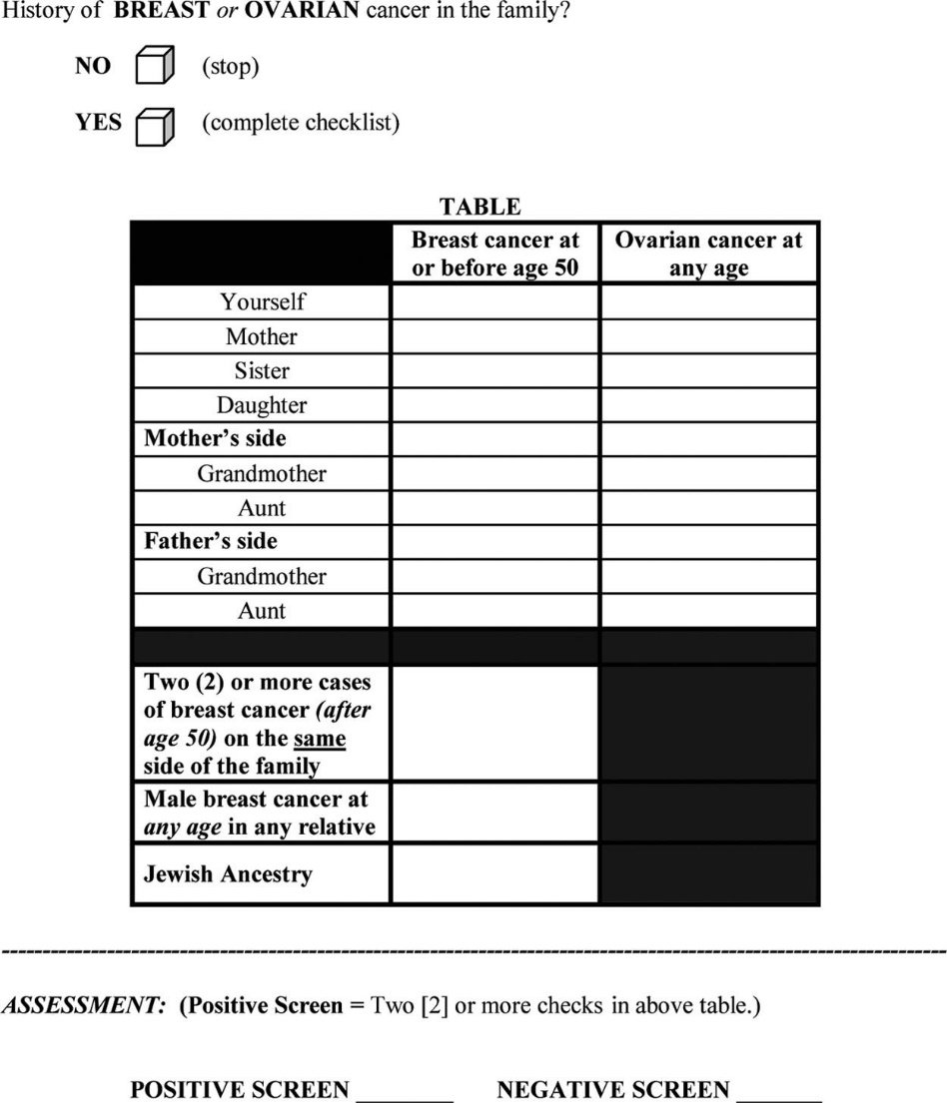

From the abstract (reprinted with permission; see above):

Methods: The RST was administered to 2464 unselected women undergoing screening mammography. Detailed four-generation cancer pedigrees were collected by telephone interview on a random subset of 296 women. The pedigrees were analyzed using four established hereditary risk models…with a ≥10% BRCA1/2 mutation probability using any [established] model as the definition of “high risk.”
Results: The RST identified 6.2% of subjects as screen “positive” (high risk). … In comparison with the pedigree analyses [i.e., the four established hereditary risk models], the RST demonstrated an overall sensitivity of 81.2%, specificity of 91.9%, [PPV of 80%, NPV of 92%], and discriminatory accuracy of 0.87.

Although the sample of 296 women for the pedigree analysis is described in the abstract as a “random subset,” it was not a simple random subset: the authors chose to oversample (randomly) from the RST-positive group. The RST-positive group only represented 6.2% of the screening mammography population, but 29% of their sample for pedigree analysis, "to provide a sufficient number of potentially high-risk pedigrees to adequately address sensitivity."

- Is the sampling of the 296 women in this study cross-sectional, case-control, or test result-based (index positive-negative)? (1 point)
The following table shows results in the pedigree analysis sample consistent with what the authors reported:
 |  | Risk based on pedigree analysis and risk models
 |  | High risk | Low risk | Total
RST result | Positive | 69 | 17 | 86 | PPV= 80%
RST result | Negative | 16 | 194 | 210 | NPV= 92%
RST result | Total | 85 | 211 | 296
 |  | Sensitivity= 81.2% | Specificity= 91.9%
Now you want to know the sensitivity and specificity of RST in the underlying mammography population (n= 2464).

- Given that 6.2% of the subjects in the entire mammography population were identified as RST positive and the predictive values observed, complete the following 2 × 2 table and calculate the sensitivity and specificity of RST in the entire mammography population. [Hint: First figure out how many in the entire population tested positive, to fill in the cell labeled "A".] (5 points)

Sample |  | Risk based on pedigree analysis and risk models
 |  | High risk | Low risk |  | Total
RST | Positive |  |  |  | A | PPV=
RST | Negative |  |  |  |  | NPV=
RST | Total |  |  |  | 2464
 |  | Sensitivity= | Specificity=
- Compare the sensitivity and specificity of the RST in the mammography population you obtained from (b) with what was reported in the abstract. Why are they different? Which do you think is correct? (4 points)

In the Results section the authors wrote:
“It should be noted that these predictive values are not representative of those that would be obtained in a general mammography population, as … high-risk subjects were intentionally oversampled. Using the prevalence of 6.2% RST screen-positive individuals in this study, and the overall sensitivity and specificity obtained, the PPV and NPV values expected in a general mammography population would be 0.39 and 0.78, respectively.”
d) Do you agree with the authors that the PPV and NPV, not the sensitivity and specificity, are the measures that needed to be adjusted to be representative of the ones in the mammography population? Explain. (5 points)

6. (EBD-2 2.6) Testing Thresholds for Strep Throat
Let's return to Clinical Scenario #1 from Chapter 1, in which we had a graduate student with sore throat, fever, pus on the tonsils and tender lymph nodes.
i. The drug cost of a course of penicillin V (500 mg 3 times a day) to treat acute Group A streptococcal throat infection (“strep throat”) is about $12 (www.GoodRx.com, with a coupon), and the expected cost in patient inconvenience, risk of adverse or allergic reactions, and contribution to antibiotic resistance is another $48. So, the total expected treatment cost is $60.
ii. Treating someone who really has strep throat (and not some other pharyngitis) decreases symptom severity, length of illness, transmission to others and the (already minute) risk of rheumatic fever. The value of this averages about $150, but since the cost of treatment is $60, the net benefit of treating someone with strep throat is $90. This can also be viewed as the net cost of failing to treat someone with strep throat. Penicillin will not help the patient if the sore throat is caused by something other than Group A strep.
- Draw a graph like figure 2.2 based on the assumptions above, labeling the axes, lines and intercepts. Although you can check your answer at www.ebd2.net, draw the graph by hand. You can use pencil and paper and paste a low-resolution photo into your HW. (2 points)

- At what probability of strep throat should you treat with penicillin? Show the point on the graph and the equation to derive it; you can check your answer at ebd2.net. (2 points)

- According to UpToDate (accessed 9/22/21) a rapid strep test is about 85% sensitive and 95% specific. For what range of prior probabilities would it have the potential to affect management? (Ignore the cost of the test.) Do this calculation using likelihood ratios (show your work), then draw a line for “free rapid strep testing” on the graph. (4 points)

- Now assume that a perfect rapid strep test for Group A streptococcal throat infection has been developed. The test causes negligible discomfort and results are available nearly instantaneously, but the test costs $40. When does it make sense to use this test? Draw a line for testing on the graph and explain. (3 points). (FYI, UCSF charges $286 for a rapid strep test. You can download a (not very user-friendly) spreadsheet with UCSF charges (the Charge Description Master) here. I have independently confirmed that the $286 charge is correct for a rapid strep test, a throat culture is $227 with an additional $135 if it is positive for Group A,C, or G strep. Our tagline could be UCSF: Helping you exceed your deductible quickly!)

References

1. Harpavat, S., et al., Diagnostic Yield of Newborn Screening for Biliary Atresia Using Direct or Conjugated Bilirubin Measurements. JAMA, 2020. 323(12): p. 1141-1150.
2. Bellcross, C.A., et al., Evaluation of a breast/ovarian cancer genetics referral screening tool in a mammography population. Genet Med, 2009. 11(11): p. 783-9.

It was actually several different previous validation studies. Their results were combined together as if there were only one validation study. For this problem, you may assume this is valid.
To simplify this problem we have combined "moderate" and "high-risk" groups into a single "positive" category.

